Supplementary Material

# Supplementary Figures

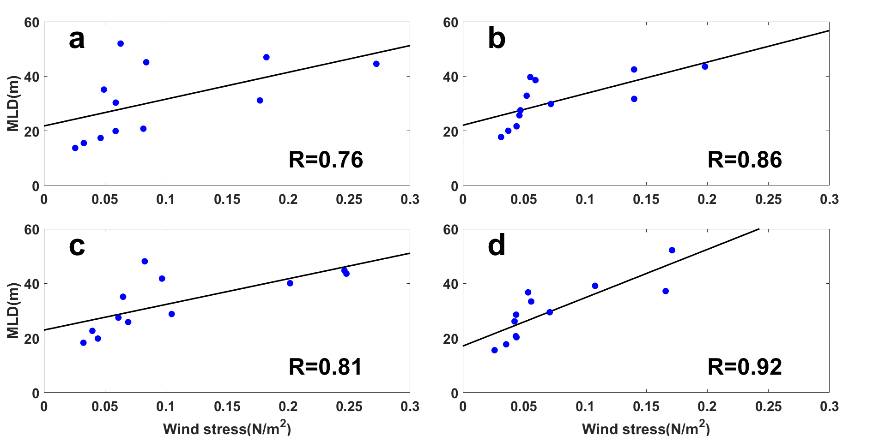

**Supplementary Figure 1.** Correlations between wind stress and MLD by region: (a) NW (R = 0.76), (b) NE (R = 0.86), (c) SW (R = 0.81), (d) SE (R = 0.92).

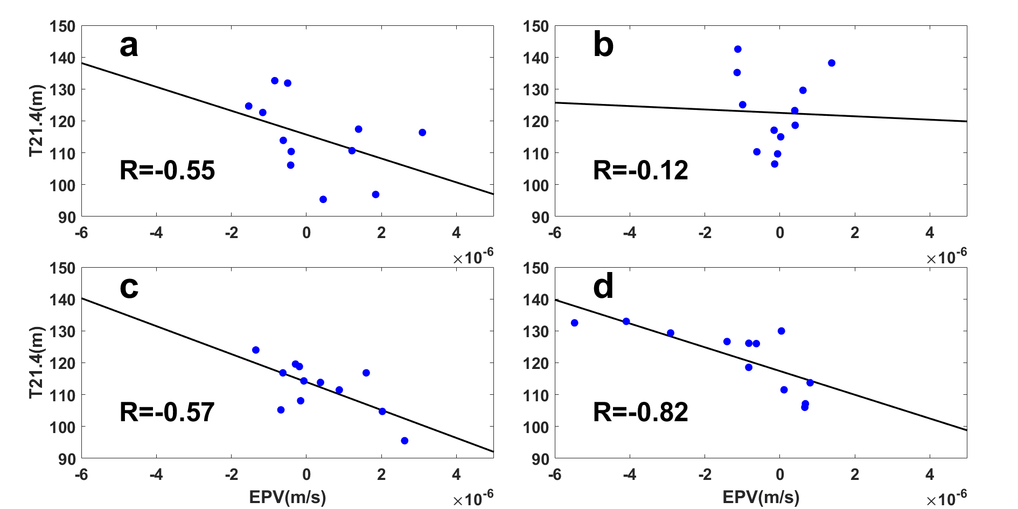

**Supplementary Figure 2.** Correlations between EPV and isotherm by region: (a) NW (R = −0.55), (b) NE (R = −0.12), (c) SW (R = −0.57), (d) SE (R = −0.82).

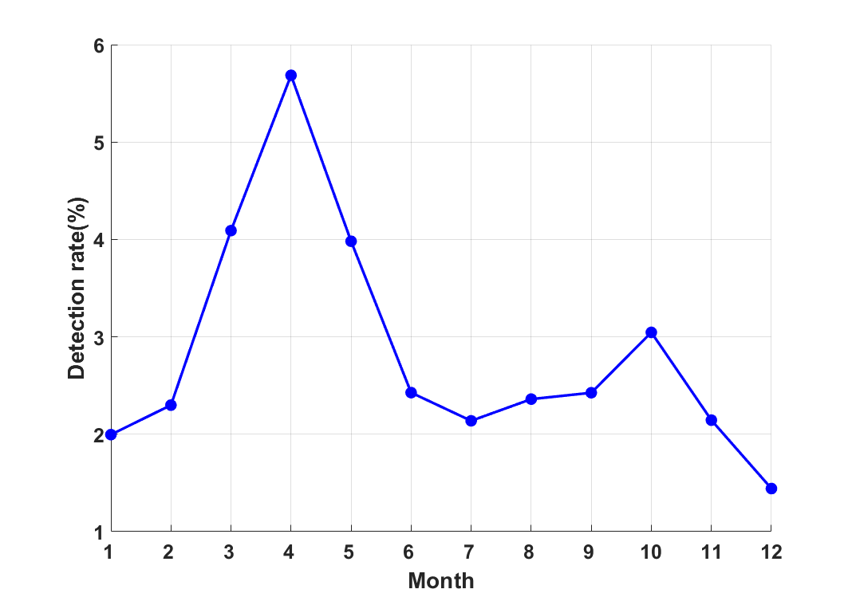

**Supplementary Figure 3.** Monthly probability density distribution of detected subduction profiles.