Supplementary Material A

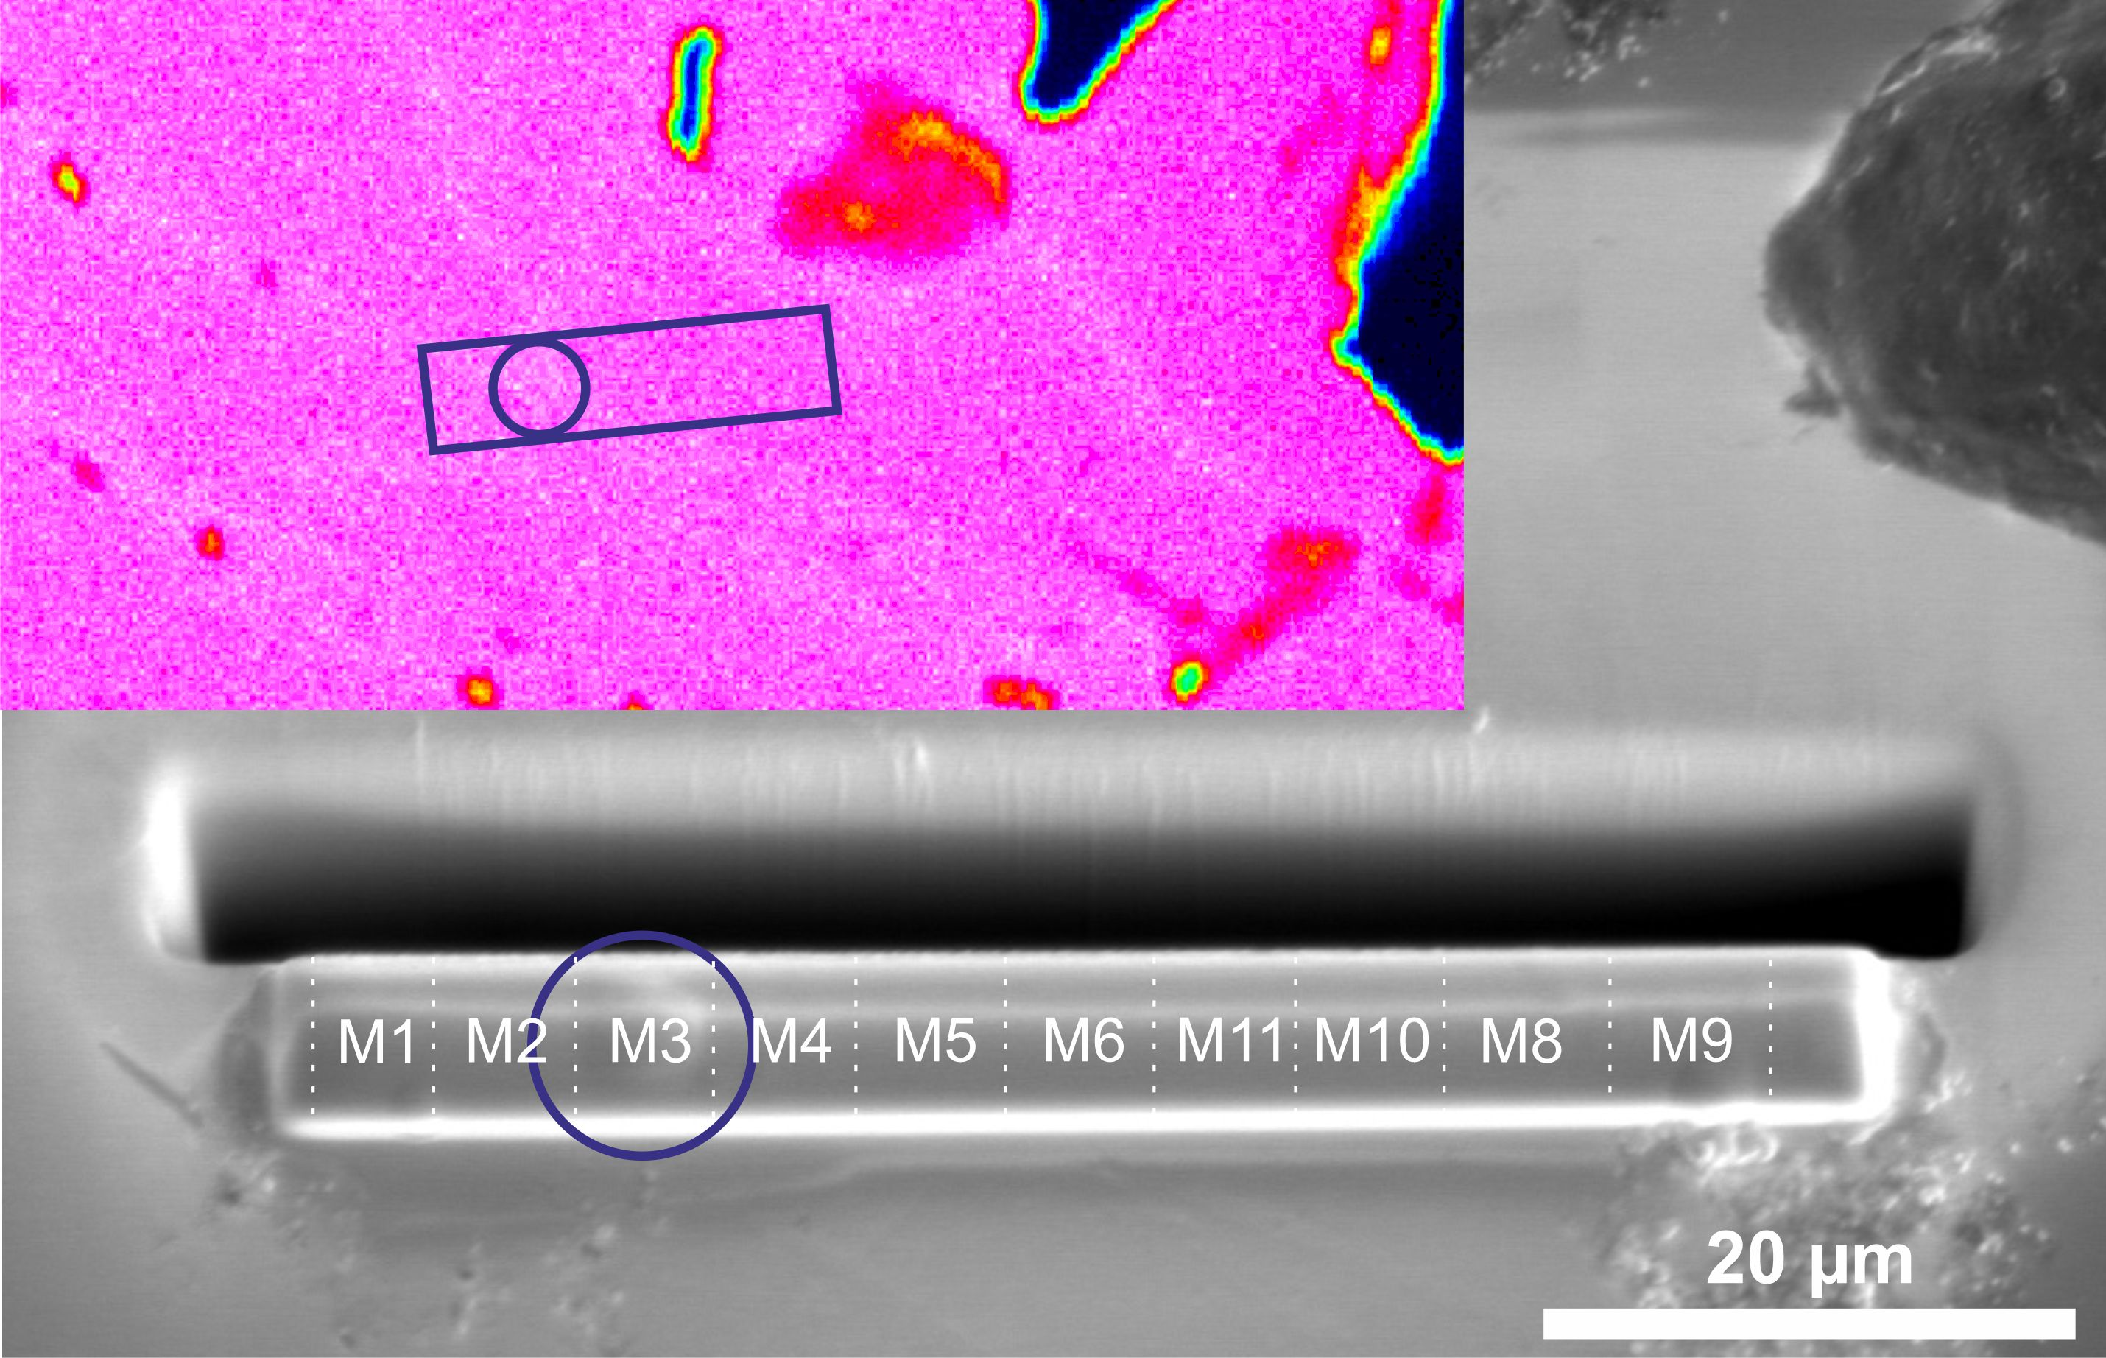

**Supplementary Figure 1.** Second electron FIB-SEM micrograph of the platinum cover that is positioned over the targeted liftout bar. Sections M9 and M11 were successfully run in the APT and used in this study. Blue circle shows a thicker platinum dot marking the intersect of the low Fe/Co network. The inset image shows the liftout bar area in an EPMA Zn element map, white lines is the low Fe/Co network.