Supplementary Material A

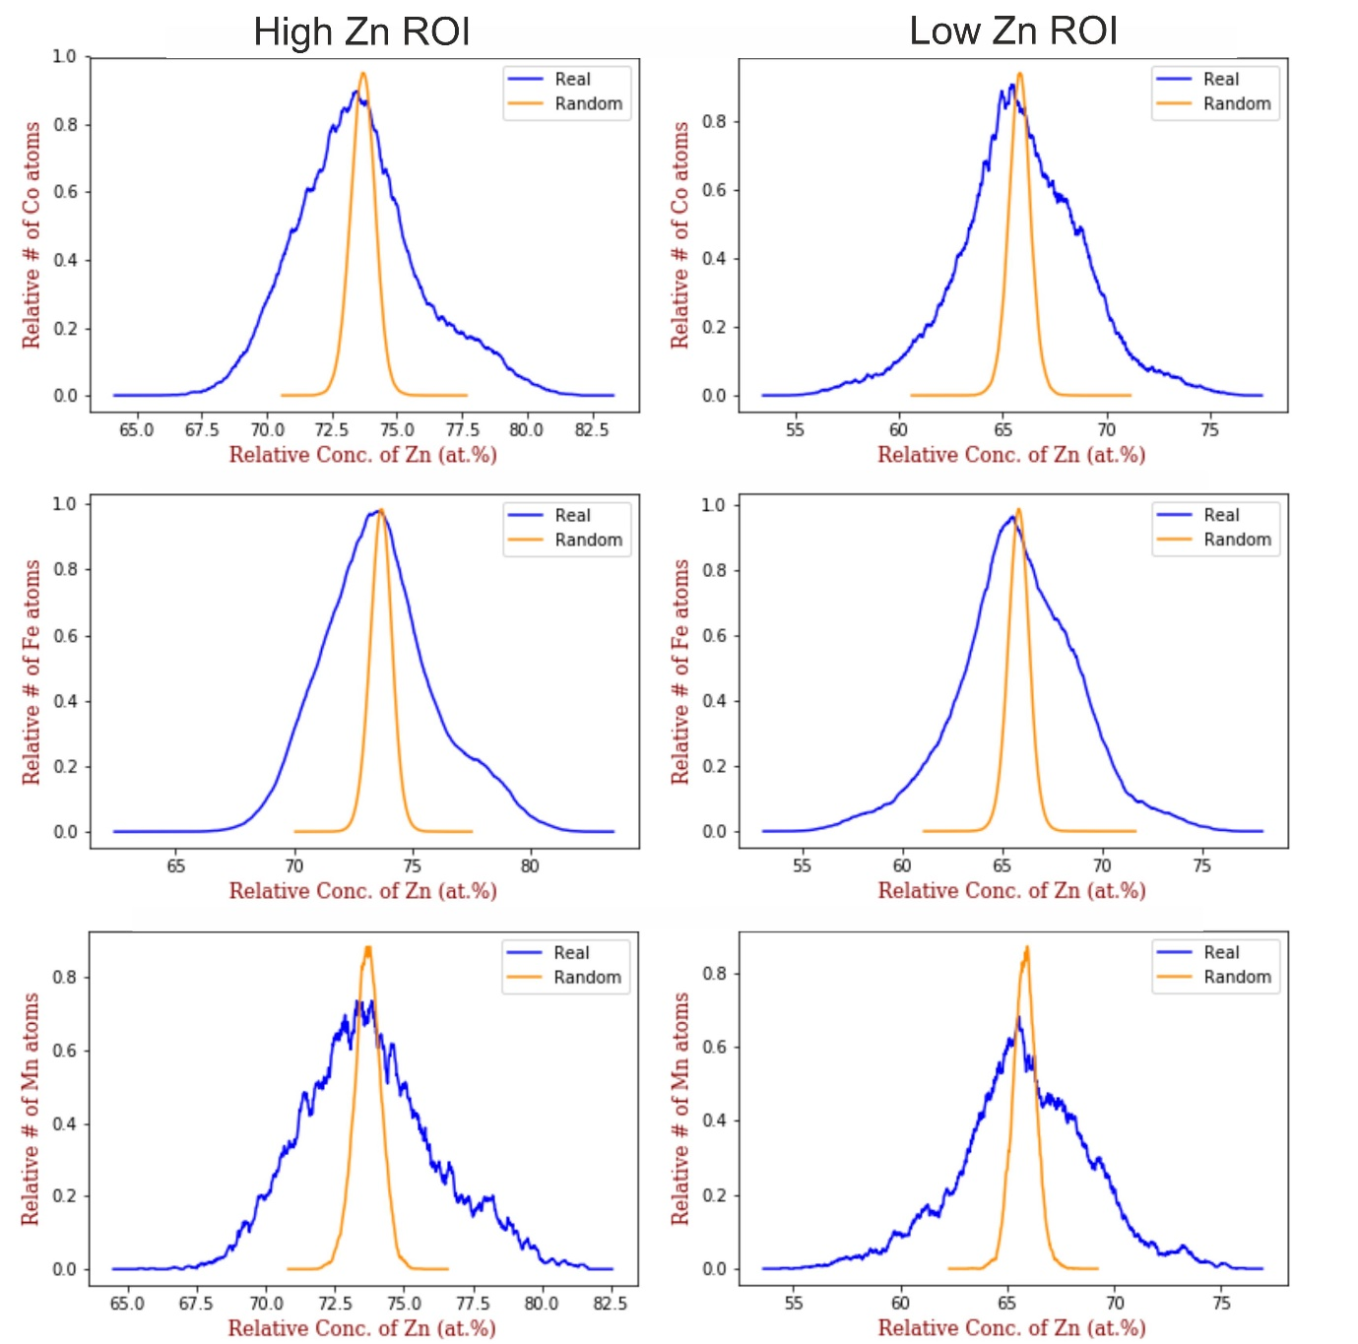

**Supplementary Figure 2.** Comparison of spatial correlation plots of the two regions of interest (ROI) made from the full APT data set. Both ROIs show similar trends, and thus using the ROIs was deemed more suitable than the complete APT dataset with the laser-induced artifacts.

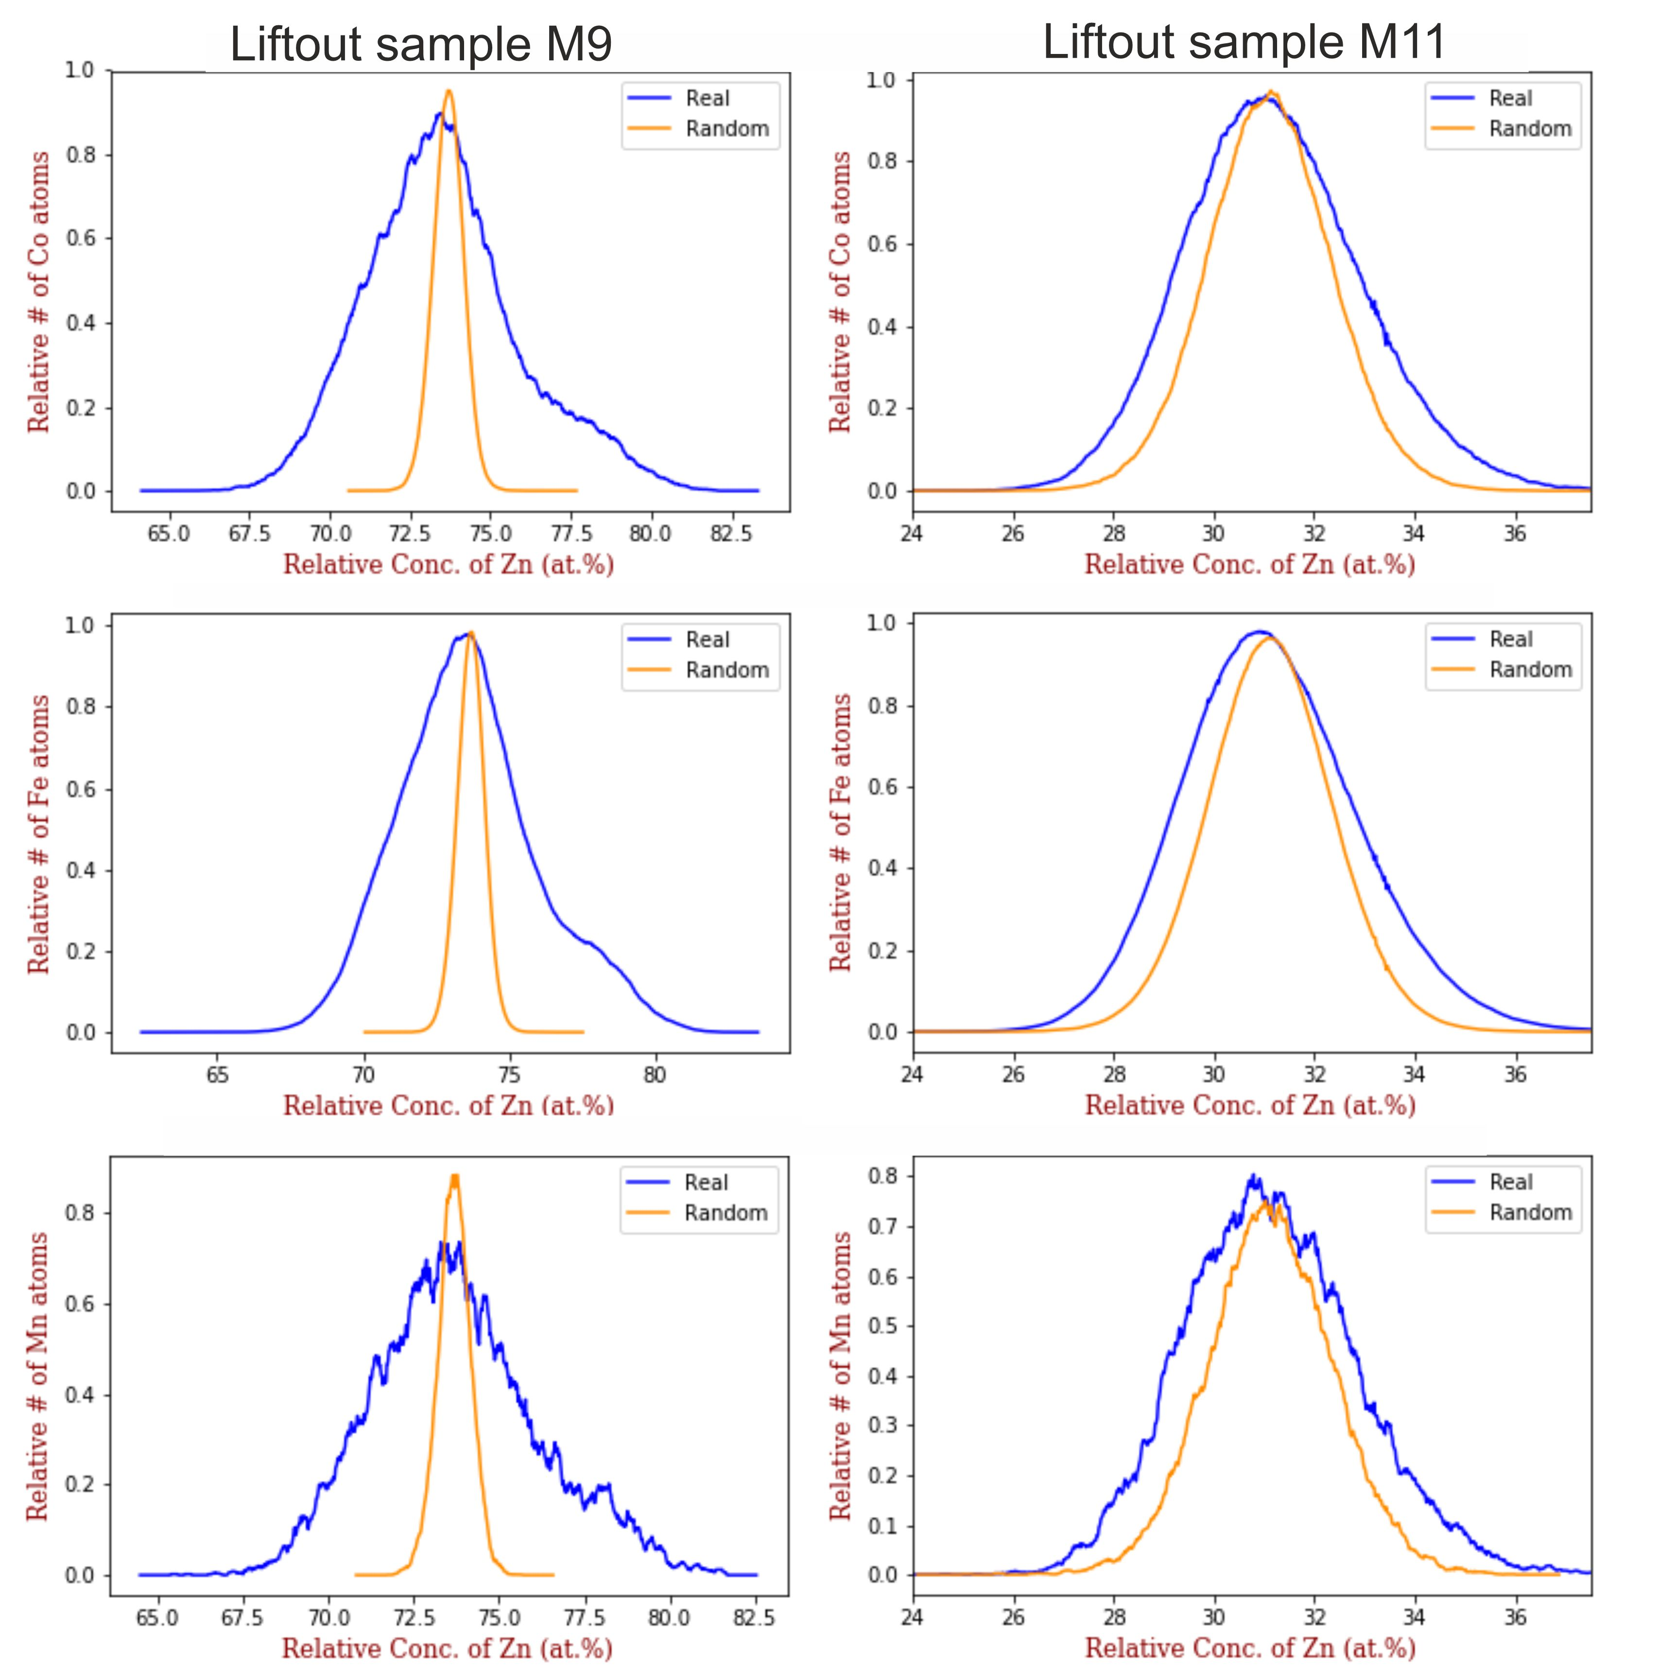

**Supplementary Figure 3.** Comparison of spatial correlation plots of the two successful APT datasets acquired. Similar negative correlations are present in both datasets, showing the reproducibility of the analysis.