Supplementary Material C

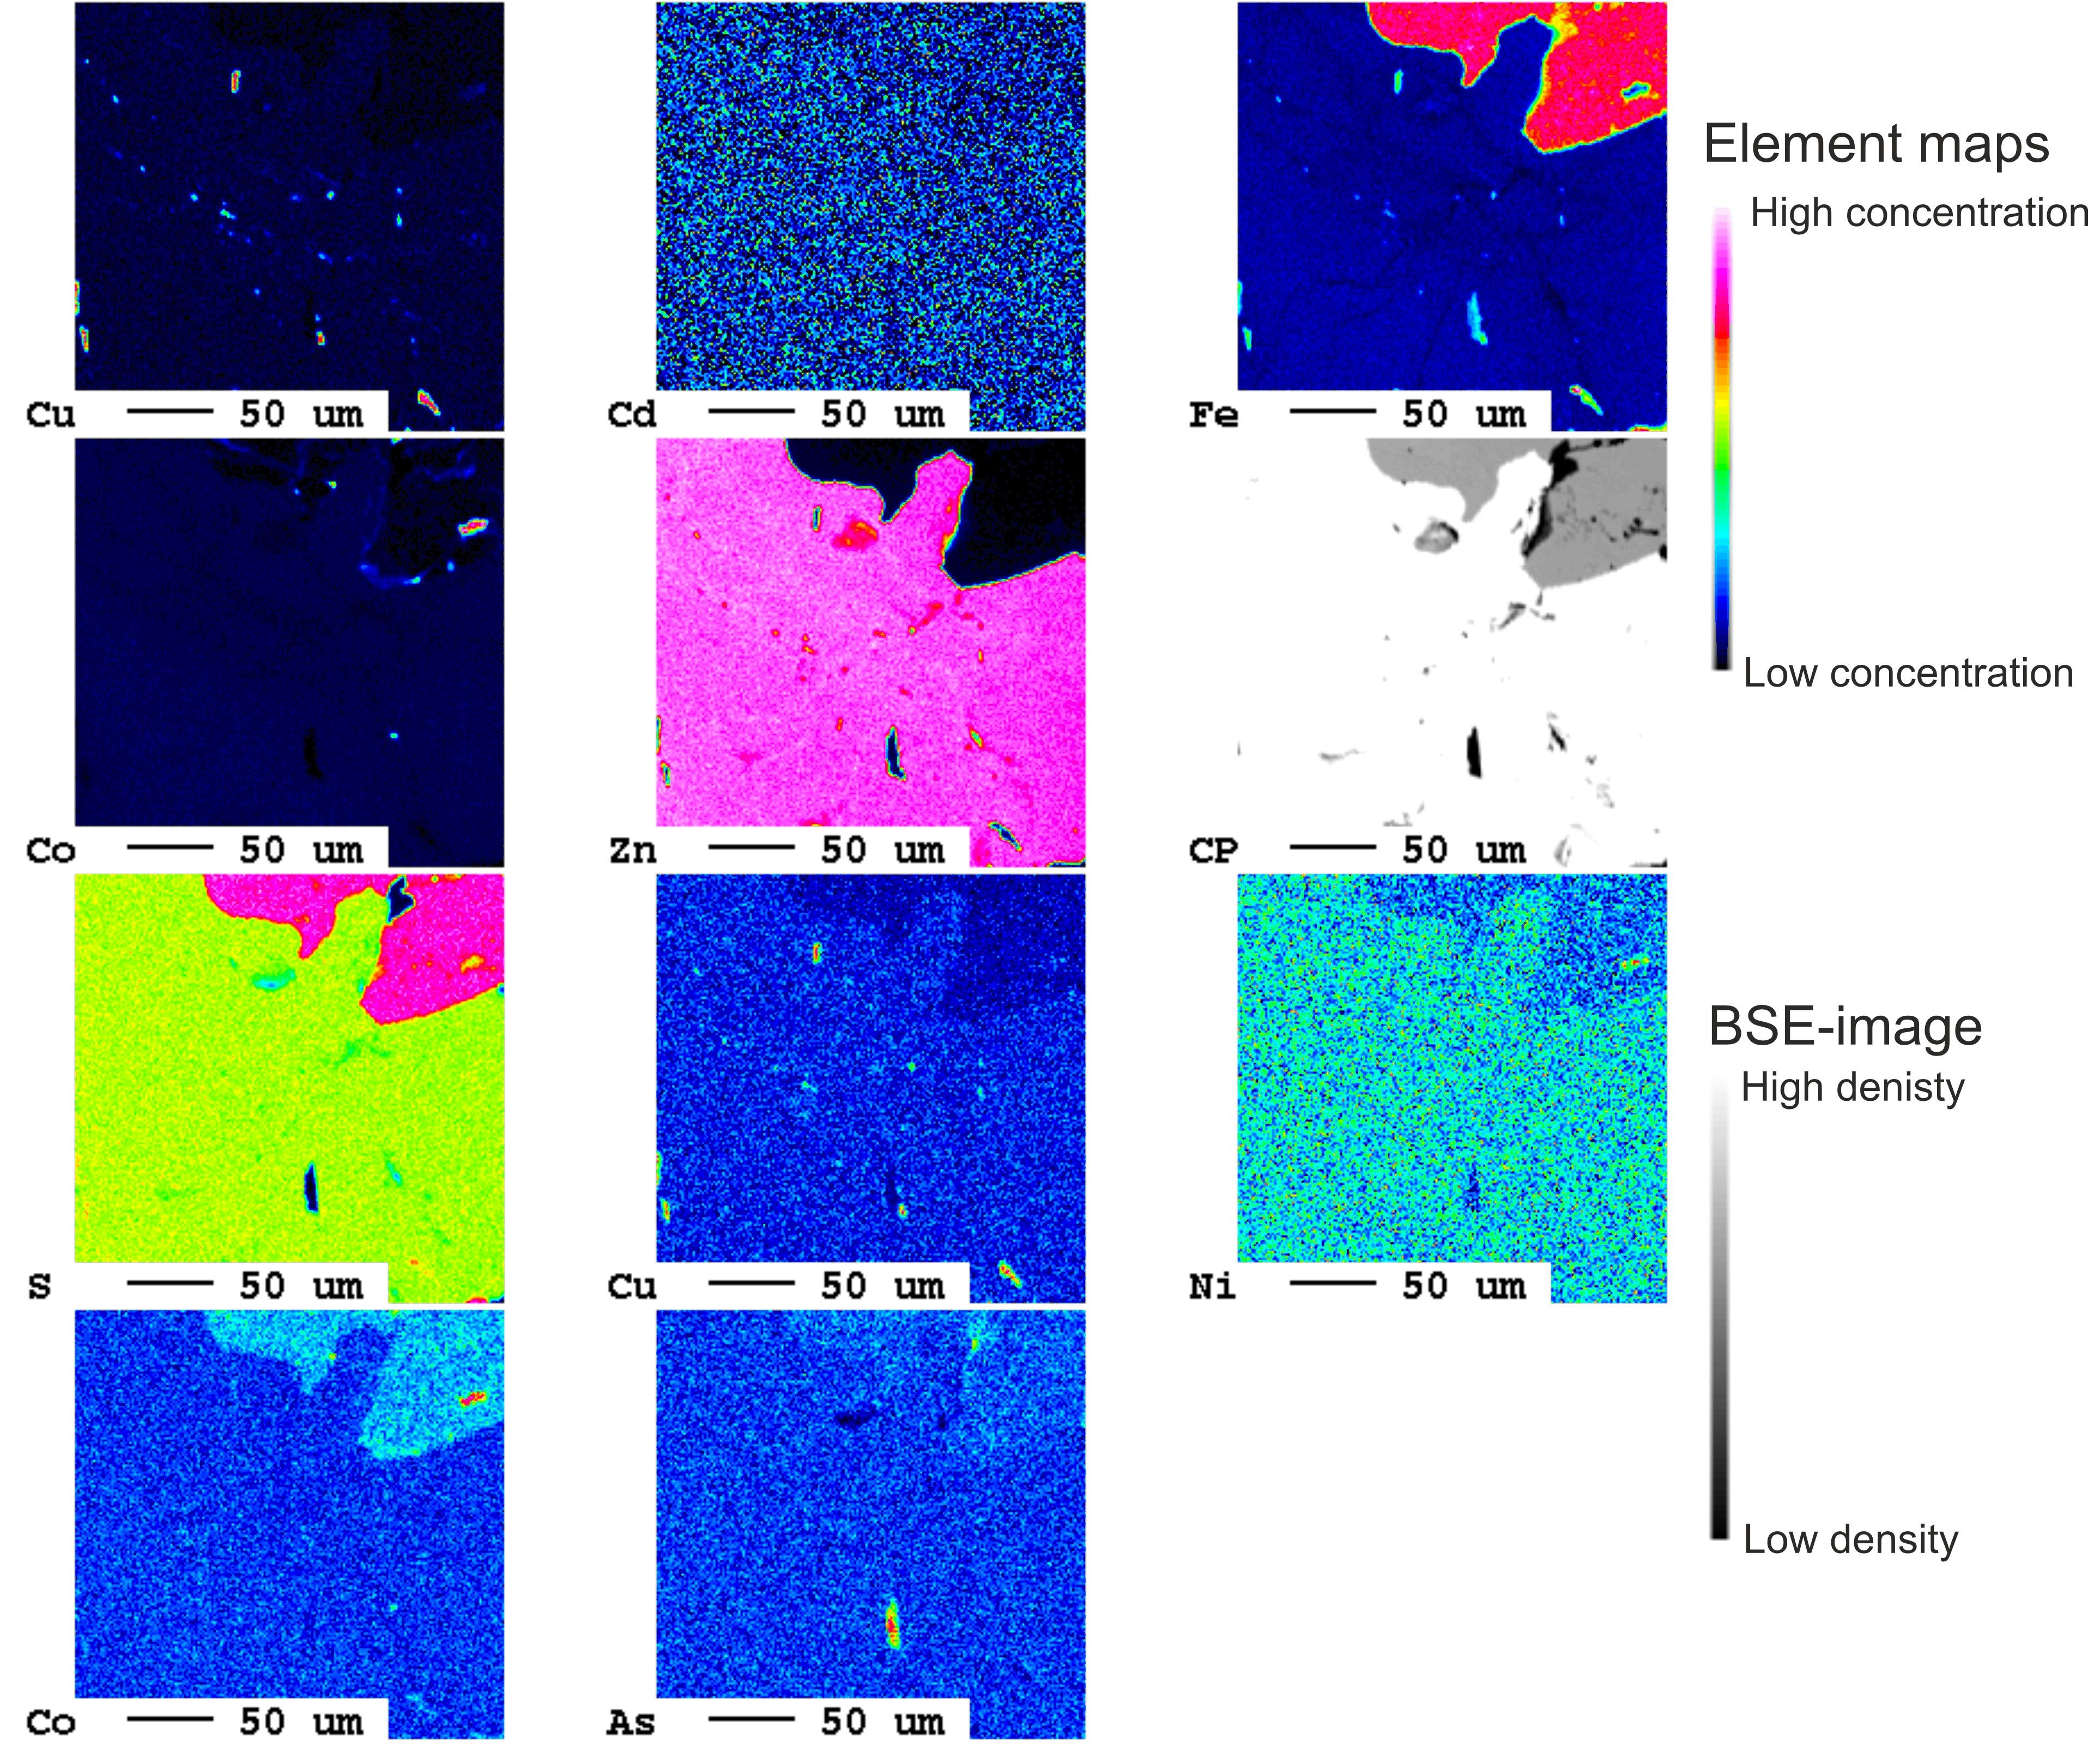

**Supplementary Figure 4.** EPMA element maps of all measured elements in the investigated area. Copper maps shows distribution of chalcopyrite inclusions within the sphalerite. Cadmium only shows background noise. Iron well displays the different sulfides present: pyrite (red), sphalerite (dark blue), and chalcopyrite (shades of bright green). Cobalt looks to be elevated in the sphalerite, compared to the hosting pyrite; this is also true for nickel. LA-ICP-MS analyses show that both cobalt and nickel are elevated in the pyrite (Bertrandsson Erlandsson et al., 2022). The lower concentrations of cobalt and nickel seen here may be due to the local redistribution of e.g. cobalt into the sphalerite (as discussed in the article), or simply be due to a cobalt-nickel-poor zone within the pyrite.