Supplementary Material D

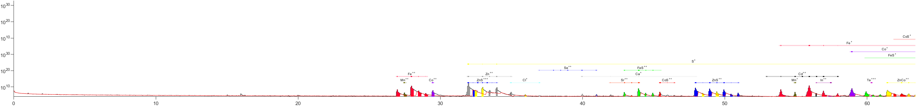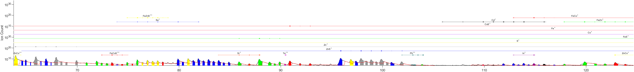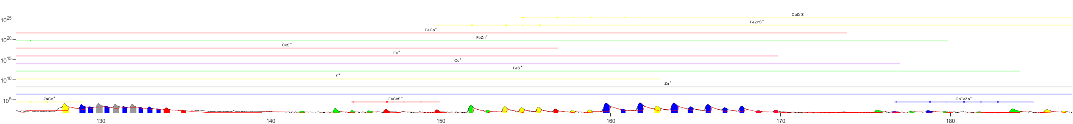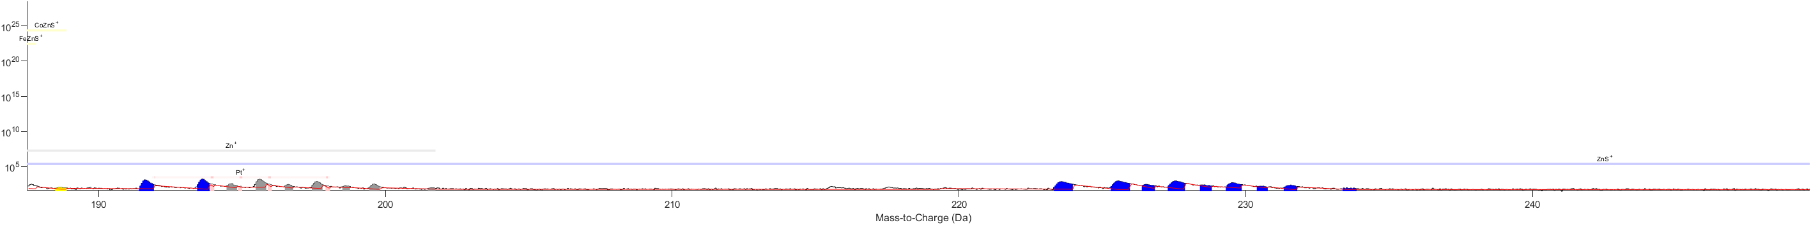

**Supplementary Figure 5.** APT mass spectrum of Co-rich sphalerite, with simplified mass ranges marked out.