Supplementary Material

Enhancement of ZnO@RuO2 bifunctional photo-electro catalytic activity toward water splitting

Katarina Aleksić1†, Ivana Stojković Simatović2†*, Ana Stanković1, Ljiljana Veselinović1, Stevan Stojadinović3, Vladislav Rac4, Nadežda Radmilović5, Vladimir Rajić5, Srečo Davor Škapin6, Smilja Marković1†*

1Institute of Technical Sciences of SASA, Belgrade, Serbia

2Faculty of Physical Chemistry, University of Belgrade, Belgrade, Serbia

3Faculty of Physics, University of Belgrade, Belgrade, Serbia

4Faculty of Agriculture, University of Belgrade, Zemun, Serbia

5Vinča Institute of Nuclear Sciences, University of Belgrade, Belgrade, Serbia

6Jožef Stefan Institute, Ljubljana, Slovenia

**\* Correspondence:** Ivana Stojković Simatović and Smilja Marković   
ivana@ffh.bg.ac.rs, and [smilja.markovic@itn.sanu.ac.rs](mailto:smilja.markovic@itn.sanu.ac.rs)

# Supplementary Figures



**Supplementary Figure 1.** HRTEM images of the pristine ZnO, bare RuO2, 10ZnO@1RuO2, 10ZnO@1RuO2-300, and 10ZnO@1RuO2-600 particles.

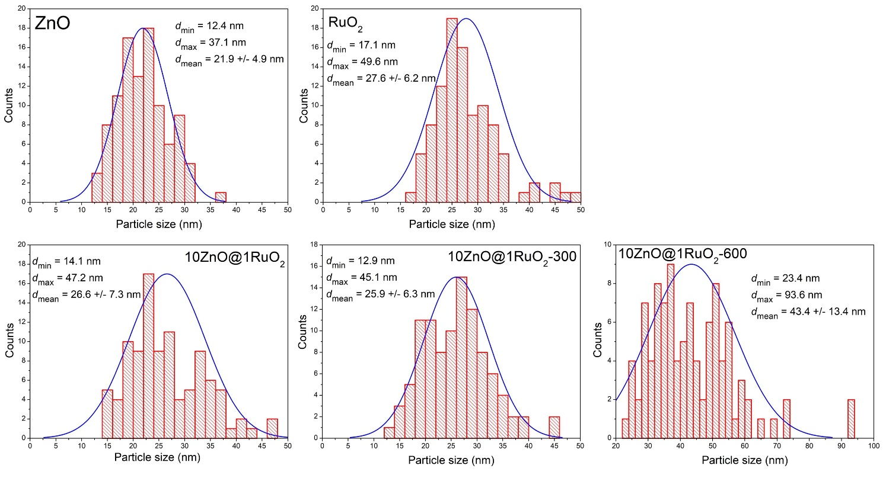

**Supplementary Figure 2.** Particle size distribution histograms estimated from TEM images.