Appendix A. Supplementary material
Three-dimensional core-shell alginate microsphere for cancer hypoxia simulation in vitro
Yejiao Ruan^{1†}, Lingyun He^{1†}, Jiamin Chen¹, Jinfeng Wang¹, Shujing Zhao¹, Xiaoling Guo¹, Yao Xie³, Zhenzhai Cai^{1*}, Xian Shen^{2*}, Chao Li^{1*}
¹The Second Affiliated Hospital and Yuying Children's Hospital of Wenzhou Medical University, Wenzhou, China.
²The First Affiliated Hospital of Wenzhou Medical University, Wenzhou, China.
³Beijing Automation Control Equipment Institute, Beijing, China.
†Yejiao Ruan and Lingyun He contributed equally to this work and share the first authorship.
* Correspondence:
Zhenzhai Cai, caizhenzhai@wmu.edu.cn, Xian Shen, shenxian@wmu.edu.cn, Chao Li, dishboy@163.com
S1. Immunohistochemistry (IHC) and immunofluorescence staining of 3d-ACS
The 3d-ACS sections were firstly incubated with primary antibody (E-Cad, MMP2, PCNA, listed in Table S1) at 4°C overnight. After wash, the sections were incubated with the HRP or fluorophores-labeled secondary antibody (Table S1). For IHC, the slides were colored with DAB (Dako, Cytomation, CA, USA) and counterstained with hematoxylin. The slides were mounted with resin and observed under microscopy (Leica DM2500) as routine.
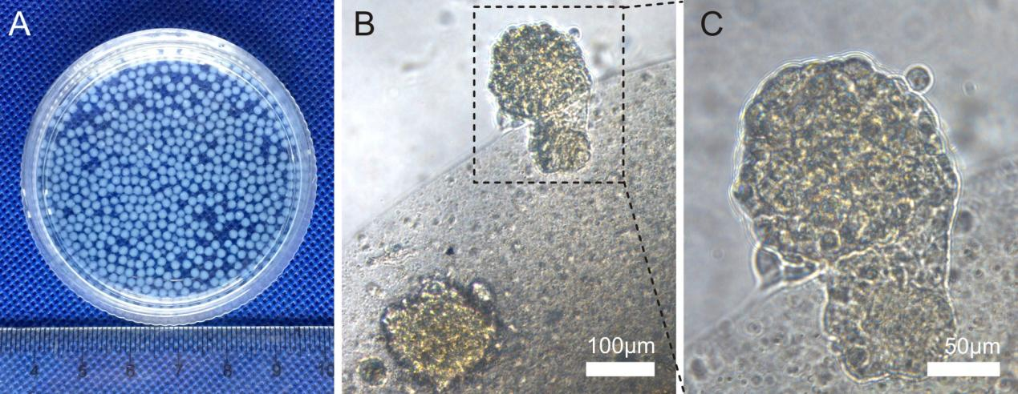
Fig. S1. The morphologies of fabricated 3d-ACS and the tumor cell growth in it. (A) The photo of the fabricated 3d-ACS. (B) The cell growth in 3d-ACS edge and the clone squeezed out from the cavity. (C) Partial enlargement of the metastasis-like structure.

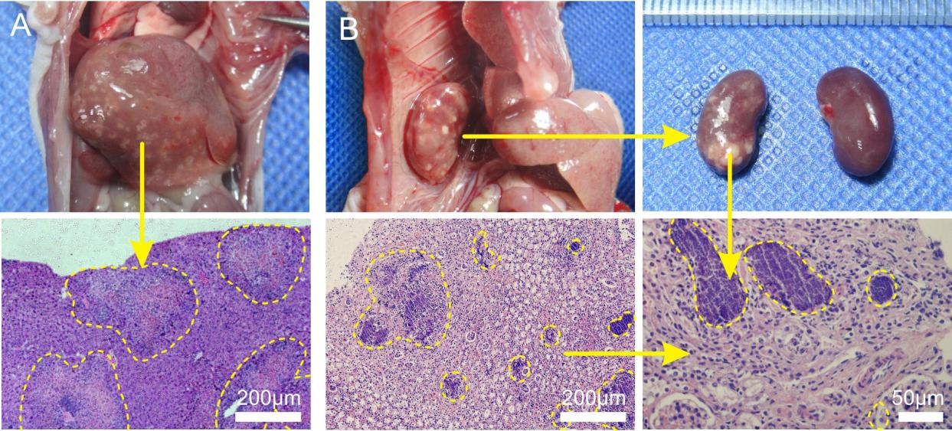
Fig. S2. The distal organ metastases in mice transplanted with GC cells cultured in 3d-ACS. (A) The liver metastasis of MGC-803 cells and the tissue section with H&E staining. (B) The kidney metastasis of BGC-823 and the tissue section with H&E staining and different magnifications.

Table S1. The antibody list used in this research.
Primary antibody | Vendor | ID | Product Name
Ki67 | Abcam | ab15580 | Rabbit polyclonal to Ki67
Caspase-3 | Abcam | ab32351 | Rabbit monoclonal [E87] to Caspase-3
HIF-1α | Abcam | H1alpha67 | Mouse monoclonal [H1alpha67] to HIF-1 alpha
E-Cadherin | Abcam | EP700Y | Rabbit monoclonal [EP700Y] to E Cadherin - Intercellular Junction Marker
MMP2 | Abcam | ab86607 | Mouse monoclonal [6E3F8] to MMP2
PCNA | Abcam | ab92552 | Rabbit monoclonal [EPR3821] to PCNA
PHD2 | Abcam | ab226890 | Rabbit polyclonal to PHD2 / prolyl hydroxylase - C-terminal
p53 | Abcam | ab26 | Mouse monoclonal [PAb 240] to p53
MRP1 | Abcam | ab233383 | Rabbit monoclonal [EPR21062] to MRP1
GAPDH | Abcam | ab9485 | Rabbit polyclonal to GAPDH
Secondary antibody | Abcam | ab96879 | Goat Anti-Mouse IgG H&L (DyLight® 488) preadsorbed
 | Abcam | ab150083 | Goat Anti-Rabbit IgG H&L (Alexa Fluor® 647) preadsorbed
 | Abcam | ab150077 | Goat Anti-Rabbit IgG H&L (Alexa Fluor® 488)
 | Abcam | ab205719 | Goat Anti-Mouse IgG H&L (HRP)
 | Abcam | ab205718 | Goat Anti-Rabbit IgG H&L (HRP)

Table S2. The primers list of for RT-PCR amplification and the references.
Primer | 5’-3’ sequence | Product length (bp) | Ref.
HIF-1α (F) | GAACGTCGAAAAGAAAAGTCTCG | 124 | (Zhao et al. 2019)
HIF-1α (R) | CCTTATCAAGATGCGAACTCACA | 124 | (Zhao et al. 2019)
c-Met (F) | AACTGGTGTCCCGGATATCA | 276 | (Uen et al. 2006)
c-Met (R) | ATATTCTTTGCTCCTTGCCA | 276 | (Uen et al. 2006)
NF-κB (F) | GAAATTGGCCAAGGTCTGATA | 155 | (Chen et al. 2015)
NF-κB (R) | TCGTAGAATCCCCGCACA | 155 | (Chen et al. 2015)
GAPDH (F) | CCTCAAGATCATCAGCAATGC | 165 | (Uen et al. 2006)
GAPDH (R) | GGAAACTGTGGCGTGATGG | 165 | (Uen et al. 2006)
References
Chen L, Han Y, Chen Y, Li Z, Wang H, Liu Y, et al. (2015). Eight SNVs in NF-κB pathway genes and their different performances between subclinical mastitis and mixed Chinese Holstein cows. Gene. 555:242-249. doi:10.1016/j.gene.2014.11.011
Uen Y-H, Lin S-R, Wu C-H, Hsieh J-S, Lu C-Y, Yu F-J, et al. (2006). Clinical significance of MUC1 and c-Met RT-PCR detection of circulating tumor cells in patients with gastric carcinoma. Clin Chim Acta. 367:55-61. doi:10.1016/j.cca.2005.11.013
Zhao L, Ma R, Zhang L, Yuan X, Wu J, He L, et al. (2019). Inhibition of HIF-1a-mediated TLR4 activation decreases apoptosis and promotes angiogenesis of placental microvascular endothelial cells during severe pre-eclampsia pathogenesis. Placenta. 83:8-16. doi:10.1016/j.placenta.2019.06.375

