Supplementary materials

Table S1. Definition of habitat types compare to Land Use and Land Cover definition based on Indonesian Ministry of Environment and Forestry

|  |  |  |  |
| --- | --- | --- | --- |
| No. | Habitat types | Code | LULC types based on MoEF definition |
| 1 | Forest | FOR | Primary dryland forest |
| 2 | Forest | FOR | Secondary dryland forest |
| 3 | Forest | FOR | Primary mangrove forest |
| 4 | Forest | FOR | Secondary mangrove forest |
| 5 | Forest | FOR | Primary swamp forest |
| 6 | Forest | FOR | Secondary swamp forest |
| 7 | Plantation | PLT | Industrial plantation forest |
| 8 | Plantation | PLT | Plantation |
| 9 | Cropland | CRP | Dryland agriculture |
| 10 | Cropland | CRP | Mixed dryland agriculture |
| 11 | Cropland | CRP | Paddy field |
| 12 | Shrubland | SHB | Savanna |
| 13 | Shrubland | SHB | Shrub |
| 14 | Shrubland | SHB | Shrub swamp |
| 15 | Shrubland | SHB | swamp |
| 16 | Non-vegetation areas | NON | Settlement |
| 17 | Non-vegetation areas | NON | Cloud |
| 18 | Non-vegetation areas | NON | Bare land |
| 19 | Non-vegetation areas | NON | Water |
| 20 | Non-vegetation areas | NON | Fishpond |
| 21 | Non-vegetation areas | NON | Airport |
| 22 | Non-vegetation areas | NON | Transmigration |
| 23 | Non-vegetation areas | NON | Mining |

Table S2. Environmental predictors are used to build habitat loss models as well as occupancy model in Leuser Ecosystem

|  |  |  |  |  |
| --- | --- | --- | --- | --- |
| **No** | **Full name** | **Abbreviated name** | **Justification** | **Data source** |
| **Habitat loss model** | | | | |
| 1 | Terrain Ruggedness Index | tri | Topographical roughness was associated with deforestation (Cushman et al., 2017) | Digital Elevation Model by Jarvis et al., 2008 |
| 2 | Minimum distance to village | dist. to village | Forest patches closer to settlements were highly vulnerable to deforestation | Village points by Indonesian Geospatial Agency (BIG) |
| 3 | Minimum distance to roads | dist. to road | Forest patches closer to roads were highly vulnerable to deforestation (Gaveau et al., 2009). | Road networks by Indonesian Geospatial Agency (BIG) |
| 4 | Minimum distance to river | dist. to river | Forest clearance activities were likely occurred close to river | River networks by Indonesian Geospatial Agency (BIG) |
| 5 | Minimum distance to forest edge in 2000 | dist. to forest edge | Forest patches closer to forest edge were highly vulnerable to deforestation (Gaveau et al., 2009). | Land use and land cover by Ministry of Environmental Forestry, 2018 |
| 6 | Minimum distance to oil palm plantation | dist. to oilpalm | Vulnerable areas for deforestation were associated with the expansion of oil palm plantations (Vijay et al., 2016) | The extent of oil palm plantation in South East Asia between 1980 and 2017 by Danylo et al., 2021 |
| **Occupancy model** | | | | |
| 7 | Mean elevation in meter at species’ home-range level | elevation | Occupancy of tiger increased strongly with altitude (Sunarto et al., 2012). While wild boar occupancy decreased with altitude (Widodo et al., 2022). | Digital Elevation Model by Jarvis et al., 2008 |
| 8 | Mean steepness of a surface (degree) generated from elevation data at species’ home-range level | slope | Sambar were likely to occupy flatter terrain (Pusparini et al., 2017). | Digital Elevation Model by Jarvis et al., 2008 |
| 9 | Total forest cover area at species’ home-range level | fcover_area | Occupancy of tiger and sambar were higher in higher total area of forest cover (Wibisono, 2021) | Land use and land cover data for 2009 and 2019 by Indonesian Ministry of Environmental and Forestry |
| 10 | Number of forest cover patches at species’ home-range level | fcover_patches | Increase in number of habitat patches due to fragmentation will increase the extinction risk of species due to reduced heterozygosity and greater population isolation (Smith et al., 2018) | Land use and land cover data for 2009 and 2019 by Indonesian Ministry of Environmental and Forestry |
| 11 | Proportion of wild prey detected along the transect lines for each cell | prey | Tiger presence were associated with wild prey density (Karanth et al., 2011). | SWTS survey in 2009 and 2019 |
| 12 | Proportion of human disturbance detected along the transect lines for each cell | disturbance | Human presence showed negative association with tiger occupancy (Karanth et al., 2011). | SWTS survey in 2009 and 2019 |
| 13 | Proportion of forested habitat collected along the transect lines for each cell. | Forest_hab | Occupancy of tiger and sambar were higher in higher total area of forest cover (Wibisono, 2021) | SWTS survey in 2009 and 2019 |

SWTS stands for Sumatran-wide Tiger Survey

Table S3. Model performance for each species using 2009 occupancy data

|  |  |  |  |  |
| --- | --- | --- | --- | --- |
| No | Species | Model | DAICc | wgt |
| 1 | Elephant | psi(~fcover_area + disturbance)theta(~PRIME)p(~forest_hab)th0pi(~1) | 0.00 | 0.79 |
| 2 | Elephant | psi(~fcover_area)theta(~PRIME)p(~forest_hab)th0pi(~1) | 2.87 | 0.19 |
| 3 | Elephant | psi(~1)theta(~PRIME)p(~1)th0pi(~1) | 9.66 | 0.01 |
| 4 | Elephant | psi(~disturbance)theta(~PRIME)p(~forest_hab)th0pi(~1) | 10.32 | 0.00 |
| 5 | Elephant | psi(~elevation)theta(~PRIME)p(~forest_hab)th0pi(~1) | 11.24 | 0.00 |
| 6 | Elephant | psi(~elevation + disturbance)theta(~PRIME)p(~forest_hab)th0pi(~1) | 11.87 | 0.00 |
| 7 | Elephant | psi(~slope + disturbance)theta(~PRIME)p(~forest_hab)th0pi(~1) | 12.58 | 0.00 |
| 8 | Elephant | psi(~fcover_patches)theta(~PRIME)p(~forest_hab)th0pi(~1) | 12.78 | 0.00 |
| 9 | Elephant | psi(~slope)theta(~PRIME)p(~forest_hab)th0pi(~1) | 13.06 | 0.00 |
| 10 | Elephant | psi(~slope + fcover_patches)theta(~PRIME)p(~forest_hab)th0pi(~1) | 14.39 | 0.00 |
| 11 | Tiger | psi(~fcover_area + disturbance)theta(~PRIME)p(~forest_hab)th0pi(~1) | 0.00 | 0.93 |
| 12 | Tiger | psi(~disturbance)theta(~PRIME)p(~forest_hab)th0pi(~1) | 7.34 | 0.02 |
| 13 | Tiger | psi(~slope + disturbance)theta(~PRIME)p(~forest_hab)th0pi(~1) | 7.75 | 0.02 |
| 14 | Tiger | psi(~fcover_area)theta(~PRIME)p(~forest_hab)th0pi(~1) | 7.75 | 0.02 |
| 15 | Tiger | psi(~fcover_area + prey)theta(~PRIME)p(~forest_hab)th0pi(~1) | 9.92 | 0.01 |
| 16 | Tiger | psi(~1)theta(~PRIME)p(~1)th0pi(~1) | 11.48 | 0.00 |
| 17 | Tiger | psi(~elevation)theta(~PRIME)p(~forest_hab)th0pi(~1) | 13.96 | 0.00 |
| 18 | Tiger | psi(~prey)theta(~PRIME)p(~forest_hab)th0pi(~1) | 14.92 | 0.00 |
| 19 | Tiger | psi(~slope)theta(~PRIME)p(~forest_hab)th0pi(~1) | 14.95 | 0.00 |
| 20 | Tiger | psi(~fcover_patches)theta(~PRIME)p(~forest_hab)th0pi(~1) | 14.98 | 0.00 |
| 21 | Wild boar | psi(~elevation + disturbance)theta(~PRIME)p(~1)th0pi(~1) | 0.00 | 0.87 |
| 22 | Wild boar | psi(~fcover_area)theta(~PRIME)p(~1)th0pi(~1) | 5.16 | 0.07 |
| 23 | Wild boar | psi(~fcover_area + disturbance)theta(~PRIME)p(~1)th0pi(~1) | 5.70 | 0.05 |
| 24 | Wild boar | psi(~elevation)theta(~PRIME)p(~1)th0pi(~1) | 9.55 | 0.01 |
| 25 | Wild boar | psi(~slope + fcover_patches)theta(~PRIME)p(~1)th0pi(~1) | 9.77 | 0.01 |
| 26 | Wild boar | psi(~slope + disturbance)theta(~PRIME)p(~1)th0pi(~1) | 14.20 | 0.00 |
| 27 | Sambar | psi(~slope + fcover_patches)theta(~PRIME)p(~forest_hab)th0pi(~1) | 0.00 | 0.50 |
| 28 | Sambar | psi(~slope)theta(~PRIME)p(~forest_hab)th0pi(~1) | 1.01 | 0.30 |
| 29 | Sambar | psi(~slope + disturbance)theta(~PRIME)p(~forest_hab)th0pi(~1) | 3.03 | 0.11 |
| 30 | Sambar | psi(~elevation + disturbance)theta(~PRIME)p(~forest_hab)th0pi(~1) | 3.63 | 0.08 |
| 31 | Sambar | psi(~1)theta(~PRIME)p(~1)th0pi(~1) | 81.25 | 0.00 |

Table S4. Model performance for each species using 2019 occupancy data

|  |  |  |  |  |
| --- | --- | --- | --- | --- |
| No | Species | Model | DAICc | wgt |
| 1 | Elephant | psi(~fcover_area + disturbance)theta(~PRIME)p(~forest_hab)th0pi(~1) | 0.00 | 0.26 |
| 2 | Elephant | psi(~disturbance)theta(~PRIME)p(~forest_hab)th0pi(~1) | 0.58 | 0.19 |
| 3 | Elephant | psi(~slope + disturbance)theta(~PRIME)p(~forest_hab)th0pi(~1) | 0.64 | 0.19 |
| 4 | Elephant | psi(~slope)theta(~PRIME)p(~forest_hab)th0pi(~1) | 1.70 | 0.11 |
| 5 | Elephant | psi(~fcover_area)theta(~PRIME)p(~forest_hab)th0pi(~1) | 2.17 | 0.09 |
| 6 | Elephant | psi(~elevation + disturbance)theta(~PRIME)p(~forest_hab)th0pi(~1) | 2.39 | 0.08 |
| 7 | Elephant | psi(~elevation)theta(~PRIME)p(~forest_hab)th0pi(~1) | 2.70 | 0.07 |
| 8 | Elephant | psi(~fcover_patches)theta(~PRIME)p(~forest_hab)th0pi(~1) | 4.40 | 0.03 |
| 9 | Tiger | psi(~fcover_area + prey)theta(~PRIME)p(~forest_hab)th0pi(~1) | 0.00 | 0.37 |
| 10 | Tiger | psi(~fcover_area)theta(~PRIME)p(~forest_hab)th0pi(~1) | 1.05 | 0.22 |
| 11 | Tiger | psi(~slope + fcover_patches)theta(~PRIME)p(~forest_hab)th0pi(~1) | 1.53 | 0.17 |
| 12 | Tiger | psi(~fcover_area + disturbance)theta(~PRIME)p(~forest_hab)th0pi(~1) | 1.95 | 0.14 |
| 13 | Tiger | psi(~disturbance)theta(~PRIME)p(~forest_hab)th0pi(~1) | 4.62 | 0.04 |
| 14 | Tiger | psi(~prey)theta(~PRIME)p(~forest_hab)th0pi(~1) | 5.73 | 0.02 |
| 15 | Tiger | psi(~elevation)theta(~PRIME)p(~forest_hab)th0pi(~1) | 6.15 | 0.02 |
| 16 | Tiger | psi(~fcover_patches)theta(~PRIME)p(~forest_hab)th0pi(~1) | 6.15 | 0.02 |
| 17 | Tiger | psi(~1)theta(~PRIME)p(~1)th0pi(~1) | 7.79 | 0.01 |
| 18 | Wild boar | psi(~slope + fcover_patches)theta(~PRIME)p(~1)th0pi(~1) | 0.00 | 0.60 |
| 19 | Wild boar | psi(~fcover_patches)theta(~PRIME)p(~1)th0pi(~1) | 1.04 | 0.36 |
| 20 | Wild boar | psi(~1)theta(~PRIME)p(~1)th0pi(~1) | 6.64 | 0.02 |
| 21 | Wild boar | psi(~fcover_area)theta(~PRIME)p(~1)th0pi(~1) | 6.83 | 0.02 |
| 22 | Sambar | psi(~fcover_area)theta(~PRIME)p(~forest_hab)th0pi(~1) | 0.00 | 0.92 |
| 23 | Sambar | psi(~elevation + fcover_patches)theta(~PRIME)p(~forest_hab)th0pi(~1) | 6.58 | 0.03 |
| 24 | Sambar | psi(~disturbance)theta(~PRIME)p(~forest_hab)th0pi(~1) | 7.21 | 0.03 |
| 25 | Sambar | psi(~fcover_patches)theta(~PRIME)p(~forest_hab)th0pi(~1) | 7.66 | 0.02 |
| 26 | Sambar | psi(~1)theta(~PRIME)p(~1)th0pi(~1) | 39.18 | 0.00 |

Table S5. Covariates effect on psi estimate (±SE) from the top-ranked models for each species in each survey periods

|  |  |  |  |  |  |  |  |
| --- | --- | --- | --- | --- | --- | --- | --- |
| **Species** | **Int** | **fcover_area** | **disturbance** | **elevation** | **slope** | **fcover_patches** | **prey** |
| **SWTS 2009 data** | | | | | | | |
| Elephant | -1.06(0.3) | 1.01(0.32) | 0.52(0.24) | - | - | - | - |
| Tiger | 2.25(1.06) | 1.63(0.63) | 3.85(1.66) | - | - | - | - |
| Wild boar | 2.08(0.75) | - | 2.01(1.5) | -1.16(0.32) | - | - | - |
| Sambar | 7.02(3.92) | - | - | - | -2.05(0.93) | 8.28(9.39) | - |
| **SWTS 2019 data** | | | | | | | |
| Elephant | -1.5(0.5) | 0.8(0.5) | 0.87(0.61) | - | - | - | - |
| Tiger | 2.71(2.05) | 1.74(0.86) | - | - | - | - | 7.05(4.77) |
| Wild boar | -0.62(0.48) | - | - | - | -0.61(0.25) | 0.43(0.55) | - |
| Sambar | 3.64(3.38) | 5.18(3.8) | - | - | - | - | - |

Table S6. Model summary from deforestation modelling in Leuser Ecosystem.

|  |  |  |  |  |
| --- | --- | --- | --- | --- |
| Models | AICc | DAICc | wgt | AUC |
| tri + dist. to forest edge | 72.7 | 0 | 0.5 | 0.94 |
| dist. to road | 73.9 | 1.2 | 0.3 | 0.93 |
| dist. to road + dist. to river | 75.4 | 2.7 | 0.1 | 0.93 |
| tri | 79.9 | 7.2 | 0 | 0.9 |
| tri + dist. to river | 80.4 | 7.7 | 0 | 0.91 |
| dist. to oilpalm + dist. to forest edge | 80.6 | 7.9 | 0 | 0.91 |
| dist. to river + dist. to forest edge + dist. to oilpalm | 81.2 | 8.5 | 0 | 0.92 |
| dist. to village | 94.5 | 21.7 | 0 | 0.81 |
| dist. to village + dist. to river | 95.7 | 23 | 0 | 0.83 |
| dist. to oilpalm | 96.1 | 23.4 | 0 | 0.88 |
| dist. to river + dist. to oilpalm | 96.3 | 23.6 | 0 | 0.89 |
| dist. to forest edge | 103.2 | 30.5 | 0 | 0.82 |
| dist. to river + dist. to forest edge | 105 | 32.3 | 0 | 0.82 |
| null | 140.7 | 68 | 0 | 0.5 |
| dist. to river | 142 | 69.2 | 0 | 0.67 |

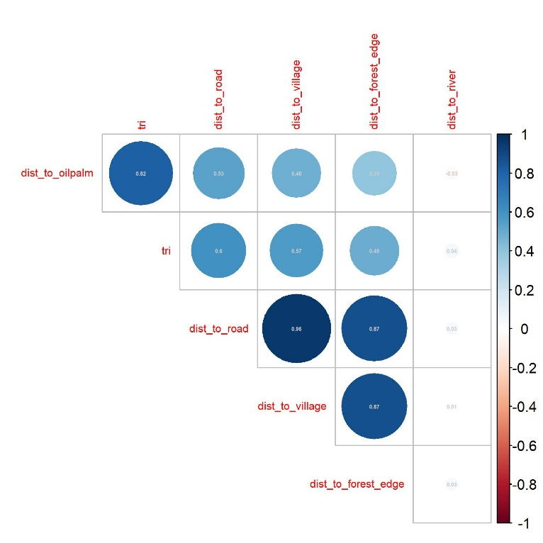

Figure S1. Correlation coefficient among variables used to model the habitat loss in Leuser Ecosystem

|  |  |
| --- | --- |
|  |  |
|  |  |
| Figure S2. Correlation plot among variables using 2009 (top) and 2019 (bottom) data with 17 km grid cell (left), and 8.5 km grid cell (right) | |



Figure S3. Possible scenarios of forest habitats in Northern Sumatra landscape to be used to project the future occupancy of Sumatran elephant and Sumatran tiger. Scenario 1-5 were developed using habitat loss modelling from this study and scenario 6-10 were developed from reforestation potential areas based on Rayden et al., (2023) study.

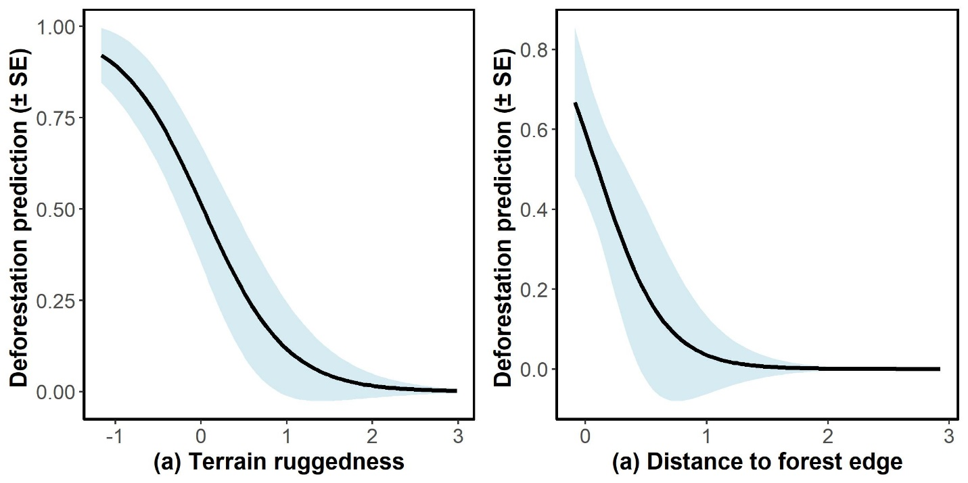

Figure S4. Correlation between terrain ruggedness index (a) and Distance to forest edge in 2000 with the probability of habitat loss based on top-ranked habitat loss model

**References list**

Cushman, S.A., Macdonald, E.A., Landguth, E.L., Malhi, Y. & Macdonald, D.W. (2017) Multiple-scale prediction of forest loss risk across Borneo. *Landscape Ecology*, 32, 1581–1598.

Danylo, O., Pirker, J., Lemoine, G., Ceccherini, G., See, L., McCallum, I., et al. (2021) A map of the extent and year of detection of oil palm plantations in Indonesia, Malaysia and Thailand. *Scientific Data*, 8, 4–11.

Gaveau, D.L.A., Wich, S., Epting, J., Juhn, D., Kanninen, M. & Leader-Williams, N. (2009) The future of forests and orangutans (Pongo abelii) in Sumatra: Predicting impacts of oil palm plantations, road construction, and mechanisms for reducing carbon emissions from deforestation. *Environmental Research Letters*, 4, 034013.

Jarvis, A., Reuter, H.I., Nelson, A. & Guevara, E. (2008) Hole-filled seamless SRTM data Version 4, available from the CGIAR-CSI SRTM 90m Database. Http://srtm.csi.cgiar.org.

Karanth, K.U., Gopalaswamy, A.M., Kumar, N.S., Vaidyanathan, S., Nichols, J.D. & MacKenzie, D.I. (2011) Monitoring carnivore populations at the landscape scale: occupancy modelling of tigers from sign surveys. *Journal of Applied Ecology*, 48, 1048–1056.

Pusparini, W., Batubara, T., Surahmat, F., Ardiantiono, Sugiharti, T., Muslich, M., et al. (2017) A pathway to recovery: the Critically Endangered Sumatran tiger Panthera tigris sumatrae in an ‘in danger’ UNESCO World Heritage Site. *Oryx*, 1–10.

Rayden, T., Jones, K.R., Austin, K. & Radachowsky, J. (2023) Improving climate and biodiversity outcomes through restoration of forest integrity. *Conservation Biology*, 1–11.

Smith, O., Wang, J. & Carbone, C. (2018) Evaluating the effect of forest loss and agricultural expansion on Sumatran tigers from scat surveys. *Biological Conservation*, 221, 270–278.

Sunarto, S., Kelly, M.J., Parakkasi, K., Klenzendorf, S., Septayuda, E. & Kurniawan, H. (2012) Tigers need cover: Multi-scale occupancy study of the big cat in Sumatran forest and plantation landscapes. *PLoS ONE*, 7.

Vijay, V., Pimm, S.L., Jenkins, C.N. & Smith, S.J. (2016) The Impacts of Oil Palm on Recent Deforestation and Biodiversity Loss. *PLOS ONE*, 11, e0159668.

Wibisono, H.T. (2021) An Island-wide Status of Sumatran tiger (Panthera tigris sumatrae) and Principal Prey in Sumatra, Indonesia. University of Delaware.

Widodo, F.A., Imron, M.A., Sunarto, S. & Giordano, A.J. (2022) Carnivores and their prey in Sumatra: Occupancy and activity in human-dominated forests. *PLoS ONE*, 17, 1–25.