**Supplemental Materials**

**Evaluation and development of deep neural networks for RNA 5-Methyluridine classifications using autoBioSeqpy**

Lezheng Yu1,†, Yonglin Zhang2,†, Li Xue3, Fengjuan Liu4, Runyu Jing5,* and Jiesi Luo6,7,*

1School of Chemistry and Materials Science, Guizhou Education University, Guiyang, China, 2Department of Pharmacy, Affiliated Hospital of North Sichuan Medical College, Nanchong, China, 3School of Public Health, Southwest Medical University, Luzhou, China, 4School of Geography and Resources, Guizhou Education University, Guiyang, China, 5School of Cyber Science and Engineering, Sichuan University, Chengdu, China, 6Basic Medical College, Southwest Medical University, Luzhou 646000, China, 7Sichuan Key Medical Laboratory of New Drug Discovery and Druggability Evaluation, Luzhou Key Laboratory of Activity Screening and Druggability Evaluation for Chinese Materia Medica, Southwest Medical University, Luzhou 646000, China

**\*Corrspondence:**

Runyu Jing

jingryedu@gmail.com

Jiesi Luo

ljs@swmu.edu.cn

†These authors have contributed equally to this work and share first authorship.

**Supplementary Table S1.** Base datasets used for building our m5U site predictor

|  |  |  |  |  |
| --- | --- | --- | --- | --- |
| Type | Mode | Positive samples | Negative samples | Name |
| Training dataset | Full transcript | 2956 | 2956 | *Full_train* |
| Mature mRNA | 985 | 985 | *Mature_train* |
| Independent test set | Full transcript | 740 | 740 | *Full_test* |
| Mature mRNA | 247 | 247 | *Mature_test* |

**Supplementary Table S2.** Validation datasets used for evaluating the performance of Deepm5U

|  |  |  |  |  |  |  |
| --- | --- | --- | --- | --- | --- | --- |
| Mode | Cross type | Specific type | Testing Method | Positive samples | Negative samples | Name |
| Full transcript | Cell line | HAP1 | Cross validation | 1229 | 12290 | *HAP_full* |
| Independent test set | 2467 | 24670 | *HEK_full* |
| HEK293 | Cross validation | 2467 | 24670 | *HEK_full* |
| Independent test set | 1229 | 12290 | *HAP_full* |
| Technique | FICC-Seq | Cross validation | 1471 | 14710 | *FICC_full* |
| Independent test set | 2225 | 22250 | *miCLIP_full* |
| miCLIP-Seq | Cross validation | 2225 | 22250 | *miCLIP_full* |
| Independent test set | 1471 | 14710 | *FICC_full* |
|  |  |  |  |  |  |  |
| Mature mRNA | Cell line | HAP1 | Cross validation | 364 | 3640 | *HAP_mature* |
| Independent test set | 868 | 8680 | *HEK_mature* |
| HEK293 | Cross validation | 868 | 8680 | *HEK_mature* |
| Independent test set | 364 | 3640 | *HAP_mature* |
| Technique | FICC-Seq | Cross validation | 409 | 4090 | *FICC_mature* |
| Independent test set | 823 | 8230 | *miCLIP_mature* |
| miCLIP-Seq | Cross validation | 823 | 8230 | *miCLIP_mature* |
| Independent test set | 409 | 4090 | *FICC_mature* |

**Supplementary Table S3.** Hyperparameter optimization of the CNN and CNN+BiLSTM models on the *Full_train* dataset

|  |  |  |  |  |  |  |
| --- | --- | --- | --- | --- | --- | --- |
| Value | Architecture | ACC (%) | *F*-value (%) | Recall (%) | PRE (%) | MCC |
| Filter number | | | | | | |
| 50 | CNN | 88.77 | 88.73 | 88.59 | 88.97 | 0.7764 |
| 150 | 88.49 | 88.37 | 87.75 | 89.13 | 0.7709 |
| **250** | **89.10** | **89.21** | **88.91** | **89.31** | **0.7831** |
| 50 | CNN-BiLSTM | 87.88 | 88.21 | 87.52 | 88.97 | 0.7580 |
| 150 | 88.06 | 88.09 | 88.03 | 88.42 | 0.7630 |
| **250** | CNN-BiGRU | **88.84** | **88.75** | **88.41** | **89.20** | **0.7777** |
| 50 | 88.42 | 88.52 | 89.93 | 87.22 | 0.7695 |
| 150 | 88.86 | 89.03 | 89.36 | 88.75 | 0.7776 |
| **250** | **88.98** | **88.90** | **88.48** | **89.47** | **0.7807** |
| Kernel size | | | | | | |
| 3 | CNN | 89.10 | 89.21 | 88.91 | 89.31 | 0.7831 |
| 5 | 88.18 | 87.96 | 88.19 | 87.79 | 0.7638 |
| 7 | 88.62 | 88.74 | 88.43 | 89.07 | 0.7723 |
| 9 | 88.96 | 89.05 | 88.36 | 89.77 | 0.7795 |
| **11** | **89.21** | **89.31** | **88.96** | **89.68** | **0.7843** |
| 3 | CNN-BiLSTM | 88.84 | 88.75 | 88.41 | 89.20 | 0.7777 |
| 5 | 88.94 | 88.91 | 89.96 | 88.03 | 0.7804 |
| **7** | **90.13** | **90.10** | **91.46** | **89.01** | **0.8050** |
| 9 | 89.04 | 88.85 | 87.45 | 90.95 | 0.7864 |
| 11 | CNN-BiGRU | 89.89 | 88.85 | 87.45 | 90.95 | 0.7864 |
| 3 | 88.98 | 88.90 | 88.48 | 89.47 | 0.7807 |
| 5 | 89.74 | 89.56 | 88.49 | 90.74 | 0.7957 |
| 7 | 90.28 | 90.32 | 90.92 | 89.76 | 0.8059 |
| 9 | 90.89 | 91.06 | 90.86 | 91.29 | 0.8181 |
| **11** | **90.94** | **90.98** | **90.59** | **91.44** | **0.8193** |
| Pooling size | | | | | | |
| 2 | CNN | 89.21 | 89.31 | 88.96 | 89.68 | 0.7843 |
| 4 | 89.23 | 89.22 | 88.75 | 89.72 | 0.7848 |
| 6 | 90.35 | 90.29 | 90.46 | 90.18 | 0.8073 |
| 8 | 89.70 | 89.64 | 88.68 | 90.64 | 0.7945 |
| **10** | **91.07** | **91.10** | **90.61** | **92.03** | **0.8216** |
| 2 | CNN-BiLSTM | 90.13 | 90.10 | 91.46 | 89.01 | 0.8050 |
| **4** | **90.45** | **90.29** | **89.36** | **91.29** | **0.8095** |
| 6 | 89.40 | 89.48 | 90.51 | 88.55 | 0.7889 |
| 8 | 89.28 | 89.67 | 92.21 | 87.47 | 0.7887 |
| 10 | CNN-BiGRU | 89.08 | 89.42 | 90.81 | 88.14 | 0.7825 |
| 2 | 90.94 | 90.98 | 90.59 | 91.44 | 0.8193 |
| 4 | 90.96 | 91.04 | 91.32 | 90.78 | 0.8190 |
| 6 | 90.96 | 91.08 | 92.24 | 90.00 | 0.8199 |
| 8 | 89.25 | 89.09 | 87.88 | 90.33 | 0.7853 |
| **10** | **91.21** | **91.23** | **90.35** | **92.16** | **0.8245** |
| Convolution layer number | | | | | | |
| 1 | CNN | 91.07 | 91.10 | 90.61 | 92.03 | 0.8216 |
| **2** | **91.56** | **91.50** | **90.04** | **93.04** | **0.8319** |
| 3 | 89.15 | 88.77 | 86.84 | 90.98 | 0.7851 |
| 1 | CNN-BiLSTM | 90.45 | 90.29 | 89.36 | 91.29 | 0.8095 |
| **2** | **92.32** | **92.29** | **91.93** | **92.65** | **0.8465** |
| 3 | CNN-BiGRU | 90.87 | 91.00 | 91.74 | 90.29 | 0.8176 |
| **1** | **91.85** | **91.94** | **92.46** | **91.44** | **0.8370** |
| 2 | 90.87 | 90.67 | 90.70 | 90.64 | 0.8173 |
| 3 | 89.97 | 89.45 | 87.57 | 91.48 | 0.8002 |

**Supplementary Table S4.** Hyperparameter optimization of the BiLSTM and CNN+BiLSTM models on the *Full_train* dataset

|  |  |  |  |  |  |  |
| --- | --- | --- | --- | --- | --- | --- |
| Value | Architecture | ACC (%) | F-value (%) | Recall (%) | PRE (%) | MCC |
| LSTM size | | | | | | |
| 32 | BiLSTM | 78.58 | 82.34 | 84.38 | 80.48 | 0.6412 |
| 64 | 83.42 | 83.67 | 86.89 | 80.77 | 0.6714 |
| 128 | 84.92 | 84.56 | 81.31 | 88.30 | 0.7019 |
| **256** | **88.08** | **87.95** | **87.75** | **88.20** | **0.7620** |
| 32 | CNN+BiLSTM | 89.28 | 89.67 | 92.21 | 87.47 | 0.7887 |
| 64 | 90.45 | 90.29 | 89.36 | 91.29 | 0.8095 |
| 128 | 89.74 | 89.47 | 89.23 | 89.90 | 0.7958 |
| **256** | **90.48** | **90.60** | **89.61** | **91.73** | **0.8108** |
| BiLSTM layer number | | | | | | |
| 1 | BiLSTM | 88.08 | 87.95 | 87.75 | 88.20 | 0.7620 |
| **2** | **88.59** | **88.55** | **87.58** | **89.65** | **0.7730** |
| 3 | 88.17 | 88.05 | 87.80 | 88.33 | 0.7634 |
| 1 | CNN+BiLSTM | 90.45 | 90.29 | 89.36 | 91.29 | 0.8095 |
| **2** | **92.32** | **92.29** | **91.93** | **92.65** | **0.8465** |
| 3 | 90.87 | 91.00 | 91.74 | 90.29 | 0.8176 |

**Supplementary Table S5.** Hyperparameter optimization of the BiGRU and CNN+BiGRU models on the *Full_train* dataset

|  |  |  |  |  |  |  |
| --- | --- | --- | --- | --- | --- | --- |
| Value | Architecture | ACC (%) | F-value (%) | Recall (%) | PRE (%) | MCC |
| LSTM size | | | | | | |
| 32 | BiGRU | 86.64 | 86.68 | 87.80 | 85.67 | 0.7337 |
| 64 | 87.39 | 87.64 | 88.17 | 87.15 | 0.7479 |
| 128 | 87.40 | 87.45 | 87.18 | 87.77 | 0.7485 |
| **256** | **87.22** | **87.27** | **87.04** | **87.60** | **0.7820** |
| 32 | CNN+BiGRU | 90.99 | 90.98 | 91.25 | 90.72 | 0.8198 |
| 64 | 91.21 | 91.23 | 90.35 | 92.16 | 0.8245 |
| 128 | 91.85 | 91.69 | 91.85 | 91.53 | 0.8369 |
| **256** | **91.85** | **91.94** | **92.46** | **91.44** | **0.8370** |
| BiGRU layer number | | | | | | |
| **1** | BiGRU | **87.22** | **87.27** | **87.04** | **87.60** | **0.7820** |
| 2 | 87.90 | 87.66 | 86.87 | 88.53 | 0.7584 |
| 3 | 88.20 | 88.17 | 90.01 | 86.44 | 0.7651 |
| **1** | CNN+BiGRU | **91.85** | **91.94** | **92.46** | **91.44** | **0.8370** |
| 2 | 90.89 | 90.84 | 90.97 | 90.90 | 0.8191 |
| 3 | 90.21 | 90.20 | 91.11 | 89.55 | 0.8067 |

**Supplementary Table S6. Prediction results of the CNN-BiLSTM model on the** **mature mRNA mode**

|  |  |  |  |  |  |  |
| --- | --- | --- | --- | --- | --- | --- |
| Dataset | ACC (%) | *F*-value (%) | | Recall (%) | PRE (%) | MCC |
| Training dataset | 91.12 | 91.00 | 91.71 | | 90.31 | 0.8224 |
| Independent test set | 92.07 | 91.75 | 88.57 | | 95.18 | 0.8434 |

**Supplementary Table S7. Prediction results of the CNN-BiLSTM model on the second independent test set**

|  |  |  |
| --- | --- | --- |
| Number | Probability | Prediction |
| 1 | 0.705720 | 1 |
| 2 | 0.999997 | 1 |
| 3 | 0.724142 | 1 |
| 4 | 0.868581 | 1 |
| 5 | 0.739882 | 1 |
| 6 | 0.999946 | 1 |
| 7 | 0.000108 | 0 |
| 8 | 0.999999 | 1 |
| 9 | 0.999193 | 1 |
| 10 | 1.000000 | 1 |
| 11 | 0.998471 | 1 |
| 12 | 0.993151 | 1 |
| 13 | 0.999161 | 1 |
| 14 | 0.993382 | 1 |
| 15 | 0.990964 | 1 |
| 16 | 0.999985 | 1 |
| 17 | 0.999893 | 1 |
| 18 | 0.001282 | 0 |
| 19 | 1.000000 | 1 |
| 20 | 0.999926 | 1 |
| 21 | 1.000000 | 1 |
| 22 | 1.000000 | 1 |
| 23 | 0.999029 | 1 |
| 24 | 0.999507 | 1 |
| 25 | 0.999663 | 1 |
| 26 | 0.999663 | 1 |
| 27 | 1.000000 | 1 |
| 28 | 0.179193 | 0 |
| 29 | 0.734869 | 1 |
| 30 | 0.284077 | 0 |
| 31 | 0.999486 | 1 |
| 32 | 1.000000 | 1 |
| 33 | 0.512879 | 1 |
| 34 | 0.998790 | 1 |
| 35 | 0.999998 | 1 |
| 36 | 0.992671 | 1 |
| 37 | 0.999999 | 1 |
| 38 | 0.032318 | 0 |
| 39 | 1.000000 | 1 |
| 40 | 0.991149 | 1 |
| 41 | 0.996424 | 1 |

**Supplementary Table S8. Performance comparison of Deepm5U and m5UPred on the Cross-Techniques and Cross-Cell-Type datasets**

|  |  |  |  |  |  |  |  |  |
| --- | --- | --- | --- | --- | --- | --- | --- | --- |
| Mode | Testing Method | Method | Evaluation Metric | Cross-Technique Validation | | | Cross-Cell-Type Validation | |
| miCLIP-Seq | | FICC-Seq | HEK293 | HAP1 |
| Full transcript | intra-dataset evaluation | Deepm5U | *ACC* (%) | 98.31 | 97.41 | | 98.21 | 97.61 |
| m5UPred | 86.76 | 90.58 | | 86.72 | 80.15 |
| Deepm5U | *Recall* (%) | 87.09 | 79.90 | | 87.01 | 81.50 |
| m5UPred | 86.70 | 89.80 | | 86.26 | 89.67 |
| Deepm5U | *MCC* | 0.8932 | 0.8362 | | 0.8886 | 0.8478 |
| m5UPred | 0.735 | 0.812 | | 0.735 | 0.901 |
| Deepm5U | auROC | 0.9769 | 0.9729 | | 0.9858 | 0.9770 |
| m5UPred | 0.946 | 0.966 | | 0.942 | 0.969 |
| inter-dataset evaluation | Deepm5U | *ACC* (%) | 95.64 | 93.90 | | 97.10 | 94.33 |
| m5UPred | 82.29 | 73.29 | | 86.20 | 73.99 |
| Deepm5U | *Recall* (%) | 61.05 | 39.44 | | 74.29 | 44.13 |
| m5UPred | 75.36 | 56.48 | | 82.79 | 57.77 |
| Deepm5U | *MCC* | 0.7093 | 0.5574 | | 0.8135 | 0.5967 |
| m5UPred | 0.652 | 0.495 | | 0.726 | 0.507 |
| Deepm5U | auROC | 0.9324 | 0.8332 | | 0.9727 | 0.8700 |
| m5UPred | 0.910 | 0.853 | | 0.941 | 0.857 |
| Mature mRNA | intra-dataset evaluation | Deepm5U | *ACC* (%) | 99.36 | 98.30 | | 99.38 | 98.22 |
| m5UPred | 89.43 | 96.09 | | 90.50 | 96.02 |
| Deepm5U | *Recall* (%) | 94.62 | 87.80 | | 94.89 | 89.04 |
| m5UPred | 88.34 | 94.14 | | 89.86 | 95.32 |
| Deepm5U | *MCC* | 0.9621 | 0.8913 | | 0.9619 | 0.8922 |
| m5UPred | 0.789 | 0.922 | | 0.810 | 0.920 |
| Deepm5U | auROC | 0.9999 | 0.9820 | | 0.9928 | 0.9856 |
| m5UPred | 0.962 | 0.992 | | 0.964 | 0.987 |
| inter-dataset evaluation | Deepm5U | *ACC* (%) | 98.28 | 95.06 | | 98.62 | 94.88 |
| m5UPred | 90.46 | 68.16 | | 92.17 | 68.57 |
| Deepm5U | *Recall* (%) | 89.14 | 48.41 | | 93.90 | 44.77 |
| m5UPred | 90.07 | 38.81 | | 95.41 | 39.01 |
| Deepm5U | *MCC* | 0.8945 | 0.6574 | | 0.9181 | 0.6408 |
| m5UPred | 0.809 | 0.449 | | 0.845 | 0.461 |
| Deepm5U | auROC | 0.9931 | 0.8893 | | 0.9943 | 0.8733 |
| m5UPred | 0.970 | 0.873 | | 0.981 | 0.871 |

Figure S1

**Supplementary Figure S1**

Workflow of all the deep learning model.

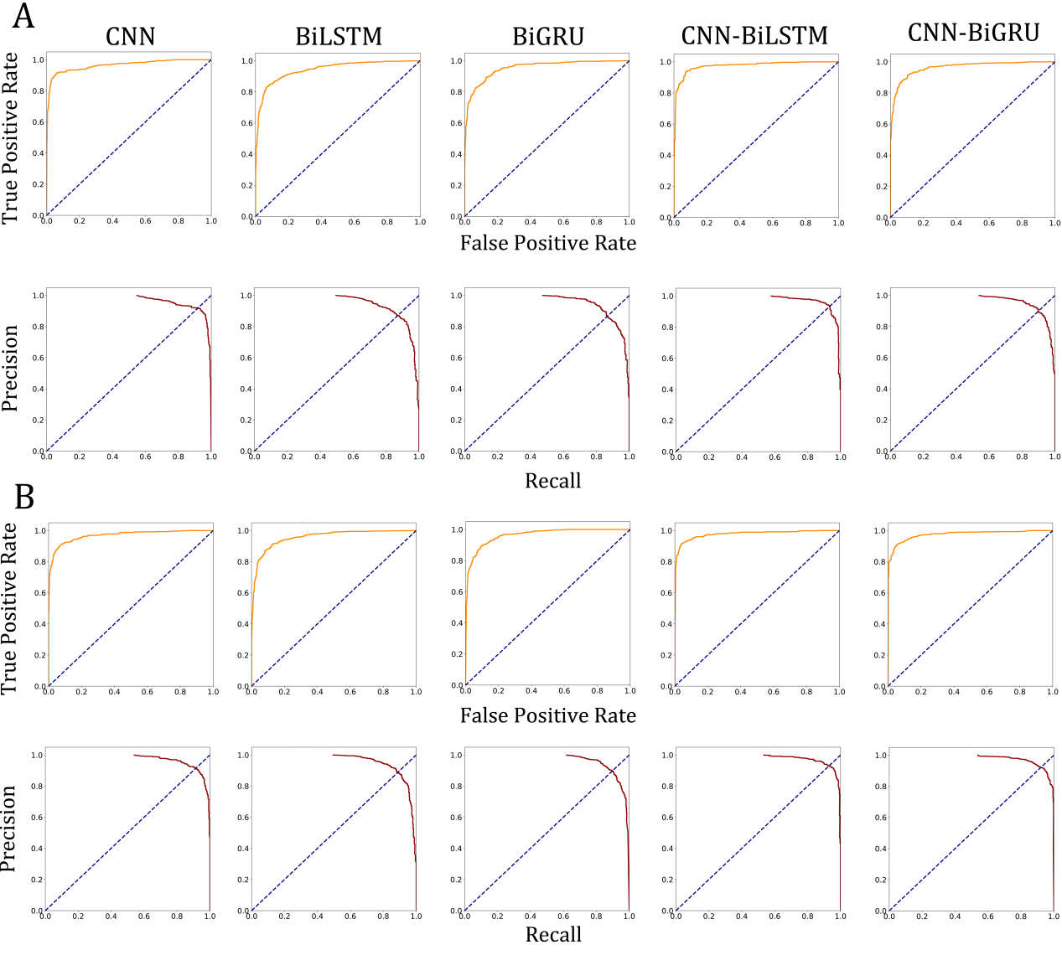

**Supplementary Figure S2**

Receiver operating characteristic (ROC) curves and precision-recall curves (PR) for candidate m5U sites identified by five deep learning models using the set of full transcript mode as ground truth. **(A)** Training dataset, **(B)** Independent test set.

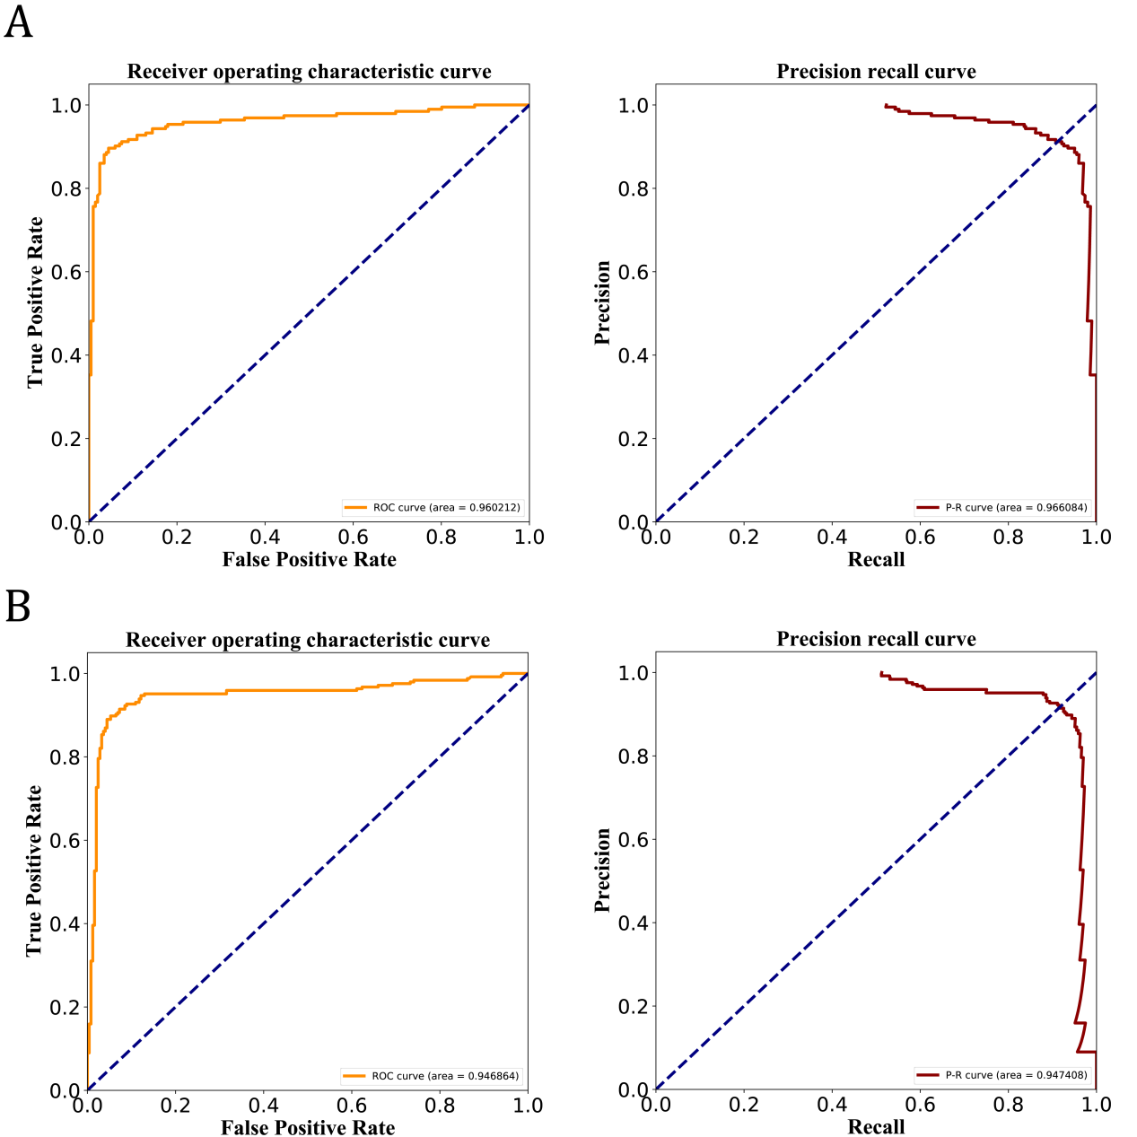

**Supplementary Figure S3**

ROC and PR curves of the CNN-BiLSTM model for the mature mRNA mode. **(A)** Training dataset, **(B)** Independent test set.

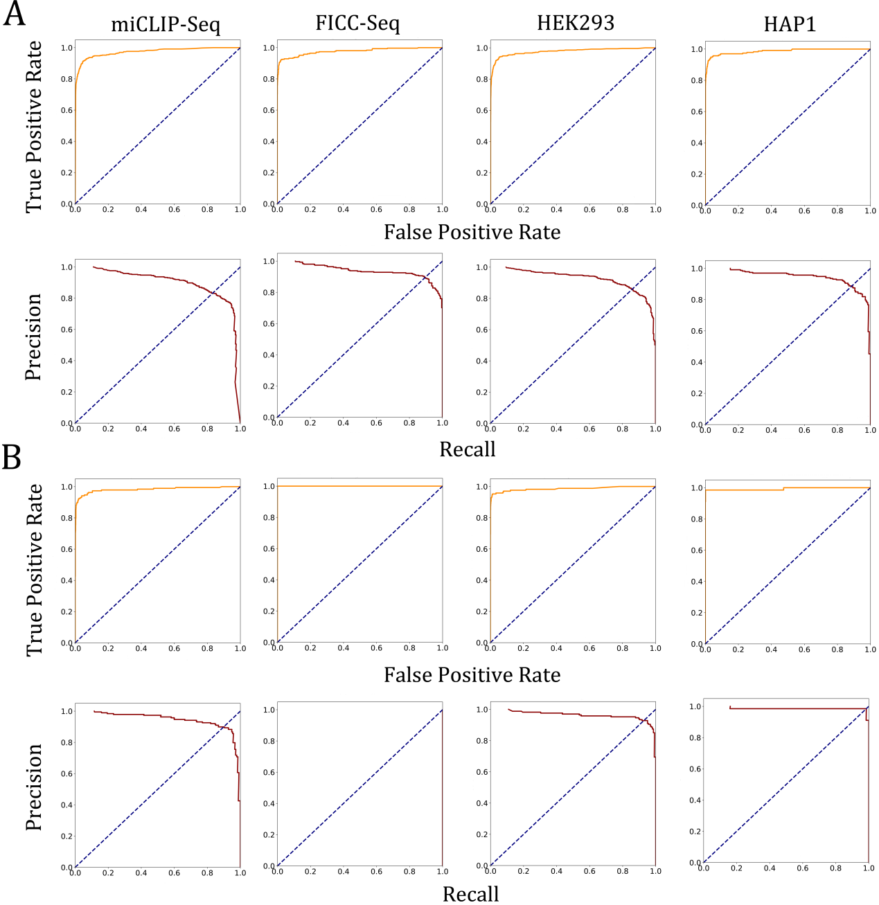

**Supplementary Figure S4**

ROC and PR curves of Deepm5U for the intra-dataset evaluation across technologies and cell types. **(A)** Full transcript mode, **(B)** Mature mRNA mode.

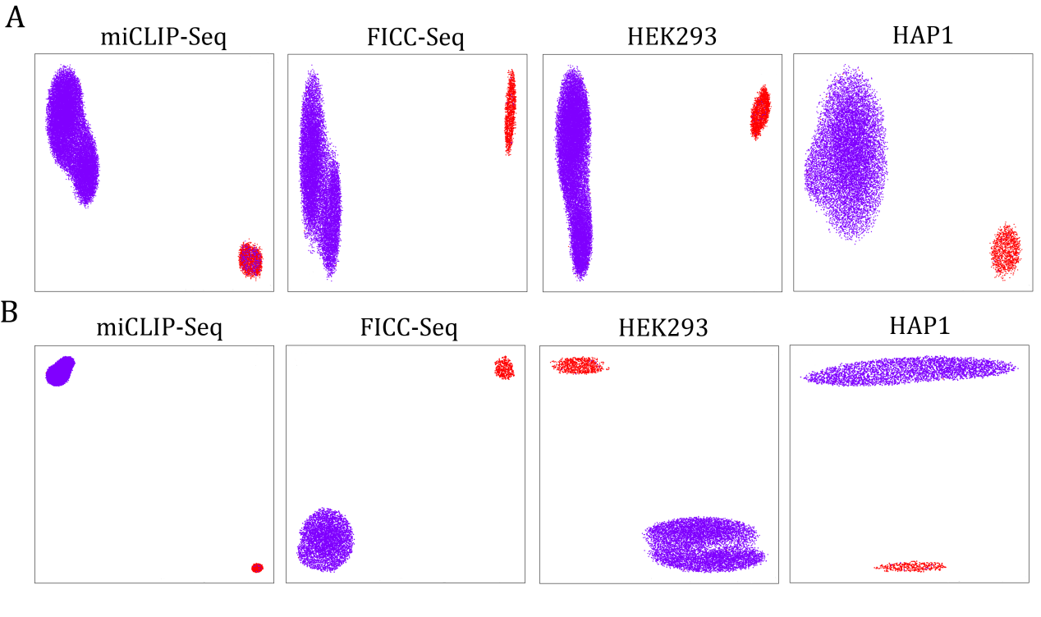

**Supplementary Figure S5**

UMAP visualization of the features learned by Deepm5U from the cross-technique and cross-cell-type datasets.

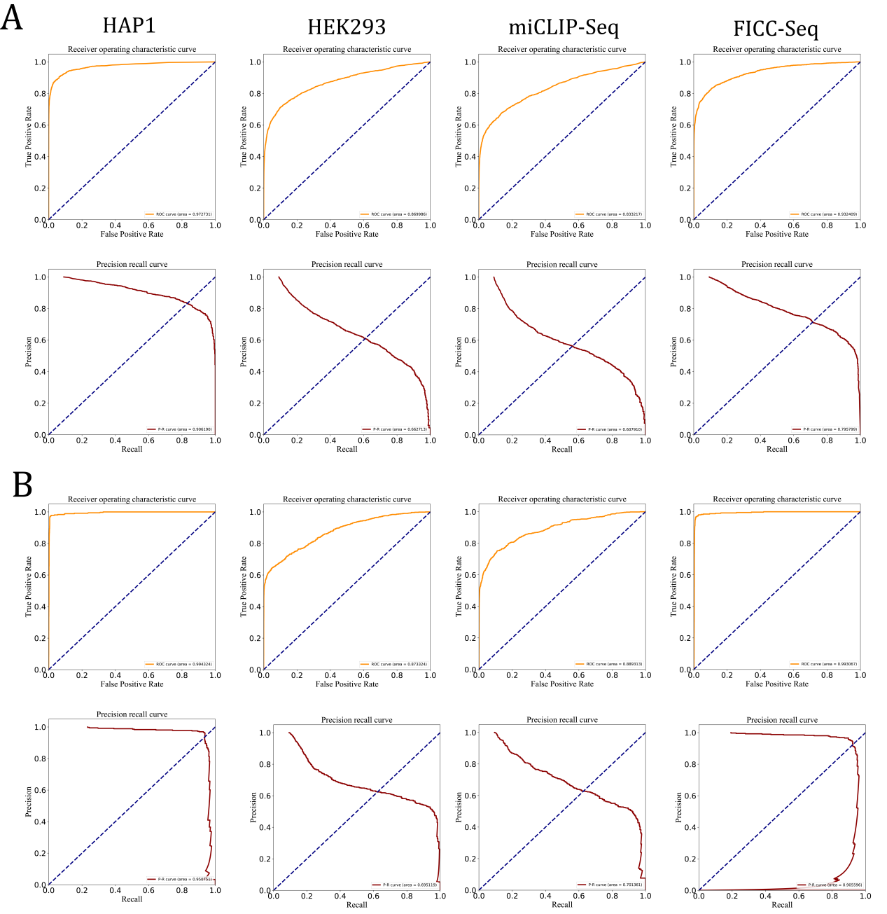**Supplementary Figure S6**

ROC and PR curves of Deepm5U for the inter-dataset evaluation across technologies and cell types. **(A)** Full transcript mode, **(B)** Mature mRNA mode.