**Supplementary 1.** **The culture of microalgae used in this study over time.**

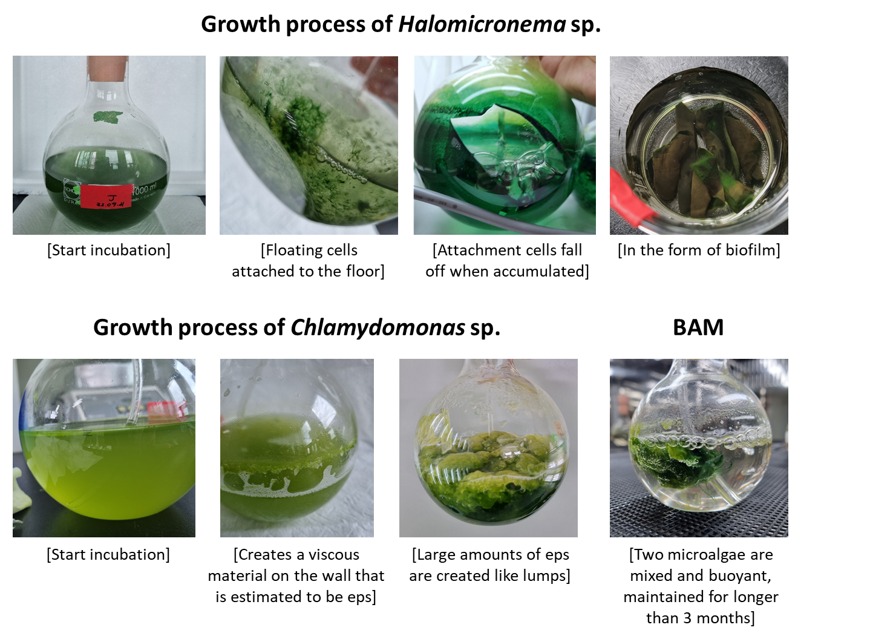

|  |  |  |  |  |  |  |  |  |  |  |  |  |  |  |  |  |  |  |  |  |  |  |  |  |  |  |  |  |  |  |  |  |  |  |  |  |  |  |  |  |  |  |  |  |  |  |  |  |  |  |  |  |  |  |  |  |  |  |  |  |  |  |  |  |  |  |  |  |  |  |  |  |  |  |  |  |  |  |  |  |  |  |  |  |  |  |  |  |  |  |  |  |  |  |  |  |  |  |  |  |  |  |  |  |  |  |  |  |  |  |  |  |  |  |  |  |  |  |  |  |  |  |  |  |  |  |  |  |  |  |  |  |  |  |  |  |  |  |  |  |  |  |  |  |  |  |  |  |  |  |  |  |  |  |  |  |  |  |  |  |  |  |  |  |  |  |  |  |  |  |  |  |  |  |  |  |  |  |  |  |  |  |  |  |  |  |  |  |  |  |  |  |  |  |  |  |  |  |  |  |  |  |  |  |  |  |  |  |  |  |  |  |  |  |  |  |  |  |  |  |  |  |  |  |  |  |  |  |  |  |  |  |  |  |  |  |  |  |  |  |
| --- | --- | --- | --- | --- | --- | --- | --- | --- | --- | --- | --- | --- | --- | --- | --- | --- | --- | --- | --- | --- | --- | --- | --- | --- | --- | --- | --- | --- | --- | --- | --- | --- | --- | --- | --- | --- | --- | --- | --- | --- | --- | --- | --- | --- | --- | --- | --- | --- | --- | --- | --- | --- | --- | --- | --- | --- | --- | --- | --- | --- | --- | --- | --- | --- | --- | --- | --- | --- | --- | --- | --- | --- | --- | --- | --- | --- | --- | --- | --- | --- | --- | --- | --- | --- | --- | --- | --- | --- | --- | --- | --- | --- | --- | --- | --- | --- | --- | --- | --- | --- | --- | --- | --- | --- | --- | --- | --- | --- | --- | --- | --- | --- | --- | --- | --- | --- | --- | --- | --- | --- | --- | --- | --- | --- | --- | --- | --- | --- | --- | --- | --- | --- | --- | --- | --- | --- | --- | --- | --- | --- | --- | --- | --- | --- | --- | --- | --- | --- | --- | --- | --- | --- | --- | --- | --- | --- | --- | --- | --- | --- | --- | --- | --- | --- | --- | --- | --- | --- | --- | --- | --- | --- | --- | --- | --- | --- | --- | --- | --- | --- | --- | --- | --- | --- | --- | --- | --- | --- | --- | --- | --- | --- | --- | --- | --- | --- | --- | --- | --- | --- | --- | --- | --- | --- | --- | --- | --- | --- | --- | --- | --- | --- | --- | --- | --- | --- | --- | --- | --- | --- | --- | --- | --- | --- | --- | --- | --- | --- | --- | --- | --- | --- | --- | --- | --- | --- | --- | --- | --- | --- |
| **Supplementary 2. Calcium adhesion ratio results from observation and measurement of EDS-SEM.**  Figure 4A   |  |  |  |  |  |  |  |  |  |  | | --- | --- | --- | --- | --- | --- | --- | --- | --- | --- | | Element | Line Type | Apparent Concentration | k Ratio | Wt% | Wt% Sigma | Atomic % | Standard Label | Factory Standard | Standard Calibration Date | | C | K series | 24.21 | 0.24208 | 74.59 | 0.18 | 79.94 | C Vit | Yes |  | | O | K series | 7.67 | 0.02582 | 24.46 | 0.18 | 19.68 | SiO2 | Yes |  | | Na | K series | 0.03 | 0.00011 | 0.03 | 0.02 | 0.02 | Albite | Yes |  | | Mg | K series | 0.08 | 0.00056 | 0.12 | 0.01 | 0.06 | MgO | Yes |  | | Si | K series | 0.01 | 0.00012 | 0.02 | 0.01 | 0.01 | SiO2 | Yes |  | | P | K series | 0.25 | 0.00137 | 0.22 | 0.02 | 0.09 | GaP | Yes |  | | S | K series | 0.14 | 0.00125 | 0.20 | 0.02 | 0.08 | FeS2 | Yes |  | | Cl | K series | 0.01 | 0.00007 | 0.01 | 0.01 | 0.00 | NaCl | Yes |  | | K | K series | 0.16 | 0.00131 | 0.21 | 0.02 | 0.07 | KBr | Yes |  | | Ca | K series | 0.11 | 0.00094 | 0.14 | 0.02 | 0.05 | Wollastonite | Yes |  | | Total: |  |  |  | 100.00 |  | 100.00 |  |  |  |   Figure 4B   |  |  |  |  |  |  |  |  |  |  | | --- | --- | --- | --- | --- | --- | --- | --- | --- | --- | | Element | Line Type | Apparent Concentration | k Ratio | Wt% | Wt% Sigma | Atomic % | Standard Label | Factory Standard | Standard Calibration Date | | C | K series | 19.32 | 0.19318 | 59.86 | 0.20 | 69.17 | C Vit | Yes |  | | O | K series | 12.15 | 0.04090 | 32.27 | 0.18 | 27.99 | SiO2 | Yes |  | | Na | K series | 0.04 | 0.00016 | 0.04 | 0.02 | 0.03 | Albite | Yes |  | | Mg | K series | 0.11 | 0.00072 | 0.14 | 0.01 | 0.08 | MgO | Yes |  | | Si | K series | 0.03 | 0.00024 | 0.03 | 0.01 | 0.02 | SiO2 | Yes |  | | P | K series | 0.34 | 0.00188 | 0.26 | 0.02 | 0.12 | GaP | Yes |  | | S | K series | 0.22 | 0.00194 | 0.27 | 0.02 | 0.12 | FeS2 | Yes |  | | Cl | K series | 0.16 | 0.00139 | 0.19 | 0.02 | 0.08 | NaCl | Yes |  | | K | K series | 0.17 | 0.00143 | 0.19 | 0.02 | 0.07 | KBr | Yes |  | | Ca | K series | 5.71 | 0.05100 | 6.74 | 0.05 | 2.33 | Wollastonite | Yes |  | | Total: |  |  |  | 100.00 |  | 100.00 |  |  |  | |

|  |  |  |  |  |  |  |  |  |  |  |  |  |  |  |  |  |  |  |  |  |  |  |  |  |  |  |  |  |  |  |  |  |  |  |  |  |  |  |  |  |  |  |  |  |  |  |  |  |  |  |  |  |  |  |  |  |  |  |  |  |  |  |  |  |  |  |  |  |  |  |  |  |  |  |  |  |  |  |  |  |  |  |  |  |  |  |  |  |  |  |  |  |  |  |  |  |  |  |  |  |  |  |  |  |  |  |  |  |  |  |  |  |  |  |  |  |  |  |  |  |  |  |  |  |  |  |  |  |  |  |  |  |  |  |  |  |  |  |  |  |  |  |  |  |  |  |  |  |  |  |  |  |  |  |  |  |  |  |  |  |  |  |  |  |  |  |  |  |  |  |  |  |  |  |  |  |  |  |  |  |  |  |  |  |  |  |  |  |  |  |  |  |  |  |  |  |  |  |  |  |  |  |  |  |  |  |  |  |  |  |  |  |  |  |  |  |  |  |  |  |  |  |  |  |  |  |  |  |  |  |  |  |  |  |  |  |  |  |  |  |  |  |  |  |  |  |  |  |  |  |  |  |  |  |  |  |  |  |  |  |  |  |  |  |  |  |  |  |  |  |  |  |  |  |  |  |  |  |  |  |  |  |  |  |  |  |  |  |  |  |  |  |  |  |  |  |  |  |  |  |  |  |  |  |  |  |  |  |  |  |  |  |  |  |  |  |  |  |  |  |  |  |  |  |  |  |  |  |  |  |  |  |  |  |  |  |  |  |  |  |  |  |  |  |  |  |  |  |  |  |  |  |  |  |  |  |  |  |  |  |  |  |  |  |  |  |  |  |  |  |  |  |  |  |  |  |  |  |  |  |  |  |
| --- | --- | --- | --- | --- | --- | --- | --- | --- | --- | --- | --- | --- | --- | --- | --- | --- | --- | --- | --- | --- | --- | --- | --- | --- | --- | --- | --- | --- | --- | --- | --- | --- | --- | --- | --- | --- | --- | --- | --- | --- | --- | --- | --- | --- | --- | --- | --- | --- | --- | --- | --- | --- | --- | --- | --- | --- | --- | --- | --- | --- | --- | --- | --- | --- | --- | --- | --- | --- | --- | --- | --- | --- | --- | --- | --- | --- | --- | --- | --- | --- | --- | --- | --- | --- | --- | --- | --- | --- | --- | --- | --- | --- | --- | --- | --- | --- | --- | --- | --- | --- | --- | --- | --- | --- | --- | --- | --- | --- | --- | --- | --- | --- | --- | --- | --- | --- | --- | --- | --- | --- | --- | --- | --- | --- | --- | --- | --- | --- | --- | --- | --- | --- | --- | --- | --- | --- | --- | --- | --- | --- | --- | --- | --- | --- | --- | --- | --- | --- | --- | --- | --- | --- | --- | --- | --- | --- | --- | --- | --- | --- | --- | --- | --- | --- | --- | --- | --- | --- | --- | --- | --- | --- | --- | --- | --- | --- | --- | --- | --- | --- | --- | --- | --- | --- | --- | --- | --- | --- | --- | --- | --- | --- | --- | --- | --- | --- | --- | --- | --- | --- | --- | --- | --- | --- | --- | --- | --- | --- | --- | --- | --- | --- | --- | --- | --- | --- | --- | --- | --- | --- | --- | --- | --- | --- | --- | --- | --- | --- | --- | --- | --- | --- | --- | --- | --- | --- | --- | --- | --- | --- | --- | --- | --- | --- | --- | --- | --- | --- | --- | --- | --- | --- | --- | --- | --- | --- | --- | --- | --- | --- | --- | --- | --- | --- | --- | --- | --- | --- | --- | --- | --- | --- | --- | --- | --- | --- | --- | --- | --- | --- | --- | --- | --- | --- | --- | --- | --- | --- | --- | --- | --- | --- | --- | --- | --- | --- | --- | --- | --- | --- | --- | --- | --- | --- | --- | --- | --- | --- | --- | --- | --- | --- | --- | --- | --- | --- | --- | --- | --- | --- | --- | --- | --- | --- | --- | --- | --- | --- | --- | --- | --- | --- | --- | --- | --- | --- | --- | --- | --- | --- | --- | --- | --- | --- | --- | --- | --- | --- | --- | --- | --- | --- | --- | --- | --- | --- | --- | --- | --- | --- | --- | --- | --- | --- | --- | --- | --- | --- | --- | --- | --- | --- | --- | --- | --- | --- | --- | --- | --- | --- | --- | --- |
| Figure 4C   |  |  |  |  |  |  |  |  |  | | --- | --- | --- | --- | --- | --- | --- | --- | --- | | Element | Line Type | Apparent Concentration | k Ratio | Wt% | Wt% Sigma | Standard Label | Factory Standard | Standard Calibration Date | | C | K series | 37.23 | 0.37230 | 77.69 | 0.13 | C Vit | Yes |  | | O | K series | 9.31 | 0.03132 | 22.01 | 0.13 | SiO2 | Yes |  | | Mg | K series | 0.12 | 0.00076 | 0.12 | 0.01 | MgO | Yes |  | | P | K series | 0.23 | 0.00128 | 0.15 | 0.01 | GaP | Yes |  | | Ca | K series | 0.04 | 0.00038 | 0.04 | 0.01 | Wollastonite | Yes |  | | Total: |  |  |  | 100.00 |  |  |  |  |   Figure 4D   |  |  |  |  |  |  |  |  |  | | --- | --- | --- | --- | --- | --- | --- | --- | --- | | Element | Line Type | Apparent Concentration | k Ratio | Wt% | Wt% Sigma | Standard Label | Factory Standard | Standard Calibration Date | | C | K series | 12.88 | 0.12881 | 55.56 | 0.49 | C Vit | Yes |  | | N | K series | 2.60 | 0.00463 | 8.86 | 0.72 | BN | Yes |  | | O | K series | 8.34 | 0.02808 | 28.16 | 0.30 | SiO2 | Yes |  | | Mg | K series | 0.25 | 0.00167 | 0.38 | 0.02 | MgO | Yes |  | | P | K series | 0.67 | 0.00374 | 0.61 | 0.02 | GaP | Yes |  | | S | K series | 0.42 | 0.00361 | 0.60 | 0.02 | FeS2 | Yes |  | | Cl | K series | 0.89 | 0.00778 | 1.29 | 0.03 | NaCl | Yes |  | | K | K series | 0.62 | 0.00529 | 0.85 | 0.03 | KBr | Yes |  | | Ca | K series | 2.64 | 0.02361 | 3.69 | 0.05 | Wollastonite | Yes |  | | Total: |  |  |  | 100.00 |  |  |  |  |   Figure 4E   |  |  |  |  |  |  |  |  |  |  | | --- | --- | --- | --- | --- | --- | --- | --- | --- | --- | | Element | Line Type | Apparent Concentration | k Ratio | Wt% | Wt% Sigma | Atomic % | Standard Label | Factory Standard | Standard Calibration Date | | C | K series | 10.12 | 0.10125 | 50.65 | 0.32 | 60.16 | C Vit | Yes |  | | O | K series | 16.44 | 0.05531 | 41.48 | 0.29 | 36.99 | SiO2 | Yes |  | | Mg | K series | 0.21 | 0.00138 | 0.31 | 0.02 | 0.18 | MgO | Yes |  | | S | K series | 0.29 | 0.00249 | 0.40 | 0.02 | 0.18 | FeS2 | Yes |  | | Cl | K series | 1.94 | 0.01695 | 2.73 | 0.04 | 1.10 | NaCl | Yes |  | | K | K series | 0.81 | 0.00690 | 1.08 | 0.03 | 0.39 | KBr | Yes |  | | Ca | K series | 1.77 | 0.01583 | 2.40 | 0.05 | 0.85 | Wollastonite | Yes |  | | Zr | L series | 0.56 | 0.00560 | 0.94 | 0.15 | 0.15 | Zr | Yes |  | | Total: |  |  |  | 100.00 |  | 100.00 |  |  |  |   Figure 4F   |  |  |  |  |  |  |  |  |  |  | | --- | --- | --- | --- | --- | --- | --- | --- | --- | --- | | Element | Line Type | Apparent Concentration | k Ratio | Wt% | Wt% Sigma | Atomic % | Standard Label | Factory Standard | Standard Calibration Date | | C | K series | 17.70 | 0.17703 | 59.57 | 0.20 | 70.13 | C Vit | Yes |  | | O | K series | 9.66 | 0.03252 | 29.18 | 0.19 | 25.79 | SiO2 | Yes |  | | Na | K series | 0.01 | 0.00005 | 0.01 | 0.02 | 0.01 | Albite | Yes |  | | Mg | K series | 0.12 | 0.00080 | 0.16 | 0.01 | 0.10 | MgO | Yes |  | | Si | K series | 0.06 | 0.00044 | 0.07 | 0.01 | 0.03 | SiO2 | Yes |  | | P | K series | 0.18 | 0.00100 | 0.15 | 0.02 | 0.07 | GaP | Yes |  | | S | K series | 0.18 | 0.00152 | 0.23 | 0.02 | 0.10 | FeS2 | Yes |  | | Cl | K series | 0.45 | 0.00391 | 0.58 | 0.02 | 0.23 | NaCl | Yes |  | | K | K series | 0.18 | 0.00155 | 0.22 | 0.02 | 0.08 | KBr | Yes |  | | Ca | K series | 7.92 | 0.07076 | 9.85 | 0.07 | 3.48 | Wollastonite | Yes |  | | Total: |  |  |  | 100.00 |  | 100.00 |  |  |  | |