Supplementary Material

**Modeling approaches to nitrogen management**

**for food production in closed, life-support systems**

Tyler Wallentine1*, David Merkley1, Noah J. Langenfeld2, Bruce Bugbee2, Lance C. Seefeldt1

1Department of Chemistry and Biochemistry, Utah State University, Logan, UT, United States

2Crop Physiology Laboratory, Utah State University, Logan, UT, United States

**\*Correspondence:**Tyler Wallentine  
tyler.wallentine@usu.edu

# Supplementary Data

**Supplementary Table 1.** Results from Hach Kit analyses on *Rhodopseudomonas palustris* nifA* biomass demonstrates a nitrogen mass fraction of dry biomass between 12.0 and 20.5%. A fraction of 17% was subsequently assumed for Table S2 calculations

|  |  |  |
| --- | --- | --- |
| **Sample:** | **% N of Wet:** | **% N of Dry:** |
| Acetate Standard 1 | 1.20% | 12.0% |
| Acetate Standard 2 | 1.44% | 14.4% |
| Acetate Standard 3 | 2.05% | 20.5% |
| Wastewater 1 | 1.87% | 18.7% |
| Wastewater 2 | 1.87% | 18.7% |
| Wastewater 3 | 1.68% | 16.8% |
| **Average % N of Dry:** |  |
| Acetate: | 15.7% |
| Wastewater: | 18.1% |

**Supplementary Table 2.** Results from reactor harvests in which a rate of N fixation was calculated, averaging between 13-14 g N / L day in the systems provided. A conservative estimate of 13 mg N / L day was assumed in the model.



# Supplementary Figures

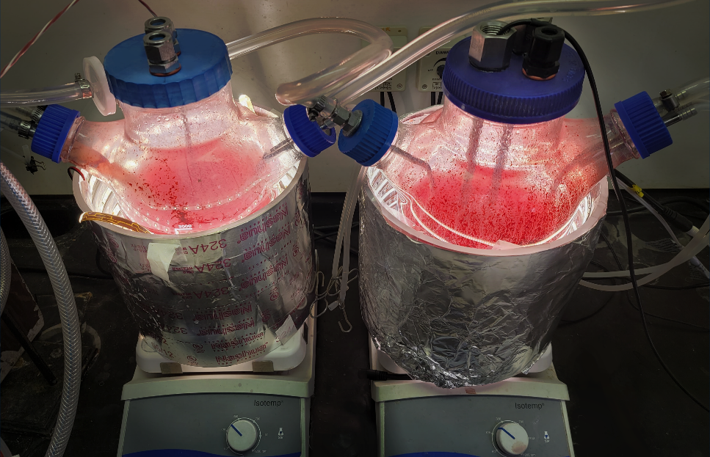

**Supplemental Figure 1.** 3L anaerobic reactors utilized for *Rhodopseudomonas palustris* growth studies

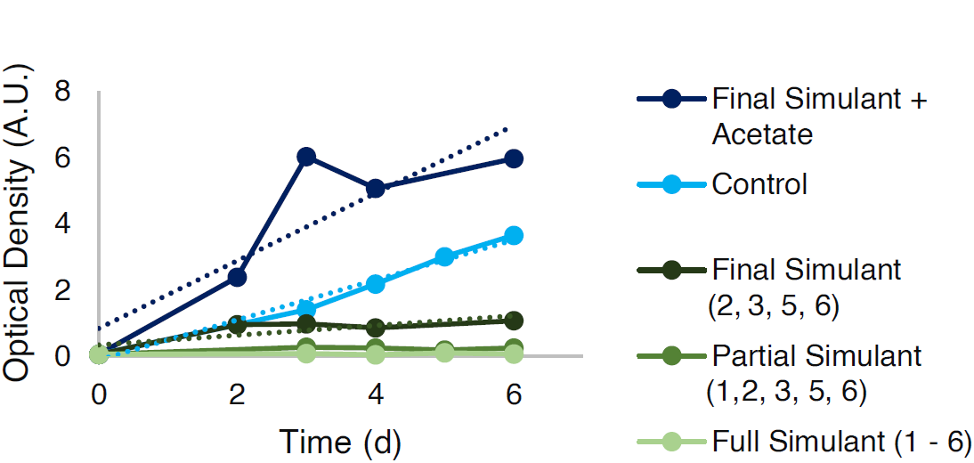

**Supplementary Figure 2.** Results of tests in which *Rhodopseudomonas palustris* was grown using a Johnson center wastewater recipe and compared to controls using 60 mM acetate with or without wastewater components. Comparing the slopes of the simulant + acetate curve with that of the control curve yields a value of approximately 1.6.

**Supplementary Figure 3.** Results of different N management simulations demonstrating an increasing performance from the combined NFR regiment with increasing reactor volume