Supplementary Figure 1 The Phylogenetic tree and gene structure of CsABCG genes in cucumber. Phylogenetic tree was constructed based on the protein sequence of cucumber by MAGE7.0.

Supplementary Figure 2 The sequence logos of motifs of the ABCG.

Supplementary Figure 3 Alignment of the partial ABCG proteins between cucumber and other species. (A) Alignment of the partial full-size ABCG (PDR) proteins between cucumber and other species. (B) Alignment of the partial half-size ABCG (WBC) proteins between cucumber and other species.

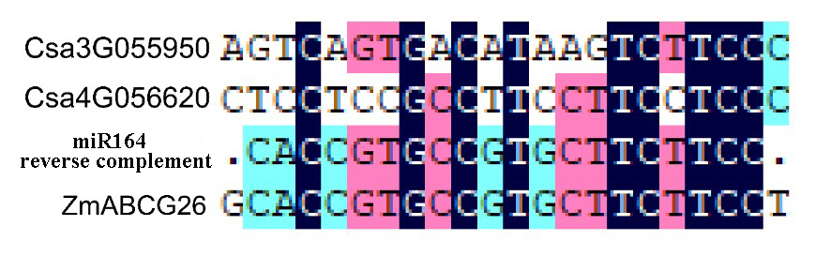

Supplementary Figure 4 Alignment of the binding sites of the miR164 on ZmABCG26 and its corresponding sites of the ortholog genes Csa3G055950 and Cs4G056620.

