***Supplementary material***

**Evidence of poro-elastic inflation at the onset of the 2021 Vulcano Island (Italy) unrest**

*Santina Chiara Stissi, Gilda Currenti*, Flavio Cannavò and Rosalba Napoli*

Istituto Nazionale di Geofisica e Vulcanologia – Osservatorio Etneo, Catania, Italy

**\* Correspondence:** Gilda Currenti (gilda.currenti@ingv.it)

**1. Geometric illustration of the elementary ring source**

In Section 2.2, we provided a way to compute the displacement induced by pore-pressure and temperature changes for a cylindrical source by extending the formulation proposed in Hemmings et al. (2016) for the gravity changes. The cylinder is discretized into smaller elementary sources ($ρ_{i},z_{i}$), each of which represents the portion of an elementary source ring centred on the axis of symmetry of the cylinder. The displacement is calculated as the sum of the displacements induced by the single smaller sources. We provide below a geometric representation of the elementary ring source.

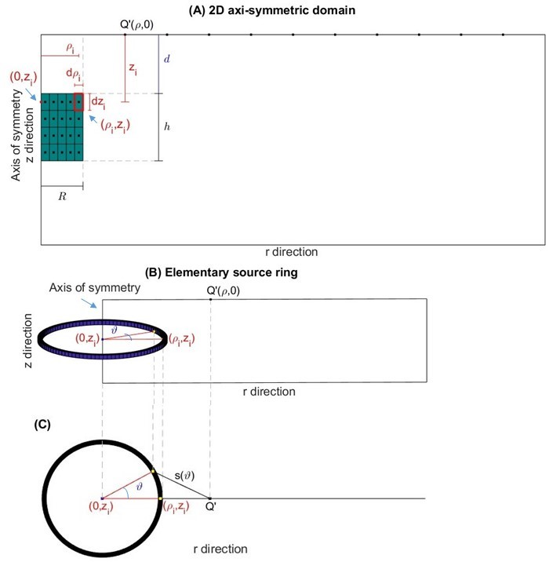

**Supplementary Figure S1:** **(A)** Representation, in a 2D axi-symmetric formulation, of the cylindrical source (green rectangle) with the top at a depth $d$ from the surface, height $h$ and radius $R$, embedded in an elastic half-space. In this figure, the source has been discretized into 20 smaller cylinders. A generic smaller cylinder centred in ($ρ_{i},z_{i}$) has been highlighted in red. Each smaller cylinder represents the portion of an elementary ring source centred at ($0,z_{i}$), radius $ρ_{i}$, radial thickness ${dρ}_{i}$ and elevation thickness ${dz}_{i}$. By varying $ϑ$ in [0,2 $π$], starting from the elementary source ($ρ_{i},z_{i}$), all the points of the elementary ring (yellow dots) are obtained. The observation points $Q^{'}\left(ρ,z_{i}\right)$ are placed along the surface $z=0$ of the half-space. The displacement in the observation point $Q^{'}$ is given by the sum of the displacements induced by the single smaller cylinders. **(B-C)** (after Hemmings et al., 2016) Representation of a generic elementary ring centred at ($0,z_{i}$) and radius $ρ_{i}$ in a 2D axis-symmetric formulation. In the panel **(B)** the representation is in the $rz$ plane, in the panel **(C)** there is a top view. By varying $ϑ$ in [0,2 $π$], $s\left(ϑ\right)$ indicates the distance between the observation point $Q^{'}$ and each point of the elementary ring.

**2. Comparison between numerical and semi-analytical solutions**

A verification of the derived formulas (16) and (17) to compute the displacement induced by temperature and pore-pressure changes within a cylindrical source was carried out by comparing the semi-analytical solution with the numerical displacement provided by the software COMSOL (COMSOL, 2012) which solves the set of Eqs. (1-3) using a finite-element discretization. A computational domain of 8.0 x 1.0 km was set up in an axi-symmetric half-space model. The bottom and lateral borders of the domain are bounded by infinite elements to ensure that the displacement vanishes toward infinity. A stress-free boundary condition (**σ $⋅$ n $=0$** ) is applied on the ground surface. It has modelled an homogeneous domain with Poisson’s ratio $ν=$ 0.25, Biot-Willis coefficient $β=$ 0.83, drained bulk modulus $K_{d}=$ 5 GPa and thermo-elastic volumetric expansion coefficient 10-5 °C-1.

The comparison is performed for a cylindrical source with a height $h$ and radius $R$ of 200 m and with the top placed at a depth $d$ of 400 m. We considered two different cases: (1) the displacement induced by a change in pressure of 5 MPa, in which = 8.3 x 10-4; (2) the displacement induced by a change in both pressure and temperature of 5 MPa and 200 °C, respectively, in which $ε_{0}$ = 2.83 x 10-3.

The results, in Fig. S2, show, for both cases, that the numerical and semi-analytical solutions are in good agreement.

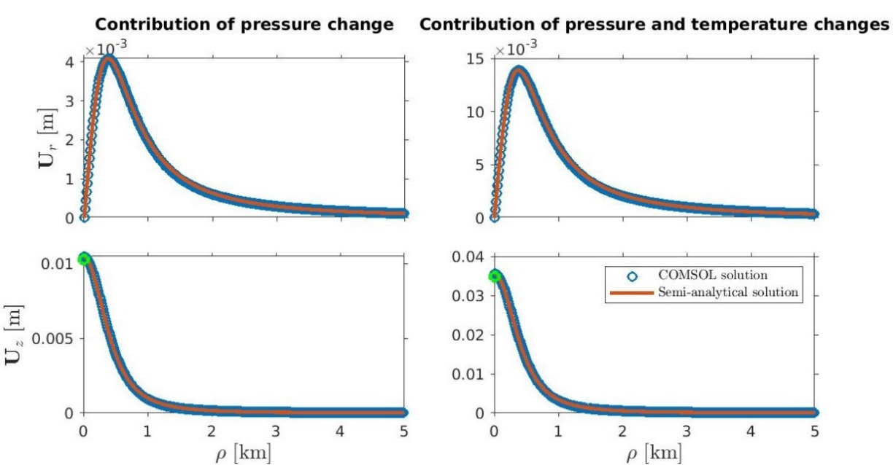

**Supplementary Figure S2:** Comparison for radial (top panels) and vertical (bottom panels) displacements between numerical (COMSOL software) and semi-analytical solutions. The cylindrical source, with the top at 400 m depth, has a radius and height of 200 m. The green circles represent the values of the vertical displacement in the axis of symmetry calculated with the formulas (SE1) (left panel) and (SE2) (right panel).

The value of the vertical displacement at the axis of symmetry computed with the semi-analytical formulation was also compared with the closed analytical solution (green circles in Fig. S2), according to (Wang, 2000):

$U_{z}= 2c_{mP}ΔP\left(1-ν\right)\left(h+\sqrt{R^{2}+d^{2}}- \sqrt{R^{2}+{\left(d+h\right)}^{2}}\right),$ (SE1)

where $c_{mP}=\frac{β(1+ν)}{3K_{d }(1-ν)}$. This formula has been also extended to take into account the contribution of thermo-elastic effects on displacement:

$U_{z}= 2{(c}_{mP}ΔP+c_{mT}ΔT)(1-ν)\left(h+\sqrt{R^{2}+d^{2}}- \sqrt{R^{2}+{\left(d+h\right)}^{2}}\right)$, (SE2)

with $c_{mT}=\frac{α_{T}(1+ν)}{3(1-ν)}$. The values obtained by the two formulas are $U_{z}=$ 1.02 x 10-2 m for the case (1) and 3.48 x 10-2 m for the case (2), both in good agreement with the values obtained from the here derived semi-analytical formulation.

It is worth to underline that the semi-analytical formulations (16) and (17) are valid to compute the displacement due to infinitesimal sources. We have therefore carried out an analysis on the resolution of the domain discretization to ensure an accurate solution. The semi-analytical solutions, obtained for two different discretizations, were compared with the numerical ones (Fig. S3). In the first case a single source, of height and radius 500 m, is considered (Fig. S3 at left), in the second case the source has been discretized into 100 smaller sources, each of height and radius 50 m, and the displacement is obtained as the sum of the displacements of the single sources (Fig. S3 at right). In this second case we obtained a more accurate semi-analytical solution.

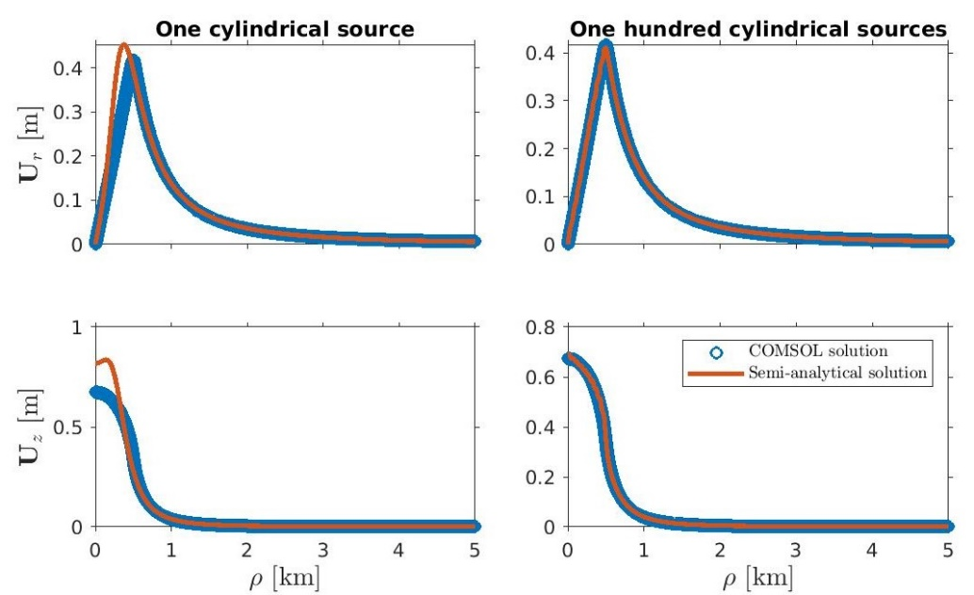

**Supplementary Figure S3:** Comparison between numerical and semi-analytical solutions. The cylindrical source has the top at the depth of 10 m, is 500 m high, its radius is 500 m and $ε_{0}$ = 2.83 x 10-3. In the left panels the source is only one cylinder, in the right panels the source is discretized into 100 smaller cylinders (10 along $r$ direction x 10 along $z$ direction).

From formulas (16) and (17) we can also derive a semi-analytical formulation to compute the tilt components, which read as:

$\frac{∂U_{z}}{∂r}\left(Q^{'}\right)=\frac{1+ν}{π}ε_{0}\sum_{{(ρ}_{i}, z_{i})}{ρ_{i}dρ_{i}dz_{i}\left(z_{Q}-z_{i}\right)}\int_{0}^{2π}{\frac{ρ_{i}\cos\left(ϑ\right)-ρ}{s{\left(ϑ\right)}^{5}}dϑ}.$ (SE3)

For a half-space flat domain under the boundary condition **σ $⋅$ n $=0,$** we get $\frac{∂U_{r}}{∂z}= - \frac{∂U_{z}}{∂r}$. In Fig. S4 the $\frac{∂U_{z}}{∂r}$ tilt component is shown for the numerical and semi-analytical solutions. Also in this case, a good match is obtained.

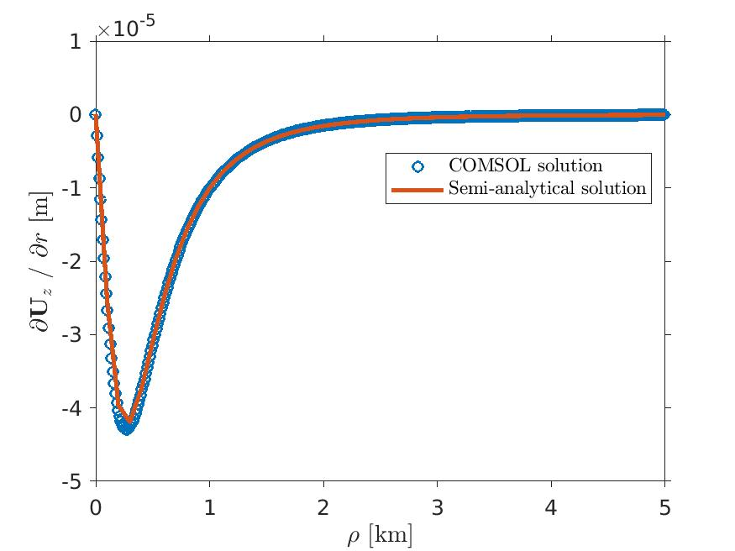

**Supplementary Figure S4:** Comparison between the tilt computed in COMSOL and the tilt computed with the semi-analytical formulation (SE3) for the cylindrical source. The parameters that describe the source are the optimum values (Tab. 2): $x_{C}$ = 496517 m, $y_{C}$ = 4250787 m, $d$ = -362 m, $R$ = 116 m, $h$ = 1000 m, $ε_{0}$ = 2.85 x 10-3. The source is discretized into 100 smaller cylinders.

**3. Sensitivity analysis of the optimal solution**

For the cylindrical source, the radius and height parameters are not well constrained and show quite wide ranges of variability (Fig. 7A). These parameters provide, for a wide range of values obtained by the inversion algorithm, solutions that have a good fit with the observed displacements. Since not only the optimal solution of the inversion algorithm fits the observed data as well, it follows that it is difficult to constrain the size of the deformation source.

We explored the solution space around the optimal solution. The incidence of the unconstrained parameters was then studied by varying their values within intervals centred on the optimal solution ( $R$ = 116 m, $h$ = 1000 m) and computing the displacement. Considered the optimal solution, we varied the values of the radius and height in the range [10, 200] and [800, 1200], respectively. The misfit was evaluated with respect to the optimal solution (magenta dot in Fig. S5). This analysis confirms the presence of several pairs of parameters that provide displacements similar to each other. Indeed, Fig. S5 highlights the presence of a large region in which the misfit assumes values close to the optimal one.

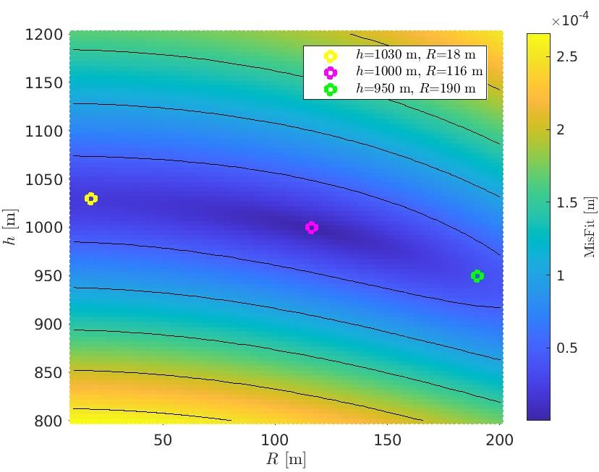

**Supplementary Figure S5:** Misfit distribution for the displacements computed with the semi-analytical formulations for the cylindrical source as a function of the radius and height values. The magenta dot indicates the optimal solution.

Each parameter pair that falls within this region provides comparable radial and vertical displacements. Fig. S6 shows a comparison of the radial and vertical displacements obtained at three different points of the search space, namely the optimal solution and other two shown in Fig. S5.

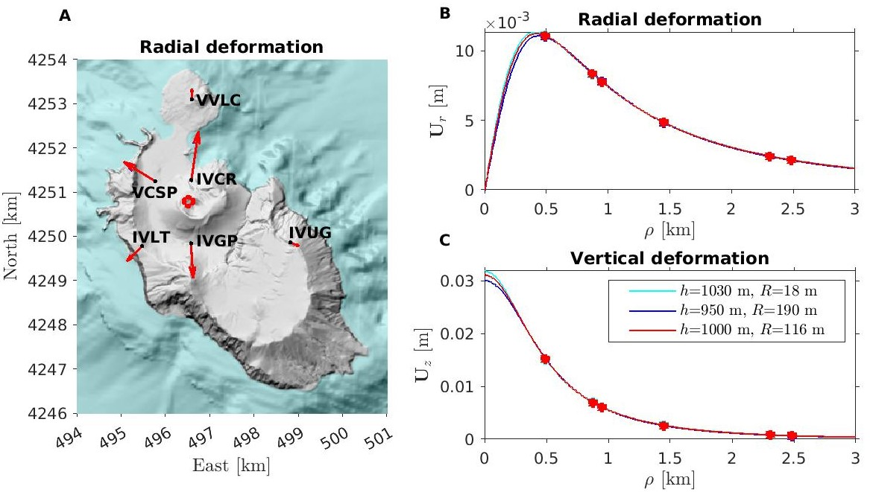

**Supplementary Figure S6:** Comparison between displacements computed with the forward model in three different points of the search space. The synthetic model has been built on the optimal solution of the inversion algorithm ( $x_{C}$ = 496517 m, $y_{C}$ = 4250787 m, $d$ = -362 m, $R$ = 116 m, $h$ = 1000 m, $ε_{0}$ = 2.85 x 10-3). The values of $ε_{0}$ to compute the displacements for $R$ = 18 m and $h$ = 1030 m and for $R$ = 190 m and $h$ = 950 m were computed using the least squares technique (Eq. 19).

**4. Topography effect**

We estimate the effect of volcano topography on the computed displacement field. We compared the analytical solutions obtained for the spherical source (Fig. 4) with those numerically computed by the software COMSOL Multiphysics using a Finite-Element discretization. A 12 x 12 x 6 km 3D computational domain was set up. Infinite elements were applied on the lateral and bottom boundaries to ensure zero displacements at infinity. The geometry of the upper stress-free surface was generated using the DEM and the bathymetry of the Vulcano Island. Applying the extended Hooke’s law for poro-elastic material and imposing a stress-free strain of 1.19 x 10-4 within a spherical source of 600 m radius, estimated from the optimal analytical solution (Tab. 1), we solved the poro-elastic equation. The source depth of the analytical solution (-722 m) was adjusted to about -300 m b.s.l. to consider the average altitude of the GPS station positions. Fig. S7 shows the observed displacement and the analytical and numerical solutions. We observe that topography has a minor effect on almost all the stations located at the base of the volcano edifice. At the summit station IVCR, a slight rotation with no significant change in amplitude with respect to the analytical solution is achieved.

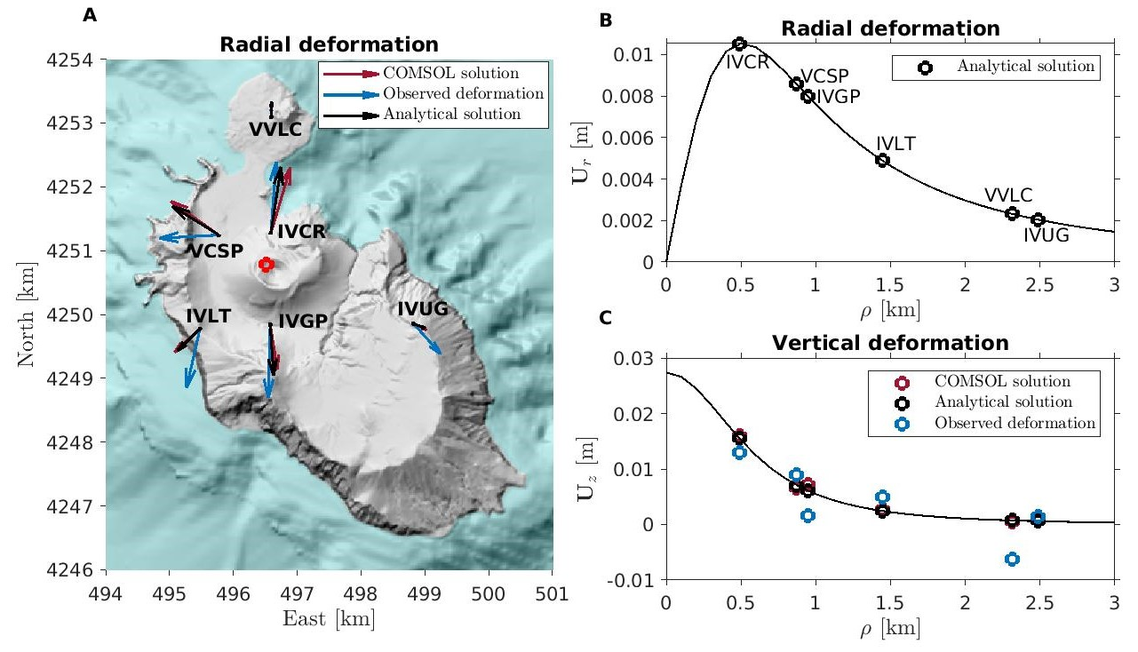

**Supplementary Figure S7:** Comparison between observed displacement, analytical solution for a flat and homogeneous domain and COMSOL solution for a 3D homogeneous medium with topography. The analytical and COMSOL solutions were computed by setting up: $x_{C}$ = 496513 m, $y_{C}$ = 4250785 m, $R$ = 600 m, $ΔV_{S}$ = 107499 m3 and = -722 b.s.l. or $z_{C}$ = -300 b.s.l. for the analytical and COMSOL solution, respectively. **(A) $U_{x}$** and $U_{y}$ components of the radial displacement in each station; the red circle indicates the position of the source; **(B)** radial displacement as a function of the radial distance of the stations from the deformation source; **(C)** vertical displacement as a function of the radial distance of the stations from the source.

**5. Size of the cylindrical source estimation**

The sensitivity analysis discussed in Section 3 has highlighted the existence of several pairs ($R$, $h$) of the cylindrical source parameters which provide solutions very similar to the optimal one. This leads us to state that cylindrical sources with different radii, heights and strain variations can equally be possible solutions for the observed ground displacements. To estimate the size of the source, we carried out a further analysis of the influence of the cylindrical source volume on the overpressures it undergoes and on the displacement pattern it generates. We compared the results for three different model parameters: (1) at the optimum values, for which $V_{0_{C}}=$ 4.23 x 107 m3 (Fig. S8A, B, C); (2) at the values for which the source has the minimum volume (3.14 x 106 m3; Fig. S8D, E, F); (3) at the values for which the source has the maximum volume (1.32 x 109 m3; Fig. S8G, H, I). The results show that sources with smaller radii induced horizontal displacements with a maximum at the IVCR station (Fig. S8A, B, D, E) and unrealistic pressure changes (Eq. (4)). Maximum volumes instead favor realistic pressure variations, and in some cases similar horizontal displacements at IVCR and VCSP stations (Fig. S8G, H). In addition, the three sources, of different volumes, underwent comparable stress-free volume changes: 1.21 x 105 m3 at the optimal solutions, 1.09 x 105 m3 and1.0 x 105 m3 for the sources withthe minimum and maximum volume, respectively.

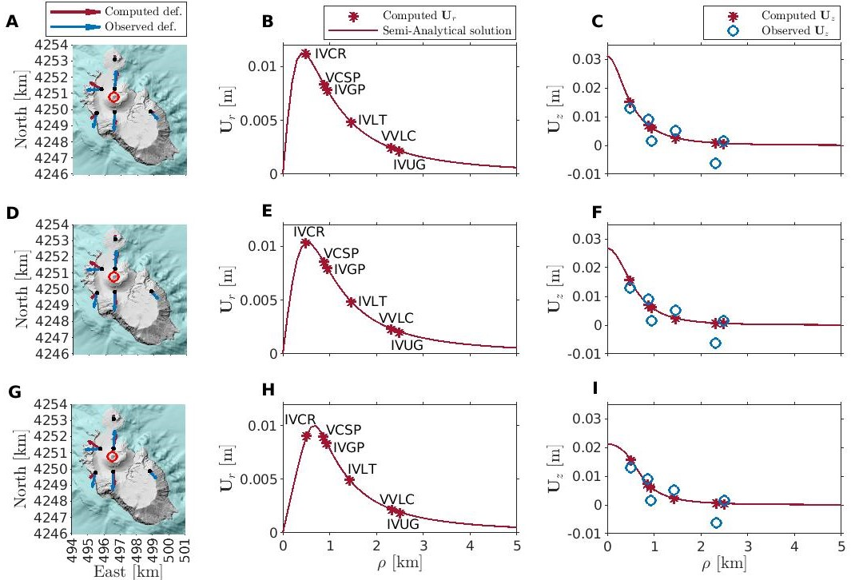

**Supplementary Figure S8:** Comparison between observed and computed radial and vertical displacements for the cylindrical source at the optimal values (A, B, C), at the values for which $V_{0_{C}}$ is minimum (D, E, F; $x_{C}$ = 496517 m, $y_{C}$ = 4250789 m, $d$ = -681 m, $R$ = 100 m, $h$ = 100 m, = 3.5 x 10-2) and at the values for which $V_{0_{C}}$ is maximum (G, H, I; $x_{C}$ = 496496 m, $y_{C}$ = 4250772 m, $d$ = -168 m, $R$ = 658 m, $h$ = 966 m, = 7.6 x 10-5).

A good agreement is found by using the optimal parameters set provided by the GA and reassigning the radius between 400 and 550 m. This choice leads to an increasing attenuation of the displacement at the IVCR station as the radius increases, causing similar radial displacements at the IVCR and VCSP stations.

**References**

COMSOL (2012). Comsol Multiphysics 4,3. Stockholm: Comsol Ab.

Wang, H.F. (2000). *Theory of Linear Poroelasticity with Applications to Geomechanics and Hydrogeology*. [Princeton University Press](https://www.jstor.org/publisher/princetonup?refreqid=excelsior%3A72e49ec0ce0f4b42aa2fd21a7a5b8bef).