**Assessment of global sorghum production, tolerance and climate risk**

**Muhammad Khalifa1* Elfatih A. B. Eltahir1**

1 Ralph M. Parsons Laboratory, Department of Civil and Environmental Engineering (CEE), Massachusetts Institute of Technology, Cambridge, USA

* Corresponding author: M. Khalifa (khalifa@mit.edu, [msakhalifa@hotmail.com](mailto:msakhalifa@hotmail.com))

**Table S1.** List of 102 countries where sorghum is cultivated (according to FAO 2022), along with their region and income group as categorized by the World Bank.

|  |  |  |
| --- | --- | --- |
| **Country** | **Region** | **Income group** |
| Albania | Europe & Central Asia | Upper middle income |
| Algeria | Middle East & North Africa | Lower middle income |
| Angola | Sub-Saharan Africa | Lower middle income |
| Argentina | Latin America & Caribbean | Upper middle income |
| Australia | East Asia & Pacific | High income |
| Austria | Europe & Central Asia | High income |
| Azerbaijan | Europe & Central Asia | Upper middle income |
| Bangladesh | South Asia | Lower middle income |
| Belize | Latin America & Caribbean | Lower middle income |
| Benin | Sub-Saharan Africa | Lower middle income |
| Bolivia | Latin America & Caribbean | Lower middle income |
| Botswana | Sub-Saharan Africa | Upper middle income |
| Brazil | Latin America & Caribbean | Upper middle income |
| Bulgaria | Europe & Central Asia | Upper middle income |
| Burkina Faso | Sub-Saharan Africa | Low income |
| Burundi | Sub-Saharan Africa | Low income |
| Cameroon | Sub-Saharan Africa | Lower middle income |
| Central African Republic | Sub-Saharan Africa | Low income |
| China | East Asia & Pacific | Upper middle income |
| Colombia | Latin America & Caribbean | Upper middle income |
| Congo, DRC | Sub-Saharan Africa | Low income |
| Costa Rica | Latin America & Caribbean | Upper middle income |
| Cote d'Ivoire | Sub-Saharan Africa | Lower middle income |
| Croatia | Europe & Central Asia | High income |
| Cuba | Latin America & Caribbean | Upper middle income |
| Dominican Republic | Latin America & Caribbean | Upper middle income |
| Ecuador | Latin America & Caribbean | Upper middle income |
| Egypt | Middle East & North Africa | Lower middle income |
| El Salvador | Latin America & Caribbean | Lower middle income |
| Eritrea | Sub-Saharan Africa | Low income |
| Ethiopia | Sub-Saharan Africa | Low income |
| Fiji | East Asia & Pacific | Upper middle income |
| France | Europe & Central Asia | High income |
| Gambia | Sub-Saharan Africa | Low income |
| Ghana | Sub-Saharan Africa | Lower middle income |
| Greece | Europe & Central Asia | High income |
| Guatemala | Latin America & Caribbean | Upper middle income |
| Guinea | Sub-Saharan Africa | Low income |
| Honduras | Latin America & Caribbean | Lower middle income |
| Hungary | Europe & Central Asia | High income |
| India | South Asia | Lower middle income |
| Iraq | Middle East & North Africa | Upper middle income |
| Israel | Middle East & North Africa | High income |
| Italy | Europe & Central Asia | High income |
| Japan | East Asia & Pacific | High income |
| Jordan | Middle East & North Africa | Upper middle income |
| Kazakhstan | Europe & Central Asia | Upper middle income |
| Kenya | Sub-Saharan Africa | Lower middle income |
| Kyrgyzstan | Europe & Central Asia | Lower middle income |
| Lebanon | Middle East & North Africa | Upper middle income |
| Madagascar | Sub-Saharan Africa | Low income |
| Malawi | Sub-Saharan Africa | Low income |
| Maldives | South Asia | Upper middle income |
| Mali | Sub-Saharan Africa | Low income |
| Mexico | Latin America & Caribbean | Upper middle income |
| Moldova | Europe & Central Asia | Upper middle income |
| Morocco | Middle East & North Africa | Lower middle income |
| Mozambique | Sub-Saharan Africa | Low income |
| Myanmar | East Asia & Pacific | Lower middle income |
| Namibia | Sub-Saharan Africa | Upper middle income |
| New Caledonia | East Asia & Pacific | High income |
| Nicaragua | Latin America & Caribbean | Lower middle income |
| Niger | Sub-Saharan Africa | Low income |
| Nigeria | Sub-Saharan Africa | Lower middle income |
| North Macedonia | Europe & Central Asia | Upper middle income |
| Oman | Middle East & North Africa | High income |
| Pakistan | South Asia | Lower middle income |
| Panama | Latin America & Caribbean | Upper middle income |
| Papua New Guinea | East Asia & Pacific | Lower middle income |
| Paraguay | Latin America & Caribbean | Upper middle income |
| Peru | Latin America & Caribbean | Upper middle income |
| Philippines | East Asia & Pacific | Lower middle income |
| Romania | Europe & Central Asia | Upper middle income |
| Russia | Europe & Central Asia | Upper middle income |
| Rwanda | Sub-Saharan Africa | Low income |
| Saudi Arabia | Middle East & North Africa | High income |
| Senegal | Sub-Saharan Africa | Lower middle income |
| Serbia | Europe & Central Asia | Upper middle income |
| Slovakia | Europe & Central Asia | High income |
| Slovenia | Europe & Central Asia | High income |
| South Africa | Sub-Saharan Africa | Upper middle income |
| South Korea | East Asia & Pacific | High income |
| Spain | Europe & Central Asia | High income |
| Sri Lanka | South Asia | Lower middle income |
| Sudan | Sub-Saharan Africa | Low income |
| Syria | Middle East & North Africa | Low income |
| Taiwan | East Asia & Pacific | High income |
| Tajikistan | Europe & Central Asia | Lower middle income |
| Tanzania | Sub-Saharan Africa | Lower middle income |
| Thailand | East Asia & Pacific | Upper middle income |
| Togo | Sub-Saharan Africa | Low income |
| Tunisia | Middle East & North Africa | Lower middle income |
| Turkey | Europe & Central Asia | Upper middle income |
| Uganda | Sub-Saharan Africa | Low income |
| Ukraine | Europe & Central Asia | Lower middle income |
| United States | North America | High income |
| Uruguay | Latin America & Caribbean | High income |
| Uzbekistan | Europe & Central Asia | Lower middle income |
| Venezuela | Latin America & Caribbean | Lower middle income |
| Yemen | Middle East & North Africa | Low income |
| Zambia | Sub-Saharan Africa | Lower middle income |
| Zimbabwe | Sub-Saharan Africa | Lower middle income |

**Fig. S1**. Relationship between sorghum yield and seasonal maximum temperature: average yield versus and seasonal maximum temperature over the period 1961-2020 (a), and relationship on region-was for East Asia and Pacific (b); Europe and Central Asia (c); Latin America and the Caribbean; (d) the Middle East and North Africa (e); North America (f); South Asia (g); and Sub-Saharan Africa (h). Each point in a represents one country and in b, c, d, e, f, g, and h represents one year.

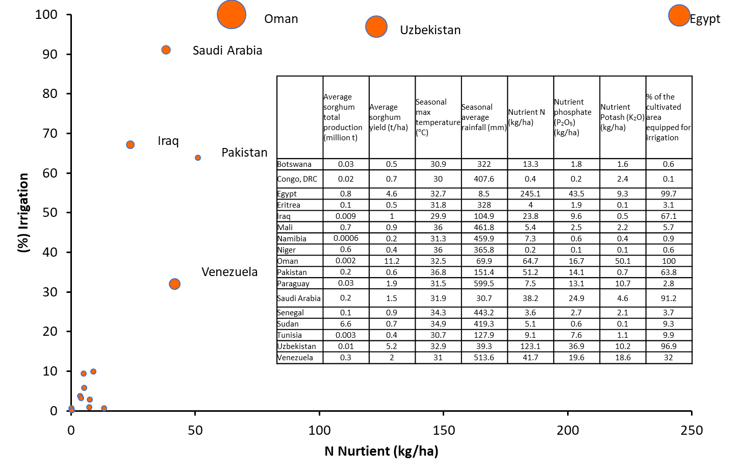

**Fig. S2**.Graphical representation of average N Nutirent (kg/ha) and percentage of irrigation in each of the 17 countries identific as countries at climate risk for sorghum cultivation. The size of circles represent average yield magnitude. The countries with the lowest fertilizer and %Irrigation levels are mostly sub-Saharan Africa.

**Fig. S3.** Use levels of three fertilizers types and the corresponding sorghum yield for the period 1961-2020 for the 17 coutnries identified in the current study as at climate risk for sorghum cutlivation. Note: Each point represents one year.