Supplementary Material

Schizophrenia-protective effect of microRNA-137 involves estrogen and is abrogated possibly by elevated prolactin in female patients

Qian Peng 1†, Zhun Dai 1†, Jingwen Yin 1, Dong Lv 1, Xudong Luo 1, Susu Xiong, Zhijiang Yang 1, Guangmin Chen 1, Yaxue Wei 1, Ying Wang 1, Dandan Zhang 1, Lulu Wang 1, Debo Yu 1, Yusheng Zhao 1, Dele Lin 1, Zhiyu Liao 1, Yongxi Zhong 1, Zhixiong Lin 1*, Juda Lin 1*

**\* Correspondence:** Juda Lin: linjuda@tom.com; Zhixiong Lin: zhixionglinzj@163.com

# Supplementary Figures and Tables

## Supplementary Tables

**Supplementary Table 1.** The demographic characteristics of samples for miR-137 genotyping

|  |  |  |  |
| --- | --- | --- | --- |
| **Variables** | **Patients**  **(n=1004)** | **Controls**  **(n=896)** | **P** |
|
| Age, mean±SD (years) | 34.8±13.7 | 34.9±9.78 | 0.868 |
| Gender, n (%) |  |  | 0.109 |
| Male | 634 (63.1) | 533 (59.5) |  |
| Female | 370 (36.9) | 363 (40.5) |

n, number; SD, standard deviation.

**Supplementary Table 2.** The demographic characteristics of samples for studies on sex hormones and miRNAs expression

|  |  |  |  |
| --- | --- | --- | --- |
| **Variables** | **Patients**  **（n=41）** | **Controls**  **（n=43）** | ***P*** |
| Age, mean±SD (years) | 30.5±11.6 | 31.3±10.6 | 0.762 |
| Gender, n (%) |  |  | 0.183 |
| Male | 25 (61.0) | 20 (46.5) |  |
| Female | 16 (39.0) | 23 (53.5) |  |

n, number; SD, standard deviation.

**Supplementary Table 3.** miRNAs species and reverse transcription and PCR primers

|  |  |  |  |
| --- | --- | --- | --- |
| **miRNAs** | **Function** | **Sequence (5'→3'）** | **Size (bp)** |
| hsa-miR-137-3p | F | ACACTCCAGCTGGGTTATTGCTTAAGAATACG | 72 |
|  | RT | CTCAACTGGTGTCGTGGAGTCGGCAATTCAGTTGAGCTACGCGT |  |
| hsa-miR-195-5p | F | ACACTCCAGCTGGGTAGCAGCACAGAAATATT | 75 |
|  | RT | CTCAACTGGTGTCGTGGAGTCGGCAATTCAGTTGAGGCCAATAT |  |
| hsa-miR-34a-5p | F | ACACTCCAGCTGGGTGGCAGTGTCTTAGCTGGT | 71 |
|  | RT | CTCAACTGGTGTCGTGGAGTCGGCAATTCAGTTGAGACAACCAG |  |
| hsa-miR-181b-5p | F | ACACTCCAGCTGGGAACATTCATTGCTGTCGG | 73 |
|  | RT | CTCAACTGGTGTCGTGGAGTCGGCAATTCAGTTGAGACCCACCG |  |
| mmu-miR-181b-5p | F | ACACTCCAGCTGGGAACATTCATTGCTGTCGGT | 74 |
|  | RT | CTCAACTGGTGTCGTGGAGTCGGCAATTCAGTTGAGAACCCACCG |  |
| U6 | F | CTCGCTTCGGCAGCACA | 94 |
|  | R | AACGCTTCACGAATTTGCGT |  |
|  | RT | AACGCTTCACGAATTTGCGT |  |

has, human; mmu, mouse; F, forward; RT, reverse transcription; R, reverse.

**Supplementary Table 4.** Pearson's chi-square test of genotype and allele frequencies of SNP rs1625579 with adjustment of sex distribution

|  |  |
| --- | --- |
| **Variables** | ***P*C** |
| Genotype |  |
| Total | 0.140 |
| Female | 0.079 |
| Allele |  |
| Total | 0.112 |
| Female | 0.069 |

*P*C, *P* values after adjustment of the sex percentage of the patient group according to the control group.

## Supplementary Figures

**Supplementary Figure 1.** Constitutive expression of miR-137 in MCF-7 and HT22 cells. MCF-7, human mammary adenocarcinoma cell line; HT22, mouse hippocampal neuron cell line; E2, 17β-estradiol.*P<0.05, **P<0.01, ***P<0.001, HT22 vs MCF-7 cells.

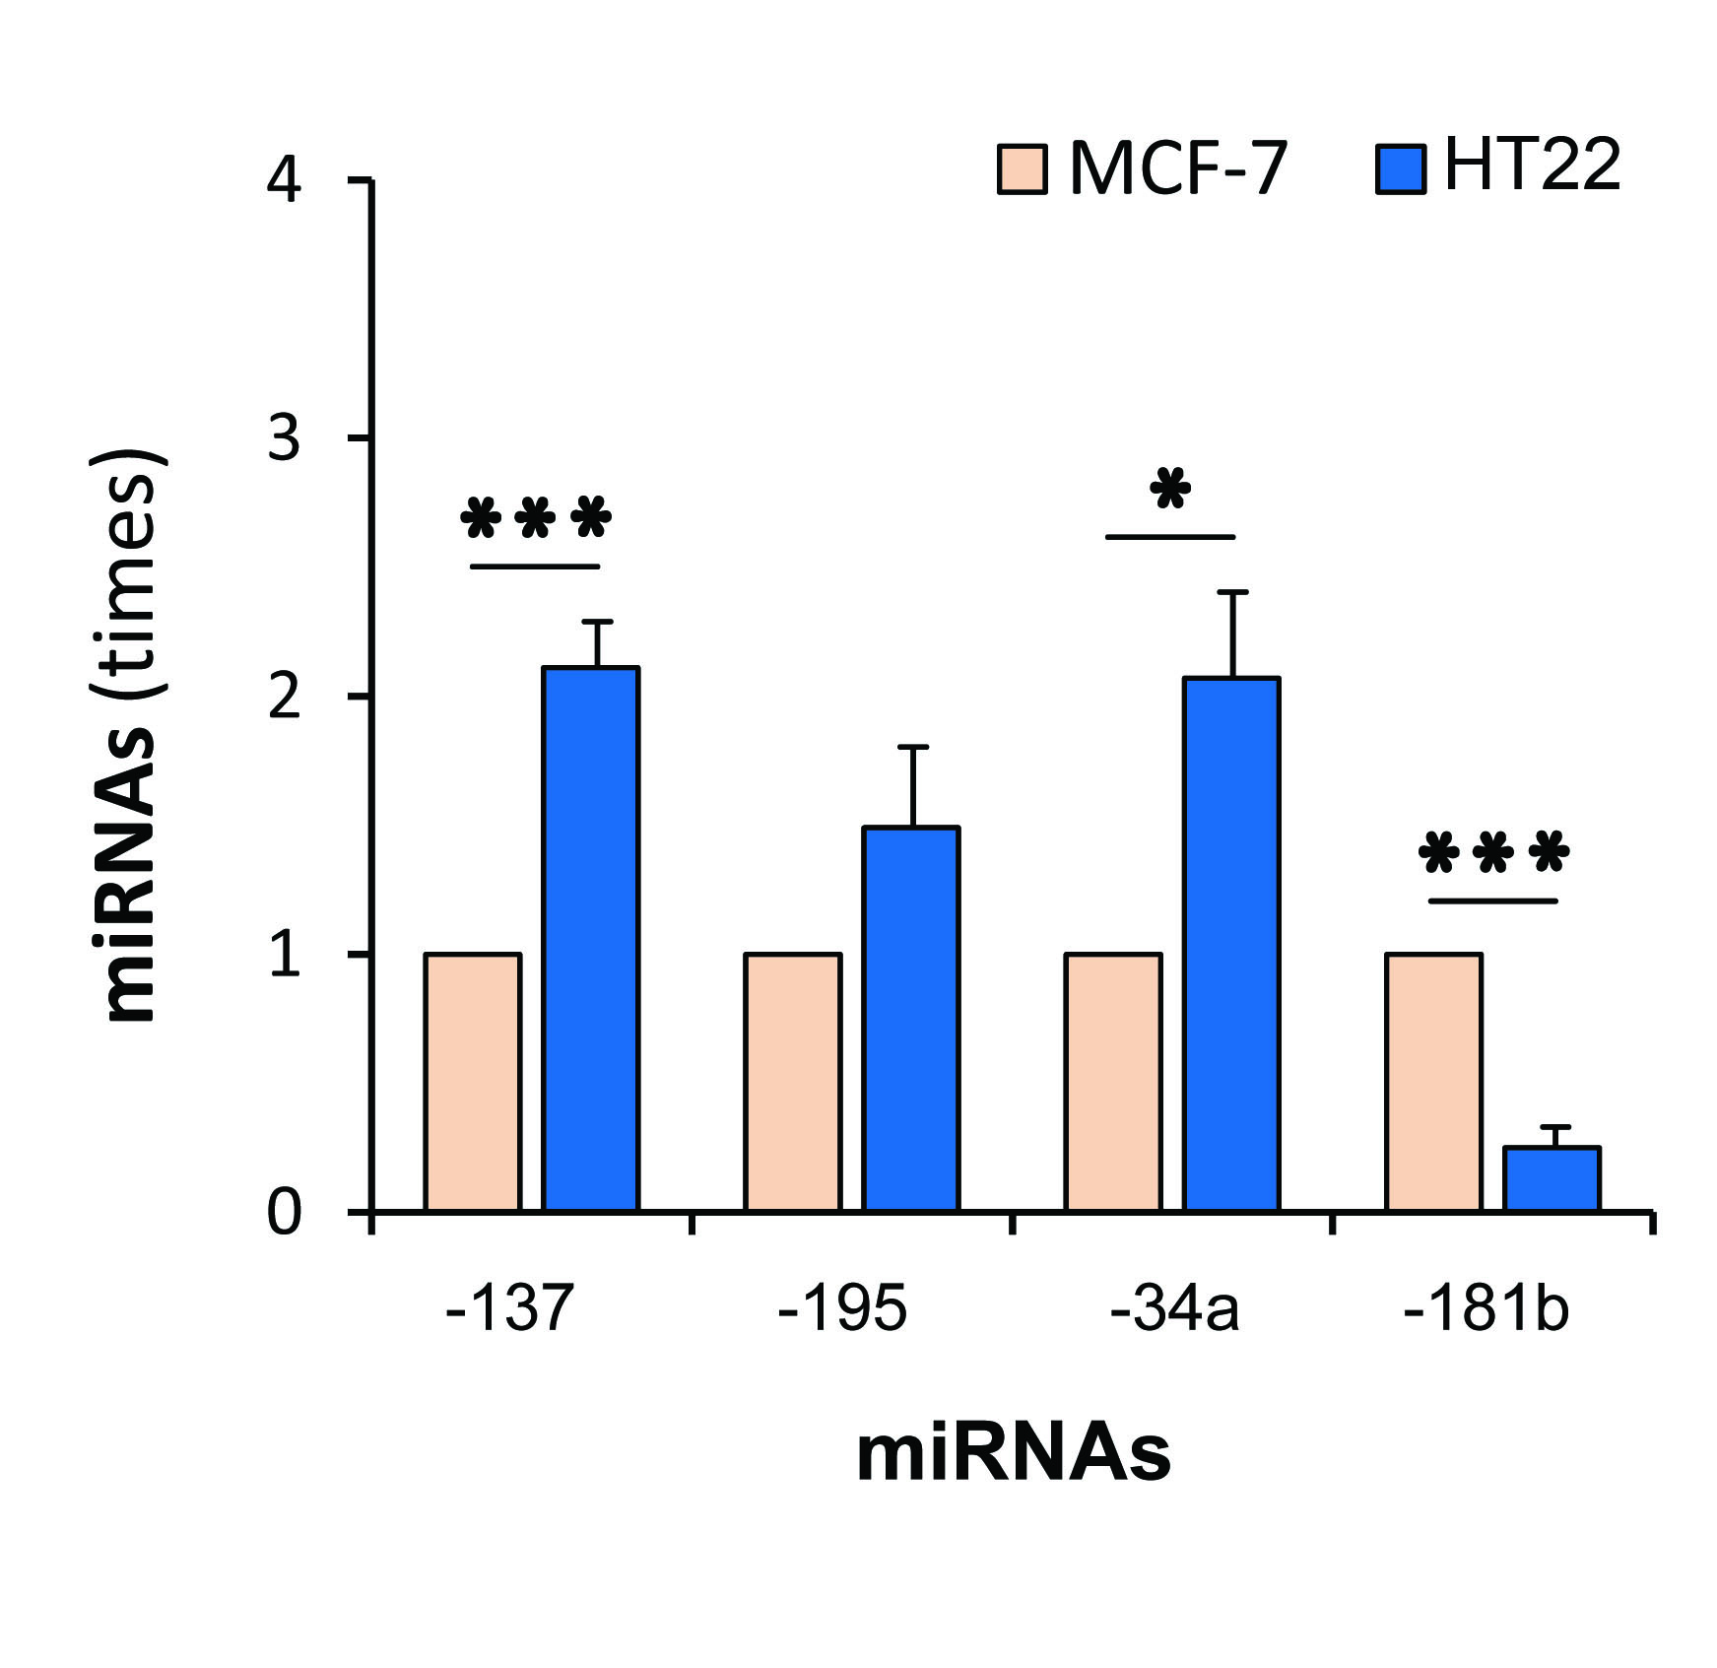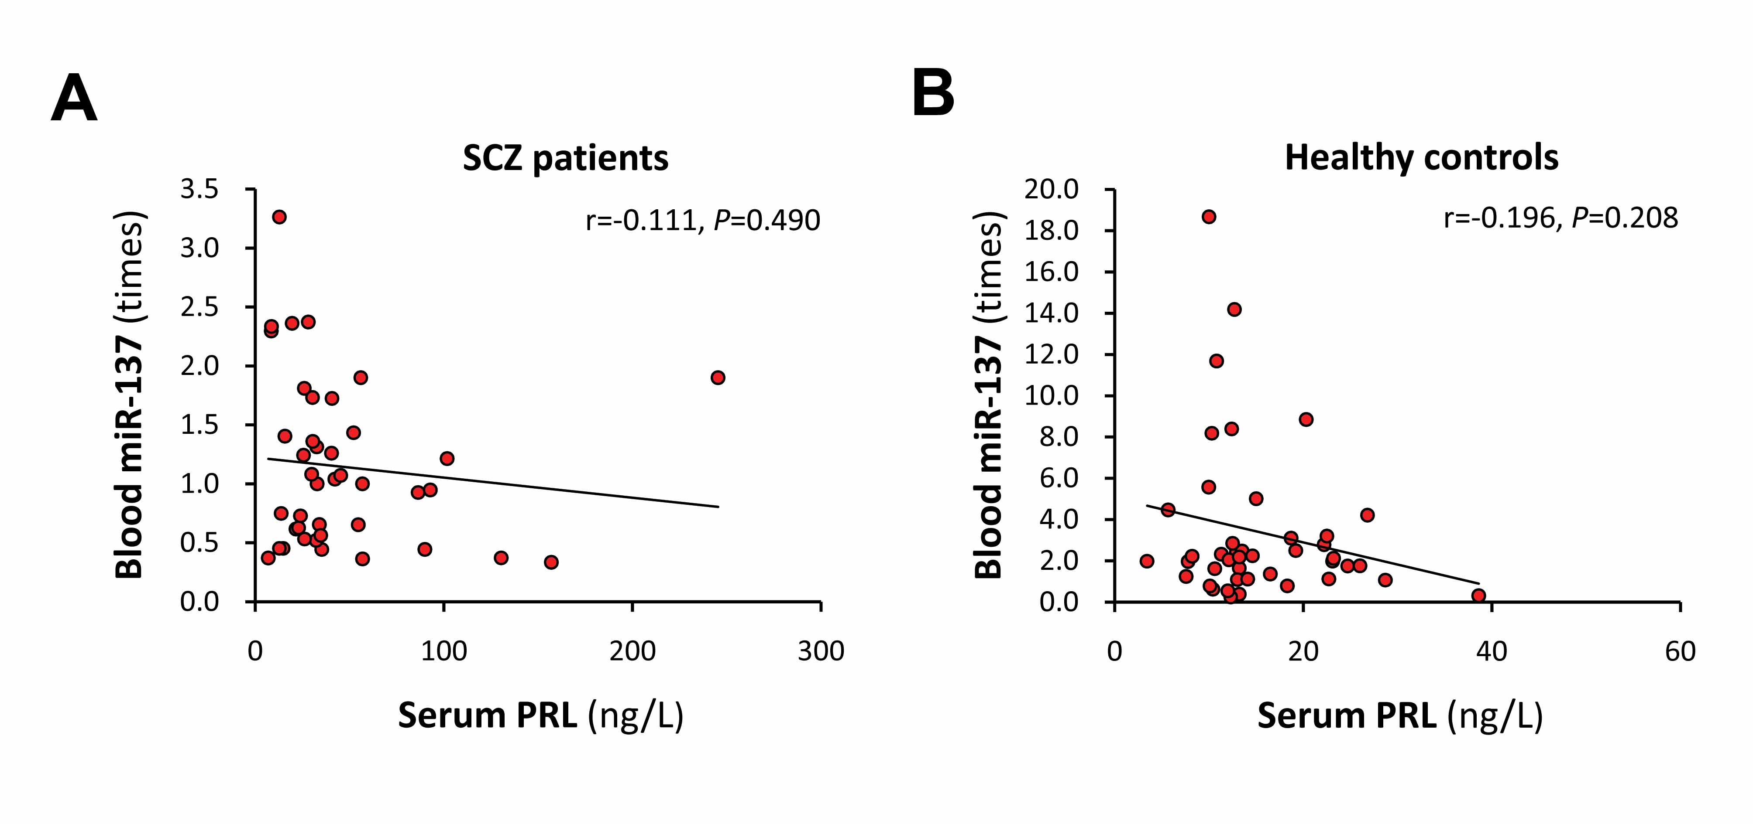

**Supplementary Figure 2.** Correlation of serum PRL with blood miR-137. SCZ, Schizophrenia; PRL, prolactin; miR-137, microRNA-137. Correlation analyses of serum PRL with blood miR-137 in SCZ patients (A) and healthy controls (B).