Supplementary Material
RCM modeling of bubble injections into the inner magnetosphere:
Geosynchronous orbit and the ionospheric responses

Sina Sadeghzadeh, Jian Yang*, Frank Toffoletto, Richard Wolf, Ameneh Mousavi, and Chih-Ping Wang
*Correspondence: Jian Yang: yangj36@sustech.edu.cn

1 Supplementary Data
In Text S1 we provide additional justification for using specific energy invariants ($λ_{e}$ and $λ_{p}$) and whether they are consistent with the radial dependent $T_{p}/T_{e}$. Text S2 provides details about Movie S1, which shows the response of the magnetosphere-ionosphere coupled system to many plasma bubble injections.
Text S1.
The reason for choosing $λ_{e}=300 eV{\left(R_{e}/nT\right)}^{2/3}$ and $λ_{p}=4000 eV{\left(R_{e}/nT\right)}^{2/3}$ is to improve the accuracy of the moment profiles (temperature, density, and pressure) of the electrons and protons. Figure S1 shows the density and temperature of electrons and protons calculated in our simulation (panels C-F) and the statistics given by Runov et al. (2015) (panels G and H). The density (C and E) and temperature (D and F) profiles of plasma at a fixed-point A ($X∼-14R_{e}$, $Y∼-10R_{e}$) in the equatorial plane are obtained at time $T_{1}=00:06:00$ before a bubble reaches point A and at time $T_{2}=00:11:00$ after the bubble reaches point A. In general, the density and temperature profiles retrieved from RCM are consistent with trends in background and intruding populations (i.e., dipolarizing flux bundles), as observed. According to Runov et al. (2015), bubbles show drop of density but increase of temperature inside the bubbles corroborating the existence of type-1 bubbles (see Figure 1 of Wang et al., 2020).
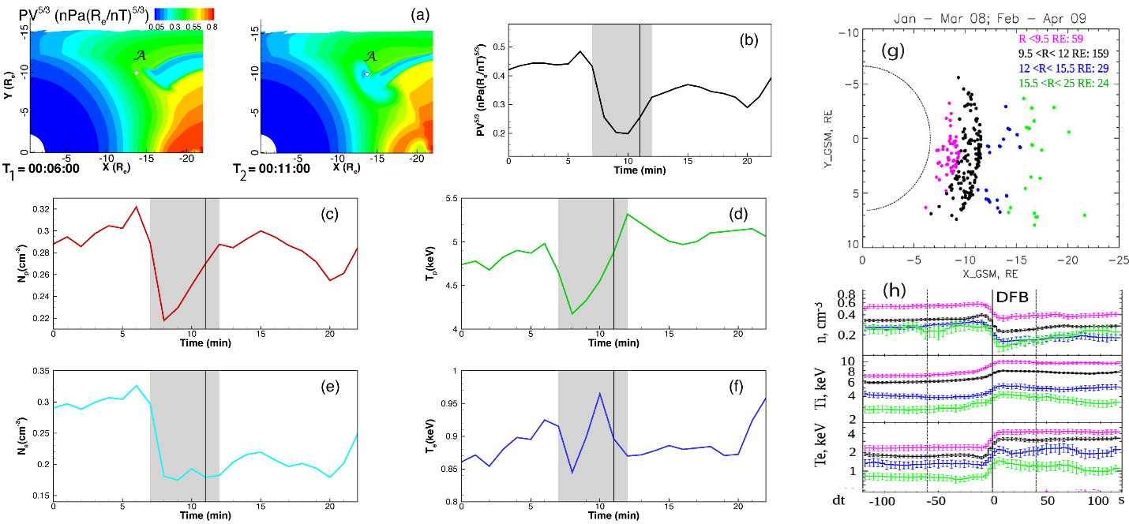
Figure S1. (A) The equatorial distribution of entropy parameter ($PV^{5/3}$) in units of $nPa{\left(R_{e}/nT\right)}^{5/3}$ at $T_{1}=00:06:00$ and $T_{2}=00:11:00$. The time-dependent (B) entropy ($PV^{5/3}$), (C) proton density (in units of ${cm}^{-3}$), (D) proton temperature (in units of $eV$), (E) electron density (in units of $cm^{-3}$), and (F) electron temperature (in units of $eV)$ at ($X∼-14R_{e}, Y∼-10R_{e}$). Panel (G) shows $XY_{GSM}$ distribution of bubble events detected by THEMIS between 2008-2009 (adapted from Figure 1 in Runov et al. 2015). Panel (H) shows superposed mean values of number density, electron and ion temperatures inside and outside of bubbles (adapted from Figure 2 in Runov et al. 2015). Colors correspond to geocentric distances.

Text S2.
Movie S1 shows the response of the coupled magnetosphere-ionosphere to random plasma bubble injections. In this file, panels (A)-(D) show the equatorial view of evolution of $PV^{5/3}$ (in units of $nPa{\left({R_{e}}/{nT}\right)}^{5/3}$), $P$ (in units of $nPa$), $FAC$ (in units of $μA/m^{2}$), and $f_{en}^{⋆}$ (in units of $erg cm^{-2}s^{-1}$). Panels (E) and (F) show the ionospheric distribution of $FAC$ (in units of $μA/m^{2}$), and $f_{en}^{⋆}$ (in units of $erg cm^{-2}s^{-1}$).

