Supplementary Material

This section relies on the Annex 1 and 2 in Schiavo et al. (2021), and on the Supplementary Materials in Mora et al. (2020).

**DETAILED AGRIMONDE TERRA SCENARIOS**

Table S1 presents the qualitative hypotheses of change of drivers to 2050 involved in the Metropolization_Ultrap and the Healthy_AE scenarios. Each component of both scenarios is presented in more details in the following sections.

**Table S1. Hypotheses of change to 2050 of drivers in both Metropolization_Ultrap and Healthy_AE**

|  |  |  |
| --- | --- | --- |
|  | **Metropolization_Ultrap** | **Healthy_AE** |
| Global context | Conventional development lead by market forces | Sustainable and cooperative world |
| Climate change | Runaway climate change | Stabilization of global warming |
| Food Diet | Transition to diet based on ultra-processed products (Ultrap diet) | Healthy diet based on food diversity (Healthy diet) |
| Cropping system | Conventional intensification | Agroecology |
| Livestock system | Conventional intensive livestock | Agroecological livestock |

**Global context**

Regarding the global context, quantitative assumptions concern population change and change in trade conditions. Change in GDP (gross domestic product) per capita is implicitly taken into account through its impact on food diet change (see hereafter). The general rules for building these quantitative assumptions are the following:

- Changes in total world and regional population are the same in both global context pathways. The median projection up to 2050 provided by the United Nations (2015 revision) is used.

- Import coefficients[1] and export shares[2] of world regions are not changed exogenously whatever the global context pathway. They may change endogenously when a region reaches its maximum cultivable area.

**Climate change and mitigation**

Climate change patterns to 2050 are described through two pathways, inspired from the Representation Concentration Pathways (RCP) of the fifth assessment report of the IPCC (Intergovernmental Panel on Climate Change): ‘Runaway climate change’ (close to RCP 8.5) for Metropolization_Ultrap and ‘Stabilisation of global warming’ (close to RCP 2.6) for Healthy_AE.

The general rules for building the corresponding quantitative assumptions are as follows:

- We assume that in the 2007-2009 (named ‘2010’ for simplicity) initial situation, the maximum cultivable area (i.e., the maximum area which can be devoted to arable and permanent crops) in each region equals the area under suitability indices 1 to 4 according to the Global Agroecological Zones (GAEZ) approach. [3]

- We assume that up to 2050, this maximum cultivable area is affected by climate change. To quantify the climate change effects we use Zabel *et al.* (2014)’s results and adopt the following assumptions: i) change according to Zabel *et al.*’s results (RCP 8.5) in the ‘Runaway climate change’ pathway; ii) no change in the ‘Stabilization of global warming’ pathway.

- We assume that climate change is likely to affect the evolution of crop yields induced by changes in cropping systems up to 2050. For quantifying the climate change effects on crop yield evolution, we use Müller and Robertson (2014)’s results and adopt the following hypotheses: i) change according to Müller and Robertson’s results (RCP 8.5) in the ‘Runaway climate change’ pathway; ii) no change in the ‘Stabilization of global warming’ pathway.

- Due to data uncertainties and absence of consensus in the literature, we did not establish quantitative hypotheses on the impact of climate change and mitigation pathways on grass and forage yield change, nor on livestock productivity change.

- Quantitative mitigation hypotheses (Table S2) have been established based on IPCC work (IPCC, 2014). In both the ‘Runaway climate change’ and the ‘Stabilization of global warming’ pathways, we assume that up to 2050, food, feed and energy crops are competing on the maximum cultivable area in each region: regional maximum areas available for food and feed crops equal regional maximum cultivable areas *minus* areas devoted to energy crops.

**Table S2. World production of energy from biomass (EJ) in 2050**

|  |  |  |  |  |
| --- | --- | --- | --- | --- |
|  | Energy crops (2G) | Forest | Residues | Other (algae) |
| Runaway climate change | 30 | 0 | 30 | 0 |
| Stabilization of global warming | 30 | 30 | 30 | 12 |

**Food diets**

Two food diet pathways are considered: ‘Transition to diet based on ultra-processed products’ (Ultrap diet) and ‘Healthy diet based on food diversity’ (Healthy diet). The general rules that we established for building our quantitative hypotheses for both food diet pathways relate to both the change in the daily calories availability per capita and the share of the various groups of food in the diet. They are reported in Table S3.

**Table S3. General rules for the changes in food diets over 2010-2050 under both diet pathways**

|  |  |  |
| --- | --- | --- |
|  | **Ultrap diet** | **Healthy diet** |
| Diet energy (Daily calories available per capita) | - Regions over 3,300 kcal/cap/day in 2010: unchanged up to 2050  - Regions between 3,000 and 3,300 kcal/cap/day in 2010: increase to 3300 in 2050  - Regions under 3,000 kcal/cap/day in 2010: increase to 3,000 kcal/cap/day in 2050 | - Regions over 3,000 kcal/cap/day in 2010: decrease to 3,000 - Regions under 2,750 kcal/cap/day in 2010: increase to 2,750 - Regions between 2,750 and 3,000 kcal/cap/day in 2010: unchanged |
| Diet pattern | - Change according to 1998/2008 trends in Brazil. In all regions except Canada/USA: no change relative to 2010 - 2 diet share minimum thresholds: 13.5% for vegetable oils; 10% for animal products  - Within the meat group: strong substitution from ruminant meat to poultry meat | - Diet share of animal products and pulses: 20% - Diet share of cereals: 50%, coarse grains accounting for 1/4 to 1/3  - Diet share of fruits and vegetables: 15% - Diet share maximum thresholds: 10% for vegetable oils, 2.5% for sugar and sweeteners  - Within the meat group: substitution from ruminant meat to poultry meat |

Under the ‘Ultrap’ pathway, the average world diet becomes richer in daily calories per capita from 2010 to 2050, with more vegetable oils and sugar and sweeteners. On the contrary, the ‘Healthy’ pathway makes the average world diet in 2050 nearly unchanged in terms of daily calories per capita, but with more fruits and vegetables, coarse grains and pulses, and significantly less meat and sugar and sweeteners, relative to 2010. As shown in Figure S1, our assumptions induce very different changes in food diets from 2010 to 2050 across regions. For developed regions, such as Canada/USA, only the ‘Healthy’ pathway leads to significant change in food diets from 2010 to 2050. While both pathways imply moderate changes in food diets for emerging countries such as China. In contrast, our assumptions induce significant changes in food diets, whatever the pathway, in developing countries such as ECS (East, Central and South) Africa.

It is worth noting that for ECS Africa, according to our assumptions:

- Both pathways involve an increase in the daily calories availability per capita. As a sharp increase in population is also expected in ECS Africa, this means that food consumption will increase significantly under both pathways in this region (the same is observed for India).

- Both pathways result in a rise in the share of animal products in diets. Once again, joint with the expected population increase, this rising share of animal products in diets will lead to a huge increase in food consumption of meat, dairy and eggs under both food diet pathways in ECS Africa (even under the healthy diet assumption) (the same is observed in India and West Africa).

**Figure S1. Food diets in 2010 and in 2050 under the Ultrap and Healthy pathways in various world regions**

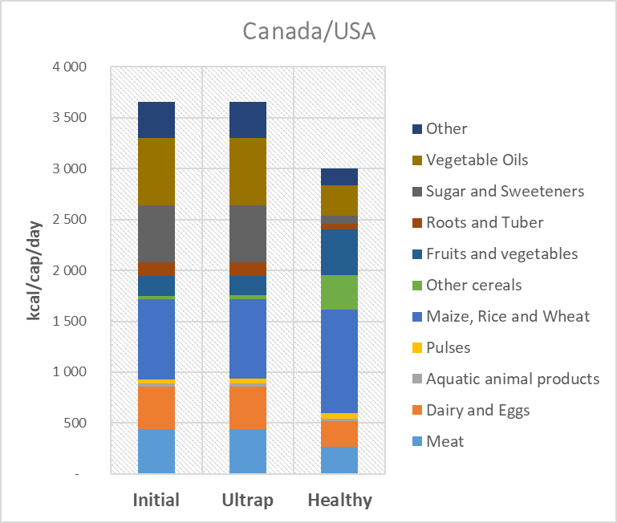

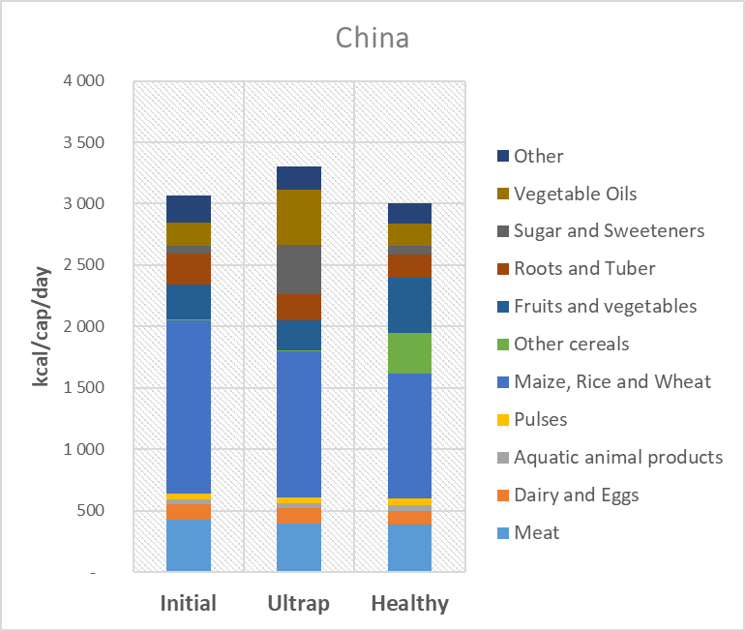

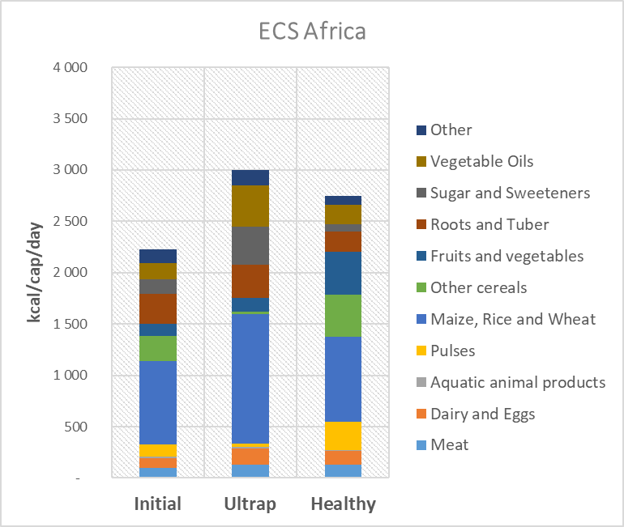

**Cropping systems**

Two pathways for the evolution of cropping systems are considered: ‘Conventional intensification’ and ‘Agroecology’.

We adopted four general rules in order to translate the cropping systems pathways into quantitative hypotheses for regional per-hectare yield changes (Table S4):

* We calculated current yield gaps for Agrimonde-Terra’s crops and regions using potential and observed per-hectare yields provided by the GAEZ database portal.[4] Then, we assumed a level of yield gap reduction between 2010 and 2050, which is differentiated according to cropping pathways, and which we applied uniformly to groups of crops (cereals, protein seeds and other crops) and grass and forages.
* We hypothesized that there is induced technical change together with induced change in the distribution of crops across land fertility classes, which results in greater rate of yield increase for crops which are the most demanded at the world level. If we consider a group of crops, such as cereals, the above-described yield gap reduction applies to the average cereal yield. Then, we assume that within the cereal group, cereal crops which are the most demanded will benefit from above-average yield gap reductions (H in Table S4), while cereal crops which are less demanded will experience below-average yield gap reductions (L in Table S4). The retained indicator for “most demanded/less demanded” crops is the change in the respective crop shares in the average world diet under the two food diet pathways.
* Grass and forage crops benefit from the same yield gap reduction than other crop groups.
* In ‘Agroecology”, developed regions (Canada/USA, Rest of Europe, and Oceania) experience the same magnitude of crop yield reduction as the EU with the TYFA scenario. Following Ponisio et al. (2015) and Guyomard et al. (2013), the reduction of 2010 yields in TYFA is in the order of -25% for cereals, between -20% and -45% for oilseeds and protein crops, -5% to -20% for fruits and vegetables and -10% to -15 % for fodder and grass (Poux and Aubert, 2018).

**Table S4. General rules for the changes in crop yields over 2010-2050 under both cropping systems pathways**

|  |  |  |
| --- | --- | --- |
|  | Average yield gap reduction | Higher (H)/Lower (L) yield gap reduction for specific crops |
| **‘Conventional intensification’**  ***with the Ultrap diet*** | -50% | Grains: H maize/L coarse grains  Oilseeds and pulses: L pulses  Other products: H sugar crops |
| **‘Agroecology’ (developing and emerging regions)**  ***With the Healthy diet*** | -30% | Grains: H coarse grains/L others  Oilseeds and pulses: H pulses/L others  Other products: H fruit and vegetables/ L Others  Grass and forage: 0 |

As far as cropping intensity ratios are concerned, our general rules imply that cropping intensity ratios in 2050 remain equivalent under ‘Conventional intensification’ and ’Agroecology’.

Following the above-described hypotheses, in average crop yield growth from 2010 to 2050 is greater in the ‘Conventional intensification’ than in the ‘Agroecology’ pathway. These hypotheses, which are key factors regarding the land-use change effects of the scenarios, are controversial and were extensively discussed with the Scenario Advisory Committee of Agrimonde-Terra (see Le Mouël *et al.*, 2018).

It is noteworthy that when simulating the whole scenarios, the 2050 yields are those including both the impacts of changes in cropping systems and the impacts of climate change. Five main points may be underlined:

* Following our general rules, per-hectare yields increase between 2010 and 2050 in both ‘Conventional intensification’ and ‘Agroecology’ pathways, for all crops in all regions, except those exhibiting initial zero yield gaps (such as rice in Rest of Asia for instance) and except in developed regions in the ’Agroecology’ pathway. In all other situations, whatever the cropping system pathways, the higher the initial yield gap, the higher the yield increase over 2010-2050.
* Following our general rules, for the main current cereals (maize, rice and wheat) and oilseeds (soybean) and for sugar crops, in all regions, yield increases over 2010-2050 are greater with the ‘Conventional intensification’ than with the ’Agroecology’ pathway.
* The situation is different for other crops such as other cereals, pulses, fruits and vegetables and roots and tubers, which consumption increases more with the ‘Healthy’ diets. For these crops, in emerging and developing regions, due to our induced technical change hypothesis, yield increases between 2010 and 2050 are higher with the ‘Agroecology’ pathways than with the ‘Conventional intensification pathway'”.

**Livestock systems**

Based on trends in animal feed, efficiency of animal systems, crop-livestock synergies, and herd mobility, two hypotheses for the future of livestock systems were produced: ‘Conventional intensive livestock’ and ‘Agroecological livestock’.

In GlobAgri-Agt, regional livestock systems are quantitatively described and modeled based on data from Herrero *et al.* (2013). In each region, we consider five livestock sectors (dairy, beef, small ruminants, pork and poultry), producing six animal products (milk and dairy, beef meat, small ruminant meat, pork meat, poultry meat and eggs). Each ruminant livestock sector is made up of four production systems (Herrero *et al.*’s so-called mixed, pastoral, urban and other systems). Each monogastric sector involves two production systems (Herrero *et al.*’s so-called urban and other systems).

We faced difficulties when quantifying the hypotheses for the future of livestock systems and had to adopt restrictive assumptions. Our difficulties resulted from, at least, two main reasons. First, only two entry variables of the GlobAgri-Agt model were available to quantify the hypotheses for the future while the latter involved livestock pathways, which are differentiated on a set of various dimensions. Secondly, as far as ruminant sectors are concerned, there was not a clear ranking of the different production systems, from the least to the most intensive, emerging from the initial data we used. Hence, it was not easy to choose which production system(s) would expand more than the others in each retained hypothesis for the future (see below).

The two concerned entry variables of the GlobAgri-Agt model are:

* regional feed-to-output ratios (measuring the quantity of dry matter feed per unit of output produced) of each system in each sector;
* regional shares of the different production systems in the total output production of the considered sectors.

We assume that, in each region, the overall productivity of a livestock sector (as measured by its global feed-to-output ratio) may change between 2010 and 2050. This could happen through both the change in the feed-to-output ratios of the various systems in the sector (measuring the mixed effects of changes in the productivity per animal, in animal diseases and mortality and in the efficiency of feed rations) and the change in the relative shares in production of these various systems.

The general rules adopted for quantifying the livestock systems pathway of change are the following. They apply at the regional level:

* each future pathway is associated with one or two specific production systems per sector: the chosen systems are those where changes are occurring, other systems remain constant over 2010-2050. For each livestock systems pathway, production systems concerned by changes are chosen as those best fitting the dynamics involved in the pathway (Table S5).
* For production systems experiencing changes between 2010 and 2050, feed-to-output ratios are assumed to change according to projections to 2030 provided by Bouwman *et al.* (2005). This rule applies to all regions except West Africa and ECS Africa. In both regions, we assume that feed-to-output ratios change two times faster than expected in Bouwman *et al.*’s projections for the beef sector.[5]

**Table S5. General rules for the changes in livestock systems over 2010-2050 under both pathways**

|  |  |  |
| --- | --- | --- |
|  | **Conventional intensive livestock** | **Agroecological livestock** |
| Change in feed-to-output ratios[6] | | |
| **Ruminant**  Mixed  Pastoral  Urban  Other  **Monogastric**  Urban  Other | Decrease (Bouwman *et al.*)  Decrease (Bouwman *et al.*)  No change  No change  Decrease (Bouwman *et al.*)  No change | Decrease (Bouwman *et al.*)  Decrease, (Bouwman *et al.*)  No change  No change  No change  No change |
| Change in production shares | | |
| **Ruminant**  Mixed  Pastoral  Urban  Other  **Monogastric**  Urban  Other | Increase  Decrease  Decrease  Decrease  Increase  Decrease | Increase  No change  Decrease  Decrease  Decrease  Increase |

Following our general rules, applied reductions on feed-to-output ratios:

- do not differ between ‘Conventional intensive livestock’ and ‘Agroecological livestock’ for ruminant sectors. Indeed, in contrast to our quantitative hypotheses regarding cropping systems pathways, we were not able to find evidence of any performance gaps (in terms of feed-to-output ratios) between conventional and agroecological systems. Hence, the only difference in global performance changes in ruminant sectors lies in the diverging evolution of production shares of the various ruminant systems under both pathways: the production shares of mixed systems increase to the detriment of all systems in the ‘Conventional intensive livestock’ pathways, including the pastoral one, while in the ‘Agroecological livestock’ pathway, the production shares of the mixed systems increase to the detriment of urban and other systems only, the shares of pastoral systems remaining constant;

- are greater in ‘Conventional intensive livestock’ than in ‘Agroecological livestock’ for monogastric sectors. Based on expert knowledge, we considered that shifting to agroecological systems would not allow to gain any efficiency in monogastric sectors as far as feed-to-output ratios are concerned;

- are significantly greater in developing regions than in developed regions. For the latter, Bouwman *et al.*’s projections to 2030 suggest that nearly no further improvement in efficiency (as measured by feed-to-output ratios) could be realized in the dairy, pork and poultry sectors.

Finally, following our general rules and due to initial data, our quantitative hypotheses generally lead to:

- improvement of the global efficiency of ruminant sectors for both the ‘Conventional intensive livestock’ and the ‘Agroecological’ pathways;

- ambiguous results regarding the global efficiency of monogastric sectors, mainly due to the initial better performances of “Other” systems in terms of feed-to-output ratios, which contribute to deteriorate the global efficiency of the sectors when the production shares of these “Other” systems are adjusted down.

**THE GLOBAGRI-AGT DATABASE AND MODEL**

**The GlobAgri-Agt model**

The GlobAgri platform was set up by CIRAD and INRA to generate consistent databases and biomass balance models using data from FAOSTAT and different institutions. The databases generated are balanced and account for the links between products (through animal feed or oilseed crushing for instance). Biomass balance models provide a balance equation between resources (domestic production plus imports minus exports) and utilization (food, feed and other) for each region and each agri-food product. In each equation, imports are a linear function of total domestic use and exports are a linear function of the world market size. A world trade balance equation ensures that world imports equal world exports for each agri-food product. The system of balance equations can simulate land-use change in each region induced by changes in the use of agri-food products, provided that hypotheses on a set of variables (such as plant and animal yields, maximum available cultivable land, trade conditions etc.) are made.

The GlobAgri platform has been used to generate a database and a biomass balance model specifically customized for the Agrimonde-Terra foresight (Le Mouël *et al.*, 2018). The resulting tool is named GlobAgri-Agrimonde-Terra (GlobAgri-Agt). It encompasses 38 agri-food products and 14 world regions (Table S6 and Table S7). The reference year is the 2007-2009 average (often named “2010”) and the simulation horizon is 2050. Data used are mainly the FAO’s Commodity Balances (FAOSTAT Statistics Database, 2016). Additional data used are from Herrero *et al*. (2013) for feed rations (including grass and forage), Monfreda *et al*. (2008) for production and area of forage plants, and GAEZ (2012) for maximum cultivable areas.

The GlobAgri-Agt biomass balance model is made up of a resource-utilization balance equation for each agri-food product in each region:

$${Prod}_{ijt}+{Imp}_{ijt}-{Exp}_{ijt}={Food}_{ijt}+{Feed}_{ijt}+{Oth}_{ijt}+{Waste}_{ijt}+{VStock}_{ijt}$$

Where *i* is the product ($i∈I)$, *j* the region, *t* the reference year, *Prod* the domestic production, *Imp* imports, *Exp* exports, *Food* the domestic food consumption, *Feed* the domestic feed use, *Oth* the other domestic uses, *Waste* the waste and *VStock* the stock change.[7]

For all plant (vegetal) products ($v∈I$), domestic production equals harvested area (*A*) multiplied by per-hectare yield (*Y*):

$${Prod}_{vjt}=A_{vjt}*Y_{vjt}$$

For all products, the domestic feed use is a linear function of the domestic production of reference animal products ()[8]:

Where is the fixed transformation coefficient of product *i* into animal product *a* in region *j* for year *t*. $β_{iajt}$ are thus what we call the feed-to-output ratios. For each animal product (e.g. milk), they are a weighted average of the corresponding feed-to-output ratios observed in the various production systems co-existing in the sector concerned (e.g. mixed, pastoral, urban and other systems co-existing in the dairy sector). For the five sectors under consideration (dairy, beef, small ruminants, pork and poultry), the various production systems are those suggested by Herrero *et al*. (2013). The way the feed-to-output ratios are computed at the production system level and at the sector level is described in detail in Dumas (2014).

Finally, for all products *i*, imports are written as a fixed share of total domestic use:

$${Imp}_{ijt}=α_{ijt}*({Food}_{ijt}+{Feed}_{ijt}+{Oth}_{ijt}{+Waste}_{ijt}+{VStock}_{ijt})$$

Where $α_{ijt}$ is the import dependence coefficient of region *j* for product *i* in year *t*. In other words, GlobAgri-Agt assumes that when total domestic use of one product increases in region *j*, a fixed share of the additional need is covered by imports from abroad, while the remaining share is covered by increased domestic production, provided that region *j*’s maximum cultivable area is not binding (see below).

Exports of product *i* by region *j* are written as a fixed share of the world market size of product *i*:

$${Exp}_{ijt}=σ_{ijt}*(\sum_{j}{{Imp}_{ijt}})$$

Where $σ_{ijt}$ is the world export market share of region *j* for product *i* in year *t*.

Import and export specifications in GlobAgri-Agt imply some rigidity in international trade: each region imports a fixed share of its domestic use and regional world export market shares are constant. Such rigidity may result from several factors such as the slow change in regional comparative advantages, and slow change in transport infrastructures and commercial channels. However, such specifications are rather restrictive when dealing with mid- to long-term analysis. We should emphasize, however, that import dependence coefficients ($α_{ijt}$) and/or world export market shares ($σ_{ijt}$) may be changed exogenously as part of simulated scenarios and may change endogenously as part of the scenario simulations in regions where the maximum cultivable land area is binding (see below). In both cases such adjustments of import dependence coefficients and world export market shares may figure changes in regional comparative advantages or transport or trade costs potentially implied by trade, agricultural and/or environmental policies for instance.

Finally, when replacing in the balance equations all variables by their respective expression in the additional equations, provided that *Vstock* is fixed, *Food*, *oth* and *Waste* are the model’s exogenous variables while the area harvested (*A*) is the model’s endogenous variable.

**The model closure**

The model is closed firstly adding a world trade equilibrium equation for each product and secondly adding an agricultural land constraint equation in each region.

For each product *i*, the world trade equilibrium equation is written:

$$\sum_{j}{{Imp}_{ijt}}=\sum_{j}{{Exp}_{ijt}}$$

While for each region *j*, the agricultural land constraint equation is:

$$\sum_{v}{{Surf}_{vjt}}≤\overline{{Surf}_{jt}}$$

This agricultural land constraint may be defined for various sets of products *v* so that the *Surf* and $\overline{Surf}$ may have different meanings: the land constraint may be defined for the cropland area, for the pastureland area or for the total agricultural land area for instance, or for all other sets of products. In GlobAgri-Agt, because of the lack of data regarding the maximum pastureland area in each region, we defined the agricultural land constraint on the cropland area. Hence ${Surf}_{vjt}$ is the cultivated area devoted to crop product *v* in region *j* during year *t* and $\overline{{Surf}_{jt}}$ is the maximum cultivable area in region *j* in year *t*. Let us emphasize at this stage that defining the land constraint on the cropland area has important implications since it means that pastureland may adjust freely to all the shocks introduced into the model. This limit does not result from the GlobAgri-Agt model since the latter can very easily deal with other levels of agricultural land constraints. It results from the lack of data on potential maximum areas, which could be shifted to permanent pasture in each region.

Finally, as in the balance equations the domestic production of each crop *v* in each region *j* is linked to the harvested area and the per-hectare yield of corresponding products and regions, we need an additional equation linking the harvested area to the cultivated area for each crop in each region:

$\sum_{v}{{Surf}_{vjt}}=e_{jt}*(\sum_{v}{A_{vjt})}$

Where $e_{jt}$ measures the ratio of total cultivated area over total harvested area in region *j* for year *t*. This ratio is lower than one when the cultivated area is lower than the harvested area, indicating the extent of multi-cropping (or the level of cropping intensity) in the concerned region. In contrast, the cropping intensity coefficient is greater than one when the cultivated area is greater than the harvested area, indicating the extent of fallow land or of harvest abandonment due to difficult climatic, economic or geopolitical conditions.

**The model solving**

In the initial ‘2010’ situation, domestic resources utilizations and world trade are balanced for all products and the observed cropland area is lower or nearly equal to the maximum cultivable area in all regions.

Let us assume that food consumption of product *i* increases in region *j*. According to our model specification, this increase is covered partly by rising imports and partly by expanding domestic production. This results in an expansion of cropland and, possibly, pastureland areas in region *j*. At this stage, two situations may arise:

* Region *j*’s cropland area is still lower than region *j*’s maximum cultivable area, then the resolution of the model stops.
* Region *j*’s cropland area becomes greater than region *j*’s maximum cultivable area, then two stages are considered:

1. Region *j*’s exports are first evenly reduced (through equi-proportional decrease in its world export market shares $σ_{ijt}$) until the domestic cropland area falls below the maximum cultivable area. At this stage, the resolution of the model stops.
2. If, even with zero exports, region *j* still needs more cropland area than its maximum cultivable area, then region *j* starts increasing its imports (through increases in import dependence coefficients $α_{ijt}$). In other words, region *j* increases the share of its food needs which is covered by imports in order to reduce the required rise in domestic production and save some cropland area. As initial regional import dependence coefficients vary widely across products, we defined intervals of initial levels upon which the $α_{ijt}$ coefficients are increased evenly, making it possible to differentiate the level of increase by band.

Therefore, in the last case, the world export market shares and import dependence coefficients of regions constrained by their maximum cultivable land area become endogenous.

**Table S6. Agri-food aggregates in GlobAgri-Agt**

|  |  |  |  |
| --- | --- | --- | --- |
| Aquatic animals  Bovine meat  Dairy  Eggs  Pork meat  Poultry meat  Small ruminant meat | Fibres etc.  Fruit and vegetables  Pulses  Roots and tubers  Maize  Other cereals  Rice  Wheat  Sugar plants and products  Other products | Other oilcrops  Cake other oilcrops  Oil other oilcrops  Oilpalm fruit  Palm product oil  Palm kernel cake  Rape and mustard seeds  Rape and mustard cake  Rape and mustard oil  Soybeans  Soybean cake  Soybean oil  Sunflower seeds  Sunflower seed cake  Sunflower seed oil | Grass (grass from direct grazing and as silage of permanent pastures)  Grass-like forages (mixed grass and ryegrass from temporary pastures)  Other forages (alfalfa and fodder crops: beats, vegetables, sorghum, maize etc.)  Occasional feeds (food leftovers, cut-and-carry forages and legumes, roadside grasses)  Stover (crop residues) |

**Table S7. Broad geographic regions in GlobAgri-Agt**

|  |  |  |  |
| --- | --- | --- | --- |
| Brazil/Argentina  Rest of America  Rest of Europe | Canada/USA  EU-27  Oceania  Former Soviet Union | China  India  Rest of Asia  Near and Middle East | North Africa  West Africa  East, Central and Southern (ECS) Africa |

The results presented in the main text closely depend on the modelling approach and adopted quantitative hypotheses in simulated scenarios. Both the model and hypotheses have several limits. These limits, which relate to the general limits of the model and those of the general rules adopted to translate the scenarios into quantitative inputs to the model, are presented and discussed in Le Mouël *et al*. (2018).

**References**

1. Bouwman, A. F., et al. "Exploring changes in world ruminant production systems." *Agricultural systems* 84.2 (2005). <http://dx.doi.org/10.1016/j.agsy.2004.05.006>
2. FAOSTAT Statistics Database. Food and Agriculture Organization of the United Nations; (2016). <http://www.fao.org/faostat/en/#data>
3. GAEZ, Global Agroecological Zones database (v 3.0). IIASA/FAO 2012; IIASA, Laxenburg, Austria and FAO, Rome, Italy. <http://www.gaez.iiasa.ac.at/>
4. Guyomard, Hervé. Vers des agricultures à hautes performances. Volume 1. Analyse des performances de l’agriculture biologique, INRA, (2013), 368 p. <https://hal.archives-ouvertes.fr/hal-01209961/document>
5. Herrero, Mario, et al. "Biomass use, production, feed efficiencies, and greenhouse gas emissions from global livestock systems." *Proceedings of the National Academy of Sciences* 110.52 (2013): 20888-20893. <http://dx.doi.org/10.1073/pnas.1308149110>
6. IPCC Climate Change. "Mitigation of climate change." Contribution of working group III to the fifth assessment report of the intergovernmental panel on climate change 1454 (2014).
7. Le Mouël, Chantal, De Lattre-Gasquet, and Olivier Mora. Land use and food security in 2050: a narrow road. éditions Quae, 2018. <http://dx.doi.org/10.35690/978-2-7592-2880-5>
8. Monfreda, Chad, Navin Ramankutty, and Jonathan A. Foley. "Farming the planet: 2. Geographic distribution of crop areas, yields, physiological types, and net primary production in the year 2000." *Global biogeochemical cycles* 22.1 (2008). <http://dx.doi.org/10.1029/2007GB002947>
9. Mora, Olivier, et al. "Exploring the future of land use and food security: A new set of global scenarios." PloS one 15.7 (2020). <http://dx.doi.org/10.1371/journal.pone.0235597>
10. Müller, Christoph, and Richard D. Robertson. "Projecting future crop productivity for global economic modeling." *Agricultural Economics* 45.1 (2014). <http://dx.doi.org/10.1111/agec.12088>
11. Ponisio, Lauren C, et al., « Diversification Practices Reduce Organic to Conventional Yield Gap ». Proceedings of the Royal Society B: Biological Sciences 282, no 1799 (2015). <http://dx.doi.org/10.1098/rspb.2014.1396>
12. Poux, Xavier, and Pierre-Marie Aubert. "An agroecological Europe in 2050: multifunctional agriculture for healthy eating." Findings from the Ten Years For Agroecology (TYFA) modelling exercise, Iddri-AScA, Study 9 (2018), 18. <https://www.iddri.org/en/publications-and-events/study/agroecological-europe-2050-multifunctional-agriculture-healthy-eating>
13. Schiavo, Michele et al. An agroecological Europe by 2050: What impact on land use, trade and global food security?, Working paper IDDRI-INRAE, (2021). <https://www.iddri.org/en/publications-and-events/study/agroecological-europe-2050-what-impact-land-use-trade-and-global-food>
14. Zabel, Florian, Birgitta Putzenlechner, and Wolfram Mauser. "Global agricultural land resources–a high resolution suitability evaluation and its perspectives until 2100 under climate change conditions." PloS one 9.9 (2014). <http://dx.doi.org/10.1371/journal.pone.0107522>
15. Dumas, P. "GlobAgri: Disaggregation and reaggregation of livestock data." *Note rédigée pour Agrimonde-Terra* (2014).

1. Ratio between imports and total use of a commodity.
2. Ratio between the exports of a commodity of one region and the sum of total world exports of this commodity.
3. In the GAEZ approach, land is classified according to its quality or suitability for agricultural production. There are eight classes ranging from ‘very suitable’ to ‘not suitable’. GAEZ suitability indices 1 to 4 correspond to ‘very suitable’ to ‘moderately suitable’ land. For more details, see Le Mouël *et al.* (2018).
4. We used the data for year 2000, the potential yields obtained with so-called “high inputs” cropping systems (potential yields are also available for “intermediate inputs” and “low inputs” cropping systems) and, for both actual and potential yields, a weighted average of rainfed and irrigated yields (the weights being the relative shares of rainfed and irrigated land areas).
5. As shown in Le Mouël *et al.* (2018), initial feed-to-output ratios of the mixed system in the beef sector in West Africa and ECS Africa are very high compared to those exhibited by the other regions. There are consistent explanations for such a situation related to the specific role of livestock in both regions: livestock provide nutrient-rich food but also draught power, organic manure and domestic fuel; livestock also serve as a source of income, as a means for capital accumulation and insurance against income shocks, etc. Despite huge uncertainties, we assumed however, notably on the basis of literature and experiences, that there exist rooms of manoeuvre for improving livestock feed-to-output ratios in West and ECS Africa, and that Bouwman *et al.*’s projections are rather pessimistic to this regard.
6. For feed-to-output ratios: decrease means that 1 ton of animal product requires less quantity of dry-matter feed, implying higher productivity of the production system.
7. For Grass, Occasional feeds and Stover, there is no international trade and no stock change. The only utilization is feed. The *Feed* variable (linked to livestock production) determines alone, through the balance, the domestic production (*Prod*).
8. In the case of co-products, such as ‘milk’ and ‘bovine meat’ or ‘oil’ and ‘cake’, one co-product is chosen as a reference product while the other becomes a by-product