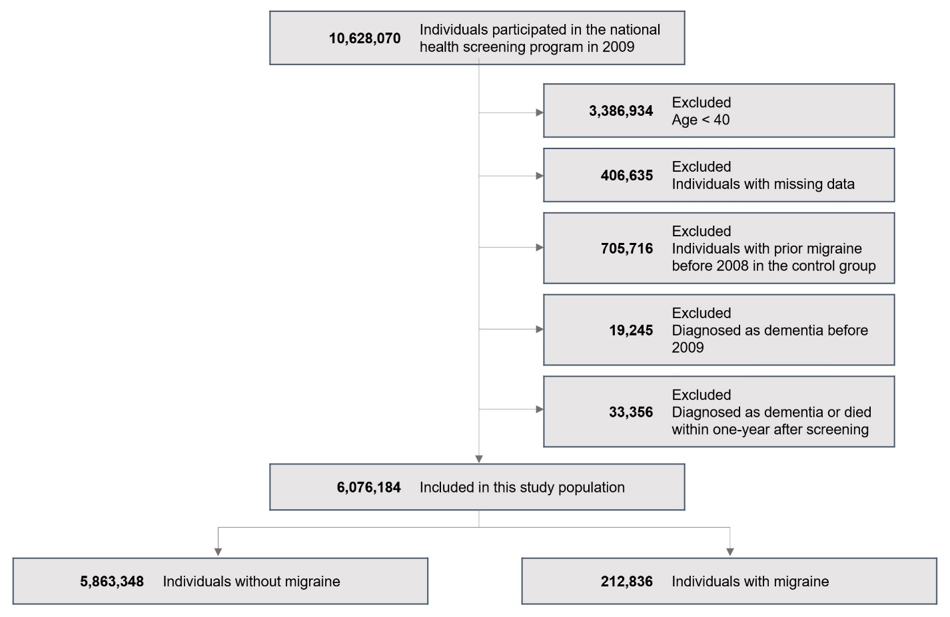

**Supplement Figure 1.** Flowchart of the study