Supplementary Material

Microplastics in feed cause sublethal changes in the intestinal microbiota and a non-specific immune response of the freshwater crayfish Procambarus clarkii (Decapoda: Cambaridae)
Rossy Guillén-Watson, Maria Arias-Andres*, Keilor Rojas-Jimenez, Ingo S. Wehrtmann
* Correspondence: Corresponding Author: maria.arias.andres@una.cr

Supplementary Figures and Tables

Supplementary Figures

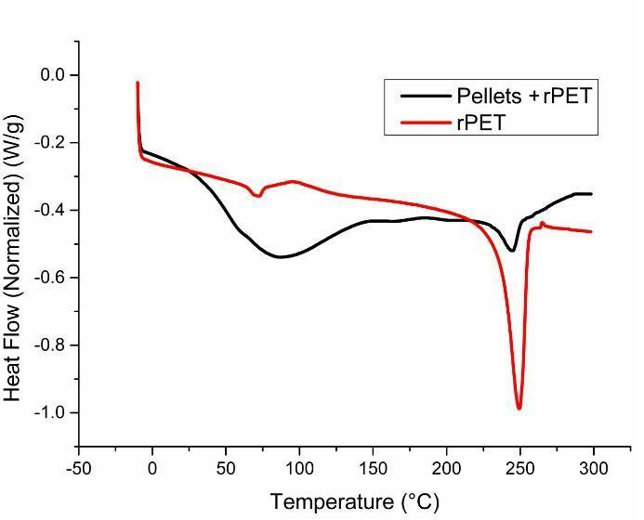
Supplementary Figure 1. Differential Scanning Calorimetry (DSC) signals from food pellets with 30% rPET MPs (black line), and only rPET-MPs (red line).

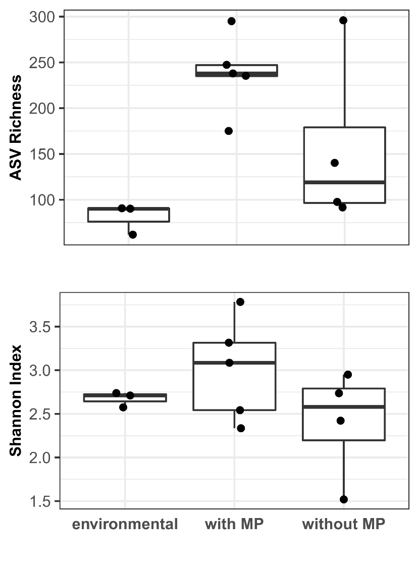
Supplementary Figure 2. Alpha- and Beta-diversity of intestinal microbial communities of Procambarus clarkii among environmental samples from the Cachí reservoir, Costa Rica, and the exposure groups with and without MPs. (A) ASV (amplicon sequence variant) for species richness, these different are statistically significant according to the Kruskal-Wallis test (p = 0.028); (B) Shannon index for species diversity with an average of 3.01, compared to 2.4 and 2.7 of the samples without microplastics and from the Cachí reservoir, respectively.

Supplementary Figure 3. Results of PCR-DGGE from the red swamp crayfish Procambarus clarkii guts. A= Control from the Cachí reservoir, Costa Rica; S= Soil, AG= Water, C= fed pellets without microplastic and T= fed pellets with microplastic. A total of 25 different bands were counted in all samples analyzed.

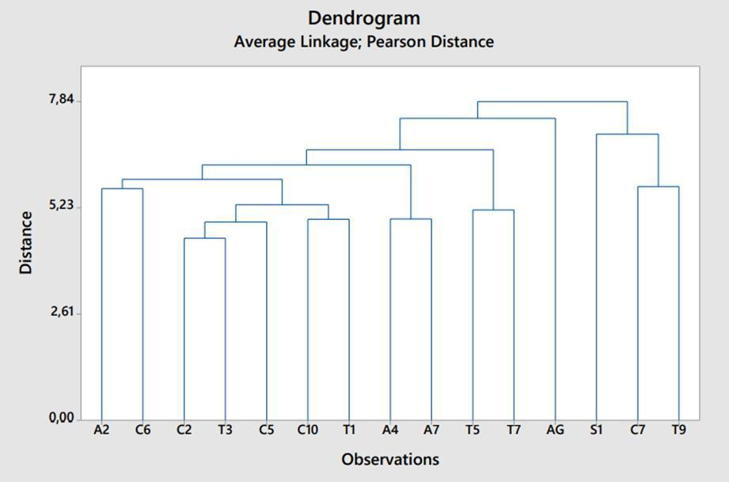
Supplementary Figure 4. 16S rRNA dendrogram of the intestinal tracts of the red swamp crayfish Procambarus clarkii and water and soil samples from the collection site. * A= Control Cachí reservoir, Costa Rica; S= Soil, AG= Water, C= fed pellets without microplastic and T= fed pellets with microplastic. Data generated from Pearson's correlation coefficient, performed with Minitab® 19.1.1 statistical software (Minitab, LLC, United States).

Supplementary Tables

Supplementary Table 1. Measurements of adult Procambarus clarkii reared under laboratory conditions.
Description | Minimum | Maximum | Standard  Average deviation
Total length (cm)
measured from tip of the rostrum to posterior median edge of the telson
Initial treatment with pellets without MPs | 5.61 | 7.45 | 6.28 | 0.62
Final treatment with pellets without MPs | 5.81 | 7.56 | 6.39 | 0.61
Initial treatment with pellets with MPs | 5.31 | 7.30 | 6.09 | 0.60
Final treatment with pellets with MPs | 5.86 | 7.14 | 6.58 | 0.46
Weight (g)
Initial treatment with pellets without MPs | 18.87 | 39.16 | 28.59 | 6.69
Final treatment with pellets without MPs | 22.82 | 39.33 | 30.27 | 6.10
Initial treatment with pellets with MPs | 25.21 | 34.84 | 29.62 | 3.09
Final treatment with pellets with MPs | 19.07 | 39.33 | 29.99 | 5.39
Supplementary Table 2. Measured water parameters of adult Procambarus clarkii reared under experimental conditions for 96 hrs.
Description | pH |  | Temperature (°C) |  | DO (mg/L) |  | Conductivity (µS/cm)
Treatment with pellets without MPs | Initial | Final | Initial | Final | Initial | Final | Initial | Final
Minimum | 7.17 | 6.30 | 20.70 | 20.90 | 7.96 | 6.51 | 253 | 275
Maximum | 7.17 | 7.15 | 20.70 | 21.40 | 7.96 | 7.87 | 253 | 282
Average | 7.17 | 6.58 | 20.70 | 21.18 | 7.96 | 7.43 | 253 | 279.50
Standard deviation | 0.0 | 0.39 | 0.00 | 0.22 | 0.00 | 0.63 | 0.00 | 3.11
Treatment with pellets with MPs | Initial | Final | Initial | Final | Initial | Final | Initial | Final
Minimum | 7.17 | 6.28 | 20.70 | 21.20 | 7.96 | 7.38 | 253 | 270
Maximum | 7.17 | 6.45 | 20.70 | 21.80 | 7.96 | 7.86 | 253 | 280
Average | 7.17 | 6.35 | 20.70 | 21.52 | 7.96 | 7.59 | 253 | 275.60
Standard deviation | 0.00 | 0.06 | 0.00 | 0.26 | 0.00 | 0.18 | 0.00 | 4.16
Supplementary Table 3. Microplastics (MPs) identified in samples of intestinal tracts of Procambarus clarkii maintained in the laboratory and fed with pellets containing MPs.
Sample | MP Types |  | Color
 | No. Fibers | No. fragments
T1 | 1 | 6 | Transparent
T3 | 2 | 1 | Transparent
T7 | 2 | 0 | Black

Supplementary Table 4. Profile matrix of 16S RNA banding of 13 intestinal tract samples of Procambarus clarkii for banding pattern analysis, based on the presence and absence of bands.
 | Samples
Band | A2 | A4 | A7 | S1 | AG | C2 | C5 | C6 | C7 | C10 | T1 | T3 | T5 | T7 | T9
1 | 0 | 1 | 1 | 0 | 0 | 0 | 0 | 0 | 1 | 0 | 0 | 0 | 0 | 0 | 1
2 | 0 | 1 | 1 | 0 | 0 | 0 | 0 | 0 | 1 | 1 | 0 | 0 | 1 | 1 | 1
3 | 1 | 0 | 0 | 0 | 0 | 1 | 0 | 1 | 0 | 1 | 1 | 0 | 0 | 1 | 0
4 | 0 | 1 | 0 | 0 | 1 | 1 | 0 | 0 | 0 | 1 | 0 | 1 | 0 | 0 | 0
5 | 1 | 1 | 1 | 0 | 1 | 1 | 1 | 1 | 0 | 1 | 1 | 1 | 1 | 1 | 0
6 | 0 | 1 | 1 | 0 | 1 | 1 | 1 | 1 | 1 | 1 | 1 | 1 | 1 | 0 | 0
7 | 1 | 1 | 1 | 0 | 1 | 0 | 0 | 0 | 0 | 0 | 0 | 0 | 1 | 1 | 0
8 | 0 | 0 | 1 | 0 | 0 | 0 | 1 | 0 | 1 | 0 | 0 | 0 | 0 | 0 | 0
9 | 1 | 1 | 1 | 0 | 1 | 1 | 1 | 1 | 0 | 0 | 1 | 1 | 1 | 0 | 0
10 | 0 | 0 | 0 | 0 | 1 | 0 | 0 | 1 | 0 | 0 | 1 | 1 | 1 | 0 | 0
11 | 1 | 1 | 1 | 1 | 0 | 1 | 1 | 1 | 0 | 1 | 1 | 1 | 1 | 1 | 0
12 | 1 | 1 | 1 | 0 | 1 | 1 | 0 | 0 | 0 | 0 | 0 | 1 | 1 | 1 | 0
13 | 1 | 0 | 0 | 0 | 0 | 0 | 1 | 0 | 0 | 1 | 1 | 1 | 0 | 1 | 0
14 | 1 | 1 | 1 | 1 | 1 | 1 | 1 | 1 | 1 | 1 | 0 | 1 | 1 | 1 | 0
15 | 1 | 1 | 1 | 1 | 1 | 1 | 1 | 1 | 1 | 1 | 1 | 1 | 1 | 1 | 1
16 | 1 | 1 | 0 | 0 | 1 | 1 | 1 | 1 | 0 | 1 | 1 | 1 | 1 | 1 | 0
17 | 1 | 1 | 0 | 1 | 1 | 0 | 0 | 0 | 0 | 1 | 1 | 1 | 1 | 1 | 0
18 | 0 | 0 | 0 | 1 | 1 | 0 | 0 | 0 | 0 | 0 | 0 | 0 | 1 | 1 | 0
19 | 0 | 0 | 0 | 1 | 1 | 0 | 0 | 0 | 0 | 0 | 0 | 0 | 1 | 1 | 0
20 | 0 | 0 | 0 | 1 | 0 | 0 | 0 | 0 | 0 | 0 | 0 | 0 | 1 | 1 | 1
21 | 0 | 0 | 0 | 1 | 1 | 0 | 0 | 0 | 0 | 1 | 1 | 0 | 1 | 1 | 1
22 | 0 | 0 | 0 | 1 | 0 | 0 | 1 | 0 | 0 | 1 | 1 | 1 | 0 | 0 | 0
23 | 0 | 0 | 0 | 0 | 1 | 0 | 0 | 1 | 0 | 0 | 0 | 0 | 0 | 0 | 0
24 | 0 | 0 | 0 | 1 | 1 | 0 | 0 | 0 | 1 | 0 | 0 | 0 | 0 | 0 | 0
25 | 1 | 1 | 0 | 0 | 0 | 0 | 0 | 1 | 0 | 0 | 0 | 0 | 0 | 0 | 0
* 1 means presence of the band and 0 absence of the band. Red numbers show a possible change in bacterial community structure when one or more of the bands are absent in one sample but present in another type of sample.

Supplementary Table 5. Measured protein and phenoloxidase activities in the hemolymph of Procambarus clarkii individuals reared under experimental conditions for 96 hrs.
Treatment | Replicate | Sample | Protein mg/mL | U/mL | U/mg of protein
Control | 1 | C1 | 62,2438103 | 137,73406 | 2,21281536
Control | 2 | C2 | 125,313364 | 193,044412 | 1,54049341
Control | 3 | C4 | 38,3835931 | 104,032937 | 2,71034909
Control | 4 | C5 | 71,4133441 | 187,917827 | 2,63141055
Control | 5 | C6 | 70,2961614 | 181,140866 | 2,57682443
Control | 6 | C7 | 62,6863658 | 37,7292133 | 0,60187272
Control | 7 | C8 | 75,4611077 | 137,183868 | 1,81794135
Control | 8 | C9 | 52,2107536 | 15,0196434 | 0,28767337
Control | 9 | C10 | 101,291237 | 0 | 0
MP | 1 | T1 | 69,5729609 | 0 | 0
MP | 2 | T2 | 80,5397018 | 24,9123779 | 0,30931798
MP | 3 | T3 | 72,1041625 | 20,515427 | 0,28452486
MP | 4 | T5 | 51,9624907 | 34,983611 | 0,67324739
MP | 5 | T6 | 30,7899885 | 0 | 0
MP | 6 | T7 | 57,1922013 | 38,4644407 | 0,67254695
MP | 7 | T9 | 62,2977805 | 16,3030754 | 0,26169593
MP | 8 | T10 | 47,4182014 | 0 | 0

