Supplementary Material

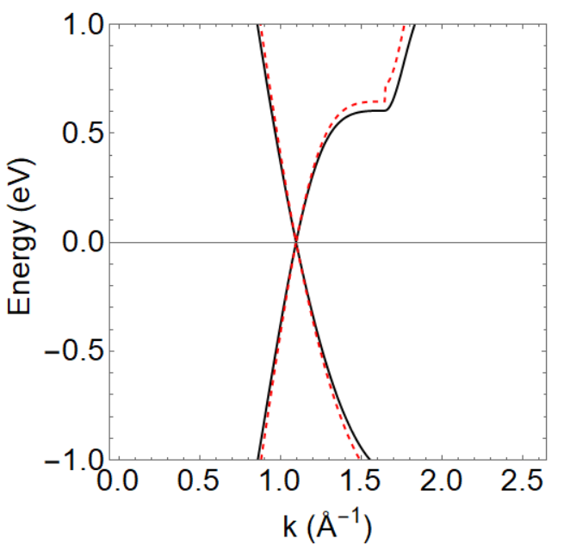
Figure S1. Band structure of optimized silicene at the K-point and around the Fermi level, featuring the $π$ and $π^{*}$ energy bands, and considering LDA (black) and GGA (red) calculations.

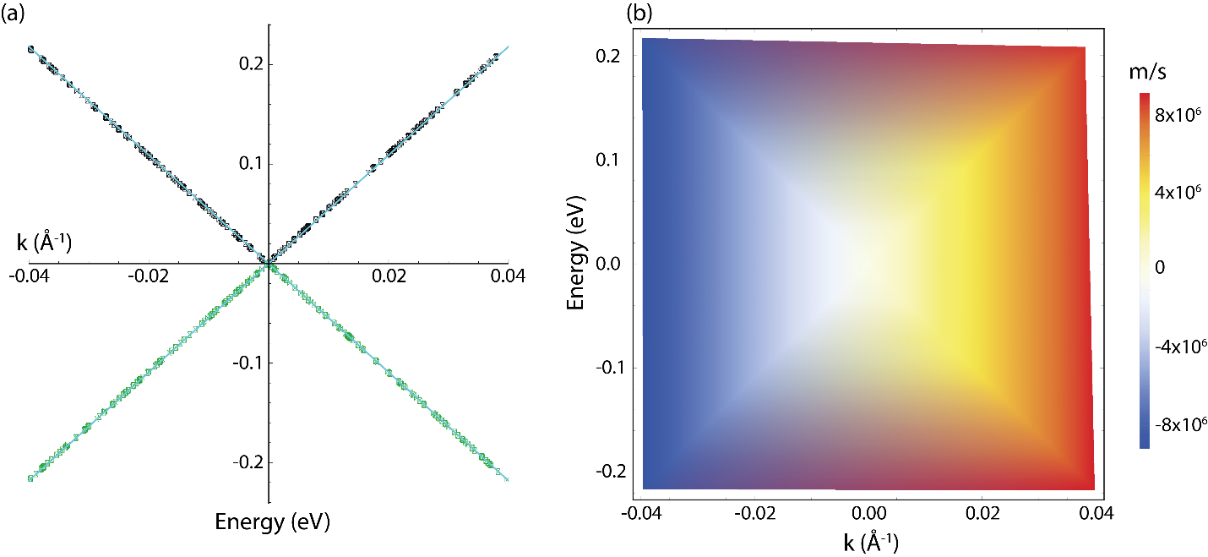
Figure S2. (a) DFT Band structure of graphene at the K-point and around the Fermi level, featuring the $π$ and $π^{*}$ energy bands in green and black respectively. The cyan line indicates a linear fit. (b) A color plot depicting the charge-carrier velocity (10⁶ m/s) of graphene in the vicinity of the K-point. The plot shows how the velocity changes with energy and wavevector. The negative value of charge-carrier velocity refers to the velocity in the valence band.

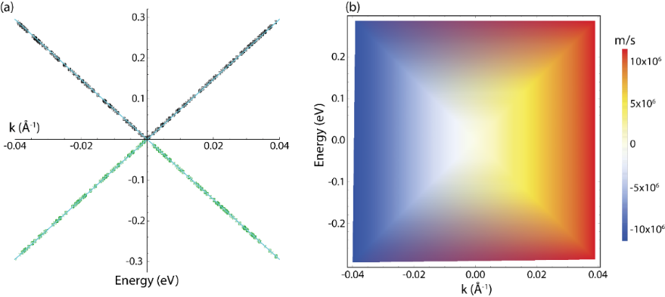
Figure S3. (a) GW Band structure of graphene at the K-point and around the Fermi level, featuring the $π$ and $π^{*}$ energy bands in green and black respectively. The cyan line indicates a linear fit. (b) A color plot depicting the charge-carrier velocity (10⁶ m/s) of graphene in the vicinity of the K-point. The plot shows how the velocity changes with energy and wavevector. The negative value of charge-carrier velocity refers to the velocity in the valence band.

