Supplementary Materials
- Results
  - Responders versus non-responders
BOLD signal change in the right amygdala (MNI; x=18 y=-6 z=-20) significantly differed between responders and non-responders. Specifically, non-responders had significantly greater right amygdala activation compared to responders in the fearful versus happy facial expression contrast, t(14)=-2.32, p=.04 (see Supplementary Table 2). When controlling for age (which significantly differed between groups), the difference between responders versus non-responders in right amygdala (MNI; x=18 y=-6 z=-20) remained significant, p=.048. Responder vs. non-responder groups did not differ on any other brain response variable (ps>.07).
Supplementary Table 1
Participant Characteristics of Completers and Dropouts
 | Completers (n=16) |  |  | Dropouts (n=7)
 | Mean | SD | Mean |  | SD | t | p
Age | 43.62 | 12.57 | 39.29 |  | 6.82 | 0.85 | .40
Education (years) | 16.25 | 2.59 | 13.79 |  | 1.68 | 2.95 | .03*
Time since trauma (years)^{a,b} | 7.60 | 8.97 | 3.13 |  | 0.18 | .68 | .51
SPRINT pre-treatment scores^{c} | 21.38 | 5.76 | 21.60 |  | 3.29 | -0.08 | .94
CGI-S pre-treatment scores^{c} | 4.75 | .77 | 4.60 |  | 0.55 | 0.40 | .69
Fearful versus happy contrast
Amygdala
-20, -8, -18 | .52 | .93 | -.08 |  | 1.13 | 1.34 | .20
22, 4, -14 | -.12 | 1.21 | -.78 |  | 1.37 | 1.17 | .26
18, -6, -20 | -.09 | 1.03 | -.12 |  | .59 | .07 | .95
rACC/vmPFC
14, 48, 8 | .07 | .29 | -.35 |  | .37 | 2.89 | .01**
0, 46, -10 | .20 | 1.10 | -.41 |  | .21 | 2.14 | .05*
16, 38, 22 | -.03 | .46 | .17 |  | .42 | -1.00 | .33
-12, 52, -10 | .11 | .51 | -.08 |  | .41 | .87 | .40
Fear block 3 versus fear block 1 contrast
Amygdala
-20, -8, -18 | 1.00 | 3.68 | 1.69 |  | 5.34 | -.36 | .72
22, 4, -14 | 1.44 | 6.25 | 2.06 |  | 5.90 | -.22 | .83
18, -6, -20 | 3.20 | 3.82 | .52 |  | 3.24 | 1.62 | .12
rACC/vmPFC
14, 48, 8 | .14 | 1.29 | -.17 |  | 2.16 | .43 | .67
0, 46, -10 | -.42 | 4.09 | -.66 |  | 2.25 | .15 | .88
16, 38, 22 | -.49 | 1.82 | .31 |  | 1.72 | -.99 | .33
-12, 52, -10 | -.91 | 3.01 | -1.24 |  | 1.91 | .27 | .79
Notes.
SPRINT = Short Posttraumatic Stress Disorder Rated Interview
CGI-S = Clinical Global Improvement Severity Scale
rACC = rostral anterior cingulate cortex
vmPFC = ventromedial prefrontal cortex
SD = Standard deviation
** = p=.01
* = p=.05
ªCompleters (n=13)
^{b}Dropouts (n=2)
^{c}Completers (n=16), dropouts (n=5)

Supplementary Table 2
Participant Characteristics of Responders and Non-Responders
 | Responders (n=9) |  | Non-Responders (n=7)
 | Mean | SD | Mean | SD | t | p
Age | 38.11 | 13.09 | 50.71 | 7.91 | -2.24 | .04*
Education (years) | 16.67 | 2.60 | 15.71 | 2.69 | .72 | .49
Time since trauma (years)ª | 9.64 | 10.47 | 4.33 | 5.29 | 1.04 | .32
SPRINT pre-treatment scores | 19.22 | 4.68 | 24.14 | 6.15 | -1.82 | .09
SPRINT post-treatment scores | 4.22 | 1.92 | 21.29 | 7.89 | -5.59 | .001***
SPRINT changes scores | 15.00 | 4.53 | 2.86 | 5.79 | 4.72 | <.001***
SPRINT percent improvement scores | 77.44 | 9.73 | 12.95 | 26.11 | 6.21 | <.001***
CGI-S pre-treatment scores | 4.56 | .73 | 5.00 | .82 | -1.15 | .27
CGI-S post-treatment scores | 2.33 | .50 | 4.28 | 1.25 | -3.89 | .01**
CGI-S change scores | 2.22 | .97 | .71 | .49 | 3.74 | .002
CGI-S percent improvement scores | 47.41 | 14.86 | 15.71 | 10.97 | 4.72 | <.001***
CGI-I Scores | 1.78 | .67 | 3.29 | 1.11 | -3.38 | .005**
Fearful versus happy contrast
Amygdala
-20, -8, -18 | .25 | .66 | .86 | 1.15 | -1.33 | .20
22, 4, -14 | -.43 | 1.54 | .28 | .40 | -1.33 | .21
18, -6, -20 | -.55 | .91 | .51 | .90 | -2.32 | .04*
rACC/vmPFC
14, 48, 8 | .00 | .27 | .14 | .31 | -.94 | .36
0, 46, -10 | .44 | .91 | -.10 | 1.31 | .98 | .34
16, 38, 22 | .10 | .57 | -.20 | .16 | 1.38 | .19
-12, 52, -10 | .31 | .49 | -.15 | .42 | 1.96 | .07
Fear block 3 versus fear block 1 contrast
Amygdala
-20, -8, -18 | -.53 | 2.39 | 2.96 | 4.26 | -2.08 | .06
22, 4, -14 | 3.96 | 6.25 | -1.80 | 4.86 | 2.01 | .06
18, -6, -20 | 3.30 | 3.52 | 3.07 | 4.47 | .11 | .91
rACC/vmPFC
14, 48, 8 | .04 | 1.21 | .27 | 1.49 | -.33 | .74
0, 46, -10 | -1.74 | 3.71 | 1.28 | 4.18 | -1.53 | .15
16, 38, 22 | -.19 | 2.26 | -.88 | 1.08 | .74 | .47
-12, 52, -10 | -.73 | 1.76 | -1.13 | 4.29 | .25 | .80
Notes. Responder is defined here as a patient who had ≥ 50% reduction in symptoms at the end of treatment.
SPRINT = Short Posttraumatic Stress Disorder Rated Interview
CGI-S = Clinical Global Improvement Severity Scale
rACC = rostral anterior cingulate cortex
vmPFC = ventromedial prefrontal cortex
SD = Standard deviation
*** = p<.001
** = p<.01
* = p<.05
ªResponders (n=8), non-responders (n=5)

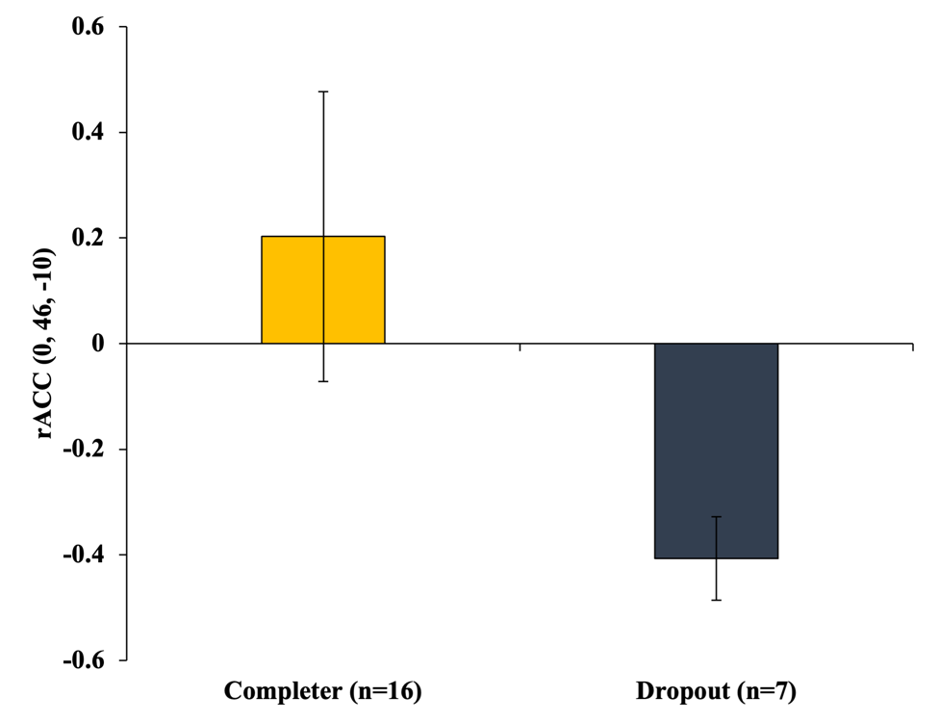

Supplementary Figure 1. Differences in the rostral anterior cingulate cortex (rACC; MNI x=0 y=46 z=-10) activation (fearful versus happy) between those who completed treatment (n=16) and those who prematurely dropped out of treatment (n=7). Error bars represent standard error.

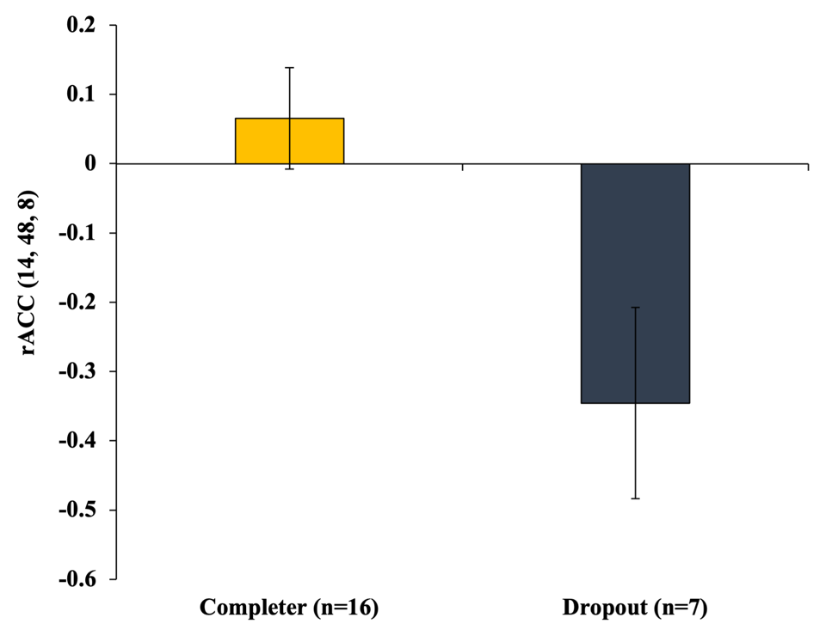

Supplementary Figure 2. Differences in the rostral anterior cingulate cortex (rACC; MNI x=14 y=48 z=8) activation (fearful versus happy) between those who completed treatment (n=16) and those who prematurely dropped out of treatment (n=7). Error bars represent standard error.

