Fig. S1

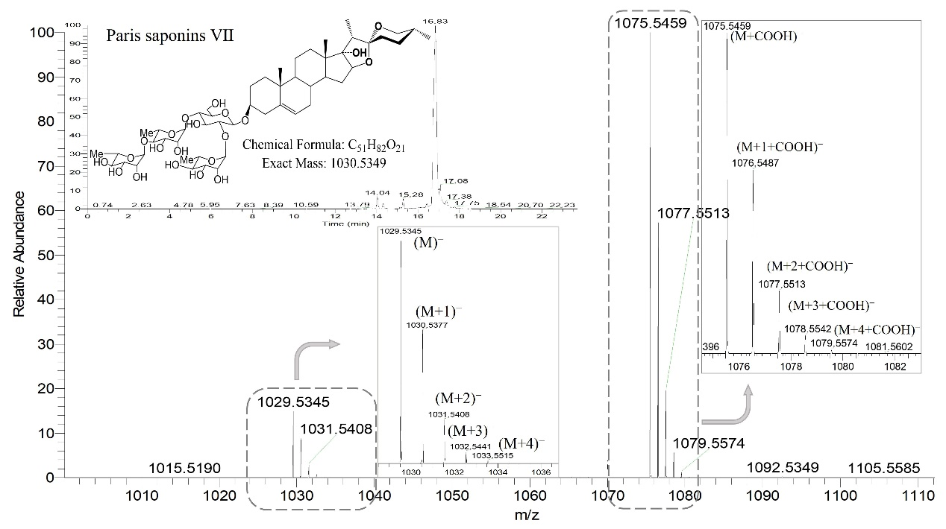

**Figure S1. PS Ⅶ ion bar diagram by UPLC-mass spectrometry.**

Negative ion by high-resolution mass spectrometry of PS Ⅶ (C51H82O21, 1030.5349) was detected with a retention time of 16.83 min. Owing to the natural abundance of 13C with the exact molecular weight of 13.003 (12C 12.000), there will be a series of isotope peaks exiting in the same retention time position of the PS Ⅶ molecular ion peak (M−), mainly (M+1)−, (M+2)−, (M+3)− and (M+4)−, etc. The detailed figure displays an enlarged bar diagram of the series isotope peaks. The calculation of the ion current ratio is (M+1)−/M−, (M+2)−/M−, (M+3)−/M−, and (M+4)−/M−. The ratio changes of the series isotope ion peaks were used to track and infer the biosynthesis of saponins. M− means the sum of the peak areas of ion current (M+COOH)− and M−, which were mainly ionized with COOH− ions in formic acid water.

Fig. S2

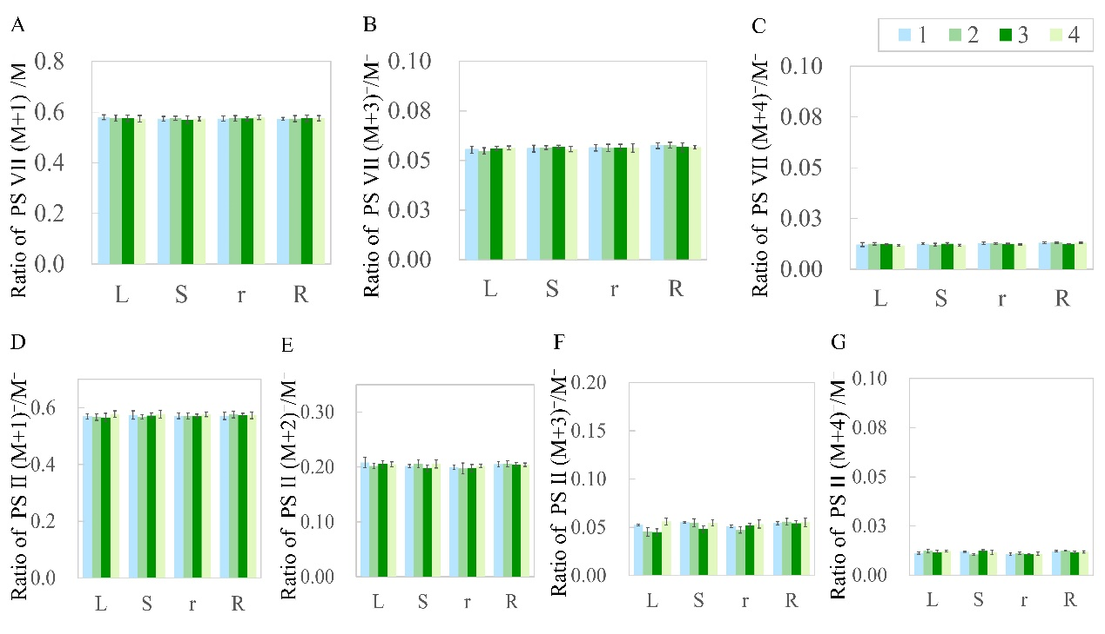

**Figure S2. The ratios of PS Ⅶ and PS Ⅱ in organs of the four groups via 13C-glucose (13C6H12O6) feeding.**

(A–C) The ratios of PS Ⅶ (M+1)−/ M−, (M+3)−/ M−, and (M+4)−/ M− in each organ of the four groups were not significantly different. (D–G) The ratios of PS Ⅱ (M+1)−/ M−, (M+2)−/ M−,(M+3)−/ M−, and (M+4)−/ M− in each organ of the four groups were not significantly different. L, leaf; S, stem; r, root; R, rhizome. Each column represents the mean (± SE) of three replicates.

Fig. S3

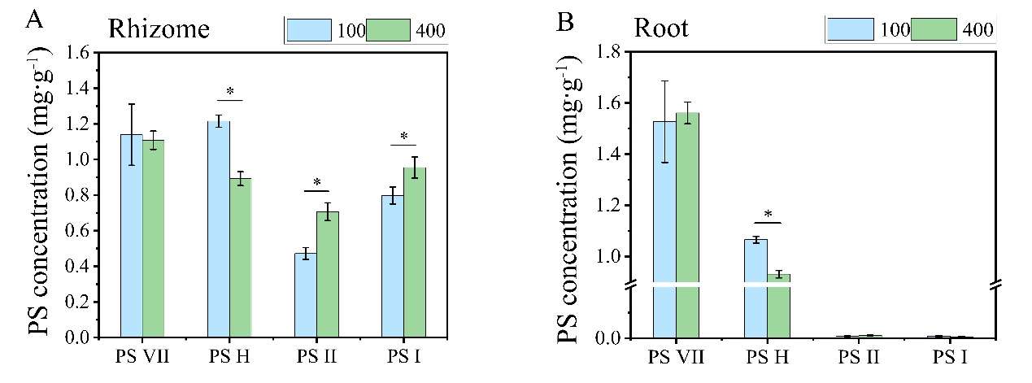

**Figure S3.** **Concentration of saponins in the root and rhizome of PPY under different light intensities.**

The saponins of 2-year-old PPY seedlings under light intensities of 100 and 400 μmol m−2 s−1 for 1 week. PS H in the root and rhizome of 100 μmol m−2 s−1 are a little higher than that of 400 μmol m−2 s−1. PS Ⅱ and PS I in the root and rhizome of 400 μmol m−2 s−1 are a little higher than that of 100 μmol m−2 s−1. PS Ⅶ, PS H, PS Ⅱ, PS Ⅰ, *Paris* saponin Ⅶ, H, Ⅱ, and Ⅰ, respectively. * indicates a significant difference between the same saponin components at a given light treatment (t-test at *p ≤ 0.01*).