Supplementary Material

Experimental renal transplantation in rats improves cardiac dysfunction caused by chronic kidney disease while LVH persists

Linda Hagmayer1, Christina Mayer1, Nadja Ebert1, Kerstin Amann1, Christoph Daniel1*

1Department of Nephropathology, Friedrich-Alexander University (FAU) Erlangen- Nuremberg, Germany

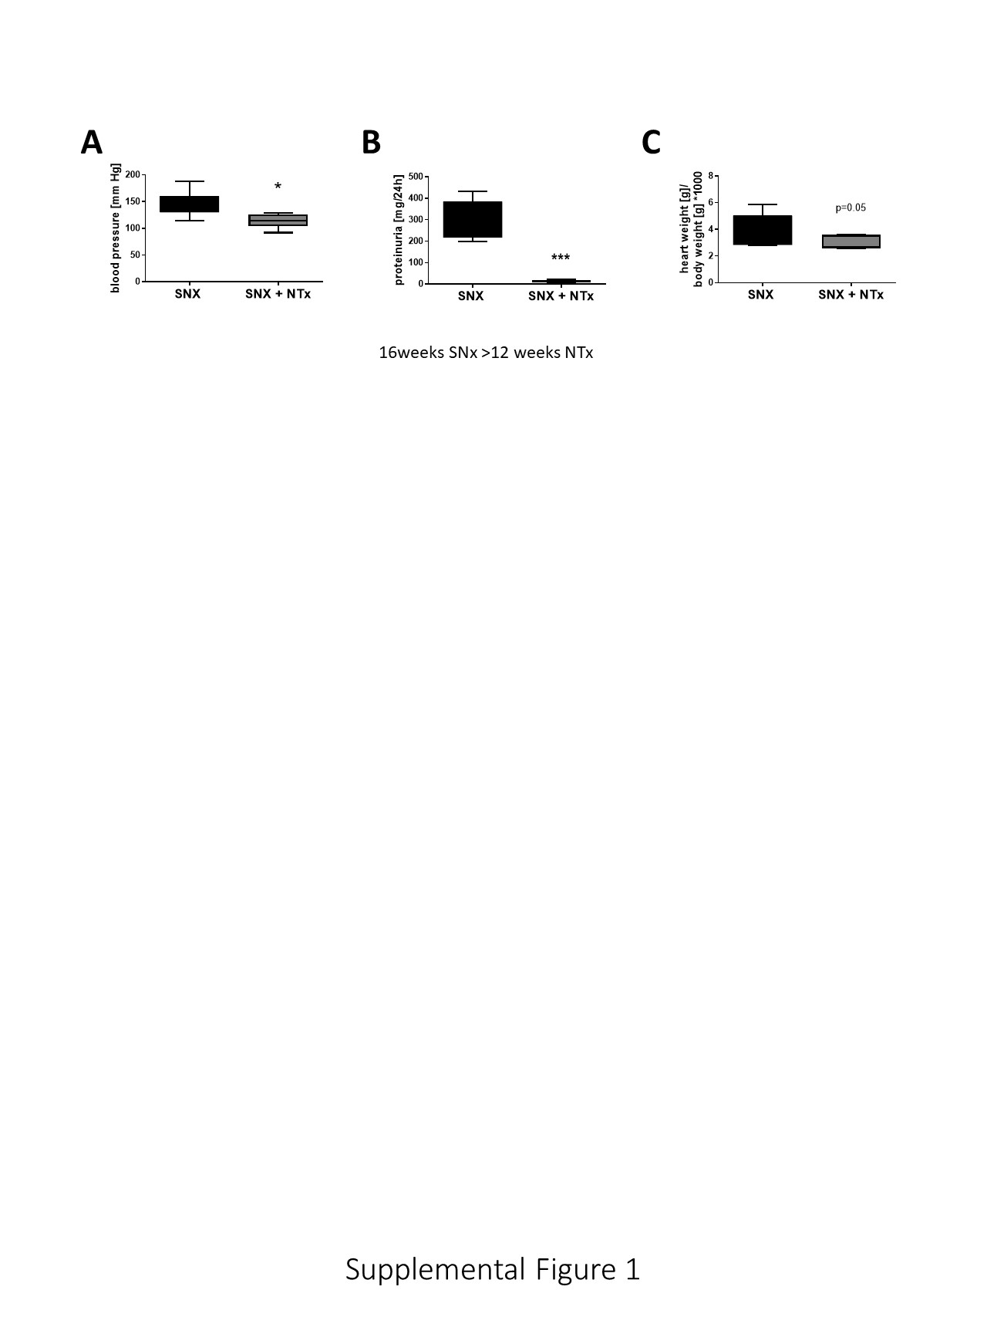

**Supplemental Figure 1: Changes in blood pressure, proteinuria and relative heart weight after SNx followed by kidney transplantation.** In a preliminary experiment, F344 rats underwent 5/6 nephrectomy (SNx, n=11) for 16 weeks and renal function was subsequently restored in a proportion of the animals by renal transplantation (RTx, n=6). Twelve weeks after RTx, the experiment was terminated and intra-arterial blood pressure (A), proteinuria (B) and relative heart weight (C) were determined at the end of the experiment.