Supplementary Material

**Analyses of the *Dmrt* family in a decapod crab, *Eriocheir sinensis* uncover new facets on the evolution of DM domain genes**

**Peng Zhang, Yanan Yang, Yuanfeng Xu, Zhaoxia Cui\***

**\* Correspondence:** Corresponding Author: cuizhaoxia@nbu.edu.cn

# Supplementary Figures

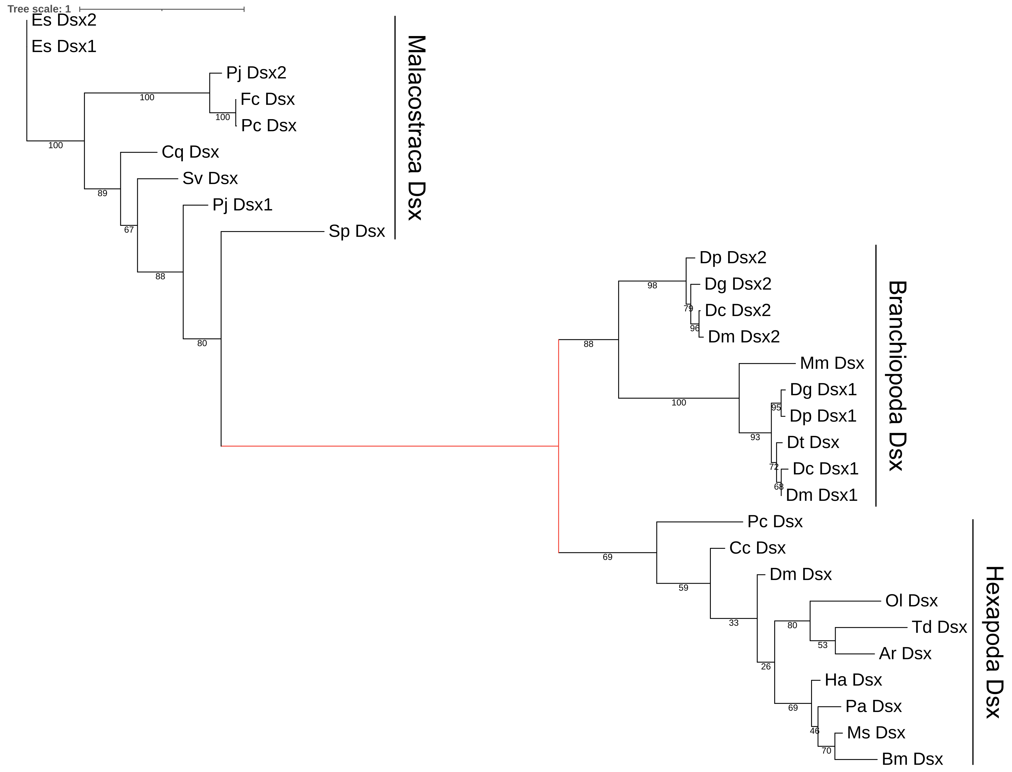

**Supplementary Figure 1.** The guide tree used for positive selection analysis and ancestral sequence reconstruction of the *Dsx* groups in Pancrustacean. The foreground branch was annotated as red. The tree was constructed using the nucleotide alignment of the N-terminus of *Dsx*, including the N-terminal DM domain, by PRANK and IQ-TREE.

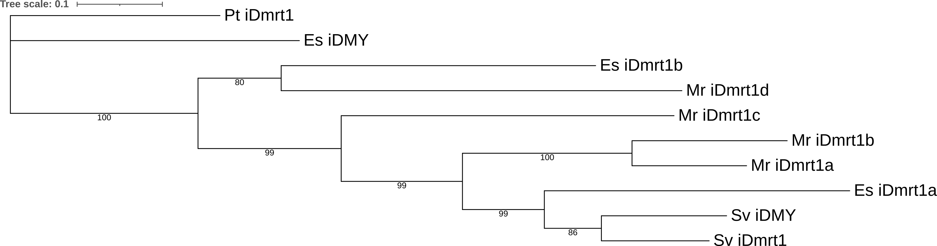

**Supplementary Figure 2.** The guide tree used for positive selection analysis of the *iDmrt1* group in Malacostraca. The tree was constructed using the nucleotide alignment of the N-terminus of *iDmrt1*, including the N-terminal DM domain, by PRANK and IQ-TREE.

**Supplementary Figure 3.** Accuracy of structure predictions of the DM domain of Dsx. Results of the prediction of DM structure of Dsx in common ancestor of Branchiopoda. **(A)** the common ancestor of Hexapoda. **(B)** the common ancestor of Branchiopoda and Hexapoda. **(C)** and the common ancestor of Pancrustacea. **(D)** In each panel, the right 3D model shows the predicted structure of *Dsx* colored by its predicted local distance difference test (plDDT) score. The legend of color in the 3D model is shown at the bottom of the figure.

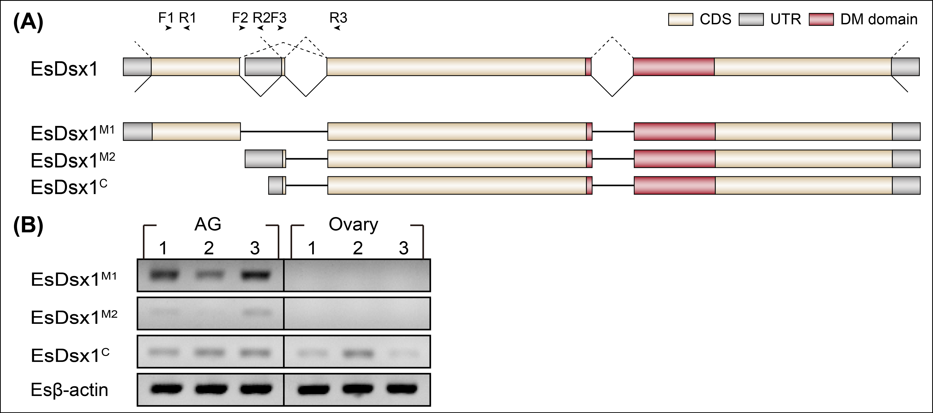

**Supplementary Figure 4.** Identification of alternative splicing events in *EsDsx1*. **(A)** Diagram of putative *EsDsx1* pre-mRNAs. *EsDsx1M1* and *EsDsx1M2* encode for two different proteins. *EsDsx1C* and *EsDsx1M2* encode the same protein and only differ in the 5’ UTR. Arrows showed primer positions. Primer F1 and R1 were used to amplify partial sequence of *EsDsx1M1*, primer F2 and R2 were used to amplify partial sequence of *EsDsx1M2*,and primer F3 and R3 were used to amplify partial sequence of *EsDsx1C* (Primer sequences are listed in Supplementary Table 5). **(B)** Gel picture showing two isoforms that expressed specifically in AG compared to ovary, and one isoform that expressed in both. *Esβ-actin* was conducted as a reference. M represents DNA size marker.

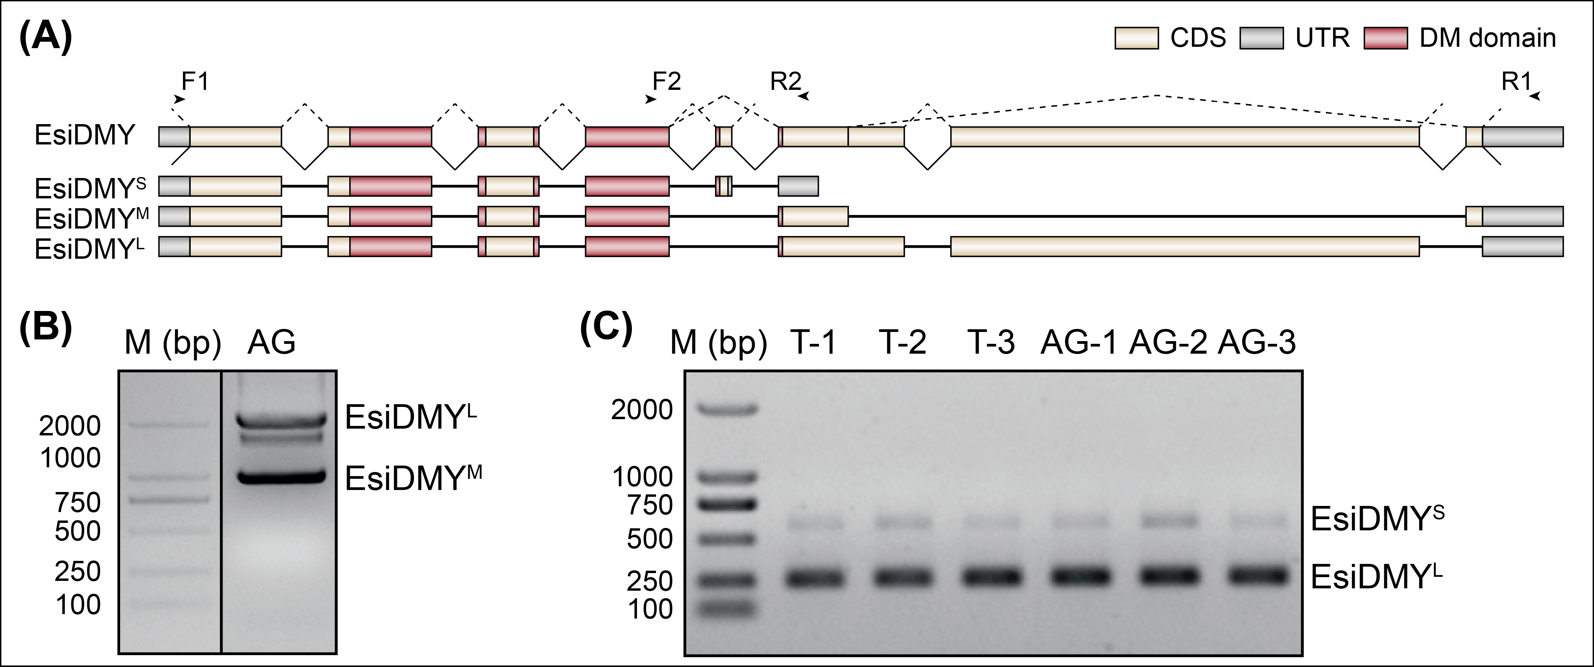**Supplementary Figure 5.** Identification of alternative splicing events in *EsiDMY*. **(A)** Diagram of putative *EsiDMY* pre-mRNAs. *EsiDMYS*, *EsiDMYM* and *EsiDMYL* encode for three different proteins. Arrows showed primer positions. Primer F1 and R1 were used to amplify full ORF of *EsiDMYL* and *EsiDMYM*.Primer F2 and R2 were used to detect alternative splicing event of exon skipping (Primer sequences are listed in Supplementary Table 5). **(B)** Gel picture showing two bands (*EsiDMYL* and *EsiDMYM*) in AG and one band (uncharacterized) as a result of RT-PCR using primer 1. M represents DNA size marker. **(C)** Gel picture showing two bands (*EsiDMYL* and *EsiDMYS*) in testis and AG as a result of RT-PCR using primer 2. M represents DNA size marker.



**Supplementary Figure 6.** Column graph illustrating zinc binding prediction score for DM domain from ancestral sequences using ZincExplorer. The mutation that causes the loss of one zinc ion is indicated with blue dot.

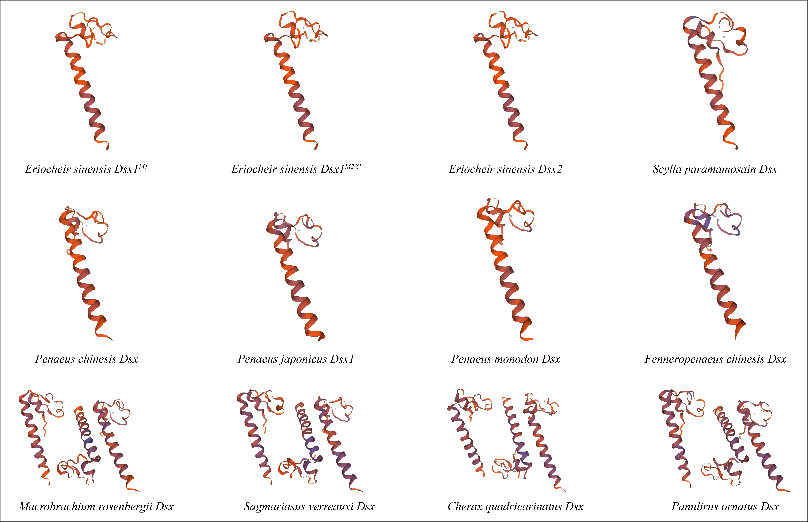

**Supplementary Figure 7.** Three-dimension structures of Malacostraca Dsx modelled using Swiss-Model online software. Each predicted protein only chelates one zinc ion.