Supplementary Material

Graphene-coated D-shaped Terahertz fiber modulator

Shaona Wang *, Mengya Su, Longhuang Tang, Xianguo Li, Xiuyan Li, Hua Bai, Pingjuan Niu, Jianquan Yao and Jia Shi

**\* Correspondence:** Jia Shi: shijia@tiangong.edu.cn

# Supplementary Figures



**Supplementary Figure 1.** (**a**) 3D view, (**b**) cross-section view of the proposed graphene-coated D-shaped THz fiber modulator.

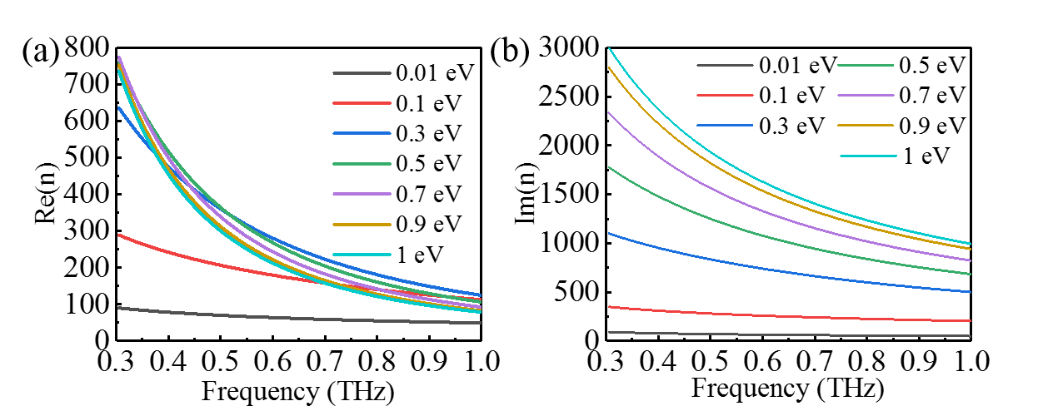

**Supplementary Figure 2.** (**a**) Real; (**b**) imaginary refractive index of graphene with the different the Fermi energy levels versus frequency.

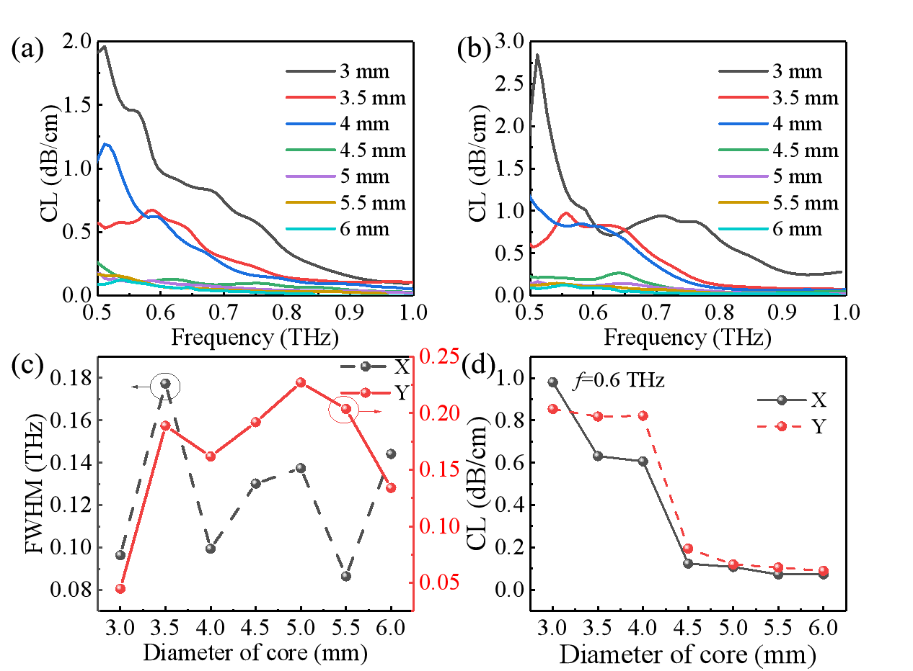

**Supplementary Figure 3.** (**a**), (**b**) Confinement loss versus frequency for different diameters of the core of X polarization and Y polarization; (**c**) FWHM; (**d**) Confinement loss at 0.6 THz of X polarization and Y polarization with the different diameters of the core. The remaining structural parameters are =800 μm, and =0.335 nm.

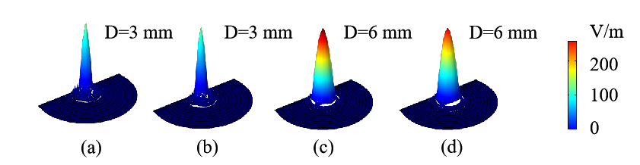

**Supplementary Figure 4.** The electric field distribution of the fundamental mode with the different diameters of the core at 0.6 THz: (**a**), (**c**) X polarization; (**b**), (**d**) Y polarization.

图表

**Supplementary Figure 5.** (**a**), (**b**) Confinement loss versus frequency for different thicknesses of the cladding layers of X polarization and Y polarization; (**c**) FWHM; (**d**) Confinement loss at 0.6 THz of X polarization and Y polarization with the different thicknesses of the cladding layers. The remaining structural parameters are =4.5 mm, and =0.335 nm.

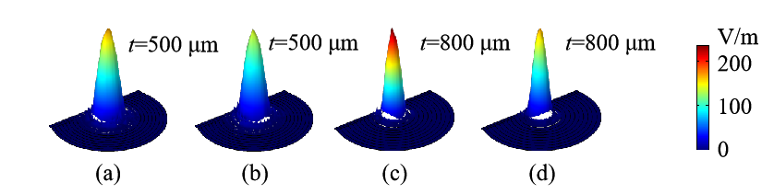

**Supplementary Figure 6.** The electric field distribution of the fundamental mode with the different diameters of the core at 0.6 THz: (**a**), (**c**) X polarization; (**b**), (**d**) Y polarization.



**Supplementary Figure 7.** Different positions of the graphene layer in the fiber: (**a**) in the first layer; (**b**) in the second layer; (**c**) in the third layer; (**d**) in the fourth layer; (**e**) in the fifth layer.

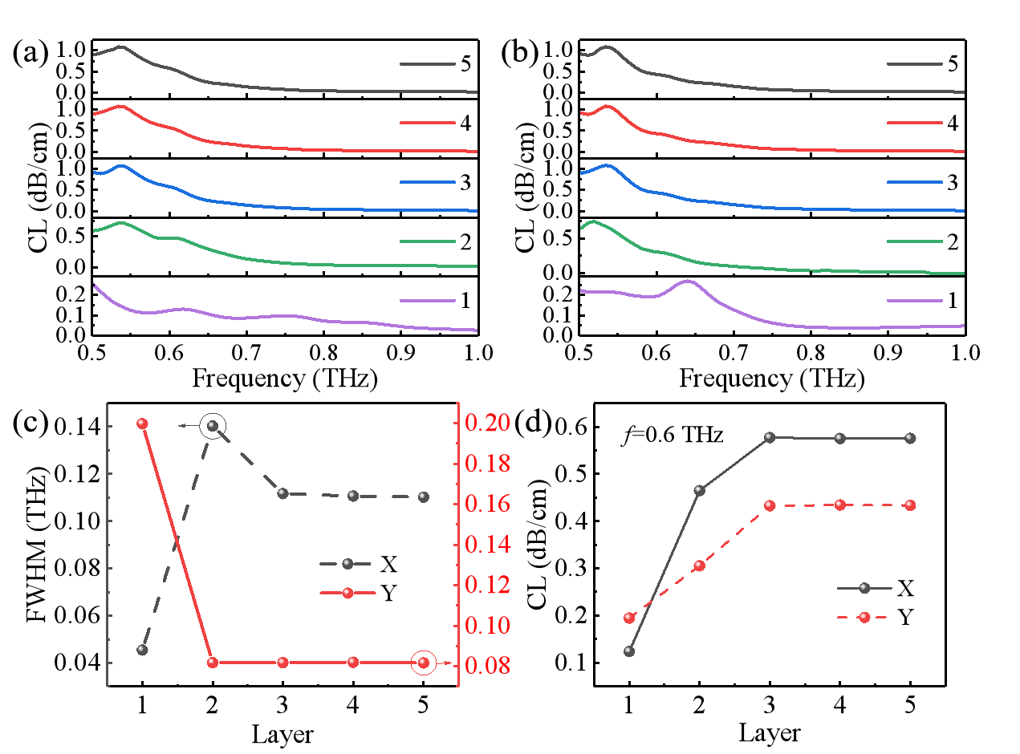

**Supplementary Figure 8.** (**a**), (**b**) Confinement loss versus frequency for different positions of the graphene layer of X polarization and Y polarization. (**c**) FWHM (**d**) Confinement loss at 0.6 THz of X polarization and Y polarization with the different positions of the graphene layer.

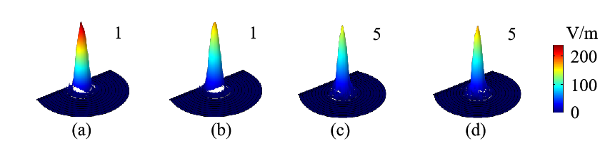

**Supplementary Figure 9.** The electric field distribution of the fundamental mode with the different positions of the graphene layer at 0.6 THz: (**a**), (**c**) X polarization; (**b**), (**d**) Y polarization.

电脑萤幕画面

**Supplementary Figure 10.** (**a**), (**b**) Confinement loss versus frequency for different graphene Fermi levels of X polarization and Y polarization.

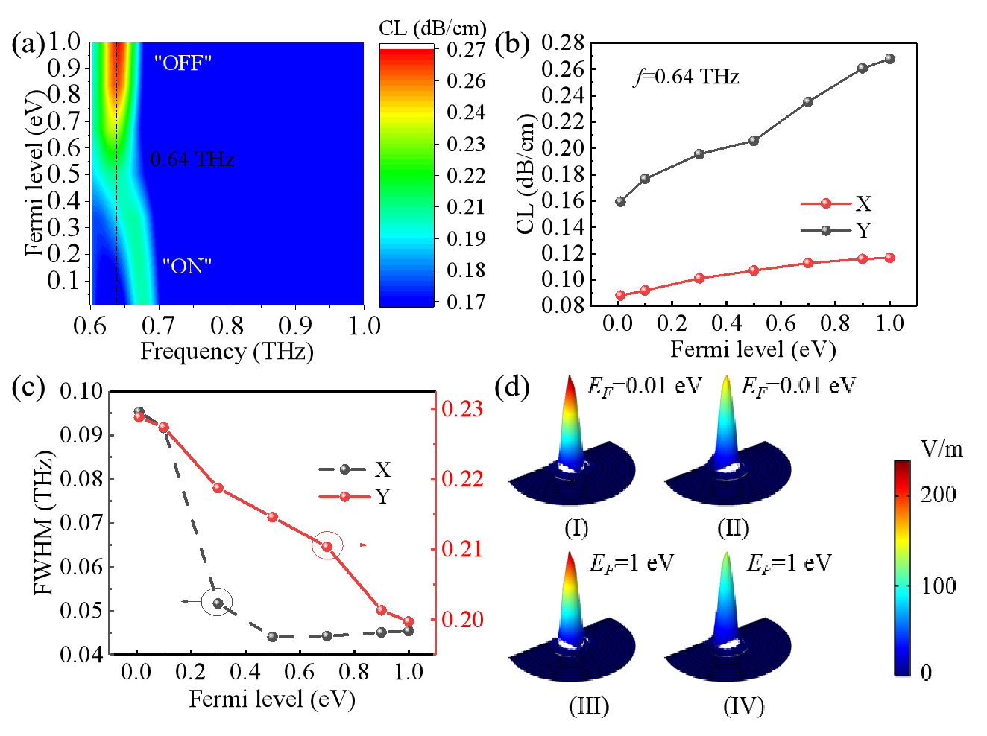

**Supplementary Figure 11.** (**a**) 2D contour map of confinement loss; (**b**) Confinement loss at 0.64 THz; (**c**) FWHM of X polarization and Y polarization with different graphene Fermi levels; (**d**) The electric field distribution of the fundamental mode of X polarization (I) and (III), and Y polarization (II) and (IV) at 0.64 THz.