Supplementary Material

Effectiveness of acupuncture as auxiliary combined with Western medicine for epilepsy: A systematic review and Meta-analysis

Hua Xue1*, Li Zeng2, Hongxian He1, Dongxun Xu1,Kaixin Ren3

1Department of Neurology, Sichuan Taikang Hospital, Chengdu, Sichuan, 610213, China

2Department of Respiratory, Affiliated Hospital of Youjiang Medical University for Nationalities,

Baise, Guangxi, 533000, China

3Department of Rehabilitation, Affiliated Hospital of Yunnan University, Kunming, Yunnan, 650032, China

**\* Correspondence:** Hua Xue: [xueh1895@163.com](mailto:xueh1895@163.com)

**Supplementary Materials**

**Search strategy**

|  |  |
| --- | --- |
| PUBMED | |
| #1 | Epilepsy [Mesh] |
| #2 | ((((((Epilepsies[Title/Abstract]) OR (Seizure Disorder[Title/Abstract])) OR (Seizure Disorders[Title/Abstract])) OR (Awakening Epilepsy[Title/Abstract])) OR (Epilepsy, Awakening[Title/Abstract])) OR (Cryptogenic Epilepsies[Title/Abstract])) OR (Auras[Title/Abstract]) |
| #3 | #1 OR #2 |
| #4 | Acupuncture Therapy[Mesh] |
| #5 | (((((((((Acupuncture Treatment[Title/Abstract]) OR (Acupuncture Treatments[Title/Abstract])) OR (Treatment, Acupuncture[Title/Abstract])) OR (Therapy, Acupuncture[Title/Abstract])) OR (Pharmacoacupuncture Treatment[Title/Abstract])) OR (Treatment, Pharmacoacupuncture[Title/Abstract])) OR (Pharmacoacupuncture Therapy[Title/Abstract])) OR (Therapy, Pharmacoacupuncture[Title/Abstract])) OR (Acupotomy[Title/Abstract])) OR (Acupotomies[Title/Abstract]) |
| #6 | #4 OR #5 |
| #7 | # 6 AND #3 |
| Embase | |
| #1 | 'epilepsy'/exp |
| #2 | 'epilepsy':ab,ti |
| #3 | ##1 OR #2 |
| #4 | 'acupuncture'/exp |
| #5 | 'acupressure':ab,ti |
| #6 | 'needle':ab,ti |
| #7 | 'electroacupuncture':ab,ti |
| #8 | #4 OR #5 OR #6 OR #7 |
| #9 | #8 AND #3 |
| Cochrane library | |
| #1 | MeSH descriptor: [Acupuncture] explode all trees |
| #2 | (Acupuncture Treatment):ti,ab,kw OR (Acupuncture Treatments):ti,ab,kw OR (Treatment, Acupuncture):ti,ab,kw OR (Acupotomy):ti,ab,kw OR ("needle"):ti,ab,kw |
| #3 | #1 OR #2 |
| #4 | MeSH descriptor: [epilepsy] explode all trees |
| #5 | (epilepsy):ti,ab,kw OR (Seizure):ti,ab,kw OR (Seizure Disorder):ti,ab,kw |
| #6 | #4 OR #5 |
| #7 | #6 AND #3 |
| China National Knowledge Infrastructure (CNKI) | |
| ( SU='针灸' OR SU='针刺' OR SU='电针' OR SU='头针' OR SU='耳针' OR SU=温针' OR SU='浮针' OR SU='眼针' OR SU='皮内针' OR SU='火针' OR SU='温针' OR SU='体针' OR SU='腕踝针' OR SU='干针' OR SU='芒针' ) AND (SU='癫痫' OR SU='原发性癫痫'）AND (TKA='随机' OR TKA='对照') | |
| Wangfang Database | |
| (((((主题=癫痫) OR 主题=继发性癫痫))) AND ((((((主题=针灸) OR 主题=针刺) OR 主题=体针) OR 主题=温针灸) OR 主题=电针))) | |
| Chinese BioMedical Literature Database | |
| 1. "癫痫"[不加权:扩展] 2. "癫痫"[加权:扩展] OR "原发性癫痫"[加权:扩展] OR "羊角风"[加权:扩展] OR "痹症"[加权:扩展] OR "羊癫疯"[加权:扩展] 3. "针灸"[加权:扩展] OR "体针"[加权:扩展] OR "温针"[加权:扩展] OR "火针"[加权:扩展] OR "穴位"[加权:扩展] OR "温针灸"[加权:扩展] 4. ((#3) AND (#2)) | |

***Supplementary Figure***

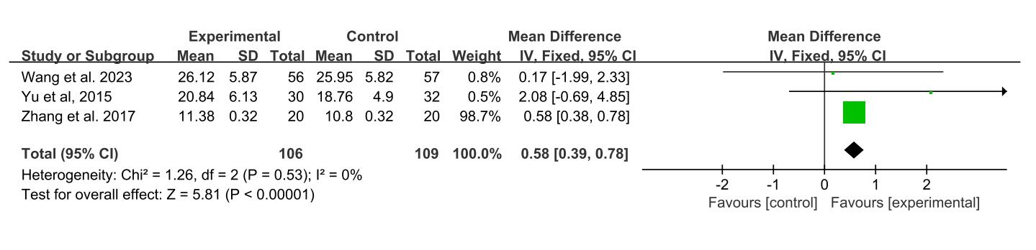

Forest plot of the α wave of acupuncture combined with Western medicine for patients

with epilepsy

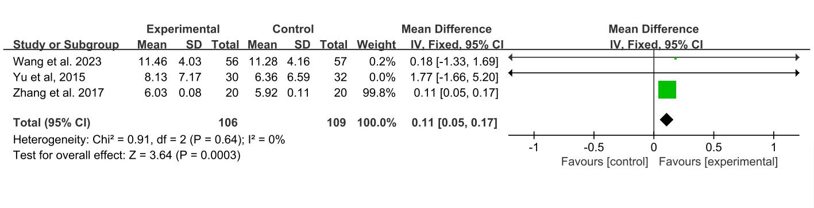Forest plot of the β wave of acupuncture combined with Western medicine for patients

with epilepsy

Forest plot of the δ wave of acupuncture combined with Western medicine for patients

with epilepsy

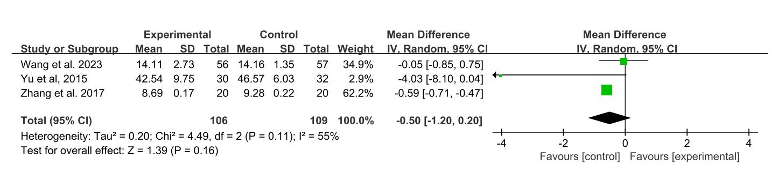

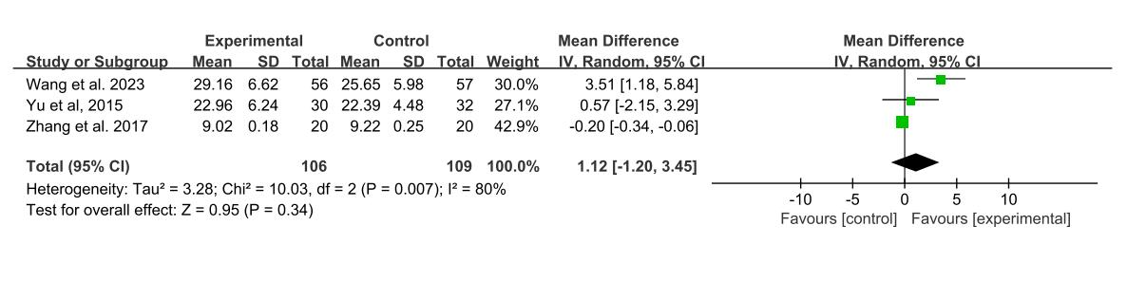

Forest plot of the θ wave of acupuncture combined with Western medicine for patients

with epilepsy