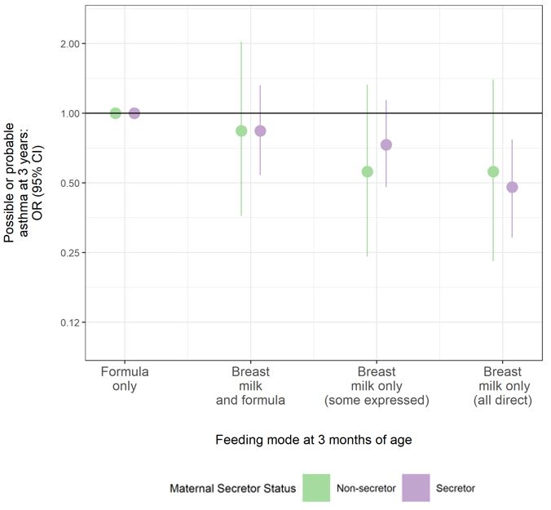
Figure S1: Adjusted associations from multivariable regression models are shown in Figure S1. Unadjusted models display a consistent protective association between breastfeeding at 3 months and possible or probable asthma at 3 years, regardless of maternal secretor status. Odds ratios (ORs) of possible or probable asthma at 3 years by feeding mode at 3 months. Lines represent 95% confidence intervals that display the (un)certainty in sub-sampling study participants from a larger population.

