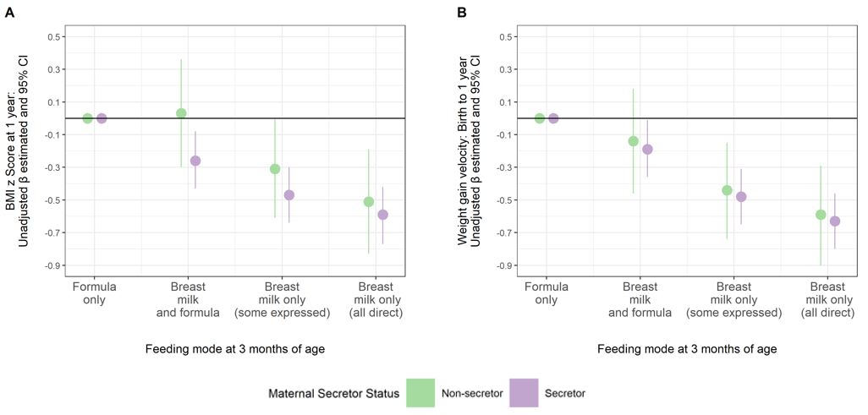
Figure S2. Adjusted associations from multivariable regression models are shown in Figure S2. Unadjusted models display a consistent beneficial association of breastfeeding at 3 months with BMI z score and infant weight gain velocity at 1 year, regardless of maternal secretor status. Unadjusted β estimates for (A) BMI z score and (B) weight gain velocity by infant feeding mode at 3 months. Lines represent 95% confidence intervals that display the (un)certainty in sub-sampling study participants from a larger population.

