Supplementary Material

**Human Papillomavirus (HPV) prevalence and vaccine effectiveness in young women in Germany, 2017/2018: results from a nationwide study**

**Anna Loenenbach, Viktoria Schönfeld, Anja Takla, Miriam Wiese-Posselt, Adine Marquis, Sarah Thies, Matthias Sand, Andreas M. Kaufmann, Ole Wichmann, Thomas Harder**

**\* Correspondence: Corresponding Author: taklaa@rki.de**

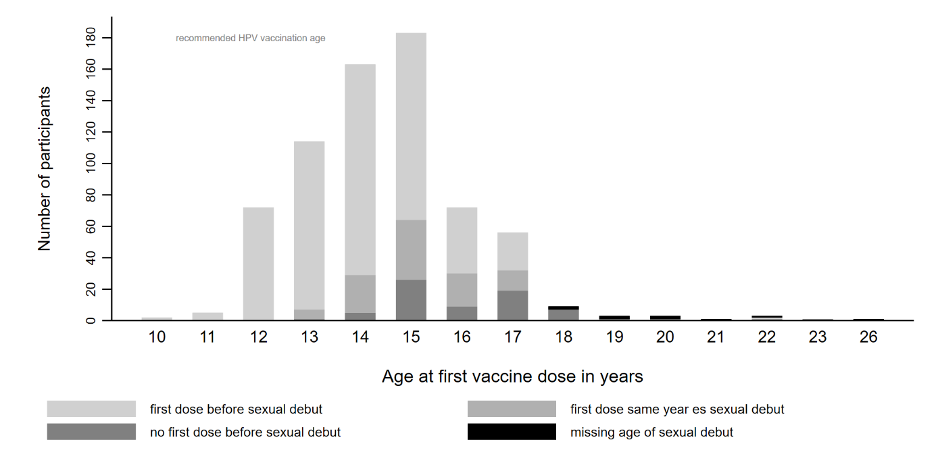

Supplementary Figure 1. Age of first vaccination dose stratified by status if first dose was given before sexual debut.