Supplementary Material

**Human Papillomavirus (HPV) prevalence and vaccine effectiveness in young women in Germany, 2017/2018: results from a nationwide study**

**Anna Loenenbach, Viktoria Schönfeld, Anja Takla, Miriam Wiese-Posselt, Adine Marquis, Sarah Thies, Matthias Sand, Andreas M. Kaufmann, Ole Wichmann, Thomas Harder**

**\* Correspondence: Corresponding Author: taklaa@rki.de**

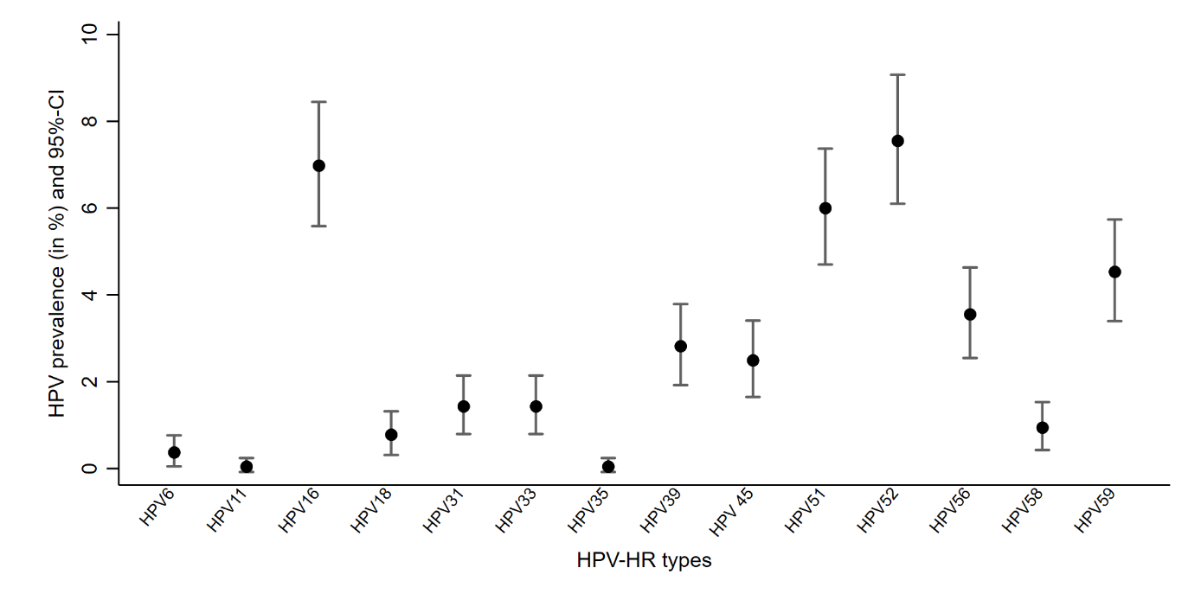

Supplementary Figure 2. HPV prevalence and 95% confidence intervals (CI) of 18 high risk (HR) types; HPV prevalence study (n=1,226).