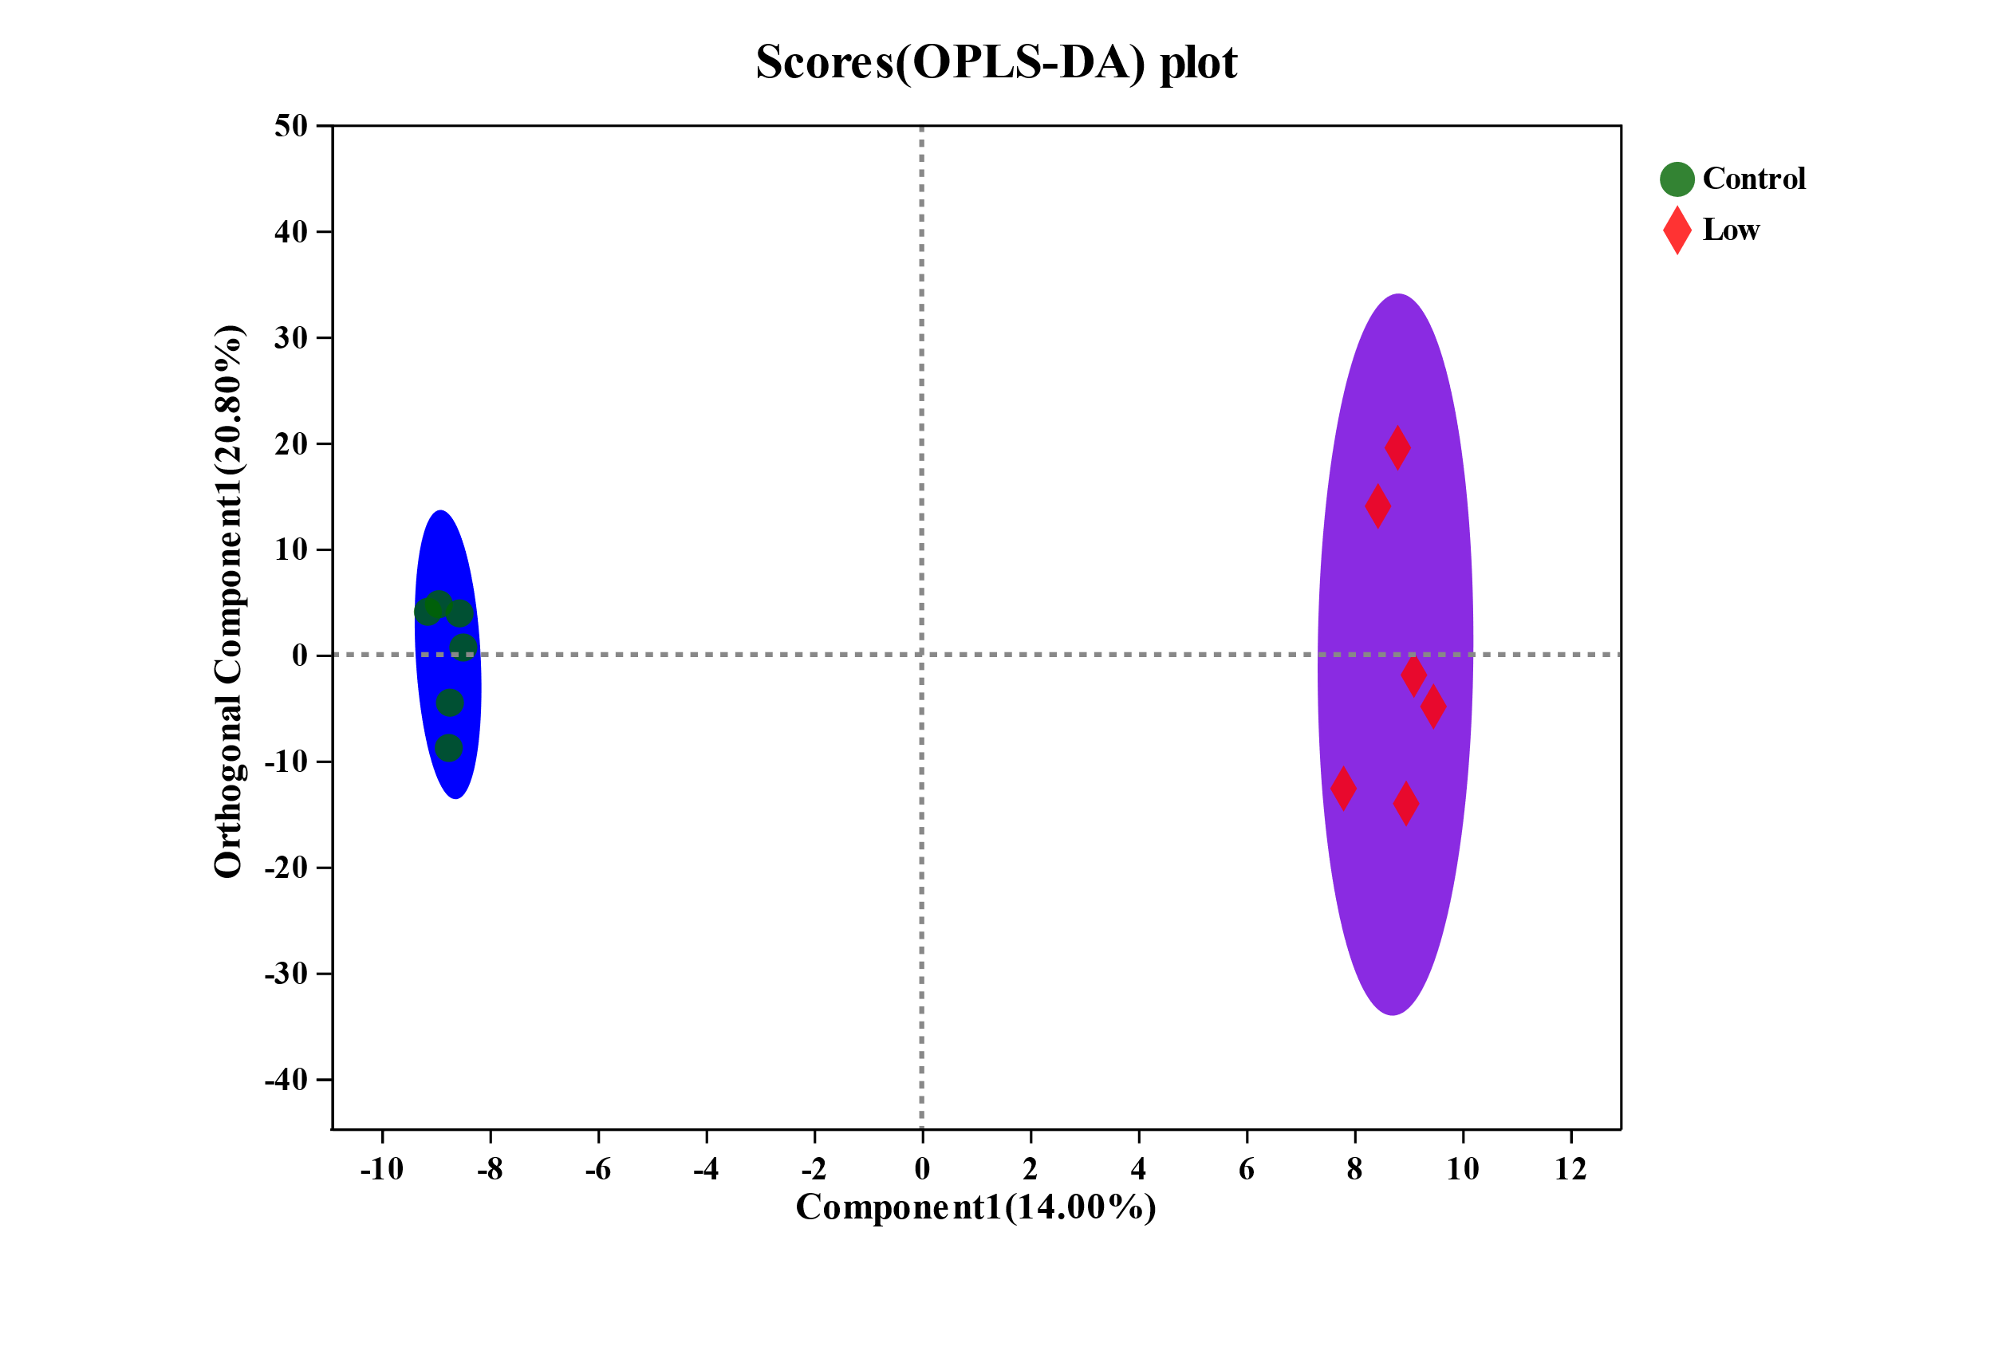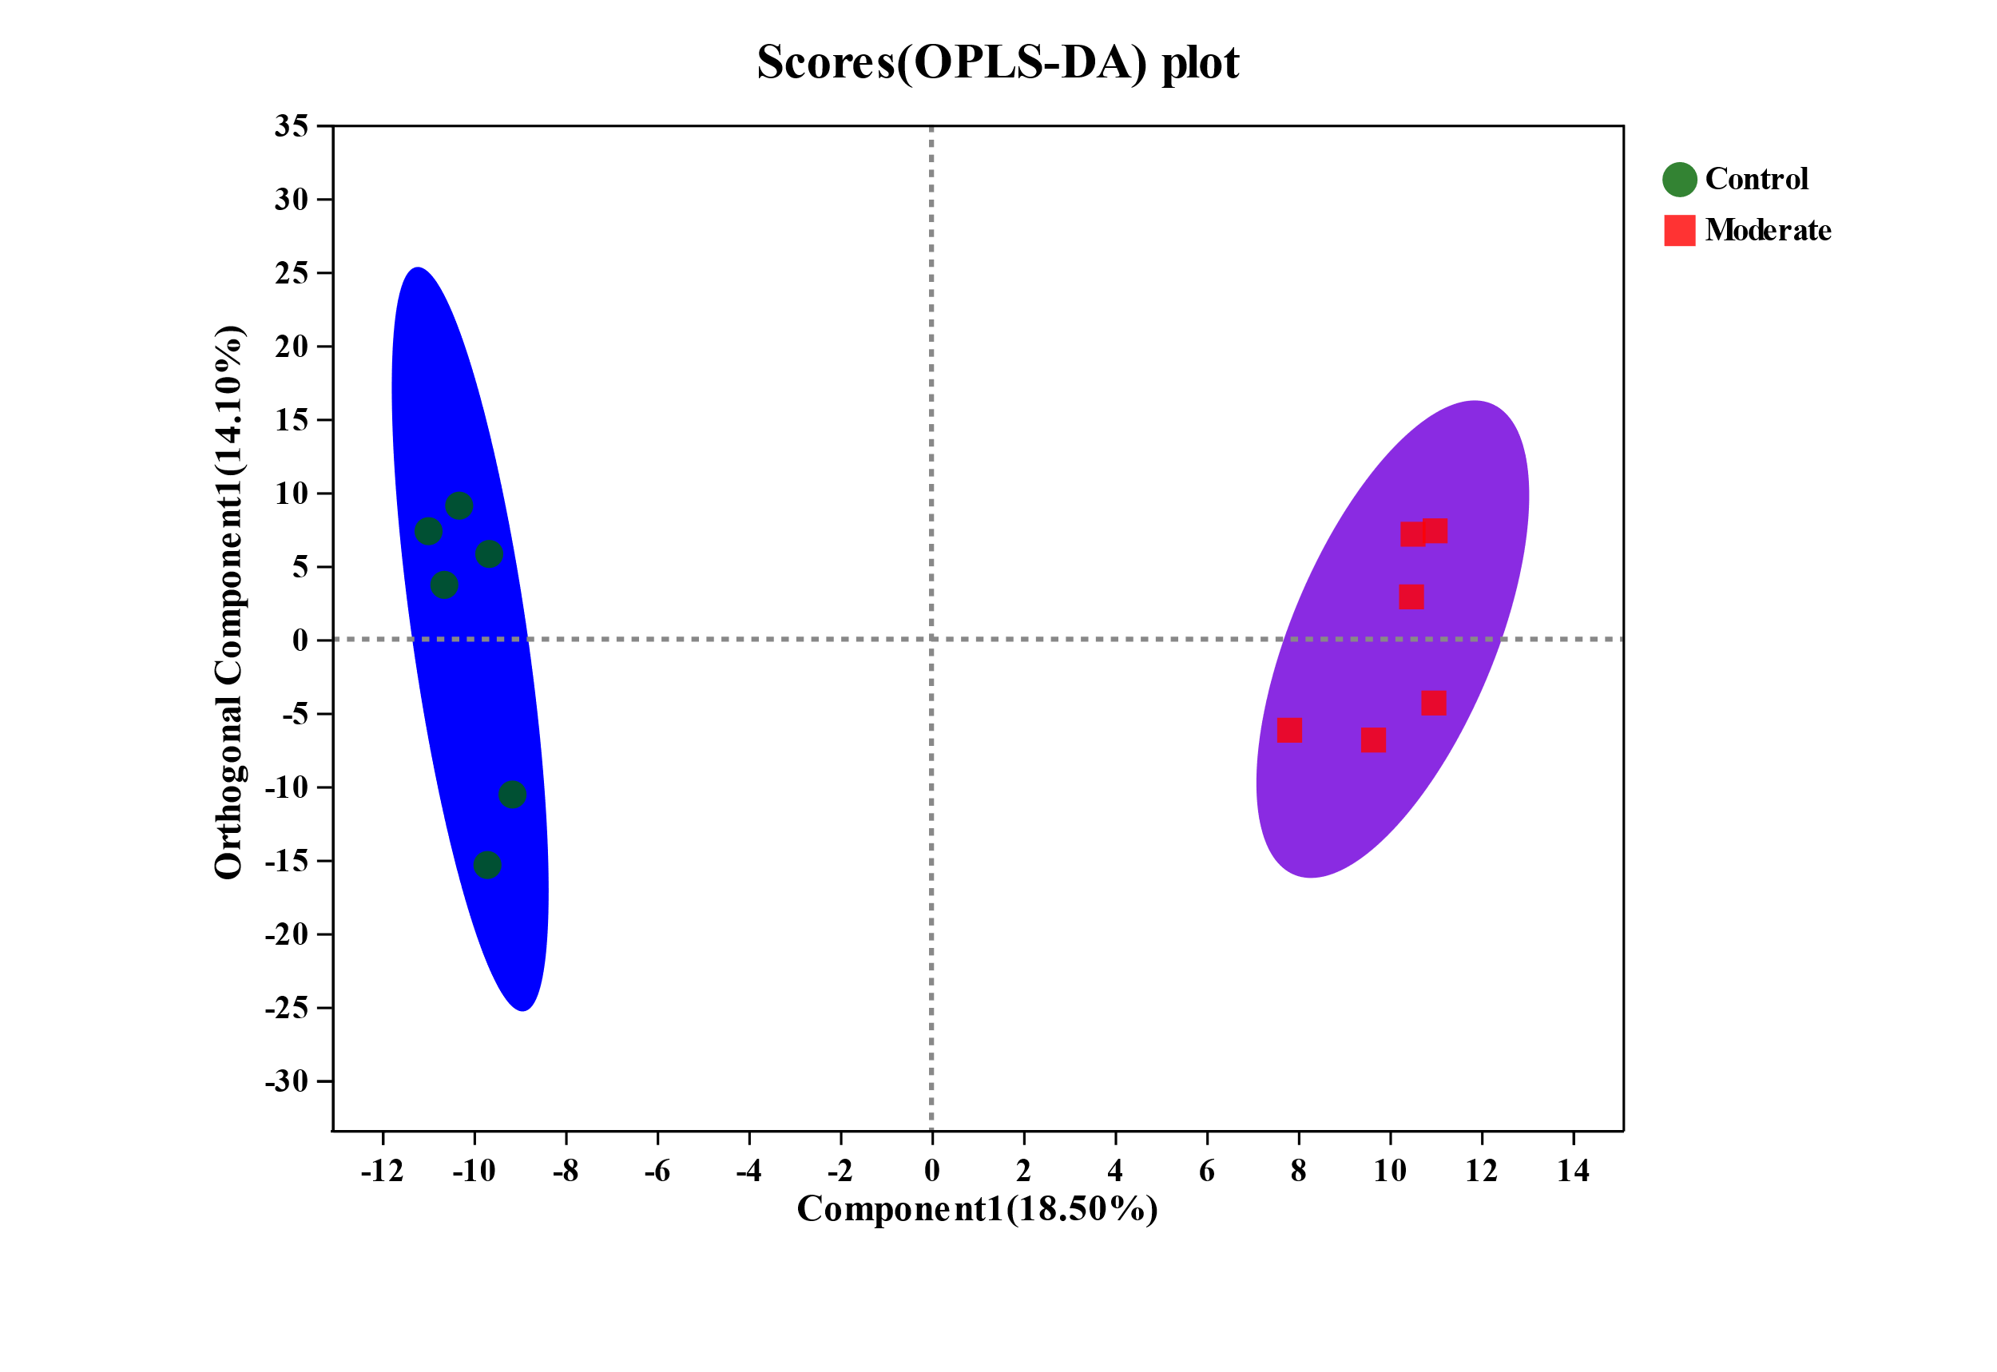

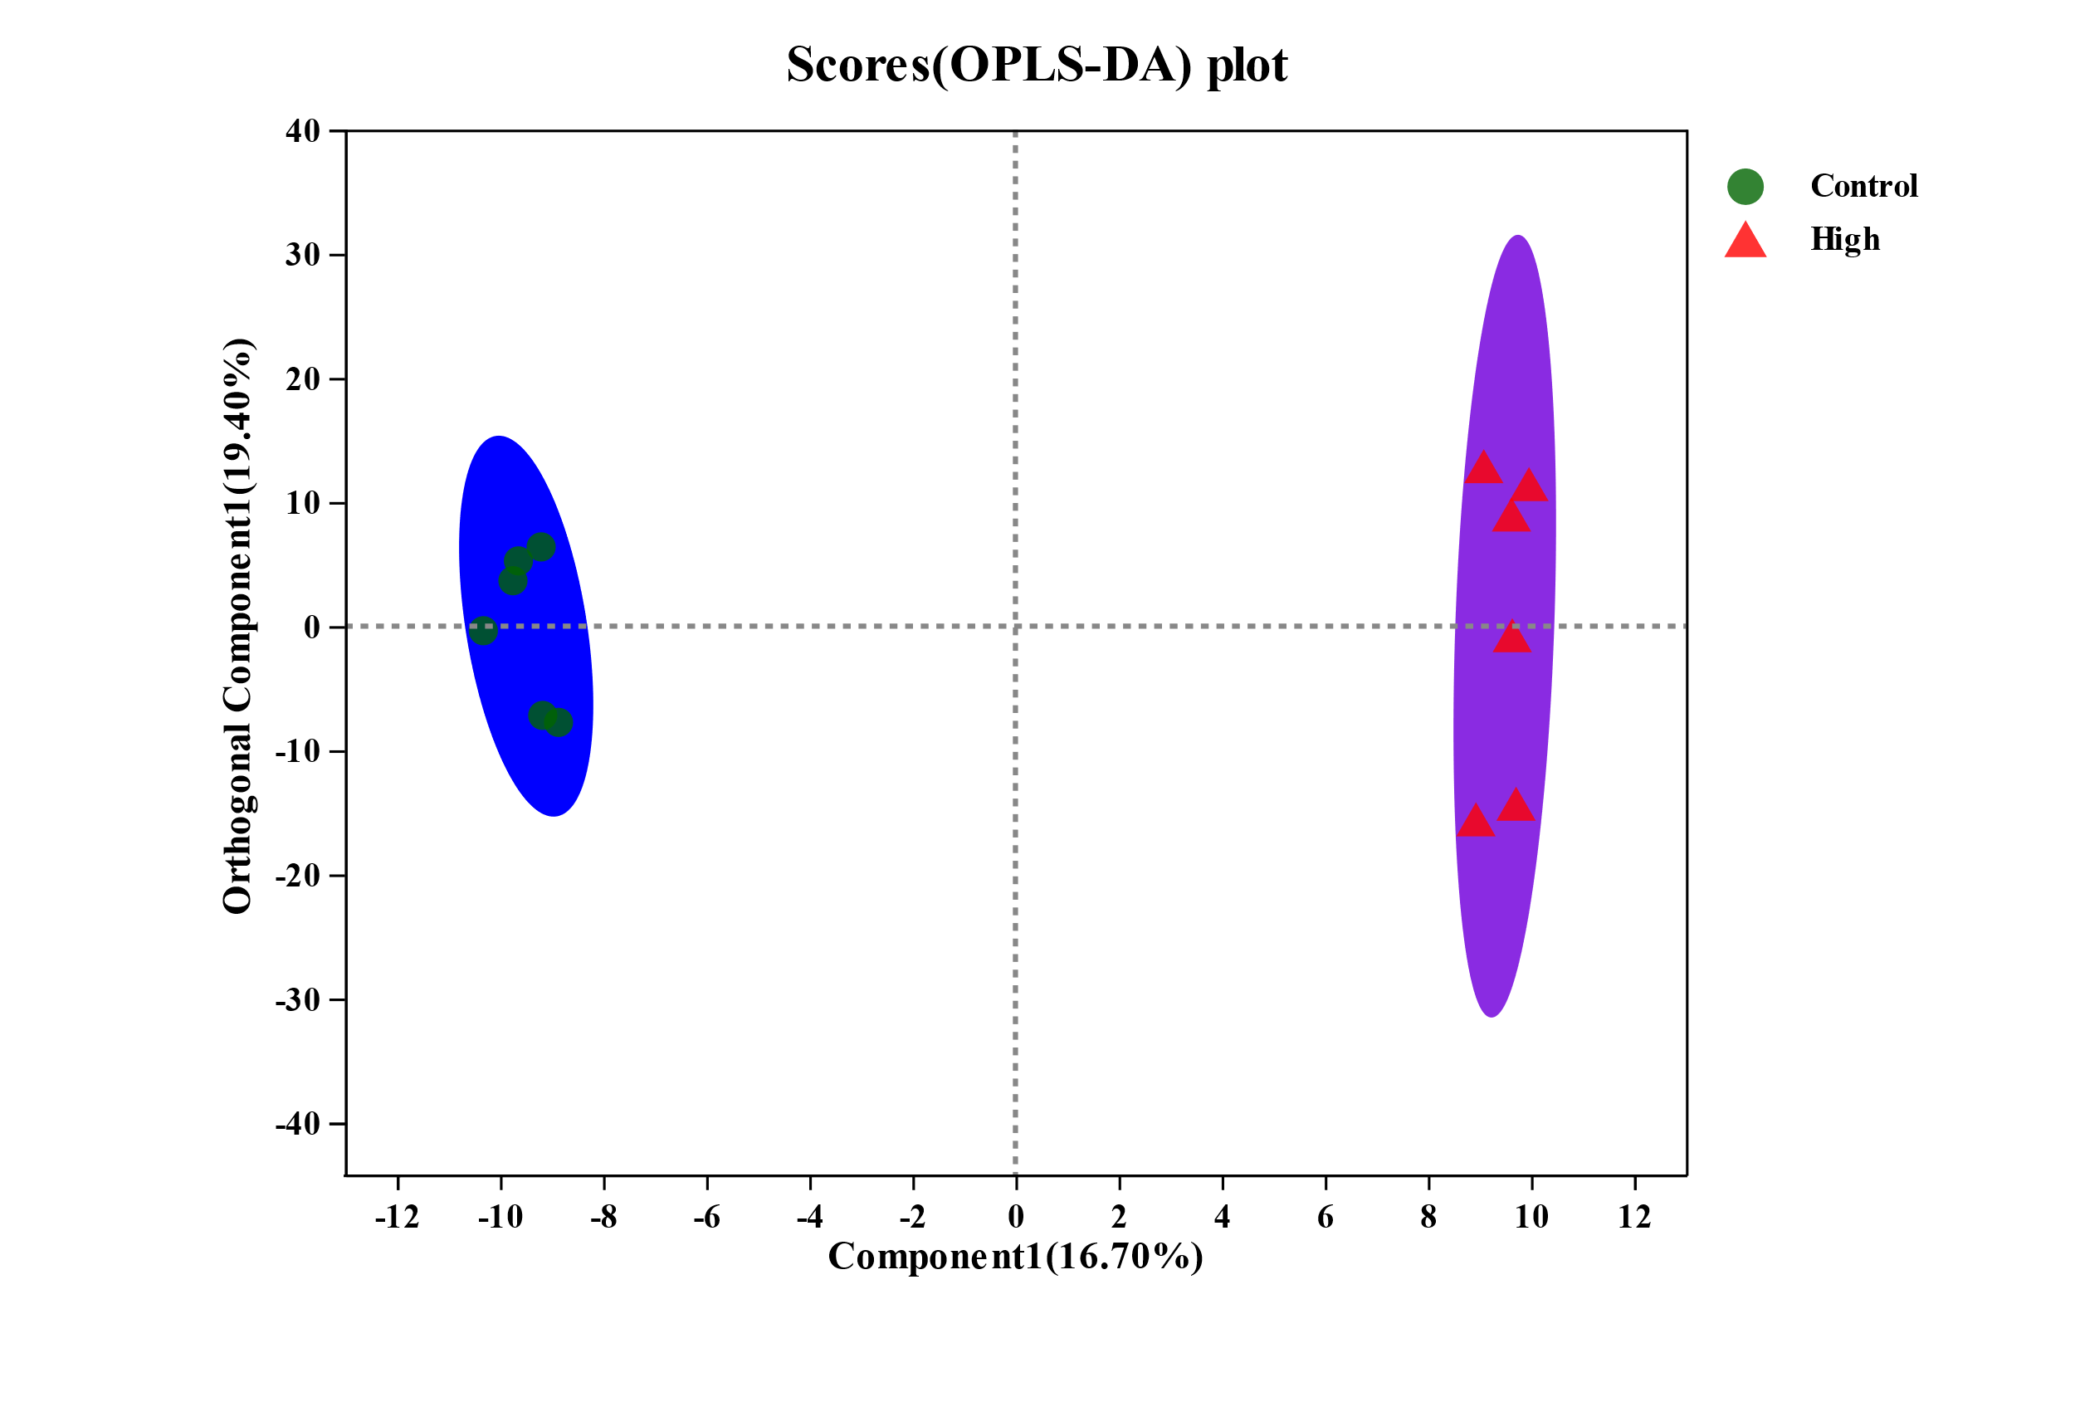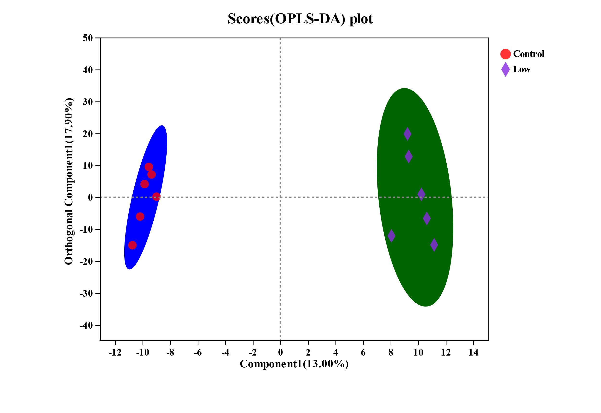

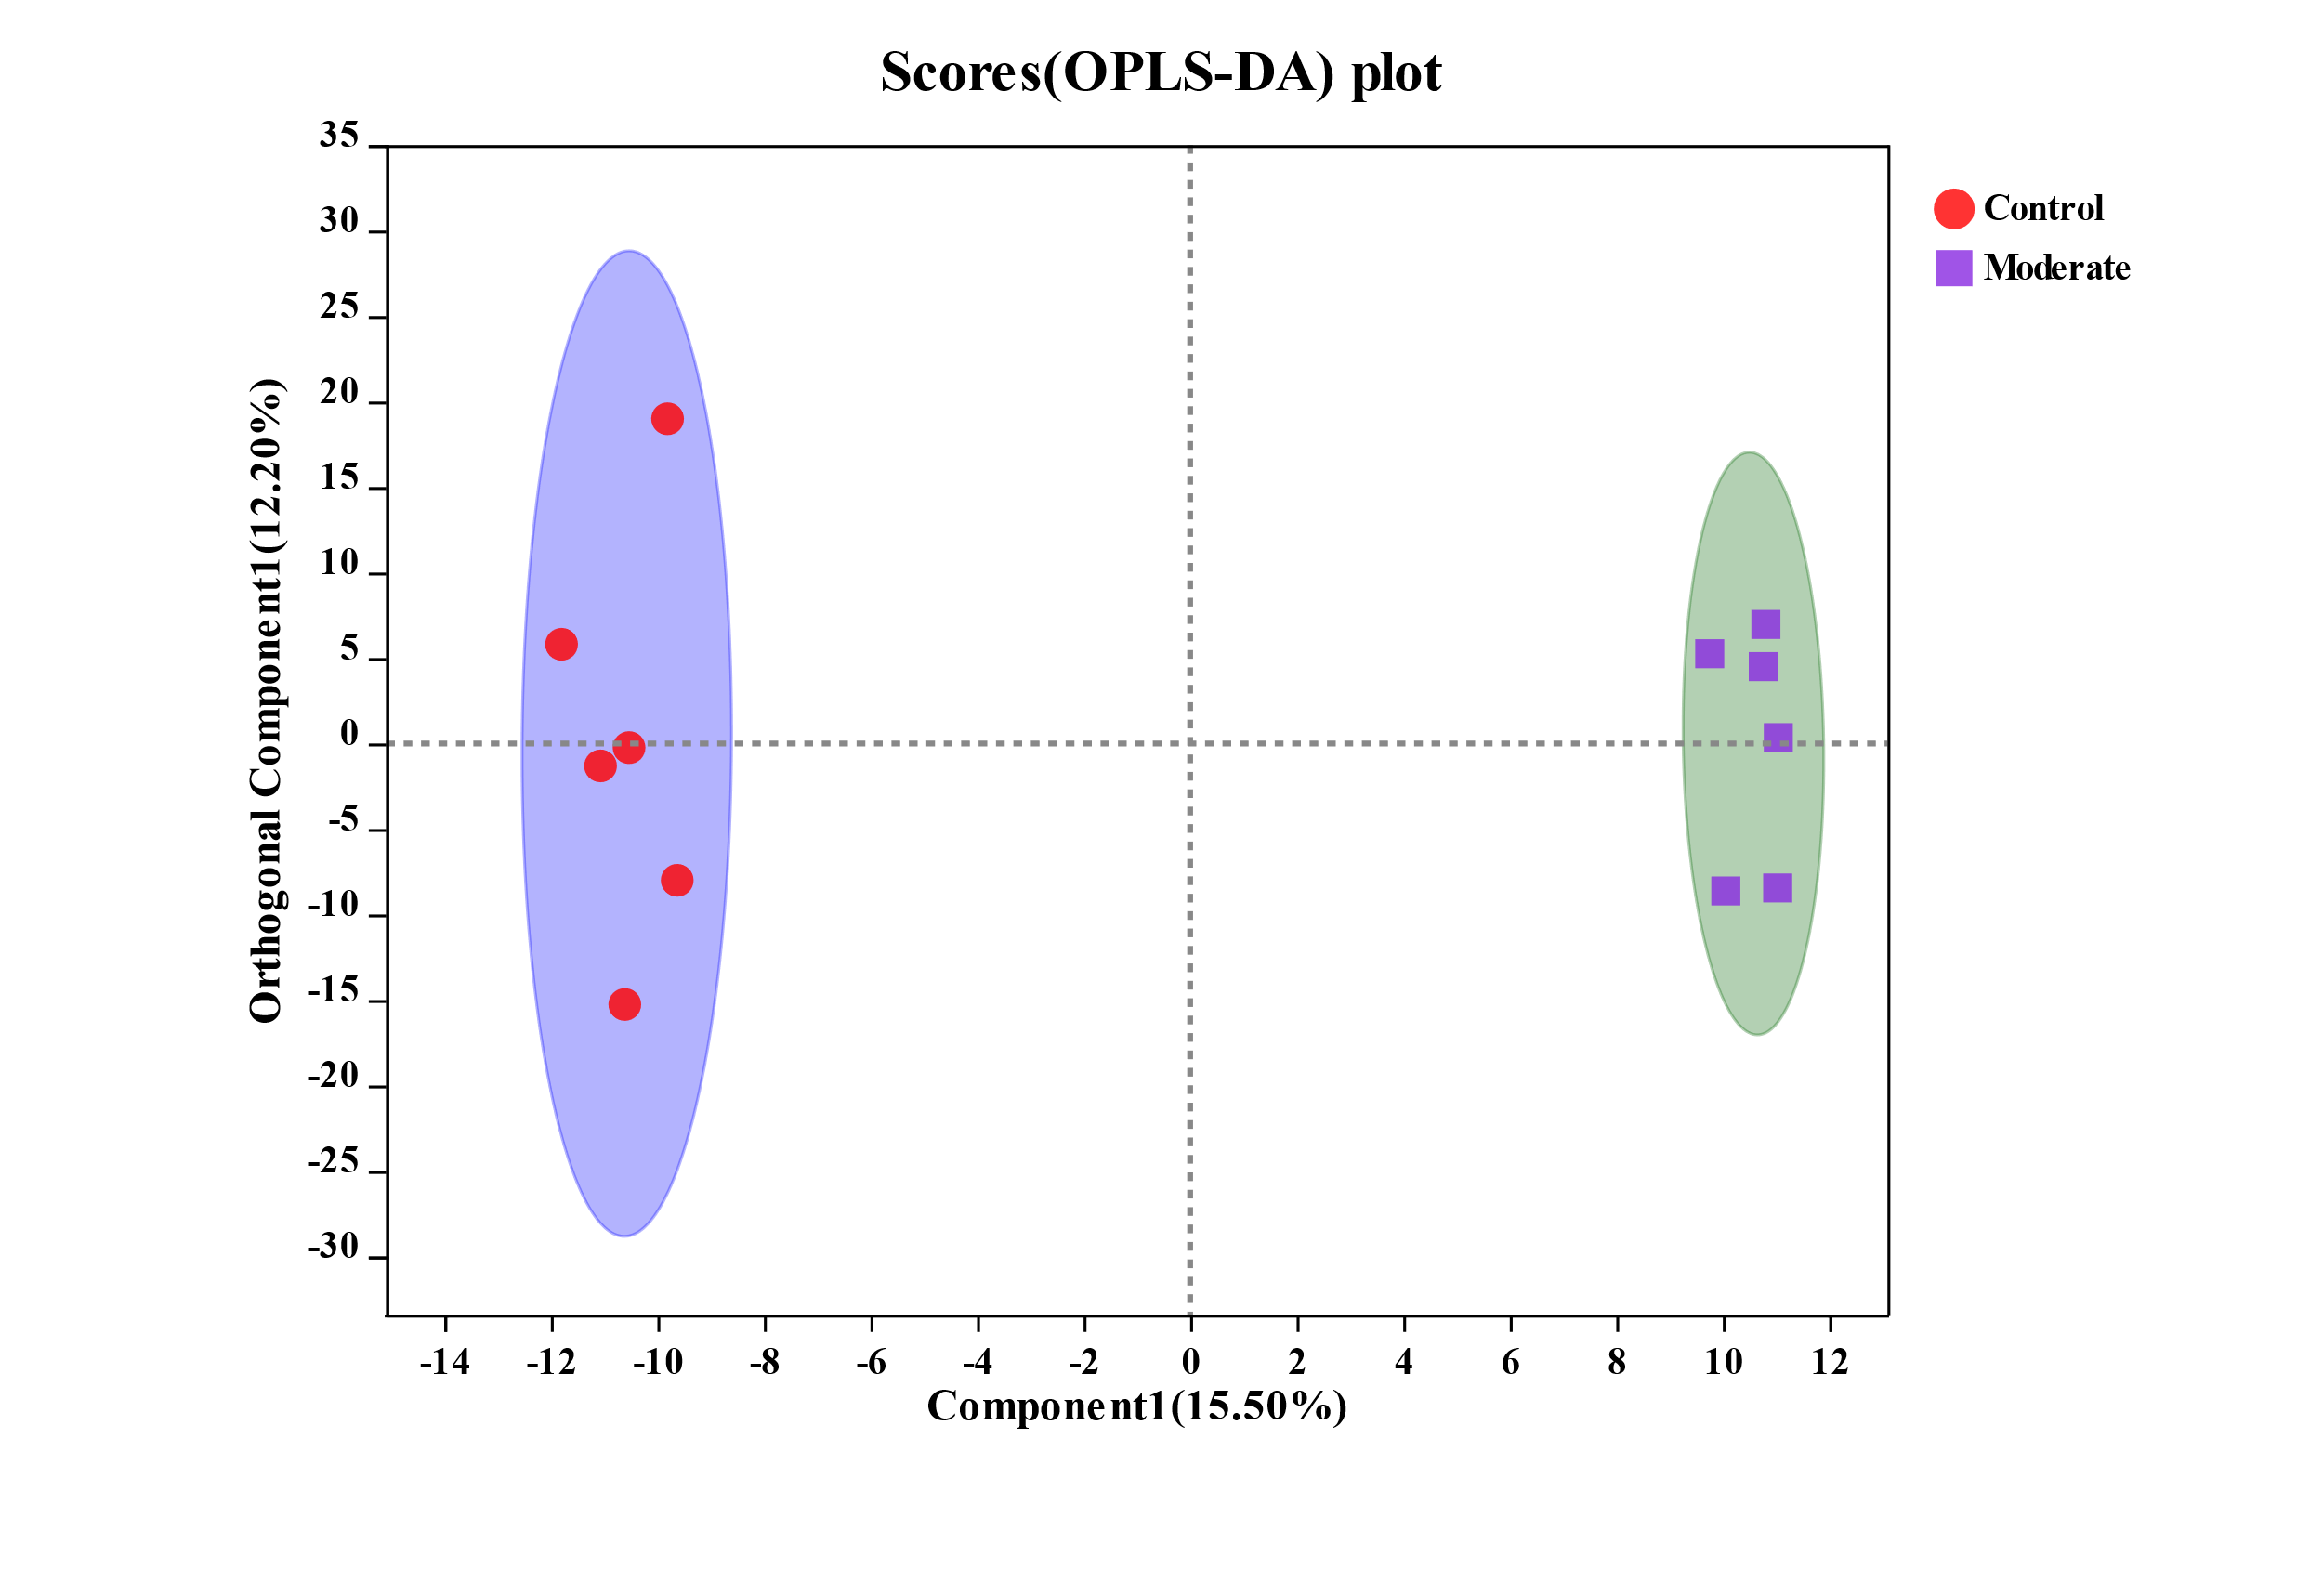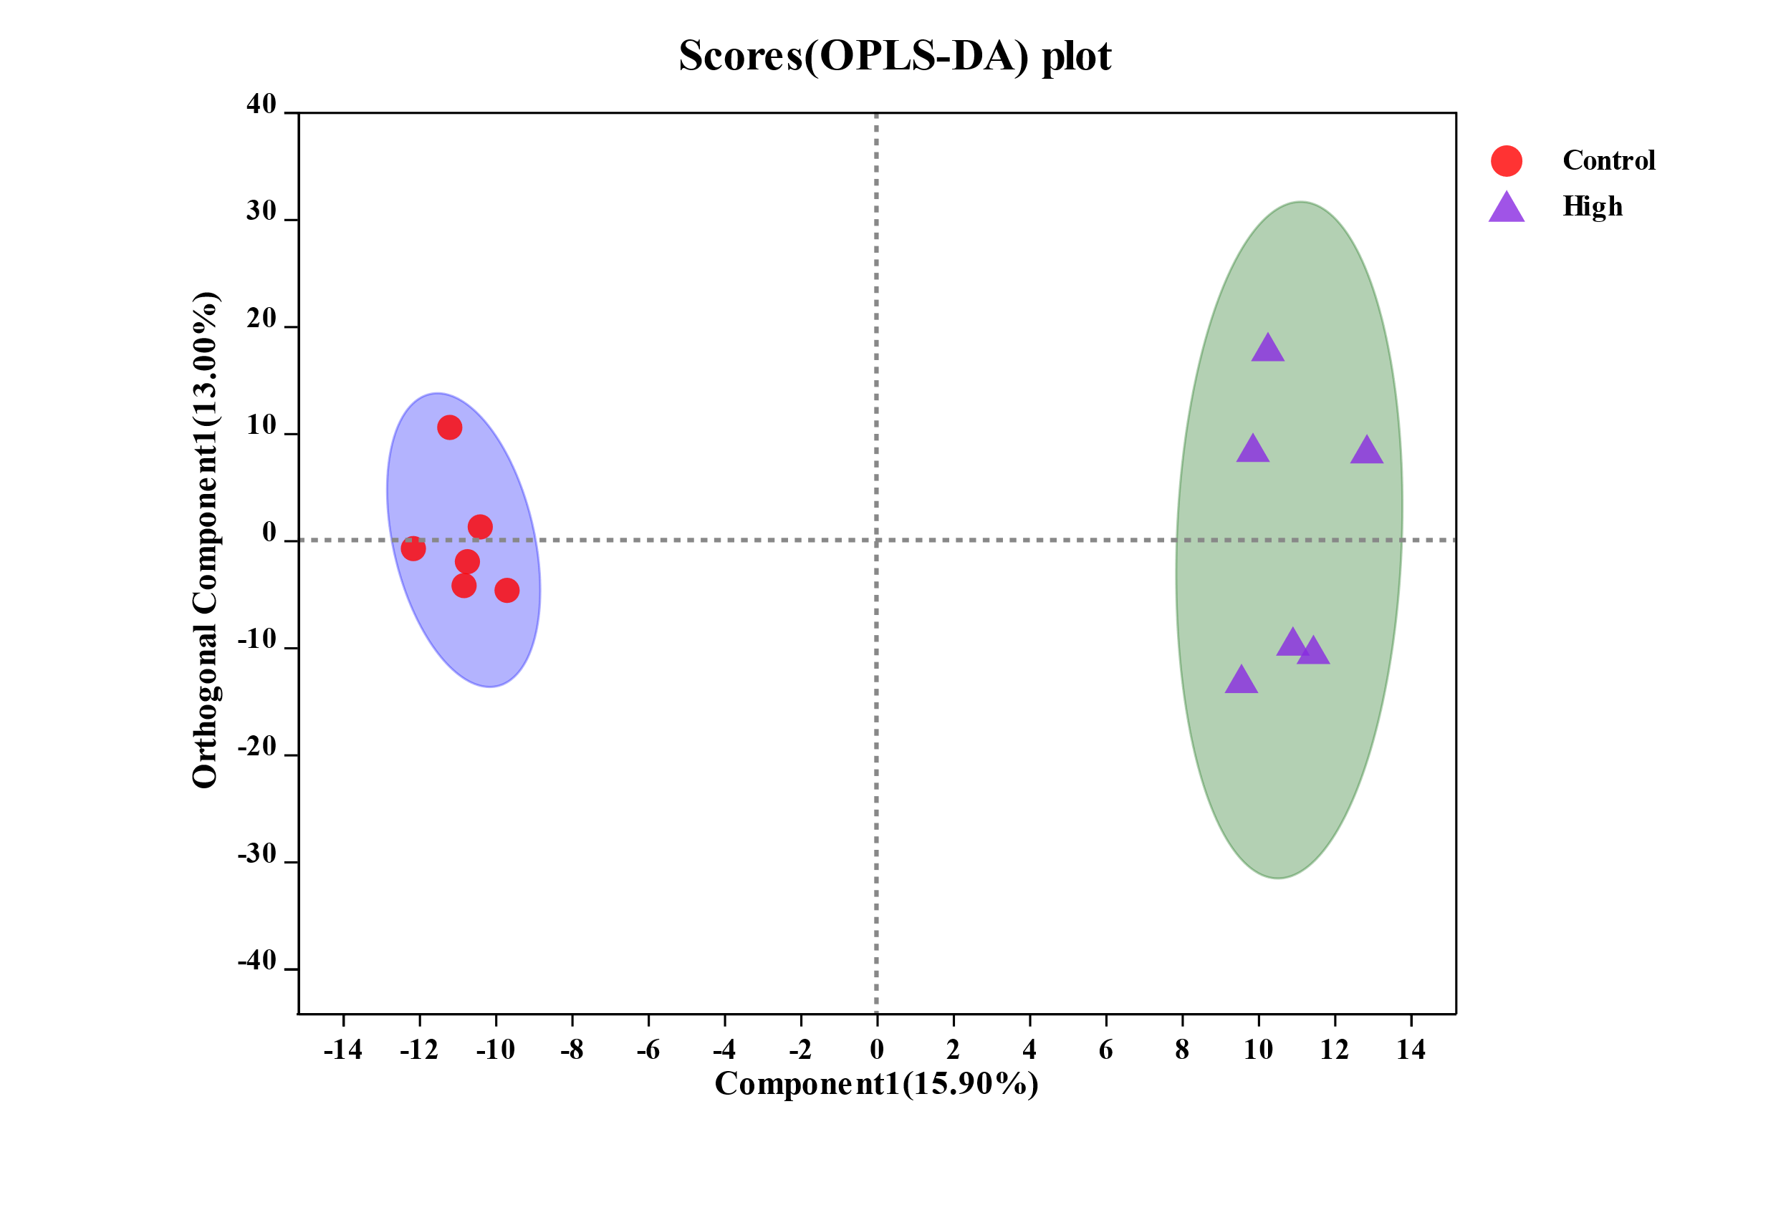

**Figure S1. Orthogonal projections to latent structures discriminant analysis (OPLS-DA) (A, B, C for negative ions, D, E, F for positive ions) scores plots of metabolites in intestines from the control and three BDE-47 treated groups.** The x-axis and y-axis represent the Component 1 and the Orthogonal component 1, respectively.