Supplementary Material

Article Title

# Classification Performance of fNIRS Features

The classification performance obtained from the model with only fNIRS features was lower (accuracy: 69%, precision: 0.68, recall: 0.68, F1 score: 0.68) compared to models with EEG features or with hybrid EEG and fNIRS features. We acknowledge that there is still room for improvement before practical application. As a result, we have not included these classification results in the main text. We added the classification performance with only fNIRS features in the supplementary material.

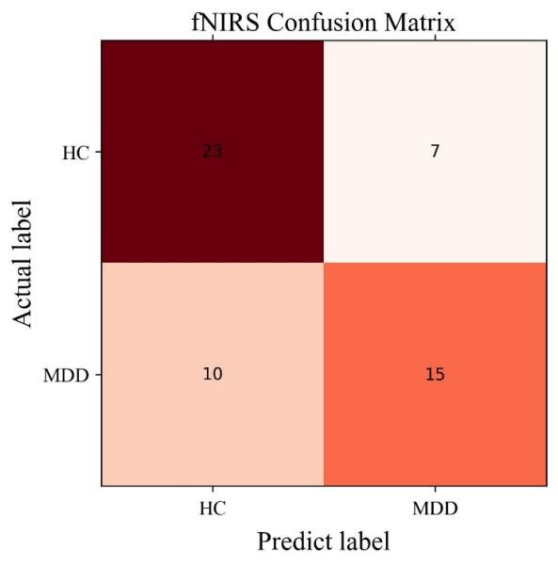

**Figure 1.** The confusion matrix for the SVM model with only fNIRS features.

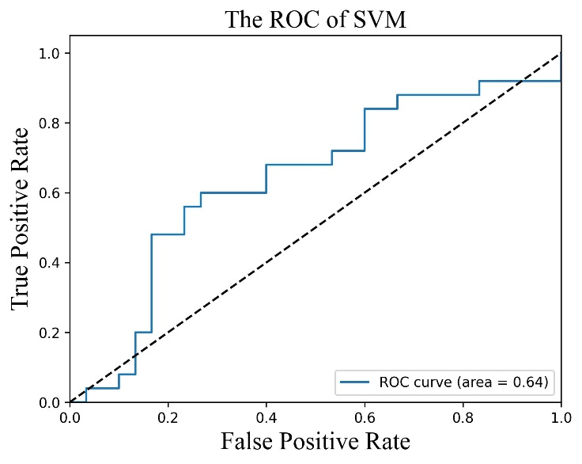

**Figure 2.** The ROC curve of the SVM models with only fNIRS features.