**ONLINE SUPPLEMENT**

**Cell-type specific transcriptome changes in the hypothalamic arcuate nucleus in a mouse deoxycorticosterone acetate (DOCA)-salt model of hypertension**

Valerie A. Wagner1,2, Guorui Deng3, Kristin E. Claflin3, McKenzie L. Ritter1, Huxing Cui3,4,5, Pablo Nakagawa1,6, Curt D. Sigmund1,6,7, Lisa L. Morselli8, Justin L. Grobe1,6,7,9,10,*, and Anne E. Kwitek1,6,10,11,*

1Department of Physiology, Medical College of Wisconsin, Milwaukee, WI

2Genetics Graduate Program, University of Iowa, Iowa City, IA

3Department of Neuroscience and Pharmacology, University of Iowa, Iowa City, IA

4Obesity Research and Education Initiative, University of Iowa, Iowa City, IA

5Fraternal Order of Eagles Diabetes Research Center, University of Iowa, Iowa City, IA

6Cardiovascular Center, Medical College of Wisconsin, Milwaukee, WI

7Neuroscience Research Center, Medical College of Wisconsin, Milwaukee, WI

8Department of Medicine, Division of Endocrinology and Molecular Medicine, Medical College of Wisconsin, Milwaukee, WI

9Comprehensive Rodent Metabolic Phenotyping Core, Medical College of Wisconsin, Milwaukee, WI

10Department of Biomedical Engineering, Medical College of Wisconsin, Milwaukee, WI

11Linda T. and John A. Mellowes Center for Genomic Sciences and Precision Medicine, Medical College of Wisconsin, Milwaukee, WI

* denotes co-corresponding authors

Running title: snRNAseq of arcuate nucleus after DOCA-salt

Correspondence:

Justin L. Grobe, PhD

Department of Physiology

Medical College of Wisconsin

8701 Watertown Plank Rd

Milwaukee, WI 53226

[jgrobe@mcw.edu](mailto:jgrobe@mcw.edu)

(414) 955-4981

or

Anne E. Kwitek, PhD

Department of Physiology

Medical College of Wisconsin

8701 Watertown Plank Rd

Milwaukee, WI 53226

[akwitek@mcw.edu](mailto:akwitek@mcw.edu)

(414) 955-8241

**Table S1. Sample Cohort**

|  |  |  |  |
| --- | --- | --- | --- |
| Condition | Animal ID | ARC Punch Count | Sample ID (samples pooled after nuclei isolation) |
| Sham | 539_4 | 2 | Sham 1 |
| 540_1 | 2 |
| 541_2 | 2 | Sham 2 |
| 540_3 | 1 |
| DOCA | 539_1 | 2 | DOCA 1 |
| 539_3 | 2 |
| 539_5 | 1 | DOCA 2 |
| 540_2 | 2 |

Bilateral arcuate nucleus (ARC) punches (10µm thick, 0.74 diameter) were obtained from brains of Sham (n=4) and DOCA-salt treated (n=4) mice, and nuclei were isolated. Nuclei obtained from individual mice were then quantitated and pooled to generate four pooled samples for snRNAseq with roughly similar abundances.

**Table S2.** **Quality control metric comparison of raw datasets versus a previously published single nucleus RNA-seq study of the mouse arcuate nucleus of the hypothalamus.**

|  |  |  |  |  |  |  |  |  |  |  |
| --- | --- | --- | --- | --- | --- | --- | --- | --- | --- | --- |
|  | ***Samples from current study*** | | | | ***Samples from our previous study (PMC7347451)*** | | | | | |
| **Sample / Mouse_ID:** | **Sham 1:**  **539-4 &**  **540-1** | **Sham 2:**  **541-2 &**  **540-3** | **DOCA 1:**  **539-1 &**  **539-3** | **DOCA 2:**  **539-5 &**  **540-2** | **536-1** | **536-3** | **536-5** | **536-2 &**  **536-4** | **537-1 &**  **537-3** | **537-5 &**  **538-2** |
| **Metrics before application of exclusion criteria** | | | | | | | | | | |
| **Estimated # of Cells** | 2,805 | 8,325 | 10,765 | 19,754 | 5,436 | 4,083 | 1,871 | 7,087 | 2,842 | 6,238 |
| **Median Genes per Cell** | 4,482 | 2,156 | 1,638 | 1,684 | 2,617 | 2,227 | 2,357 | 2,309 | 3,391 | 1,125 |
| **Reads Mapped Confidently to Genome (%)** | 89.2 | 87.6 | 91.0 | 92.0 | 78.7 | 87.1 | 87.6 | 83.2 | 86.8 | 85.2 |
| **Reads Mapped Confidently to Intergenic Regions (%)** | 6.8 | 7.2 | 7.0 | 6.5 | 6.0 | 6.4 | 6.8 | 6.1 | 7.2 | 6.5 |
| **Reads Mapped Confidently to Intronic Regions (%)** | 35.7 | 36.7 | 41.3 | 35.1 | 33.3 | 36 | 35.2 | 37.1 | 39.5 | 30.8 |
| **Reads Mapped Confidently to Exonic Regions (%)** | 46.8 | 43.8 | 42.7 | 50.4 | 39.4 | 44.7 | 45.5 | 40 | 40.1 | 47.8 |
| **Reads Mapped Confidently to Transcriptome (%)** | 43.9 | 41.1 | 39.8 | 47.7 | 37.3 | 42.6 | 43.2 | 37.9 | 37.9 | 45.7 |
| **Reads Mapped Antisense to Gene (%)** | 0.9 | 0.9 | 1.1 | 1.0 | 1.0 | 1.0 | 1.1 | 0.9 | 1.0 | 1.0 |
| **Total Genes Detected** | 21,084 | 21,557 | 21,253 | 21,584 | 21,399 | 21,686 | 20,700 | 21,762 | 21,395 | 21,316 |
| **Mean Reads per Cell** | 92,993 | 34,284 | 23,438 | 13,504 | 42,009 | 70,922 | 169,944 | 43,891 | 114,980 | 48,545 |
| **Sequencing Saturation (%)** | 34.9 | 27.2 | 29.4 | 20.0 | 30.7 | 45.6 | 75.7 | 36.9 | 59.1 | 49.1 |
| **Total Nuclei detected** | 2,203 | 7,759 | 10,307 | 18,906 | 4,996 | 16 | 1,609 | 6,421 | 2,405 | 5,570 |

**Table S3. Tissue masses after three weeks of DOCA-salt treatment.**

|  |  |  |  |
| --- | --- | --- | --- |
| **Tissue** | **Sham (n=7)** | **DOCA-salt (n=8)** | **p-value** |
| Interscapular brown adipose (mg)  (mg/g) | 75.7±11.8  4.9±0.4 | 105.7±14.7  4.1±0.5 | 0.140  0.103 |
| Inguinal white adipose (mg)  (mg/g) | 309±27  11.5±1.0 | 397±51  15.3±1.7 | 0.340  0.218 |
| Peri-gonadal white adipose (mg)  (mg/g) | 336±57  12.9±2.3 | 486±54  18.7±1.7 | 0.068  0.051 |
| Heart ventricles (mg)  (mg/g) | 138±8  5.3±0.4 | 124±5  4.8±0.1 | 0.142  0.241 |
| Liver (g)  (mg/g) | 1.14±0.05  43.8±2.7 | 1.31±0.06  51.2±2.4 | 0.066  0.053 |
| Kidneys (mg)  (mg/g) | 346±14  13.3±0.7 | 427±11  16.7±0.3 | 0.002  <0.001 |
| Adrenal glands (mg)  (mg/g) | 4.9±0.4  0.19±0.02 | 2.9±0.33  0.12±0.02 | 0.006  0.804 |

Data presented as mean±sem, and analyzed using 2-tailed independent t-tests.

**Table S5. Count and percent of Sham and DOCA-salt samples contributing to each cluster.**

|  |  |  |  |  |
| --- | --- | --- | --- | --- |
| Cluster | Sham | | DOCA-salt | |
| Nuclei Count | Nuclei Percent (%) | Nuclei Count | Nuclei Percent (%) |
| C0_Snhgll/Meg3 | 807 | 20.7 | 3090 | 79.3 |
| C1_Gm42418/Rpl41 | 1251 | 40 | 1880 | 60 |
| C2_GABAergic | 448 | 14.5 | 2650 | 85.5 |
| C3_Gm42418/Rps12 | 973 | 32.9 | 1985 | 67.1 |
| C4_Astrocytes 1 | 793 | 27.4 | 2100 | 72.6 |
| C5_Glutamatergic | 561 | 22.3 | 1952 | 77.7 |
| C6_Nap1i5/Isl1 | 779 | 31 | 1732 | 69 |
| C7_Astrocytes 2 | 370 | 20.2 | 1463 | 79.8 |
| C8_Oligodendrocytes 1 | 548 | 34 | 1064 | 66 |
| C9_Sim1 | 283 | 20.5 | 1095 | 79.5 |
| C10_Oligodendrocytes 2 | 324 | 26.9 | 881 | 73.1 |
| C11_preOligodendrocyte | 299 | 25.1 | 892 | 74.9 |
| C12_Pomc | 441 | 38.9 | 692 | 61.1 |
| C13_Endothelium | 276 | 29.6 | 655 | 70.4 |
| C14_Rgs16 | 161 | 17.4 | 762 | 82.6 |
| C15_Arpp21/Meis2 | 4 | 0.4 | 910 | 99.6 |
| C16_Sst/Dlk1 | 228 | 25.7 | 658 | 74.3 |
| C17_Ghrh | 179 | 23.7 | 575 | 76.3 |
| C18_Fezf1/Cacna2d1 | 102 | 13.7 | 645 | 86.3 |
| C19_Agrp | 246 | 35 | 456 | 65 |
| C20_Tac1/Ar | 64 | 12.3 | 458 | 87.7 |
| C21_Tanycytes | 143 | 28 | 367 | 72 |
| C22_KNDy | 148 | 32.7 | 305 | 67.3 |
| C23_Microglia 1 | 119 | 26.3 | 334 | 73.7 |
| C24_Tac1/Rreb1 | 2 | 0.5 | 374 | 99.5 |
| C25_Microglia 2 | 140 | 37.3 | 235 | 62.7 |
| C26_Pmch | 14 | 4 | 339 | 96 |
| C27_Astrocytes 3 | 78 | 24.8 | 236 | 75.2 |
| C28_Ptgds/Atp1a2 | 83 | 36.1 | 147 | 63.9 |
| C29_Slc18a2/Hdc | 59 | 29.5 | 141 | 70.5 |
| C30_Slc5a7/Elavl2 | 10 | 10.8 | 83 | 89.2 |
| C31_Oligodendrocytes 3 | 29 | 33.7 | 57 | 66.3 |

**Table S8. Count and percent of Sham and DOCA-salt samples contributing to each neuropeptide-related subcluster.**

|  |  |  |  |  |
| --- | --- | --- | --- | --- |
| Cluster | Sham | | DOCA-salt | |
| Nuclei Count | Nuclei Percent (%) | Nuclei Count | Nuclei Percent (%) |
| N_SC0_Agrp/Npy/Sst/Lrp1b | 203 | 33.1 | 411 | 66.9 |
| N_SC1_Lamp5/Tcf7l2 | 218 | 35.7 | 393 | 64.3 |
| N_SC2_Agrp/Npy/Acvr1c | 151 | 28.6 | 377 | 71.4 |
| N_SC3_Six3/Col25a1 | 107 | 25.5 | 312 | 74.5 |
| N_SC4_KNDy | 128 | 31.5 | 278 | 68.5 |
| N_SC5_Ghrh/Gal | 82 | 26.0 | 233 | 74.0 |
| N_SC6_Crabp1/Vgll3 | 113 | 38.8 | 178 | 61.2 |
| N_SC7_Cartpt/Trh | 43 | 16.3 | 220 | 83.7 |
| N_SC8_Pomc/Cartpt | 96 | 50.3 | 95 | 49.7 |
| N_SC9_Agrp/Npy | 69 | 46.6 | 79 | 53.4 |
| N_SC10_Gal/Gpr50 | 6 | 8.3 | 66 | 91.7 |
| N_SC11_Slc6a3/Th | 26 | 37.1 | 44 | 62.9 |

**Table S26. Count and percent of Sham and DOCA-salt samples contributing to each cluster of activated microglia subclusters.**

|  |  |  |  |  |
| --- | --- | --- | --- | --- |
| Cluster | Sham | | DOCA-salt | |
| Nuclei Count | Nuclei Percent (%) | Nuclei Count | Nuclei Percent (%) |
| M_SC0_Csf2rb/Hpgd | 118 | 86.1 | 19 | 13.9 |
| M_SC1_Itgam/Sall1 | 11 | 10.5 | 94 | 89.5 |
| M_SC2_Ptprd/Sorbs2 | 4 | 8.2 | 45 | 91.8 |
| M_SC3_Gjc3/Lmo4 | 3 | 6.8 | 41 | 93.2 |
| M_SC4_Ncf1/Tyrobp | 4 | 10.0 | 36 | 90.0 |

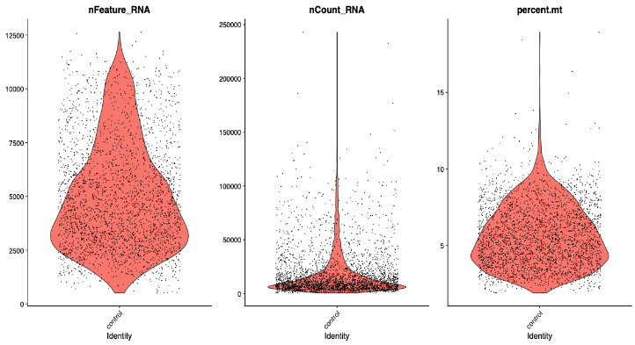

**Sham 1 (539-4 & 540-1)**

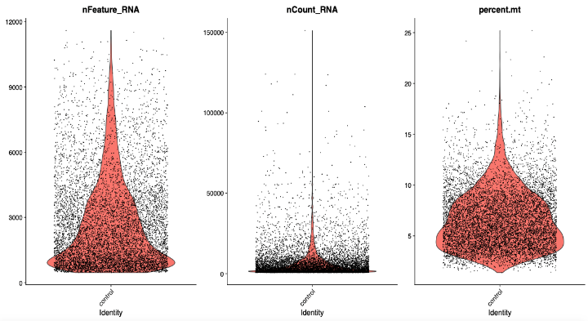

**Sham 2 (541-2 & 540-3)**

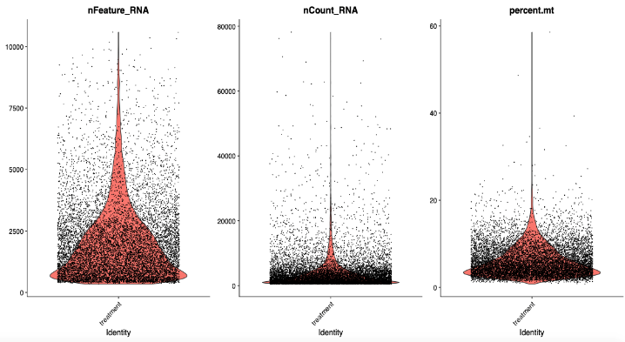

**DOCA 1 (539-1 & 539-3)**

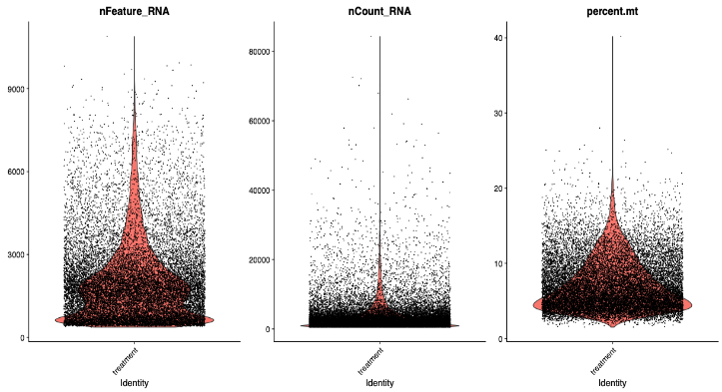

**DOCA 2 (539-5 & 540-2)**

**A**

**B**

**C**

**D**

**Figure S1.** **Quality control metrics prior to application of exclusion criteria in arcuate nucleus of the hypothalamus isolated nuclei.** Expressed gene count (nFeature), transcript count (nCount_RNA), and percent mitochondrial gene expression (percent.mt) from Sham (A) and DOCA-salt treated datasets (B). Percent of nuclei contributing to study dataset split by experimental conditions (Sham, DOCA) (C) and by sample ID (D).

**Sham 1(539-4 & 540-1)**

**Sham 2 (541-2 & 540-3)**

**DOCA 1 (539-1 & 539-3)**

**DOCA 2 (539-5 & 540-2)**

**A**

**B.**

**C**

**D**

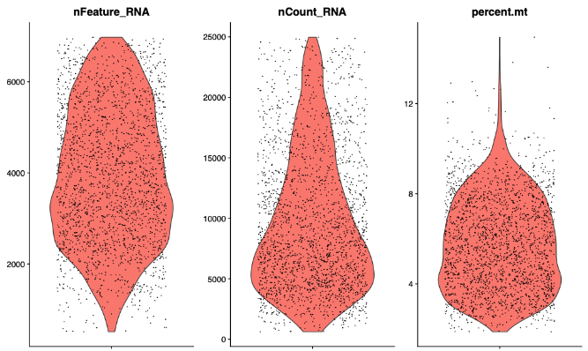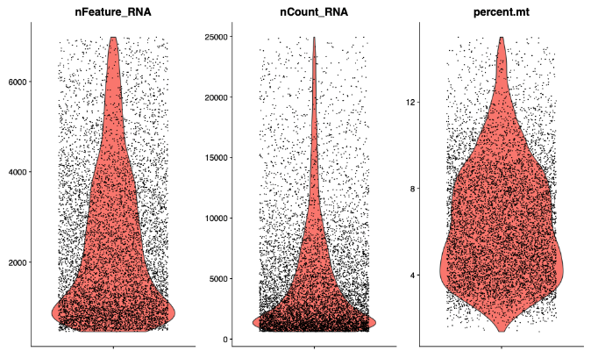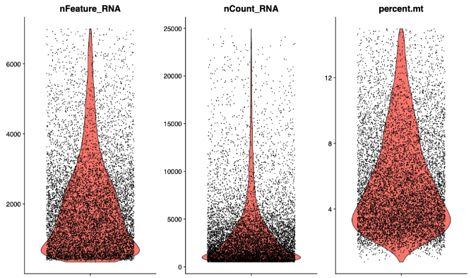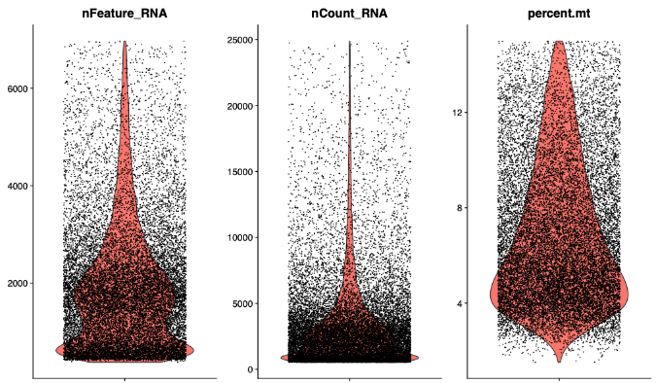

**Figure S2.** **Quality control metrics after application of exclusion criteria in arcuate nucleus of the hypothalamus isolated nuclei.** Expressed gene count (nFeature), transcript count (nCount_RNA), and percent mitochondrial gene expression (percent.mt) from Sham (A) and DOCA-salt treated datasets (B). Percent of nuclei contributing to study dataset split by experimental conditions (Sham, DOCA) (C) and by sample ID (D).