Supplementary Material

Quantitative Texture Analysis Comparison of Three Legumes
Rebekah Miller*, Susan Duncan, Yin Yun, Bo Zhang, Jacob Lahne
* Correspondence: Rebekah Miller: rebekahm20@vt.edu

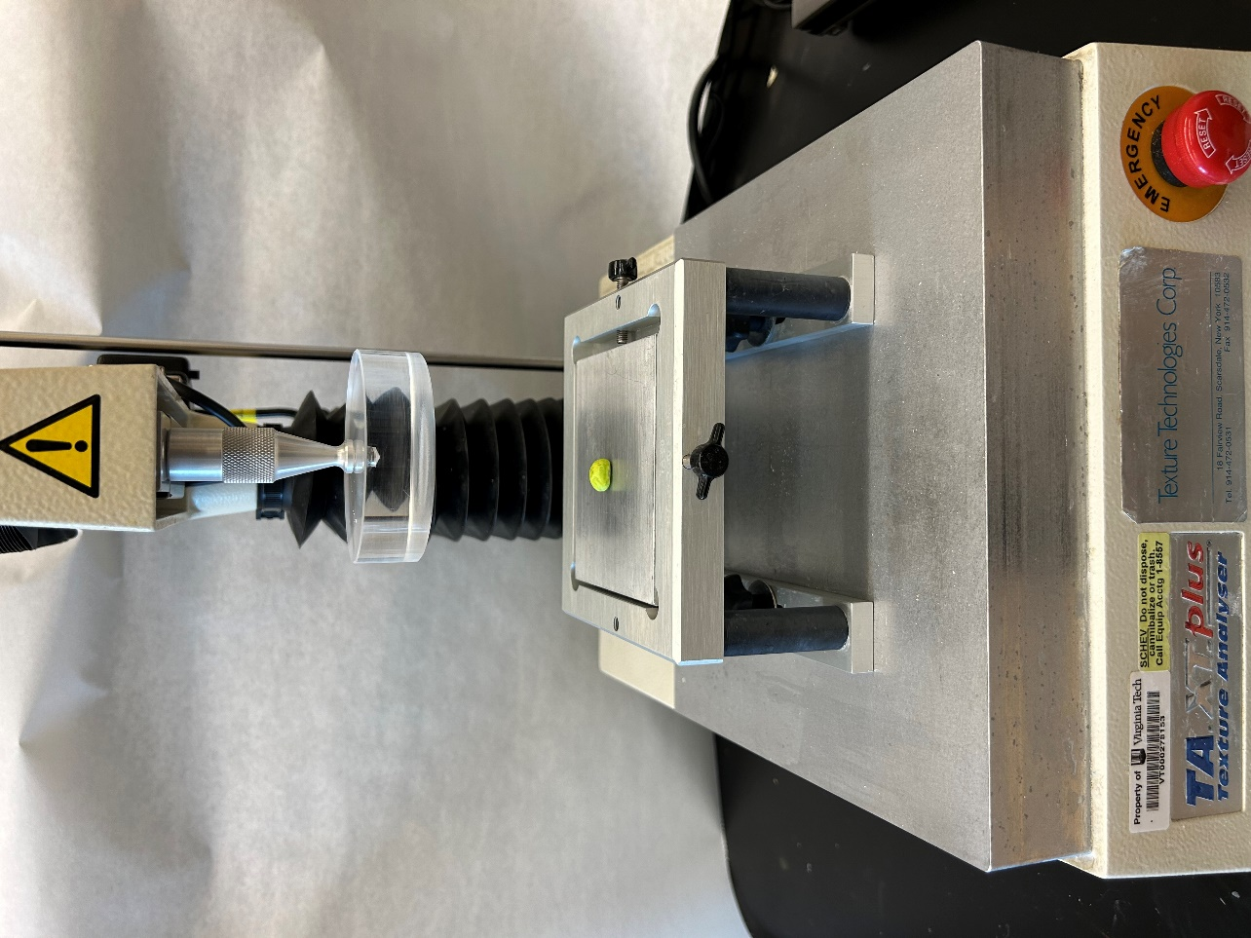
Supplementary Figure
Supplementary Figure 1. TA XT Plus texture analyzer by Texture Technologies Corporation (Hamilton, MA) used in this study fitted with the compression probe and edamame bean in place for analysis.

