Supplementary Material

PLX4032 resistance of patient-derived melanoma cells: crucial role of oxidative metabolism

**Ombretta Garbarino1✝, Giulia Elda Valenti1✝, Lorenzo Monteleone1, Gabriella Pietra1,2, Mingari Maria Cristina1,2, Andrea Benzi3, Santina Bruzzone2,3, Silvia Ravera4, Riccardo Leardi5, Emanuele Farinini5, Stefania Vernazza1, Melania Grottoli1, Barbara Marengo1✝ and Cinzia Domenicotti1*✝**

**✝** These authors contributed equally to this work

**\* Correspondence:**Cinzia Domenicotti[cinzia.domenicotti@unige.it](mailto:cinzia.domenicotti@unige.it)

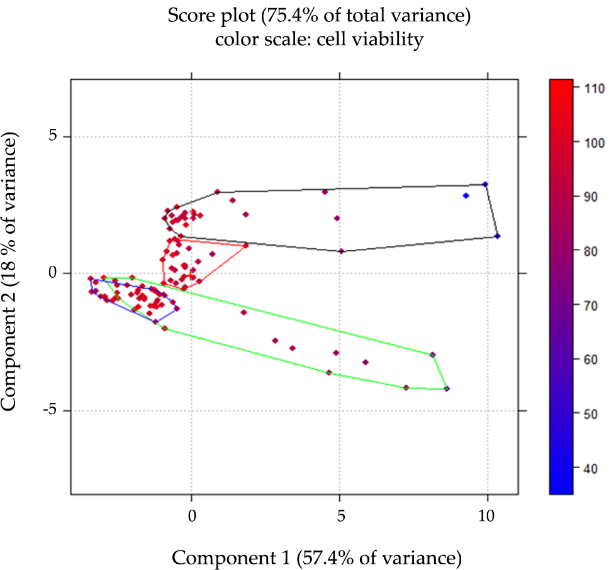

**Supplementary Figure 1.** Supplementary data. The score plot displays the objects in the component space, with each sample connected by a convex hull according to the cell line and the type of resistance (MeOV-DMSO-R, MeOV-PLX-R, MeTA-DMSO-R, MeTA-PLX-R) and colored according to the independently measured viability variable (r=-0.89; p<0.05).