**Appendix A. Individual Tagging Model**

App. Tables 1 - 3 below provide the mathematical terms and equations of the individual tagging model that operates within the existing ABTMSE framework (Anon 2021).

App. Table. 1. Subscript terms for fishery dynamics model and individual tagging model

|  |  |
| --- | --- |
| **Subscript** | **Description** |
| *t* | Time step (year – quarter) |
| *a* | Age |
| *r* | Area (area moving to) |
| *k* | Area moving from |
| *f* | Fleet |
| *s* | Stock |
| *i* | Individual tag number |

App. Table 2. Parameter and variable names for fishery dynamics model and individual tagging model. Note that the MSE calculations include have *F*, *N*, *Y* and *R* parameters that vary by simulation. For simplicity, a subscript for simulation is not included in the mathematical description of the model below.

|  |  |
| --- | --- |
| **Parameter / Variable** | **Description** |
| $$F_{t,a,r,f}$$ | Instantaneous fishing mortality rate (per time step, year - quarter) |
| $$M_{t,a,s}$$ | Instantaneous natural mortality rate (per time step, year - quarter) |
| $$N_{t,a,r,s}$$ | Number of individual fish at liberty (both untagged and tagged) |
| $$R_{t,r}$$ | Number of released tags |
| $$T_{i,t,a,r,s}$$ | State of tagged fish at liberty before survival and movement in time step *t.* |
| $${\dot{T}}_{i,t,a,r,s}$$ | State of tagged fish after survival in time step *t* |
| $${\ddot{T}}_{i,t,a,r,s}$$ | State of tagged fish after survival and movement in time step *t* |
| $$H_{i,t,s}$$ | Observed tag history |
| $$P_{t,a,r,s}$$ | Expected magnitude of exploitation |
| $$S_{i,t,a,r,s}$$ | Individual survival switch |
| $$Y_{t,a,r,k,s}$$ | Movement probability (from area *k* to area *r*) |
| $$U_{t,a,r,s}$$ | Harvest rate (fraction of individual caught by fishing) |
| $$L_{i,t,a,s}$$ | Probability of recapturing a tag |
| $$K_{i,t,a,s}$$ | Recapture switch |
| $$W_{i,t,a,s}$$ | Probability of harvesting a tag |

App. Table 3. Equations for individual tagging model in order of operation: survival, movement, release / recapture, harvesting.

|  |  |
| --- | --- |
| **Tagged fish survival** | Eqn. |
| Natural individual tag survival *S*, is sampled from a binomial distribution: $$S_{i,t,a,r,s}\sim bin\left(n=1, p=e^{-M_{t,a,s}}\right)$$ If the tagged fish survives, the initial tagged state $\dot{T}$ is unchanged from the final state $T$ of the previous time step. Otherwise the tagged fish dies (S = 0) and the tagged state becomes zero: $${\dot{T}}_{i,t,a,r,s}={S_{i,t,a,r,s}T}_{i,t-1,a,r,s}$$ | 1  2 |
| **Tagged fish movement** |  |
| The state of tags is subject to movement according to a seasonal, spatial, age-specific, stock-specific movement matrix *Y* leading to a distribution of expected tag fractions $\ddot{T}$, among areas *r*: $${\ddot{T}}_{i,t,a,r,s}=\sum_{k}{{\dot{T}}_{i,t,a,r,s}Y_{t,a,r,k,s}}$$ | 3 |
| **Tag releases** |  |
| For each of the tag releases *R*, in each time step *t*, and area *r*, the tag is assigned to age *a*, and stock *s*, according to a multinomial distribution: $$T_{i,t,a,r,s}\sim multinom\left(n=1, p=\frac{P_{t,a,r,s}}{\sum_{a}{\sum_{s}{P_{t,a,r,s}}}} \right)$$ where the probability of a tag release in a given age and stock is determined by the relative frequency of operating model numbers *N*, multiplied by fishing mortality rate *F*: $$P_{t,a,r,s}=N_{t,a,r,s}\sum_{f}{F_{t,a,r,f}}$$ | 4  5 |
| **Initializing tag history** |  |
| The observed tag history *H*, is recorded for each tag *i*, and uses integer numbers to record a release (*H* = 1), no new information (*H* = 0), an at-sea recapture and re-release (*H* > 1 where the number reflects the number of at-sea recaptures of the same tagged fish) or a negative integer (H < 0) that reflects the index of the fleet that harvested the tagged fish. When a tag is initially released *H* is updated to reflect a new release: $$H_{i,t,s}= \left\{ \begin{matrix}1 & \sum_{r}{T_{i,t,a,r,s}}=1 \\ 0 & \sum_{r}{T_{i,t,a,r,s}}=0\end{matrix}\right.$$ | 6 |
| **Tag recaptures at sea** |  |
| Tag recapture probability is determined by the total harvest rate *U,* calculated from the fishing mortality rate *F*, across all fleets f: $$U_{t,a,r}=\left(1-e^{-\sum_{f}{F_{t,a,r,f}}}\right)$$ The recapture probability *L* of a given tag *i*, in a given area *r,* is the total harvest rate multiplied by the tag distribution: $$L_{i,t,a,r,s}=U_{t,a,r}{\ddot{T}}_{i,t,a,r,s}$$   Tag recapture events are sampled from a binomial distribution determined by the product of recaptures probabilities over all areas: $$K_{i,t,a,s}\sim bin\left(1, 1-\prod_{r}{1-L_{i,t,a,r,s}}\right)$$ Given a tag recapture (*K* = 1) the recapture is assigned to a single area based on the probability of recapture by area: $$T_{i,t,a,r,s}=\left\{\begin{matrix}\sim multinom\left(1, \frac{L_{i,t,a,r,s}}{\sum_{r}{L_{i,t,a,r,s}}} \right) & K_{i,t,a,s}=1 \\ {\ddot{T}}_{i,t,a,r,s} & K_{i,t,a,s}=0\end{matrix}\right.$$ The tag history is updated to log a new recapture of the same tag: $$H_{i,t,s}= \left\{ \begin{matrix}H_{i,t-1,s}+1 & K_{i,t,a,s}=1 \\ H_{i,t-1,s} & K_{i,t,a,s}=0\end{matrix}\right.$$ This tag recapture model assumes that fish are genotyped in proportion to the seasonal and spatial pattern of recaptures by the various fishing fleets. Note that in these simulations, due to the very low mark rate (less than 1 in 10,000 fish are tagged), sampling a fish that is already tagged and re-releasing it, rarely occurs. | 7  8  9  10  11 |
| **Tag harvesting** |  |
| Tag harvesting events are sampled from a binomial distribution determined by the product of the harvest rate over all areas: $$W_{i,t,a,s}\sim bin\left(1, 1-\prod_{r}{1-U_{t,a,r}}\right)$$ Given a harvesting event, the area the tag was recaptured in is determined by a multinomial distribution where the area is sampled based on the relative magnitude of the harvest rate in each area: $$T_{i,t,a,r,s}=\left\{\begin{matrix}\sim multinom\left(1, \frac{U_{t,a,r}}{\sum_{r}{U_{t,a,r}}} \right) & W_{i,t,a,s}=1 \\ 0 & W_{i,t,a,s}=0\end{matrix}\right.$$ Similarly, the fleet responsible for recapture is recorded in the tag history as the negative value of the fleet index (an integer value). The fleet index is sampled from a multinomial distribution based on the relative magnitude of fishing mortality rate *F*: $$H_{i,t,s}= \left\{ \begin{matrix}-\sim multinom\left(1, \frac{F_{t,a,r,f}}{\sum_{f}{F_{t,a,r,f}}} \right) & W_{i,t,a,s}=1 \\ H_{i,t-1,s} & W_{i,t,a,s}=0\end{matrix}\right.$$ | 12  13  14 |

**Appendix B. Multiyear Brownie Estimator**

The Brownie model (Brownie 1978, 1985; as cited in Hoenig et al. 1998) is an approach for estimating annual survival in a population from multiple years of tagged releases of animals and subsequent recaptures over time. The model has proven to be flexible framework and allows for modifications to relax the strict assumptions, such as the immediate, complete mixing of the tags into the population and complete tag retention (see Hoenig et al. 1998 and Waterhouse and Hoenig, 2011, as examples) which are typically associated with tagging models. Methodological improvements have re-parameterized survival into fishing mortality and natural mortality components, increasing the model’s utility for fisheries assessment (Hoenig et al. 1998).

In a Brownie model, we first consider the number of tags released in year *i* (*Ri,s*) for stock *s* (for simplicity, subscript *s* is dropped hereafter, but the Brownie estimator is applied independently for each stock). Assuming immediate mixing of tagged fished into the population, the number of tagged fish *Υi,j* of cohort *i* in year *j* would be:

$Υ_{i,j}=\left\{\begin{matrix}R_{i} & i=j \\ Υ_{i,j-1}\exp\left(-\left[F_{j-1}+M\right]\right)ϕ & i<j\end{matrix}\right.$ (Eqn. 1)

where *Fj* is the instantaneous fishing mortality rate (where the harvest rate, *U* of equation 1 of the main text is calculated *U* = 1-*e-F*) in year *j*, *M* is the natural mortality, and *ϕ* is the chronic tag retention rate (here assumed to be one).

For Atlantic bluefin tuna, a modification is made for incomplete mixing within the year of release:

$Υ_{i,j}=\left\{\begin{matrix}R_{i} & i=j \\ Υ_{i,j-1}\exp\left(-\left[q_{j-i-1}F_{j-1}+M\right]\right)ϕ & i<j\end{matrix}\right.$. (Eqn. 2)

The catchability of within-year recaptures, relative to those in later years, is expected to be higher as fish initially remain in the area in which they were tagged. This difference is represented by parameter *qk* where *k*=*j-i* is the time lag between release and recapture in calendar years and is modeled as a separable effect on *Fj*. After one year, tags is considered to be fully mixed into the population, i.e., *qk* =1 for *k*=1,2,3,…

For years *i*≤j, the recaptures *Δi,j* are predicted by the Baranov equation:

$Δ_{i,j}=\frac{{q_{j-i}F}_{j}}{{q_{j-i}F}_{j}+M}\left(1-\exp{\{-[q_{j-i}F_{j}+M]\}}\right)Υ_{i,j}λ$ (Eqn. 3)

where *λ* is the tag reporting rate. Here a 100% reporting rate was assumed (*λ* = 1).

The log-likelihood *L* of the model uses a multinomial distribution for the fates of tag cohort *i* over years *i*≤*j*:

$L=\sum_{i}{\left(\sum_{i≤j}{\left[h_{i,j}log⁡({\hat{p}}_{i,j})\right]}+(R_{i}-Σ_{i}h_{i,j})log⁡(1- Σ_{i}{\hat{p}}_{i,j})\right)}$ (Eqn. 4)

where *hi,j* is the observed number of recaptures, ${\hat{p}}_{i,j}=Δ_{i,j}/R_{i}$ is the predicted proportion of tags recaptured, with the hat operator (^) denoting an estimate, and the last term in the equation is the likelihood component of tags that have not been seen since release. Here, the estimated parameters were *Fj* and *qk*=0.

The Brownie model has been implemented in Template Model Builder (TMB), an R package for implementing rapid, complex models (Kristensen et al. 2016) which provides estimated precision for leading model parameters, for example the precision in estimates of annual harvest rates $\overline{σ}$.

**References**

Anon. 2021. Specifications for MSE trials for Atlantic bluefin tuna. Version 21-03. September 9, 2021. International Commission for the Conservation of Atlantic Tunas. Retrieved from: https://www.iccat.int/GBYP/DOCS/MSE_Trials_Specifications_v21-03.pdf [June 2023]

Brownie, C., Anderson, D.R., Burnham, K.P., and Robson, D.S. 1978. Statistical inference from band recovery data - a handbook. U.S. Fish Wildl. Serv. Resour. Publ. No. 131.

Brownie, C., Anderson, D.R., Burnham, K.P., and Robson, D.S. 1985. Statistical inference from band recovery data: a handbook. 2nd ed. U.S. Fish Wildl. Serv. Resour. Publ. No. 156.

Hoenig, J.M., Barrowman, N.J., Pollock, K.H., Brooks, E.N., Hearn, W.S., and Polacheck T. 1998. Models for tagging data that allow for incomplete mixing of newly tagged animals Can. J. Fish. Aquat. Sci. 55: 1477-1483.

Kristensen, K., Nielsen, A., Berg, C.W., Skaug, H., and Bell, B.M. 2016. TMB: Automatic Differentiation and Laplace Approximation. J. Stat. Soft. 70. doi:10.18637/jss.v070.i05

Waterhouse, L., and Hoenig, J.M. 2011. Instantaneous-Rates Tagging Models Allowing for Delayed Mixing of Newly Tagged Cohorts: Partial Year Tabulation of Recaptures. N. Am. J. Fish. Manage. 31: 995-1004.

**Supplementary Materials**

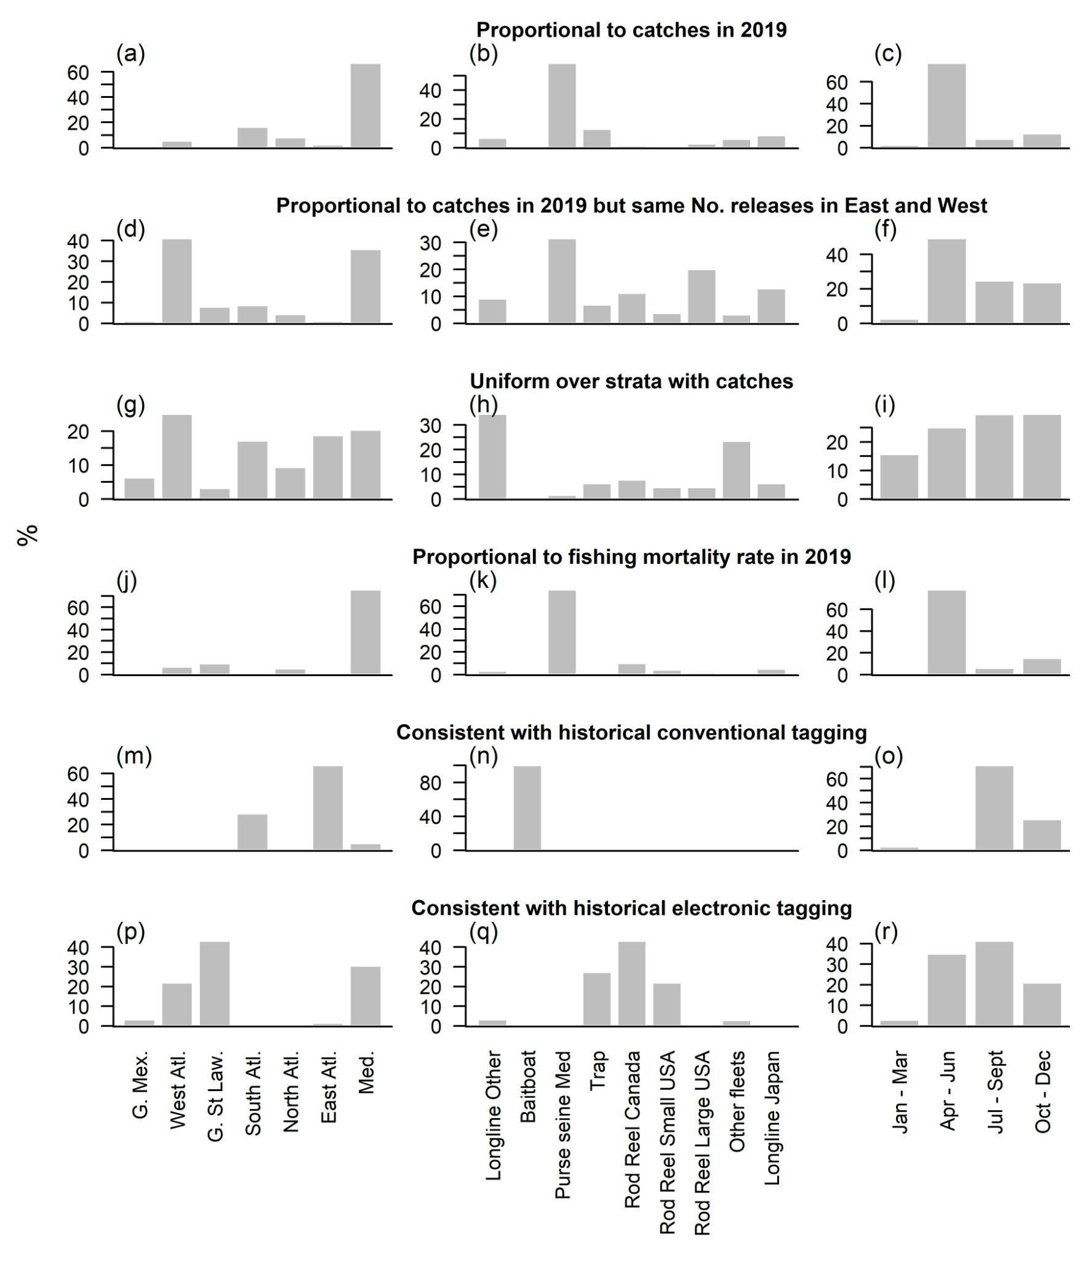

Figure 1. The distribution of tag releases by area, fleet and season for the six simulated tag release experimental designs (rows). Recreational hand line and rod and reel fleets are included in ‘Other fleets’ and make up less than 0.5% of catches (1986-2021).

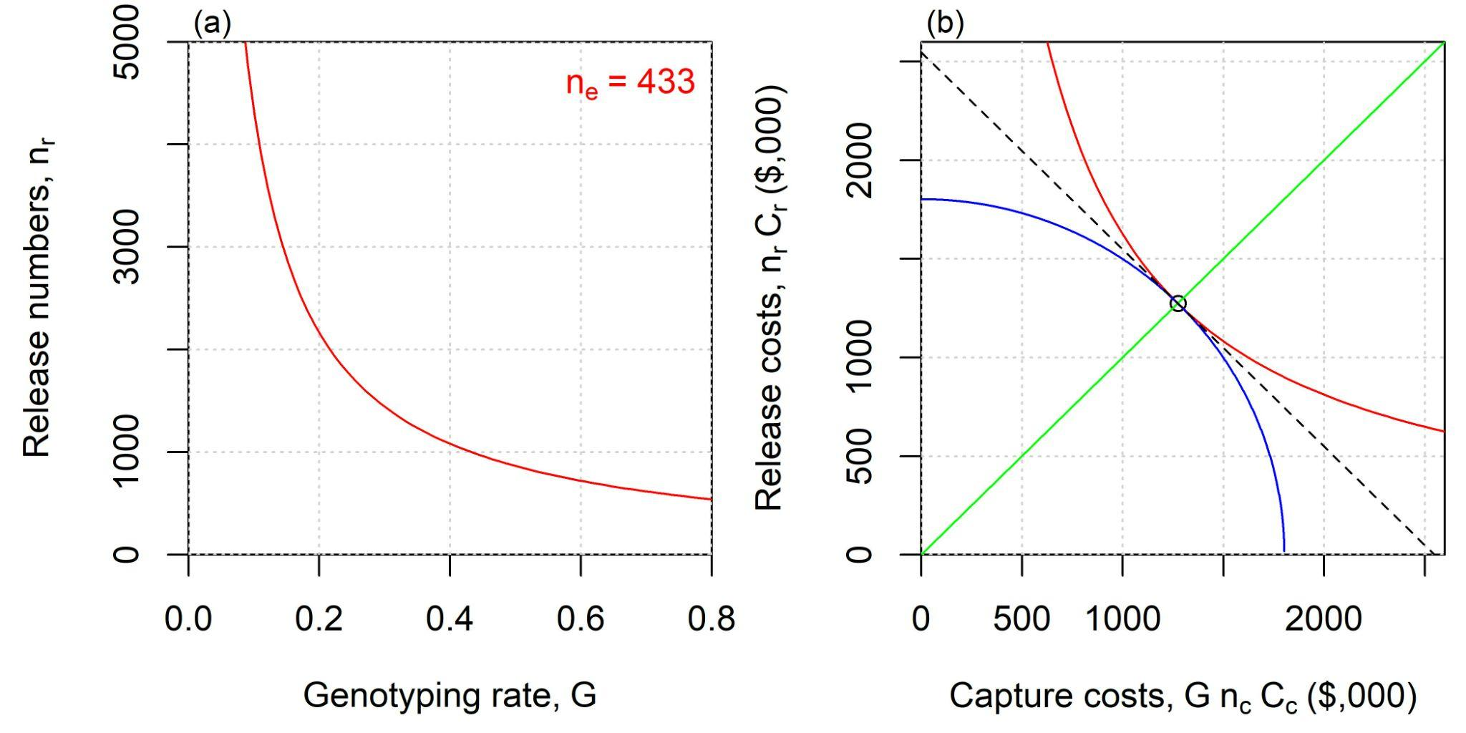

Figure 2. Release (*nrCr*) costs equal recapture costs (*GncCc*) where total cost is minimized with respect to genotyping rate *G*. The red line represents the combination of genotyping rate (*G*) and release numbers (*nr*) that provide the specified number of effective releases (*ne* = *Gnr*). Panel b presents the costs of the *G* and *nr* combinations of panel a (red line). The black point represents the lowest overall cost (*nrCr* + *GncCc*) of any combination of *G* and *nr* values whose product equals *ne*. The blue line represents combinations of *G* and *nr* that correspond with the lowest total cost of values. The green 1:1 line represents equal release and recapture costs. Panel b demonstrates that since total cost is additive with respect to *G* and *nr*, given these assumptions, the optimal (cheapest) tagging design will always have equal release and capture costs. This illustrative example is for the western linear model and default parameter values (see left hand side of Table 3: *ne* = 433, *nc*= 250,000, *Cc* = $15, *Cr* = $1,000).