**APPENDIX I: Survey dataset summary**

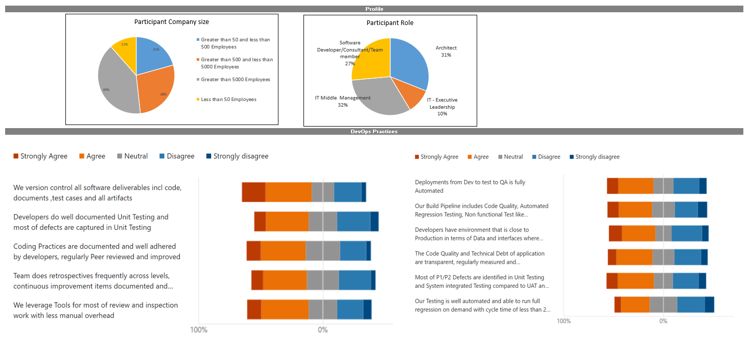

**APPENDIX II : Comparison of outcomes with various classification algorithms**

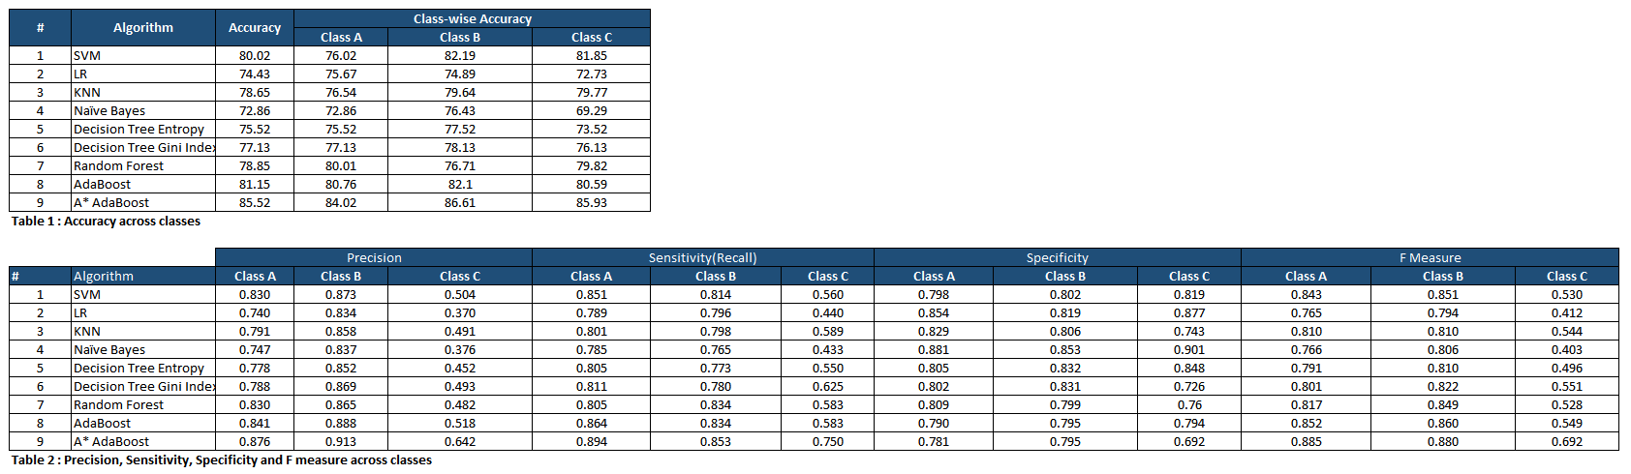

Accuracy, precision, recall and f measure computation.

Confusion Matrix sample

|  |  |  |  |
| --- | --- | --- | --- |
|  | Class A | Class B | Class C |
| Not Recommended | 304 | 29 | 14 |
| Highly Recommended | 17 | 350 | 16 |
| Recommended | 19 | 31 | 90 |

Accuracy = (TP + TN) / (TP + TN + FP + FN)

Accuracy = (304 + 350 + 90) / (304 + 29 + 14 + 17 + 350 + 16 + 19 + 31 + 90) ≈ 0.8785 (87.85%)

Precision = TP / (TP + FP)

Precision (Not Recommended) = 304 / (304 + 17 + 19) ≈ 0.9039 (90.39%)

Precision (Highly Recommended) = 350 / (350 + 29 + 31) ≈ 0.8844 (88.44%)

Precision (Recommended) = 90 / (90 + 14 + 16) ≈ 0.7684 (76.84%)

Recall = TP / (TP + FN)

Recall (Not Recommended) = 304 / (304 + 29 + 14) ≈ 0.8852 (88.52%)

Recall (Highly Recommended) = 350 / (350 + 17 + 16) ≈ 0.9378 (93.78%)

Recall (Recommended) = 90 / (90 + 31 + 19) ≈ 0.6545 (65.45%)

F1-measure = 2 * (Precision * Recall) / (Precision + Recall)

F1-measure (Not Recommended) = 2 * (0.9039 * 0.8852) / (0.9039 + 0.8852) ≈ 0.8945 (89.45%)

F1-measure (Highly Recommended) = 2 * (0.8844 * 0.9378) / (0.8844 + 0.9378) ≈ 0.9102 (91.02%)

F1-measure (Recommended) = 2 * (0.7684 * 0.6545) / (0.7684 + 0.6545) ≈ 0.7062 (70.62%)

**Figure 3 : Accuracy**

**Figure 4 : Sensitivity, Specificity and F Measure comparison across classes**