Supplementary Material

Genome-wide characterization of soybean DOMAIN OF UNKNOWN FUNCTION 679 membrane protein (DMP) gene family highlights their potential involvement in growth and stress response.

**Bhagwat Nawade 1,2†, Tejas C. Bosamia3†, Jae Hyun Lee1,2, Jin Hoon Jang1,2, and Ok Ran Lee1,2\***

**\* Correspondence:** Ok Ran Lee (mpizlee@jnu.ac.kr)

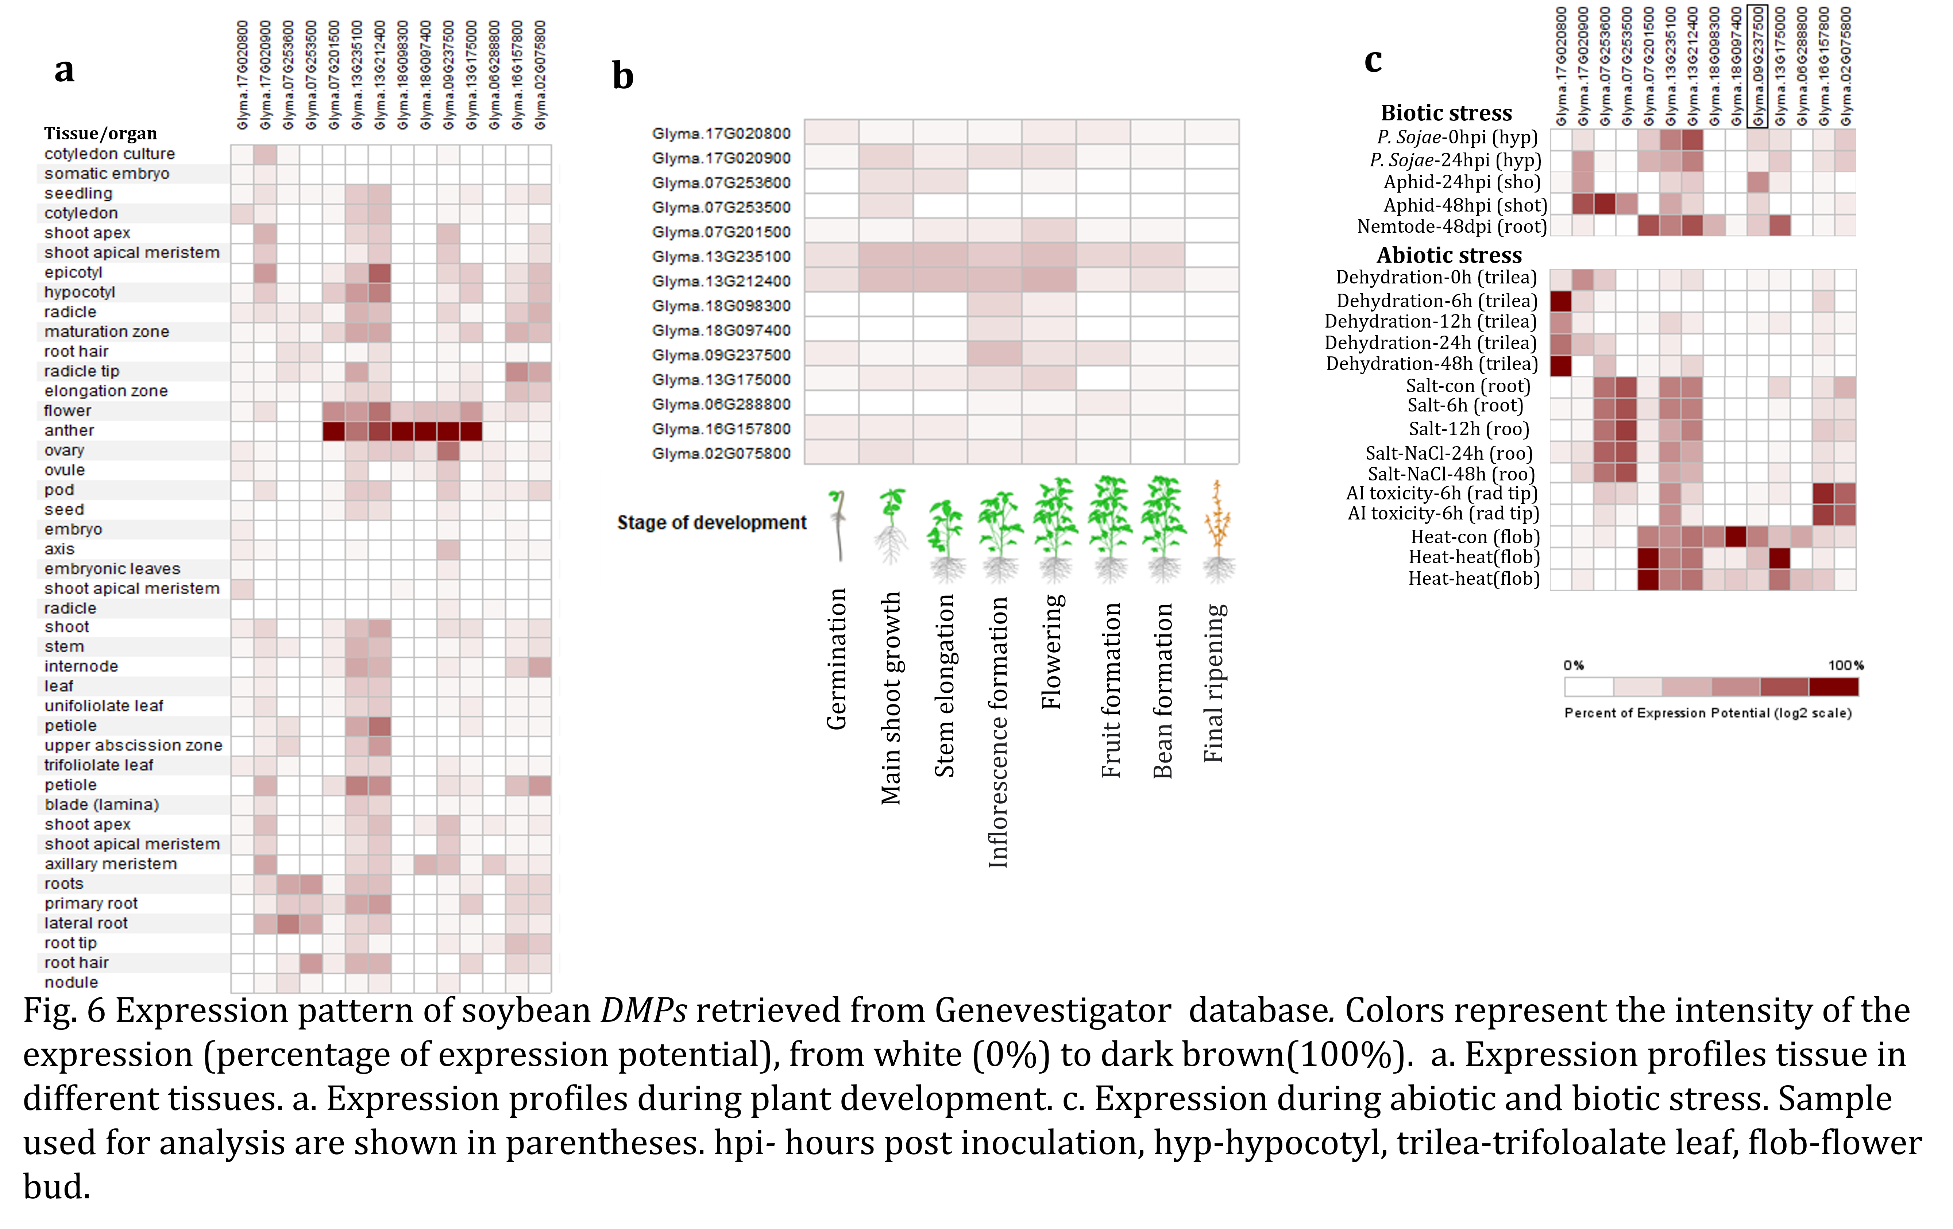

**Supplementary Figure S1.** Expression pattern of soybean *DMPs* retrievedfrom Genevestigator database*.* Colors represent the intensity of the expression (percentage of expression potential), from white (0%) to dark brown (100%). **a.** Expression profiles tissue in different tissues. **b.** Expression profiles during plant development. **c.** Expression during abiotic and biotic stress. Samples used for analysis are shown in parentheses. hpi*-* hours post-inoculation, hyp-hypocotyl, trilea-trifoloalate leaf, flob-flower bud.