***Supplementary Material 5-******Results of trim-and-fill method***

**Effects of Potentilla discolor Bunge extracts on oxidative stress and glycolipid metabolism in diabetic animal models: A systematic review and meta-analysis**

Yunjiao Yang, Wen Deng, Yue Wu, Changyan Zi, Qiu Chen,*

**\*Corresponding author:** Qiu Chen

E-mail: [chenqiu1005@cdutcm.edu.cn](mailto:chenqiu1005@cdutcm.edu.cn)

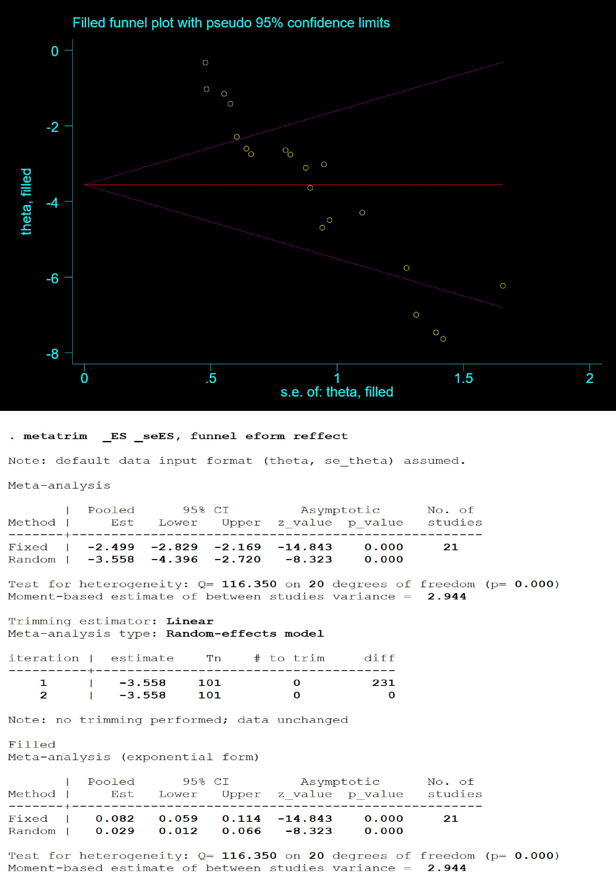

**Figure 1.** Result of trim-and-fill method for the effect of PDB extracts on FBG

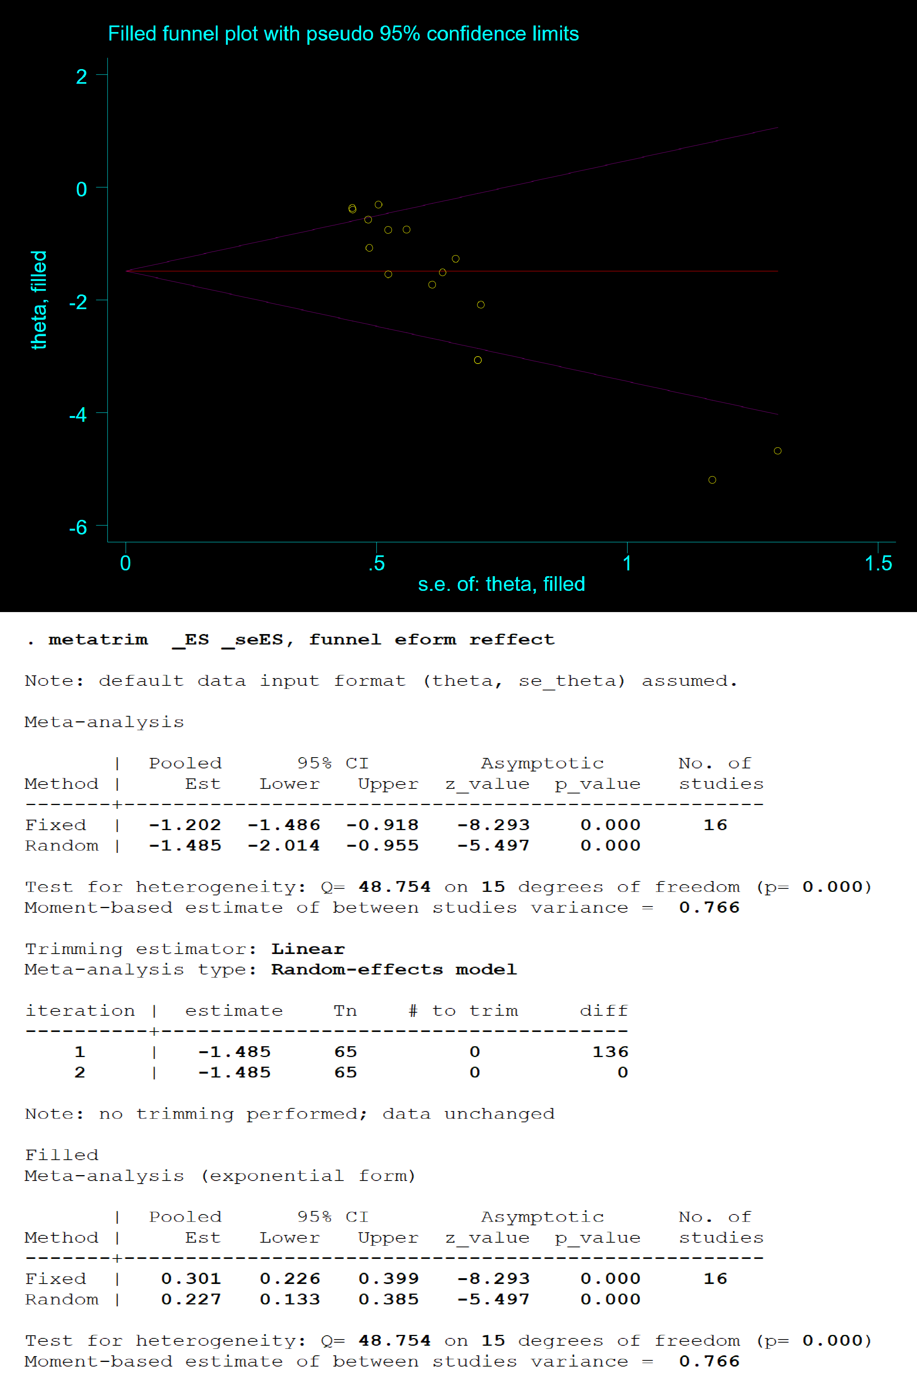

**Figure 2.** Result of trim-and-fill method for the effect of PDB extracts on TG

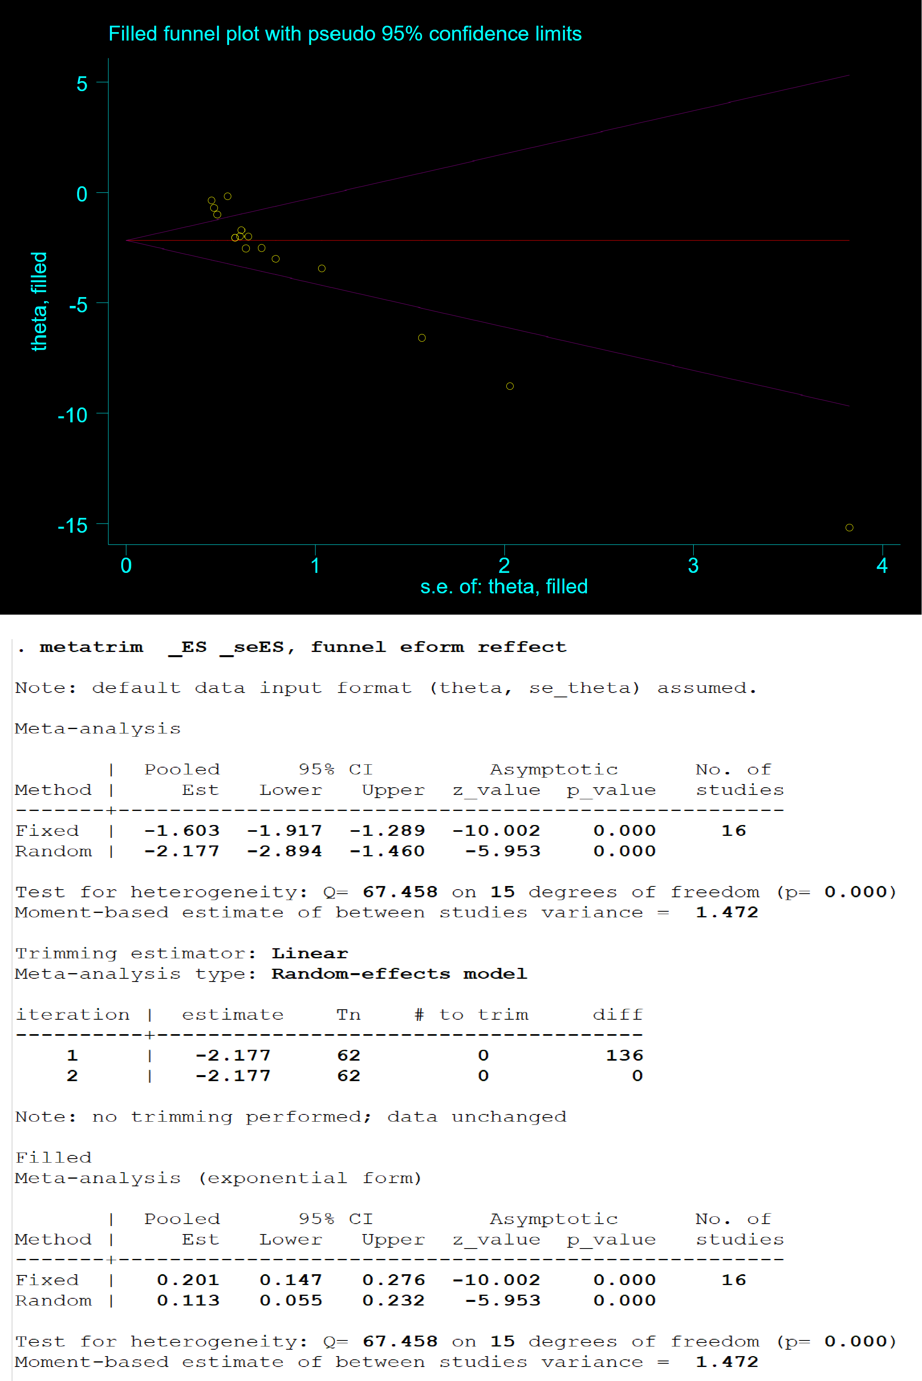

**Figure 3.** Result of trim-and-fill method for the effect of PDB extracts on TC

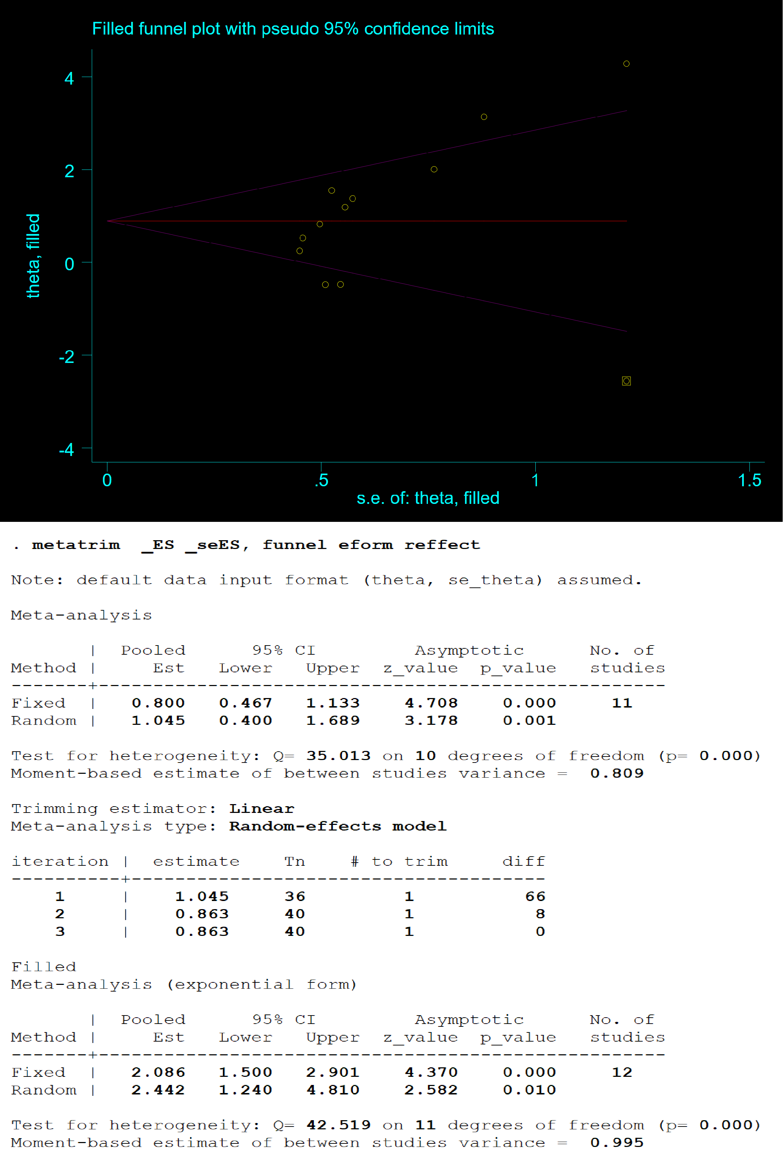

**Figure 4.** Result of trim-and-fill method for the effect of PDB extracts on HDL-C

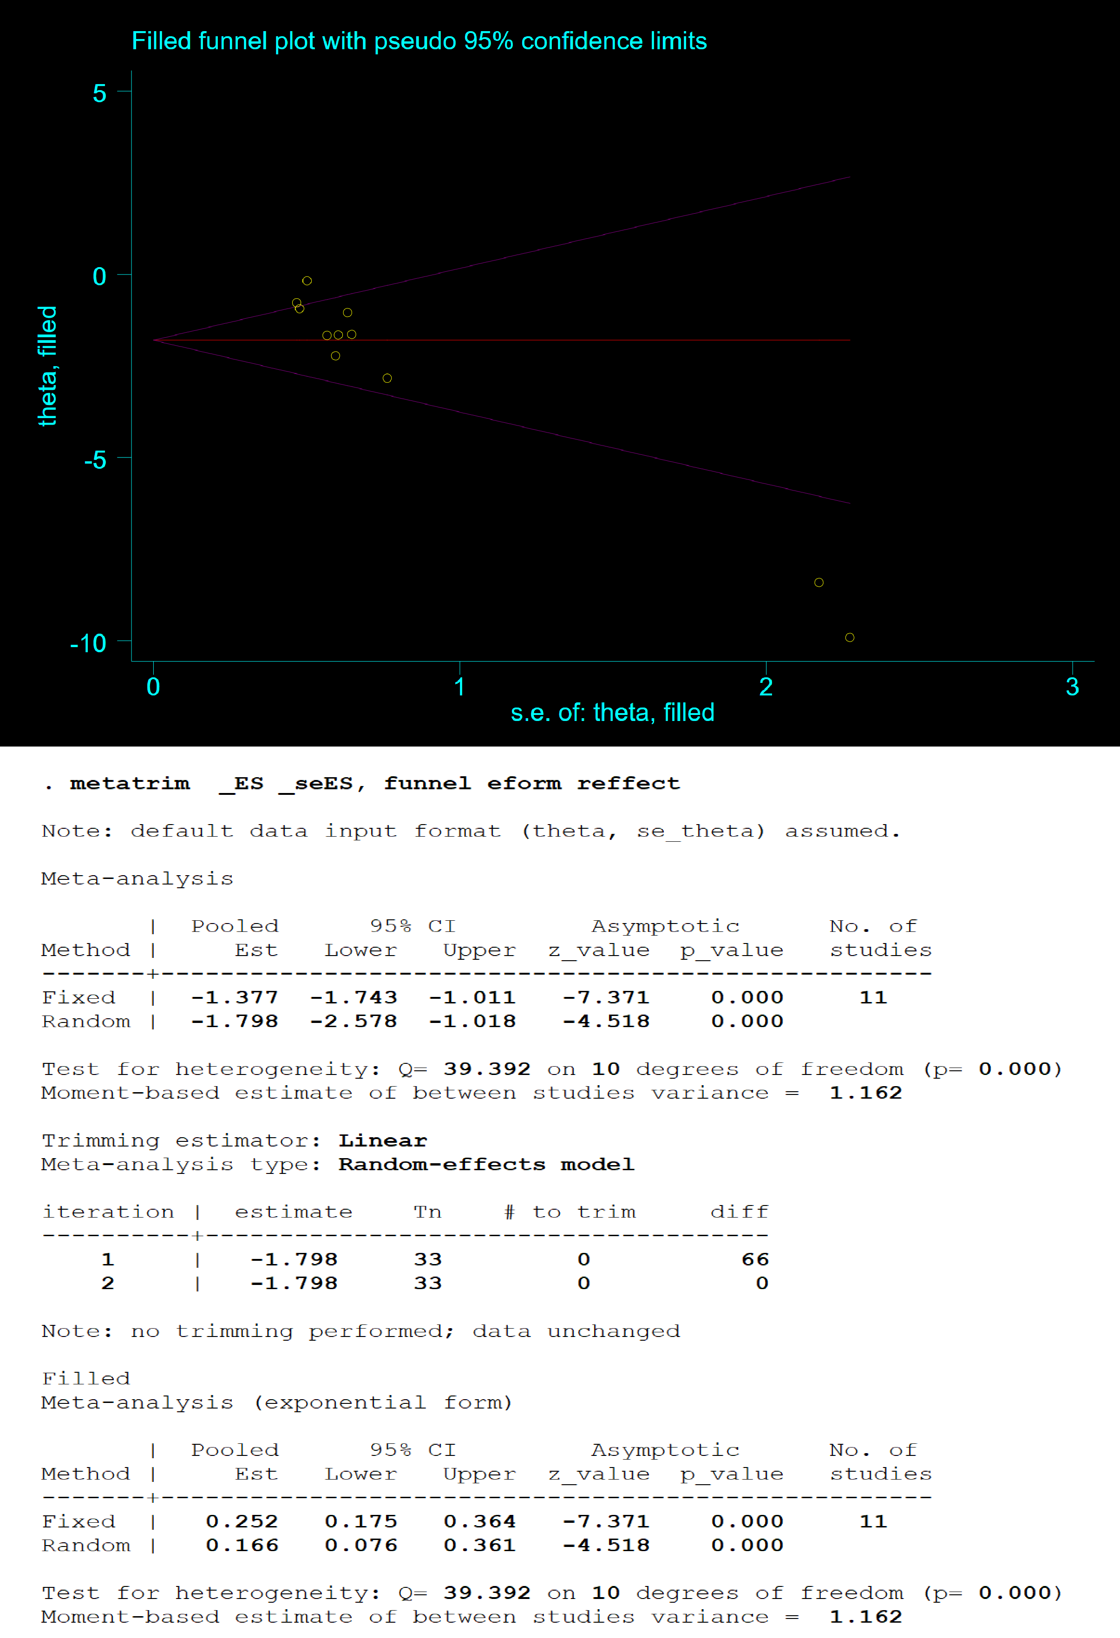

**Figure 5.** Result of trim-and-fill method for the effect of PDB extracts on LDL-C

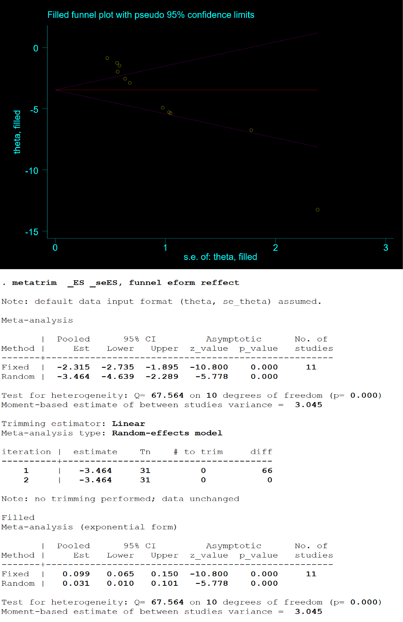

**Figure 6.** Result of trim-and-fill method for the effect of PDB extracts on MDA

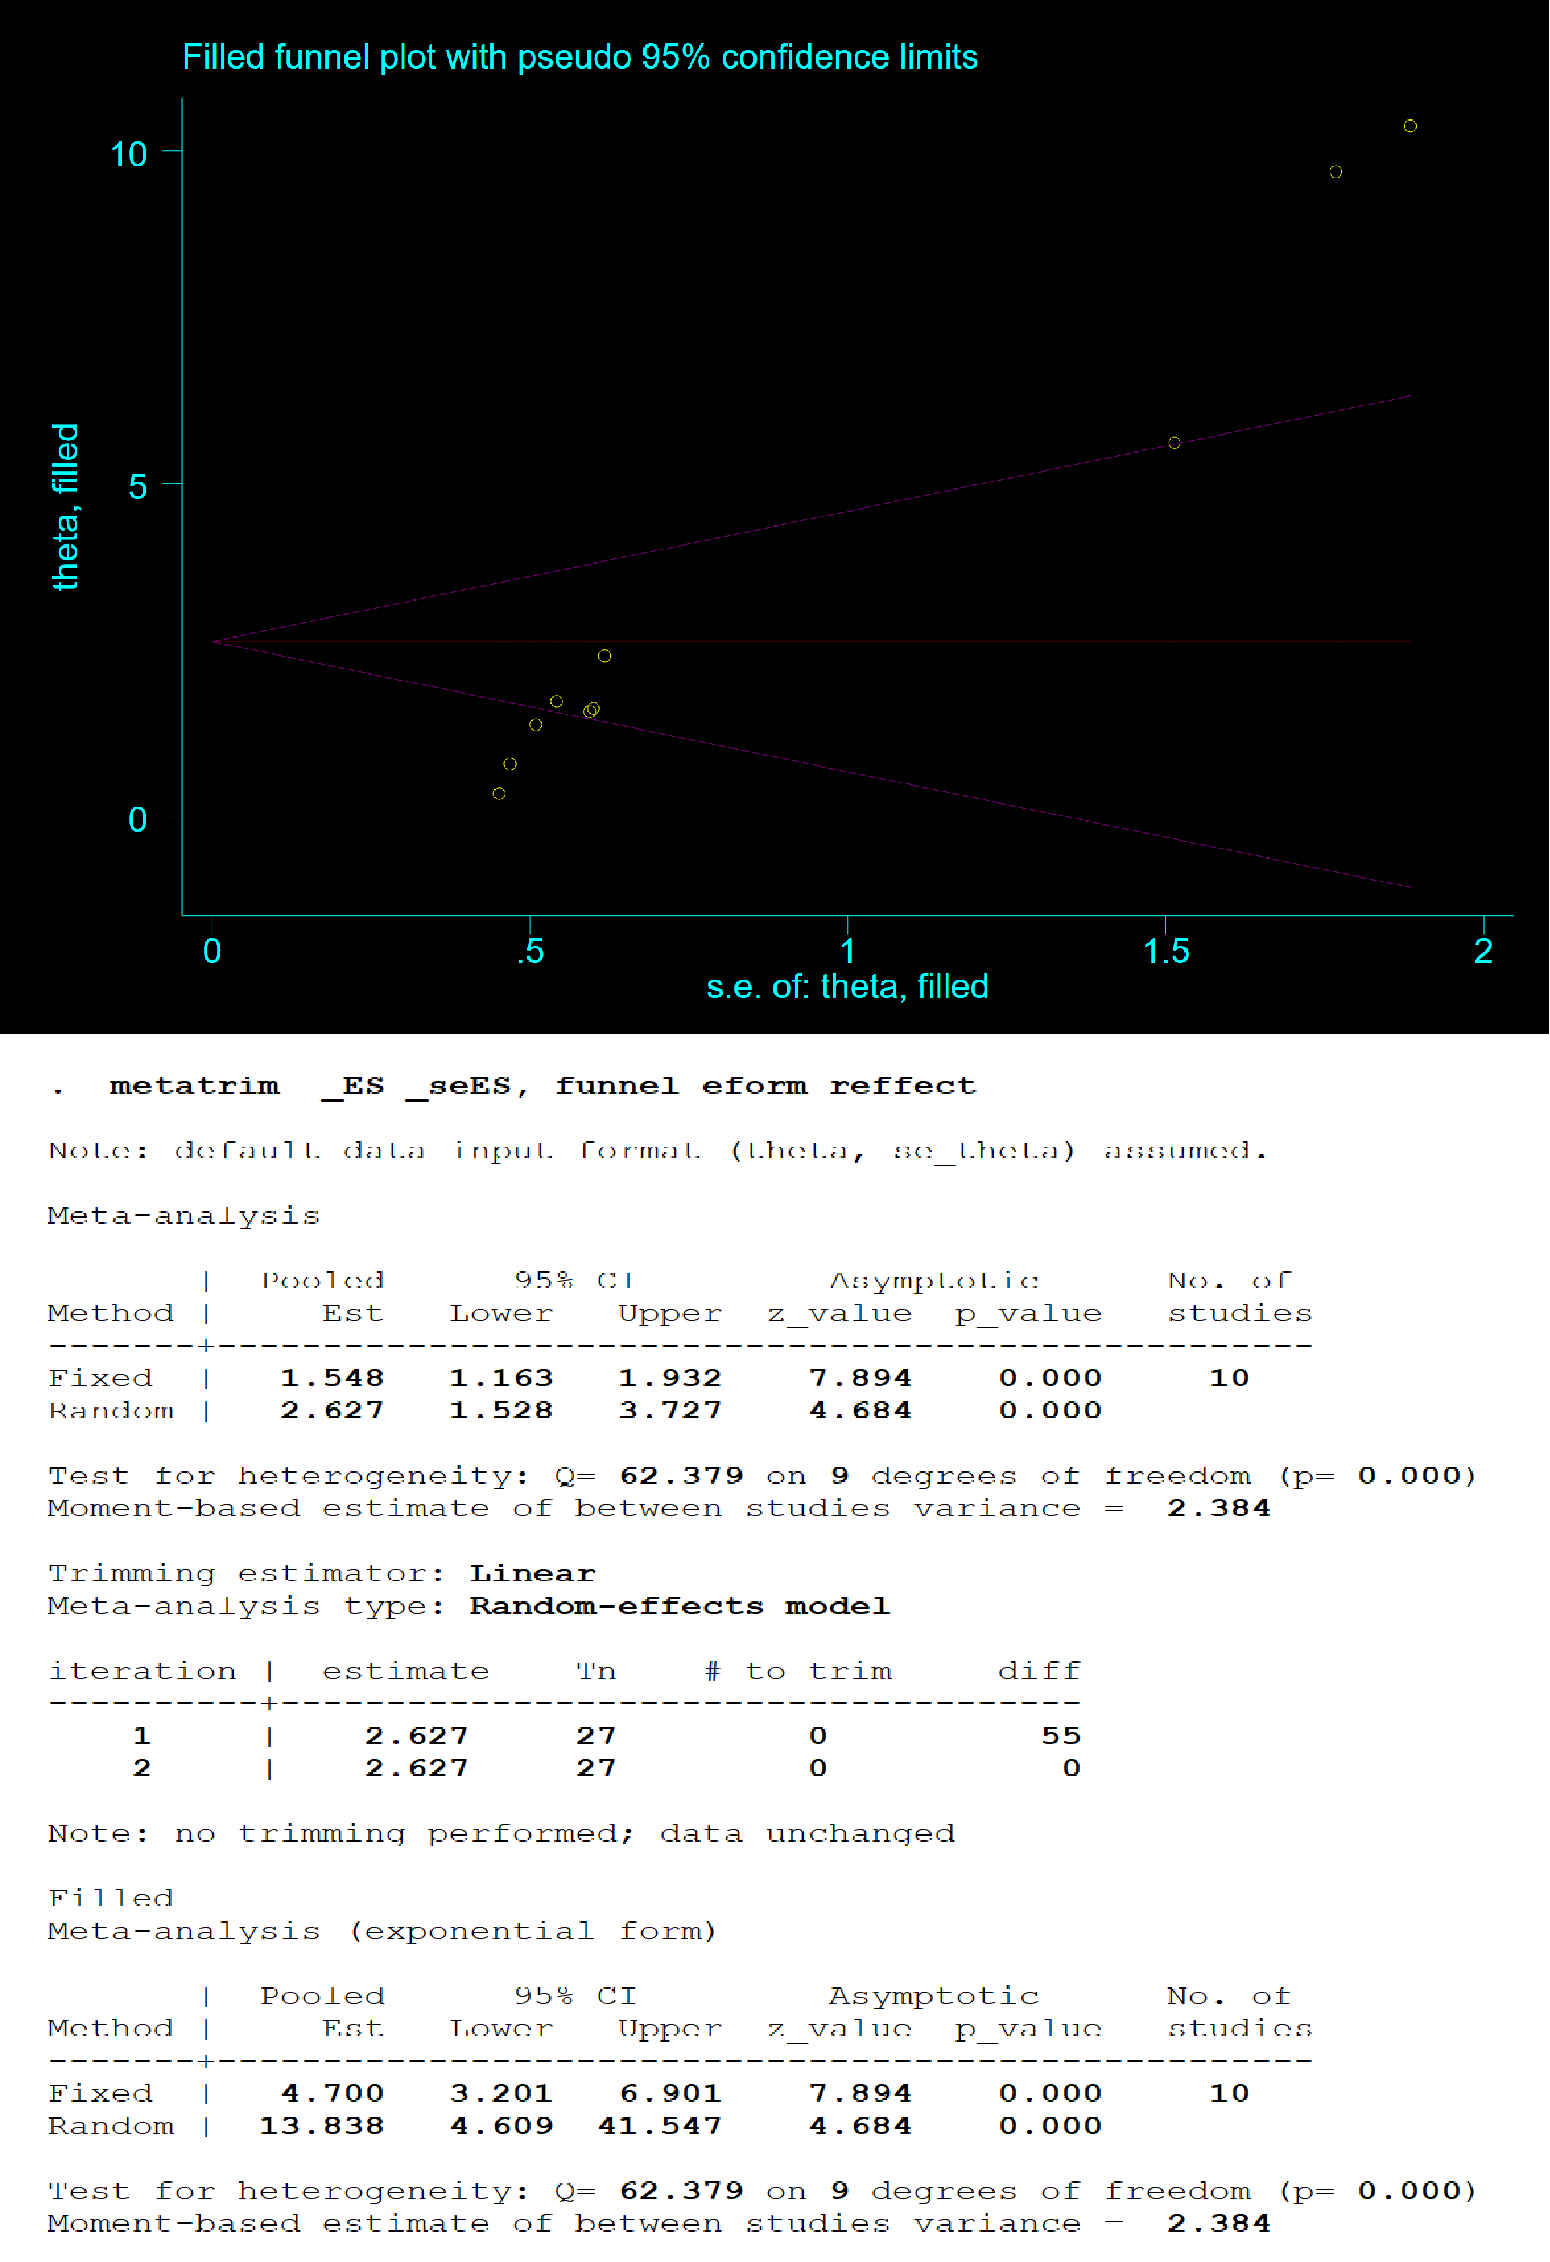

**Figure 7.** Result of trim-and-fill method for the effect of PDB extracts on SOD