S1. LA TE ANDES S.A. Laboratory U-Pb methodology
U/Pb analyses were carried out at the LA TE ANDES S.A. Laboratory. The analyses were performed using a combination of instrumental LA-ICP-MS (Laser Ablation - Inductively Coupled Plasma Mass Spectrometry): a Resolution 193 nm laser ablation system manufactured by Australian Scientific Instruments and an 8900 triple quadrupole ICP-MS model manufactured by Agilent Technologies. This technique allows for spot isotopic analysis on individual zircon grains. For this purpose, grains were selected, avoiding inclusions or fractures as much as possible. The measurements generally include one spot per analyzed zircon; however, some zircons are selected where, if the morphology allows, two or more spots are analyzed to confirm agreement in the calculated ages for the same grain.
The spot diameter is selected according to the size and homogeneity of the zircons, ranging from 20, 24, or 30 μm. A larger spot diameter corresponds to a lower fluence value, based on the results reported by Mukherjee et al. (2019), and generally, a lower frequency, which is selected based on achieving the lowest relative standard deviation (RSD) during ICP-MS tuning in LA-ICP-MS mode. ICP-MS tuning is performed in two stages. In the first stage, sensitivity and stability in solution mode are optimized using an Agilent tuning solution containing 1 ppb of 7Li, 89Y, and 205Tl. In the second stage, tuning is performed in LA-ICP-MS mode using linear ablation (spot diameter and fluence according to those used in the measurement sequence, frequency between 5 and 10 Hz, scan rate of 1 μm/s) on NIST SRM 612 glass to achieve maximum intensity in cps (counts per second) at mass 238, satisfying the relationships 238U/232Th≈1.05, 207Pb/206Pb≈0.917, 208Pb/206Pb≈2.17, and 248ThO/232Th˂0.3%, with an RSD ≤ 5%. A flow rate of 5 ml/min of N2 was added to enhance the ionization of elements in the plasma (Solari et al., 2009). The He flow rate was 370 ml/min.
Elemental concentrations are obtained using NIST 610 glass as the primary reference material (RM) and NIST 612 as the secondary RM (Jochum et al., 2011). U-Pb ages are calculated from the isotopic ratios using zircon 91500 as the reference material (Wiedenbeck et al., 2004) and repeated measurements on Plesovice zircon (TIMS reference age of 337.13 +/- 0.37 Ma; Slama et al., 2008) as the monitor. A typical analytical sequence consists of 100-130 grains from a sample, at the beginning and end of each sample, three measurements of NIST SRM612 and 610 glass, three measurements of 91500, and two measurements of Plesovice; with one analysis point of Plesovice and one of 91500 after every 20-30 analyses. The precision of the results is confirmed by obtaining the weighted mean 206Pb/238U age of the monitor (Plesovice).
The analytical sequence comprised 25 seconds of background measurements (no ablation), followed by 25 seconds of ablation and 5 seconds of rinsing (laser off). The following masses were monitored using ICP-MS: 89 (Y), 91 (Zr), 111 (Cd), 131 (La), 206 (Pb), 207 (Pb), 208 (Pb), 232 (Th), 235 (U), and 238 (U). The LADR 1.1.05 software was used for data reduction. Further processing was carried out using Isoplot 4.15 and IsoplotR (Ludwig, 2003).
S2. Laboratory of Geochronology and Isotope Geochemistry, University of Brasilia. U-Pb methodology
U-Pb isotopic analyses were performed using a Thermo Fisher Neptune HR-MC-ICP-MS coupled with a Nd:YAG UP213 New Wave laser ablation system at the Laboratory of Geochronology of the University of Brasilia. Zircon grains were characterized by back-scattered electro imaging using a JEOL QUANTE 450 scanning electron microscope to provide the basis for selecting locations for laser ablation analyses. The U-Pb analyses on zircon grains were carried out by the standard-sample bracketing method (Albarède et al. 2004) using the GJ-1 standard zircon (Jackson et al., 2004) in order to quantify the amount of ICP-MS fractionation. The tuned masses were Uranium 238, Lead 207, 206 and 204 and Mercury 202. The integration time was 1 second and the ablation time was 40 second. A 25 µm spot size was used and the laser setting was 10 Hz and 2-3 J/cm². Two to four unknown grains were analyzed between GJ-1 analyses. ²⁰⁶Pb/²⁰⁷Pb and ²⁰⁶Pb/²³⁸U ratios were time corrected. On smaller zircon grains (about 50 μm), single-spot laser-induced fractionation of the ²⁰⁶Pb/²³⁸U ratio was corrected using the linear regression method (Košler et al. 2002). The raw data were processed off-line and reduced using an Excel worksheet (Buhn et al., 2009). During the analytical sessions the zircon standard Plešovice (Sláma et al., 2008) was also analyzed as an unknown. The obtained concordant age of 336.82±0.42 Ma and the weighted mean ²⁰⁶Pb/²³⁸U data of 336.57±0.77 Ma is in agreement with the weighted mean ²⁰⁶Pb/²³⁸U data of 337.13±0.37 Ma obtained for this standard (Sláma et al., 2008). Common ²⁰⁴Pb was monitored using the ²⁰²Hg and (²⁰⁴Hg+²⁰⁴Pb) masses. Common Pb corrections were not done due to very low signals for ²⁰⁴Pb (< 30 cps) and high ²⁰⁶Pb/²⁰⁴Pb ratios. Reported errors are propagated by quadratic addition [(2SD^2+2SE^2)1/2] (SD=standard deviation; SE = standard error) of external reproducibility and within-run precision. External reproducibility is represented by the standard deviation obtained from repeated analyses (n=20, ~1.1 % for ²⁰⁷Pb/²⁰⁶Pb and up to ~2 % for ²⁰⁶Pb^{/238}U) of the GJ-1 zircon standard during the analytical sessions, and the within-run precision is the standard error calculated for each analysis. Concordia diagrams (2σ error ellipses) and weighted average ages were calculated using the Isoplot-3/Ex software (Ludwig, 2003).

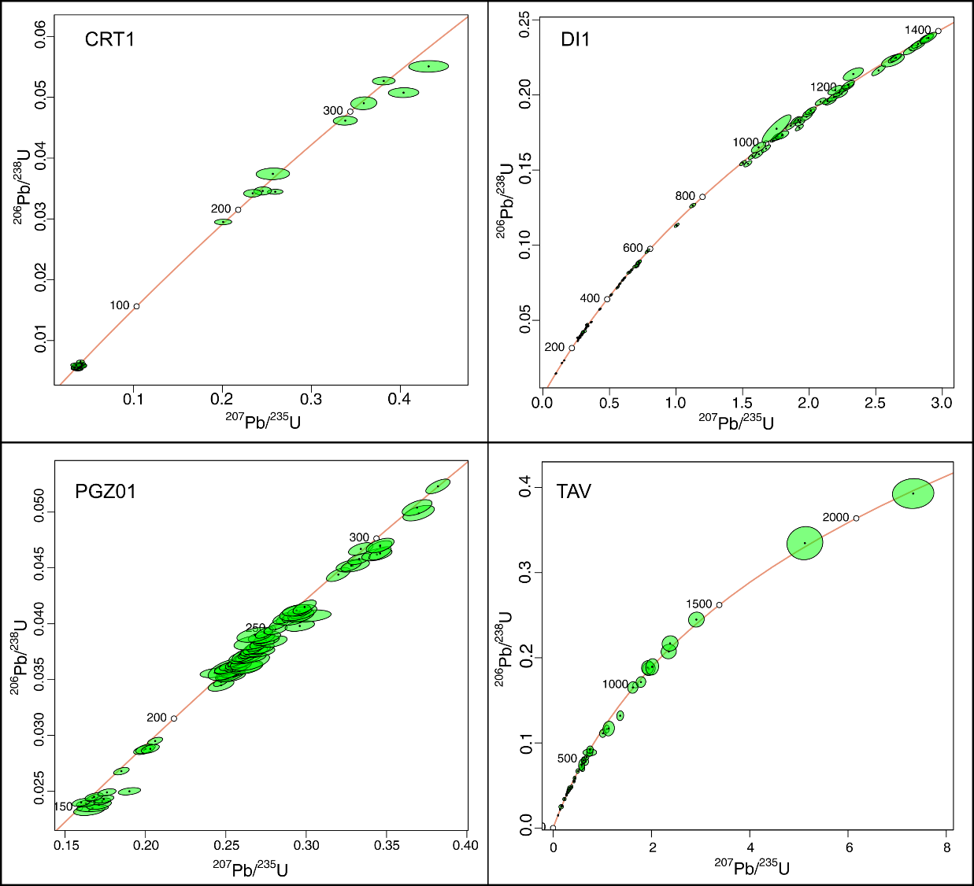
Figure S1. Concordia plots from the U/Pb samples analyzed.
References
Albarède, F., Telouk, S. Blichert-Toft, J., Boyet, M., Agranier, A., Nelson, B. (2004). Precise and accurate isotopic measurements using multiple-collector ICPMS. Geochimica et Cosmochimica Acta 68, 2725–2744.
Bühn, B., Pimentel, M. M., Matteini, M., Dantas, E. L. (2009). High spatial resolution analysis of Pb and U isotopes for geochronology by laser ablation multi-collector inductively coupled plasma mass spectrometry (LA-MC-ICP-MS). Anais da Academia Brasileira de Ciências, 81, 99-114.
Jackson, S.E., Pearson, N.J., Griffin, W.L., Belousova, E.A. (2004). The application of laser ablation-inductively coupled plasma-mass spectrometry to in situ U–Pb zircon geochronology. Chemical Geology 211, 47-69.
Jochum, K.P., Weis, U., Stoll, B., Kuzmin, D., Yang, Q., Raczek, I., Jacob, D.E., Stracke, A., Birbaum, K., Frick, D.A., Günther, D., Enzweiler, J. 2011. Determination of Reference values for NIST SRM 610-617 Glasses following ISO Guidelines. Geostandards and Geoanalytical research 35(4), 397-429.
Košler, J., Fonneland, H., Sylvester, P., Tubrett, M., Pedersen, R. B. (2002). U–Pb dating of detrital zircons for sediment provenance studies—a comparison of laser ablation ICPMS and SIMS techniques. Chemical Geology, 182(2-4), 605-618.
Ludwig, K. R. (2003). User's manual for IsoPlot 3.0. A geochronological toolkit for Microsoft Excel, 71.
Mukherjee, P.K., Souders, A.K., y Sylvester, P.J. (2019). Accuracy and precision of U-Pb zircon geochronology at high spatial resolution (7-20 μm spots) by laser ablation-ICP-single-collector-sector-field-mass-spectrometry. JAAS 34, 180-192.
Sláma, J., Košler, J., Condon, D.J., Crowley, J.L., Gerdes, A., Hanchar, J.M., Horstwood, M.S.A., Morris, G.A., Nasdala, L., Norberg, N., Schaltegger, U., Schoene, B., Tubrett, M.N., Whitehouse, M.J. (2008). Plešovice zircon — A new natural reference material for U–Pb and Hf isotopic microanalysis. Chemical Geology 249, 1-35.
Solari, L.A., Gómez-Tuena, A., Bernal, J.P., Pérez-Arvizu, O, Tanner, Martin. (2009). U-Pb Zircon Geochronologywith na inte-grated LA-ICPMS microanalytical workstation: Achievments in precision and accuracy. Geostandards and Geoanalytical Research, 34(1), 5–18.
Wiedenbeck M., Hanchar, J.M., Peck, W.H., Sylvester, P., Valley, J., Whitehouse, M. Kronz, A., Morichita, Y., Nasdala, L., Fiebig, J., Franchi, I., Girard, J.P., Greenwood, R.C., Hinton, R., Kita, N., Mason, P.R.D., Norman, M., Ogasawara, P.M., Piccoli, P.M., Rhede, D., Satoh, H., Schulz-Dobrick, B., Skar, O., Spicuzza, M.J., Terada, K., Tindle, A., Togashi, S., Vennemann, T., Xie, Q., Zheng, Y.F. (2004). Further characterisation of the 91500 zircon crystal. Geostandards and Geoanalytical Research 28(1), 9–39.

