**Supplemental Materials**

**Network Linguistic Diversity and PT**

Per our pre-registration, we explored how Network Linguistic Diversity was related to children’s PT skill and found a null result. There was no evidence that Network Linguistic Diversity was related to 3-year-old’s perspective taking ability (all *p*’s > .05). See below for details about how Network Linguistic Diversity was calculated as well as our analyses.

There are two conceptually distinct measures to define network diversity –entropy and EI Index. Entropy describes the representation of different social groups in the network, while the EI Index indicates how diverse the network was relative to the child. The measure most similar to prior developmental work is entropy – this measure describes the different language speakers present in children’s networks. The analysis primarily focused on how Language Entropy was correlated with PT. See below for the analysis on Linguistic EI Index and PT.

The measure we used to index children’s Network Linguistic Diversity was Language Entropy. In network science, entropy indicates the relative presence of different social categories among the nodes in a network and is calculated as follows for a given probability vector of P(X): *H(X) =* - *∑* *P(X) * log2(P(X))* (Drost, 2018; Krenz et al., 2020; Shannon, 1948). To calculate Language Entropy, the language(s) spoken by each node in the social network were identified through the demographic form. Each node was categorized by a discrete language category (see Supplemental Materials for all categories). Data was not collected on whether and how often these languages were directed at or spoken around the child; instead it was analyzed whether each node spoke the language. All children in this sample had monolingual English speakers represented in their network, and may have also had one or more speakers of another language or languages. An entropy score of 0 means there is no diversity of language categories; for this particular sample, a score of 0 indicates all the nodes were monolingual English speakers. An entropy score of 1 indicates that there are equal amounts of two different categories. For example, a child could have a Language Entropy score of 1 if their network was half monolingual English speakers and half English/Spanish bilingual speakers. The highest Language Entropy score in this sample is 2.71, which corresponds to a network where there is a combination of English monolingual speakers, English/Korean bilinguals, an English/ASL bilingual, a Russian/German bilingual, and a few multilingual speakers.

Children’s Network Language Diversity was on average 1.03 (*SD* = 0.79, range = 0 – 2.72) indicating that on average, children’s networks included an equal number of two different groups of language speakers (i.e., a child where half their network was English monolingual speakers and half their network was English/Spanish bilingual speakers). To assess whether Network Language Diversity was related to PT, the same models were run as the Network Size analysis with Explicit PT and Implicit PT as the dependent variables predicted by Trial Type and Network Language Diversity, and the interaction between Trial Type and Network Language Diversity, with Subject as a random effect. In a model with Explicit PT as the dependent variable, there was the same significant effect of Trial Type (*ß* = .24, *p* < .05), but no significant effect of Network Language Diversity (*ß* = -.04, *p* > .05) and the interaction was not significant (*ß* = -.11, *p* > .05; Figure S1). There was no evidence that Network Language Diversity was related to Explicit PT performance. An identical analysis was performed to test the relation between Network Language Diversity and Implicit PT performance. The model yielded a null result. There was no significant effect of Trial Type (*ß* = -0.05, *p* > 0.05) or Network Language Diversity (*ß* = -0.02, *p* > 0.05) and the interaction was not significant (*ß* = 0.06, *p* > 0.05; Figure S1). There was therefore no evidence that Language Entropy was related to either Explicit or Implicit PT performance.

**Figure S1**

*Network Language Diversity and PT*

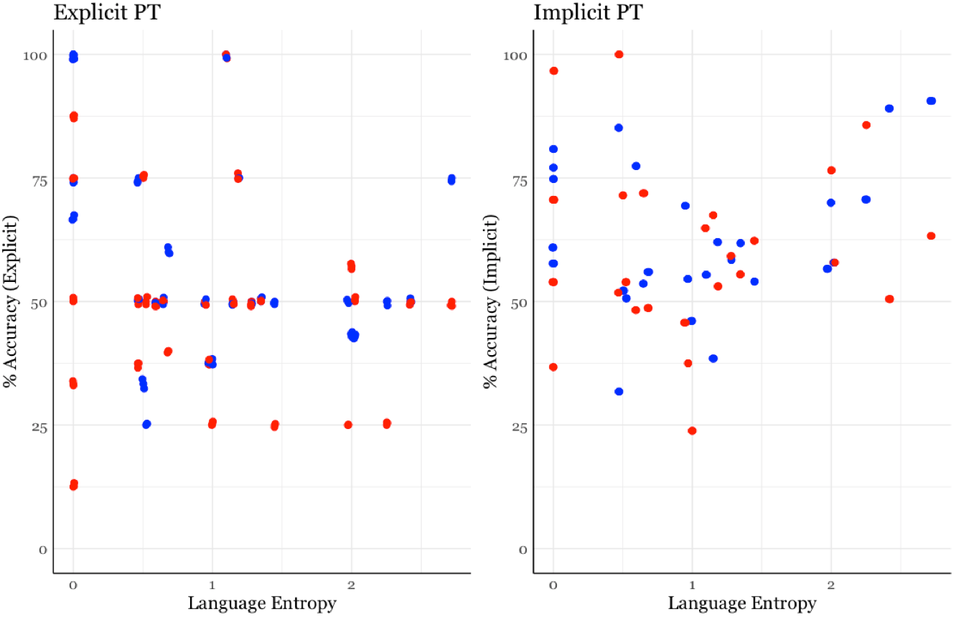



*Note.* Scatterplots of Network Linguistic Diversity in relation to Explicit PT and Implicit PT.

was related to Explicit PT performance.

**Network Size and Implicit PT**

**Figure S2**

*Network Size and Implicit PT*

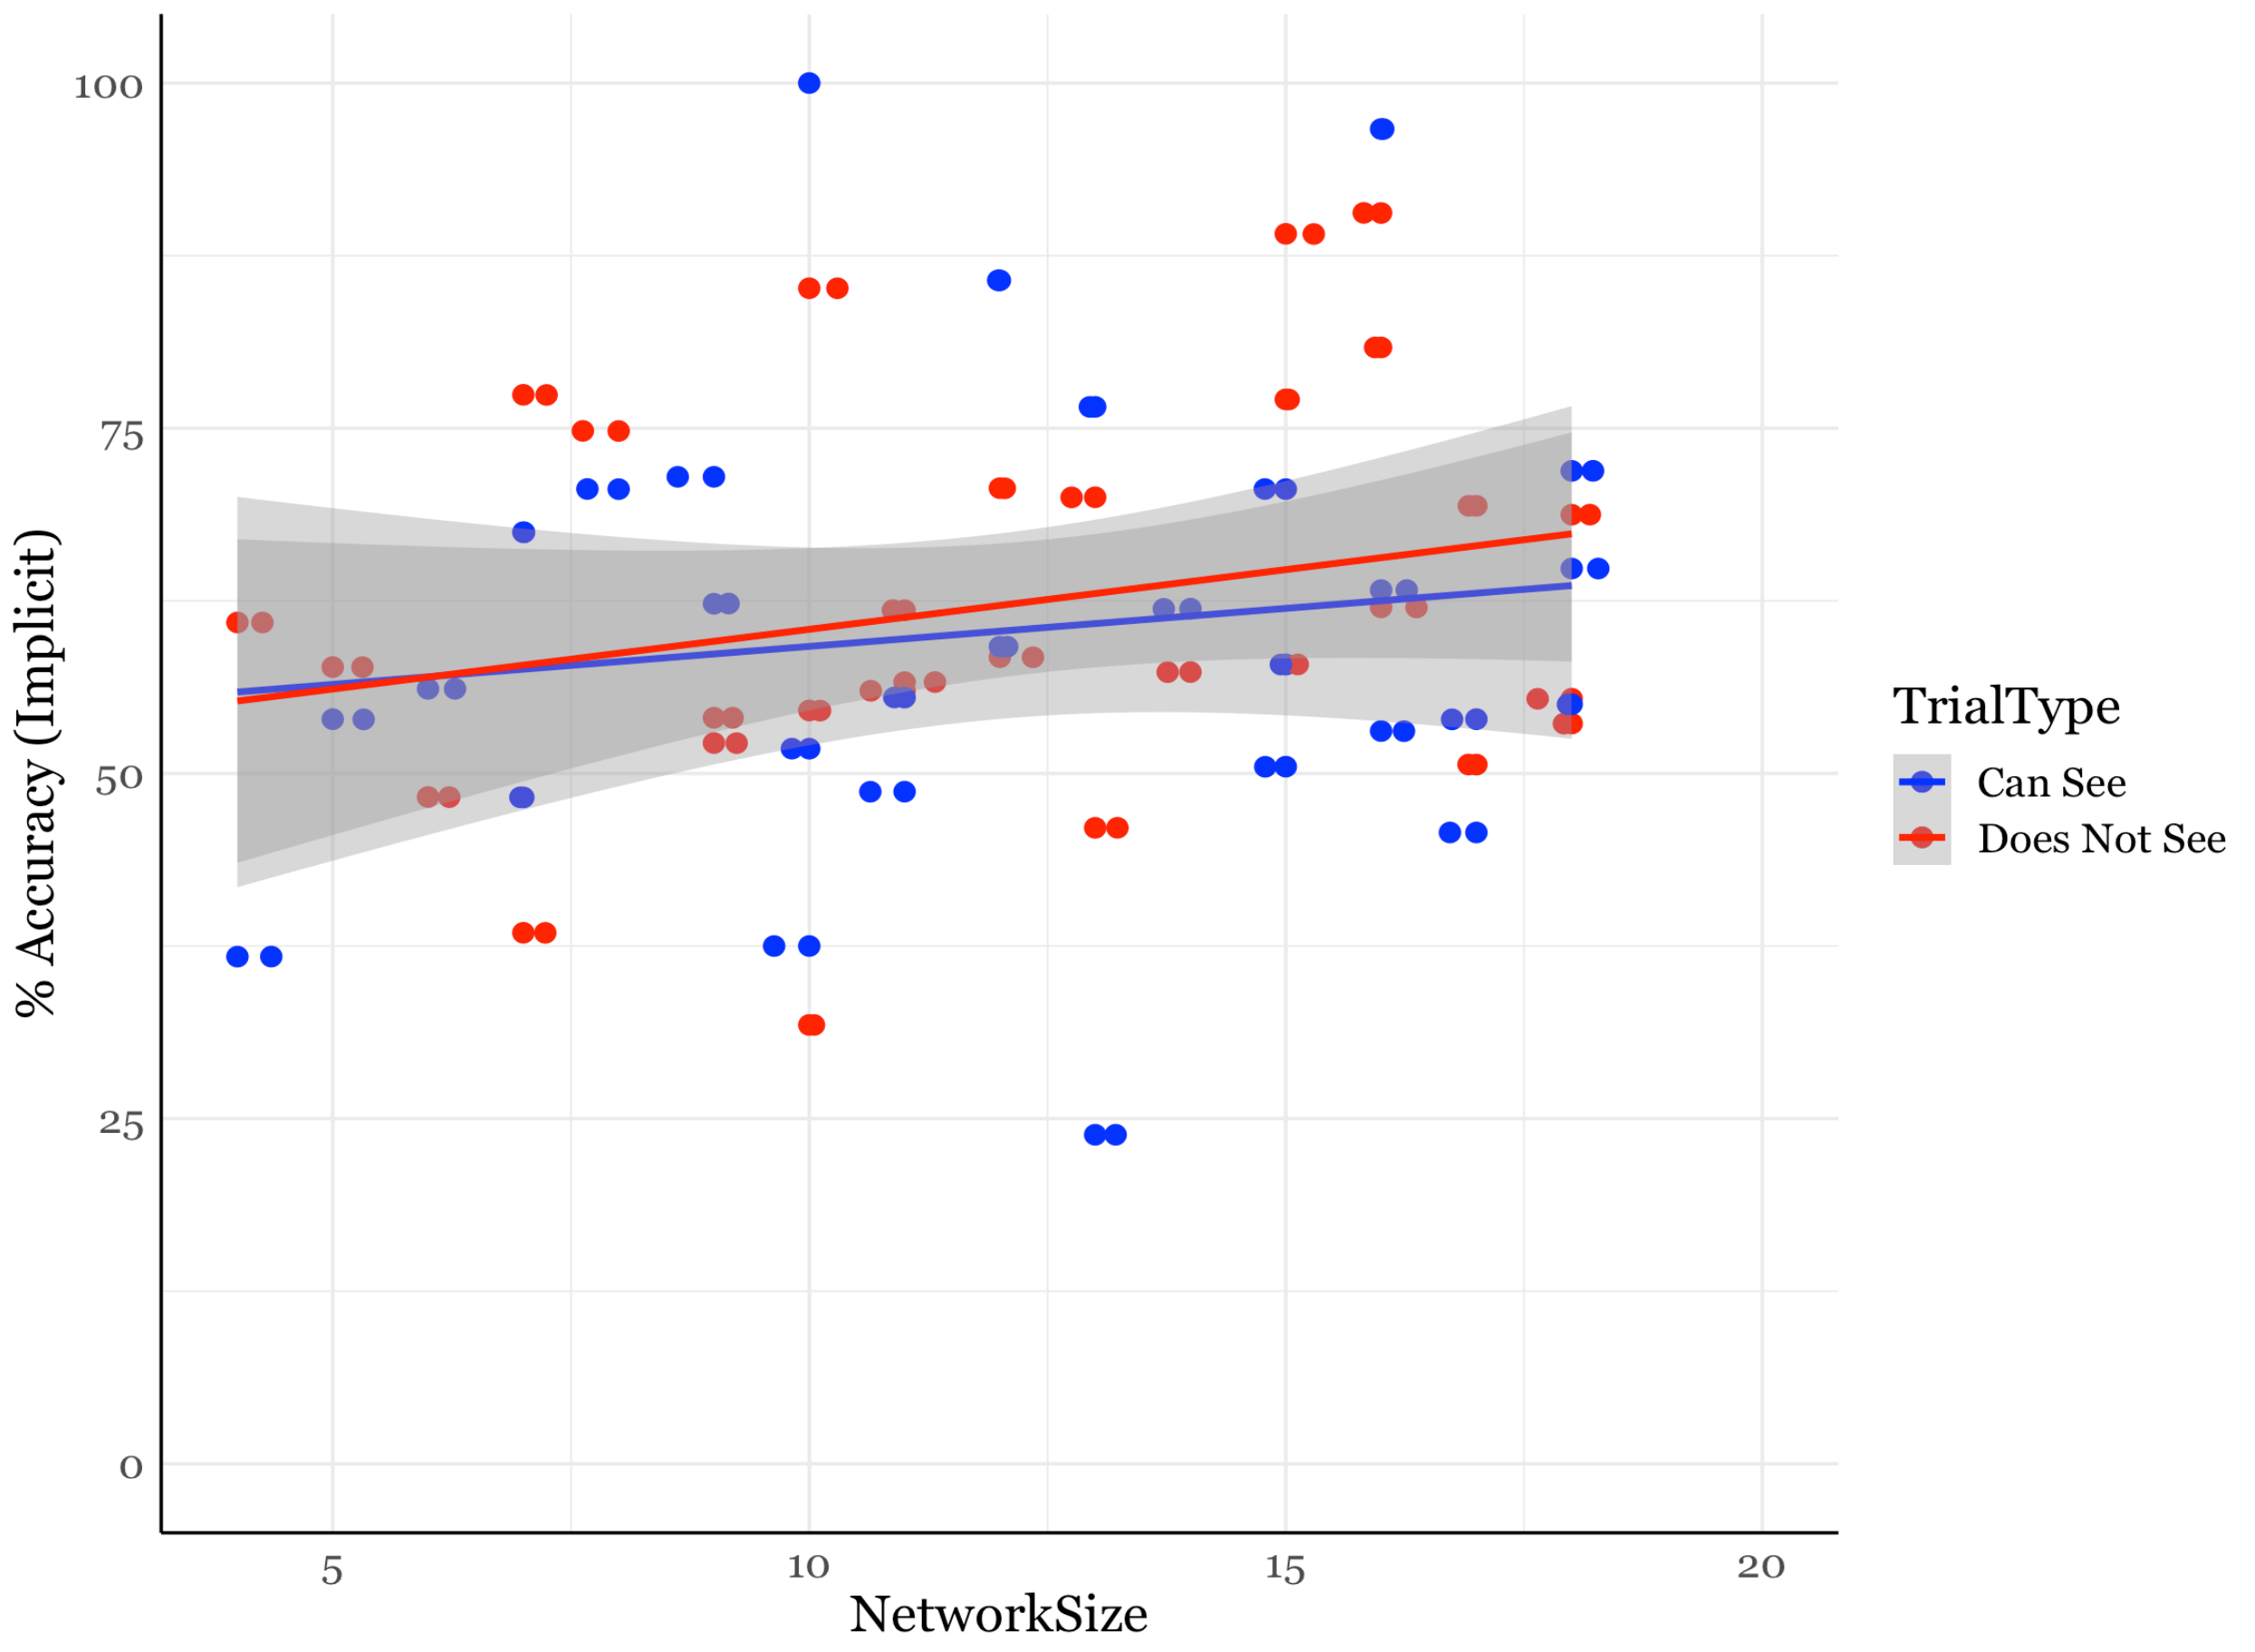

*Note.* Scatterplot of Network Size in relation to Implicit PT Performance is shown. Dot are colored by Trial Type: Can See and Does Not See.

**Network Variables on Control Trials**

2 linear mixed effect models were conducted to test the effects of Network Size and Network Linguistic Diversity on children’s performance on the control trials. Both models revealed null results. There was no evidence that Network Size (ß = 0.19, *p* > 0.05) or Network Linguistic Diversity (ß = -0.20, *p* > 0.05) were related to their performance on the control trials. While the network variable did not explain any variance in children’s ability to engage in the task, there was evidence to suggest their social environments related to their ability to take another person’s perspective.

**Exploratory Analysis Examining the Influence of Daycare/Preschool Attendance**

One possible explanation for the finding that having a larger network related to better Explicit PT performance is that Network Size indexes the effects of school on cognition. Indeed, children who were in Daycare or Preschool had larger social networks than children who were not in school (Daycare or Preschool: *n* = 15; *MNetworkSize* =14 people; No Daycare or Preschool: *n* = 15; *MNetworkSize* = 10 people; *t*(23) = -2.94, *p* < 0.01). It is possible the Network Size finding is masking an effect of school on PT understanding. Half of the sample (*n* = 15) was in Daycare or Preschool, so an exploratory analysis was performed to test whether being in Daycare or Preschool was related to Explicit PT performance. The same analyses as above were performed separately with Explicit PT performance and Implicit PT performance as dependent variables, including Daycare as a fixed effect. Neither model showed a significant effect of Daycare or an interaction between Trial Type and Daycare (all *p*’s > .05). Thus, there was no evidence that being in Daycare or Preschool was related to PT performance.

Figure S3 demonstrates that children in Preschool or Daycare have larger social networks than children not in Preschool or Daycare (*MPreschool* = 14 people, *MNoPreschool* = 10 people; *t*(23) = -2.94, *p* < 0.01).

**Figure S3**

*Network Size and Preschool/Daycare*

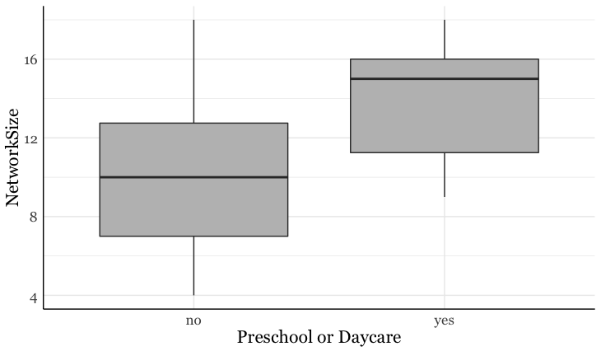

*Note.* Children in Preschool or Daycare have significantly larger networks than children who are not in Preschool or Daycare (*MPreschool* = 14 people, *MNoPreschool* = 10 people; *t*(23) = -2.94, *p* < 0.01).

Figure S4 shows children’s performance on the Explicit PT by Trial Type and whether or not they were in Preschool or Daycare. There was no effect of school experience and the interaction was not significant.

**Figure S4**

*Preschool/Daycare and Explicit PT*

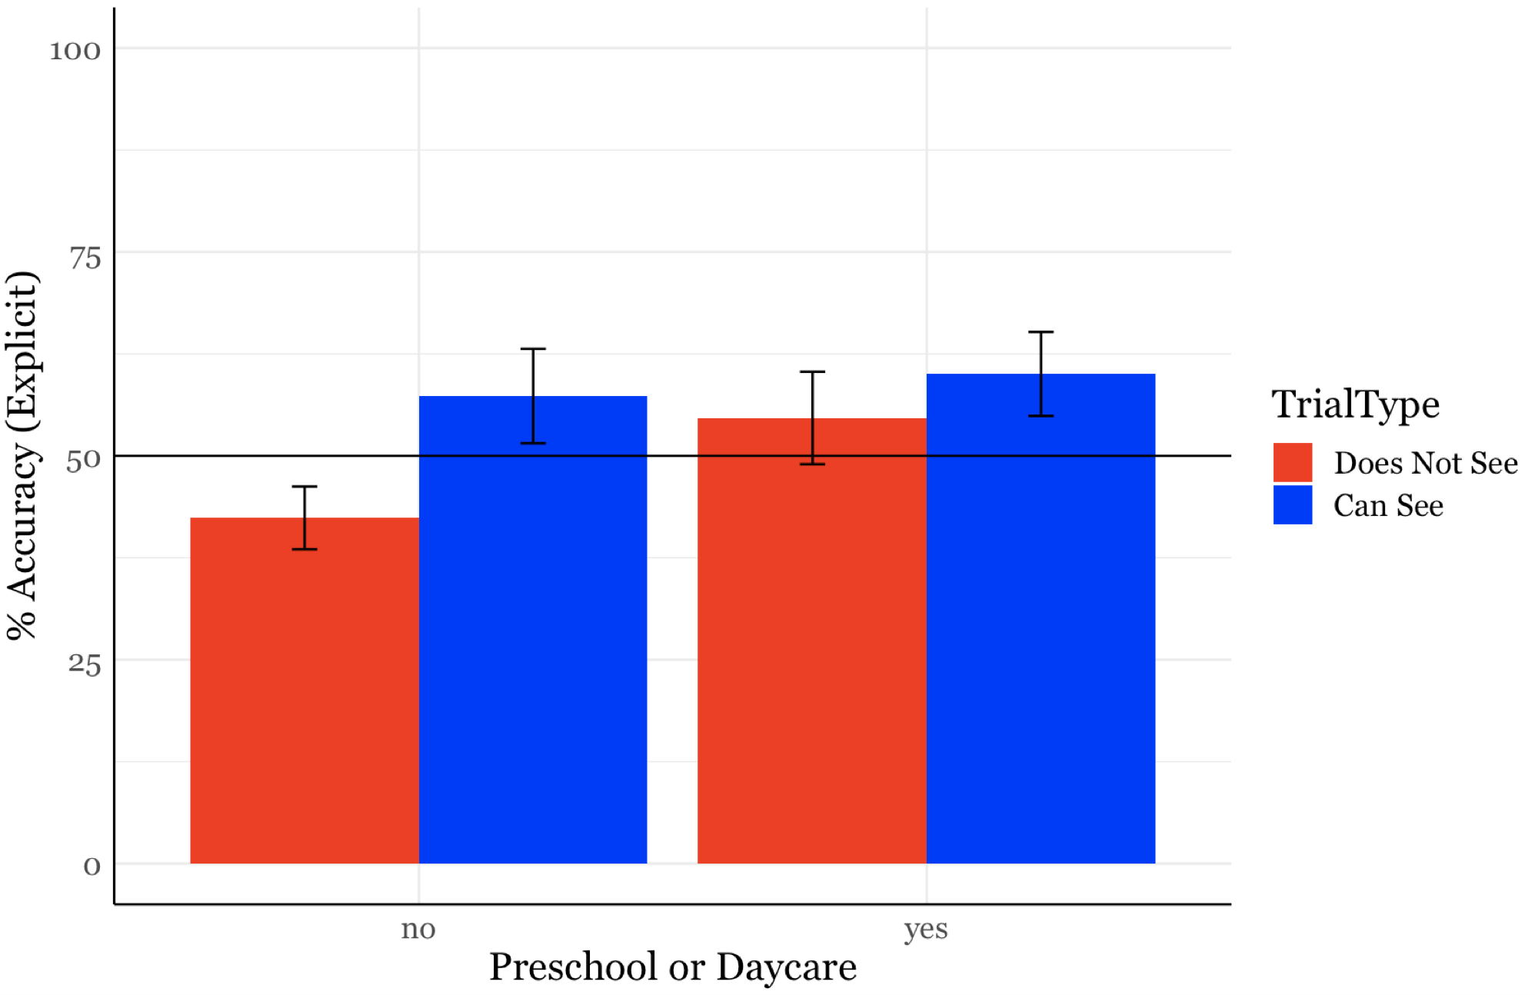

*Note.* The model revealed a significant main effect of Trial Type consistent with the previous models (*ß* = 0.19, *p* < 0.05), but did not reveal a main effect of Daycare (*ß* = 0.15, *p* > 0.05) or an interaction (*ß* = -0.12, *p* > 0.05). There was no evidence that School experience was related to Explicit PT performance.

**Language Entropy**

The following discrete language categories were used to calculate Language Entropy. Each node in the child’s social network was a speaker of one of the following categories:

* English only
* English/Spanish
* English/Dutch/French/German
* English/Chinese/Spanish
* English/Eastern European Language
* Spanish only
* English/Spanish/Russian
* English/Chinese
* English/French
* English/Hebrew
* English/French/Russian/Romanian
* English/Chinese/Hebrew/Spanish
* English/Arabic
* English/Arabic/Mandarin/Spanish
* English/Balinese/Indonesian
* English/Malayalam
* English/American Sign Language
* Preverbal
* English/Yoruba
* English/Cantonese/Mandarin
* English/Mandarin
* English/Korean/Spanish
* English/Russian/Ukrainian
* English/Russian
* English/Ukrainian
* English/French/Spanish
* English/Bengali
* English/Russian/Uzbek/Turkish/Persian
* English/Polish
* English/American Sign Language/Spanish
* Russian/German/Spanish/Chinese
* German/Russian
* English/Korean

**Linguistic EI Index and PT**

EI Index is a network diversity measure. It is a measure of homophily the child shares with the network. “E” stands for external or different nodes and “I” stands for internal or same nodes. Each node is categorized as either “same” or “different” from the child based on some attribute and is calculated as follows: (Number of Different Nodes – Number of Same Nodes)/Network Size. The EI Index ranges from -1 to 1; a score of -1 indicates the entire network is the same as the child on some attribute and a score of 1 would indicate that the entire network is different from the child on some attribute. For the Linguistic EI Index, each node was coded as same-speaker or different-speaker. For monolingual English children, this meant anyone who spoke a language other than English was coded as different-speaker. For bilingual and multilingual children, a node was coded as different-speaker if that person spoke a language the child did not speak or hear from their parent. For example, imagine an English/Spanish bilingual child with a network where 2 people spoke English, 1 spoke English and Spanish, and one spoke English and Dutch. The only node that is a different-speaker is the English/Dutch bilingual because the child does not speak Dutch and would therefore have a Linguistic EI Index of -0.5 ([Different-speaker – Same-speaker]/Network Size; [1 – 3]/4).

Children’s Linguistic EI Index was on average -0.70 (*SD* = 0.32, range = -1 - 0.08). A histogram of the 3-year-olds’ Linguistic EI Index is presented below. To assess whether Linguistic EI Index had an effect on PT, a Linear Mixed Effect model was performed analogous to the analysis for Network Size. The Explicit PT score was the dependent variable. Trial Type and Linguistic EI Index were included as fixed effects and Subject was included as a random effect. The model revealed null results; there were no main effects of Trial Type (*ß* = 0.04, *p* > 0.05) or Linguistic EI Index (*ß* = 0.006, *p* > 0.05) and the interaction was not significant (*ß* = -0.13, *p* > 0.05). There was no evidence that Linguistic EI Index was related to Explicit PT performance. This does not conceptually replicate previous work that children with more multilingual experience are better at PT . While we should exert caution in interpreting a null result, there is no evidence that Linguistic EI Index is related to Explicit PT performance.

The same model was performed to test the effect of Network Linguistic Diversity with Implicit PT as the dependent variable. Similar to Explicit PT, the model did not show a main effect of Trial Type (*ß* = 0.13, *p* > 0.05) or Network Linguistic Diversity (*ß* = -0.02, *p* > 0.05), and there was no significant interaction (*ß* = 0.17, *p* > 0.05). Thus, there is no evidence that Network Linguistic Diversity was related to Implicit PT.

**Figure S5**

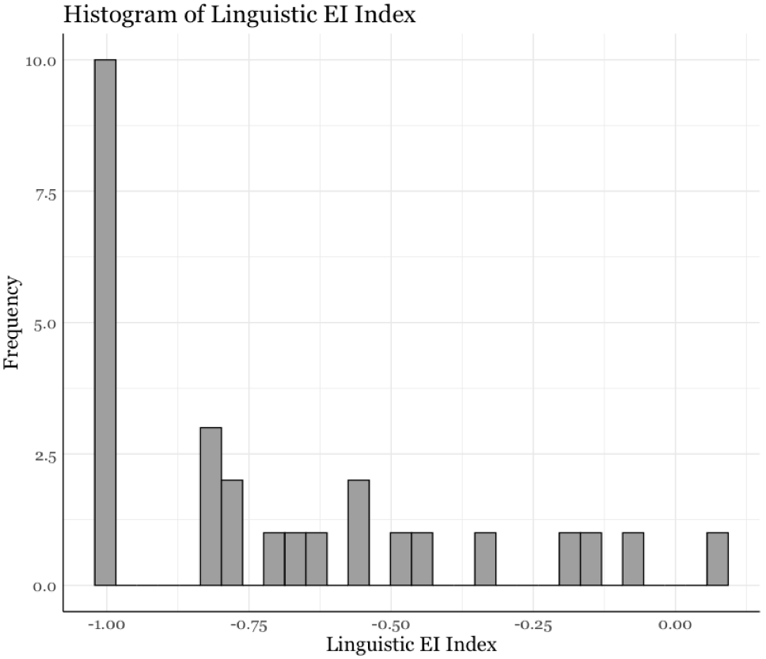*Histogram of Linguistic EI Index*

**Figure S6**

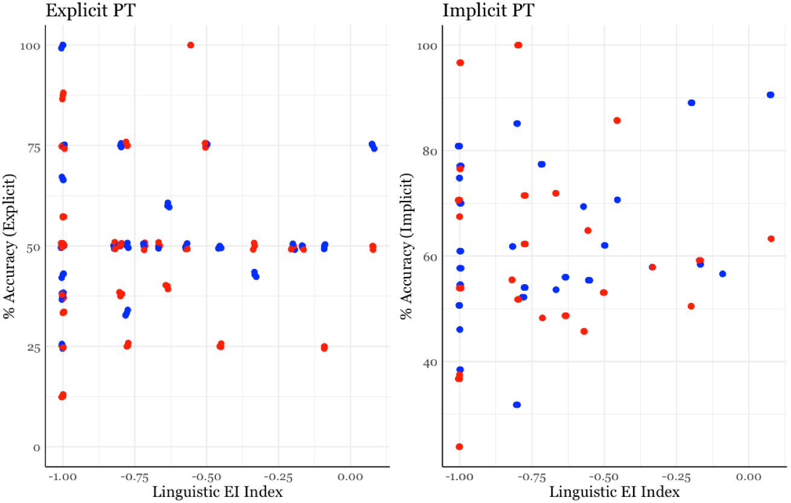*Linguistic EI Index and PT*



**Network Size and Network Linguistic Diversity**

**Figure S7**

*Correlations between Network Size and Language Entropy*

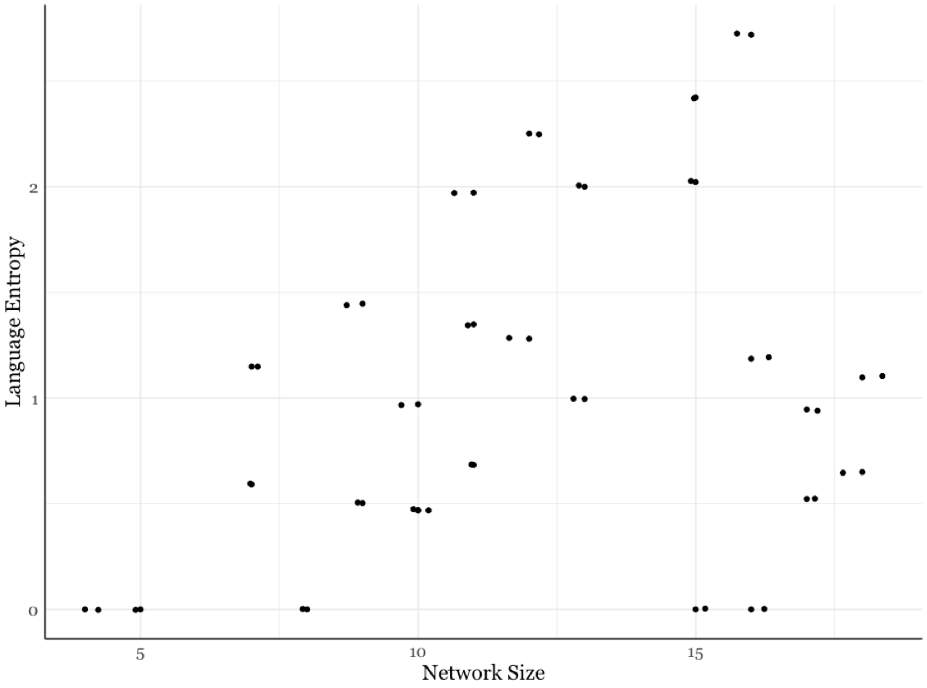

*Note*. There was no correlation between Language Entropy and Network Size (*rho* = 0.29, *p* = 0.15); however, the scatterplots demonstrate that there are no participants with high Language Entropy in small social networks.

**Additional Network Properties and Explicit PT**

Below are additional analyses we conducted to explore how other properties of children’s social networks might relate to PT. All the models were Linear Mixed Effects models that had Subjects as a random factor, Trial Type as a fixed factor, and the network variable of interest as a fixed factor. Explicit PT was the dependent variable. We focused our supplemental analyses on Explicit PT because this is where we saw effects for our pre-registered analyses.

**Calculation of Additional Network Properties**

Using *The Child Social Network Questionnaire* we could also calculate the following network properties for each child: Proportion of Low Intense Relationships, Proportion Adult Relationships, Proportion Kin Relationships, Component Ratio, Number of Components, and Number of Friends.

***Proportion of Low Intense Relationships***

See the previous section “Network Size and Weak Ties” for a description on how the intensity of the relationships was measured. Once relationships were categorized as either high or low intense, the proportion of low intense relationships was simply: *Number of Low Intense Relationships / Network Size*.

***Proportion Adult Relationships***

Each node in the social network was classified as “adult” or “child”. A child was anyone 12-years-old or younger. The proportion of adult relationships was calculated as follows: *Number of Adults / Network Size*.

***Proportion Kin Relationships***

Each node in the social network was classified as either “kin” or “not kin”; kin was any individual in the immediate or extended family (e.g., grandparents, aunts, uncles, cousins, etc.). The proportion of kin relationships was calculated as follows: *Number of Kin / Network Size*.

***Number of Friends***

A friend was any named peer node of the child. In this sample, children had an average of 2.5 friends (range: 0 – 10).

***Number of Components***

Components are a way to describe the structure of the network. A component emerges in the network when all the nodes are connected to each other in some way (Perry et al., 2018). In an egocentric network, a component emerges when all the nodes are connected even when you remove the child. The number of components are determined from the parent interview. See Burke et al. (submitted) for more details. In this sample, children on average had 3.3 components (range: 1-7).

***Component Ratio***

Another way to describe network structure is to describe how fragmented the network is. The measure to describe how fragmented a network is called the Component Ratio. Larger networks tend to have more components, so to account for network size the Component Ratio can be calculated as follows where C is the number of components: *(C – 1) / (Network Size – 1)* (Perry et al., 2018). Larger values of the component ratio indicate that the network is more fragmented.

**Regression Table**

Below is a regression table showing the effects of the Network Variable of Interest, Trial Type, and the interaction with Explicit PT as the dependent variable. The models revealed mostly null results. With the exception of Number of Friends, there was no evidence to suggest these other network properties were related to PT. The positive effect of Number of Friends suggests that the more named friends children had in their network, the better they did on the Explicit PT measure.

**Table S1**

*Exploratory Network Variable Analysis and Explicit PT*

|  |  |  |  |  |  |  |
| --- | --- | --- | --- | --- | --- | --- |
| Network Variable | Network Variable | | Trial Type | | Interaction | |
|  | *ß* | *p* | *ß* | *p* | *ß* | *p* |
| Proportion of Low Intense Relationships | 0.22 | 0.20 | 0.28 | 0.08 | -0.20 | 0.32 |
|  |  |  |  |  |  |  |
| Proportion of Adult Relationships | -0.20 | 0.57 | 0.08 | 0.81 | 0.08 | 0.85 |
|  |  |  |  |  |  |  |
| Proportion of Kin Relationships | -0.07 | 0.63 | -0.07 | 0.66 | 0.08 | 0.67 |
|  |  |  |  |  |  |  |
| Number of Friends | 0.03 | 0.42 | **0.19** | **0.02** | -0.05 | 0.29 |
|  |  |  |  |  |  |  |
| Number of Components | 0.09 | 0.48 | 0.43 | 0.14 | -0.16 | 0.29 |
|  |  |  |  |  |  |  |
| Component Ratio | 0.06 | 0.81 | 0.21 | 0.12 | -0.19 | 0.51 |

*Note*. Each line in the table represents a separate regression that tested the Network Variable on Explicit PT; we did not run a model that included all these variables given the collinearity.

**Exploratory Analysis: Network Size, Language Entropy, and Explicit PT**

Before exploring how Network Size and Network Language Diversity interact to affect PT performance, a correlation was run to see whether and how Network Size and Language Entropy were related to each other. There was not a reliable correlation between Network Size and Network Language Diversity (*rho* = 0.29, *p* > 0.05; see Supplemental Materials). We then ran a linear mixed effect model predicting Explicit PT from Trial Type, Network Size, Language Entropy, and their interactions, with Subjects as a random effect. Consistent with the pre-registered analyses, the model revealed a significant main effect of Trial Type (*ß* = 1.77, *p* < 0.001) and Network Size (*ß* = 0.23, *p* < 0.01) and no significant main effect of Network Language Diversity (*ß* = -0.26, *p* > 0.05). These effects reflect the patterns, reported above, that children did better on Can See than Does Not See trials and children in larger networks had better Explicit PT performance. There was no significant interaction between Network Size and Network Language Diversity (*ß* = 0.04, *p* > 0.05), but the interaction with Trial Type and each network variable was significant (Network Size x Trial Type: *ß* = -0.46, *p* < 0.001; Language Entropy x Trial Type: *ß* = -1.26, *p* < 0.01). Consistent with the results of the pre-registered analysis, there was marginal evidence that children with smaller networks performed worse on the Does Not See Trials than children with larger networks (*r* = 0.40, *p* = 0.057), whereas there was no relation with performance on the Can See trials and Network Size (*r* = -0.13, *p* > 0.05). Post-hoc FDR corrected correlations did not show significant correlations between Network Language Diversity and Can See or Does Not See Trials (*p*’s > .05).

Finally, the 3-way interaction between Network Size, Network Language Diversity, and Trial Type was significant (*ß* = 0.34, *p* < 0.01). To explore the nature of this interaction, a Johnson-Neyman analysis was conducted to identify the point in an interaction at which the difference between two groups become significant (Carden et al., 2017). Children were median-split by “small” or “large” social networks (Median Network Size = 12) for illustration purposes in Figure S8. For the Does Not See Trials a Johnson-Neyman interval could not be found; the slopes of the Language Diversity were not significant at any value of Network Size for the Does Not See Trials (all *p’s* > 0.05). For the Can See Trials, when Network Size was below 13 people, the slope of Language Diversity was significant (slope of Language Diversity when Network Size is 1 standard deviation below the mean = -0.43, *p* < 0.001). For children in small networks, as their Network Language Diversity increased they performed worse on the Explicit PT task for Can See Trials (Figure S8).

Taken together, the findings suggest that children in large social networks performed well on the task regardless of Network Language Diversity levels and across Trial Types. When children in small networks had higher levels of Network Language Diversity, they performed worse on the Can See trials. This suggests that small, linguistically diverse networks may negatively affect children’s ability to consider others’ points of view, particularly on the more straightforward Can See PT trials.

**Figure S8**

*Network Size, Network Linguistic Diversity, and Explicit PT*

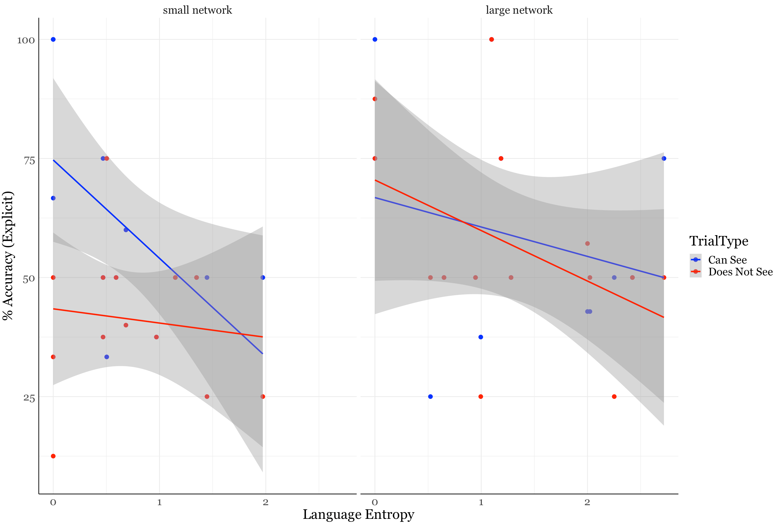

*Note.* Scatterplots showing the relation between Network Linguistic Diversity and Explicit PT performance, presented in two panels showing Network Size as a median-split for small and large networks (a large network was a child who had 12 or more nodes in their social network). Dots are colored by Trial Type.