Supplementary Material

Molecular residual disease detection in resected, muscle-invasive urothelial cancer with a tissue-based comprehensive genomic profiling–informed personalized monitoring assay

Thomas Powles*, Amanda Young, Halla Nimeiri, Russell W. Madison, Alexander Fine, Daniel R. Zollinger, Yanmei Huang, Chang Xu, Ole V. Gjoerup, Vasily N. Aushev, Hsin-Ta Wu, Alexey Aleshin, Corey Carter, Nicole Davarpanah, Viraj Degaonkar, Pratyush Gupta, Sanjeev Mariathasan, Erica Schleifman, Zoe June Assaf, Geoffrey Oxnard, and Priti S. Hegde

* Correspondence: Thomas Powles: thomas.powles1@nhs.net

1 Supplementary Figures and Tables

1.1 Supplementary Figures

Supplementary Figure 1. Comparison of the ITT populationª (A and B) with BEP (C and D): DFS (A and C) and OS (B and D).^{b} ªITT survival curves from Powles T, et al. Nature 2021;595(7867):432-437. ^{b}HR for ITT population is based on Cox proportional hazards model stratified by tumor stage, nodal status, and PD-L1 status. However, HR for BEP is stratified by nodal status and PD-L1 status only, owing to small strata size with tumor stage. Atezo, atezolizumab; BEP, biomarker-evaluable population; ctDNA, circulating tumor DNA; DFS, disease-free survival; ITT, intention-to-treat; Obs, observation; OS, overall survival; PD-L1, programmed cell death-ligand 1.
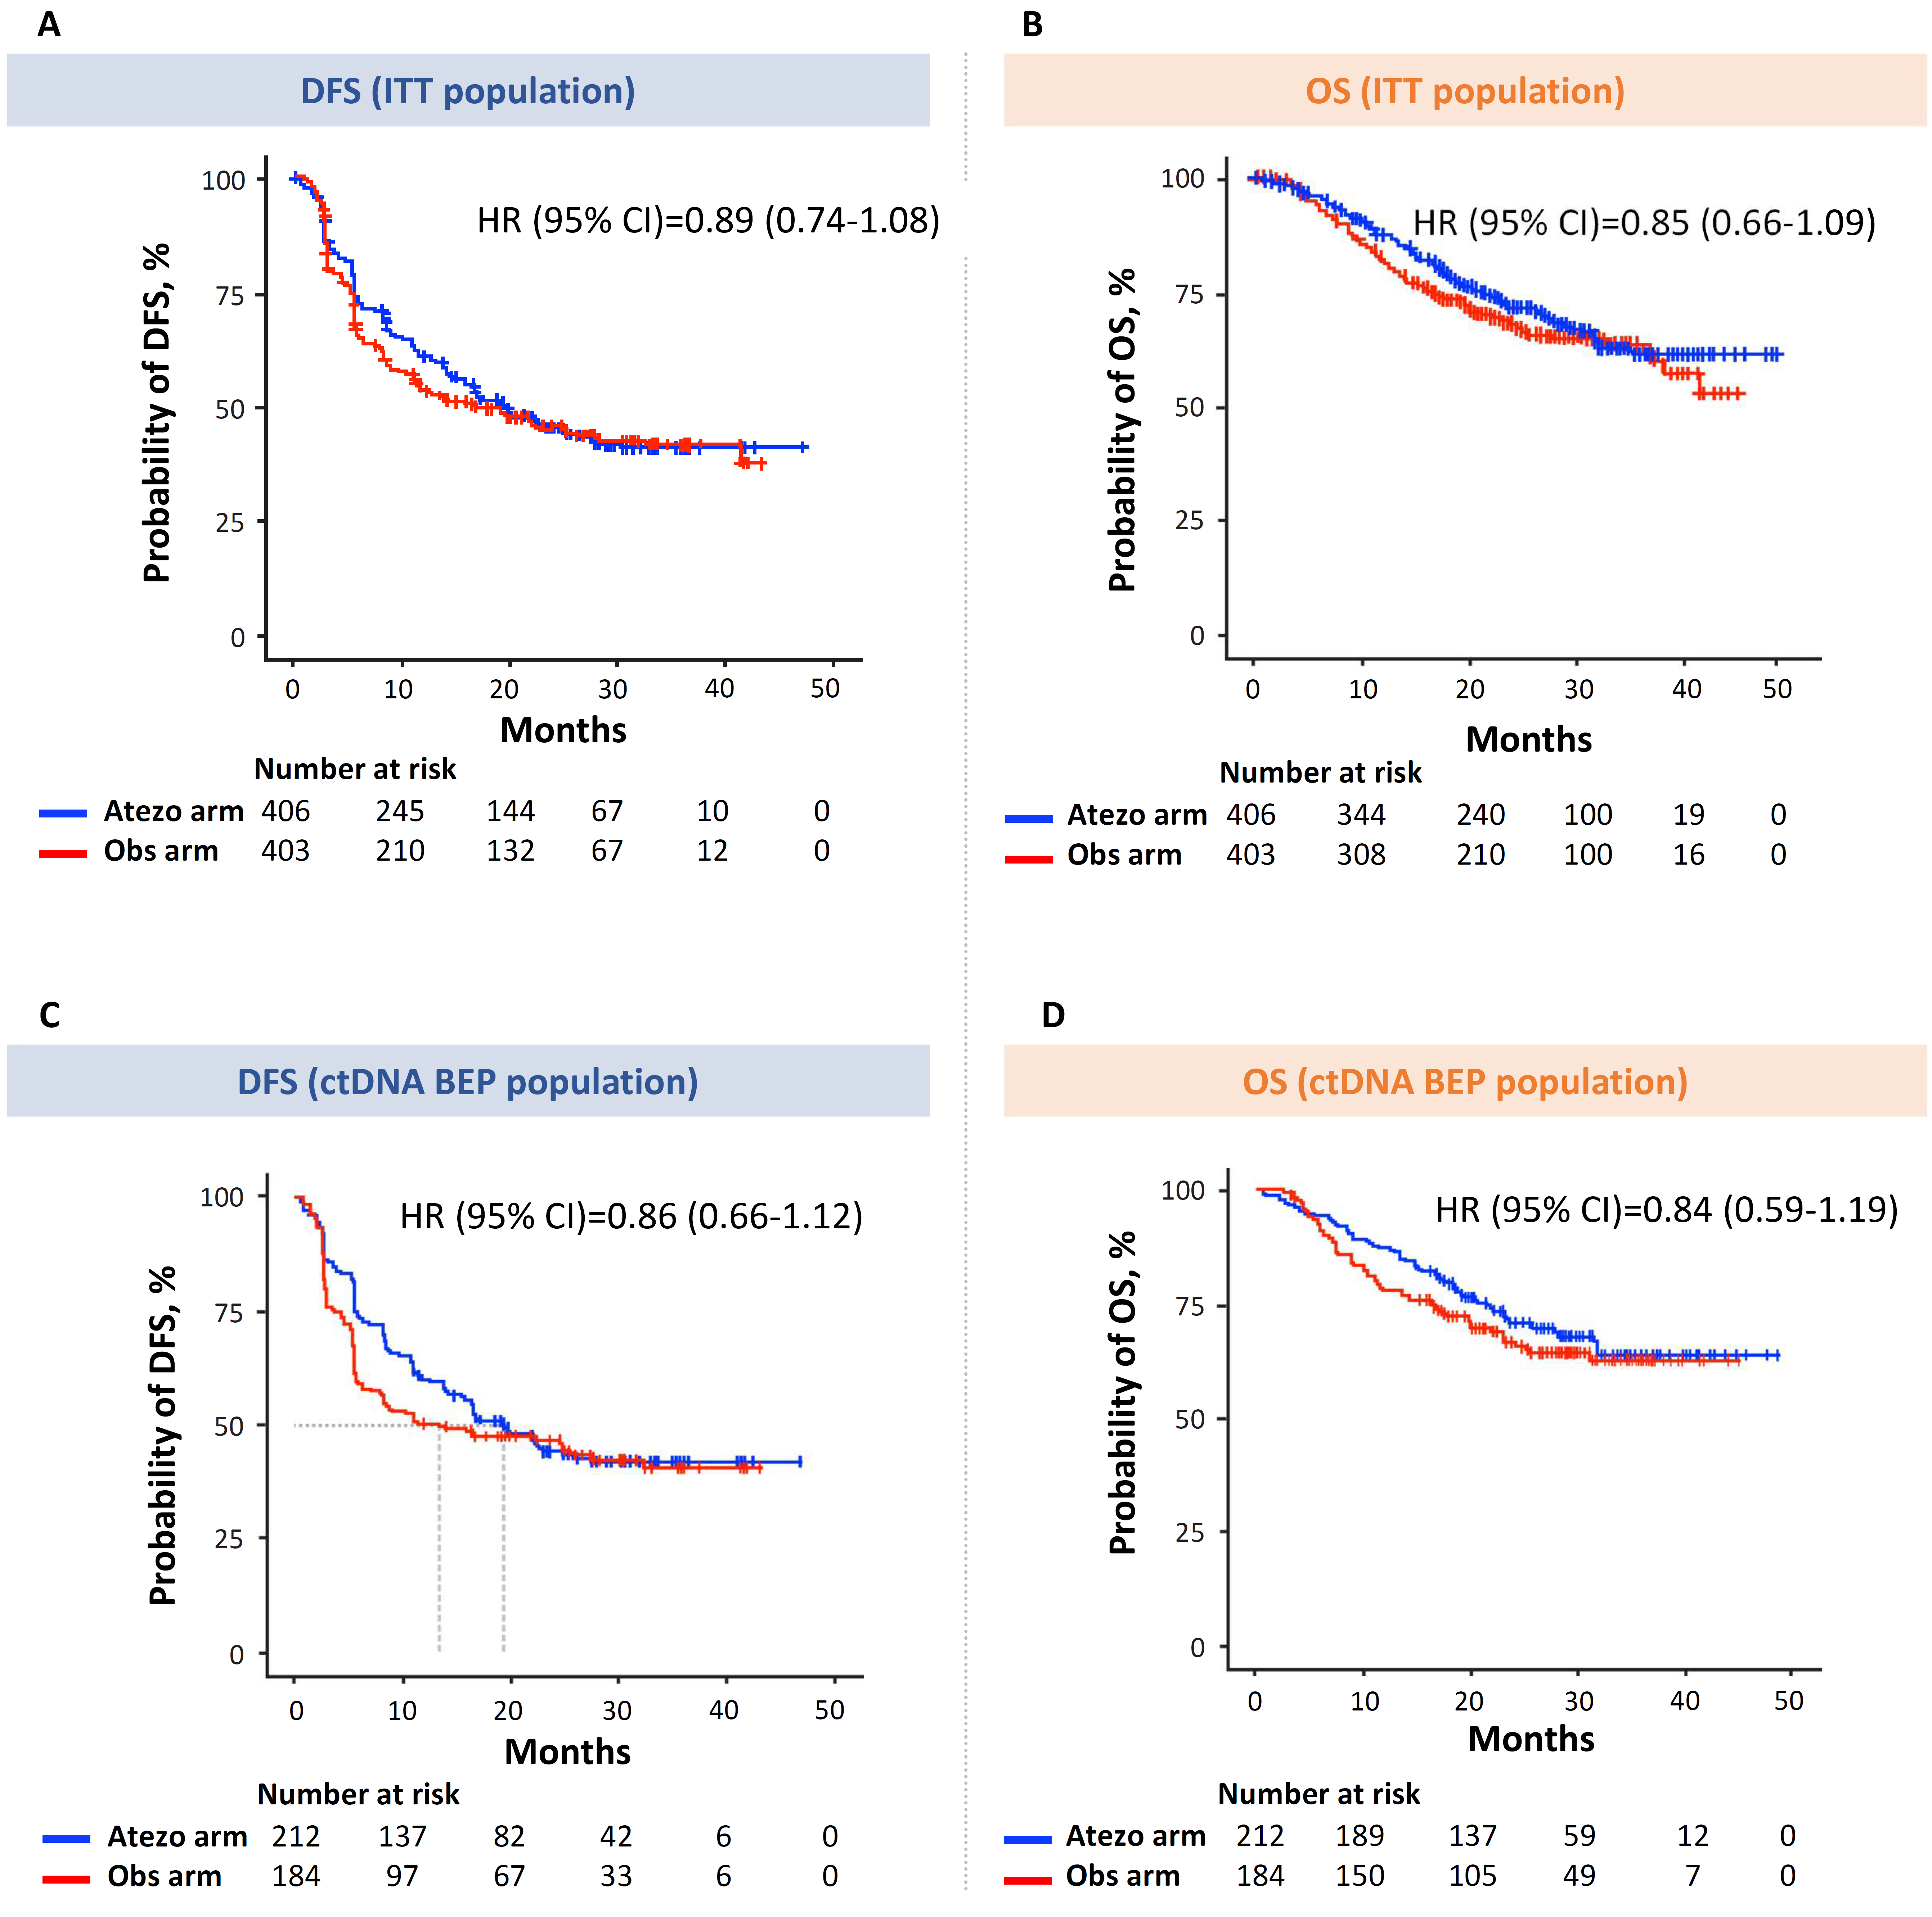
Supplementary Figure 2. Distribution of MTM/mL in ctDNA-positive samples by arm. ctDNA, circulating tumor DNA; MTM/mL, mean tumor molecules per mL of plasma.

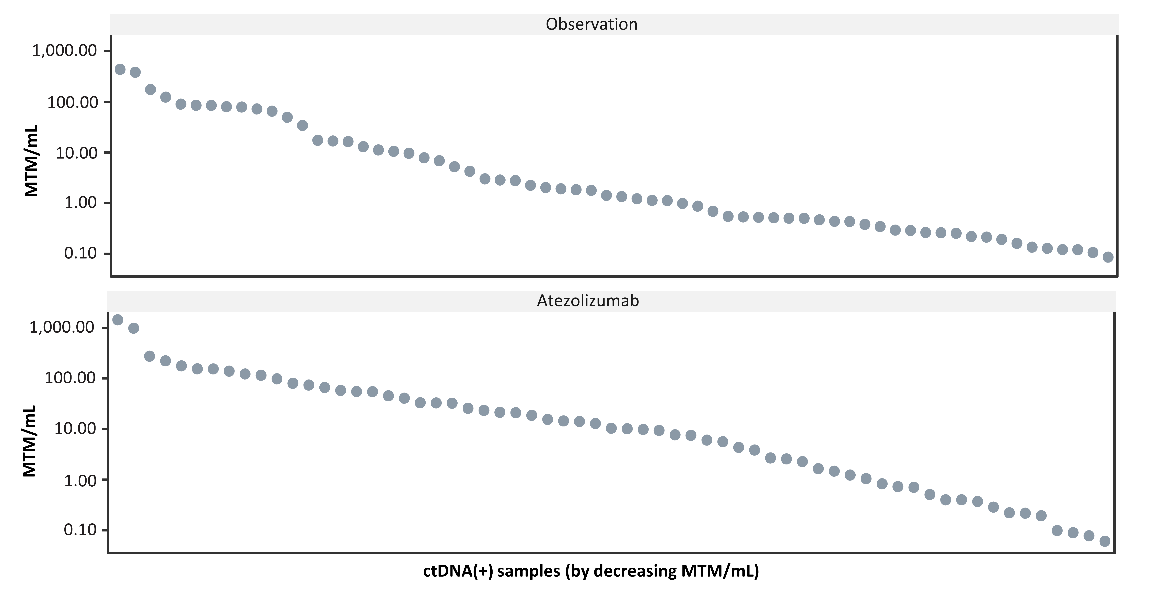
Supplementary Figure 3. DFS analysis by TMB in ctDNA-positive patients of the IMvigor010 study. High TMB was defined as ≥10 mutations/Mb. Low TMB was defined as <10 mutations/Mb. CI, confidence interval; ctDNA, circulating tumor DNA; DFS, disease-free survival; IC, immune cell; Mb, megabase; PD-L1, programmed cell death-ligand 1; pT, primary tumor; TMB, tumor mutational burden; tx, therapy.
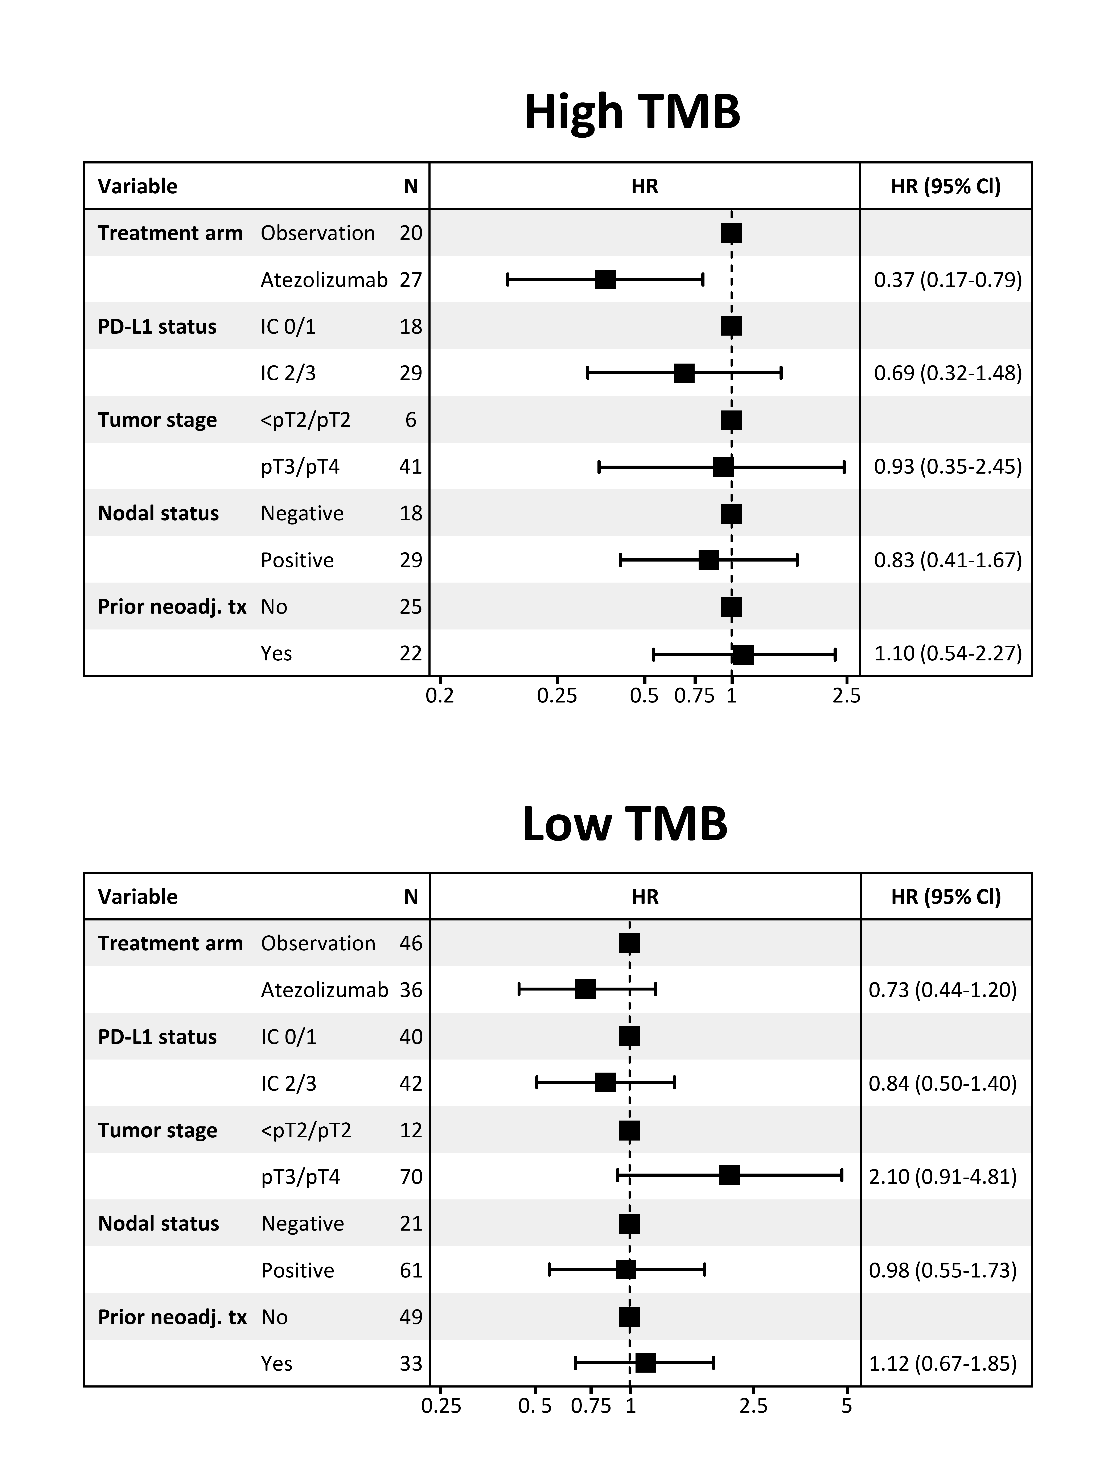
Supplementary Figure 4. OS analysis by TMB in ctDNA-positive patients of the IMvigor010 study. Kaplan-Meier estimates of OS for ctDNA-positive patients monitored and stratified by TMB. High TMB was defined as ≥10 mutations/Mb. Low TMB was defined as <10 mutations/Mb. ªUnivariable. CI, confidence interval; ctDNA, circulating tumor DNA; IC, immune cell; IQR, interquartile range; Mb, megabase; NE, not evaluable; neoadj., neoadjuvant; OS, overall survival; PD-L1, programmed cell death-ligand 1; pT, primary tumor; ref, reference; TMB, tumor mutational burden; tx, therapy.

Supplementary Figure 5. DFS analysis by PD-L1 status in ctDNA-positive patients of the IMvigor010 study. Kaplan-Meier estimates of DFS for ctDNA-positive patients monitored and stratified by PD-L1 status (IC 0/1 vs IC 2/3). ªUnivariable. CI, confidence interval; ctDNA, circulating tumor DNA; DFS, disease-free survival; IC, immune cell; IQR, interquartile range; neoadj., neoadjuvant; PD-L1, programmed cell death-ligand 1; pT, primary tumor; ref, reference; tx, therapy.

Supplementary Figure 6. OS analysis by PD-L1 status in ctDNA-positive patients of the IMvigor010 study. Kaplan-Meier estimates of OS for ctDNA-positive patients monitored and stratified by PD-L1 status (IC 0/1 vs IC 2/3). ªUnivariable. CI, confidence interval; ctDNA, circulating tumor DNA; IC, immune cell; IQR, interquartile range; NE, not evaluable; neoadj., neoadjuvant; OS, overall survival; PD-L1, programmed cell death-ligand 1; pT, primary tumor; ref, reference; tx, therapy.

Supplementary Figure 7. Univariable exploratory biomarker analyses of DFS (A) and OS (B) in ctDNA-positive patients, comparing atezolizumab to observation. CDKN2A, cyclin dependent kinase inhibitor 2A; CI, confidence interval; ctDNA, circulating tumor DNA; DFS, disease-free survival; ERBB2, v-erb-b2 avian erythroblastic leukemia viral oncogene homolog 2; FGFR, fibroblast growth factor receptor; HRD, homologous recombination deficiency; MDM2, mouse double minute 2; PD-L1, programmed cell death-ligand 1; PIK3CA, phosphatidylinositol-4,5-bisphosphate 3-kinase, catalytic subunit alpha; OS, overall survival; TMB, tumor mutational burden.
Supplementary Figure 8. Multivariable exploratory biomarker analyses of DFS (A) and OS (B) in ctDNA-positive patients, comparing atezolizumab to observation. CDKN2A, cyclin dependent kinase inhibitor 2A; CI, confidence interval; ctDNA, circulating tumor DNA; DFS, disease-free survival; ERBB2, v-erb-b2 avian erythroblastic leukemia viral oncogene homolog 2; FGFR, fibroblast growth factor receptor; HRD, homologous recombination deficiency; MDM2, mouse double minute 2; PD-L1, programmed cell death-ligand 1; PIK3CA, phosphatidylinositol-4,5-bisphosphate 3-kinase, catalytic subunit alpha; OS, overall survival; TMB, tumor mutational burden.
Supplementary Figure 9. Univariable exploratory analyses of clinical factors associated with (A) DFS and (B) OS in the observation arm. CI, confidence interval; ctDNA, circulating tumor DNA; DFS, disease-free survival; IC, immune cell; neoadj., neoadjuvant; PD-L1, programmed cell death-ligand 1; pT, primary tumor; OS, overall survival; TMB, tumor mutational burden; tx, therapy.
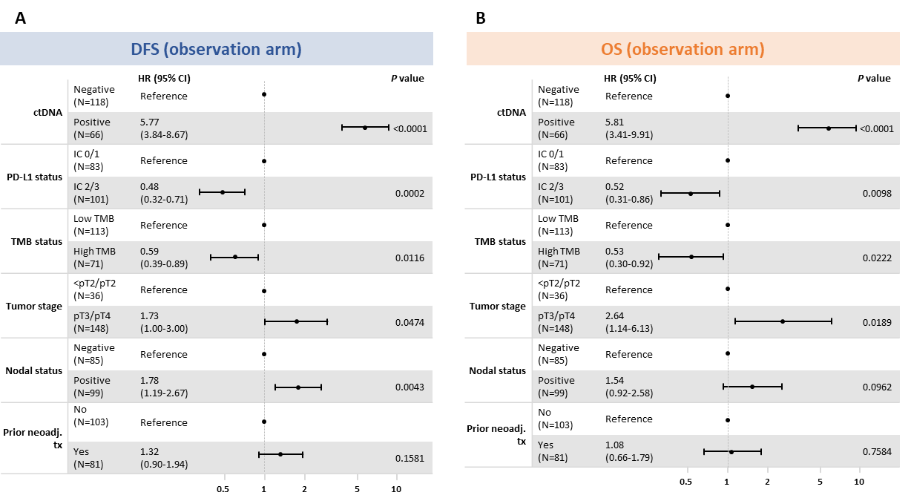

1.2 Supplementary tables

Supplementary Table 1. Comparison of clinical variables in the ITT and ctDNA BEPs
 | ITT population |  | BEP
Clinical variable, n (%) | Atezolizumab  (n=406) | Observation  (n=403) | Atezolizumab  (n=212) | Observation  (n=184)
Median age (IQR), years | 67 (60-72) | 66 (60-73) | 66 (59.75-72) | 67 (61-74)
Gender
Male | 322 (79.3) | 316 (78.4) | 158 (74.5) | 145 (78.8)
Female | 84 (20.7) | 87 (21.6) | 54 (25.5) | 39 (21.2)
Tumor stage
<pT2/pT2 | 104 (25.6) | 101 (25.1) | 38 (17.9) | 36 (19.6)
pT3/pT4 | 302 (74.4) | 302 (74.9) | 174 (82.1) | 148 (80.4)
Nodal status
Negative | 194 (47.8) | 195 (48.4) | 109 (51.4) | 85 (46.2)
Positive | 212 (52.2) | 208 (51.6) | 103 (48.6) | 99 (53.8)
Prior neoadjuvant or adjuvant treatment
No | 210 (51.7) | 214 (53.1) | 120 (56.6) | 103 (56.0)
Yes | 196 (48.3) | 189 (46.9) | 92 (43.4) | 81 (44.0)
ECOG performance status
0 | 248 (61.1) | 259 (64.3) | 132 (62.3) | 119 (64.7)
1 | 142 (35.0) | 130 (32.3) | 73 (34.4) | 57 (31.0)
2 | 16 (3.9) | 14 (3.5) | 9 (4.2) | 8 (4.3)
PD-L1 status
IC 0/1 | 210 (51.7) | 207 (51.4) | 102 (48.1) | 83 (45.1)
IC 2/3 | 196 (48.3) | 196 (48.6) | 110 (51.9) | 101 (54.9)
BEP, biomarker-evaluable population; ctDNA, circulating tumor DNA; ECOG, Eastern Cooperative Oncology Group; IC, immune cells; IQR, interquartile range; ITT, intention-to-treat; PD-L1, programmed cell death ligand 1; pT, primary tumor.

Supplementary Table 2. DFS and OS analyses of patients monitored and stratified by ctDNA detection (MRD) at the postsurgical time point

DFS | ctDNA (−) |  | ctDNA (+) |  | Observation arm (n=184)
 | Observation [ref] | Atezolizumab | Observation [ref] | Atezolizumab | ctDNA (−) [ref] | ctDNA (+)
Patient with events | 43/118 (36%) | 69/149 (46%) | 60/66 (91%) | 47/63 (75%) | 43/118 (36%) | 60/66 (91%)
Median DFS (95% CI), months | NR | NR | 3.0 (2.9-5.5) | 5.9 (5.6-13.9) | NR | 3.0 (2.9-5.5)
HR (95% CI)ª | 1.28 (0.88-1.88) |  | 0.56 (0.38-0.83) |  | 5.77 (3.84-8.67)
P value | 0.195 |  | 0.003 |  | <0.0001
OS | ctDNA (−) |  | ctDNA (+) |  | Observation arm (n=184)
 | Observation [ref] | Atezolizumab | Observation [ref] | Atezolizumab | ctDNA (−) [ref] | ctDNA (+)
Patient with events | 21/118 (18%) | 33/149 (22%) | 41/66 (62%) | 32/63 (51%) | 21/118 (18%) | 41/66 (62%)
Median OS (95% CI), months | NR | NR | 14.1 (10.5-23.0) | 23.1 (18.4-NE) | NR | 14.1 (10.5-23.0)
HR (95% CI)ª | 1.25 (0.72-2.15) |  | 0.66 (0.42-1.05) |  | 5.81 (3.41-9.91)
P value | 0.432 |  | 0.081 |  | <0.0001
ªUnivariable. CI, confidence interval; ctDNA, circulating tumor DNA; DFS, disease-free survival; MRD, molecular residual disease; NE, not evaluable; NR, not reached; OS, overall survival; ref, reference.

Supplementary Table 3. DFS analysis by TMB in ctDNA-positive patients of the IMvigor010 study

DFS | High TMB |  | Low TMB
 | Observation [ref] | Atezolizumab | Observation [ref] | Atezolizumab
Patients with events | 20/20 (100%) | 19/27 (70%) | 40/46 (87%) | 28/36 (78%)
Median DFS (IQR), months | 3.8 (2.8-7.9) | 13.9 (5.6-NE) | 3.0 (2.9-5.5) | 5.6 (2.9-12.6)
HR (95% CI)ª | 0.31 (0.15-0.62) |  | 0.73 (0.45-1.19)
P value | 0.00055 |  | 0.21
High TMB was defined as ≥10 mutations/Mb. Low TMB was defined as <10 mutations/Mb. ªUnivariable. CI, confidence interval; ctDNA, circulating tumor DNA; DFS, disease-free survival; IQR, interquartile range; Mb, megabase; NE, not evaluable; ref, reference; TMB, tumor mutational burden.

