**Transcriptome analysis reveals reduced immunity and metabolic level under cold stress in *Mauremys mutica***

Jiahui OuYang1,2†, Yangchun Gao2†, Yufeng Wei2, Huangping Huang3, Yan Ge2, Jun Zhao1\*, Shiping Gong3\*

1 School of Life Science, South China Normal University, Guangzhou 510631, China

2 Guangdong Key Laboratory of Animal Conservation and Resource Utilization, Guangdong Public Laboratory of Wild Animal Conservation and Utilization, Institute of Zoology, Guangdong Academy of Sciences, Guangzhou 510260, China

3 College of Life Science and Technology, Jinan University, Guangzhou 510632, China

† These authors contributed equally to this work and share first authorship

Figure S1. KEGG pathway enrichment maps for each time point. The green, red and blue background colours in the pathway represent down-regulated, up-regulated and up-down-regulated genes respectively. ( Steroid hormone biosynthesis in 48h (A) and R (B). Glycine, serine and threonine metabolism in 48h (C) and R (D). Unsaturated fatty acid biosynthetic pathways in 48h (E) and R (F). NOD-like receptor signalling pathways in 48h (G) and 24h (H). Neuroactive ligand receptor interactions in 48h (I) and 24h(J). Cytokine-cytokine receptor interactions in 48h (K) and 24h (L). Ether lipid metabolism in 24h (M) and R (N).)

A

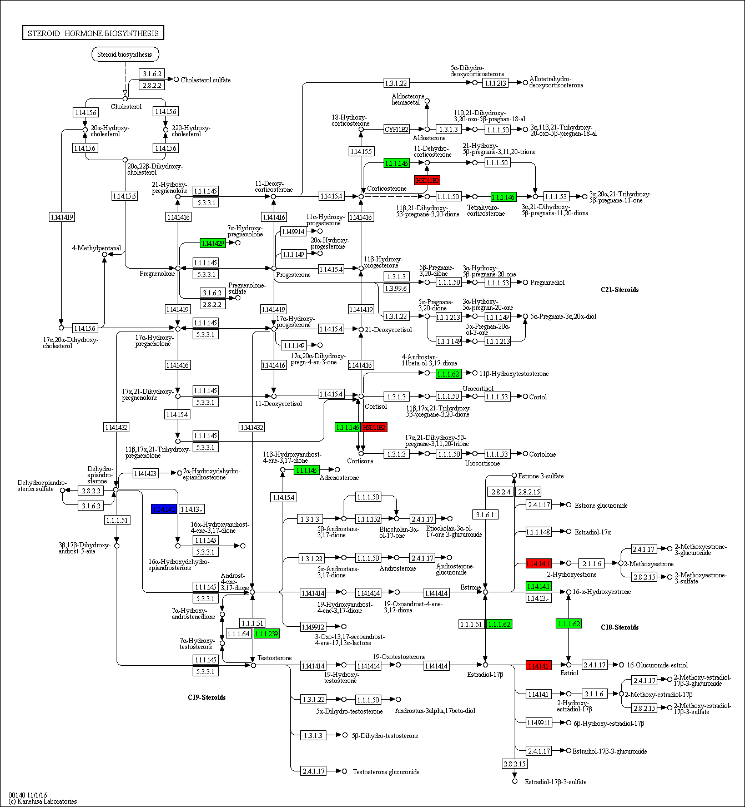

B

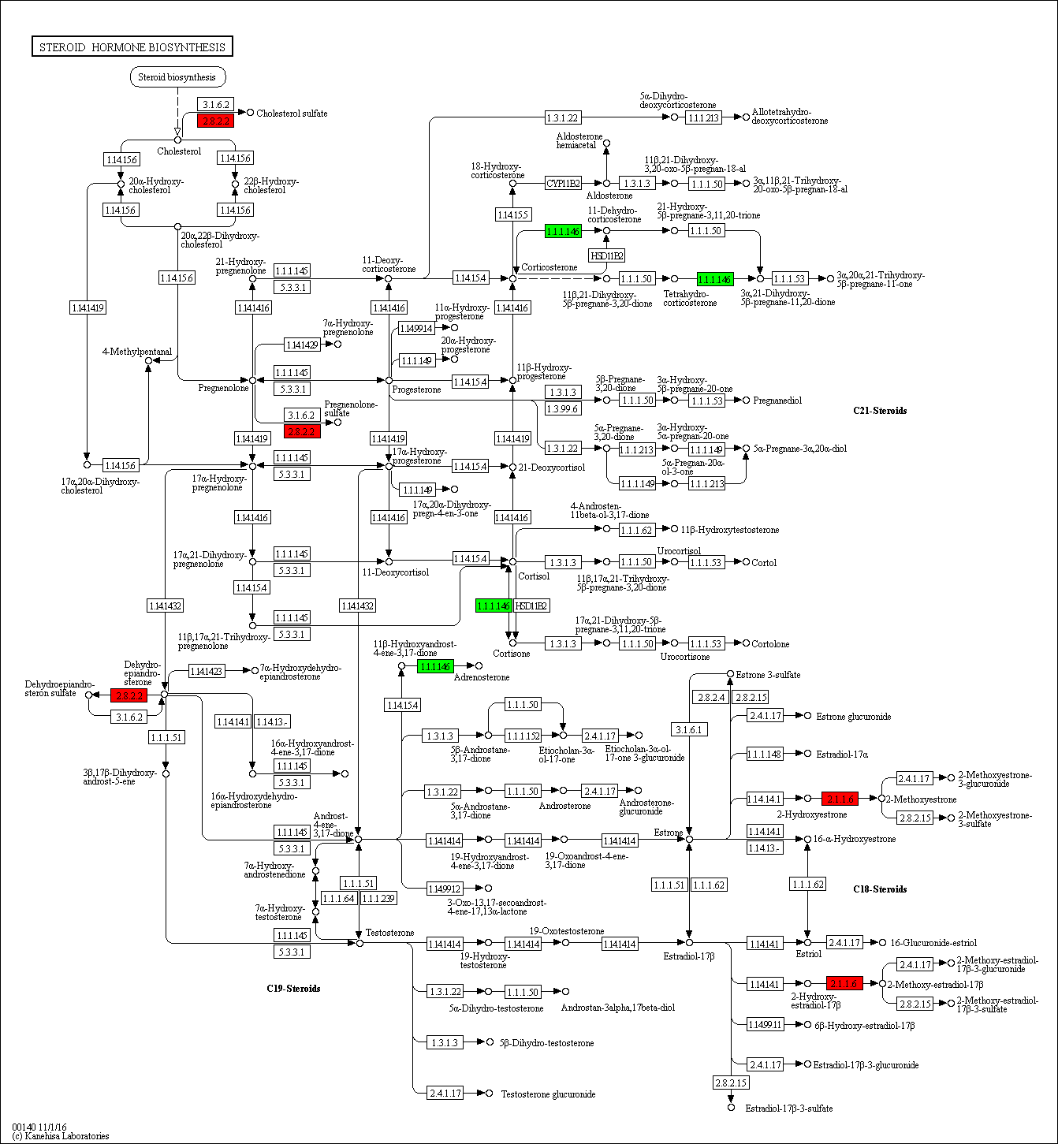

C

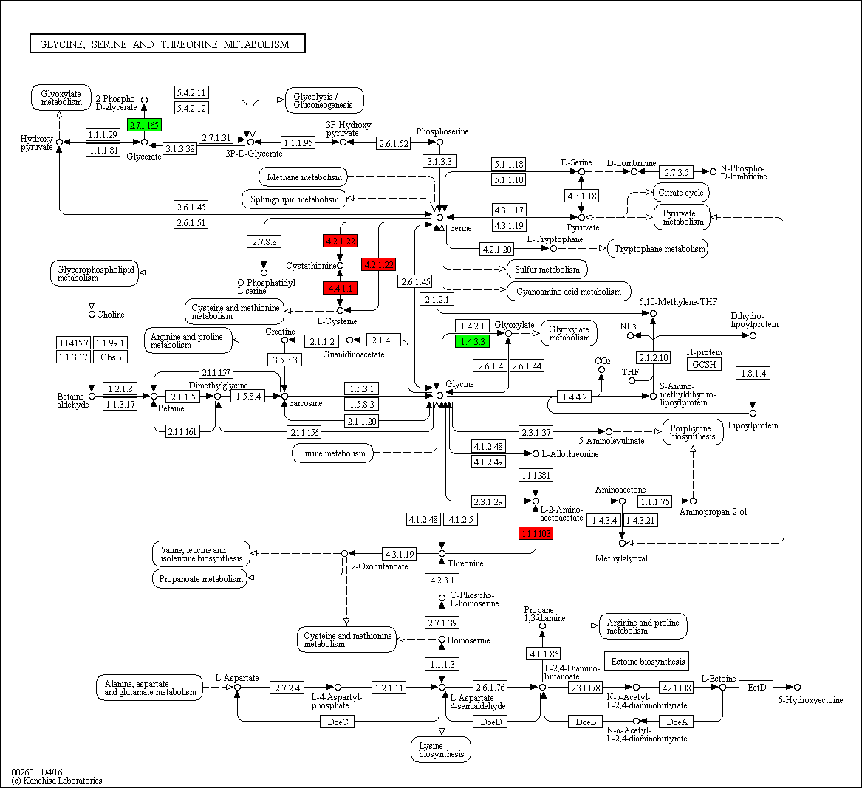

D

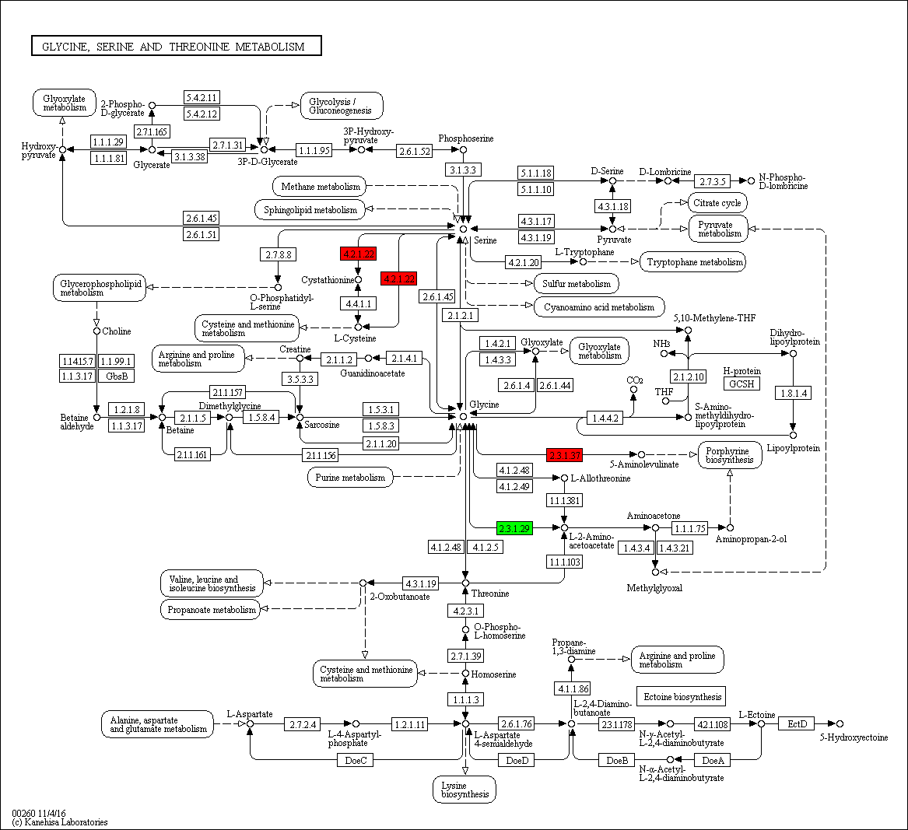

E

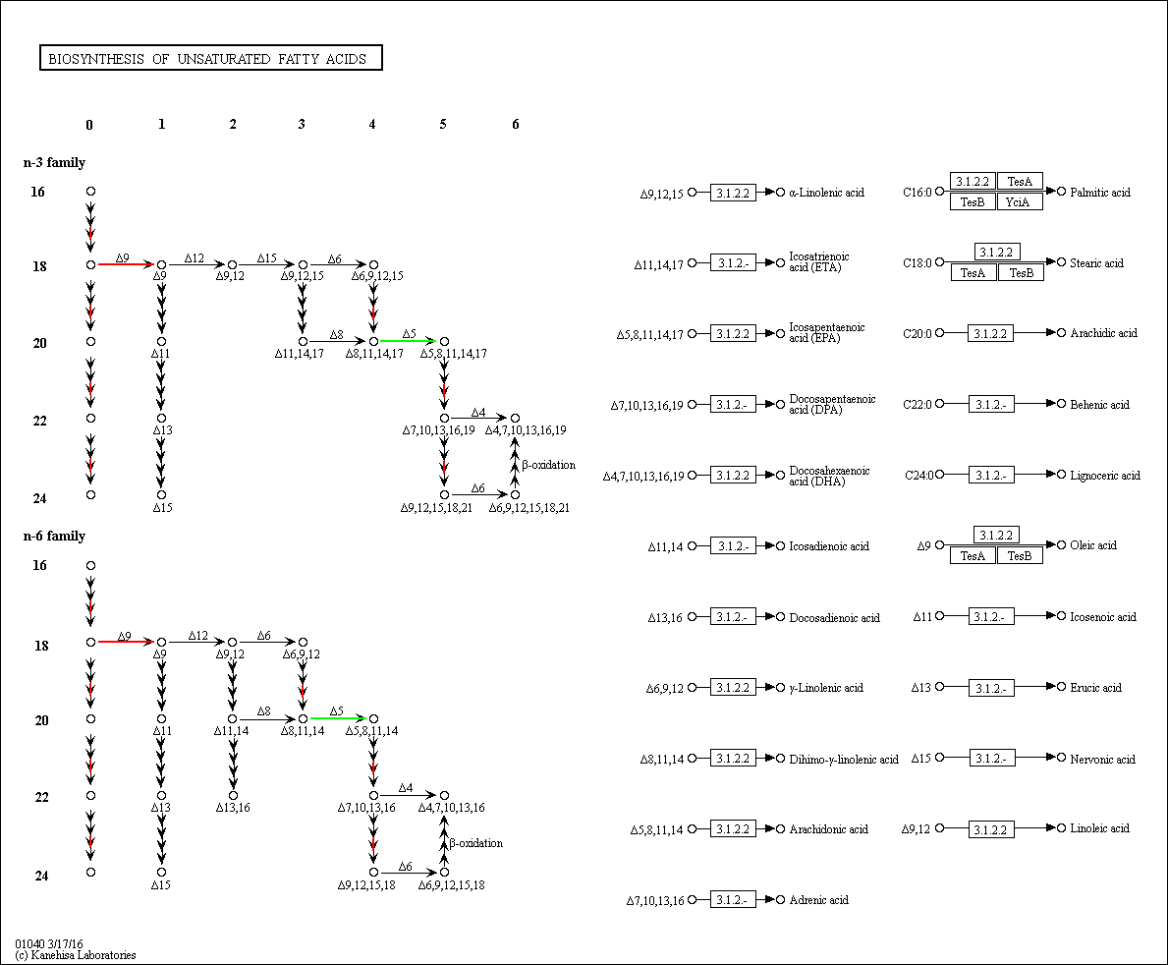

F

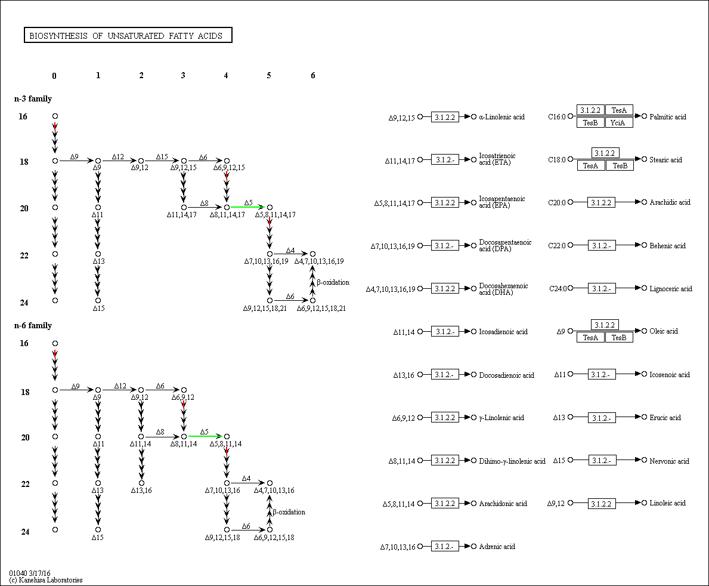

G

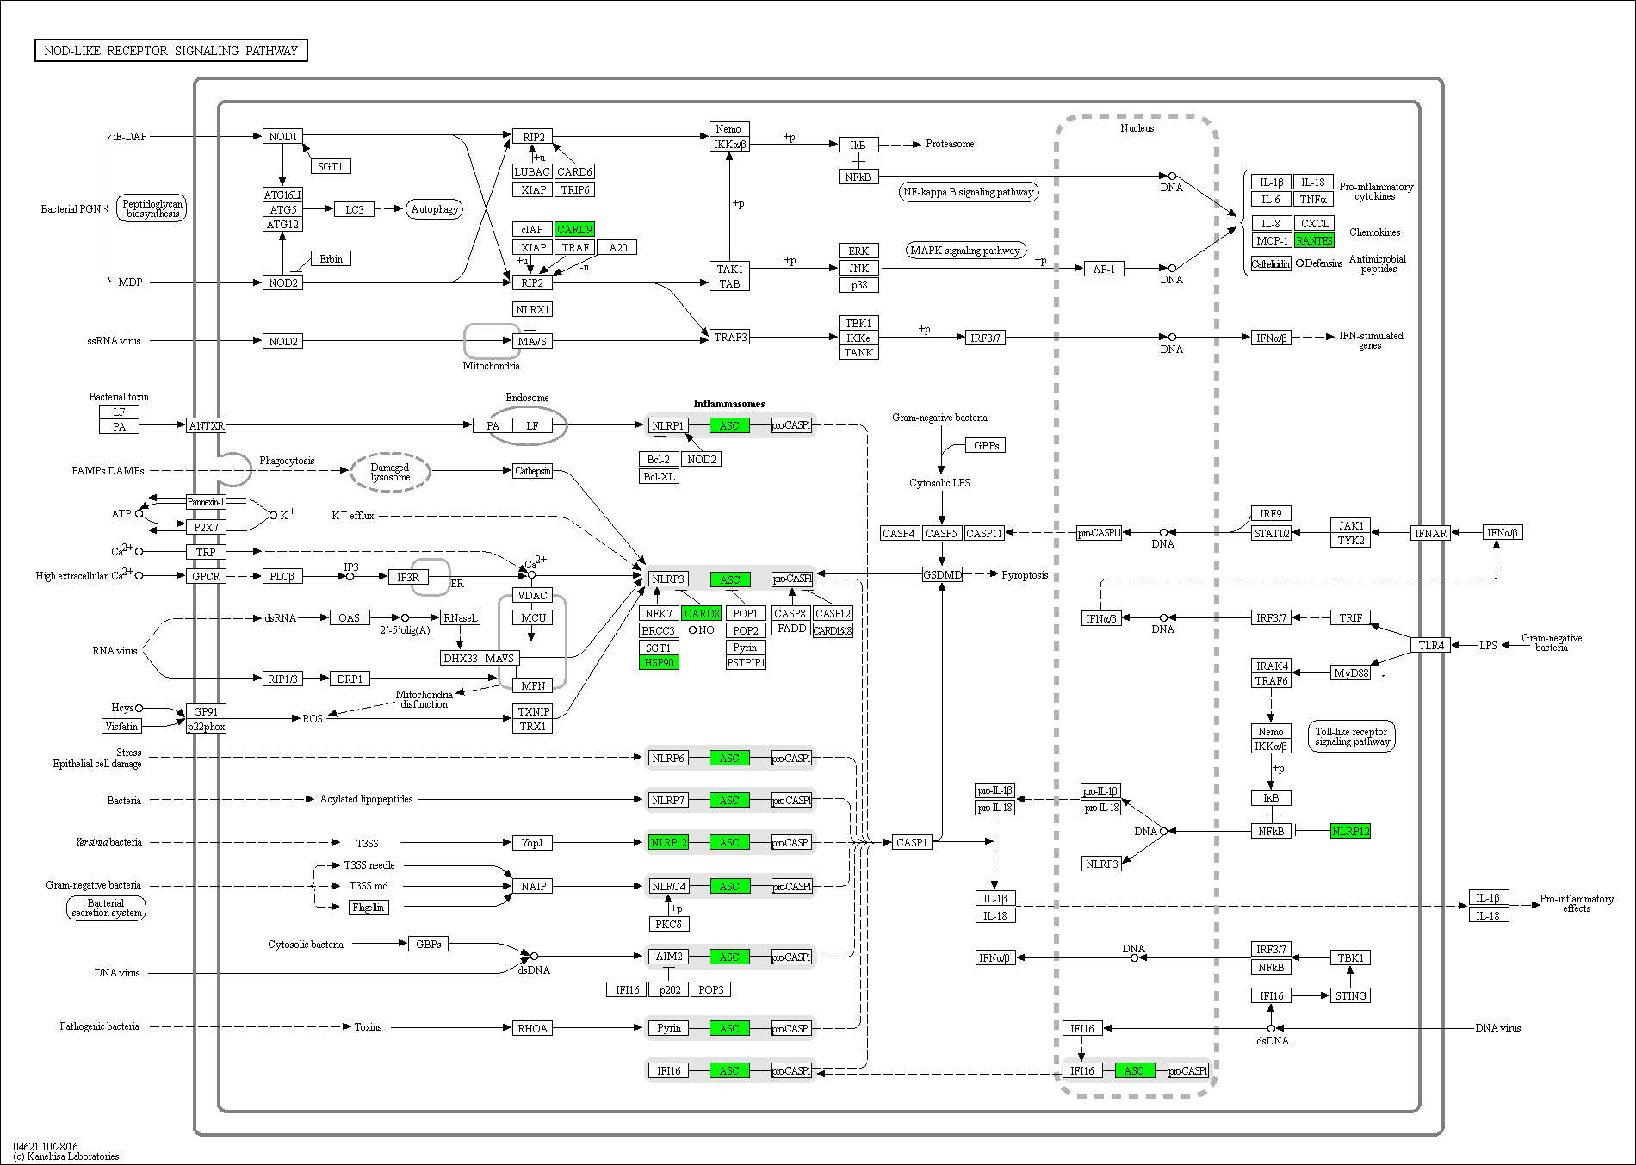

H

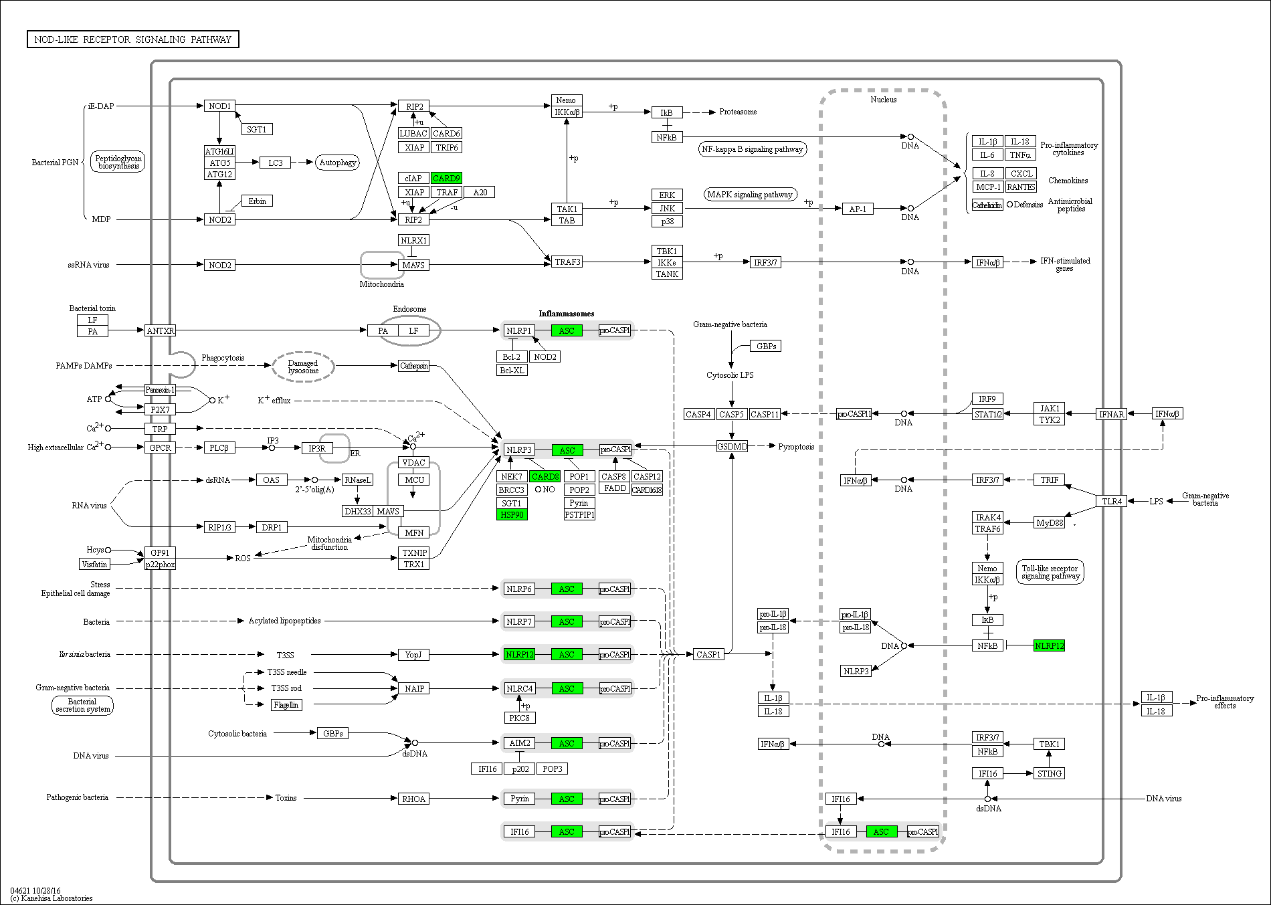

I

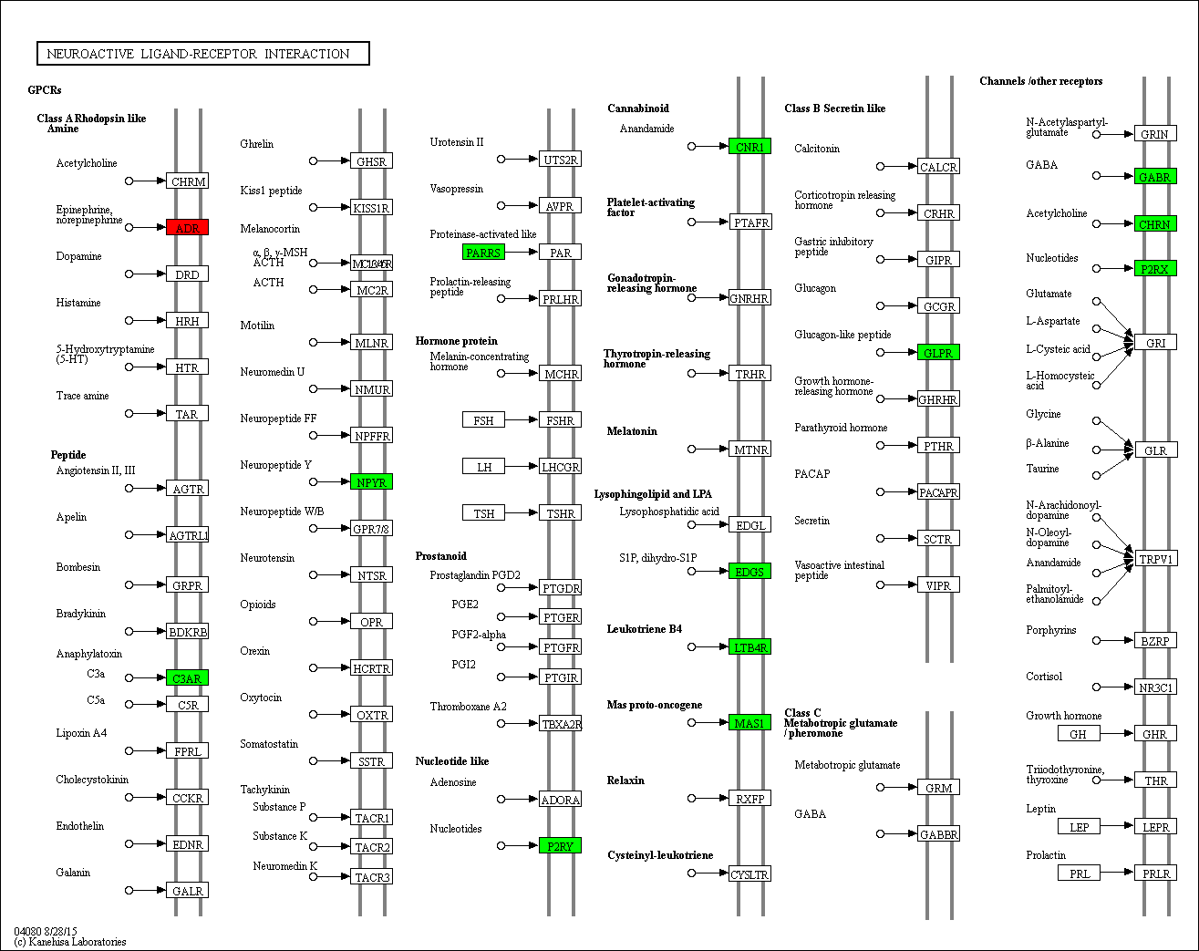

J

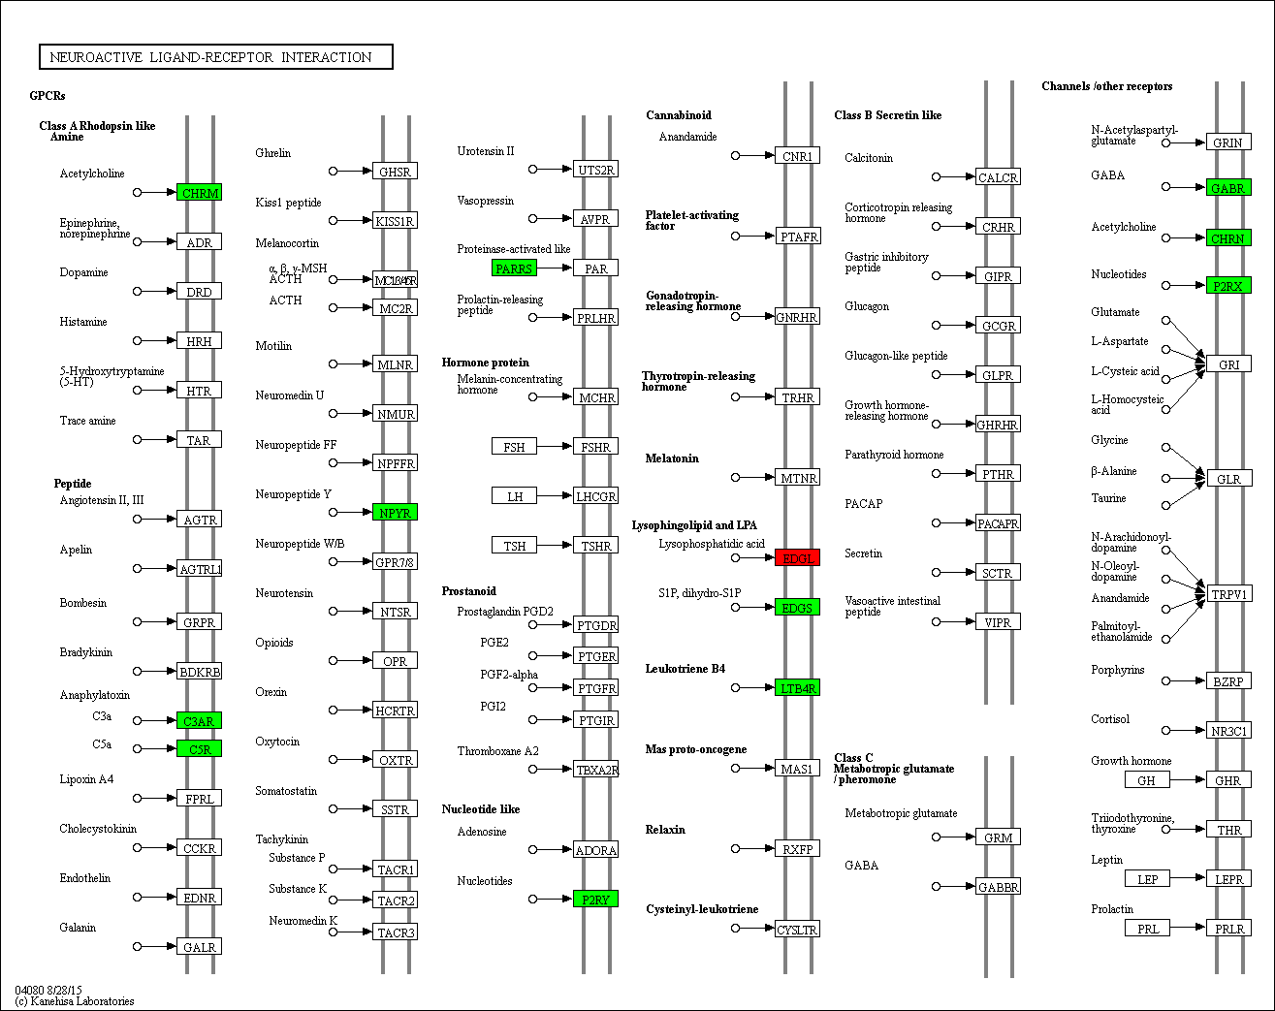

K

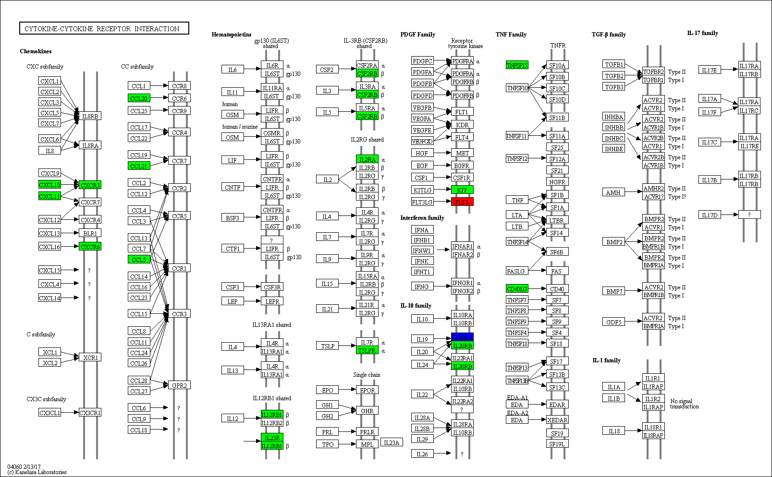

L

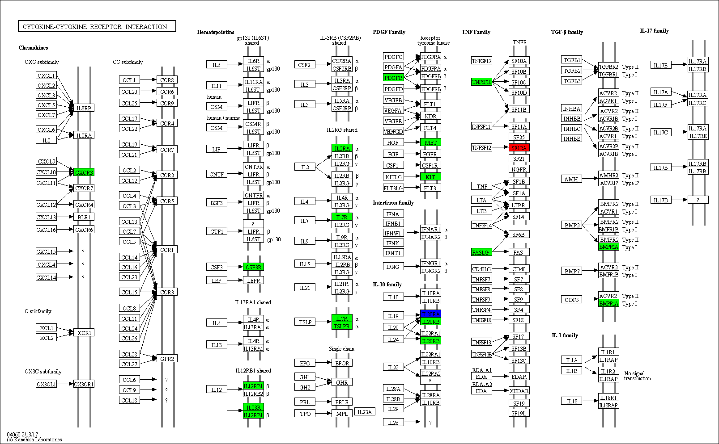

M

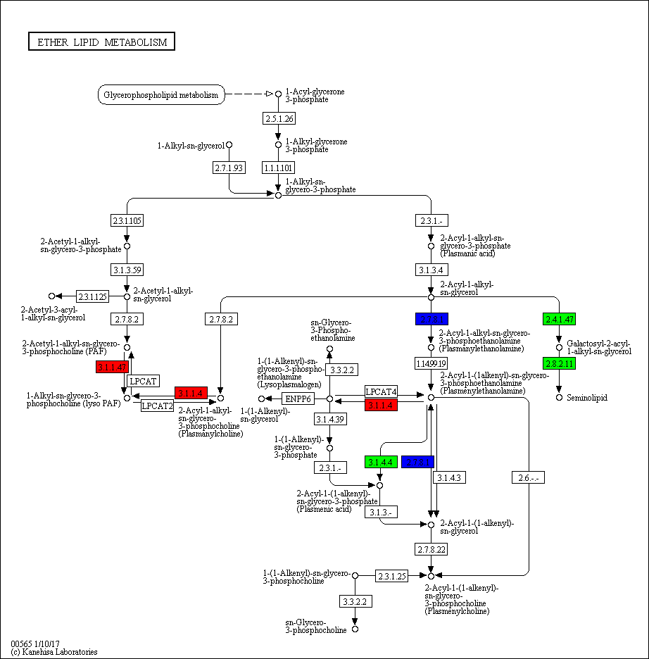

N

