Supplementary materials

Identifying major predictors for parenting stress in a caregiver of autism spectrum disorder using machine learning models
Table of Contents
eAppendix 1. STROBE Statement—checklist of items that should be included in reports of observational studies 6
eAppendix 2. Definitions and measurements for model features 8
eTable 2.1. Caregiver variables 8
eTable 2.2. Autism spectrum disorder (ASD) patient variables 9
eAppendix 3. Missing value information 11
eAppendix 4. Formulas for variance inflation factor, area under the receiver operating curve, sensitivity, specificity, positive predictive value, negative predictive value, and accuracy 13
eAppendix 5. Variance inflation factor calculation for continuous features 14
eAppendix 6. Model information and detailed results (Sample: Overall sample [n=496], Outcome: Parental distress) 15
eTable 6.1. Model features (Variables are on the second columns) 15
eTable 6.2. Performance of each model on the training set 16
eTable 6.3. Performance of each model on the test set 16
eFigure 6.4. SHapley Additive exPlanations (SHAP) summary plot for RF and XGBoost models (only top 20 predictors were presented) 17
eFigure 6.5. Receiver operating characteristic curves (ROC) for the training and test set 17
eAppendix 7. Model information and detailed results (Sample: Overall sample [n=496] Outcome: Parent-child dysfunctional interaction) 18
eTable 7.1. Model features (Variables are on the second columns) 18
eTable 7.2. Performance of each model on the training set 19
eTable 7.3. Performance of each model on the test set 19
eFigure 7.4. SHapley Additive exPlanations (SHAP) summary plot for RF and XGBoost models (only top 20 predictors were presented) 20
eFigure 7.5. Receiver operating characteristic curves (ROC) for the training and test set 20
eAppendix 8. Model information and detailed results (Sample: Overall sample [n=496], Outcome: Difficult child) 21
eTable 8.1. Model features (Variables are on the second columns) 21
eTable 8.2. Performance of each model on the training set 22
eTable 8.3. Performance of each model on the test set 22
eFigure 8.4. SHapley Additive exPlanations (SHAP) summary plot for RF and XGBoost models (only top 20 predictors were presented) 23
eFigure 8.5. Receiver operating characteristic curves (ROC) for the training and test set 23
eAppendix 9. Model information and detailed results (Sample: Overall sample [n=496], Outcome: Total parenting stress) 24
eTable 9.1. Model features (Variables are on the second columns) 24
eTable 9.2. Performance of each model on the training set 25
eTable 9.3. Performance of each model on the test set 25
eFigure 9.4. SHapley Additive exPlanations (SHAP) summary plot for RF and XGBoost models (only top 20 predictors were presented) 26
eFigure 9.5. Receiver operating characteristic curves (ROC) for the training and test set 26
eAppendix 10. Model information and detailed results (Sample: CBCL 1.5-5 sample [n=194], Outcome: Parental distress) 27
eTable 10.1. Model features (Variables are on the second columns) 27
eTable 10.2. Performance of each model on the training set 28
eTable 10.3. Performance of each model on the test set 28
eFigure 10.4. SHapley Additive exPlanations (SHAP) summary plot for RF and XGBoost models (only top 20 predictors were presented) 29
eFigure 10.5. Receiver operating characteristic curves (ROC) for the training and test set 29
eAppendix 11. Model information and detailed results (Sample: CBCL 1.5-5 sample [n=194], Outcome: Parent-child dysfunctional interaction) 30
eTable 11.1. Model features (Variables are on the second columns) 30
eTable 11.2. Performance of each model on the training set 31
eTable 11.3. Performance of each model on the test set 31
eFigure 11.4. SHapley Additive exPlanations (SHAP) summary plot for RF and XGBoost models (only top 20 predictors were presented) 32
eFigure 11.5. Receiver operating characteristic curves (ROC) for the training and test set 32
eAppendix 12. Model information and detailed results (Sample: CBCL 1.5-5 sample [n=194], Outcome: Difficult child) 33
eTable 12.1. Model features (Variables are on the second columns) 33
eTable 12.2. Performance of each model on the training set 34
eTable 12.3. Performance of each model on the test set 34
eFigure 12.4. SHapley Additive exPlanations (SHAP) summary plot for RF and XGBoost models (only top 20 predictors were presented) 35
eFigure 12.5. Receiver operating characteristic curves (ROC) for the training and test set 35
eAppendix 13. Model information and detailed results (Sample: CBCL 1.5-5 sample [n=194], Outcome: Total parenting stress) 36
eTable 13.1. Model features (Variables are on the second columns) 36
eTable 13.2. Performance of each model on the training set 37
eTable 13.3. Performance of each model on the test set 37
eFigure 13.4. SHapley Additive exPlanations (SHAP) summary plot for RF and XGBoost models (only top 20 predictors were presented) 38
eFigure 13.5. Receiver operating characteristic curves (ROC) for the training and test set 38
eAppendix 14. Model information and detailed results (Sample: CBCL 6-18 sample [n=302], Outcome: Parental distress) 39
eTable 14.1. Model features (Variables are on the second columns) 39
eTable 14.2. Performance of each model on the training set 40
eTable 14.3. Performance of each model on the test set 40
eFigure 14.4. SHapley Additive exPlanations (SHAP) summary plot for RF and XGBoost models (only top 20 predictors were presented) 41
eFigure 14.5. Receiver operating characteristic curves (ROC) for the training and test set 41
eAppendix 15. Model information and detailed results (Sample: CBCL 6-18 sample [n=302], Outcome: Parent-child dysfunctional interaction) 42
eTable 15.1. Model features (Variables are on the second columns) 42
eTable 15.2. Performance of each model on the training set 43
eTable 15.3. Performance of each model on the test set 43
eFigure 15.4. SHapley Additive exPlanations (SHAP) summary plot for RF and XGBoost models (only top 20 predictors were presented) 44
eFigure 15.5. Receiver operating characteristic curves (ROC) for the training and test set 44
eAppendix 16. Model information and detailed results (Sample: CBCL 6-18 sample [n=302], Outcome: Difficult child) 45
eTable 16.1. Model features (Variables are on the second columns) 45
eTable 16.2. Performance of each model on the training set 46
eTable 16.3. Performance of each model on the test set 46
eFigure 16.4. SHapley Additive exPlanations (SHAP) summary plot for RF and XGBoost models (only top 20 predictors were presented) 47
eFigure 16.5. Receiver operating characteristic curves (ROC) for the training and test set 47
eAppendix 17. Model information and detailed results (Sample: CBCL 6-18 sample [n=302], Outcome: Total parenting stress) 48
eTable 17.1. Model features (Variables are on the second columns) 48
eTable 17.2. Performance of each model on the training set 49
eTable 17.3. Performance of each model on the test set 49
eFigure 17.4. SHapley Additive exPlanations (SHAP) summary plot for RF and XGBoost models (only top 20 predictors were presented) 50
eFigure 17.5. Receiver operating characteristic curves (ROC) for the training and test set 50
eAppendix 18. Model information and detailed results (Sample: with ADHD [n=168], Outcome: Parental distress) 51
eTable 18.1. Model features (Variables are on the second columns) 51
eTable 18.2. Performance of each model on the training set 52
eTable 18.3. Performance of each model on the test set 52
eFigure 18.4. SHapley Additive exPlanations (SHAP) summary plot for RF and XGBoost models (only top 20 predictors were presented) 53
eFigure 18.5. Receiver operating characteristic curves (ROC) for the training and test set 53
eAppendix 19. Model information and detailed results (Sample: with ADHD [n=168], Outcome: Parent-child dysfunctional interaction) 54
eTable 19.1. Model features (Variables are on the second columns) 54
eTable 19.2. Performance of each model on the training set 55
eTable 19.3. Performance of each model on the test set 55
eFigure 19.4. SHapley Additive exPlanations (SHAP) summary plot for RF and XGBoost models (only top 20 predictors were presented) 56
eFigure 19.5. Receiver operating characteristic curves (ROC) for the training and test set 56
eAppendix 20. Model information and detailed results (Sample: with ADHD [n=168], Outcome: Difficult child) 57
eTable 20.1. Model features (Variables are on the second columns) 57
eTable 20.2. Performance of each model on the training set 58
eTable 20.3. Performance of each model on the test set 58
eFigure 20.4. SHapley Additive exPlanations (SHAP) summary plot for RF and XGBoost models (only top 20 predictors were presented) 59
eFigure 20.5. Receiver operating characteristic curves (ROC) for the training and test set 59
eAppendix 21. Model information and detailed results (Sample: with ADHD [n=168], Outcome: Total parenting stress) 60
eTable 21.1. Model features (Variables are on the second columns) 60
eTable 21.2. Performance of each model on the training set 61
eTable 21.3. Performance of each model on the test set 61
eFigure 21.4. SHapley Additive exPlanations (SHAP) summary plot for RF and XGBoost models (only top 20 predictors were presented) 62
eFigure 21.5. Receiver operating characteristic curves (ROC) for the training and test set 62
eAppendix 22. Model information and detailed results (Sample: without ADHD [n=328], Outcome: Parental distress) 63
eTable 22.1. Model features (Variables are on the second columns) 63
eTable 22.2. Performance of each model on the training set 64
eTable 22.3. Performance of each model on the test set 64
eFigure 22.4. SHapley Additive exPlanations (SHAP) summary plot for RF and XGBoost models (only top 20 predictors were presented) 65
eFigure 22.5. Receiver operating characteristic curves (ROC) for the training and test set 65
eAppendix 23. Model information and detailed results (Sample: without ADHD [n=328], Outcome: Parent-child dysfunctional interaction) 66
eTable 23.1. Model features (Variables are on the second columns) 66
eTable 23.2. Performance of each model on the training set 67
eTable 23.3. Performance of each model on the test set 67
eFigure 23.4. SHapley Additive exPlanations (SHAP) summary plot for RF and XGBoost models (only top 20 predictors were presented) 68
eFigure 23.5. Receiver operating characteristic curves (ROC) for the training and test set 68
eAppendix 24. Model information and detailed results (Sample: without ADHD [n=328], Outcome: Difficult child) 69
eTable 24.1. Model features (Variables are on the second columns) 69
eTable 24.2. Performance of each model on the training set 70
eTable 24.3. Performance of each model on the test set 70
eFigure 24.4. SHapley Additive exPlanations (SHAP) summary plot for RF and XGBoost models (only top 20 predictors were presented) 71
eFigure 24.5. Receiver operating characteristic curves (ROC) for the training and test set 71
eAppendix 25. Model information and detailed results (Sample: without ADHD [n=328], Outcome: Total parenting stress) 72
eTable 25.1. Model features (Variables are on the second columns) 72
eTable 25.2. Performance of each model on the training set 73
eTable 25.3. Performance of each model on the test set 73
eFigure 25.4. SHapley Additive exPlanations (SHAP) summary plot for (only top 20 predictors were presented) 74
eFigure 25.5. Receiver operating characteristic curves (ROC) for the training and test set 74

eAppendix 1. STROBE Statement—checklist of items that should be included in reports of observational studies
 | Item No. | Recommendation | Page  No.
Title and abstract | 1 | (a) Indicate the study’s design with a commonly used term in the title or the abstract | Title page
 |  | (b) Provide in the abstract an informative and balanced summary of what was done and what was found | Abstract
Introduction
Background/rationale | 2 | Explain the scientific background and rationale for the investigation being reported | Manuscript #3
Objectives | 3 | State specific objectives, including any prespecified hypotheses | Manuscript #3
Methods
Study design | 4 | Present key elements of study design early in the paper | Manuscript #3-4
Setting | 5 | Describe the setting, locations, and relevant dates, including periods of recruitment, exposure, follow-up, and data collection | Manuscript #3-4
Participants | 6 | (a) Cohort study—Give the eligibility criteria, and the sources and methods of selection of participants. Describe methods of follow-up  Case-control study—Give the eligibility criteria, and the sources and methods of case ascertainment and control selection. Give the rationale for the choice of cases and controls  Cross-sectional study—Give the eligibility criteria, and the sources and methods of selection of participants | Manuscript #3-4
 |  | (b) Cohort study—For matched studies, give matching criteria and number of exposed and unexposed  Case-control study—For matched studies, give matching criteria and the number of controls per case | Not applicable
Variables | 7 | Clearly define all outcomes, exposures, predictors, potential confounders, and effect modifiers. Give diagnostic criteria, if applicable | Manuscript #4
Data sources/ measurement | 8* | For each variable of interest, give sources of data and details of methods of assessment (measurement). Describe comparability of assessment methods if there is more than one group | Appendix #8-10
Bias | 9 | Describe any efforts to address potential sources of bias | Not applicable
Study size | 10 | Explain how the study size was arrived at | Not applicable
Quantitative variables | 11 | Explain how quantitative variables were handled in the analyses. If applicable, describe which groupings were chosen and why | Manuscript #4
Statistical methods | 12 | (a) Describe all statistical methods, including those used to control for confounding | Manuscript #5
 |  | (b) Describe any methods used to examine subgroups and interactions | Manuscript #5
 |  | (c) Explain how missing data were addressed | Manuscript #4
 |  | (d) Cohort study—If applicable, explain how loss to follow-up was addressed  Case-control study—If applicable, explain how matching of cases and controls was addressed  Cross-sectional study—If applicable, describe analytical methods taking account of sampling strategy | Not applicable
 |  | (e) Describe any sensitivity analyses | Manuscript #5
Participants | 13* | (a) Report numbers of individuals at each stage of study—eg numbers potentially eligible, examined for eligibility, confirmed eligible, included in the study, completing follow-up, and analysed | Manuscript #5-6
 |  | (b) Give reasons for non-participation at each stage | Not applicable
 |  | (c) Consider use of a flow diagram | Not applicable
Descriptive data | 14* | (a) Give characteristics of study participants (eg demographic, clinical, social) and information on exposures and potential confounders | Table 1
 |  | (b) Indicate number of participants with missing data for each variable of interest | Appendix #11-12
 |  | (c) Cohort study—Summarise follow-up time (eg, average and total amount) | Not applicable
Outcome data | 15* | Cohort study—Report numbers of outcome events or summary measures over time | -
 |  | Case-control study—Report numbers in each exposure category, or summary measures of exposure | -
 |  | Cross-sectional study—Report numbers of outcome events or summary measures | Manuscript #5-6
Main results | 16 | (a) Give unadjusted estimates and, if applicable, confounder-adjusted estimates and their precision (eg, 95% confidence interval). Make clear which confounders were adjusted for and why they were included | Manuscript #5-6
 |  | (b) Report category boundaries when continuous variables were categorized | Not applicable
 |  | (c) If relevant, consider translating estimates of relative risk into absolute risk for a meaningful time period | Not applicable
Other analyses | 17 | Report other analyses done—eg analyses of subgroups and interactions, and sensitivity analyses | Manuscript #6
Discussion
Key results | 18 | Summarise key results with reference to study objectives | Manuscript #7
Limitations | 19 | Discuss limitations of the study, taking into account sources of potential bias or imprecision. Discuss both direction and magnitude of any potential bias | Manuscript #8-9
Interpretation | 20 | Give a cautious overall interpretation of results considering objectives, limitations, multiplicity of analyses, results from similar studies, and other relevant evidence | Manuscript #7-8
Generalisability | 21 | Discuss the generalisability (external validity) of the study results | Manuscript #7-8
Other information
Funding | 22 | Give the source of funding and the role of the funders for the present study and, if applicable, for the original study on which the present article is based | Acknowledgement
*Give information separately for cases and controls in case-control studies and, if applicable, for exposed and unexposed groups in cohort and cross-sectional studies.

von Elm E, Altman DG, Egger M, Pocock SJ, Gøtzsche PC, Vandenbroucke JP. Strengthening the Reporting of Observational Studies in Epidemiology (STROBE) statement: guidelines for reporting observational studies. Bmj 2007; 335(7624): 806-8

eAppendix 2. Definitions and measurements for model features

eTable 2.1. Caregiver variables
Assistant caregiver status | - Categorical variable: yes or no  - Definition: Is the caregiver has an assistant caregiver?
Current working status | - Categorical variable: yes or no  - Definition: Is the caregiver in a working condition?
Existence of another child with a mental disorder | - Categorical variable: yes or no  - Definition: Are there any children raised by the caregiver who have mental disorder other than the ASD patient?
Age of caregiver | - Continuous variable  - Definition: the age of the caregiver at the time of study
The order of birth | - Continuous variable  - Definition: N of the following sentence (the ASD patient is a N-th child of a caregiver)
Number of children | - Continuous variable  - Definition: How many children the caregiver has?
Minnesota Multiphasic Personality Inventory-2 (MMPI-2) clinical scales | - Continuous variables  - Description: The MMPI-2 is a validated tool for measuring one's personality and psychopathology. The MMPI-2 contains 567 items.  - Definitions of MMPI-2 clinical scales:  - Hypochondriasis: measures one's vague and non-specific complaints about bodily symptoms  - Depression: measures one's depressive symptoms (poor morale, dissatisfaction for one's life, etc.)  - Hysteria: measures one's poor physical health, shyness, cynicism, headaches, and neuroticism  - Psychopathy: measures one's general social maladjustments  - Masculinity/femininity: measures one's adherence to gender stereotypes for both men and women  - Paranoia: measures one's moral self-righteousness, interpersonal sensitivity, and suspicion  - Psychasthenia: measures the inability of a person to withstand a particular action or thought  - Schizophrenia: measures one's tendencies toward bizarre thinking and social isolation  - Hypomania: measures one's excitability, elevated but unstable mood, and flight of ideas  - Social introversion: measures one's orientation (introversion or extroversion)

eTable 2.2. Autism spectrum disorder (ASD) patient variables
Sex | - Categorical variable: male or female  - Definition: sex of the ASD patient
Family history of mental disorder | - Categorical variable: yes or no  - Definition: Is the ASD patient has a family member with any mental disorder?
History of the major disease | - Categorical variable: yes or no  - Definition: Is the ASD patient has suffered a disease that required operation or hospitalization?
Psychotropic medication status | - Categorical variable: drug-free, monotherapy of antipsychotics, combined therapy of antipsychotics, or other psychotic medication  - Definitions:  - Drug-free: the ASD patient was not taking any psychotropic medication at the time of study  - Monotherapy of antipsychotics: the ASD patient was taking only one kind of antipsychotics at the time of study  - Combined therapy of antipsychotics: the ASD patient was taking multiple kind of antipsychotics at the time of study  - Other psychotic medication: the ASD patient was taking any psychotropic drug(s) other than antipsychotics at the time of study
Mode of delivery | - Categorical variable: vaginal delivery or cesarean section  - Definition: Which mode was the ASD patient born with, vaginal delivery or cesarean section?
Age of the patient | - Continuous variable  - Definition: the ASD patient's age at the time of study
Gestational age | - Continuous variable  - Definition: gestational age of the ASD patient
Birth weight | - Continuous variable  - Definition: the ASD patient's weight at the time of birth
Full-scale intelligence quotient (FSIQ) | - Continuous variable  - Definition: the ASD patient’s complete cognitive capacity at the time of study
Social responsiveness scale-2 (SRS-2) subscales | - Continuous variables  - Description: The SRS-2 is a validated tool for assessing symptoms that is associated with autism. It contains 65 items.  - Definitions of SRS-2 subscales  - Social awareness: measures the ASD patient's ability to understand social cues  - Social cognition: measures the ASD patient's ability to interpret social behaviors  - Social communication: measures the ASD patient's ability to engage in reciprocal communication in social situation  - Social motivation: measures the ASD patient's motivation to join the social interaction  - Autistic mannerisms: measures the ASD patient's restricted interests and stereotypy
Child behavior checklist (CBCL) syndrome subscales | - Continuous variables  - Description: The CBCL is a validated tool for evaluating problematic behaviors in children and often used for ASD patients in both clinical and research contexts. There are two forms: one for preschoolers (CBCL 1.5-5) and the other for school-aged children (CBCL 6-18). CBCL 1.5-5 contains 100 items, and CBCL 6-18 contains 118 items.  - Definitions of CBCL syndrome subscales (common ones between CBCL 1.5-5 and 6-18)  - Anxious/depressed: measures one's disposition to be anxious, overly concerned, or emotionally depressed  - Aggressive behavior: measures one's disposition to be aggressive and rebellious  - Attention problems: measures one's problems with attention and related behaviors  - Somatic complaints: measures one's subjective physical symptoms without medical signs  - Withdrawn: measures one's disposition to be socially inhibited and having passive attitude  - Other problems: measures one's problematic behaviors that do not belong to any other syndrome subscales but appear with significant frequency  - Definitions of CBCL 1.5-5 only syndrome subscales  - Emotionally reactivity: measures one's tendency to be intensive and emotionally aroused to emotional challenges  - Sleep problems: measures one's difficulties related to sleep  - Definitions of CBCL 6-18 only syndrome subscales  - Social problems: measures one's developmental problems and social immaturity  - Thought problems: measures one's unrealistic and bizarre thoughts and behaviors related to them  - Rule-breaking behavior: measures one's delinquent behaviors

eAppendix 3. Missing value information
 | Overall sample, n (%) (n=496) | CBCL, n (%) |  | ADHD, n (%)
 |  | CBCL 1.5-5 (n=194) | CBCL 6-18 (n=302) | With (n=168) | Without (n=328)
Age of caregiver | 52 (10.5) | 21 (11.0) | 31 (10.0) | 17 (10.1) | 35 (10.7)
Assistant caregiver status | 16 (3.2) | 9 (4.6) | 7 (2.3) | 4 (2.4) | 12 (3.7)
Current working status | 58 (11.7) | 24 (12.4) | 34 (11.3) | 19 (11.3) | 39 (11.9)
The order of birth | 0 (0.0) | 0 (0.0) | 0 (0.0) | 0 (0.0) | 0 (0.0)
Number of children | 0 (0.0) | 0 (0.0) | 0 (0.0) | 0 (0.0) | 0 (0.0)
Existence of another child with mental disorder | 1 (0.2) | 0 (0.0) | 1 (0.3) | 1 (0.6) | 0 (0.0)
MMPI (T-score)
Hypochondriasis | 0 (0.0) | 0 (0.0) | 0 (0.0) | 0 (0.0) | 0 (0.0)
Depression | 0 (0.0) | 0 (0.0) | 0 (0.0) | 0 (0.0) | 0 (0.0)
Hysteria | 0 (0.0) | 0 (0.0) | 0 (0.0) | 0 (0.0) | 0 (0.0)
Psychopathy | 0 (0.0) | 0 (0.0) | 0 (0.0) | 0 (0.0) | 0 (0.0)
Masculinity/Femininity | 0 (0.0) | 0 (0.0) | 0 (0.0) | 0 (0.0) | 0 (0.0)
Paranoia | 0 (0.0) | 0 (0.0) | 0 (0.0) | 0 (0.0) | 0 (0.0)
Psychasthenia | 0 (0.0) | 0 (0.0) | 0 (0.0) | 0 (0.0) | 0 (0.0)
Schizophrenia | 0 (0.0) | 0 (0.0) | 0 (0.0) | 0 (0.0) | 0 (0.0)
Hypomania | 0 (0.0) | 0 (0.0) | 0 (0.0) | 0 (0.0) | 0 (0.0)
Social Introversion | 0 (0.0) | 0 (0.0) | 0 (0.0) | 0 (0.0) | 0 (0.0)
Age of patient | 0 (0.0) | 0 (0.0) | 0 (0.0) | 0 (0.0) | 0 (0.0)
Sex | 0 (0.0) | 0 (0.0) | 0 (0.0) | 0 (0.0) | 0 (0.0)
Family history of mental disorders | 29 (5.8) | 19 (9.8) | 10 (3.3) | 7 (4.2) | 22 (6.7)
History of major disease | 8 (1.6) | 4 (2.1) | 4 (1.3) | 2 (1.2) | 6 (1.8)
Psychotropic medication status | 0 (0.0) | 0 (0.0) | 0 (0.0) | 0 (0.0) | 0 (0.0)
Gestational age | 45 (9.1) | 14 (7.0) | 31 (10.0) | 20 (11.9) | 25 (7.6)
Birth weight | 35 (7.1) | 16 (8.0) | 19 (6.0) | 12 (7.1) | 23 (7.0)
Mode of delivery | 32 (6.5) | 14 (7.2) | 18 (6.0) | 12 (7.1) | 20 (6.1)
FSIQ | 6 (1.2) | 6 (3.0) | 0 (0.0) | 1 (0.6) | 5 (1.5)
SRS (T-score)
Social awareness | 0 (0.0) | 0 (0.0) | 0 (0.0) | 0 (0.0) | 0 (0.0)
Social cognition | 0 (0.0) | 0 (0.0) | 0 (0.0) | 0 (0.0) | 0 (0.0)
Social communication | 0 (0.0) | 0 (0.0) | 0 (0.0) | 0 (0.0) | 0 (0.0)
Social motivation | 0 (0.0) | 0 (0.0) | 0 (0.0) | 0 (0.0) | 0 (0.0)
Autistic mannerisms | 0 (0.0) | 0 (0.0) | 0 (0.0) | 0 (0.0) | 0 (0.0)
CBCL (T-score)
Anxious/depressed | 0 (0.0) | 0 (0.0) | 0 (0.0) | 0 (0.0) | 0 (0.0)
Aggressive behavior | 0 (0.0) | 0 (0.0) | 0 (0.0) | 0 (0.0) | 0 (0.0)
Attention problems | 0 (0.0) | 0 (0.0) | 0 (0.0) | 0 (0.0) | 0 (0.0)
Somatic complaints | 0 (0.0) | 0 (0.0) | 0 (0.0) | 0 (0.0) | 0 (0.0)
Withdrawn | 0 (0.0) | 0 (0.0) | 0 (0.0) | 0 (0.0) | 0 (0.0)
Other problems | 0 (0.0) | 0 (0.0) | 0 (0.0) | 0 (0.0) | 0 (0.0)
CBCL 1.5-5 (T-score)
Emotionally reactivity | 0 (0.0) | 0 (0.0) | 0 (0.0) | 0 (0.0) | 0 (0.0)
Sleep problems | 0 (0.0) | 0 (0.0) | 0 (0.0) | 0 (0.0) | 0 (0.0)
CBCL 6-18 (T-score)
Social problems | 0 (0.0) | 0 (0.0) | 0 (0.0) | 0 (0.0) | 0 (0.0)
Thought problems | 0 (0.0) | 0 (0.0) | 0 (0.0) | 0 (0.0) | 0 (0.0)
Rule-breaking behavior | 0 (0.0) | 0 (0.0) | 0 (0.0) | 0 (0.0) | 0 (0.0)
PSI
Parental distress | 0 (0.0) | 0 (0.0) | 0 (0.0) | 0 (0.0) | 0 (0.0)
Parent-child dysfunctional interaction | 0 (0.0) | 0 (0.0) | 0 (0.0) | 0 (0.0) | 0 (0.0)
Difficult child | 0 (0.0) | 0 (0.0) | 0 (0.0) | 0 (0.0) | 0 (0.0)
Total parenting stress | 0 (0.0) | 0 (0.0) | 0 (0.0) | 0 (0.0) | 0 (0.0)
* Missing values were highlighted with bold

Abbreviations: ADHD=attention-deficit/hyperactivity disorder, CBCL=child behavior checklist, FSIQ=full scale intelligence quotient, MMPI=Minnesota Multiphasic Personality Inventory, PSI=parenting stress index, SD=standard deviation, SRS=social responsiveness scale

eAppendix 4. Formulas for variance inflation factor, area under the receiver operating curve, sensitivity, specificity, positive predictive value, negative predictive value, and accuracy

1. Variance inflation factor
$${Variance inflation factor}_{i}= \frac{1}{1-R_{i}^{2}}$$
R_{i}² = the coefficient of determination for the regression model with the ith independent variable on the remaining ones

2. Area under the receiver operating curve (AUROC)
$$AUROC= 1 - \int_{0}^{1}{(1-TPR)×FPR dTPR}$$
TPR = true positive rate
FPR = false positive rate

3. Sensitivity
$$Sensitivity= \frac{TP}{TP+FN}$$
TP = true positive
FN = false negative

4. Specificity
$$Specificity= \frac{TN}{TN+FP}$$
TN = true negative
FP = false positive

5. Positive predictive value (PPV)
$$PPV= \frac{TP}{TP+FP}$$
TP = true positive
FP = false positive

6. Negative predictive value (NPV)
$$NPV= \frac{TN}{TN+FN}$$
TN = true negative
FN = false negative
​
6. Accuracy
$$Accuracy= \frac{TP+TN}{TP+TN+FP+FN}$$
TP = true positive
TN = true negative
FP = false positive
FN = false negative

eAppendix 5. Variance inflation factor calculation for continuous features
 | Overall sample, n (%) (n=496) | CBCL, n (%) |  | ADHD, n (%)
 |  | CBCL 1.5-5 (n=194) | CBCL 6-18 (n=302) | With (n=168) | Without (n=328)
Age of caregiver | 1.328100103 | 1.21683276 | 1.32154809 | 1.47818223 | 1.38412588
The order of birth | 1.38464456 | 1.63747073 | 1.43822986 | 1.42872323 | 1.47480947
Number of children | 1.32141622 | 1.65917738 | 1.29162735 | 1.30243065 | 1.49131966
MMPI (T-score)
Hypochondriasis | 2.69030249 | 2.98090466 | 2.80877733 | 2.82202298 | 2.79836466
Depression | 3.29692133 | 2.99782422 | 3.74881065 | 3.77784991 | 3.32863437
Hysteria | 3.19511041 | 3.30219083 | 3.25589665 | 3.296105 | 3.33589341
Psychopathy | 2.07683498 | 1.84055648 | 2.40879049 | 2.15998201 | 2.18378947
Masculinity/Femininity | 1.15345209 | 1.19943478 | 1.33395136 | 1.48402914 | 1.16764758
Paranoia | 2.0538148 | 1.86845747 | 2.40129807 | 3.05332692 | 1.89908027
Psychasthenia | 3.77436547 | 4.85216277 | 3.71274271 | 4.9251616 | 3.73292488
Schizophrenia | 3.7725289 | 4.74285693 | 3.83389231 | 4.32794182 | 3.78480263
Hypomania | 1.57600991 | 1.95262512 | 1.52873142 | 1.46403474 | 1.76890074
Social Introversion | 2.72548731 | 2.88021529 | 2.87127723 | 3.0770664 | 2.77122783
Age of patient | 1.7343944 | 1.19492412 | 1.48882369 | 1.59969954 | 1.84480557
Gestational age | 1.65541438 | 1.75072794 | 1.7172887 | 1.5598499 | 1.79395961
Birth weight | 1.61000863 | 1.75115103 | 1.61373783 | 1.51611491 | 1.75945733
FSIQ | 1.48300538 | 1.45934134 | 1.4473346 | 1.33707042 | 1.45808249
SRS (T-score)
Social awareness | 2.39427667 | 2.573166 | 2.63901968 | 2.88009649 | 2.37466077
Social cognition | 3.23991034 | 2.89247688 | 3.89125635 | 3.5315031 | 3.311269
Social communication | 3.96908575 | 5.07636924 | 3.93299892 | 4.86340139 | 4.04144448
Social motivation | 2.55758267 | 2.51288292 | 2.99993135 | 2.49234013 | 2.74344348
Autistic mannerisms | 2.47749655 | 2.58875341 | 2.87654823 | 2.93380698 | 2.50259427
CBCL (T-score)
Anxious/depressed | 2.15825398 | 2.40611544 | 2.23088472 | 2.60734014 | 2.05765852
Aggressive behavior | 2.28356794 | 2.48881085 | 3.175078 | 2.69966726 | 2.17146278
Attention problems | 1.9951402 | 1.77192373 | 2.53021872 | 2.50741092 | 1.94874762
Somatic complaints | 1.59829161 | 1.64466112 | 1.77332942 | 1.87609899 | 1.60462628
Withdrawn | 2.11811194 | 2.42107869 | 2.41777019 | 1.97138492 | 2.29429633
Other problems | 2.10224083 | 3.37041151 | 2.1088584 | 1.97946259 | 2.34168061
CBCL 1.5-5 (T-score)
Emotionally reactivity |  | 3.69679062
Sleep problems |  | 1.64406101
CBCL 6-18 (T-score)
Social problems |  |  | 2.3922338
Thought problems |  |  | 2.28530668
Rule-breaking behavior |  |  | 2.31402069
Abbreviations: ADHD=attention-deficit/hyperactivity disorder, CBCL=child behavior checklist, FSIQ=full scale intelligence quotient, MMPI=Minnesota Multiphasic Personality Inventory, PSI=parenting stress index, SD=standard deviation, SRS=social responsiveness scale

eAppendix 6. Model information and detailed results (Sample: Overall sample [n=496], Outcome: Parental distress)

eTable 6.1. Model features (Variables are on the second columns)
Caregiver variables | - Assistant caregiver status [Yes/No]  - Current working status [Yes/No]  - Minnesota Multiphasic Personality Inventory (MMPI) Hypochondriasis (T-score)  - MMPI Depression (T-score)  - MMPI Hysteria (T-score)  - MMPI Psychopathy (T-score)  - MMPI Masculinity/Femininity (T-score)  - MMPI Paranoia (T-score)  - MMPI Psychasthenia (T-score)  - MMPI Schizophrenia (T-score)  - MMPI Hypomania (T-score)  - MMPI Social Introversion (T-score)  - The order of birth  - Number of children
ASD patient variables | - Age  - Sex [Male/Female]  - Family history of mental disorder [Yes/No]  - History of major disease [Yes/No]  - Psychotropic medication status [Drug free/Monotherapy of antipsychotics/Combined therapy of antipsychotics/Other psychotic medication]  - Gestational age  - Birth weight  - Mode of delivery [Vaginal delivery/Caesarean section]  - Existence of another child with mental disorder [Yes/No]  - Full-Scale Intelligence Quotient (FSIQ)  - Social responsiveness scale (SRS) Social awareness (T-score)  - SRS Social cognition (T-score)  - SRS Social communication (T-score)  - SRS Social motivation (T-score)  - SRS Autistic mannerisms (T-score)  - Child Behavior Checklist (CBCL) Anxious/depressed (T-score)  - CBCL Withdrawn/depressed (T-score)  - CBCL Somatic complaints (T-score)  - CBCL Attention problems (T-score)  - CBCL Aggressive behavior (T-score)  - CBCL Other problems (T-score)

eTable 6.2. Performance of each model on the training set
 | RF model | XGBoost model | LR model | SVM model
ROC AUC (95% CI) | 0.945 (0.923-0.965) | 0.915 (0.886-0.941) | 0.848 (0.806-0.888) | 0.843 (0.799-0.884)
Sensitivity (95% CI) | 0.591 (0.500-0.681) | 0.539 (0.448-0.631) | 0.496 (0.406-0.587) | 0.487 (0.398-0.578)
Specificity (95% CI) | 0.972 (0.951-0.989) | 0.961 (0.937-0.982) | 0.932 (0.901-0.960) | 0.936 (0.906-0.964)
PPV (95% CI) | 0.895 (0.822-0.958) | 0.849 (0.764-0.927) | 0.750 (0.649-0.844) | 0.757 (0.656-0.851)
NPV (95% CI) | 0.853 (0.814-0.891) | 0.836 (0.796-0.875) | 0.819 (0.776-0.860) | 0.817 (0.774-0.858)
Accuracy (95% CI) | 0.861 (0.828-0.894) | 0.838 (0.803-0.874) | 0.806 (0.765-0.843) | 0.806 (0.765-0.843)
Abbreviations: AUC=area under curve, CI=confidence interval, NA=not available, NPV=negative predictive value, LR=logistic regression, RF=random forest, ROC=receiver operating characteristic, PPV=positive predictive value, SVM=support vector machine, XGBoost=Extreme Gradient Boosting.

eTable 6.3. Performance of each model on the test set
 | RF model | XGBoost model | LR model | SVM model
ROC AUC (95% CI) | 0.831 (0.740-0.910) | 0.802 (0.699-0.890) | 0.828 (0.731-0.911) | 0.809 (0.711-0.894)
Sensitivity (95% CI) | 0.655 (0.478-0.821) | 0.483 (0.296-0.667) | 0.586 (0.400-0.769) | 0.552 (0.367-0.735)
Specificity (95% CI) | 0.859 (0.773-0.934) | 0.859 (0.773-0.933) | 0.845 (0.757-0.926) | 0.887 (0.808-0.957)
PPV (95% CI) | 0.655 (0.478-0.826) | 0.583 (0.375-0.781) | 0.607 (0.419-0.789) | 0.667 (0.467-0.857)
NPV (95% CI) | 0.859 (0.773-0.934) | 0.803 (0.707-0.890) | 0.833 (0.743-0.917) | 0.829 (0.739-0.910)
Accuracy (95% CI) | 0.800 (0.720-0.880) | 0.750 (0.660-0.830) | 0.770 (0.690-0.850) | 0.790 (0.710-0.870)
Abbreviations: AUC=area under curve, CI=confidence interval, NA=not available, NPV=negative predictive value, LR=logistic regression, RF=random forest, ROC=receiver operating characteristic, PPV=positive predictive value, SVM=support vector machine, XGBoost=Extreme Gradient Boosting.

eFigure 6.4. SHapley Additive exPlanations (SHAP) summary plot for RF and XGBoost models (only top 20 predictors were presented)

<RF model> | <XGBoost model>
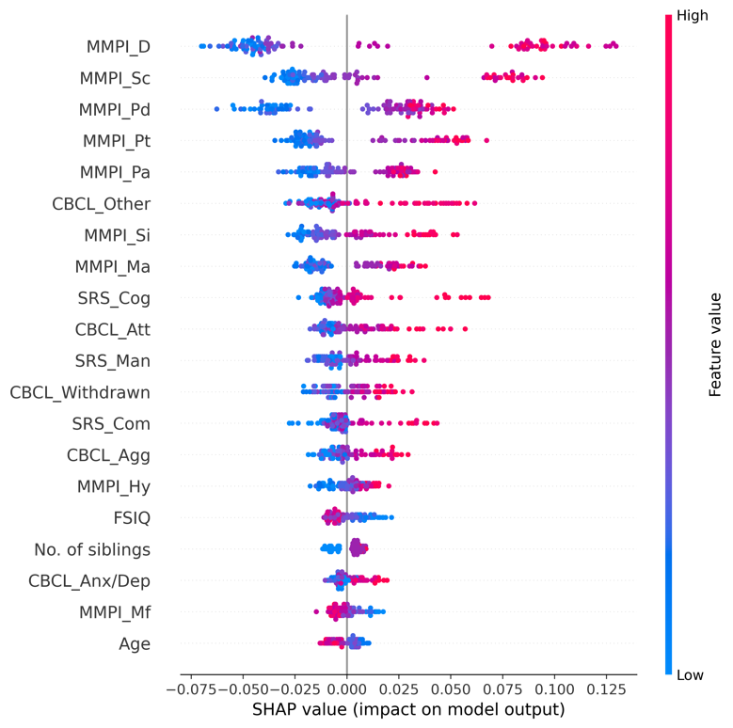 | 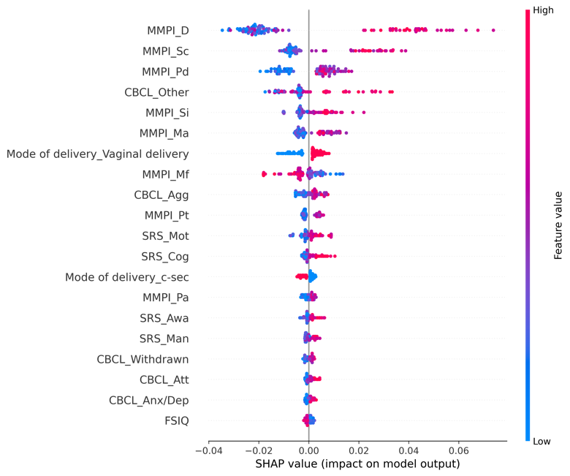

eFigure 6.5. Receiver operating characteristic curves (ROC) for the training and test set

<Training set> | <Test set>
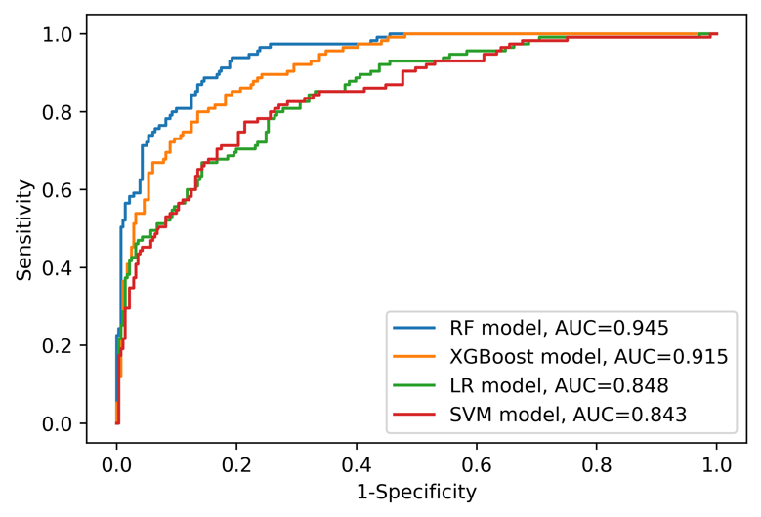 | 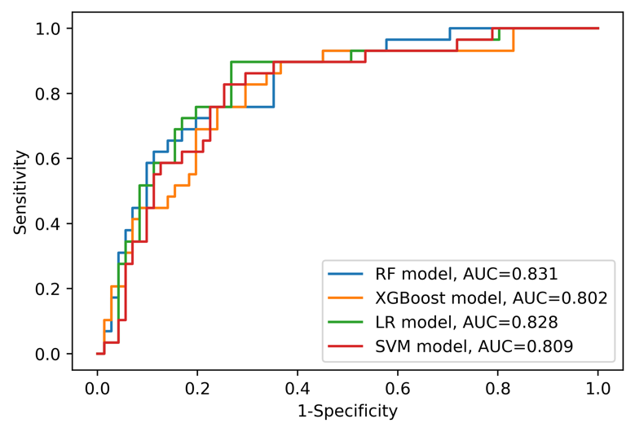
Abbreviations: AUC=area under curve, LR=logistic regression, RF=random forest, SVM=support vector machine, XGBoost=Extreme Gradient Boosting.

eAppendix 7. Model information and detailed results (Sample: Overall sample [n=496] Outcome: Parent-child dysfunctional interaction)

eTable 7.1. Model features (Variables are on the second columns)
Caregiver variables | - Assistant caregiver status [Yes/No]  - Current working status [Yes/No]  - Minnesota Multiphasic Personality Inventory (MMPI) Hypochondriasis (T-score)  - MMPI Depression (T-score)  - MMPI Hysteria (T-score)  - MMPI Psychopathy (T-score)  - MMPI Masculinity/Femininity (T-score)  - MMPI Paranoia (T-score)  - MMPI Psychasthenia (T-score)  - MMPI Schizophrenia (T-score)  - MMPI Hypomania (T-score)  - MMPI Social Introversion (T-score)  - The order of birth  - Number of children
ASD patient variables | - Age  - Sex [Male/Female]  - Family history of mental disorder [Yes/No]  - History of major disease [Yes/No]  - Psychotropic medication status [Drug free/Monotherapy of antipsychotics/Combined therapy of antipsychotics/Other psychotic medication]  - Gestational age  - Birth weight  - Mode of delivery [Vaginal delivery/Caesarean section]  - Existence of another child with mental disorder [Yes/No]  - Full-Scale Intelligence Quotient (FSIQ)  - Social responsiveness scale (SRS) Social awareness (T-score)  - SRS Social cognition (T-score)  - SRS Social communication (T-score)  - SRS Social motivation (T-score)  - SRS Autistic mannerisms (T-score)  - Child Behavior Checklist (CBCL) Anxious/depressed (T-score)  - CBCL Withdrawn/depressed (T-score)  - CBCL Somatic complaints (T-score)  - CBCL Attention problems (T-score)  - CBCL Aggressive behavior (T-score)  - CBCL Other problems (T-score)

eTable 7.2. Performance of each model on the training set
 | RF model | XGBoost model | LR model | SVM model
ROC AUC (95% CI) | 0.960 (0.943-0.975) | 0.904 (0.873-0.932) | 0.805 (0.761-0.846) | 0.800 (0.755-0.842)
Sensitivity (95% CI) | 0.826 (0.766-0.881) | 0.725 (0.655-0.790) | 0.557 (0.480-0.633) | 0.545 (0.468-0.621)
Specificity (95% CI) | 0.943 (0.912-0.972) | 0.908 (0.870-0.945) | 0.830 (0.780-0.877) | 0.838 (0.790-0.885)
PPV (95% CI) | 0.914 (0.868-0.957) | 0.852 (0.791-0.909) | 0.705 (0.627-0.781) | 0.711 (0.632-0.789)
NPV (95% CI) | 0.882 (0.839-0.920) | 0.819 (0.770-0.865) | 0.720 (0.665-0.772) | 0.716 (0.662-0.769)
Accuracy (95% CI) | 0.894 (0.864-0.924) | 0.831 (0.793-0.866) | 0.715 (0.669-0.758) | 0.715 (0.669-0.760)
Abbreviations: AUC=area under curve, CI=confidence interval, NA=not available, NPV=negative predictive value, LR=logistic regression, RF=random forest, ROC=receiver operating characteristic, PPV=positive predictive value, SVM=support vector machine, XGBoost=Extreme Gradient Boosting.

eTable 7.3. Performance of each model on the test set
 | RF model | XGBoost model | LR model | SVM model
ROC AUC (95% CI) | 0.791 (0.694-0.878) | 0.808 (0.715-0.891) | 0.814 (0.720-0.897) | 0.814 (0.720-0.896)
Sensitivity (95% CI) | 0.595 (0.444-0.744) | 0.667 (0.522-0.810) | 0.619 (0.469-0.767) | 0.595 (0.444-0.744)
Specificity (95% CI) | 0.828 (0.723-0.923) | 0.845 (0.745-0.933) | 0.828 (0.724-0.918) | 0.828 (0.724-0.918)
PPV (95% CI) | 0.714 (0.559-0.862) | 0.757 (0.610-0.892) | 0.722 (0.568-0.865) | 0.714 (0.559-0.860)
NPV (95% CI) | 0.738 (0.630-0.842) | 0.778 (0.672-0.877) | 0.750 (0.641-0.855) | 0.738 (0.629-0.844)
Accuracy (95% CI) | 0.730 (0.640-0.810) | 0.770 (0.680-0.850) | 0.740 (0.650-0.820) | 0.730 (0.640-0.810)
Abbreviations: AUC=area under curve, CI=confidence interval, NA=not available, NPV=negative predictive value, LR=logistic regression, RF=random forest, ROC=receiver operating characteristic, PPV=positive predictive value, SVM=support vector machine, XGBoost=Extreme Gradient Boosting.

eFigure 7.4. SHapley Additive exPlanations (SHAP) summary plot for RF and XGBoost models (only top 20 predictors were presented)
<RF model> | <XGBoost model>
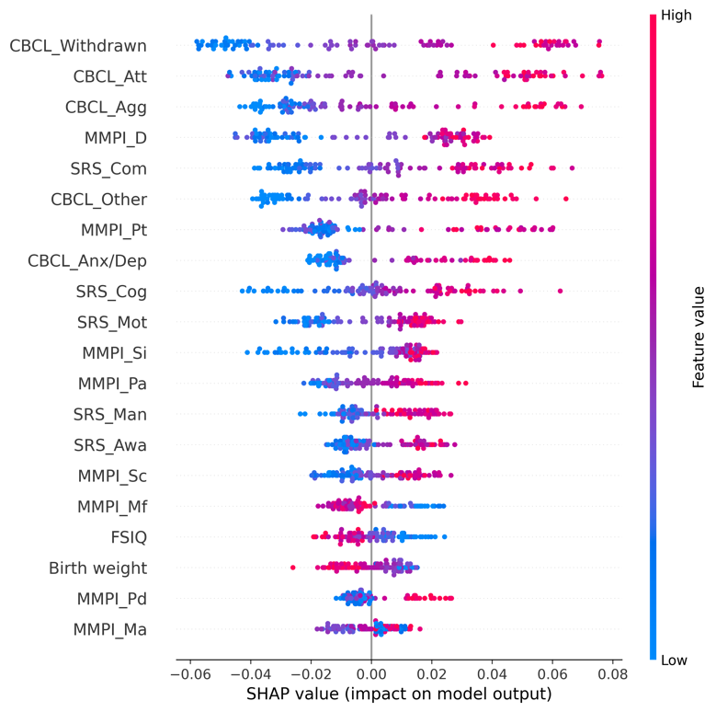 | 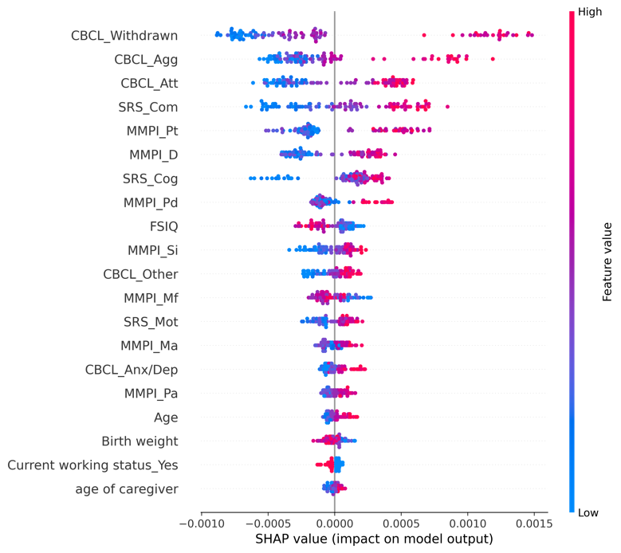

eFigure 7.5. Receiver operating characteristic curves (ROC) for the training and test set

<Training set> | <Test set>
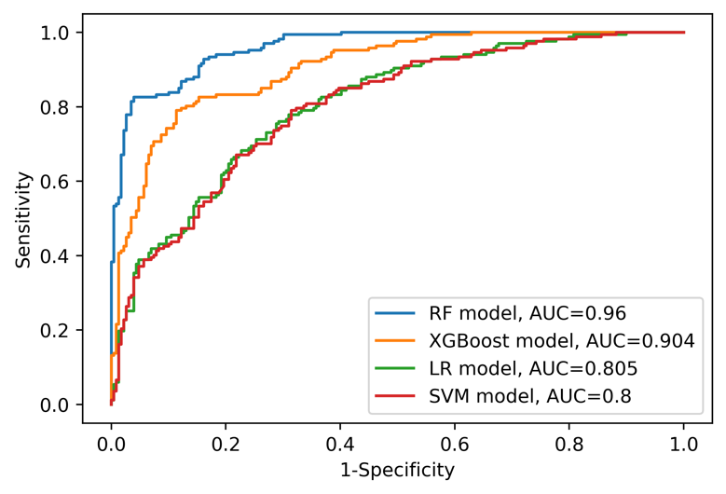 | 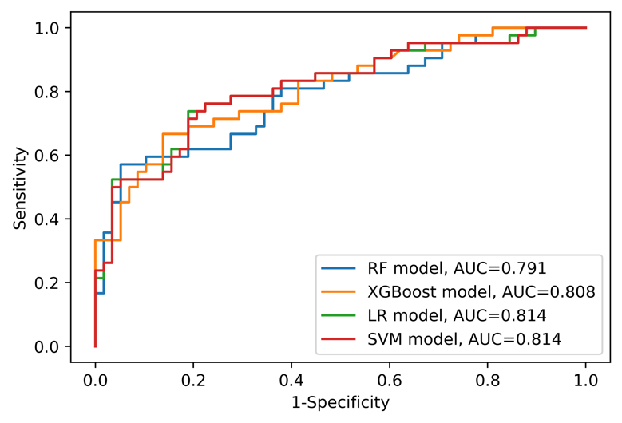
Abbreviations: AUC=area under curve, LR=logistic regression, RF=random forest, SVM=support vector machine, XGBoost=Extreme Gradient Boosting.

eAppendix 8. Model information and detailed results (Sample: Overall sample [n=496], Outcome: Difficult child)

eTable 8.1. Model features (Variables are on the second columns)
Caregiver variables | - Assistant caregiver status [Yes/No]  - Current working status [Yes/No]  - Minnesota Multiphasic Personality Inventory (MMPI) Hypochondriasis (T-score)  - MMPI Depression (T-score)  - MMPI Hysteria (T-score)  - MMPI Psychopathy (T-score)  - MMPI Masculinity/Femininity (T-score)  - MMPI Paranoia (T-score)  - MMPI Psychasthenia (T-score)  - MMPI Schizophrenia (T-score)  - MMPI Hypomania (T-score)  - MMPI Social Introversion (T-score)  - The order of birth  - Number of children
ASD patient variables | - Age  - Sex [Male/Female]  - Family history of mental disorder [Yes/No]  - History of major disease [Yes/No]  - Psychotropic medication status [Drug free/Monotherapy of antipsychotics/Combined therapy of antipsychotics/Other psychotic medication]  - Gestational age  - Birth weight  - Mode of delivery [Vaginal delivery/Caesarean section]  - Existence of another child with mental disorder [Yes/No]  - Full-Scale Intelligence Quotient (FSIQ)  - Social responsiveness scale (SRS) Social awareness (T-score)  - SRS Social cognition (T-score)  - SRS Social communication (T-score)  - SRS Social motivation (T-score)  - SRS Autistic mannerisms (T-score)  - Child Behavior Checklist (CBCL) Anxious/depressed (T-score)  - CBCL Withdrawn/depressed (T-score)  - CBCL Somatic complaints (T-score)  - CBCL Attention problems (T-score)  - CBCL Aggressive behavior (T-score)  - CBCL Other problems (T-score)

eTable 8.2. Performance of each model on the training set
 | RF model | XGBoost model | LR model | SVM model
ROC AUC (95% CI) | 0.988 (0.980-0.994) | 0.889 (0.855-0.919) | 0.837 (0.796-0.875) | 0.790 (0.744-0.833)
Sensitivity (95% CI) | 0.928 (0.888-0.963) | 0.761 (0.697-0.821) | 0.678 (0.608-0.744) | 0.639 (0.569-0.707)
Specificity (95% CI) | 0.949 (0.917-0.976) | 0.866 (0.819-0.909) | 0.833 (0.783-0.881) | 0.806 (0.752-0.856)
PPV (95% CI) | 0.938 (0.901-0.971) | 0.825 (0.765-0.881) | 0.772 (0.705-0.835) | 0.732 (0.662-0.800)
NPV (95% CI) | 0.940 (0.907-0.970) | 0.813 (0.762-0.863) | 0.756 (0.701-0.809) | 0.728 (0.671-0.782)
Accuracy (95% CI) | 0.939 (0.914-0.962) | 0.818 (0.780-0.856) | 0.763 (0.720-0.806) | 0.730 (0.684-0.773)
Abbreviations: AUC=area under curve, CI=confidence interval, NA=not available, NPV=negative predictive value, LR=logistic regression, RF=random forest, ROC=receiver operating characteristic, PPV=positive predictive value, SVM=support vector machine, XGBoost=Extreme Gradient Boosting.

eTable 8.3. Performance of each model on the test set
 | RF model | XGBoost model | LR model | SVM model
ROC AUC (95% CI) | 0.813 (0.724-0.891) | 0.805 (0.716-0.884) | 0.801 (0.711-0.882) | 0.740 (0.638-0.831)
Sensitivity (95% CI) | 0.733 (0.600-0.857) | 0.711 (0.571-0.837) | 0.600 (0.452-0.739) | 0.578 (0.429-0.721)
Specificity (95% CI) | 0.745 (0.627-0.857) | 0.782 (0.667-0.887) | 0.782 (0.667-0.887) | 0.745 (0.627-0.857)
PPV (95% CI) | 0.702 (0.568-0.827) | 0.727 (0.590-0.857) | 0.692 (0.543-0.833) | 0.650 (0.500-0.795)
NPV (95% CI) | 0.774 (0.660-0.880) | 0.768 (0.655-0.875) | 0.705 (0.588-0.815) | 0.683 (0.564-0.797)
Accuracy (95% CI) | 0.740 (0.650-0.820) | 0.750 (0.660-0.830) | 0.700 (0.610-0.790) | 0.670 (0.580-0.760)
Abbreviations: AUC=area under curve, CI=confidence interval, NA=not available, NPV=negative predictive value, LR=logistic regression, RF=random forest, ROC=receiver operating characteristic, PPV=positive predictive value, SVM=support vector machine, XGBoost=Extreme Gradient Boosting.

eFigure 8.4. SHapley Additive exPlanations (SHAP) summary plot for RF and XGBoost models (only top 20 predictors were presented)
<RF model> | <XGBoost model>
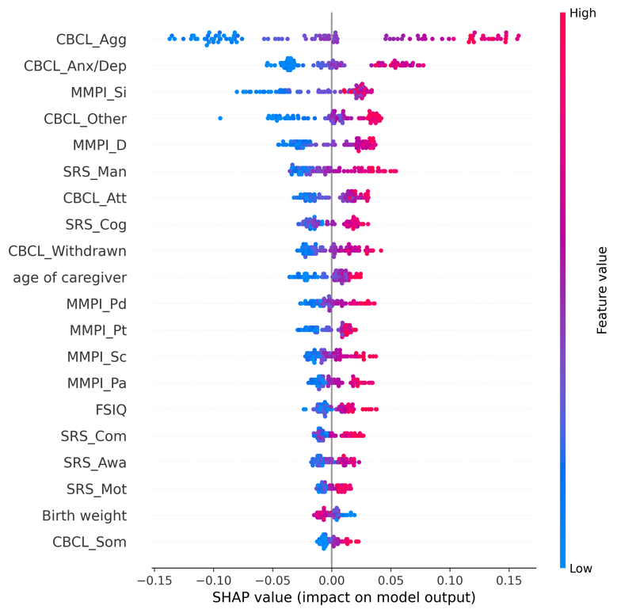 | 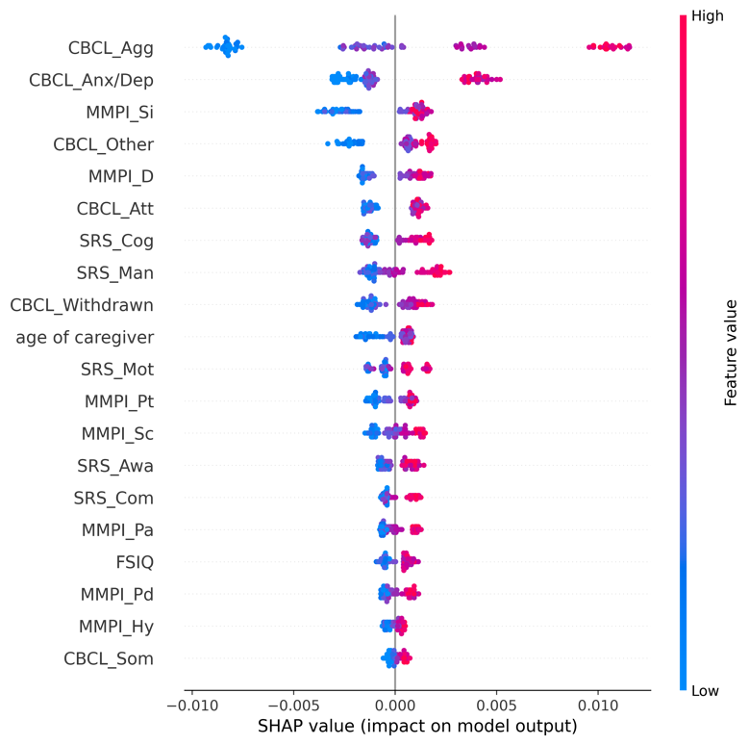

eFigure 8.5. Receiver operating characteristic curves (ROC) for the training and test set

<Training set> | <Test set>
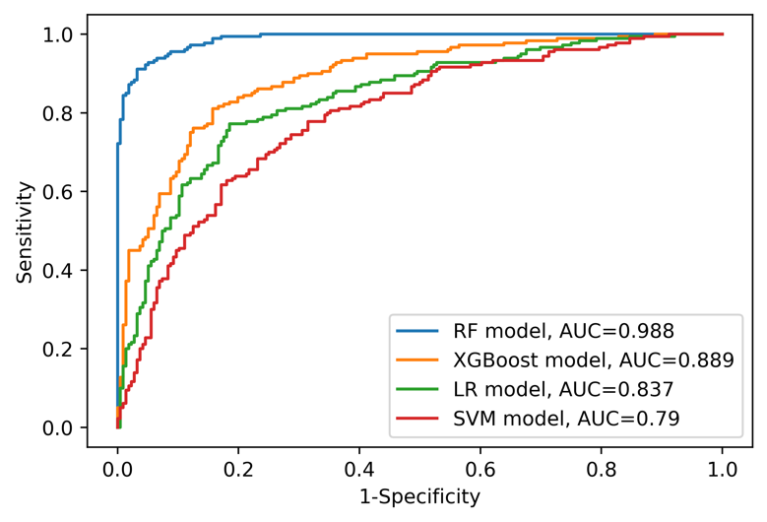 | 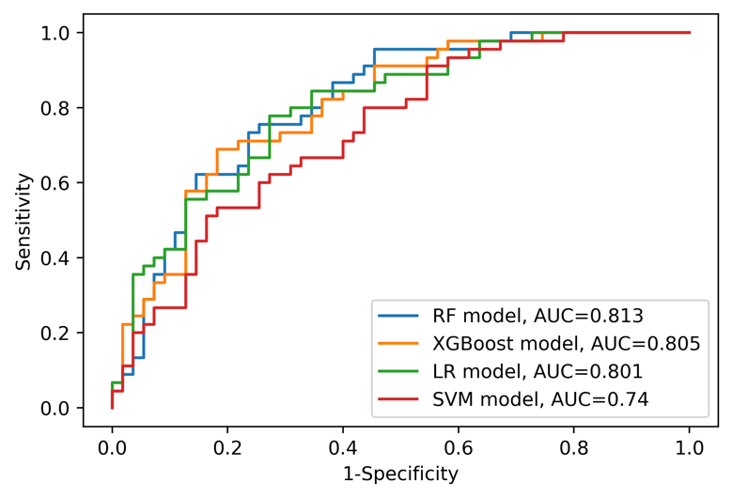
Abbreviations: AUC=area under curve, LR=logistic regression, RF=random forest, SVM=support vector machine, XGBoost=Extreme Gradient Boosting.

eAppendix 9. Model information and detailed results (Sample: Overall sample [n=496], Outcome: Total parenting stress)

eTable 9.1. Model features (Variables are on the second columns)
Caregiver variables | - Assistant caregiver status [Yes/No]  - Current working status [Yes/No]  - Minnesota Multiphasic Personality Inventory (MMPI) Hypochondriasis (T-score)  - MMPI Depression (T-score)  - MMPI Hysteria (T-score)  - MMPI Psychopathy (T-score)  - MMPI Masculinity/Femininity (T-score)  - MMPI Paranoia (T-score)  - MMPI Psychasthenia (T-score)  - MMPI Schizophrenia (T-score)  - MMPI Hypomania (T-score)  - MMPI Social Introversion (T-score)  - The order of birth  - Number of children
ASD patient variables | - Age  - Sex [Male/Female]  - Family history of mental disorder [Yes/No]  - History of major disease [Yes/No]  - Psychotropic medication status [Drug free/Monotherapy of antipsychotics/Combined therapy of antipsychotics/Other psychotic medication]  - Gestational age  - Birth weight  - Mode of delivery [Vaginal delivery/Caesarean section]  - Existence of another child with mental disorder [Yes/No]  - Full-Scale Intelligence Quotient (FSIQ)  - Social responsiveness scale (SRS) Social awareness (T-score)  - SRS Social cognition (T-score)  - SRS Social communication (T-score)  - SRS Social motivation (T-score)  - SRS Autistic mannerisms (T-score)  - Child Behavior Checklist (CBCL) Anxious/depressed (T-score)  - CBCL Withdrawn/depressed (T-score)  - CBCL Somatic complaints (T-score)  - CBCL Attention problems (T-score)  - CBCL Aggressive behavior (T-score)  - CBCL Other problems (T-score)

eTable 9.2. Performance of each model on the training set
 | RF model | XGBoost model | LR model | SVM model
ROC AUC (95% CI) | 0.958 (0.940-0.974) | 0.904 (0.874-0.931) | 0.839 (0.800-0.876) | 0.859 (0.823-0.893)
Sensitivity (95% CI) | 0.848 (0.796-0.899) | 0.806 (0.748-0.861) | 0.702 (0.635-0.766) | 0.738 (0.675-0.800)
Specificity (95% CI) | 0.917 (0.877-0.953) | 0.859 (0.809-0.905) | 0.805 (0.749-0.859) | 0.824 (0.772-0.875)
PPV (95% CI) | 0.905 (0.861-0.946) | 0.842 (0.787-0.893) | 0.770 (0.706-0.832) | 0.797 (0.736-0.854)
NPV (95% CI) | 0.866 (0.819-0.911) | 0.826 (0.774-0.877) | 0.743 (0.684-0.801) | 0.772 (0.714-0.827)
Accuracy (95% CI) | 0.884 (0.851-0.914) | 0.833 (0.795-0.869) | 0.755 (0.712-0.798) | 0.783 (0.742-0.823)
Abbreviations: AUC=area under curve, CI=confidence interval, NA=not available, NPV=negative predictive value, LR=logistic regression, RF=random forest, ROC=receiver operating characteristic, PPV=positive predictive value, SVM=support vector machine, XGBoost=Extreme Gradient Boosting.

eTable 9.3. Performance of each model on the test set
 | RF model | XGBoost model | LR model | SVM model
ROC AUC (95% CI) | 0.862 (0.783-0.930) | 0.848 (0.764-0.921) | 0.861 (0.779-0.930) | 0.854 (0.772-0.924)
Sensitivity (95% CI) | 0.708 (0.578-0.833) | 0.729 (0.600-0.848) | 0.792 (0.673-0.900) | 0.708 (0.577-0.833)
Specificity (95% CI) | 0.865 (0.764-0.951) | 0.865 (0.764-0.951) | 0.827 (0.717-0.923) | 0.808 (0.698-0.909)
PPV (95% CI) | 0.829 (0.707-0.936) | 0.833 (0.714-0.939) | 0.809 (0.690-0.915) | 0.773 (0.644-0.891)
NPV (95% CI) | 0.763 (0.650-0.864) | 0.776 (0.661-0.875) | 0.811 (0.698-0.909) | 0.750 (0.630-0.855)
Accuracy (95% CI) | 0.790 (0.710-0.870) | 0.800 (0.720-0.870) | 0.810 (0.730-0.880) | 0.760 (0.670-0.840)
Abbreviations: AUC=area under curve, CI=confidence interval, NA=not available, NPV=negative predictive value, LR=logistic regression, RF=random forest, ROC=receiver operating characteristic, PPV=positive predictive value, SVM=support vector machine, XGBoost=Extreme Gradient Boosting.

eFigure 9.4. SHapley Additive exPlanations (SHAP) summary plot for RF and XGBoost models (only top 20 predictors were presented)
<RF model> | <XGBoost model>
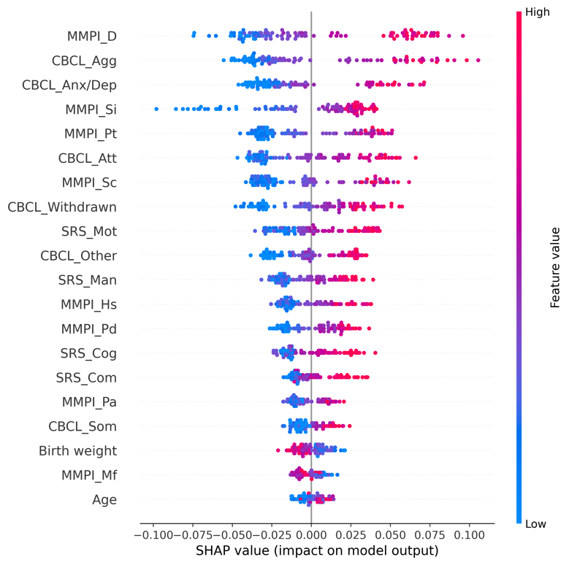 | 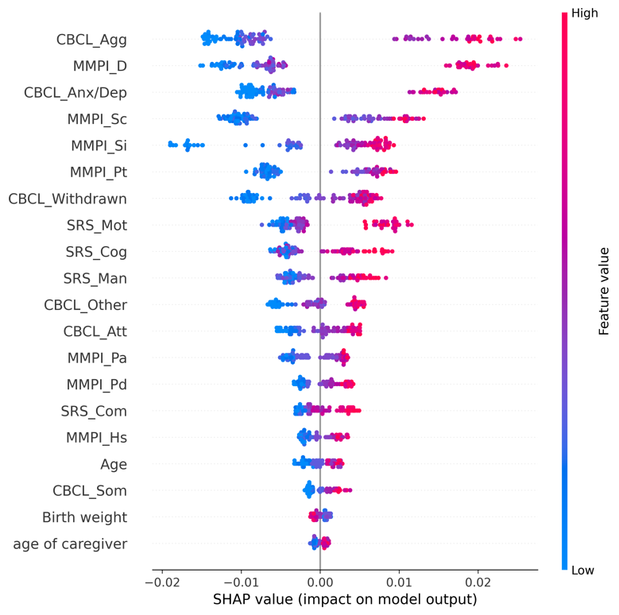

eFigure 9.5. Receiver operating characteristic curves (ROC) for the training and test set

<Training set> | <Test set>
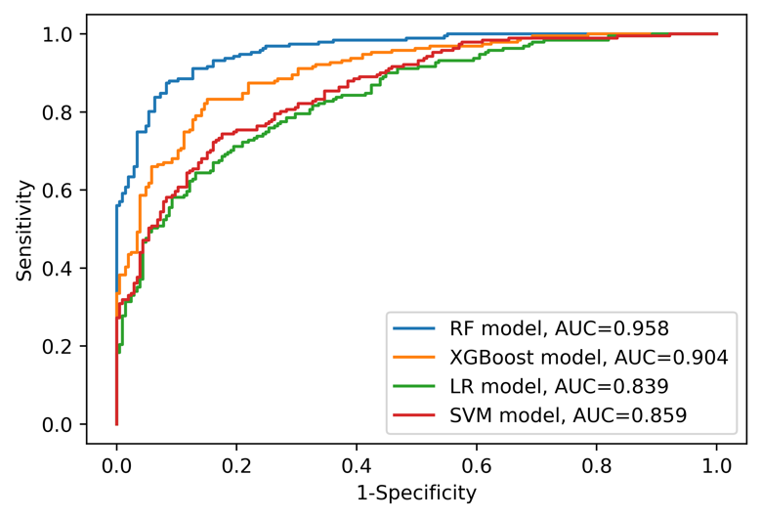 | 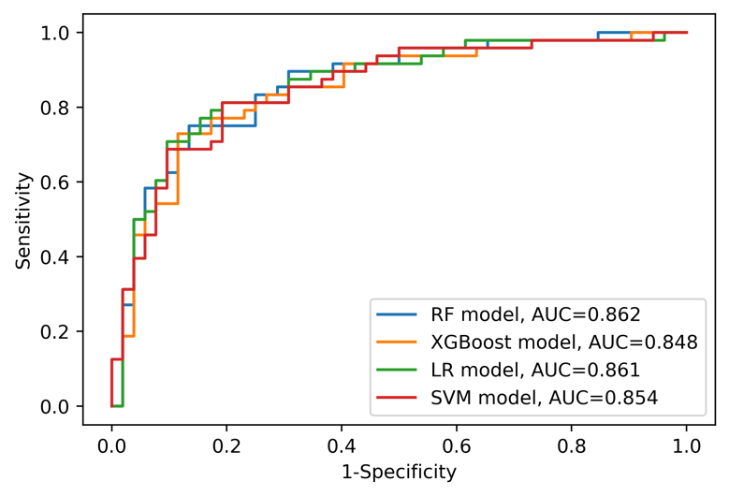
Abbreviations: AUC=area under curve, LR=logistic regression, RF=random forest, SVM=support vector machine, XGBoost=Extreme Gradient Boosting.

eAppendix 10. Model information and detailed results (Sample: CBCL 1.5-5 sample [n=194], Outcome: Parental distress)

eTable 10.1. Model features (Variables are on the second columns)
Caregiver variables | - Assistant caregiver status [Yes/No]  - Current working status [Yes/No]  - Minnesota Multiphasic Personality Inventory (MMPI) Hypochondriasis (T-score)  - MMPI Depression (T-score)  - MMPI Hysteria (T-score)  - MMPI Psychopathy (T-score)  - MMPI Masculinity/Femininity (T-score)  - MMPI Paranoia (T-score)  - MMPI Psychasthenia (T-score)  - MMPI Schizophrenia (T-score)  - MMPI Hypomania (T-score)  - MMPI Social Introversion (T-score)  - The order of birth  - Number of children
ASD patient variables | - Age  - Sex [Male/Female]  - Family history of mental disorder [Yes/No]  - History of major disease [Yes/No]  - Psychotropic medication status [Drug free/Monotherapy of antipsychotics/Combined therapy of antipsychotics/Other psychotic medication]  - Gestational age  - Birth weight  - Mode of delivery [Vaginal delivery/Caesarean section]  - Existence of another child with mental disorder [Yes/No] [Yes/No]  - Full-Scale Intelligence Quotient (FSIQ)  - Social responsiveness scale (SRS) Social awareness (T-score)  - SRS Social cognition (T-score)  - SRS Social communication (T-score)  - SRS Social motivation (T-score)  - SRS Autistic mannerisms (T-score)  - Child Behavior Checklist (CBCL) Emotionally reactivity (T-score)  - CBCL Anxious/depressed (T-score)  - CBCL Somatic complaints (T-score)  - CBCL Withdrawn/depressed (T-score)  - CBCL Sleep problems (T-score)  - CBCL Attention problems (T-score)  - CBCL Aggressive behavior (T-score)  - CBCL Other problems (T-score)

eTable 10.2. Performance of each model on the training set
 | RF model | XGBoost model | LR model | SVM model
ROC AUC (95% CI) | 0.954 (0.921-0.981) | 0.862 (0.799-0.917) | 0.815 (0.740-0.882) | 0.937 (0.896-0.97)
Sensitivity (95% CI) | 0.574 (0.432-0.714) | 0.234 (0.120-0.360) | 0.128 (0.041-0.231) | 0.000 (0.000-0.000)
Specificity (95% CI) | 0.972 (0.937-1.000) | 0.972 (0.938-1.000) | 0.991 (0.970-1.000) | 1.000 (1.000-1.000)
PPV (95% CI) | 0.900 (0.778-1.000) | 0.786 (0.538-1.000) | 0.857 (0.500-1.000) | NA
NPV (95% CI) | 0.840 (0.771-0.902) | 0.745 (0.671-0.816) | 0.723 (0.649-0.795) | 0.697 (0.619-0.768)
Accuracy (95% CI) | 0.852 (0.794-0.903) | 0.748 (0.677-0.813) | 0.729 (0.658-0.800) | 0.697 (0.619-0.768)
Abbreviations: AUC=area under curve, CI=confidence interval, NA=not available, NPV=negative predictive value, LR=logistic regression, RF=random forest, ROC=receiver operating characteristic, PPV=positive predictive value, SVM=support vector machine, XGBoost=Extreme Gradient Boosting.

eTable 10.3. Performance of each model on the test set
 | RF model | XGBoost model | LR model | SVM model
ROC AUC (95% CI) | 0.861 (0.708-0.976) | 0.889 (0.760-0.982) | 0.846 (0.673-0.981) | 0.815 (0.617-0.969)
Sensitivity (95% CI) | 0.583 (0.286-0.875) | 0.417 (0.133-0.714) | 0.250 (0.000-0.500) | 0.000 (0.000-0.000)
Specificity (95% CI) | 1.000 (1.000-1.000) | 1.000 (1.000-1.000) | 1.000 (1.000-1.000) | 1.000 (1.000-1.000)
PPV (95% CI) | 1.000 (1.000-1.000) | 1.000 (1.000-1.000) | 1.000 (1.000-1.000) | NA
NPV (95% CI) | 0.844 (0.706-0.967) | 0.794 (0.647-0.917) | 0.750 (0.600-0.886) | 0.692 (0.538-0.821)
Accuracy (95% CI) | 0.872 (0.769-0.974) | 0.821 (0.692-0.923) | 0.769 (0.641-0.897) | 0.692 (0.538-0.821)
Abbreviations: AUC=area under curve, CI=confidence interval, NA=not available, NPV=negative predictive value, LR=logistic regression, RF=random forest, ROC=receiver operating characteristic, PPV=positive predictive value, SVM=support vector machine, XGBoost=Extreme Gradient Boosting.

eFigure 10.4. SHapley Additive exPlanations (SHAP) summary plot for RF and XGBoost models (only top 20 predictors were presented)
<RF model> | <XGBoost model>
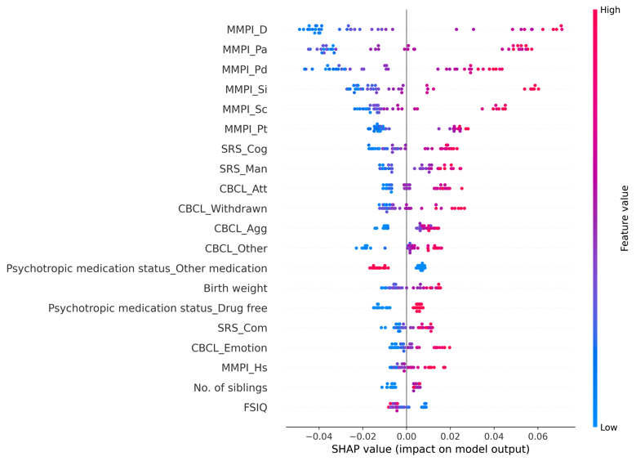 | 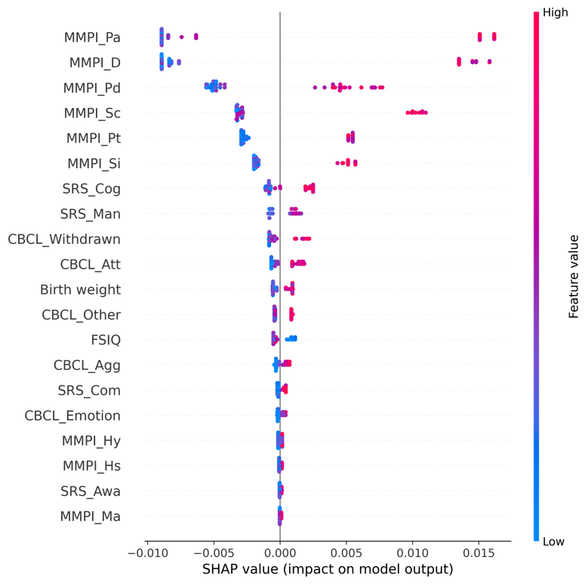

eFigure 10.5. Receiver operating characteristic curves (ROC) for the training and test set

<Training set> | <Test set>
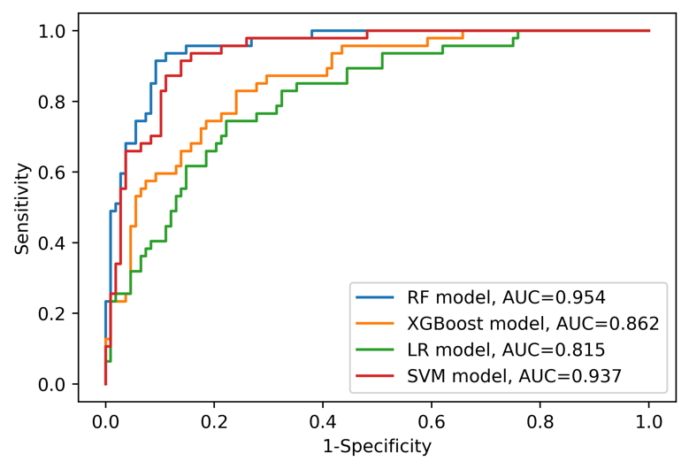 | 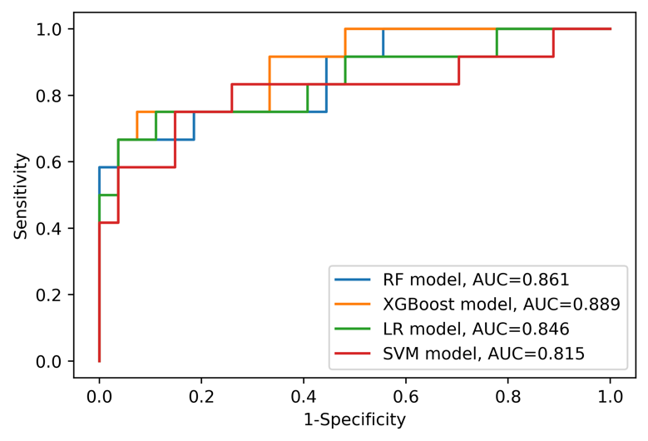
Abbreviations: AUC=area under curve, LR=logistic regression, RF=random forest, SVM=support vector machine, XGBoost=Extreme Gradient Boosting.

eAppendix 11. Model information and detailed results (Sample: CBCL 1.5-5 sample [n=194], Outcome: Parent-child dysfunctional interaction)

eTable 11.1. Model features (Variables are on the second columns)
Caregiver variables | - Assistant caregiver status [Yes/No]  - Current working status [Yes/No]  - Minnesota Multiphasic Personality Inventory (MMPI) Hypochondriasis (T-score)  - MMPI Depression (T-score)  - MMPI Hysteria (T-score)  - MMPI Psychopathy (T-score)  - MMPI Masculinity/Femininity (T-score)  - MMPI Paranoia (T-score)  - MMPI Psychasthenia (T-score)  - MMPI Schizophrenia (T-score)  - MMPI Hypomania (T-score)  - MMPI Social Introversion (T-score)  - The order of birth  - Number of children
ASD patient variables | - Age  - Sex [Male/Female]  - Family history of mental disorder [Yes/No]  - History of major disease [Yes/No]  - Psychotropic medication status [Drug free/Monotherapy of antipsychotics/Combined therapy of antipsychotics/Other psychotic medication]  - Gestational age  - Birth weight  - Mode of delivery [Vaginal delivery/Caesarean section]  - Existence of another child with mental disorder [Yes/No] [Yes/No]  - Full-Scale Intelligence Quotient (FSIQ)  - Social responsiveness scale (SRS) Social awareness (T-score)  - SRS Social cognition (T-score)  - SRS Social communication (T-score)  - SRS Social motivation (T-score)  - SRS Autistic mannerisms (T-score)  - Child Behavior Checklist (CBCL) Emotionally reactivity (T-score)  - CBCL Anxious/depressed (T-score)  - CBCL Somatic complaints (T-score)  - CBCL Withdrawn/depressed (T-score)  - CBCL Sleep problems (T-score)  - CBCL Attention problems (T-score)  - CBCL Aggressive behavior (T-score)  - CBCL Other problems (T-score)

eTable 11.2. Performance of each model on the training set
 | RF model | XGBoost model | LR model | SVM model
ROC AUC (95% CI) | 0.981 (0.962-0.994) | 0.858 (0.789-0.919) | 0.820 (0.746-0.888) | 0.789 (0.711-0.863)
Sensitivity (95% CI) | 0.870 (0.773-0.952) | 0.389 (0.256-0.523) | 0.000 (0.000-0.000) | 0.000 (0.000-0.000)
Specificity (95% CI) | 0.980 (0.949-1.000) | 0.960 (0.918-0.991) | 1.000 (1.000-1.000) | 1.000 (1.000-1.000)
PPV (95% CI) | 0.959 (0.895-1.000) | 0.840 (0.684-0.963) | NA | NA
NPV (95% CI) | 0.934 (0.883-0.978) | 0.746 (0.669-0.819) | 0.652 (0.574-0.729) | 0.652 (0.574-0.729)
Accuracy (95% CI) | 0.942 (0.903-0.974) | 0.761 (0.690-0.826) | 0.652 (0.574-0.729) | 0.652 (0.574-0.729)
Abbreviations: AUC=area under curve, CI=confidence interval, NA=not available, NPV=negative predictive value, LR=logistic regression, RF=random forest, ROC=receiver operating characteristic, PPV=positive predictive value, SVM=support vector machine, XGBoost=Extreme Gradient Boosting.

eTable 11.3. Performance of each model on the test set
 | RF model | XGBoost model | LR model | SVM model
ROC AUC (95% CI) | 0.714 (0.533-0.869) | 0.720 (0.541-0.867) | 0.660 (0.475-0.826) | 0.686 (0.503-0.844)
Sensitivity (95% CI) | 0.429 (0.167-0.700) | 0.214 (0.000-0.455) | 0.000 (0.000-0.000) | 0.000 (0.000-0.000)
Specificity (95% CI) | 0.760 (0.583-0.920) | 0.960 (0.867-1.000) | 1.000 (1.000-1.000) | 1.000 (1.000-1.000)
PPV (95% CI) | 0.500 (0.200-0.786) | 0.750 (0.000-1.000) | NA | NA
NPV (95% CI) | 0.704 (0.520-0.867) | 0.686 (0.528-0.833) | 0.641 (0.487-0.795) | 0.641 (0.487-0.795)
Accuracy (95% CI) | 0.641 (0.487-0.795) | 0.692 (0.538-0.821) | 0.641 (0.487-0.795) | 0.641 (0.487-0.795)
Abbreviations: AUC=area under curve, CI=confidence interval, NA=not available, NPV=negative predictive value, LR=logistic regression, RF=random forest, ROC=receiver operating characteristic, PPV=positive predictive value, SVM=support vector machine, XGBoost=Extreme Gradient Boosting.

eFigure 11.4. SHapley Additive exPlanations (SHAP) summary plot for RF and XGBoost models (only top 20 predictors were presented)
<RF model> | <XGBoost model>
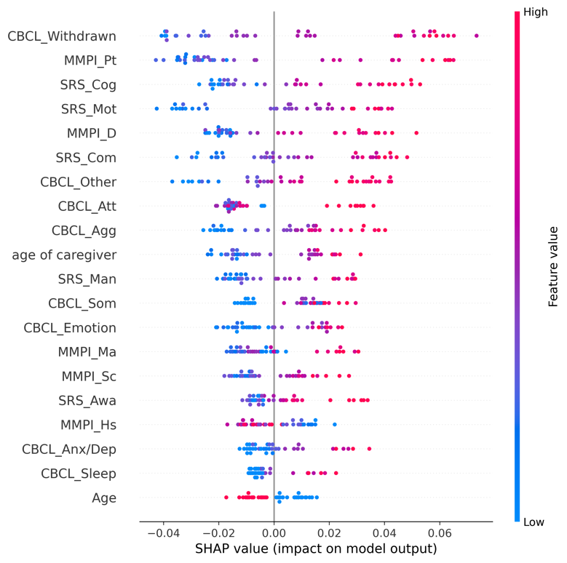 | 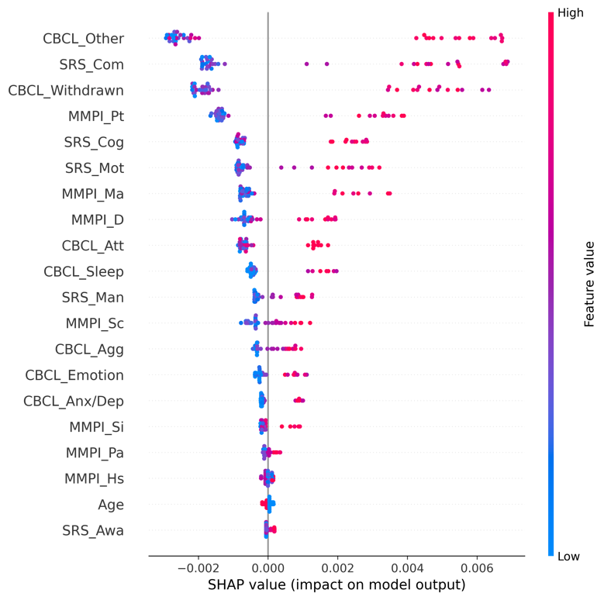

eFigure 11.5. Receiver operating characteristic curves (ROC) for the training and test set

<Training set> | <Test set>
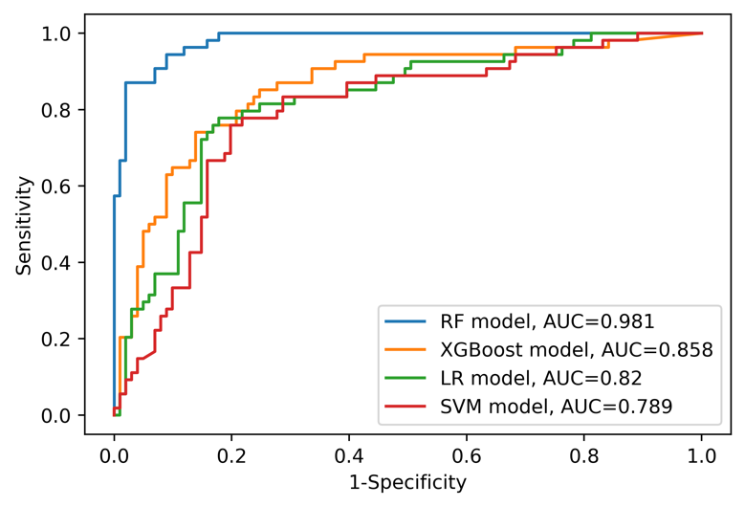 | 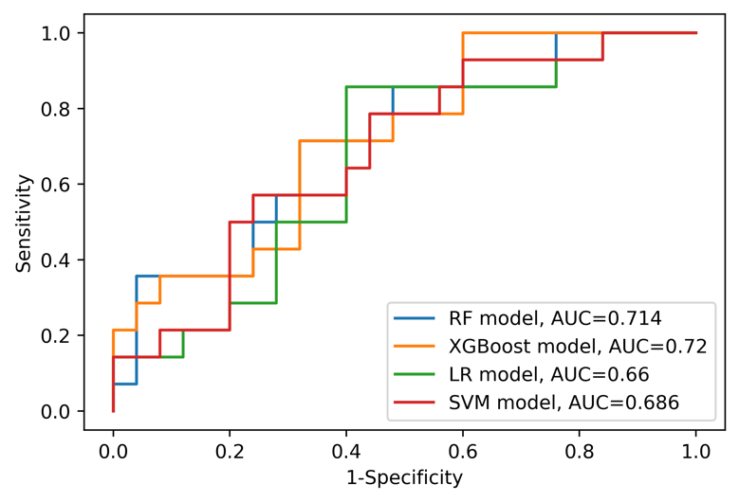
Abbreviations: AUC=area under curve, LR=logistic regression, RF=random forest, SVM=support vector machine, XGBoost=Extreme Gradient Boosting.

eAppendix 12. Model information and detailed results (Sample: CBCL 1.5-5 sample [n=194], Outcome: Difficult child)

eTable 12.1. Model features (Variables are on the second columns)
Caregiver variables | - Assistant caregiver status [Yes/No]  - Current working status [Yes/No]  - Minnesota Multiphasic Personality Inventory (MMPI) Hypochondriasis (T-score)  - MMPI Depression (T-score)  - MMPI Hysteria (T-score)  - MMPI Psychopathy (T-score)  - MMPI Masculinity/Femininity (T-score)  - MMPI Paranoia (T-score)  - MMPI Psychasthenia (T-score)  - MMPI Schizophrenia (T-score)  - MMPI Hypomania (T-score)  - MMPI Social Introversion (T-score)  - The order of birth  - Number of children
ASD patient variables | - Age  - Sex [Male/Female]  - Family history of mental disorder [Yes/No]  - History of major disease [Yes/No]  - Psychotropic medication status [Drug free/Monotherapy of antipsychotics/Combined therapy of antipsychotics/Other psychotic medication]  - Gestational age  - Birth weight  - Mode of delivery [Vaginal delivery/Caesarean section]  - Existence of another child with mental disorder [Yes/No] [Yes/No]  - Full-Scale Intelligence Quotient (FSIQ)  - Social responsiveness scale (SRS) Social awareness (T-score)  - SRS Social cognition (T-score)  - SRS Social communication (T-score)  - SRS Social motivation (T-score)  - SRS Autistic mannerisms (T-score)  - Child Behavior Checklist (CBCL) Emotionally reactivity (T-score)  - CBCL Anxious/depressed (T-score)  - CBCL Somatic complaints (T-score)  - CBCL Withdrawn/depressed (T-score)  - CBCL Sleep problems (T-score)  - CBCL Attention problems (T-score)  - CBCL Aggressive behavior (T-score)  - CBCL Other problems (T-score)

eTable 12.2. Performance of each model on the training set
 | RF model | XGBoost model | LR model | SVM model
ROC AUC (95% CI) | 0.981 (0.962-0.994) | 0.957 (0.928-0.981) | 0.837 (0.769-0.899) | 0.784 (0.708-0.856)
Sensitivity (95% CI) | 0.800 (0.695-0.897) | 0.717 (0.600-0.828) | 0.533 (0.406-0.661) | 0.533 (0.404-0.661)
Specificity (95% CI) | 0.968 (0.928-1.000) | 0.947 (0.897-0.989) | 0.947 (0.899-0.989) | 0.853 (0.779-0.920)
PPV (95% CI) | 0.941 (0.867-1.000) | 0.896 (0.800-0.977) | 0.865 (0.743-0.970) | 0.696 (0.556-0.828)
NPV (95% CI) | 0.885 (0.820-0.943) | 0.841 (0.769-0.907) | 0.763 (0.683-0.838) | 0.743 (0.658-0.823)
Accuracy (95% CI) | 0.903 (0.852-0.948) | 0.858 (0.800-0.910) | 0.787 (0.723-0.852) | 0.729 (0.658-0.800)
Abbreviations: AUC=area under curve, CI=confidence interval, NA=not available, NPV=negative predictive value, LR=logistic regression, RF=random forest, ROC=receiver operating characteristic, PPV=positive predictive value, SVM=support vector machine, XGBoost=Extreme Gradient Boosting.

eTable 12.3. Performance of each model on the test set
 | RF model | XGBoost model | LR model | SVM model
ROC AUC (95% CI) | 0.897 (0.765-0.988) | 0.925 (0.817-0.992) | 0.811 (0.653-0.934) | 0.853 (0.704-0.961)
Sensitivity (95% CI) | 0.667 (0.412-0.900) | 0.733 (0.500-0.933) | 0.333 (0.100-0.579) | 0.400 (0.154-0.647)
Specificity (95% CI) | 0.958 (0.864-1.000) | 0.917 (0.789-1.000) | 1.000 (1.000-1.000) | 0.917 (0.789-1.000)
PPV (95% CI) | 0.909 (0.700-1.000) | 0.846 (0.615-1.000) | 1.000 (1.000-1.000) | 0.750 (0.400-1.000)
NPV (95% CI) | 0.821 (0.667-0.958) | 0.846 (0.692-0.964) | 0.706 (0.545-0.853) | 0.710 (0.543-0.862)
Accuracy (95% CI) | 0.846 (0.718-0.949) | 0.846 (0.718-0.949) | 0.744 (0.615-0.872) | 0.718 (0.564-0.846)
Abbreviations: AUC=area under curve, CI=confidence interval, NA=not available, NPV=negative predictive value, LR=logistic regression, RF=random forest, ROC=receiver operating characteristic, PPV=positive predictive value, SVM=support vector machine, XGBoost=Extreme Gradient Boosting.

eFigure 12.4. SHapley Additive exPlanations (SHAP) summary plot for RF and XGBoost models (only top 20 predictors were presented)
<RF model> | <XGBoost model>
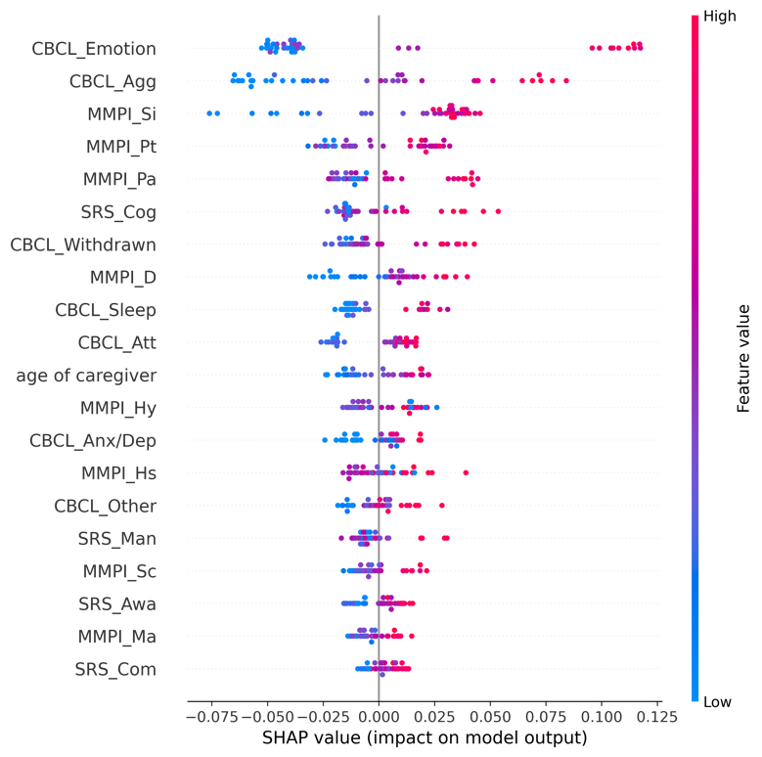 | 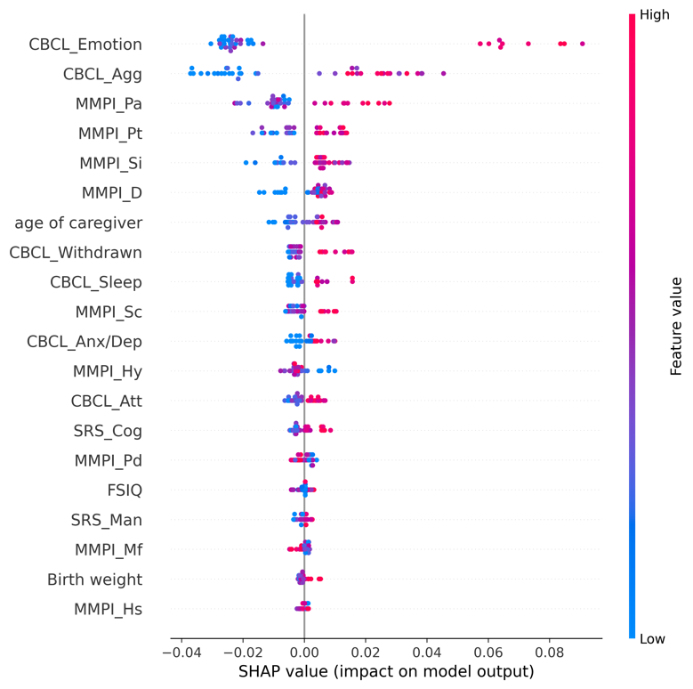

eFigure 12.5. Receiver operating characteristic curves (ROC) for the training and test set

<Training set> | <Test set>
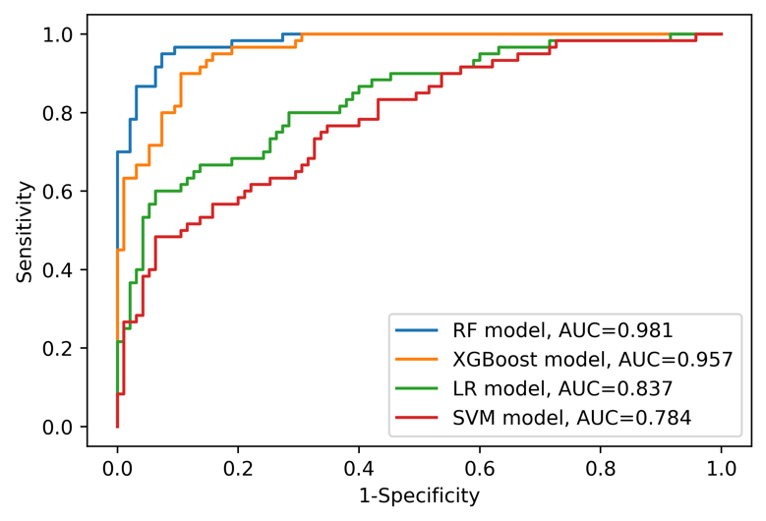 | 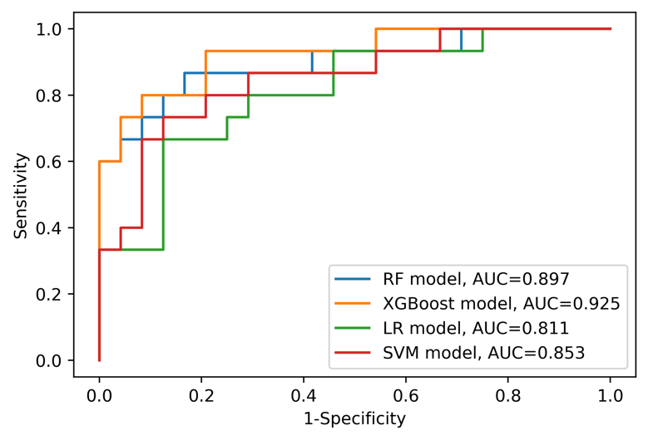
Abbreviations: AUC=area under curve, LR=logistic regression, RF=random forest, SVM=support vector machine, XGBoost=Extreme Gradient Boosting.

eAppendix 13. Model information and detailed results (Sample: CBCL 1.5-5 sample [n=194], Outcome: Total parenting stress)

eTable 13.1. Model features (Variables are on the second columns)
Caregiver variables | - Assistant caregiver status [Yes/No]  - Current working status [Yes/No]  - Minnesota Multiphasic Personality Inventory (MMPI) Hypochondriasis (T-score)  - MMPI Depression (T-score)  - MMPI Hysteria (T-score)  - MMPI Psychopathy (T-score)  - MMPI Masculinity/Femininity (T-score)  - MMPI Paranoia (T-score)  - MMPI Psychasthenia (T-score)  - MMPI Schizophrenia (T-score)  - MMPI Hypomania (T-score)  - MMPI Social Introversion (T-score)  - The order of birth  - Number of children
ASD patient variables | - Age  - Sex [Male/Female]  - Family history of mental disorder [Yes/No]  - History of major disease [Yes/No]  - Psychotropic medication status [Drug free/Monotherapy of antipsychotics/Combined therapy of antipsychotics/Other psychotic medication]  - Gestational age  - Birth weight  - Mode of delivery [Vaginal delivery/Caesarean section]  - Existence of another child with mental disorder [Yes/No] [Yes/No]  - Full-Scale Intelligence Quotient (FSIQ)  - Social responsiveness scale (SRS) Social awareness (T-score)  - SRS Social cognition (T-score)  - SRS Social communication (T-score)  - SRS Social motivation (T-score)  - SRS Autistic mannerisms (T-score)  - Child Behavior Checklist (CBCL) Emotionally reactivity (T-score)  - CBCL Anxious/depressed (T-score)  - CBCL Somatic complaints (T-score)  - CBCL Withdrawn/depressed (T-score)  - CBCL Sleep problems (T-score)  - CBCL Attention problems (T-score)  - CBCL Aggressive behavior (T-score)  - CBCL Other problems (T-score)

eTable 13.2. Performance of each model on the training set
 | RF model | XGBoost model | LR model | SVM model
ROC AUC (95% CI) | 0.988 (0.972-0.998) | 0.944 (0.910-0.972) | 0.867 (0.806-0.920) | 0.863 (0.801-0.917)
Sensitivity (95% CI) | 0.905 (0.825-0.970) | 0.825 (0.726-0.915) | 0.524 (0.400-0.648) | 0.000 (0.000-0.000)
Specificity (95% CI) | 0.978 (0.944-1.000) | 0.870 (0.798-0.933) | 0.924 (0.866-0.971) | 1.000 (1.000-1.000)
PPV (95% CI) | 0.966 (0.912-1.000) | 0.812 (0.712-0.902) | 0.825 (0.700-0.933) | NA
NPV (95% CI) | 0.938 (0.883-0.980) | 0.879 (0.806-0.943) | 0.739 (0.655-0.817) | 0.594 (0.516-0.671)
Accuracy (95% CI) | 0.948 (0.910-0.981) | 0.852 (0.794-0.903) | 0.761 (0.690-0.826) | 0.594 (0.516-0.671)
Abbreviations: AUC=area under curve, CI=confidence interval, NA=not available, NPV=negative predictive value, LR=logistic regression, RF=random forest, ROC=receiver operating characteristic, PPV=positive predictive value, SVM=support vector machine, XGBoost=Extreme Gradient Boosting.

eTable 13.3. Performance of each model on the test set
 | RF model | XGBoost model | LR model | SVM model
ROC AUC (95% CI) | 0.845 (0.703-0.954) | 0.810 (0.648-0.936) | 0.788 (0.630-0.917) | 0.815 (0.667-0.935)
Sensitivity (95% CI) | 0.625 (0.375-0.857) | 0.625 (0.375-0.857) | 0.375 (0.143-0.625) | 0.000 (0.000-0.000)
Specificity (95% CI) | 0.870 (0.714-1.000) | 0.826 (0.654-0.960) | 0.957 (0.857-1.000) | 1.000 (1.000-1.000)
PPV (95% CI) | 0.769 (0.500-1.000) | 0.714 (0.455-0.933) | 0.857 (0.500-1.000) | NA
NPV (95% CI) | 0.769 (0.594-0.920) | 0.760 (0.577-0.917) | 0.688 (0.516-0.844) | 0.590 (0.436-0.744)
Accuracy (95% CI) | 0.769 (0.641-0.897) | 0.744 (0.590-0.872) | 0.718 (0.564-0.846) | 0.590 (0.436-0.744)
Abbreviations: AUC=area under curve, CI=confidence interval, NA=not available, NPV=negative predictive value, LR=logistic regression, RF=random forest, ROC=receiver operating characteristic, PPV=positive predictive value, SVM=support vector machine, XGBoost=Extreme Gradient Boosting.

eFigure 13.4. SHapley Additive exPlanations (SHAP) summary plot for RF and XGBoost models (only top 20 predictors were presented)
<RF model> | <XGBoost model>
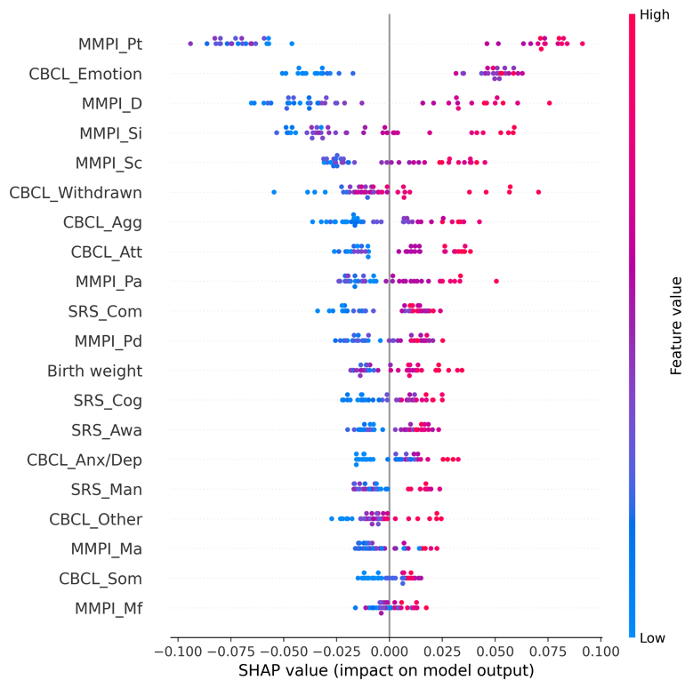 | 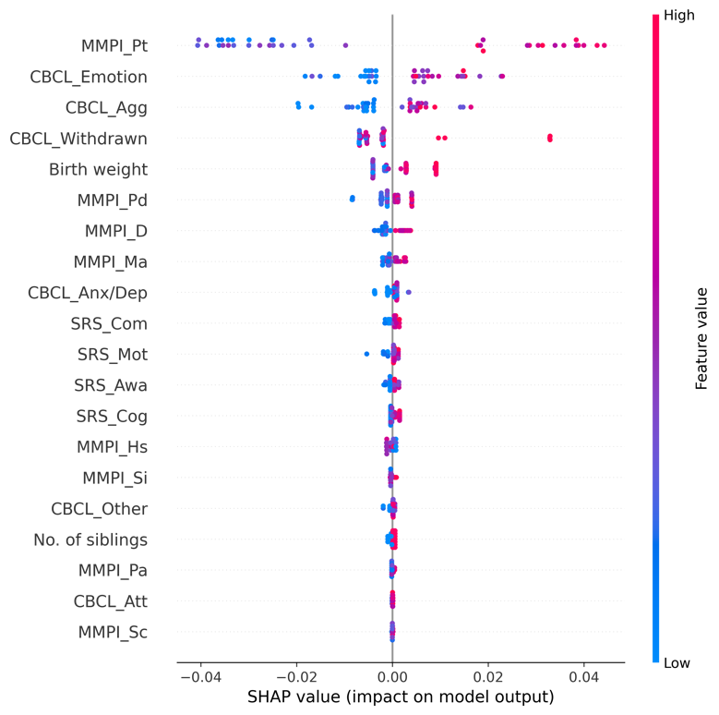

eFigure 13.5. Receiver operating characteristic curves (ROC) for the training and test set

<Training set> | <Test set>
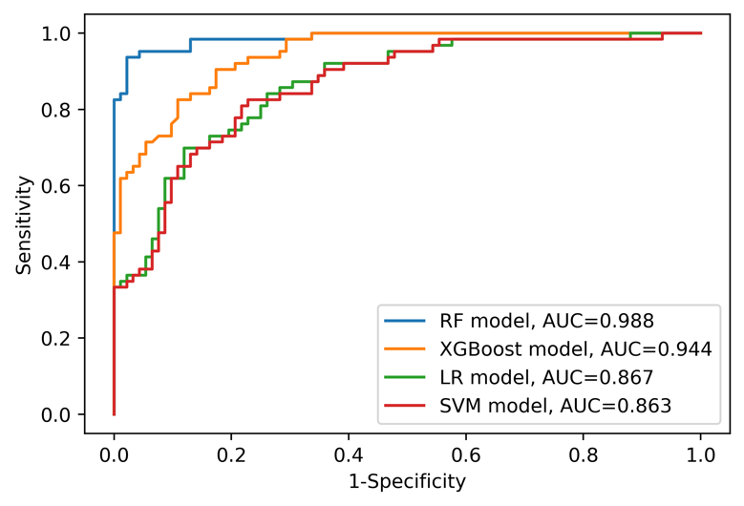 | 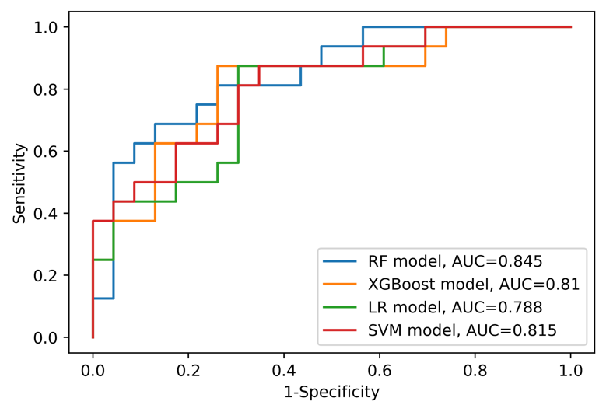
Abbreviations: AUC=area under curve, LR=logistic regression, RF=random forest, SVM=support vector machine, XGBoost=Extreme Gradient Boosting.

eAppendix 14. Model information and detailed results (Sample: CBCL 6-18 sample [n=302], Outcome: Parental distress)

eTable 14.1. Model features (Variables are on the second columns)
Caregiver variables | - Assistant caregiver status [Yes/No]  - Current working status [Yes/No]  - Minnesota Multiphasic Personality Inventory (MMPI) Hypochondriasis (T-score)  - MMPI Depression (T-score)  - MMPI Hysteria (T-score)  - MMPI Psychopathy (T-score)  - MMPI Masculinity/Femininity (T-score)  - MMPI Paranoia (T-score)  - MMPI Psychasthenia (T-score)  - MMPI Schizophrenia (T-score)  - MMPI Hypomania (T-score)  - MMPI Social Introversion (T-score)  - The order of birth  - Number of children
ASD patient variables | - Age  - Sex [Male/Female]  - Family history of mental disorder [Yes/No]  - History of major disease [Yes/No]  - Psychotropic medication status [Drug free/Monotherapy of antipsychotics/Combined therapy of antipsychotics/Other psychotic medication]  - Gestational age  - Birth weight  - Mode of delivery [Vaginal delivery/Caesarean section]  - Existence of another child with mental disorder [Yes/No] [Yes/No]  - Full-Scale Intelligence Quotient (FSIQ)  - Social responsiveness scale (SRS) Social awareness (T-score)  - SRS Social cognition (T-score)  - SRS Social communication (T-score)  - SRS Social motivation (T-score)  - SRS Autistic mannerisms (T-score)  - Child Behavior Checklist (CBCL) Anxious/depressed (T-score)  - CBCL Withdrawn/depressed (T-score)  - CBCL Somatic complaints (T-score)  - CBCL Social problems (T-score)  - CBCL Thought problems (T-score)  - CBCL Attention problems (T-score)  - CBCL Rule-breaking behavior (T-score)  - CBCL Aggressive behavior (T-score)  - CBCL Other problems (T-score)

eTable 14.2. Performance of each model on the training set
 | RF model | XGBoost model | LR model | SVM model
ROC AUC (95% CI) | 0.964 (0.941-0.982) | 0.905 (0.866-0.939) | 0.884 (0.833-0.929) | 0.889 (0.836-0.934)
Sensitivity (95% CI) | 0.618 (0.500-0.731) | 0.618 (0.500-0.731) | 0.603 (0.483-0.719) | 0.574 (0.453-0.694)
Specificity (95% CI) | 0.988 (0.970-1.000) | 0.902 (0.856-0.944) | 0.948 (0.912-0.978) | 0.965 (0.936-0.989)
PPV (95% CI) | 0.955 (0.885-1.000) | 0.712 (0.593-0.824) | 0.820 (0.706-0.921) | 0.867 (0.759-0.957)
NPV (95% CI) | 0.868 (0.818-0.914) | 0.857 (0.803-0.906) | 0.859 (0.806-0.907) | 0.852 (0.801-0.901)
Accuracy (95% CI) | 0.884 (0.842-0.921) | 0.822 (0.772-0.867) | 0.851 (0.805-0.892) | 0.855 (0.809-0.896)
Abbreviations: AUC=area under curve, CI=confidence interval, NA=not available, NPV=negative predictive value, LR=logistic regression, RF=random forest, ROC=receiver operating characteristic, PPV=positive predictive value, SVM=support vector machine, XGBoost=Extreme Gradient Boosting.

eTable 14.3. Performance of each model on the test set
 | RF model | XGBoost model | LR model | SVM model
ROC AUC (95% CI) | 0.803 (0.661-0.924) | 0.709 (0.544-0.860) | 0.787 (0.659-0.895) | 0.770 (0.639-0.881)
Sensitivity (95% CI) | 0.412 (0.182-0.667) | 0.529 (0.286-0.778) | 0.412 (0.182-0.650) | 0.412 (0.182-0.650)
Specificity (95% CI) | 0.932 (0.848-1.000) | 0.886 (0.786-0.975) | 0.818 (0.698-0.927) | 0.841 (0.725-0.939)
PPV (95% CI) | 0.700 (0.400-1.000) | 0.643 (0.375-0.889) | 0.467 (0.211-0.727) | 0.500 (0.231-0.769)
NPV (95% CI) | 0.804 (0.688-0.904) | 0.830 (0.711-0.933) | 0.783 (0.659-0.891) | 0.787 (0.667-0.894)
Accuracy (95% CI) | 0.787 (0.672-0.885) | 0.787 (0.672-0.885) | 0.705 (0.590-0.820) | 0.721 (0.607-0.820)
Abbreviations: AUC=area under curve, CI=confidence interval, NA=not available, NPV=negative predictive value, LR=logistic regression, RF=random forest, ROC=receiver operating characteristic, PPV=positive predictive value, SVM=support vector machine, XGBoost=Extreme Gradient Boosting.

eFigure 14.4. SHapley Additive exPlanations (SHAP) summary plot for RF and XGBoost models (only top 20 predictors were presented)
<RF model> | <XGBoost model>
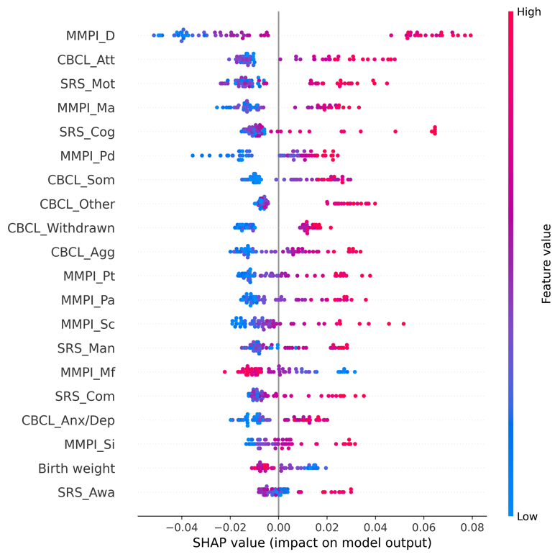 | 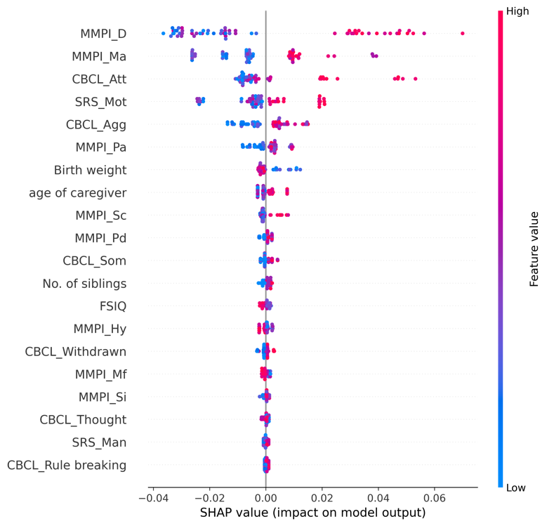

eFigure 14.5. Receiver operating characteristic curves (ROC) for the training and test set
<Training set> | <Test set>
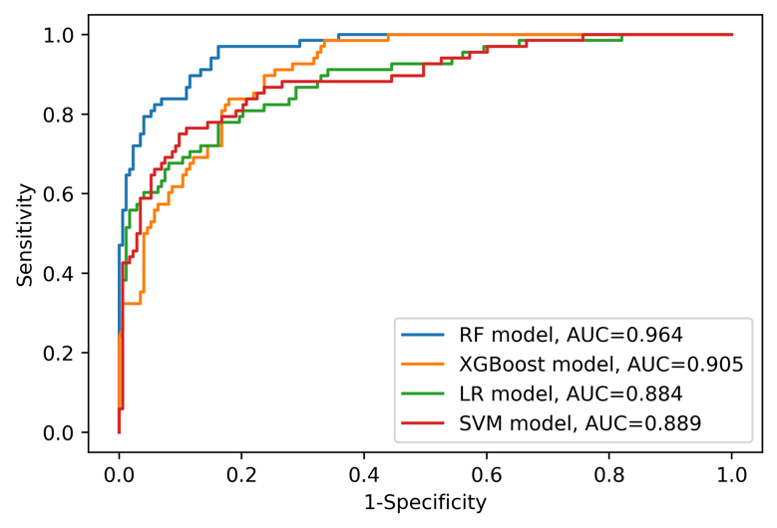 | 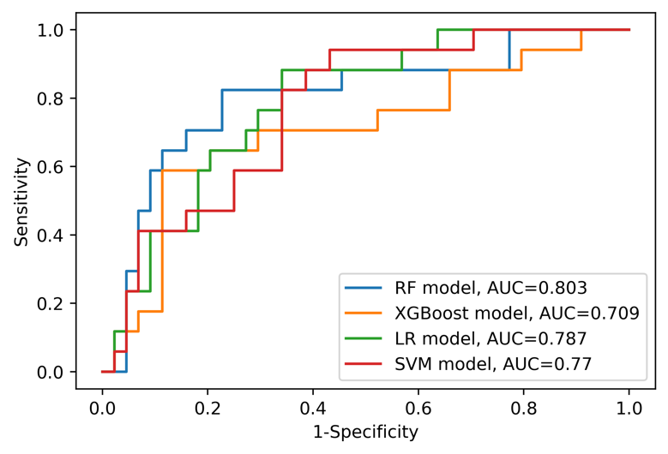
Abbreviations: AUC=area under curve, LR=logistic regression, RF=random forest, SVM=support vector machine, XGBoost=Extreme Gradient Boosting.

eAppendix 15. Model information and detailed results (Sample: CBCL 6-18 sample [n=302], Outcome: Parent-child dysfunctional interaction)

eTable 15.1. Model features (Variables are on the second columns)
Caregiver variables | - Assistant caregiver status [Yes/No]  - Current working status [Yes/No]  - Minnesota Multiphasic Personality Inventory (MMPI) Hypochondriasis (T-score)  - MMPI Depression (T-score)  - MMPI Hysteria (T-score)  - MMPI Psychopathy (T-score)  - MMPI Masculinity/Femininity (T-score)  - MMPI Paranoia (T-score)  - MMPI Psychasthenia (T-score)  - MMPI Schizophrenia (T-score)  - MMPI Hypomania (T-score)  - MMPI Social Introversion (T-score)  - The order of birth  - Number of children
ASD patient variables | - Age  - Sex [Male/Female]  - Family history of mental disorder [Yes/No]  - History of major disease [Yes/No]  - Psychotropic medication status [Drug free/Monotherapy of antipsychotics/Combined therapy of antipsychotics/Other psychotic medication]  - Gestational age  - Birth weight  - Mode of delivery [Vaginal delivery/Caesarean section]  - Existence of another child with mental disorder [Yes/No] [Yes/No]  - Full-Scale Intelligence Quotient (FSIQ)  - Social responsiveness scale (SRS) Social awareness (T-score)  - SRS Social cognition (T-score)  - SRS Social communication (T-score)  - SRS Social motivation (T-score)  - SRS Autistic mannerisms (T-score)  - Child Behavior Checklist (CBCL) Anxious/depressed (T-score)  - CBCL Withdrawn/depressed (T-score)  - CBCL Somatic complaints (T-score)  - CBCL Social problems (T-score)  - CBCL Thought problems (T-score)  - CBCL Attention problems (T-score)  - CBCL Rule-breaking behavior (T-score)  - CBCL Aggressive behavior (T-score)  - CBCL Other problems (T-score)

eTable 15.2. Performance of each model on the training set
 | RF model | XGBoost model | LR model | SVM model
ROC AUC (95% CI) | 0.980 (0.966-0.991) | 0.931 (0.899-0.958) | 0.812 (0.758-0.863) | 0.806 (0.752-0.859)
Sensitivity (95% CI) | 0.912 (0.857-0.960) | 0.841 (0.771-0.906) | 0.673 (0.586-0.758) | 0.681 (0.596-0.766)
Specificity (95% CI) | 0.938 (0.893-0.976) | 0.875 (0.813-0.930) | 0.789 (0.716-0.856) | 0.750 (0.672-0.824)
PPV (95% CI) | 0.928 (0.877-0.973) | 0.856 (0.787-0.918) | 0.738 (0.653-0.821) | 0.706 (0.623-0.789)
NPV (95% CI) | 0.923 (0.875-0.966) | 0.862 (0.800-0.919) | 0.732 (0.655-0.804) | 0.727 (0.649-0.803)
Accuracy (95% CI) | 0.925 (0.892-0.959) | 0.859 (0.813-0.900) | 0.734 (0.676-0.788) | 0.718 (0.660-0.776)
Abbreviations: AUC=area under curve, CI=confidence interval, NA=not available, NPV=negative predictive value, LR=logistic regression, RF=random forest, ROC=receiver operating characteristic, PPV=positive predictive value, SVM=support vector machine, XGBoost=Extreme Gradient Boosting.

eTable 15.3. Performance of each model on the test set
 | RF model | XGBoost model | LR model | SVM model
ROC AUC (95% CI) | 0.745 (0.611-0.860) | 0.750 (0.620-0.864) | 0.720 (0.580-0.841) | 0.726 (0.586-0.847)
Sensitivity (95% CI) | 0.679 (0.500-0.846) | 0.679 (0.500-0.848) | 0.571 (0.385-0.750) | 0.643 (0.458-0.816)
Specificity (95% CI) | 0.606 (0.438-0.769) | 0.606 (0.438-0.769) | 0.667 (0.500-0.824) | 0.697 (0.533-0.848)
PPV (95% CI) | 0.594 (0.414-0.759) | 0.594 (0.419-0.760) | 0.593 (0.400-0.778) | 0.643 (0.458-0.815)
NPV (95% CI) | 0.690 (0.517-0.853) | 0.690 (0.517-0.852) | 0.647 (0.483-0.800) | 0.697 (0.531-0.848)
Accuracy (95% CI) | 0.639 (0.525-0.754) | 0.639 (0.525-0.754) | 0.623 (0.492-0.738) | 0.672 (0.557-0.787)
Abbreviations: AUC=area under curve, CI=confidence interval, NA=not available, NPV=negative predictive value, LR=logistic regression, RF=random forest, ROC=receiver operating characteristic, PPV=positive predictive value, SVM=support vector machine, XGBoost=Extreme Gradient Boosting.

eFigure 15.4. SHapley Additive exPlanations (SHAP) summary plot for RF and XGBoost models (only top 20 predictors were presented)
<RF model> | <XGBoost model>
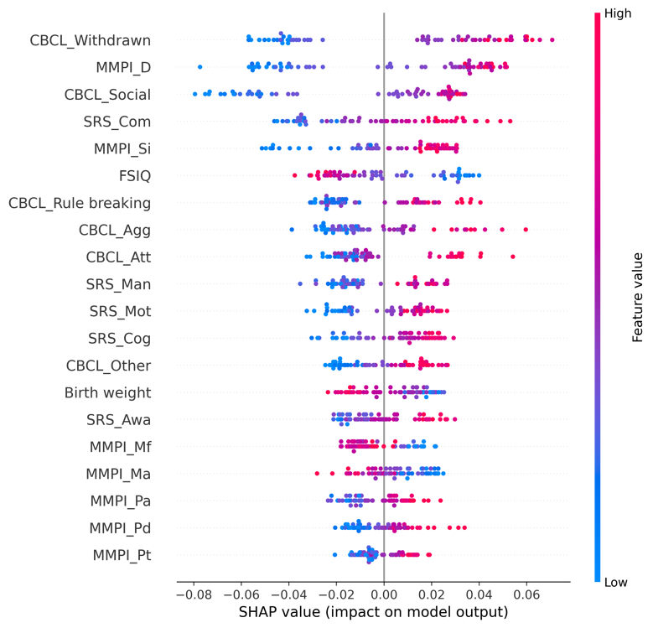 | 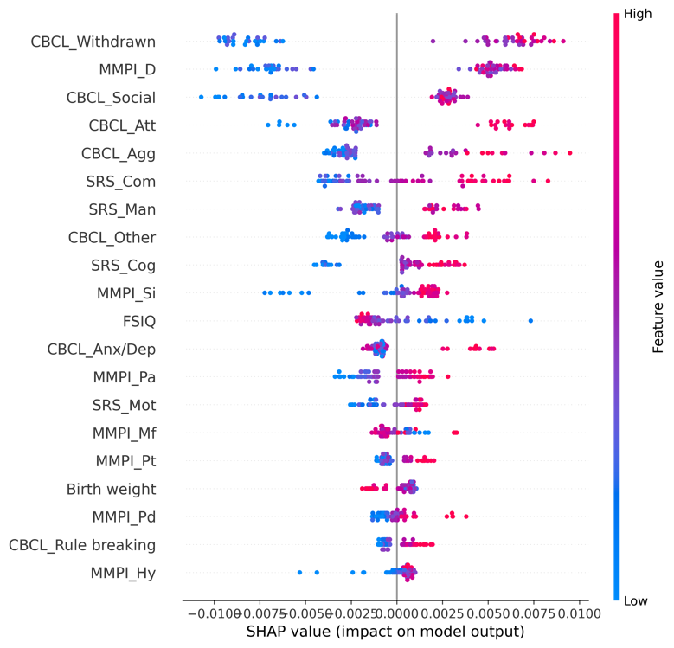

eFigure 15.5. Receiver operating characteristic curves (ROC) for the training and test set

<Training set> | <Test set>
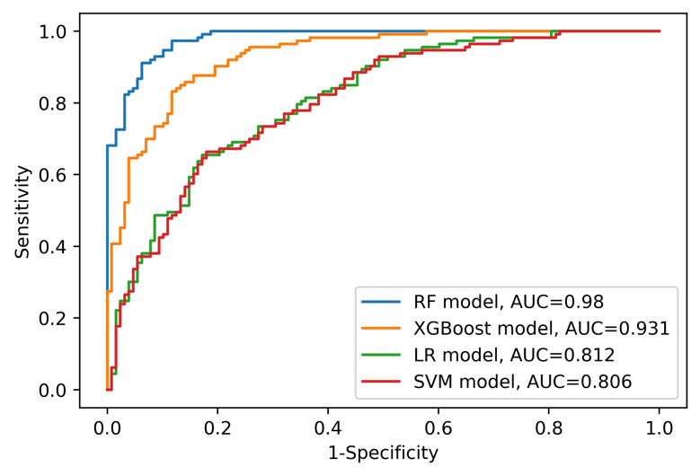 | 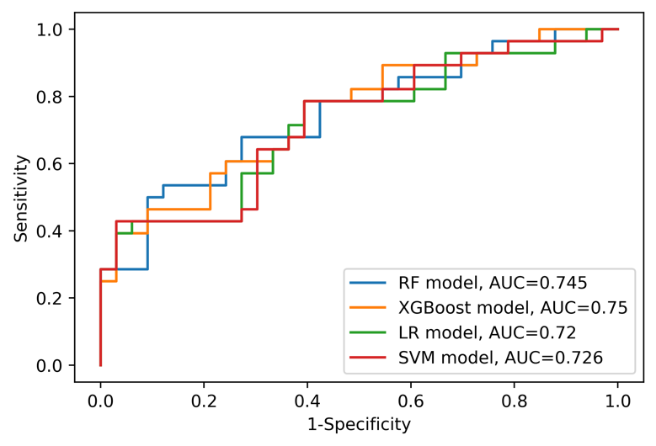
Abbreviations: AUC=area under curve, LR=logistic regression, RF=random forest, SVM=support vector machine, XGBoost=Extreme Gradient Boosting.

eAppendix 16. Model information and detailed results (Sample: CBCL 6-18 sample [n=302], Outcome: Difficult child)

eTable 16.1. Model features (Variables are on the second columns)
Caregiver variables | - Assistant caregiver status [Yes/No]  - Current working status [Yes/No]  - Minnesota Multiphasic Personality Inventory (MMPI) Hypochondriasis (T-score)  - MMPI Depression (T-score)  - MMPI Hysteria (T-score)  - MMPI Psychopathy (T-score)  - MMPI Masculinity/Femininity (T-score)  - MMPI Paranoia (T-score)  - MMPI Psychasthenia (T-score)  - MMPI Schizophrenia (T-score)  - MMPI Hypomania (T-score)  - MMPI Social Introversion (T-score)  - The order of birth  - Number of children
ASD patient variables | - Age  - Sex [Male/Female]  - Family history of mental disorder [Yes/No]  - History of major disease [Yes/No]  - Psychotropic medication status [Drug free/Monotherapy of antipsychotics/Combined therapy of antipsychotics/Other psychotic medication]  - Gestational age  - Birth weight  - Mode of delivery [Vaginal delivery/Caesarean section]  - Existence of another child with mental disorder [Yes/No] [Yes/No]  - Full-Scale Intelligence Quotient (FSIQ)  - Social responsiveness scale (SRS) Social awareness (T-score)  - SRS Social cognition (T-score)  - SRS Social communication (T-score)  - SRS Social motivation (T-score)  - SRS Autistic mannerisms (T-score)  - Child Behavior Checklist (CBCL) Anxious/depressed (T-score)  - CBCL Withdrawn/depressed (T-score)  - CBCL Somatic complaints (T-score)  - CBCL Social problems (T-score)  - CBCL Thought problems (T-score)  - CBCL Attention problems (T-score)  - CBCL Rule-breaking behavior (T-score)  - CBCL Aggressive behavior (T-score)  - CBCL Other problems (T-score)

eTable 16.2. Performance of each model on the training set
 | RF model | XGBoost model | LR model | SVM model
ROC AUC (95% CI) | 0.992 (0.984-0.997) | 0.930 (0.897-0.958) | 0.883 (0.839-0.923) | 1.000 (1.000-1.000)
Sensitivity (95% CI) | 0.950 (0.908-0.984) | 0.858 (0.792-0.917) | 0.825 (0.752-0.891) | 1.000 (1.000-1.000)
Specificity (95% CI) | 0.909 (0.856-0.957) | 0.802 (0.729-0.870) | 0.802 (0.729-0.870) | 1.000 (1.000-1.000)
PPV (95% CI) | 0.912 (0.860-0.958) | 0.811 (0.739-0.877) | 0.805 (0.733-0.873) | 1.000 (1.000-1.000)
NPV (95% CI) | 0.948 (0.904-0.983) | 0.851 (0.782-0.914) | 0.822 (0.748-0.888) | 1.000 (1.000-1.000)
Accuracy (95% CI) | 0.929 (0.896-0.959) | 0.830 (0.780-0.876) | 0.813 (0.763-0.863) | 1.000 (1.000-1.000)
Abbreviations: AUC=area under curve, CI=confidence interval, NA=not available, NPV=negative predictive value, LR=logistic regression, RF=random forest, ROC=receiver operating characteristic, PPV=positive predictive value, SVM=support vector machine, XGBoost=Extreme Gradient Boosting.

eTable 16.3. Performance of each model on the test set
 | RF model | XGBoost model | LR model | SVM model
ROC AUC (95% CI) | 0.805 (0.683-0.912) | 0.814 (0.697-0.917) | 0.777 (0.649-0.891) | 0.726 (0.589-0.847)
Sensitivity (95% CI) | 0.867 (0.735-0.969) | 0.867 (0.733-0.969) | 0.867 (0.735-0.969) | 0.900 (0.783-1.000)
Specificity (95% CI) | 0.548 (0.370-0.719) | 0.645 (0.471-0.806) | 0.645 (0.469-0.806) | 0.484 (0.306-0.658)
PPV (95% CI) | 0.650 (0.500-0.794) | 0.703 (0.548-0.844) | 0.703 (0.548-0.842) | 0.628 (0.477-0.767)
NPV (95% CI) | 0.810 (0.625-0.957) | 0.833 (0.667-0.962) | 0.833 (0.667-0.962) | 0.833 (0.640-1.000)
Accuracy (95% CI) | 0.705 (0.590-0.820) | 0.754 (0.639-0.852) | 0.754 (0.639-0.852) | 0.689 (0.574-0.803)
Abbreviations: AUC=area under curve, CI=confidence interval, NA=not available, NPV=negative predictive value, LR=logistic regression, RF=random forest, ROC=receiver operating characteristic, PPV=positive predictive value, SVM=support vector machine, XGBoost=Extreme Gradient Boosting.

eFigure 16.4. SHapley Additive exPlanations (SHAP) summary plot for RF and XGBoost models (only top 20 predictors were presented)
<RF model> | <XGBoost model>
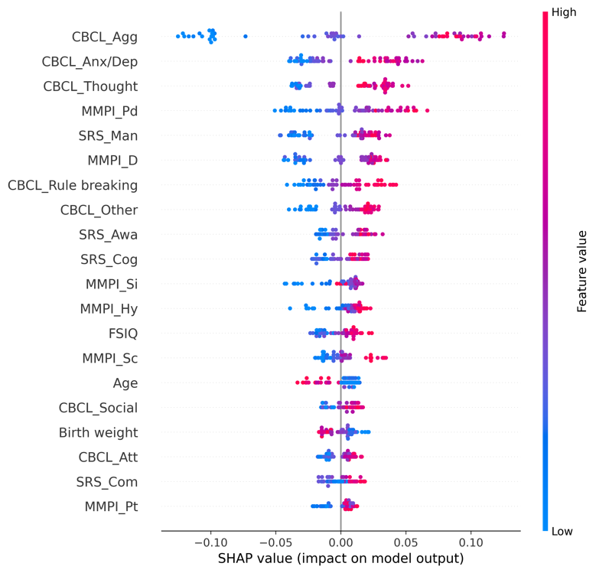 | 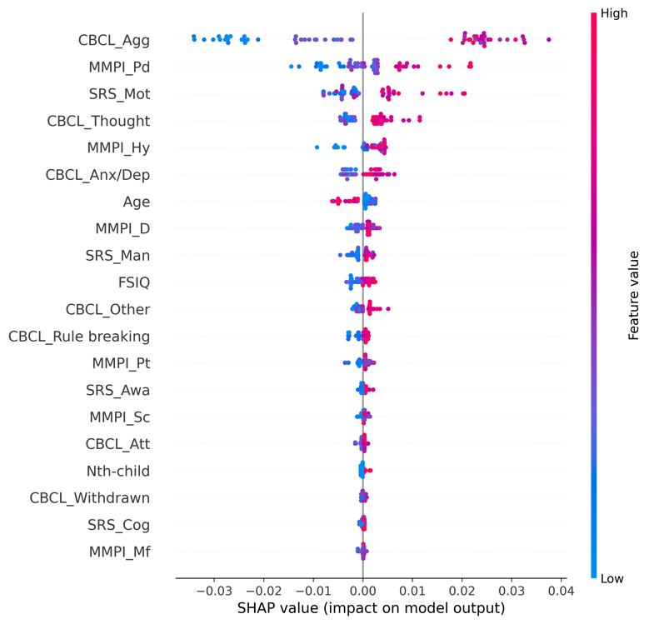

eFigure 16.5. Receiver operating characteristic curves (ROC) for the training and test set

<Training set> | <Test set>
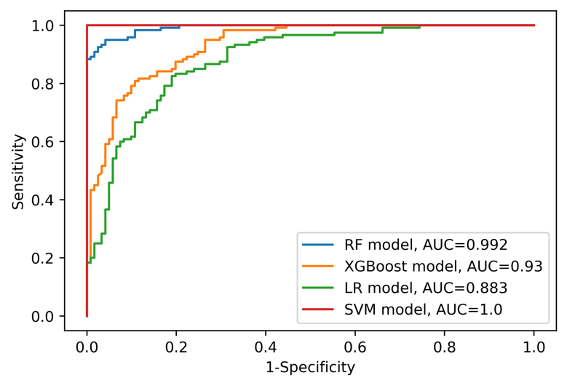 | 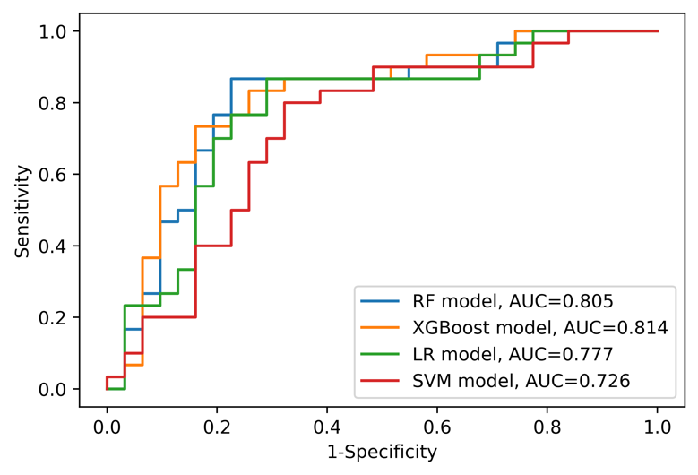
Abbreviations: AUC=area under curve, LR=logistic regression, RF=random forest, SVM=support vector machine, XGBoost=Extreme Gradient Boosting.

eAppendix 17. Model information and detailed results (Sample: CBCL 6-18 sample [n=302], Outcome: Total parenting stress)

eTable 17.1. Model features (Variables are on the second columns)
Caregiver variables | - Assistant caregiver status [Yes/No]  - Current working status [Yes/No]  - Minnesota Multiphasic Personality Inventory (MMPI) Hypochondriasis (T-score)  - MMPI Depression (T-score)  - MMPI Hysteria (T-score)  - MMPI Psychopathy (T-score)  - MMPI Masculinity/Femininity (T-score)  - MMPI Paranoia (T-score)  - MMPI Psychasthenia (T-score)  - MMPI Schizophrenia (T-score)  - MMPI Hypomania (T-score)  - MMPI Social Introversion (T-score)  - The order of birth  - Number of children
ASD patient variables | - Age  - Sex [Male/Female]  - Family history of mental disorder [Yes/No]  - History of major disease [Yes/No]  - Psychotropic medication status [Drug free/Monotherapy of antipsychotics/Combined therapy of antipsychotics/Other psychotic medication]  - Gestational age  - Birth weight  - Mode of delivery [Vaginal delivery/Caesarean section]  - Existence of another child with mental disorder [Yes/No] [Yes/No]  - Full-Scale Intelligence Quotient (FSIQ)  - Social responsiveness scale (SRS) Social awareness (T-score)  - SRS Social cognition (T-score)  - SRS Social communication (T-score)  - SRS Social motivation (T-score)  - SRS Autistic mannerisms (T-score)  - Child Behavior Checklist (CBCL) Anxious/depressed (T-score)  - CBCL Withdrawn/depressed (T-score)  - CBCL Somatic complaints (T-score)  - CBCL Social problems (T-score)  - CBCL Thought problems (T-score)  - CBCL Attention problems (T-score)  - CBCL Rule-breaking behavior (T-score)  - CBCL Aggressive behavior (T-score)  - CBCL Other problems (T-score)

eTable 17.2. Performance of each model on the training set
 | RF model | XGBoost model | LR model | SVM model
ROC AUC (95% CI) | 0.966 (0.946-0.982) | 0.951 (0.926-0.971) | 0.881 (0.839-0.919) | 0.883 (0.842-0.920)
Sensitivity (95% CI) | 0.906 (0.852-0.953) | 0.875 (0.817-0.929) | 0.797 (0.726-0.865) | 0.781 (0.706-0.851)
Specificity (95% CI) | 0.858 (0.790-0.920) | 0.841 (0.771-0.907) | 0.761 (0.681-0.838) | 0.779 (0.701-0.852)
PPV (95% CI) | 0.879 (0.820-0.932) | 0.862 (0.800-0.919) | 0.791 (0.719-0.859) | 0.800 (0.728-0.868)
NPV (95% CI) | 0.890 (0.829-0.945) | 0.856 (0.788-0.917) | 0.768 (0.688-0.842) | 0.759 (0.679-0.835)
Accuracy (95% CI) | 0.884 (0.842-0.921) | 0.859 (0.813-0.900) | 0.780 (0.726-0.830) | 0.780 (0.726-0.830)
Abbreviations: AUC=area under curve, CI=confidence interval, NA=not available, NPV=negative predictive value, LR=logistic regression, RF=random forest, ROC=receiver operating characteristic, PPV=positive predictive value, SVM=support vector machine, XGBoost=Extreme Gradient Boosting.

eTable 17.3. Performance of each model on the test set
 | RF model | XGBoost model | LR model | SVM model
ROC AUC (95% CI) | 0.847 (0.734-0.940) | 0.747 (0.615-0.864) | 0.839 (0.725-0.933) | 0.842 (0.729-0.935)
Sensitivity (95% CI) | 0.812 (0.667-0.935) | 0.656 (0.485-0.818) | 0.656 (0.485-0.815) | 0.656 (0.485-0.815)
Specificity (95% CI) | 0.793 (0.633-0.929) | 0.690 (0.516-0.850) | 0.828 (0.679-0.962) | 0.897 (0.769-1.000)
PPV (95% CI) | 0.812 (0.667-0.935) | 0.700 (0.531-0.857) | 0.808 (0.643-0.957) | 0.875 (0.722-1.000)
NPV (95% CI) | 0.793 (0.633-0.929) | 0.645 (0.469-0.815) | 0.686 (0.526-0.833) | 0.703 (0.550-0.844)
Accuracy (95% CI) | 0.803 (0.705-0.902) | 0.672 (0.557-0.787) | 0.738 (0.623-0.836) | 0.770 (0.656-0.869)
Abbreviations: AUC=area under curve, CI=confidence interval, NA=not available, NPV=negative predictive value, LR=logistic regression, RF=random forest, ROC=receiver operating characteristic, PPV=positive predictive value, SVM=support vector machine, XGBoost=Extreme Gradient Boosting.

eFigure 17.4. SHapley Additive exPlanations (SHAP) summary plot for RF and XGBoost models (only top 20 predictors were presented)
<RF model> | <XGBoost model>
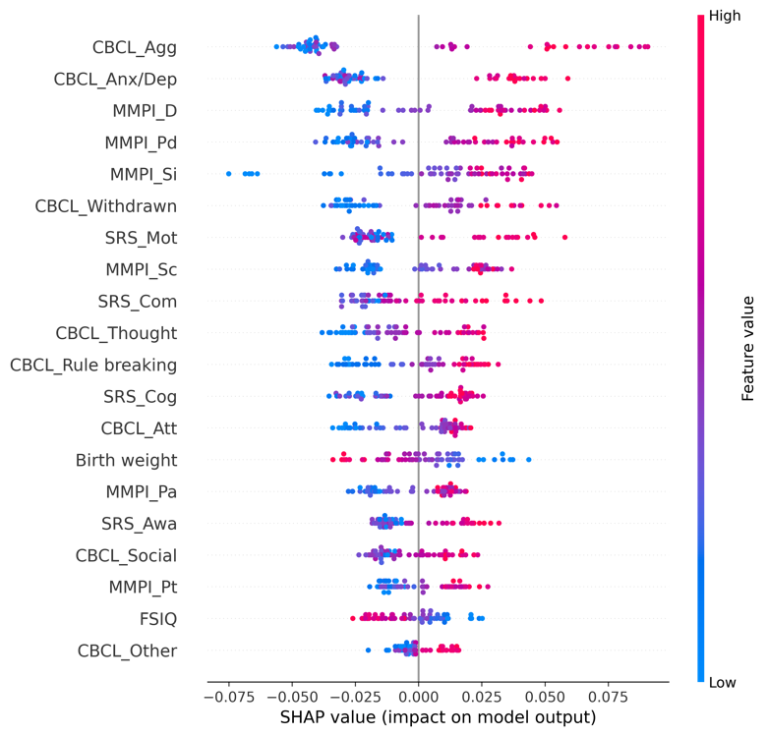 | 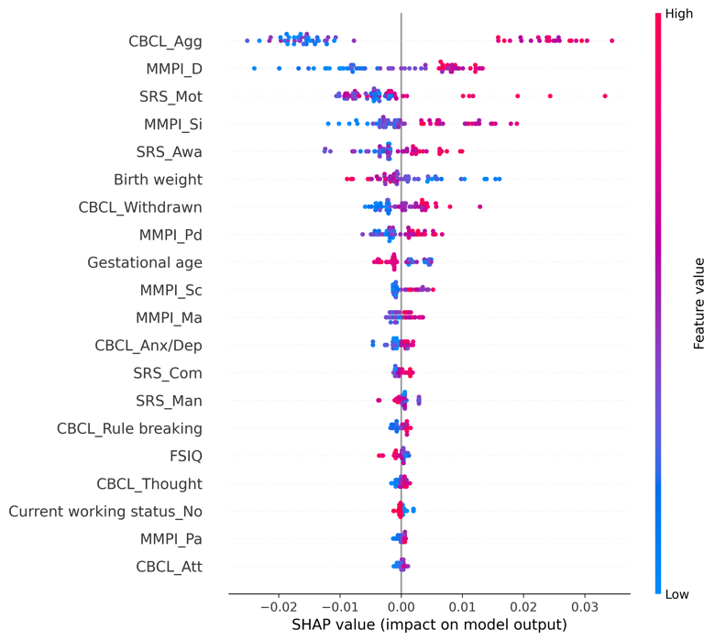

eFigure 17.5. Receiver operating characteristic curves (ROC) for the training and test set

<Training set> | <Test set>
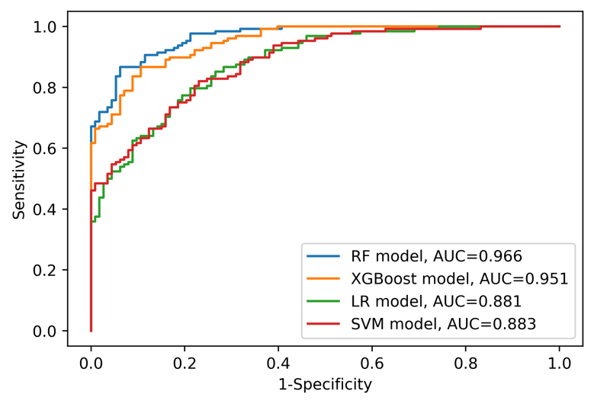 | 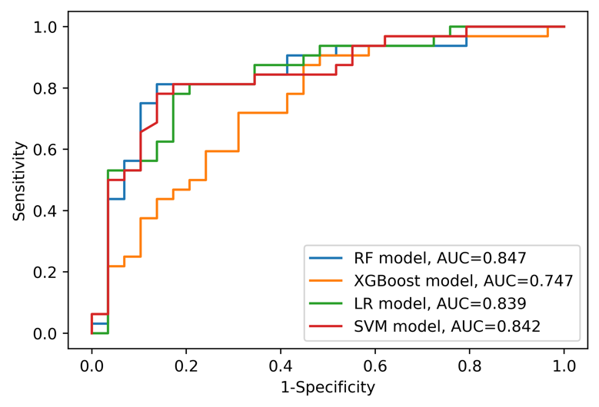
Abbreviations: AUC=area under curve, LR=logistic regression, RF=random forest, SVM=support vector machine, XGBoost=Extreme Gradient Boosting.

eAppendix 18. Model information and detailed results (Sample: with ADHD [n=168], Outcome: Parental distress)

eTable 18.1. Model features (Variables are on the second columns)
Caregiver variables | - Assistant caregiver status [Yes/No]  - Current working status [Yes/No]  - Minnesota Multiphasic Personality Inventory (MMPI) Hypochondriasis (T-score)  - MMPI Depression (T-score)  - MMPI Hysteria (T-score)  - MMPI Psychopathy (T-score)  - MMPI Masculinity/Femininity (T-score)  - MMPI Paranoia (T-score)  - MMPI Psychasthenia (T-score)  - MMPI Schizophrenia (T-score)  - MMPI Hypomania (T-score)  - MMPI Social Introversion (T-score)  - The order of birth  - Number of children
ASD patient variables | - Age  - Sex [Male/Female]  - Family history of mental disorder [Yes/No]  - History of major disease [Yes/No]  - Psychotropic medication status [Drug free/Monotherapy of antipsychotics/Combined therapy of antipsychotics/Other psychotic medication]  - Gestational age  - Birth weight  - Mode of delivery [Vaginal delivery/Caesarean section]  - Existence of another child with mental disorder [Yes/No]  - Full-Scale Intelligence Quotient (FSIQ)  - Social responsiveness scale (SRS) Social awareness (T-score)  - SRS Social cognition (T-score)  - SRS Social communication (T-score)  - SRS Social motivation (T-score)  - SRS Autistic mannerisms (T-score)  - Child Behavior Checklist (CBCL) Anxious/depressed (T-score)  - CBCL Withdrawn/depressed (T-score)  - CBCL Somatic complaints (T-score)  - CBCL Attention problems (T-score)  - CBCL Aggressive behavior (T-score)  - CBCL Other problems (T-score)

eTable 18.2. Performance of each model on the training set
 | RF model | XGBoost model | LR model | SVM model
ROC AUC (95% CI) | 0.975 (0.950-0.992) | 0.898 (0.841-0.946) | 0.865 (0.800-0.922) | 1.000 (1.000-1.000)
Sensitivity (95% CI) | 0.705 (0.562-0.837) | 0.545 (0.395-0.690) | 0.568 (0.419-0.714) | 1.000 (1.000-1.000)
Specificity (95% CI) | 0.967 (0.925-1.000) | 0.944 (0.892-0.989) | 0.889 (0.821-0.949) | 1.000 (1.000-1.000)
PPV (95% CI) | 0.912 (0.806-1.000) | 0.828 (0.679-0.960) | 0.714 (0.559-0.857) | 1.000 (1.000-1.000)
NPV (95% CI) | 0.870 (0.802-0.932) | 0.810 (0.732-0.881) | 0.808 (0.729-0.881) | 1.000 (1.000-1.000)
Accuracy (95% CI) | 0.881 (0.821-0.933) | 0.813 (0.746-0.873) | 0.784 (0.709-0.851) | 1.000 (1.000-1.000)
Abbreviations: AUC=area under curve, CI=confidence interval, NA=not available, NPV=negative predictive value, LR=logistic regression, RF=random forest, ROC=receiver operating characteristic, PPV=positive predictive value, SVM=support vector machine, XGBoost=Extreme Gradient Boosting.

eTable 18.3. Performance of each model on the test set
 | RF model | XGBoost model | LR model | SVM model
ROC AUC (95% CI) | 0.794 (0.577-0.970) | 0.818 (0.628-0.968) | 0.739 (0.493-0.949) | 0.771 (0.553-0.945)
Sensitivity (95% CI) | 0.455 (0.143-0.769) | 0.455 (0.143-0.769) | 0.364 (0.091-0.667) | 0.545 (0.231-0.857)
Specificity (95% CI) | 1.000 (1.000-1.000) | 1.000 (1.000-1.000) | 0.957 (0.857-1.000) | 0.870 (0.714-1.000)
PPV (95% CI) | 1.000 (1.000-1.000) | 1.000 (1.000-1.000) | 0.800 (0.333-1.000) | 0.667 (0.333-1.000)
NPV (95% CI) | 0.793 (0.643-0.931) | 0.793 (0.643-0.931) | 0.759 (0.594-0.900) | 0.800 (0.630-0.952)
Accuracy (95% CI) | 0.824 (0.676-0.941) | 0.824 (0.676-0.941) | 0.765 (0.618-0.912) | 0.765 (0.618-0.912)
Abbreviations: AUC=area under curve, CI=confidence interval, NA=not available, NPV=negative predictive value, LR=logistic regression, RF=random forest, ROC=receiver operating characteristic, PPV=positive predictive value, SVM=support vector machine, XGBoost=Extreme Gradient Boosting.

eFigure 18.4. SHapley Additive exPlanations (SHAP) summary plot for RF and XGBoost models (only top 20 predictors were presented)
<RF model> | <XGBoost model>
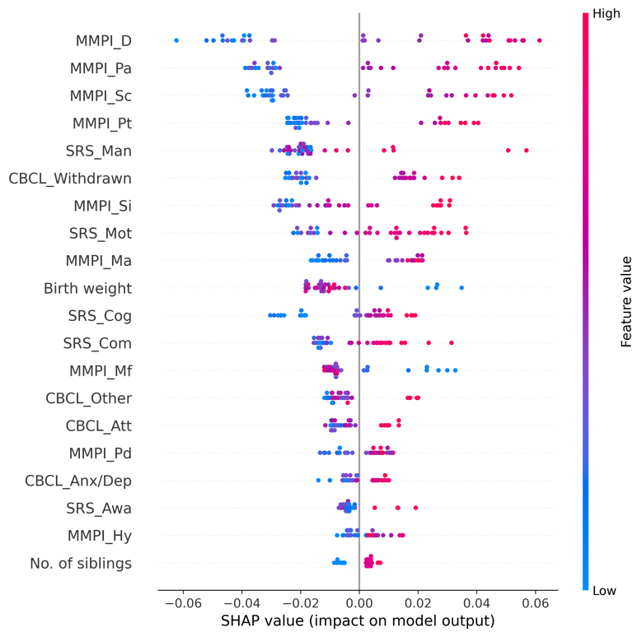 | 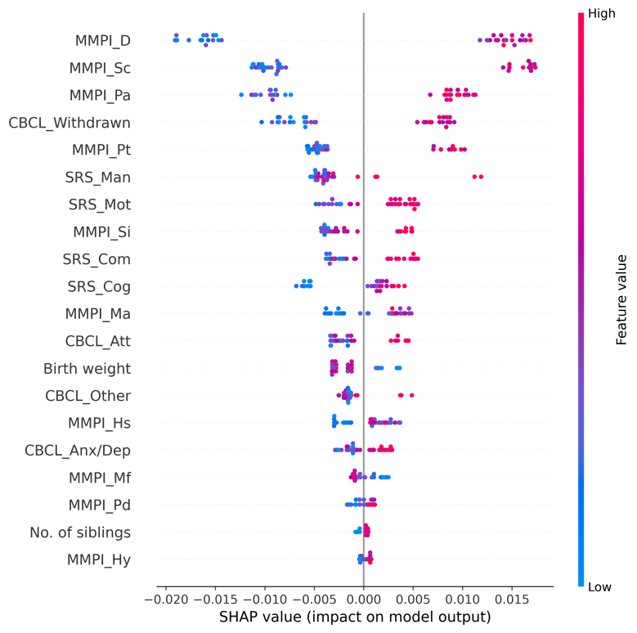

eFigure 18.5. Receiver operating characteristic curves (ROC) for the training and test set

<Training set> | <Test set>
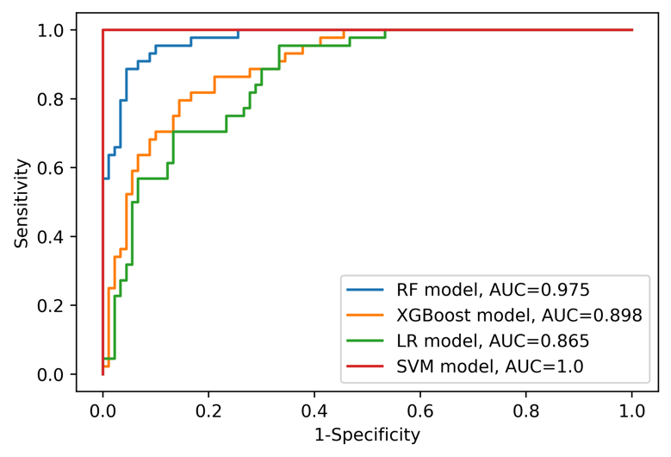 | 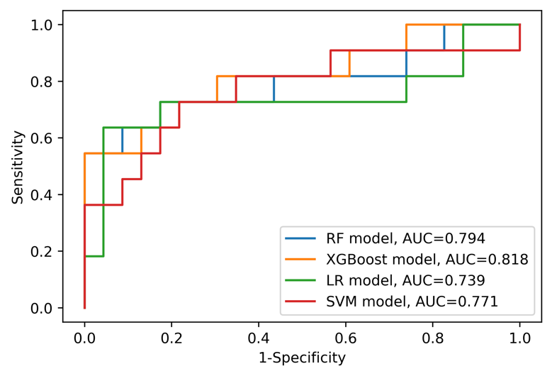
Abbreviations: AUC=area under curve, LR=logistic regression, RF=random forest, SVM=support vector machine, XGBoost=Extreme Gradient Boosting.

eAppendix 19. Model information and detailed results (Sample: with ADHD [n=168], Outcome: Parent-child dysfunctional interaction)

eTable 19.1. Model features (Variables are on the second columns)
Caregiver variables | - Assistant caregiver status [Yes/No]  - Current working status [Yes/No]  - Minnesota Multiphasic Personality Inventory (MMPI) Hypochondriasis (T-score)  - MMPI Depression (T-score)  - MMPI Hysteria (T-score)  - MMPI Psychopathy (T-score)  - MMPI Masculinity/Femininity (T-score)  - MMPI Paranoia (T-score)  - MMPI Psychasthenia (T-score)  - MMPI Schizophrenia (T-score)  - MMPI Hypomania (T-score)  - MMPI Social Introversion (T-score)  - The order of birth  - Number of children
ASD patient variables | - Age  - Sex [Male/Female]  - Family history of mental disorder [Yes/No]  - History of major disease [Yes/No]  - Psychotropic medication status [Drug free/Monotherapy of antipsychotics/Combined therapy of antipsychotics/Other psychotic medication]  - Gestational age  - Birth weight  - Mode of delivery [Vaginal delivery/Caesarean section]  - Existence of another child with mental disorder [Yes/No]  - Full-Scale Intelligence Quotient (FSIQ)  - Social responsiveness scale (SRS) Social awareness (T-score)  - SRS Social cognition (T-score)  - SRS Social communication (T-score)  - SRS Social motivation (T-score)  - SRS Autistic mannerisms (T-score)  - Child Behavior Checklist (CBCL) Anxious/depressed (T-score)  - CBCL Withdrawn/depressed (T-score)  - CBCL Somatic complaints (T-score)  - CBCL Attention problems (T-score)  - CBCL Aggressive behavior (T-score)  - CBCL Other problems (T-score)

eTable 19.2. Performance of each model on the training set
 | RF model | XGBoost model | LR model | SVM model
ROC AUC (95% CI) | 0.943 (0.902-0.976) | 0.896 (0.835-0.947) | 0.859 (0.791-0.918) | 0.824 (0.749-0.890)
Sensitivity (95% CI) | 0.776 (0.667-0.879) | 0.655 (0.529-0.776) | 0.672 (0.549-0.790) | 0.552 (0.424-0.679)
Specificity (95% CI) | 0.921 (0.855-0.974) | 0.921 (0.855-0.975) | 0.829 (0.740-0.909) | 0.855 (0.771-0.929)
PPV (95% CI) | 0.882 (0.787-0.962) | 0.864 (0.750-0.957) | 0.750 (0.629-0.864) | 0.744 (0.610-0.870)
NPV (95% CI) | 0.843 (0.761-0.919) | 0.778 (0.688-0.862) | 0.768 (0.674-0.857) | 0.714 (0.618-0.804)
Accuracy (95% CI) | 0.858 (0.799-0.910) | 0.806 (0.739-0.873) | 0.761 (0.687-0.828) | 0.724 (0.649-0.799)
Abbreviations: AUC=area under curve, CI=confidence interval, NA=not available, NPV=negative predictive value, LR=logistic regression, RF=random forest, ROC=receiver operating characteristic, PPV=positive predictive value, SVM=support vector machine, XGBoost=Extreme Gradient Boosting.

eTable 19.3. Performance of each model on the test set
 | RF model | XGBoost model | LR model | SVM model
ROC AUC (95% CI) | 0.884 (0.751-0.979) | 0.874 (0.730-0.979) | 0.839 (0.689-0.951) | 0.877 (0.743-0.969)
Sensitivity (95% CI) | 0.667 (0.412-0.909) | 0.467 (0.214-0.727) | 0.600 (0.350-0.857) | 0.533 (0.273-0.800)
Specificity (95% CI) | 0.842 (0.667-1.000) | 0.895 (0.737-1.000) | 0.895 (0.737-1.000) | 1.000 (1.000-1.000)
PPV (95% CI) | 0.769 (0.500-1.000) | 0.778 (0.462-1.000) | 0.818 (0.556-1.000) | 1.000 (1.000-1.000)
NPV (95% CI) | 0.762 (0.571-0.941) | 0.680 (0.500-0.857) | 0.739 (0.550-0.913) | 0.731 (0.556-0.895)
Accuracy (95% CI) | 0.765 (0.618-0.912) | 0.706 (0.559-0.853) | 0.765 (0.618-0.882) | 0.794 (0.647-0.912)
Abbreviations: AUC=area under curve, CI=confidence interval, NA=not available, NPV=negative predictive value, LR=logistic regression, RF=random forest, ROC=receiver operating characteristic, PPV=positive predictive value, SVM=support vector machine, XGBoost=Extreme Gradient Boosting.

eFigure 19.4. SHapley Additive exPlanations (SHAP) summary plot for RF and XGBoost models (only top 20 predictors were presented)
<RF model> | <XGBoost model>
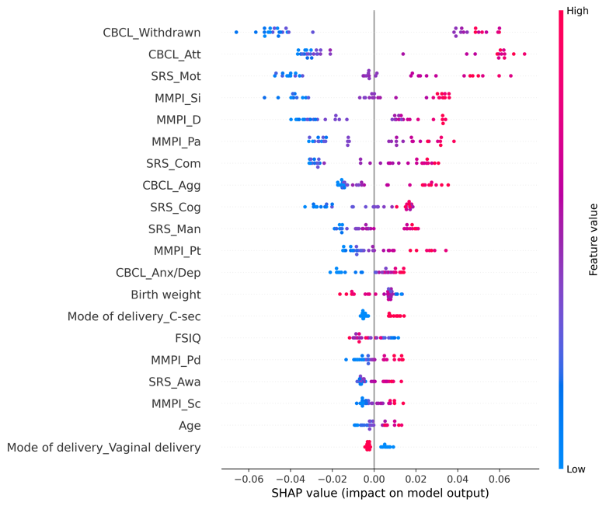 | 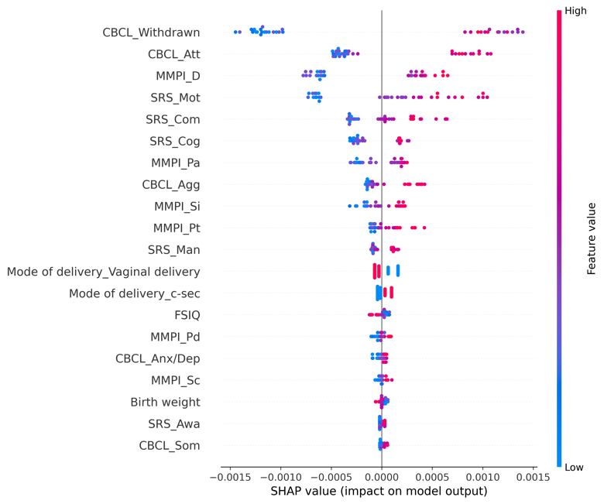

eFigure 19.5. Receiver operating characteristic curves (ROC) for the training and test set

<Training set> | <Test set>
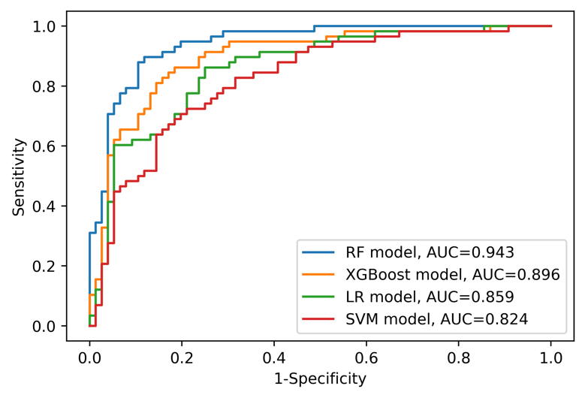 | 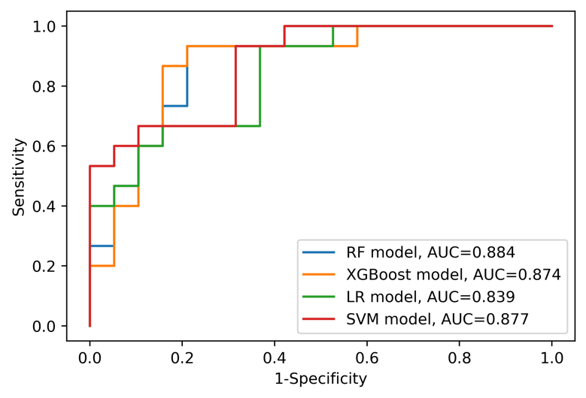
Abbreviations: AUC=area under curve, LR=logistic regression, RF=random forest, SVM=support vector machine, XGBoost=Extreme Gradient Boosting.

eAppendix 20. Model information and detailed results (Sample: with ADHD [n=168], Outcome: Difficult child)

eTable 20.1. Model features (Variables are on the second columns)
Caregiver variables | - Assistant caregiver status [Yes/No]  - Current working status [Yes/No]  - Minnesota Multiphasic Personality Inventory (MMPI) Hypochondriasis (T-score)  - MMPI Depression (T-score)  - MMPI Hysteria (T-score)  - MMPI Psychopathy (T-score)  - MMPI Masculinity/Femininity (T-score)  - MMPI Paranoia (T-score)  - MMPI Psychasthenia (T-score)  - MMPI Schizophrenia (T-score)  - MMPI Hypomania (T-score)  - MMPI Social Introversion (T-score)  - The order of birth  - Number of children
ASD patient variables | - Age  - Sex [Male/Female]  - Family history of mental disorder [Yes/No]  - History of major disease [Yes/No]  - Psychotropic medication status [Drug free/Monotherapy of antipsychotics/Combined therapy of antipsychotics/Other psychotic medication]  - Gestational age  - Birth weight  - Mode of delivery [Vaginal delivery/Caesarean section]  - Existence of another child with mental disorder [Yes/No]  - Full-Scale Intelligence Quotient (FSIQ)  - Social responsiveness scale (SRS) Social awareness (T-score)  - SRS Social cognition (T-score)  - SRS Social communication (T-score)  - SRS Social motivation (T-score)  - SRS Autistic mannerisms (T-score)  - Child Behavior Checklist (CBCL) Anxious/depressed (T-score)  - CBCL Withdrawn/depressed (T-score)  - CBCL Somatic complaints (T-score)  - CBCL Attention problems (T-score)  - CBCL Aggressive behavior (T-score)  - CBCL Other problems (T-score)

eTable 20.2. Performance of each model on the training set
 | RF model | XGBoost model | LR model | SVM model
ROC AUC (95% CI) | 0.969 (0.942-0.989) | 0.899 (0.844-0.947) | 0.839 (0.768-0.905) | 0.144 (0.084-0.210)
Sensitivity (95% CI) | 0.910 (0.838-0.971) | 0.746 (0.640-0.845) | 0.701 (0.589-0.809) | 0.716 (0.607-0.822)
Specificity (95% CI) | 0.910 (0.836-0.971) | 0.851 (0.759-0.932) | 0.821 (0.723-0.910) | 0.806 (0.703-0.896)
PPV (95% CI) | 0.910 (0.836-0.971) | 0.833 (0.732-0.923) | 0.797 (0.690-0.897) | 0.787 (0.679-0.884)
NPV (95% CI) | 0.910 (0.838-0.971) | 0.770 (0.671-0.862) | 0.733 (0.630-0.829) | 0.740 (0.636-0.836)
Accuracy (95% CI) | 0.910 (0.858-0.955) | 0.799 (0.731-0.866) | 0.761 (0.687-0.828) | 0.761 (0.687-0.828)
Abbreviations: AUC=area under curve, CI=confidence interval, NA=not available, NPV=negative predictive value, LR=logistic regression, RF=random forest, ROC=receiver operating characteristic, PPV=positive predictive value, SVM=support vector machine, XGBoost=Extreme Gradient Boosting.

eTable 20.3. Performance of each model on the test set
 | RF model | XGBoost model | LR model | SVM model
ROC AUC (95% CI) | 0.709 (0.514-0.872) | 0.678 (0.477-0.864) | 0.657 (0.453-0.837) | 0.315 (0.144-0.516)
Sensitivity (95% CI) | 0.706 (0.471-0.917) | 0.765 (0.545-0.944) | 0.588 (0.353-0.812) | 0.588 (0.353-0.812)
Specificity (95% CI) | 0.588 (0.353-0.818) | 0.647 (0.412-0.875) | 0.529 (0.286-0.765) | 0.529 (0.286-0.765)
PPV (95% CI) | 0.632 (0.400-0.842) | 0.684 (0.450-0.889) | 0.556 (0.312-0.786) | 0.556 (0.312-0.786)
NPV (95% CI) | 0.667 (0.412-0.900) | 0.733 (0.500-0.933) | 0.562 (0.308-0.812) | 0.562 (0.308-0.812)
Accuracy (95% CI) | 0.647 (0.500-0.794) | 0.706 (0.559-0.853) | 0.559 (0.382-0.735) | 0.559 (0.382-0.735)
Abbreviations: AUC=area under curve, CI=confidence interval, NA=not available, NPV=negative predictive value, LR=logistic regression, RF=random forest, ROC=receiver operating characteristic, PPV=positive predictive value, SVM=support vector machine, XGBoost=Extreme Gradient Boosting.

eFigure 20.4. SHapley Additive exPlanations (SHAP) summary plot for RF and XGBoost models (only top 20 predictors were presented)
<RF model> | <XGBoost model>
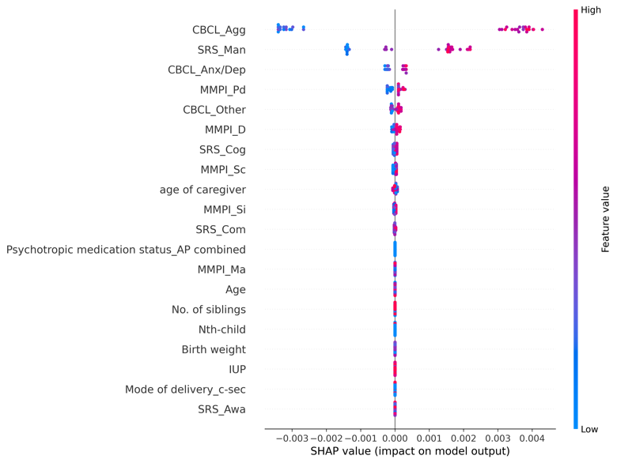 | 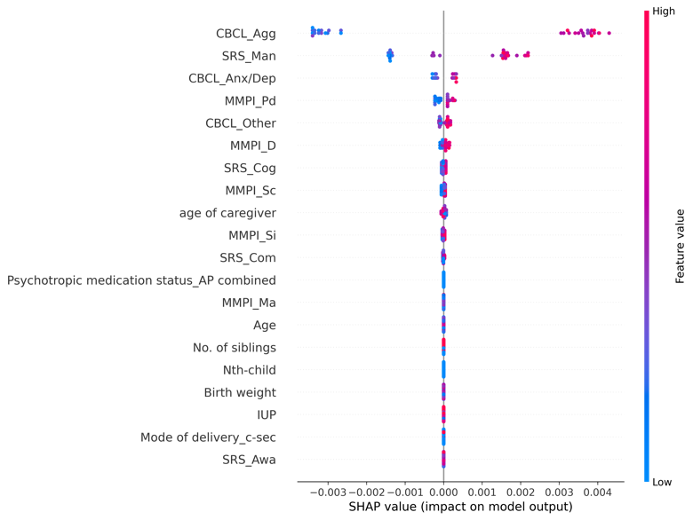

eFigure 20.5. Receiver operating characteristic curves (ROC) for the training and test set

<Training set> | <Test set>
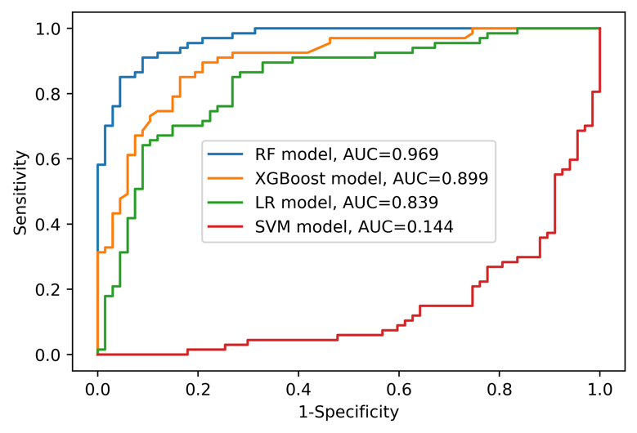 | 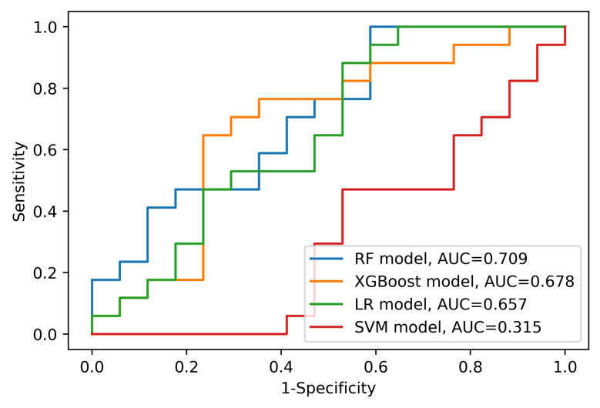
Abbreviations: AUC=area under curve, LR=logistic regression, RF=random forest, SVM=support vector machine, XGBoost=Extreme Gradient Boosting.

eAppendix 21. Model information and detailed results (Sample: with ADHD [n=168], Outcome: Total parenting stress)

eTable 21.1. Model features (Variables are on the second columns)
Caregiver variables | - Assistant caregiver status [Yes/No]  - Current working status [Yes/No]  - Minnesota Multiphasic Personality Inventory (MMPI) Hypochondriasis (T-score)  - MMPI Depression (T-score)  - MMPI Hysteria (T-score)  - MMPI Psychopathy (T-score)  - MMPI Masculinity/Femininity (T-score)  - MMPI Paranoia (T-score)  - MMPI Psychasthenia (T-score)  - MMPI Schizophrenia (T-score)  - MMPI Hypomania (T-score)  - MMPI Social Introversion (T-score)  - The order of birth  - Number of children
ASD patient variables | - Age  - Sex [Male/Female]  - Family history of mental disorder [Yes/No]  - History of major disease [Yes/No]  - Psychotropic medication status [Drug free/Monotherapy of antipsychotics/Combined therapy of antipsychotics/Other psychotic medication]  - Gestational age  - Birth weight  - Mode of delivery [Vaginal delivery/Caesarean section]  - Existence of another child with mental disorder [Yes/No]  - Full-Scale Intelligence Quotient (FSIQ)  - Social responsiveness scale (SRS) Social awareness (T-score)  - SRS Social cognition (T-score)  - SRS Social communication (T-score)  - SRS Social motivation (T-score)  - SRS Autistic mannerisms (T-score)  - Child Behavior Checklist (CBCL) Anxious/depressed (T-score)  - CBCL Withdrawn/depressed (T-score)  - CBCL Somatic complaints (T-score)  - CBCL Attention problems (T-score)  - CBCL Aggressive behavior (T-score)  - CBCL Other problems (T-score)

eTable 21.2. Performance of each model on the training set
 | RF model | XGBoost model | LR model | SVM model
ROC AUC (95% CI) | 0.977 (0.953-0.994) | 0.924 (0.874-0.963) | 0.825 (0.750-0.891) | 0.864 (0.799-0.918)
Sensitivity (95% CI) | 0.928 (0.862-0.985) | 0.884 (0.803-0.956) | 0.783 (0.682-0.877) | 1.000 (1.000-1.000)
Specificity (95% CI) | 0.877 (0.790-0.951) | 0.815 (0.716-0.905) | 0.692 (0.579-0.800) | 0.000 (0.000-0.000)
PPV (95% CI) | 0.889 (0.810-0.956) | 0.836 (0.744-0.914) | 0.730 (0.627-0.826) | 0.515 (0.425-0.597)
NPV (95% CI) | 0.919 (0.845-0.983) | 0.869 (0.778-0.948) | 0.750 (0.635-0.857) | NA
Accuracy (95% CI) | 0.903 (0.851-0.948) | 0.851 (0.791-0.910) | 0.739 (0.664-0.813) | 0.515 (0.425-0.597)
Abbreviations: AUC=area under curve, CI=confidence interval, NA=not available, NPV=negative predictive value, LR=logistic regression, RF=random forest, ROC=receiver operating characteristic, PPV=positive predictive value, SVM=support vector machine, XGBoost=Extreme Gradient Boosting.

eTable 21.3. Performance of each model on the test set
 | RF model | XGBoost model | LR model | SVM model
ROC AUC (95% CI) | 0.865 (0.726-0.969) | 0.834 (0.681-0.954) | 0.886 (0.754-0.985) | 0.886 (0.751-0.983)
Sensitivity (95% CI) | 0.882 (0.706-1.000) | 0.824 (0.625-1.000) | 0.882 (0.706-1.000) | 1.000 (1.000-1.000)
Specificity (95% CI) | 0.706 (0.474-0.917) | 0.706 (0.474-0.917) | 0.529 (0.286-0.769) | 0.000 (0.000-0.000)
PPV (95% CI) | 0.750 (0.550-0.938) | 0.737 (0.529-0.933) | 0.652 (0.455-0.842) | 0.500 (0.324-0.676)
NPV (95% CI) | 0.857 (0.643-1.000) | 0.800 (0.571-1.000) | 0.818 (0.556-1.000) | NA
Accuracy (95% CI) | 0.794 (0.647-0.912) | 0.765 (0.618-0.912) | 0.706 (0.559-0.853) | 0.500 (0.324-0.676)
Abbreviations: AUC=area under curve, CI=confidence interval, NA=not available, NPV=negative predictive value, LR=logistic regression, RF=random forest, ROC=receiver operating characteristic, PPV=positive predictive value, SVM=support vector machine, XGBoost=Extreme Gradient Boosting.

eFigure 21.4. SHapley Additive exPlanations (SHAP) summary plot for RF and XGBoost models (only top 20 predictors were presented)
<RF model> | <XGBoost model>
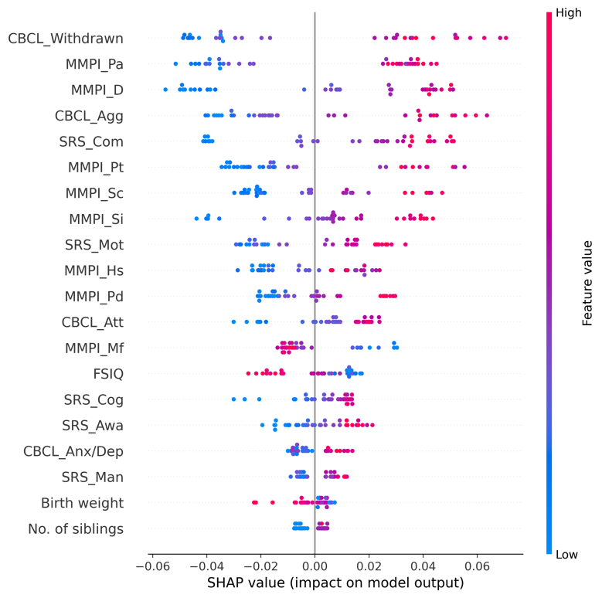 | 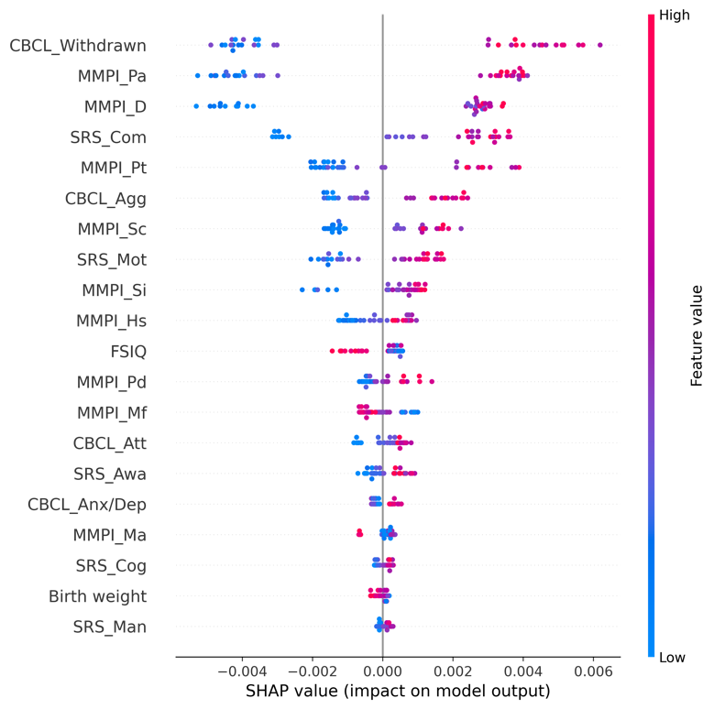

eFigure 21.5. Receiver operating characteristic curves (ROC) for the training and test set

<Training set> | <Test set>
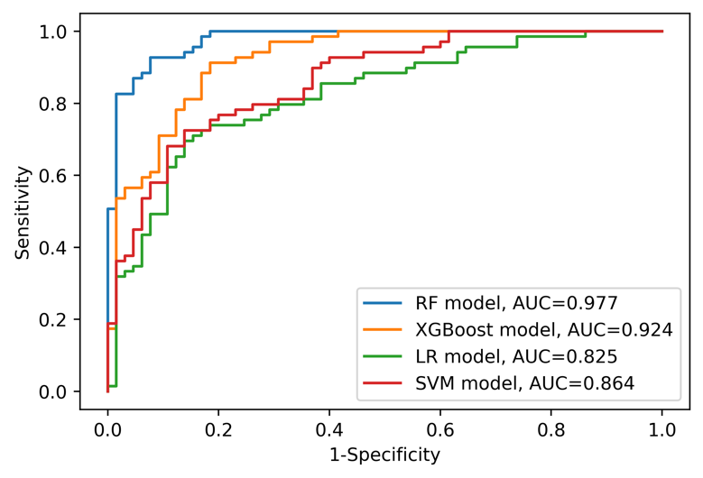 | 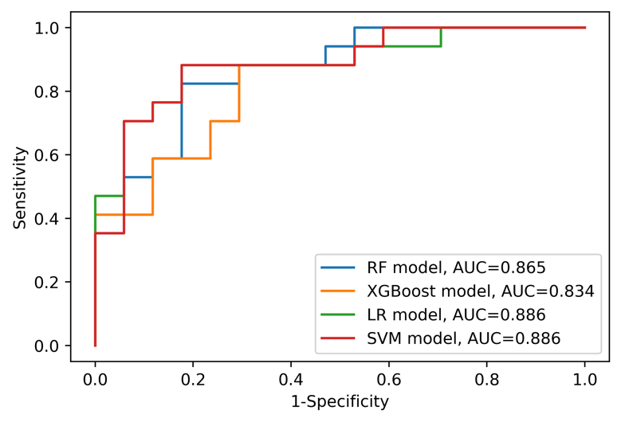
Abbreviations: AUC=area under curve, LR=logistic regression, RF=random forest, SVM=support vector machine, XGBoost=Extreme Gradient Boosting.

eAppendix 22. Model information and detailed results (Sample: without ADHD [n=328], Outcome: Parental distress)

eTable 22.1. Model features (Variables are on the second columns)
Caregiver variables | - Assistant caregiver status [Yes/No]  - Current working status [Yes/No]  - Minnesota Multiphasic Personality Inventory (MMPI) Hypochondriasis (T-score)  - MMPI Depression (T-score)  - MMPI Hysteria (T-score)  - MMPI Psychopathy (T-score)  - MMPI Masculinity/Femininity (T-score)  - MMPI Paranoia (T-score)  - MMPI Psychasthenia (T-score)  - MMPI Schizophrenia (T-score)  - MMPI Hypomania (T-score)  - MMPI Social Introversion (T-score)  - The order of birth  - Number of children
ASD patient variables | - Age  - Sex [Male/Female]  - Family history of mental disorder [Yes/No]  - History of major disease [Yes/No]  - Psychotropic medication status [Drug free/Monotherapy of antipsychotics/Combined therapy of antipsychotics/Other psychotic medication]  - Gestational age  - Birth weight  - Mode of delivery [Vaginal delivery/Caesarean section]  - Existence of another child with mental disorder [Yes/No]  - Full-Scale Intelligence Quotient (FSIQ)  - Social responsiveness scale (SRS) Social awareness (T-score)  - SRS Social cognition (T-score)  - SRS Social communication (T-score)  - SRS Social motivation (T-score)  - SRS Autistic mannerisms (T-score)  - Child Behavior Checklist (CBCL) Anxious/depressed (T-score)  - CBCL Withdrawn/depressed (T-score)  - CBCL Somatic complaints (T-score)  - CBCL Attention problems (T-score)  - CBCL Aggressive behavior (T-score)  - CBCL Other problems (T-score)

eTable 22.2. Performance of each model on the training set
 | RF model | XGBoost model | LR model | SVM model
ROC AUC (95% CI) | 0.964 (0.943-0.981) | 0.908 (0.870-0.941) | 0.826 (0.766-0.879) | 0.840 (0.780-0.893)
Sensitivity (95% CI) | 0.577 (0.459-0.691) | 0.479 (0.361-0.595) | 0.310 (0.203-0.419) | 0.507 (0.391-0.625)
Specificity (95% CI) | 0.990 (0.973-1.000) | 0.979 (0.956-0.995) | 0.979 (0.956-0.995) | 0.932 (0.894-0.964)
PPV (95% CI) | 0.953 (0.879-1.000) | 0.895 (0.784-0.977) | 0.846 (0.692-0.966) | 0.735 (0.609-0.854)
NPV (95% CI) | 0.863 (0.816-0.906) | 0.835 (0.785-0.882) | 0.792 (0.739-0.843) | 0.836 (0.785-0.883)
Accuracy (95% CI) | 0.878 (0.836-0.916) | 0.844 (0.798-0.885) | 0.798 (0.748-0.844) | 0.817 (0.771-0.863)
Abbreviations: AUC=area under curve, CI=confidence interval, NA=not available, NPV=negative predictive value, LR=logistic regression, RF=random forest, ROC=receiver operating characteristic, PPV=positive predictive value, SVM=support vector machine, XGBoost=Extreme Gradient Boosting.

eTable 22.3. Performance of each model on the test set
 | RF model | XGBoost model | LR model | SVM model
ROC AUC (95% CI) | 0.781 (0.654-0.887) | 0.765 (0.637-0.875) | 0.828 (0.713-0.923) | 0.843 (0.733-0.931)
Sensitivity (95% CI) | 0.389 (0.167-0.632) | 0.222 (0.050-0.438) | 0.333 (0.118-0.565) | 0.500 (0.267-0.750)
Specificity (95% CI) | 0.938 (0.860-1.000) | 0.958 (0.894-1.000) | 1.000 (1.000-1.000) | 0.938 (0.860-1.000)
PPV (95% CI) | 0.700 (0.375-1.000) | 0.667 (0.200-1.000) | 1.000 (1.000-1.000) | 0.750 (0.500-1.000)
NPV (95% CI) | 0.804 (0.692-0.902) | 0.767 (0.655-0.869) | 0.800 (0.694-0.898) | 0.833 (0.727-0.927)
Accuracy (95% CI) | 0.788 (0.682-0.879) | 0.758 (0.652-0.864) | 0.818 (0.712-0.909) | 0.818 (0.712-0.909)
Abbreviations: AUC=area under curve, CI=confidence interval, NA=not available, NPV=negative predictive value, LR=logistic regression, RF=random forest, ROC=receiver operating characteristic, PPV=positive predictive value, SVM=support vector machine, XGBoost=Extreme Gradient Boosting.

eFigure 22.4. SHapley Additive exPlanations (SHAP) summary plot for RF and XGBoost models (only top 20 predictors were presented)
<RF model> | <XGBoost model>
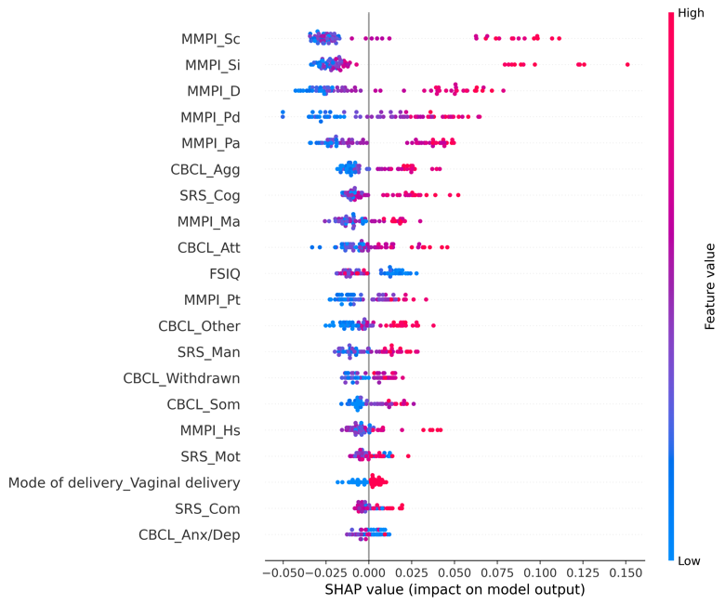 | 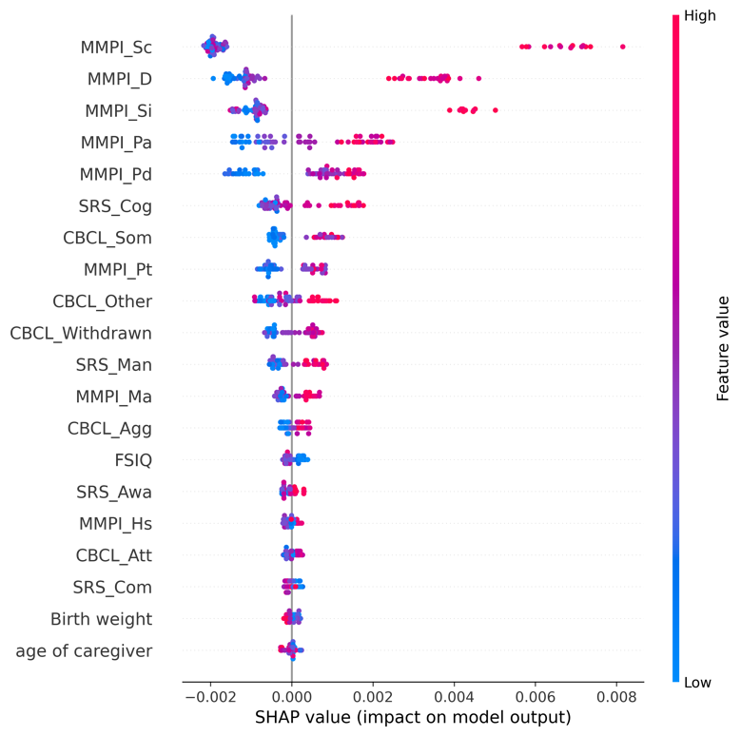

eFigure 22.5. Receiver operating characteristic curves (ROC) for the training and test set

<Training set> | <Test set>
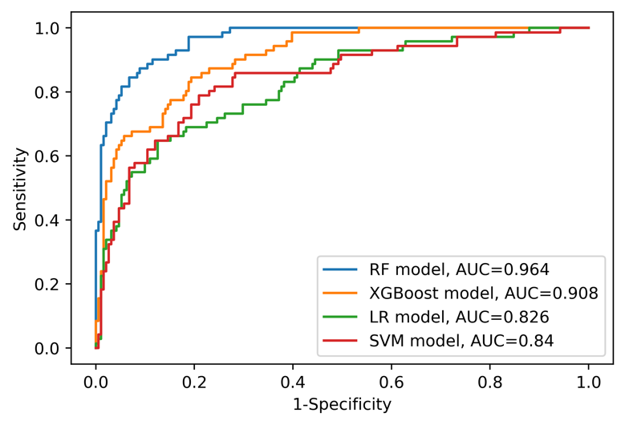 | 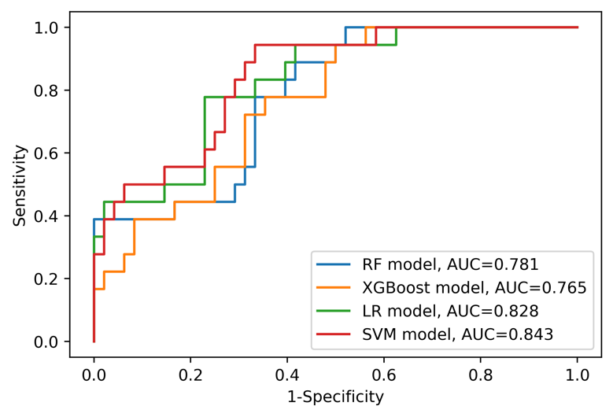
Abbreviations: AUC=area under curve, LR=logistic regression, RF=random forest, SVM=support vector machine, XGBoost=Extreme Gradient Boosting.

eAppendix 23. Model information and detailed results (Sample: without ADHD [n=328], Outcome: Parent-child dysfunctional interaction)

eTable 23.1. Model features (Variables are on the second columns)
Caregiver variables | - Assistant caregiver status [Yes/No]  - Current working status [Yes/No]  - Minnesota Multiphasic Personality Inventory (MMPI) Hypochondriasis (T-score)  - MMPI Depression (T-score)  - MMPI Hysteria (T-score)  - MMPI Psychopathy (T-score)  - MMPI Masculinity/Femininity (T-score)  - MMPI Paranoia (T-score)  - MMPI Psychasthenia (T-score)  - MMPI Schizophrenia (T-score)  - MMPI Hypomania (T-score)  - MMPI Social Introversion (T-score)  - The order of birth  - Number of children
ASD patient variables | - Age  - Sex [Male/Female]  - Family history of mental disorder [Yes/No]  - History of major disease [Yes/No]  - Psychotropic medication status [Drug free/Monotherapy of antipsychotics/Combined therapy of antipsychotics/Other psychotic medication]  - Gestational age  - Birth weight  - Mode of delivery [Vaginal delivery/Caesarean section]  - Existence of another child with mental disorder [Yes/No]  - Full-Scale Intelligence Quotient (FSIQ)  - Social responsiveness scale (SRS) Social awareness (T-score)  - SRS Social cognition (T-score)  - SRS Social communication (T-score)  - SRS Social motivation (T-score)  - SRS Autistic mannerisms (T-score)  - Child Behavior Checklist (CBCL) Anxious/depressed (T-score)  - CBCL Withdrawn/depressed (T-score)  - CBCL Somatic complaints (T-score)  - CBCL Attention problems (T-score)  - CBCL Aggressive behavior (T-score)  - CBCL Other problems (T-score)

eTable 23.2. Performance of each model on the training set
 | RF model | XGBoost model | LR model | SVM model
ROC AUC (95% CI) | 0.945 (0.919-0.967) | 0.838 (0.789-0.882) | 0.786 (0.729-0.840) | 0.756 (0.695-0.813)
Sensitivity (95% CI) | 0.716 (0.628-0.798) | 0.606 (0.510-0.696) | 0.569 (0.476-0.661) | 0.009 (0.000-0.030)
Specificity (95% CI) | 0.928 (0.886-0.967) | 0.843 (0.784-0.899) | 0.797 (0.732-0.858) | 1.000 (1.000-1.000)
PPV (95% CI) | 0.876 (0.805-0.941) | 0.733 (0.640-0.824) | 0.667 (0.570-0.761) | NA
NPV (95% CI) | 0.821 (0.762-0.876) | 0.750 (0.683-0.812) | 0.722 (0.653-0.788) | 0.586 (0.527-0.645)
Accuracy (95% CI) | 0.840 (0.794-0.882) | 0.744 (0.691-0.794) | 0.702 (0.645-0.756) | 0.588 (0.527-0.645)
Abbreviations: AUC=area under curve, CI=confidence interval, NA=not available, NPV=negative predictive value, LR=logistic regression, RF=random forest, ROC=receiver operating characteristic, PPV=positive predictive value, SVM=support vector machine, XGBoost=Extreme Gradient Boosting.

eTable 23.3. Performance of each model on the test set
 | RF model | XGBoost model | LR model | SVM model
ROC AUC (95% CI) | 0.734 (0.605-0.854) | 0.718 (0.587-0.842) | 0.762 (0.637-0.873) | 0.745 (0.616-0.861)
Sensitivity (95% CI) | 0.630 (0.438-0.815) | 0.667 (0.480-0.846) | 0.667 (0.478-0.846) | 0.000 (0.000-0.000)
Specificity (95% CI) | 0.718 (0.571-0.857) | 0.744 (0.600-0.875) | 0.744 (0.600-0.875) | 1.000 (1.000-1.000)
PPV (95% CI) | 0.607 (0.423-0.788) | 0.643 (0.458-0.818) | 0.643 (0.457-0.818) | NA
NPV (95% CI) | 0.737 (0.591-0.875) | 0.763 (0.622-0.892) | 0.763 (0.622-0.892) | 0.591 (0.470-0.712)
Accuracy (95% CI) | 0.682 (0.561-0.803) | 0.712 (0.606-0.818) | 0.712 (0.606-0.818) | 0.591 (0.470-0.712)
Abbreviations: AUC=area under curve, CI=confidence interval, NA=not available, NPV=negative predictive value, LR=logistic regression, RF=random forest, ROC=receiver operating characteristic, PPV=positive predictive value, SVM=support vector machine, XGBoost=Extreme Gradient Boosting.

eFigure 23.4. SHapley Additive exPlanations (SHAP) summary plot for RF and XGBoost models (only top 20 predictors were presented)
<RF model> | <XGBoost model>
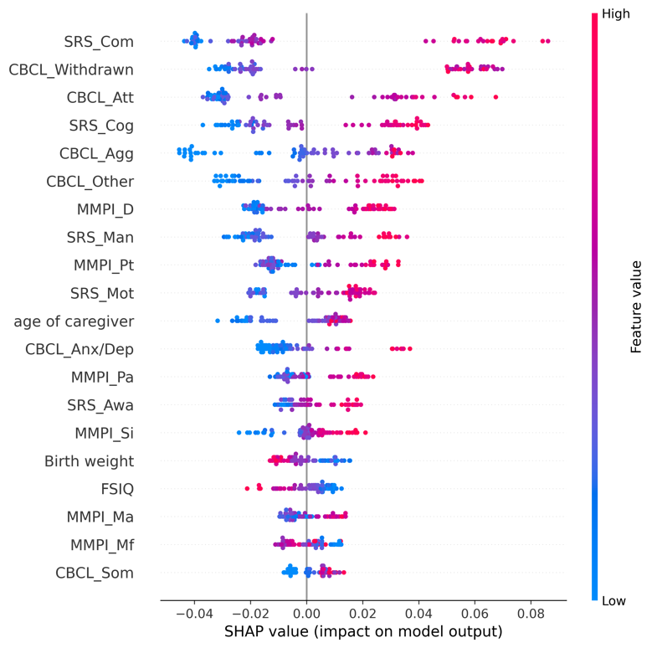 | 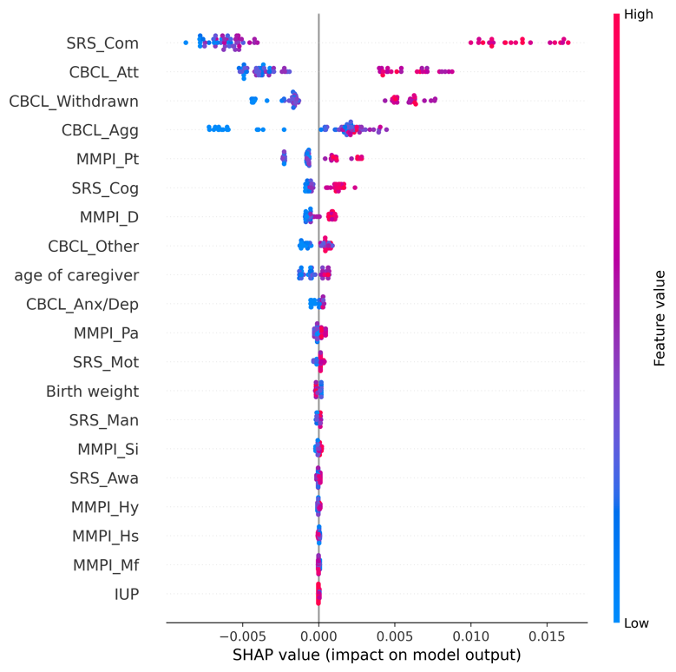

eFigure 23.5. Receiver operating characteristic curves (ROC) for the training and test set

<Training set> | <Test set>
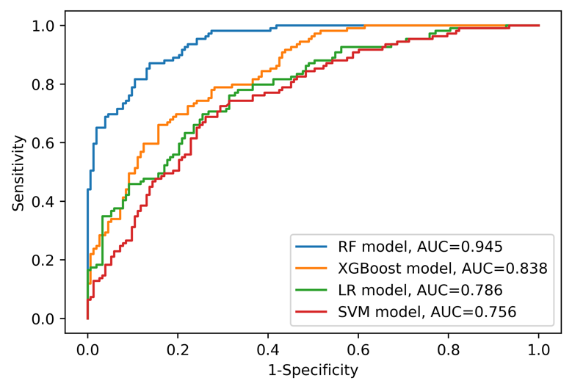 | 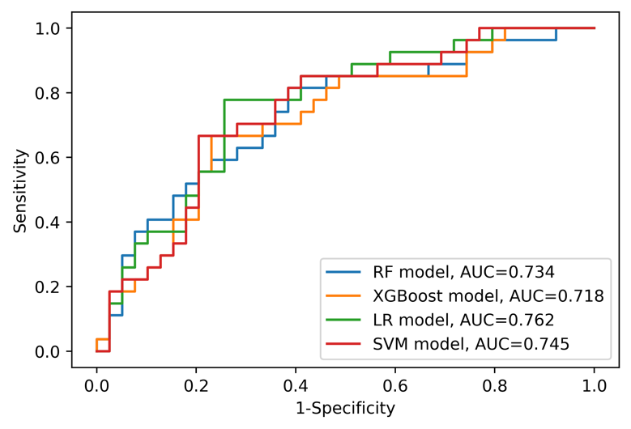
Abbreviations: AUC=area under curve, LR=logistic regression, RF=random forest, SVM=support vector machine, XGBoost=Extreme Gradient Boosting.

eAppendix 24. Model information and detailed results (Sample: without ADHD [n=328], Outcome: Difficult child)

eTable 24.1. Model features (Variables are on the second columns)
Caregiver variables | - Assistant caregiver status [Yes/No]  - Current working status [Yes/No]  - Minnesota Multiphasic Personality Inventory (MMPI) Hypochondriasis (T-score)  - MMPI Depression (T-score)  - MMPI Hysteria (T-score)  - MMPI Psychopathy (T-score)  - MMPI Masculinity/Femininity (T-score)  - MMPI Paranoia (T-score)  - MMPI Psychasthenia (T-score)  - MMPI Schizophrenia (T-score)  - MMPI Hypomania (T-score)  - MMPI Social Introversion (T-score)  - The order of birth  - Number of children
ASD patient variables | - Age  - Sex [Male/Female]  - Family history of mental disorder [Yes/No]  - History of major disease [Yes/No]  - Psychotropic medication status [Drug free/Monotherapy of antipsychotics/Combined therapy of antipsychotics/Other psychotic medication]  - Gestational age  - Birth weight  - Mode of delivery [Vaginal delivery/Caesarean section]  - Existence of another child with mental disorder [Yes/No]  - Full-Scale Intelligence Quotient (FSIQ)  - Social responsiveness scale (SRS) Social awareness (T-score)  - SRS Social cognition (T-score)  - SRS Social communication (T-score)  - SRS Social motivation (T-score)  - SRS Autistic mannerisms (T-score)  - Child Behavior Checklist (CBCL) Anxious/depressed (T-score)  - CBCL Withdrawn/depressed (T-score)  - CBCL Somatic complaints (T-score)  - CBCL Attention problems (T-score)  - CBCL Aggressive behavior (T-score)  - CBCL Other problems (T-score)

eTable 24.2. Performance of each model on the training set
 | RF model | XGBoost model | LR model | SVM model
ROC AUC (95% CI) | 0.961 (0.940-0.978) | 0.828 (0.776-0.875) | 0.811 (0.757-0.861) | 0.801 (0.746-0.852)
Sensitivity (95% CI) | 0.867 (0.802-0.926) | 0.664 (0.575-0.750) | 0.637 (0.549-0.726) | 0.000 (0.000-0.000)
Specificity (95% CI) | 0.926 (0.881-0.965) | 0.832 (0.771-0.891) | 0.846 (0.785-0.901) | 1.000 (1.000-1.000)
PPV (95% CI) | 0.899 (0.840-0.951) | 0.750 (0.663-0.832) | 0.758 (0.670-0.841) | NA
NPV (95% CI) | 0.902 (0.852-0.946) | 0.765 (0.698-0.828) | 0.754 (0.688-0.818) | 0.569 (0.508-0.626)
Accuracy (95% CI) | 0.901 (0.863-0.935) | 0.760 (0.706-0.809) | 0.756 (0.702-0.805) | 0.569 (0.508-0.626)
Abbreviations: AUC=area under curve, CI=confidence interval, NA=not available, NPV=negative predictive value, LR=logistic regression, RF=random forest, ROC=receiver operating characteristic, PPV=positive predictive value, SVM=support vector machine, XGBoost=Extreme Gradient Boosting.

eTable 24.3. Performance of each model on the test set
 | RF model | XGBoost model | LR model | SVM model
ROC AUC (95% CI) | 0.854 (0.755-0.933) | 0.827 (0.717-0.917) | 0.831 (0.720-0.924) | 0.836 (0.726-0.929)
Sensitivity (95% CI) | 0.714 (0.538-0.875) | 0.679 (0.500-0.846) | 0.679 (0.500-0.846) | 0.000 (0.000-0.000)
Specificity (95% CI) | 0.842 (0.714-0.949) | 0.789 (0.649-0.917) | 0.816 (0.686-0.930) | 1.000 (1.000-1.000)
PPV (95% CI) | 0.769 (0.600-0.923) | 0.704 (0.520-0.875) | 0.731 (0.552-0.893) | NA
NPV (95% CI) | 0.800 (0.667-0.917) | 0.769 (0.632-0.895) | 0.775 (0.641-0.900) | 0.576 (0.455-0.697)
Accuracy (95% CI) | 0.788 (0.682-0.879) | 0.742 (0.636-0.848) | 0.758 (0.652-0.848) | 0.576 (0.455-0.697)
Abbreviations: AUC=area under curve, CI=confidence interval, NA=not available, NPV=negative predictive value, LR=logistic regression, RF=random forest, ROC=receiver operating characteristic, PPV=positive predictive value, SVM=support vector machine, XGBoost=Extreme Gradient Boosting.

eFigure 24.4. SHapley Additive exPlanations (SHAP) summary plot for RF and XGBoost models (only top 20 predictors were presented)
<RF model> | <XGBoost model>
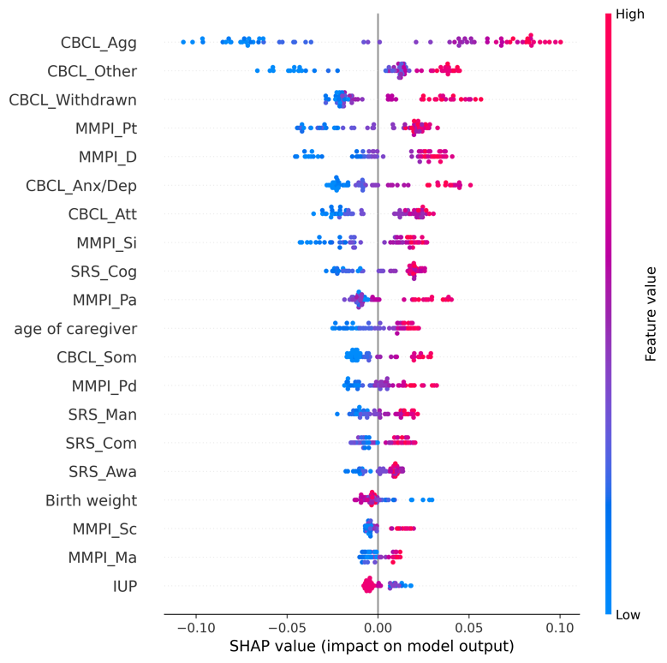 | 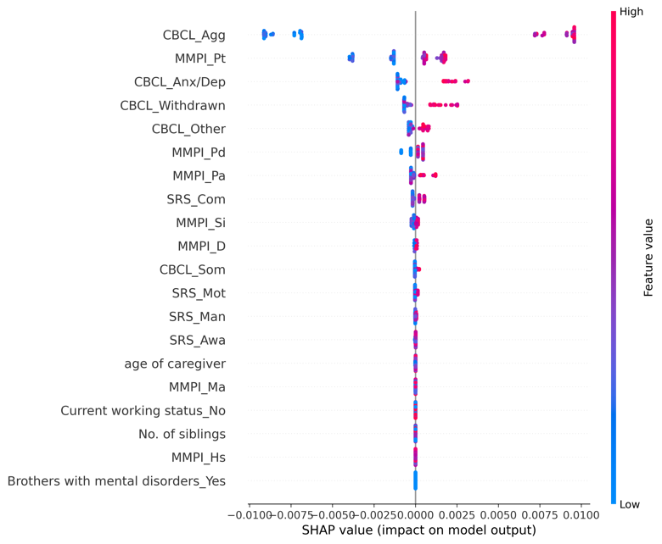

eFigure 24.5. Receiver operating characteristic curves (ROC) for the training and test set

<Training set> | <Test set>
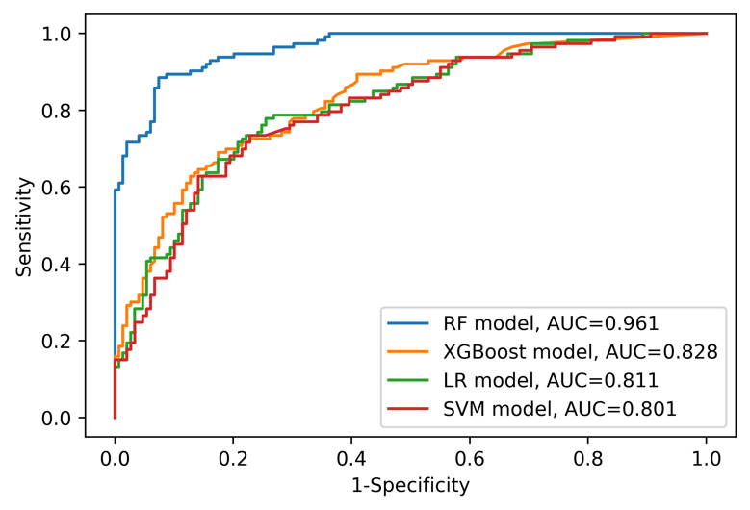 | 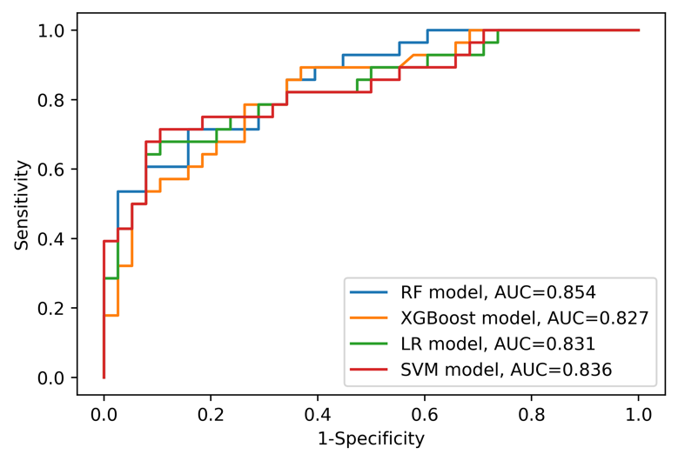
Abbreviations: AUC=area under curve, LR=logistic regression, RF=random forest, SVM=support vector machine, XGBoost=Extreme Gradient Boosting.

eAppendix 25. Model information and detailed results (Sample: without ADHD [n=328], Outcome: Total parenting stress)

eTable 25.1. Model features (Variables are on the second columns)
Caregiver variables | - Assistant caregiver status [Yes/No]  - Current working status [Yes/No]  - Minnesota Multiphasic Personality Inventory (MMPI) Hypochondriasis (T-score)  - MMPI Depression (T-score)  - MMPI Hysteria (T-score)  - MMPI Psychopathy (T-score)  - MMPI Masculinity/Femininity (T-score)  - MMPI Paranoia (T-score)  - MMPI Psychasthenia (T-score)  - MMPI Schizophrenia (T-score)  - MMPI Hypomania (T-score)  - MMPI Social Introversion (T-score)  - The order of birth  - Number of children
ASD patient variables | - Age  - Sex [Male/Female]  - Family history of mental disorder [Yes/No]  - History of major disease [Yes/No]  - Psychotropic medication status [Drug free/Monotherapy of antipsychotics/Combined therapy of antipsychotics/Other psychotic medication]  - Gestational age  - Birth weight  - Mode of delivery [Vaginal delivery/Caesarean section]  - Existence of another child with mental disorder [Yes/No]  - Full-Scale Intelligence Quotient (FSIQ)  - Social responsiveness scale (SRS) Social awareness (T-score)  - SRS Social cognition (T-score)  - SRS Social communication (T-score)  - SRS Social motivation (T-score)  - SRS Autistic mannerisms (T-score)  - Child Behavior Checklist (CBCL) Anxious/depressed (T-score)  - CBCL Withdrawn/depressed (T-score)  - CBCL Somatic complaints (T-score)  - CBCL Attention problems (T-score)  - CBCL Aggressive behavior (T-score)  - CBCL Other problems (T-score)

eTable 25.2. Performance of each model on the training set
 | RF model | XGBoost model | LR model | SVM model
ROC AUC (95% CI) | 0.990 (0.981-0.996) | 1.000 (1.000-1.000) | 0.878 (0.833-0.918) | 0.878 (0.835-0.917)
Sensitivity (95% CI) | 0.910 (0.855-0.959) | 0.984 (0.958-1.000) | 0.754 (0.677-0.829) | 0.754 (0.675-0.829)
Specificity (95% CI) | 0.971 (0.941-0.993) | 1.000 (1.000-1.000) | 0.871 (0.812-0.925) | 0.850 (0.788-0.906)
PPV (95% CI) | 0.965 (0.929-0.992) | 1.000 (1.000-1.000) | 0.836 (0.764-0.903) | 0.814 (0.741-0.883)
NPV (95% CI) | 0.925 (0.879-0.966) | 0.986 (0.964-1.000) | 0.803 (0.737-0.865) | 0.799 (0.732-0.862)
Accuracy (95% CI) | 0.943 (0.912-0.969) | 0.992 (0.981-1.000) | 0.817 (0.771-0.863) | 0.805 (0.756-0.851)
Abbreviations: AUC=area under curve, CI=confidence interval, NA=not available, NPV=negative predictive value, LR=logistic regression, RF=random forest, ROC=receiver operating characteristic, PPV=positive predictive value, SVM=support vector machine, XGBoost=Extreme Gradient Boosting.

eTable 25.3. Performance of each model on the test set
 | RF model | XGBoost model | LR model | SVM model
ROC AUC (95% CI) | 0.759 (0.636-0.869) | 0.755 (0.630-0.868) | 0.755 (0.633-0.864) | 0.753 (0.629-0.864)
Sensitivity (95% CI) | 0.742 (0.579-0.889) | 0.742 (0.576-0.892) | 0.710 (0.545-0.865) | 0.677 (0.500-0.84)
Specificity (95% CI) | 0.629 (0.464-0.788) | 0.657 (0.500-0.812) | 0.657 (0.500-0.812) | 0.657 (0.500-0.806)
PPV (95% CI) | 0.639 (0.476-0.795) | 0.657 (0.500-0.812) | 0.647 (0.484-0.806) | 0.636 (0.467-0.795)
NPV (95% CI) | 0.733 (0.568-0.889) | 0.742 (0.581-0.889) | 0.719 (0.556-0.871) | 0.697 (0.536-0.853)
Accuracy (95% CI) | 0.682 (0.561-0.788) | 0.697 (0.591-0.803) | 0.682 (0.576-0.788) | 0.667 (0.545-0.773)
Abbreviations: AUC=area under curve, CI=confidence interval, NA=not available, NPV=negative predictive value, LR=logistic regression, RF=random forest, ROC=receiver operating characteristic, PPV=positive predictive value, SVM=support vector machine, XGBoost=Extreme Gradient Boosting.

eFigure 25.4. SHapley Additive exPlanations (SHAP) summary plot for (only top 20 predictors were presented)
<RF model> | <XGBoost model>
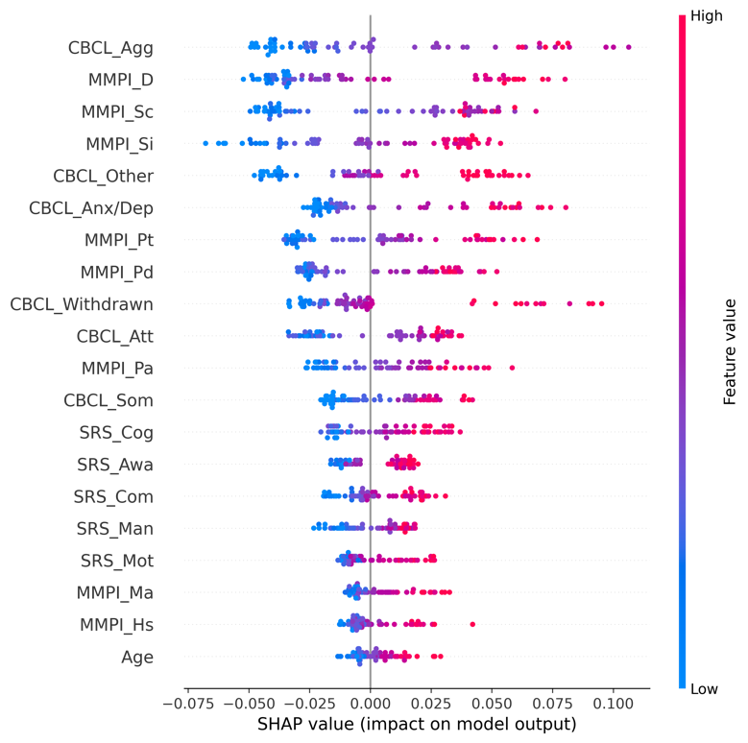 | 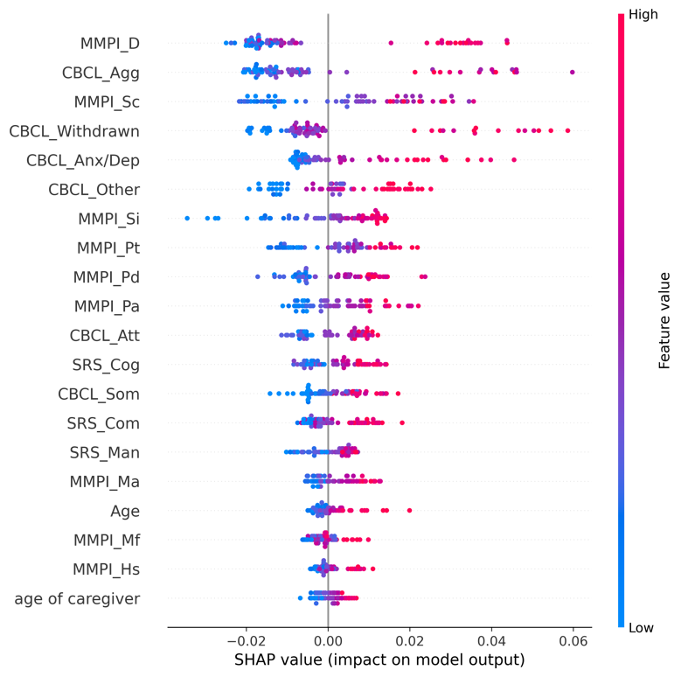

eFigure 25.5. Receiver operating characteristic curves (ROC) for the training and test set

<Training set> | <Test set>
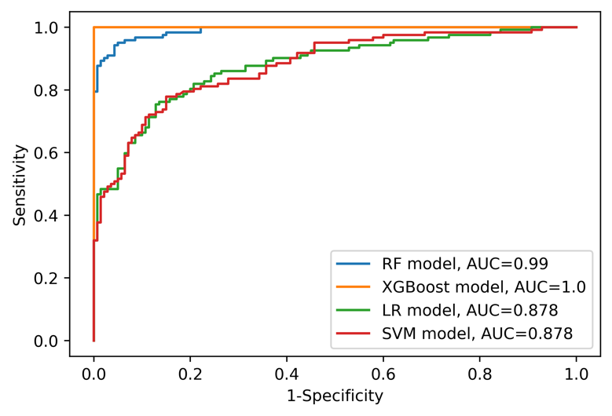 | 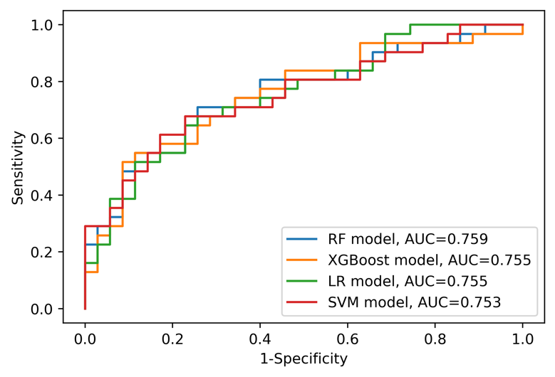
Abbreviations: AUC=area under curve, LR=logistic regression, RF=random forest, SVM=support vector machine, XGBoost=Extreme Gradient Boosting.

