Supplementary Material
Agronomic performance and remote sensing assessment of organic and mineral fertilisation in rice fields

Karen Marti-Jerez^{1**}, Mar Català-Forner^{1**}, Núria Tomàs¹, Gemma Murillo², Carlos Ortiz², María José Sánchez-Torres³, Andrea Vitali⁴, Marta S. Lopes^{5*}

¹ Institute of Agrifood Research and Technology, Amposta, Spain
² Ministry of Climate Action, Food and Rural Agenda, Lleida, Spain
³ Global Change Unit, Image Processing Laboratory, University of Valencia, Paterna (46980) Valencia, Spain
⁴ Rice Research Centre, Strada per Ceretto 4, 27030 Castello d’Agogna, (PV), Italy
⁵ Institute of Agrifood Research and Technology, Lleida, Spain

*Corresponding author: Marta S. Lopes (marta.dasilva@irta.cat)
** These authors contributed equally to the manuscript

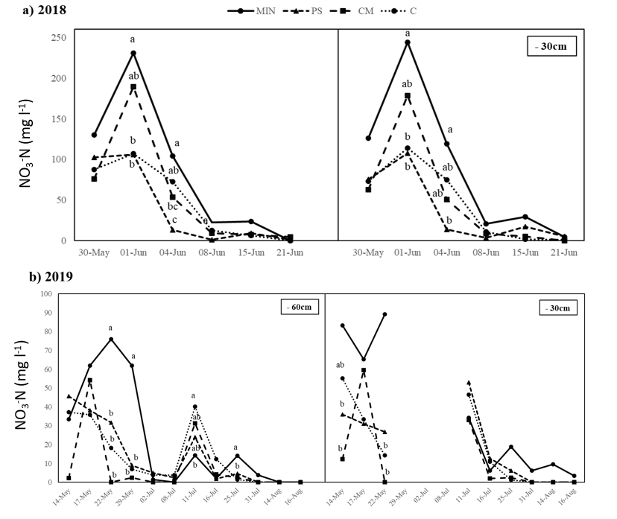
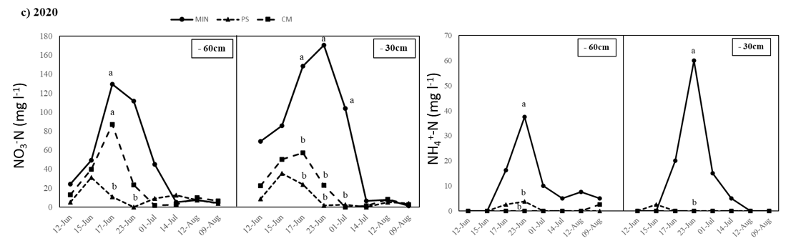
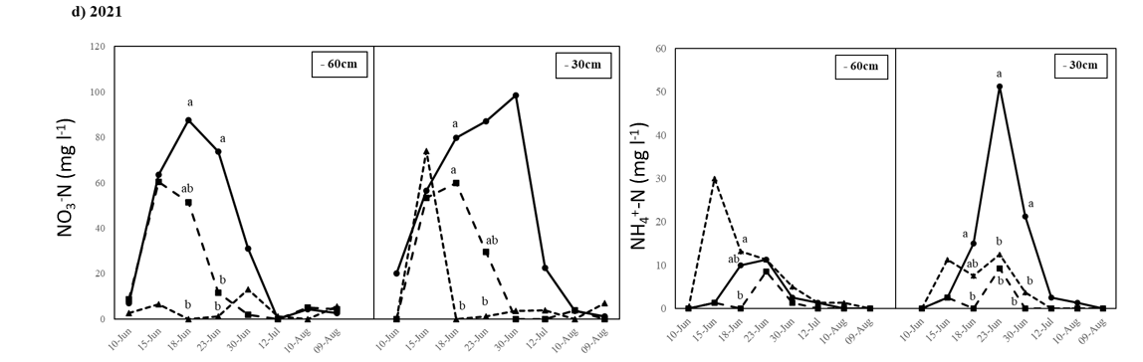
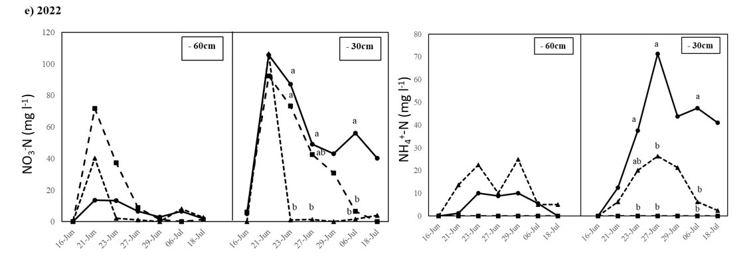
MIN, mineral fertiliser; PS, pig slurry; CM, chicken manure; C, control. Depth: arable land (-30 cm); phreatic water (60 cm). Data were not available for some 2019 dates at -30 cm. The thin lines together with an upper arrow () indicate the flooding + first top-dressing moment (3-4 leaves rice phenological stages) and the second top-dressing moment (panicle initiation rice phenological stages). Different letters indicate significant differences at p<0.05, as determined using Tukey’s test (HSD).
Supplemental Figure 1. Water nitrate and ammonium concentration evolution over cultivation time at two different depths (-60 cm and -30 cm). Nitrate data is available from 2018 to 2022. Ammonium data is available from 2020 to 2022.

Supplementary Table 1. Yearly Variations in Six-Year Yield Components, Agronomic Traits, and Disease Scoring for Different Fertilization Strategies
Year | Fertilisation |  | Yield (Mg ha⁻¹) |  |  | Plant density  (plant m⁻²) |  |  | Panicle density (panicle m⁻²) |  |  | Tillering capacity (tiller plant⁻¹) |  |  | Panicle efficiency (yield/panicle) |  |  | Plant height (cm) |  | Pyriculariosis IRRI scale (0-9) |  |  | Helminthosporiosis IRRI scale (0-9)
2017 |  | MIN | 6.79 | ± 0.42 | a | 44 | ± 3.8 | a | 247 | ± 9.3 | a |  | 5.8 | a | 27.7 | a | 68.9 |  | ± 0.5 | a | 3.5 | a |  | 1.0 | a
 |  | PS | 5.75 | ± 0.35 | a | 48 | ± 2.9 | a | 228 | ± 18.0 | a |  | 4.8 | a | 25.4 | a | 66.6 |  | ± 1.3 | a | 4.0 | a |  | 1.0 | a
 |  | CM | 5.86 | ± 0.14 | a | 46 | ± 6.9 | a | 217 | ± 11.1 | a |  | 5.0 | a | 27.1 | a | 61.4 |  | ± 0.5 | b | 3.0 | a |  | 1.0 | a
 |  | C | 2.38 | ± 0.17 | b | 50 | ± 2.7 | a | 130 | ± 4.8 | b |  | 2.6 | b | 18.3 | b | 54.8 |  | ± 0.8 | c | 3.0 | a |  | 1.0 | a
2018 |  | MIN | 8.84 | ± 0.28 | a | 98 | ± 8.1 | a | 252 | ± 9.0 | a |  | 2.6 | a | 35.2 | ab | 74.7 |  | ± 1.0 | a | 4.5 | a |  | 2.0 | b
 |  | PS | 8.00 | ± 0.65 | a | 87 | ± 10.0 | ab | 196 | ± 10.4 | b |  | 2.3 | a | 40.7 | a | 66.6 |  | ± 0.82 | bc | 1.5 | b |  | 3.0 | ab
 |  | CM | 8.73 | ± 0.26 | a | 87 | ± 5.1 | ab | 221 | ± 3.7 | ab |  | 2.6 | a | 39.5 | a | 69.6 |  | ± 1.2 | b | 3.0 | ab |  | 5.0 | a
 |  | C | 4.42 | ± 0.34 | b | 63 | ± 2.9 | b | 146 | ± 5.0 | c |  | 2.3 | a | 30.3 | b | 63.3 |  | ± 1.6 | c | 2.5 | ab |  | 3.5 | ab
2019 |  | MIN | 6.98 | ± 0.53 | a | 272 | ± 19.1 | ab | 282 | ± 12.6 | a |  | 1.1 | a | 24.8 | bc | 68.0 |  | ± 0.6 | a | 6.5 | a |  | 5.0 | b
 |  | PS | 6.78 | ± 0.07 | a | 233 | ± 22.4 | b | 212 | ± 4.5 | b |  | 0.9 | a | 32.0 | a | 63.5 |  | ± 0.5 | ab | 5.0 | ab |  | 5.0 | b
 |  | CM | 5.65 | ± 0.34 | a | 312 | ± 17.2 | a | 192 | ± 5.8 | bc |  | 0.6 | b | 29.5 | ab | 59.8 |  | ± 1.4 | bc | 4.0 | bc |  | 6.0 | ab
 |  | C | 3.72 | ± 0.10 | b | 254 | ± 12.4 | b | 164 | ± 5.7 | c |  | 0.6 | b | 22.6 | c | 57.4 |  | ± 1.2 | c | 3.0 | c |  | 7.0 | a
2020 |  | MIN | 7.50 | ± 0.23 | a | 134 | ± 3.9 | a | 225 | ± 32.3 | a |  | 1.7 | a | 36.4 | a | 69.7 |  | ± 3.6 | a | 3.0 | a |  | 3.0 | a
 |  | PS | 6.14 | ± 0.52 | ab | 116 | ± 6.5 | a | 221 | ± 27.5 | a |  | 1.9 | a | 29.6 | a | 70.5 |  | ± 2.7 | a | 3.5 | a |  | 3.0 | a
 |  | CM | 5.70 | ± 0.53 | b | 116 | ± 14.4 | a | 195 | ± 26.5 | a |  | 1.7 | a | 30.7 | a | 69.5 |  | ± 1.5 | a | 3.5 | a |  | 3.0 | a
 |  | C | 2.84 | ± 0.22 | c | 102 | ± 12.1 | a | 211 | ± 25.6 | a |  | 2.2 | a | 14.4 | b | 68.9 |  | ± 1.8 | a | 3.5 | a |  | 3.0 | a
2021 |  | MIN | 8.22 | ± 0.28 | a | 271 | ± 16.3 | a | 313 | ± 5.8 | a |  | 1.2 | a | 26.3 | ab | 79.3 |  | ± 1.6 | a | 1.0 | a |  | 1.0 | b
 |  | PS | 6.28 | ± 0.06 | b | 258 | ± 7.2 | a | 233 | ± 13.7 | b |  | 0.9 | b | 27.3 | ab | 74.4 |  | ± 0.33 | b | 1.0 | a |  | 1.0 | b
 |  | CM | 6.28 | ± 0.15 | b | 253 | ± 17.3 | a | 228 | ± 3.5 | b |  | 0.9 | b | 27.6 | a | 74.1 |  | ± 0.5 | b | 1.5 | a |  | 1.0 | b
 |  | C | 3.64 | ± 0.61 | c | 243 | ± 7.7 | a | 174 | ± 9.4 | c |  | 0.7 | b | 20.8 | b | 65.6 |  | ± 0.9 | c | 1.0 | a |  | 3.0 | a
2022 |  | MIN | 5.86 | ± 0.39 | a | 255 | ± 6.2 | a | 265.5 | ± 3.9 | a |  | 1.0 | a | 22.0 | a | 76.9 |  | ± 0.6 | a | 3.5 | a |  | 3.0 | a
 |  | PS | 5.46 | ± 0.30 | a | 223 | ± 14.4 | a | 226.1 | ± 10.5 | b |  | 1.0 | a | 24.2 | a | 77.1 |  | ± 1.6 | a | 3.5 | a |  | 3.0 | a
 |  | CM | 5.51 | ± 0.39 | a | 254 | ± 13.6 | a | 192.3 | ± 2.7 | c |  | 0.8 | b | 28.7 | a | 75.5 |  | ± 0.9 | a | 4.0 | a |  | 3.0 | a
 |  | C | 1.90 | ± 0.25 | b | 231 | ± 14.3 | a | 136.8 | ± 3.5 | d |  | 0.6 | b | 13.9 | b | 66.0 |  | ± 1.3 | b | 3.5 | a |  | 3.0 | a

MIN, mineral fertiliser; PS, pig slurry; CM, chicken manure; C, control. Measurements are shown as mean ± Standard Error (SE). Results of two-way (top of table, year and fertilisation) and one-way (fertilisation) ANOVA analysis. Different lowercase letters indicate significant differences at p<0.05 between treatments (one-way ANOVA), as determined using Tukey’s test (HSD).

