***Supplementary figures.***

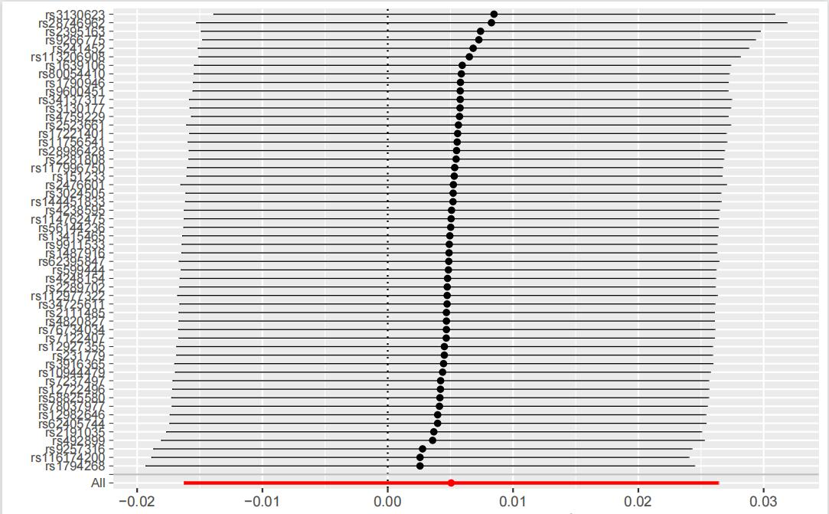

**Figure S1.** The leave-one-out analysis for genetically predicted assessed type 1 diabetes mellitus on Alzheimer’s disease

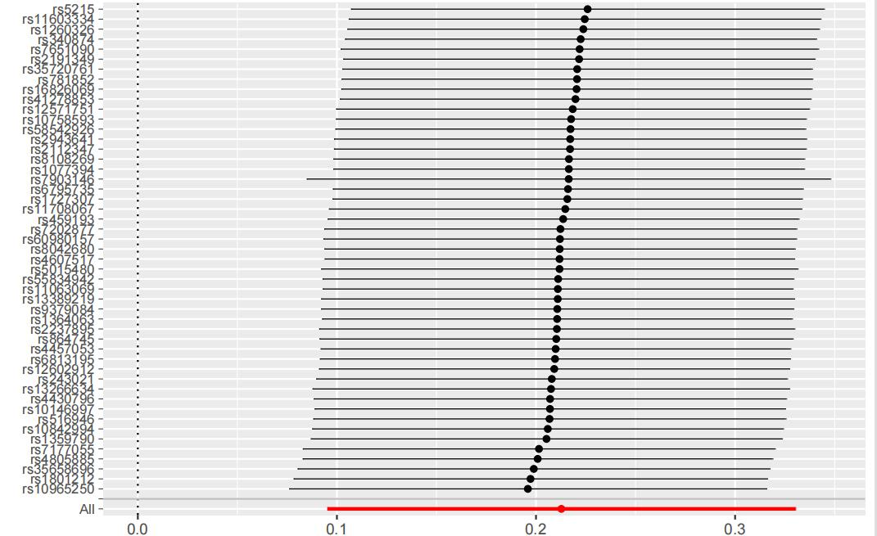

**Figure S2.** The leave-one-out analysis for genetically predicted assessed type 2 diabetes mellitus on Alzheimer’s disease

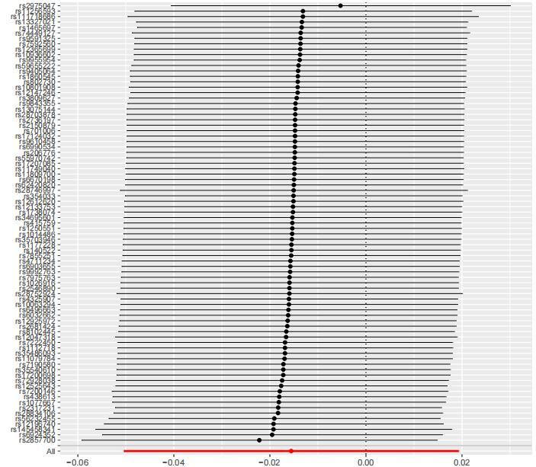

**Figure S3.** The leave-one-out analysis for genetically predicted assessed multiple sclerosis on Alzheimer’s disease

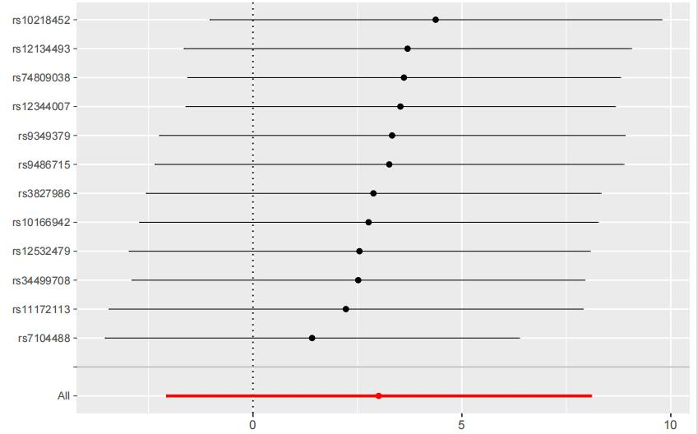

**Figure S4.** The leave-one-out analysis for genetically predicted assessed migraine on Alzheimer’s disease