Appendix
Table A. Percentage of respondents reported frequencies for their various feelings during the pandemic

 | At no time | Some of the time | Less than half of the time | More than half of the time | Most of the time | All the time
Feeling cheerful and in good spirits | 21.9% | 37.2% | 15.5% | 6.9% | 11.3% | 7.1%
Feeling calm and relaxed | 18.3% | 39.1% | 19.2% | 7.3% | 9.3% | 6.8%
Feeling active and vigorous | 12.9% | 33.3% | 19.8% | 11.3% | 10.5% | 12.1%
Feeling refreshed and rested upon waking | 16.9% | 35.9% | 21.8% | 7.8% | 9.8% | 7.8%
Daily life is full of things that matter | 5.7% | 27.4% | 17.1% | 11.2% | 13.3% | 25.4%

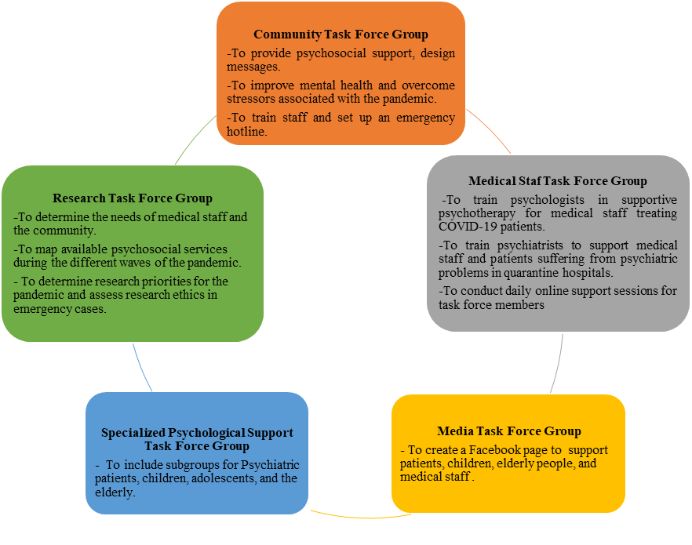

Fig A.1. The functions of the five task force groups during the pandemic

