Supplementary Material
Simira cordifolia protects against metal induced-toxicity in Caenorhabditis elegans

Margareth Duran-Izquierdo¹, Lucellys Sierra-Marquez¹, Maria Taboada-Alquerque¹, and Jesus Olivero-Verbel¹

- Environmental and Computational Chemistry Group, School of Pharmaceutical Sciences, Zaragocilla Campus, University of Cartagena, Cartagena, 130014, Colombia.

Correspondence:
Prof. Jesus Olivero-Verbel. Ph.D.
Environmental and Computational Chemistry Group
School of Pharmaceutical Sciences
Zaragocilla Campus
University of Cartagena
Cartagena, 130015.
Colombia

E-mail: joliverov@unicartagena.edu.co
Phone: 57-3185359815

Supplementary Figures and Tables
Table S1. Fragment ions of chemical constituents tentatively identified in the S. cordifolia by HPLC-QTOF-
MS/MS.
No. Fig. 1 | Positive ion fragments |  |  | Identification  criteria | References
No. Fig. 1 | Fragment type | Fragment  formula | m/z | Identification  criteria | References
1 | [M+Na]⁺  [M-C₆H₁₁O₄Na]⁺ | [C₁₉H₂₈O₁₃Na]⁺  [C₁₃H₁₇O₉]⁺ | 487.1411  317.0799 | a | (Martins and Nunez, 2015)
2 | [M+Na]⁺  [M-C₇H₁₆O₅Na]⁺ | [C₁₇H₂₆O₁₀Na]⁺  [C₁₀H₁₀O₅]⁺ | 413.1421  210.0513 | b | (Berger et al., 2015; Mass Bank code: TY000062)
3 | [M+H]⁺  [M+H-C₂H₄O]⁺ | [C₁₂H₁₈NO₃]⁺  [C₁₀H₁₄NO₂]⁺ | 224.1279  180.1012
4 | [M+H]⁺  [M+H-C₇H₁₂O₆]⁺  [M+H-C₈H₁₂O₇]⁺ | [C₁₆H₁₉O₉]⁺  [C₉H₇O₃]⁺  [C₈H₇O₂]⁺ | 355.1021  163.0383  135.0443 | b | Mass Bank code: FIO00622
5 | [M+H]⁺  [M+H-CO]⁺  [M+H-C₃H₅N₂]⁺ | [C₁₂H₁₁N₂O]⁺  [C₁₁H₁₁N₂]⁺  [C₉H₆O]⁺ | 199.0858  171.0912  131.0483
6 | [M+H]⁺  [M+H-C₆H₁₀O₅]⁺  [M+H-C₇H₁₀O₇]⁺ | [C₂₆H₂₉N₂O₉]⁺  [C₂₀H₁₉N₂O₄]⁺  [C₁₉H₁₉N₂O₂]⁺ | 513.1877  351.1335  307.1444 | a | (Martins and Nunez, 2015)
7 | [M+H]⁺  [M+H-C₇H₁₂O₆]⁺ | [C₁₆H₁₉O₉]⁺  [C₉H₇O₃]⁺ | 355.1303  163.0384 | b | (Veeren et al., 2020; Mass Mass Bank code: FIO00622)
8 | [M+H]⁺  [M+H-C₇H₁₂O₆]⁺  [M+H-C₈H₁₆O₇]⁺ | [C₁₇H₂₁O₉]⁺  [C₁₀H₉O₃]⁺  [C₉H₅O₂]⁺ | 369.1471  177.0543  145.0280 | b | (Veeren et al., 2020; Mass Bank code: CCMSLIB00000853669)
9 | [M+H]⁺  [M+H-C₆H₁₀O₅]⁺  [M+H-C₆H₁₂O₆]⁺  [M+H-C₁₀H₁₆O₆]⁺ | [C₁₆H₂₃O₉]⁺  [C₁₀H₁₃O₄]⁺  [C₁₀H₁₁O₃]⁺  [C₆H₇O₃]⁺ | 359.1421  197.0801  179.0700  127.0382 | b | (Martins and Nunez, 2015; Mass Bank code: CCMSLIB00000852242)
10 | [M+H]⁺  [M+H-C₆H₁₀O₅]⁺  [M+H-C₆H₁₂O₆]⁺  [M+H-C₁₀H₁₈O₈]⁺ | [C₁₆H₂₇O₈]⁺  [C₁₀H₁₇O₃]⁺  [C₁₀H₁₅O₂]⁺  [C₆H₉]⁺ | 347.1696  185.1172  167.1049  81.0701 | a | (Xie et al., 1988)
11 | [M+H]⁺  [M+H-C₈H₁₆O₈]⁺  [M+H-C₁₇H₂₄O₁₀]⁺  [M+H-C₁₈H₂₈O₁₁]⁺ | [C₂₇H₃₃O₁₃]⁺  [C₁₉H₁₇O₅]⁺  [C₁₀H₉O₃]⁺  [C₉H₅O₂]⁺ | 565.1918  325.1026  177.0539  145.0282 | a | (Chen et al., 2016)
12 | [M+H]⁺  [M+H-H₂O]⁺  [M+H-C₇H₉O₂]⁺ | [C₁₉H₂₁N₂O₃]⁺  [C₁₉H₁₉N₂O₂]⁺  [C₁₂H₁₀N₂]⁺ | 325.1551  307.1446  182.0837
13 | [M+H]⁺  [M+H-CH₃]⁺  [M+H-C₃H₄N₂]⁺ | [C₁₂H₁₁N₂]⁺  [C₁₁H₈N₂]⁺  [C₉H₇]⁺ | 183.0917  168.0681  115.0542 | b | (Martins and Nunez, 2015; Mass Bank code: FIO00111)
14 | [M+H]⁺  [M+H-C₈H₁₅NO₅]⁺  [M+H-C₁₇H₂₅NO₉]⁺ | [C₂₇H₃₅N₂O₉]⁺  [C₁₉H₂₀NO₄]⁺  [C₁₀H₁₀N]⁺ | 531.2331  326.1387  144.0812
15 | [M+H]⁺  [M+H-H₂O]⁺  [M+H-C₇H₉O₄]⁺ | [C₁₉H₁₉N₂O₄]⁺  [C₁₉H₁₇N₂O₃]⁺  [C₁₂H₁₀N₂]⁺ | 339.1345  321.1243  182.0827
16 | [M+H]⁺  [M+H-C₂H₆O]⁺  [M+H-C₃H₈O₃]⁺  [M+H-C₉H₁₅O₃]⁺ | [C₂₁H₂₅N₂O₃]⁺  [C₁₉H₁₉N₂O₂]⁺  [C₁₈H₁₇N₂]⁺  [C₁₂H₁₀N₂]⁺ | 353.1867  307.1447  261.1380  182.0839
17 | [M+H]⁺  [M+H-C₂H₅N]⁺  [M+H-C₉H₁₅NO]⁺ | [C₁₉H₂₅N₂O]⁺  [C₁₇H₂₀NO]⁺  [C₁₀H₁₀N]⁺ | 297.1958  254.1541  144.0800 | a | (Martins and Nunez, 2015)
18 | [M+H]⁺  [M+H-C₉H₈NO₂]⁺  [[M+H-C₁₅H₂₀O₈]⁺ | [C₂₆H₃₁N₂O₈]⁺  [C₁₇H₂₃NO₆]⁺  [C₁₁H₁₁N₂]⁺ | 499.1859  337.1530  171.0911 | b | Mass Bank code: CCMSLIB00004680054
Collision energy used to these fragments was 20 eV
ª Tentative identification based on m/z positive mode, reported in the literature for Simira genus or other species of the Rubiaceae family (Ram, et al., 2004; Vinicius et al., 2014; Martins & Nunez, 2015)
^{b} Tentative identification based on the fragmentation pattern study (ESI-QTOF) and data reported in scientific articles.

Supplementary Figures
Figure S1. Compound fragment spectrum results (MS/MS)
Positive ionization mode: Compound fragment spectrum results (MS/MS)
Compound 1  Retention time: 8.754  Monoisotopic mass: 464.1520  Formula: C₁₉H₂₈O₁₃  Tentative annotation: Diderroside  Compound class: Iridoid | 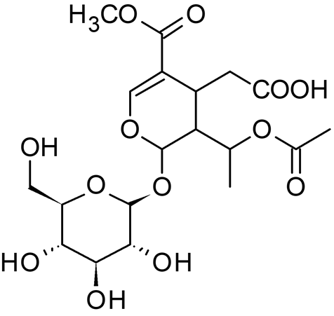

Compound 2  Retention time: 8.931  Monoisotopic mass: 390.1516  Formula: C₁₇H₂₆O₁₀  Tentative annotation: Loganin  Compound class: Iridoid | 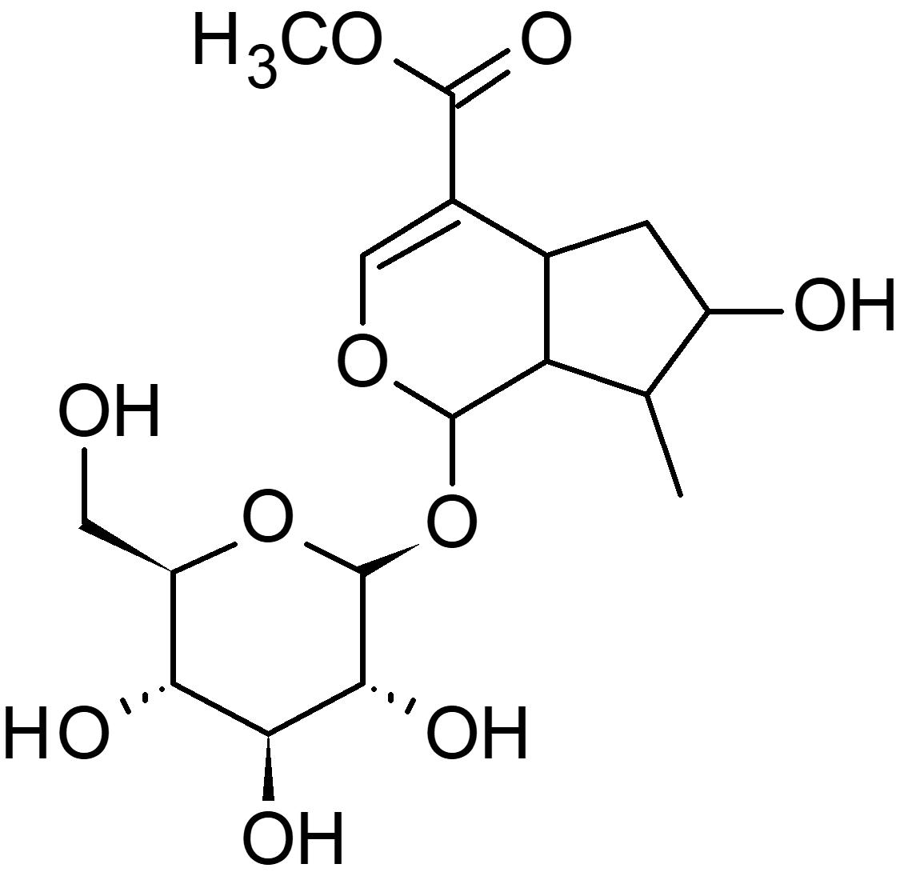

Compound 3  Retention time: 9.054  Monoisotopic mass: 223.1208  Formula: C₁₂H₁₇NO₃  Tentative annotation: Anhalonidine  Compound class: Isoquinoline Alkaloid | 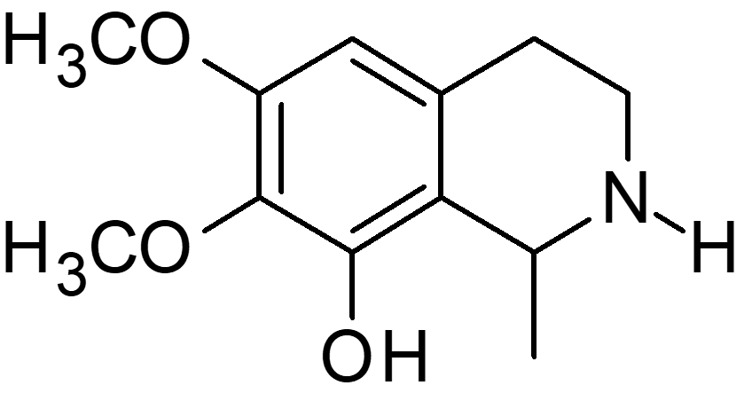

Compound 4  Retention time: 9.41  Monoisotopic mass: 354.0949  Formula: C₁₆H₁₈O₉  Tentative annotation: Chlorogenic acid  Compound class: Polyphenol | 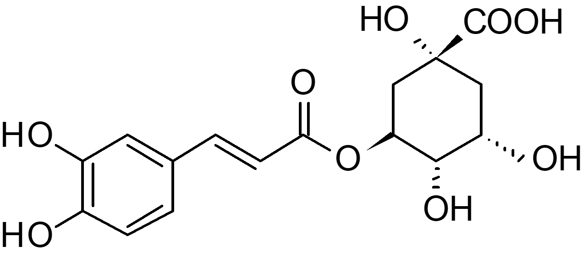

Compound 5  Retention time: 9.602  Monoisotopic mass: 198.0790  Formula: C₁₂H₁₀N₂O  Tentative annotation: Harmol  Compound class: 𝛽-carboline alkaloid | 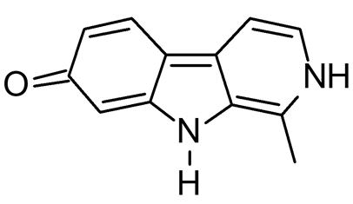

Compound 6  Retention time: 9.671  Monoisotopic mass: 512.1808  Formula: C₂₆H₂₈N₂O₉  Tentative annotation: Lyalosidic acid  Compound class: 𝛽-carboline glucoalkaloid | 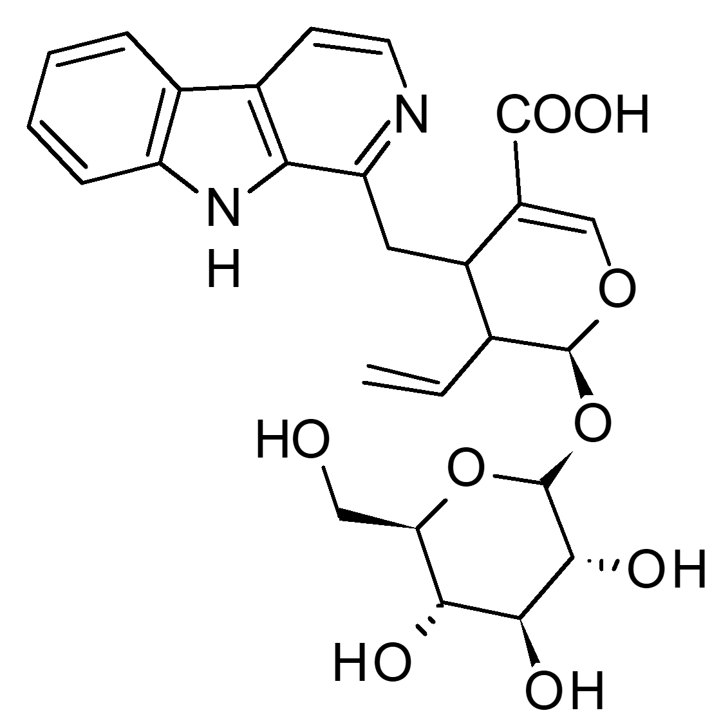

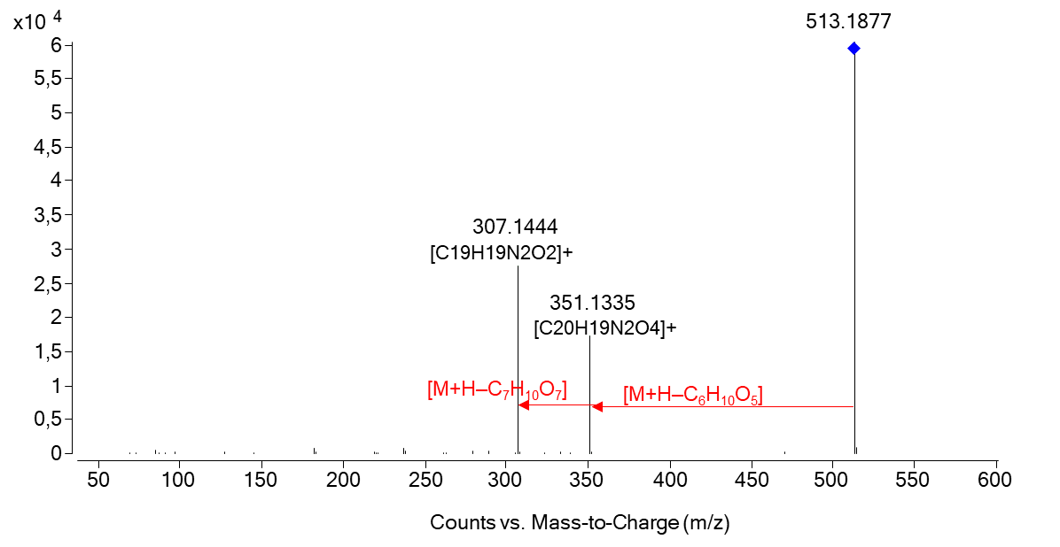
Compound 7  Retention time: 9.795  Monoisotopic mass: 354.0949  Formula: C₁₆H₁₈O₉  Tentative annotation: Chlorogenic acid isomer  Compound class: Polyphenol | 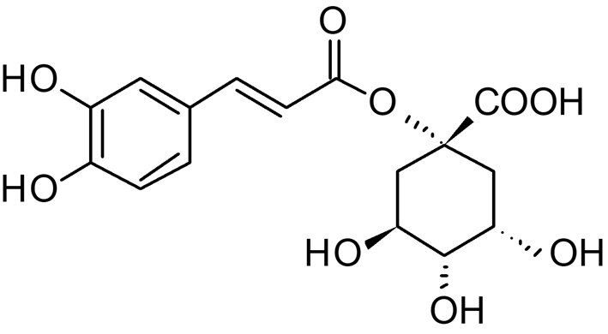
Compound 8  Retention time: 10.01  Monoisotopic mass: 368.1117  Formula: C₁₇H₂₀O₉  Tentative annotation: Feruloylquinic acid  Compound class: Polyphenol | 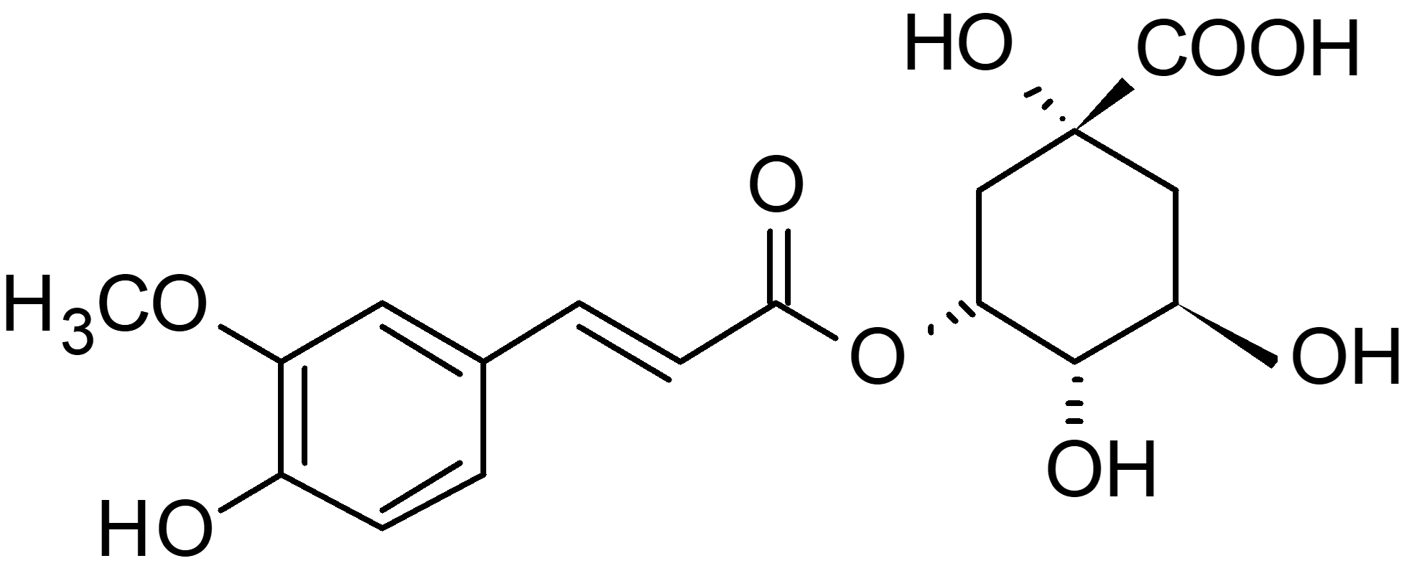

Compound 9  Retention time: 10.027  Monoisotopic mass: 358.1269  Formula: C₁₆H₂₂O₉  Tentative annotation: Sweroside  Compound class: Iridoid | 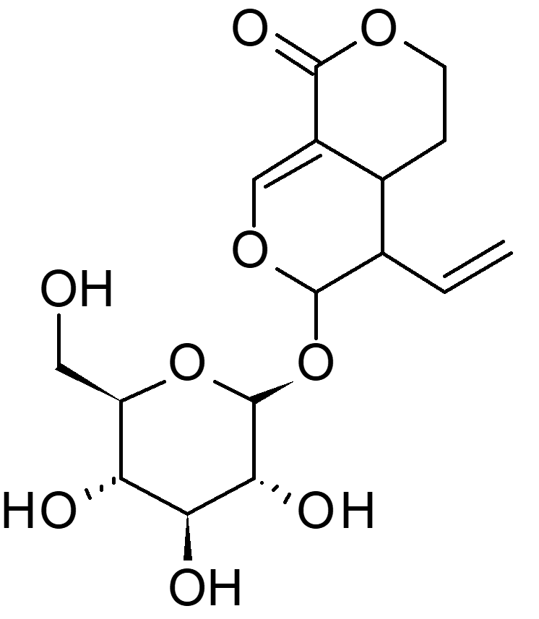

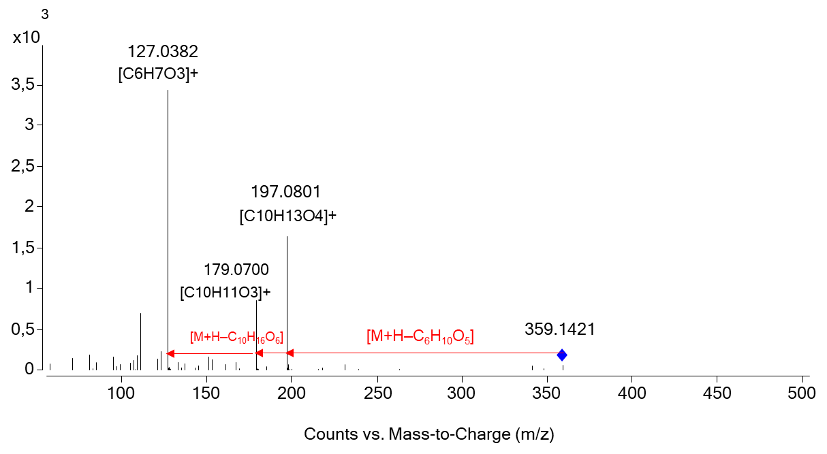

Compound 10  Retention time: 10.281  Monoisotopic mass: 346.1623  Formula: C₁₆H₂₆O₈  Tentative annotation: Nepetaside  Compound class: Iridoid | 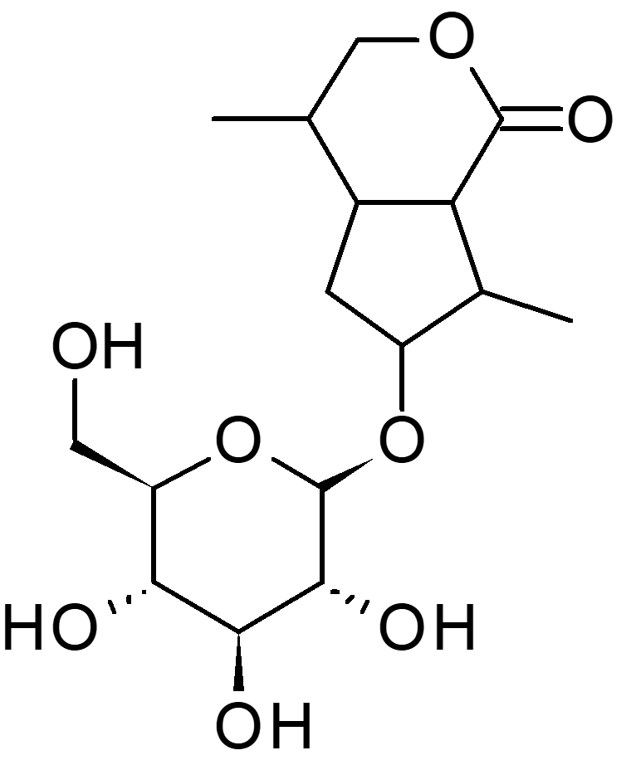
Compound 11  Retention time: 10.281  Monoisotopic mass: 564.1864  Formula: C₂₇H₃₂O₁₃  Tentative annotation: 6-O-methoxylcinnamoyl scandoside  Compound class: Iridoid ester | 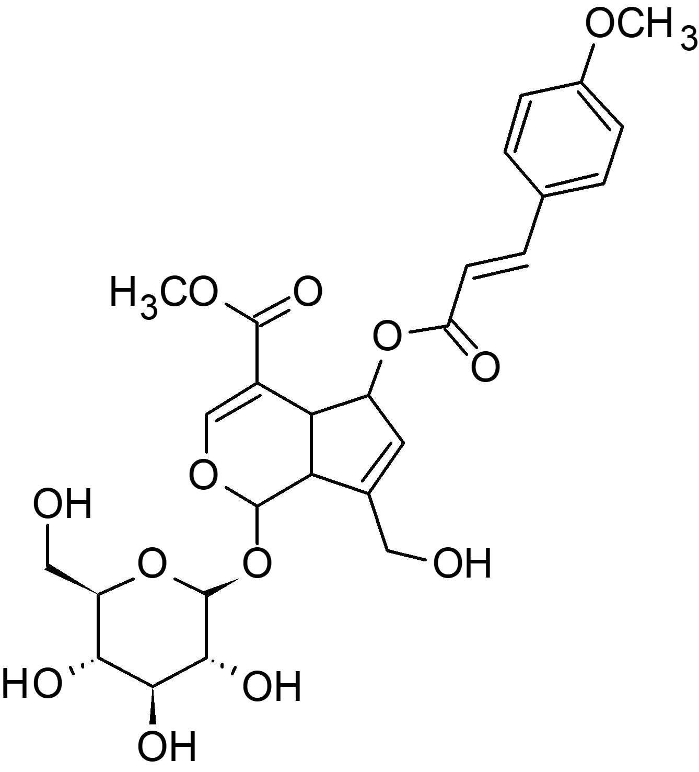
Compound 12
Retention time: 10.35
Monoisotopic mass: 324.1837
Formula: C₁₉H₂₀N₂O₃
Tentative annotation: 𝛽-carboline alkaloid type
Compound class: 𝛽-carboline alkaloid

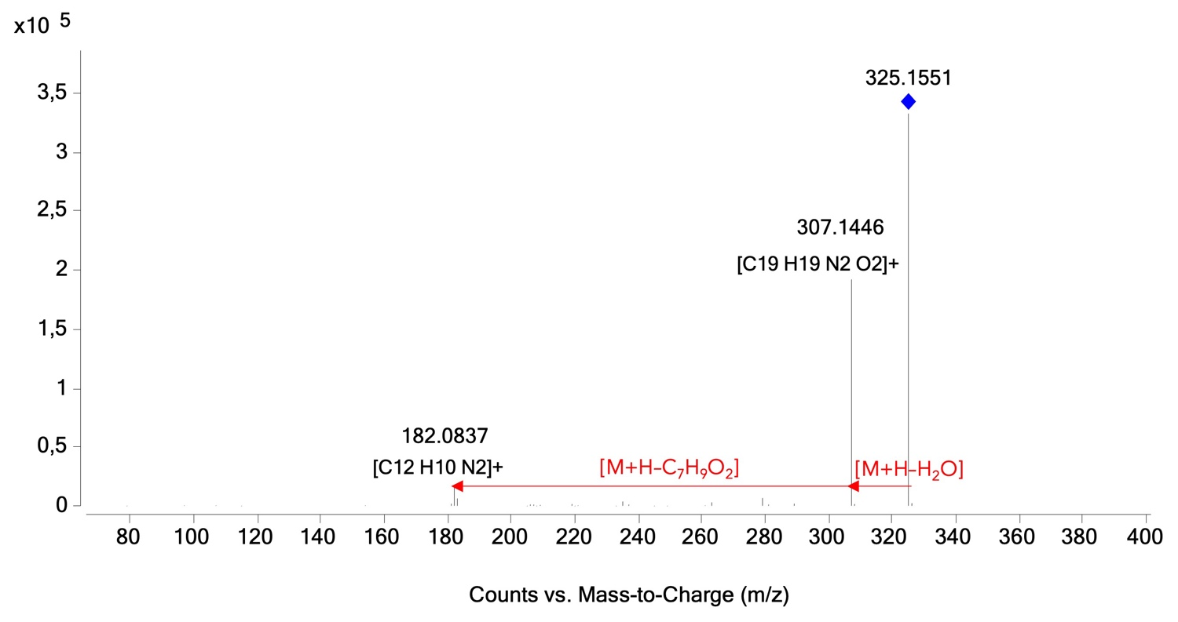
Compound 13  Retention time: 10.431  Monoisotopic mass: 182.0847  Formula: C₁₂H₁₀N₂  Tentative annotation: Harmane  Compound class: 𝛽-carboline alkaloid | 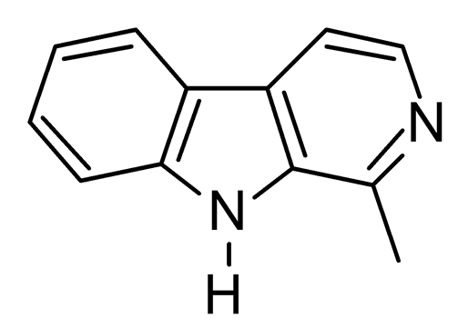

Compound 14
Retention time: 10.51
Monoisotopic mass: 530.2267
Formula: C₂₇H₃₄N₂O₉
Tentative annotation: indole glucoalkaloid type
Compound class: indole glucoalkaloid

Compound 15  Retention time: 10.712  Monoisotopic mass: 338.1271  Formula: C₁₉H₁₈N₂O₄  Tentative annotation: Alamarine  Compound class: isoquinolinonaphthyridine alkaloid | 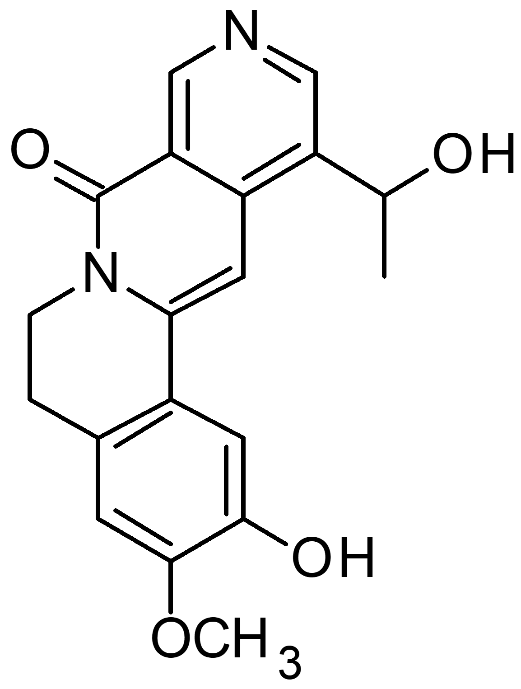

Compound 16  Retention time: 10.971  Monoisotopic mass: 352.1795  Formula: C₂₁H₂₄N₂O₃  Tentative annotation: 19-Epi-Ajmalicine  Compound class: Indole alkaloid | 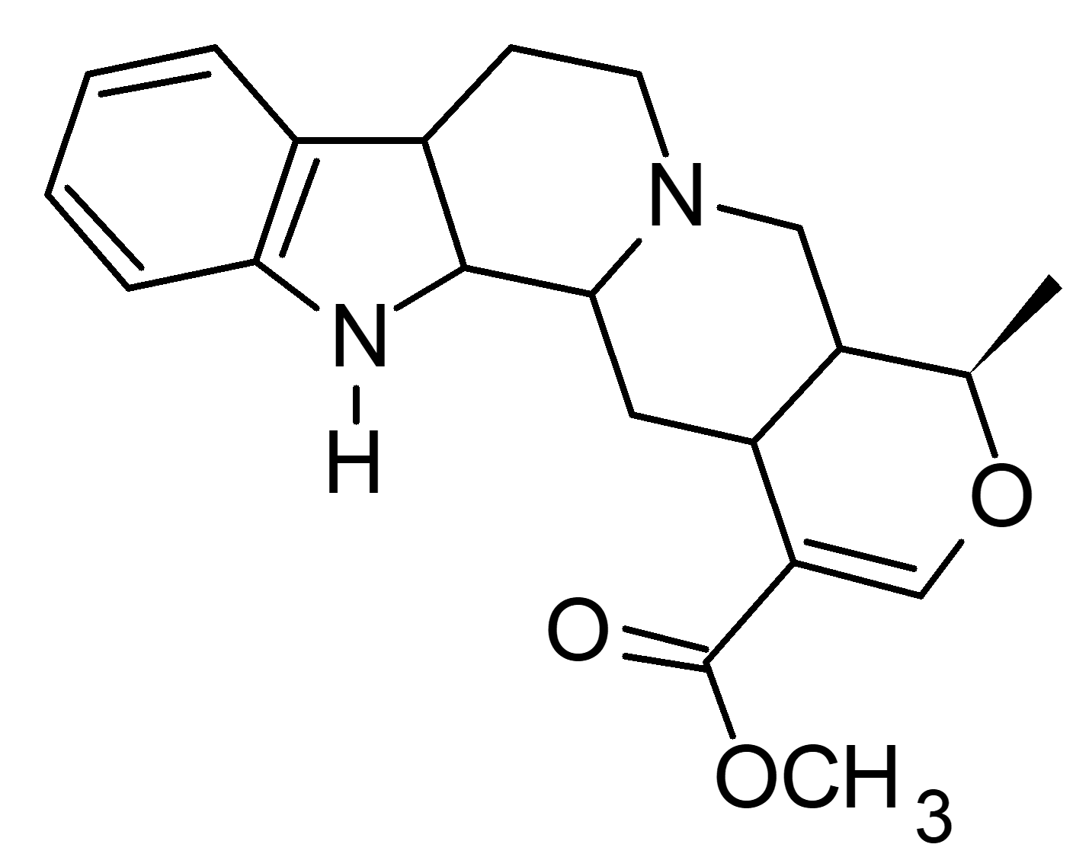

Compound 17
Retention time: 11.552
Monoisotopic mass: 296.1888
Formula: C₁₉H₂₄N₂O
Tentative annotation: No ID
Compound class: Indole alkaloid

Compound 18  Retention time: 11.840  Monoisotopic mass: 498.2019  Formula: C₂₆H₃₀N₂O₈  Tentative annotation: Strictosamide  Compound class: Indole glucoalkaloid | 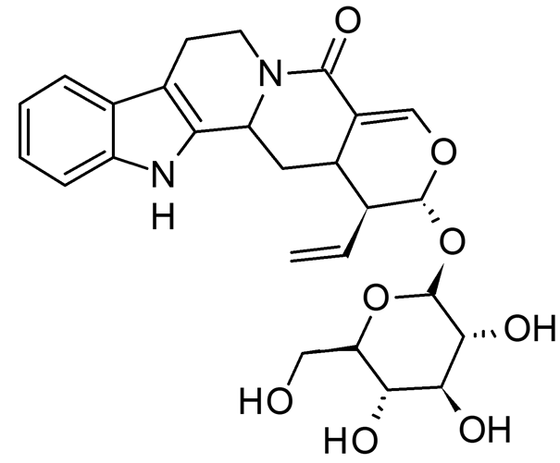

References
Berger, A., Kostyan, M. K., Klose, S. I., Gastegger, M., Lorbeer, E., Brecker, L., et al. (2015). Loganin and secologanin derived tryptamine–iridoid alkaloids from Palicourea crocea and Palicourea padifolia (Rubiaceae). Phytochem. 116, 162-169. doi: 10.1016/j.phytochem.2015.05.013
Chen, R., He, J., Tong, X., Tang, L., and Liu, M. (2016). The Hedyotis diffusa Willd.(Rubiaceae): a review on phytochemistry, pharmacology, quality control and pharmacokinetics. Mol. 21(6), 710. doi: 10.3390/molecules21060710
Martins, D., and Nunez, C. V. (2015). Secondary metabolites from Rubiaceae species. Mol. 20(7), 13422-13495. doi: 10.3390/molecules200713422
Phuong, N. M., Sung, T. V., Schmidt, J., and, A. P., and Adam, G. (1998). Capitelline-A new indole alkaloid from Hedyotis capitellata. Nat. prod. Lett. 11(2), 93-100. doi: 10.1177/1934578X211047705
Veeren, B., Ghaddar, B., Bringart, M., Khazaal, S., Gonthier, M. P., Meilhac, O., et al. (2020). Phenolic profile of herbal infusion and polyphenol-rich extract from leaves of the medicinal plant antirhea borbonica: toxicity assay determination in zebrafish embryos and larvae. Mol. 25(19), 4482. doi: 10.3390/molecules25194482
Xie, S., Uesato, S., Inouye, H., Fujita, T., Murai, F., Tagawa, M., et al. (1988). Absolute structure of nepetaside, a new iridoid glucoside from Nepeta cataria. Phytochem. 27(2), 469-472. doi: 10.1016/0031-9422(88)83122-4

