Supplementary Material

The synthesis of copper-modified biochar from Elsholtzia Harchowensis and its electrochemical activity towards the reduction of carbon dioxide
Shiqi Chen¹, Wei Liu¹, Ziwei Mei¹, Haifu Li¹, Wenyu Zhao¹, Junkai Zhao¹, HongTao^{1,2}
* Correspondence: Corresponding Author: email@uni.edu

Supplementary Electrochemical test
The catalyst was first activated by reduction in 0.2 M Na₂SO₄ solution at a potential of -0.82 V (vs. RHE) for 3600 s. All electrode potentials (vs. Ag/AgCl) in the experiments could be converted to standard electrode potentials (vs. RHE) by equation [1]. The cyclic voltammetry (CV) in 0.2 M Na₂SO₄ solution with various scan rates, and the final results could be got through equation [2] (Wei et al., 2019; Zhong et al., 2022).
$E(vs. RHE)= E(vs. Ag/AgCl)+0.209 V + 0.05916 × pH$ [1]
$ECSA= \frac{C_{dl}}{C_{s}}= \frac{I_{c}}{v∙C_{s}}$ [2]
where C_{dl} is the doubled-layer capacitance of the catalyst, I_{c} is the average value of the charging current, and v is the scan rates. Linear sweep voltammetry (LSV) was performed at a scan rate of 10 mV/s within the range of 0 ~ -0.82 V(vs. RHE). Electrochemical impedance spectroscopy (EIS) was tested at a voltage of -0.32 ~ -0.72 V (vs. RHE), within frequency ranges of 10⁵ ~ 0.1 Hz, and an amplitude wave of 5 mV. Turnover frequency (TOF) is calculated by equation [3] (Hua et al., 2022):
$TOF=\frac{{I_{product}}/{nF}}{{α×m_{cat}}/{M_{metal}}}×3600$ [3]
I_{product} is the partial current density of certain product, n is the number of electrons for the conversion of CO₂ to certain product, F is the Faraday constant (96485 C/mol), m_{cat} is the mass of the catalyst, α and M_{metal} are the mass ratio of active atoms in the catalyst and the atomic mass of the metal, respectively.

Supplementary Figures and Tables

Supplementary Figures
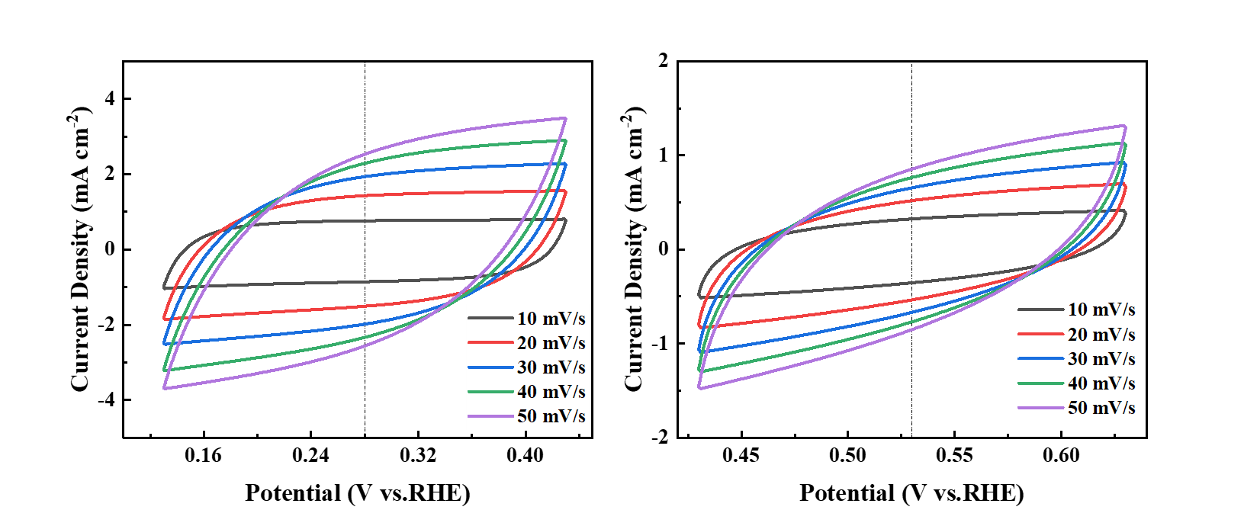
b
a
Supplementary Figure 1. CV curves of BC(a) and Cu/C-S(b) materials in 1 M KHCO₃ solution at different sweep rates.
a
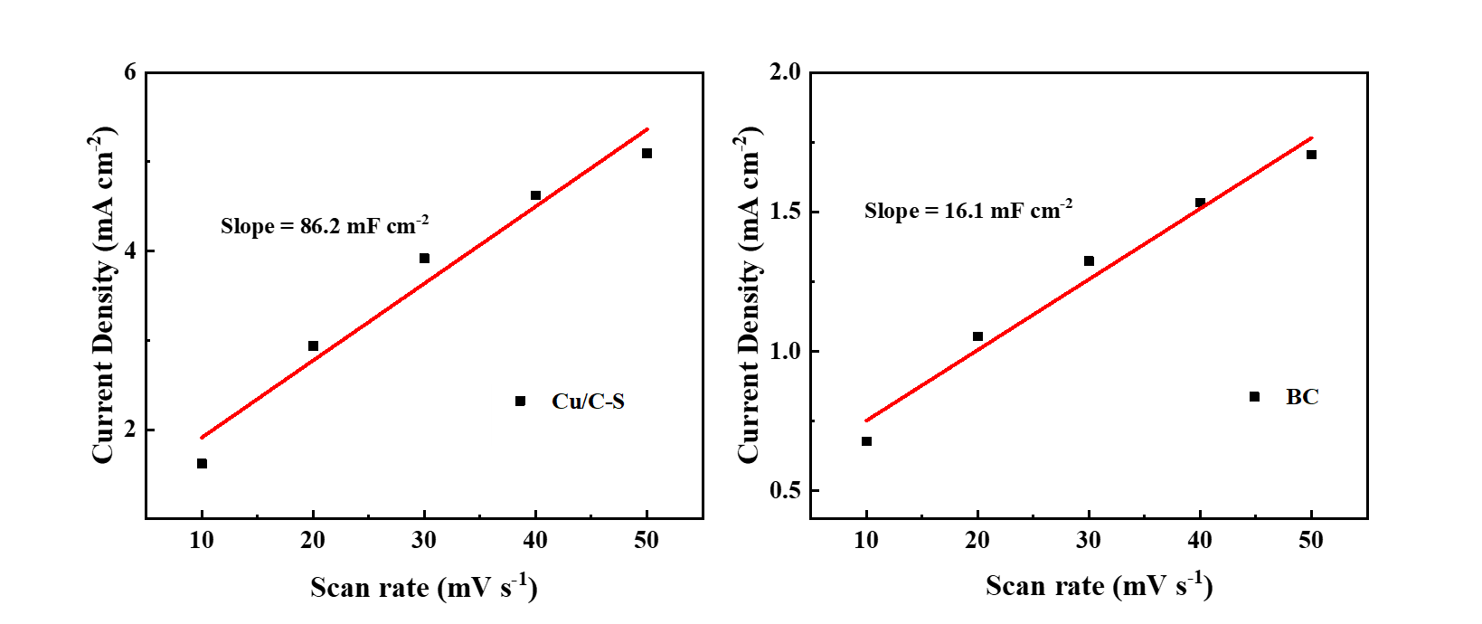
b
Supplementary Figure 2. Electrochemical activity area of BC(a) and Cu/C-S(b) materials.
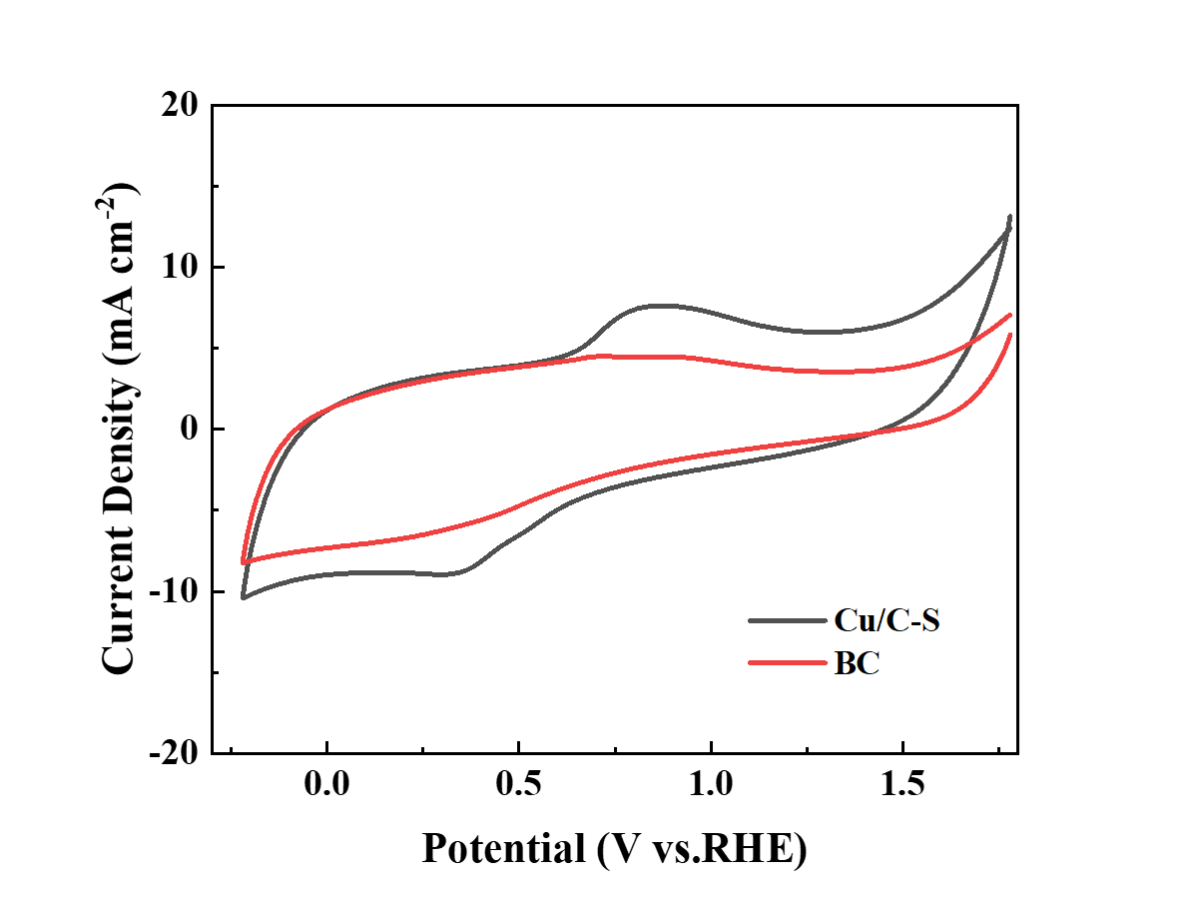
Supplementary Figure 3. CV curves of BC and Cu/C-S materials in 0.2 M Na₂SO₄ solution with a sweep rate of 50 mV/s.
a
b
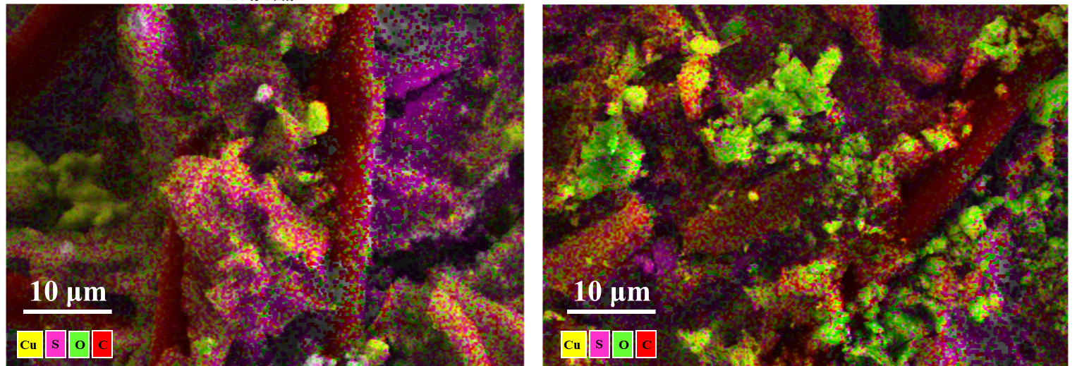
Supplementary Figure 4. EDS layered images of Cu/C-S material before and after electrochemical testing. a, before testing; b, after testing.
a
b
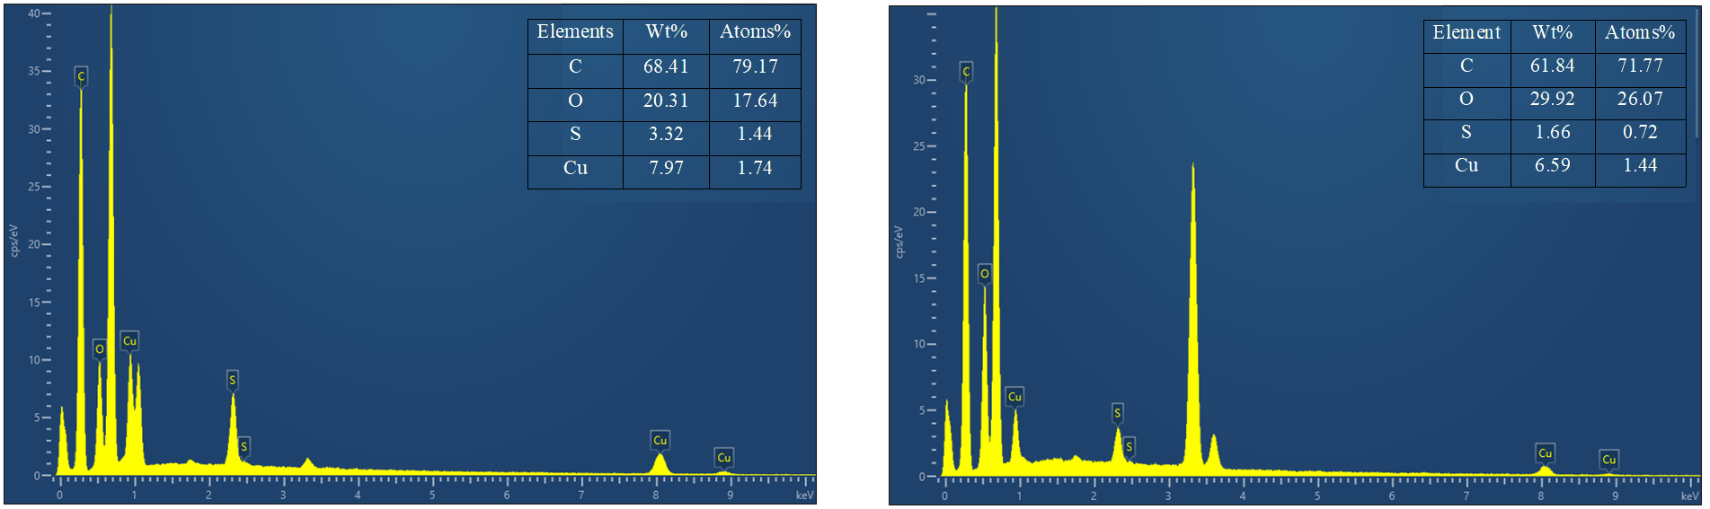
Supplementary Figure 5. Total spectra of elemental distribution maps of Cu/C-S materials before and after electrochemical tests. a, Before the test; b, After the test.
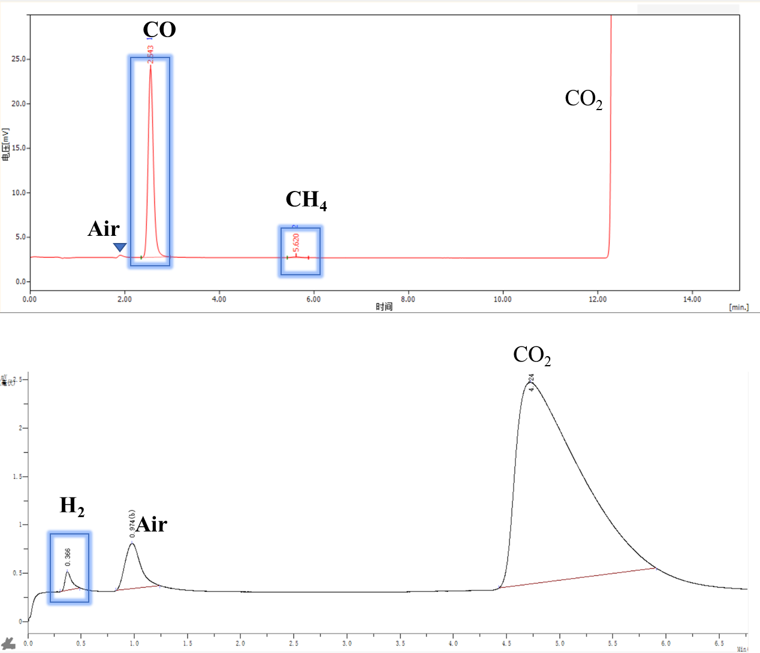
a
b
Supplementary Figure 6. Typical GC chromatogram of the gas phase product after electrolysis. a, FID detector; b, TCD detector.
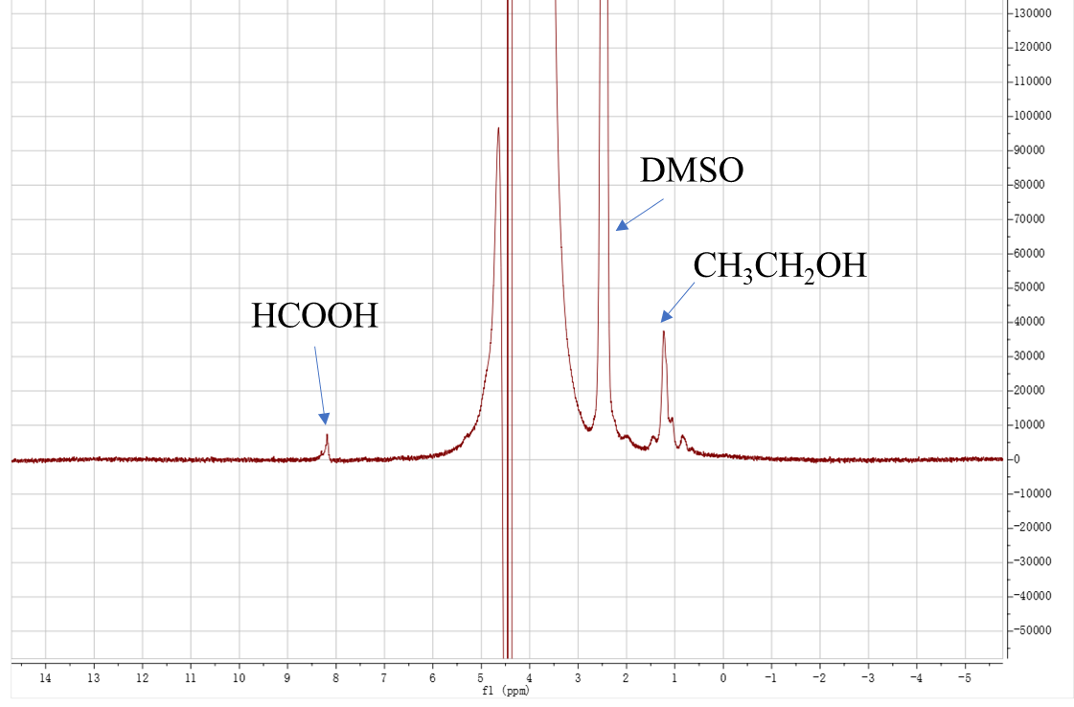
Supplementary Figure 7. Typical 1H NMR spectra of liquid phase products after electrolysis.

Supplementary Tables
Supplementary Table 1. Specific surface area, pore volume, and pore diameter of BC and Cu/C-S materials.
Materials | Surface Area  (m²/g) | Total pore volume  (cm³/g) | Average pore Diameter  (nm)
BC | 1202.9 | 0.58 | 1.93
Cu/C-S | 1005.8 | 0.53 | 2.09

Supplementary Table 2. EIS fitting data for Cu/C-S material in 1.0 M KHCO₃ solution.
Potential  V(vs.RHE) | R_{S}(Ω) | R_{CT}(Ω) | CPE-T | CPE-P
0.38 | 2.06 | 7.86 | 0.050 | 0.43
-0.32 | 2.17 | 44.88 | 0.0038 | 0.73
-0.42 | 2.03 | 7.48 | 0.018 | 0.56
-0.52 | 2.14 | 10.04 | 0.0042 | 0.71
-0.62 | 2.02 | 3.69 | 0.013 | 0.58
-0.72 | 2.03 | 2.56 | 0.0086 | 0.62

Supplementary Table 3. Product efficiency of Cu/C-S materials in 1.0 M KHCO₃ solution at different potentials.
Potential  V(vs.RHE) | H₂  FE | CO  FE | CH₄  FE | CH₃CH₂OH  FE | HCOOH  FE
-0.72 | 92.25% | 3.65% | 0.14% | 0.55% | 0.02%
-0.62 | 80.36% | 7.40% | 0.21% | 2.53% | 0.08%
-0.52 | 65.29% | 17.05% | 0.80% | 8.72% | 0.23%
-0.42 | 53.20% | 37.87% | 1.56% | 2.07% | 0.68%
-0.32 | 18.57% | 74.61% | 1.89% | 0.28% | 0.45%

Supplementary Table 4. Comparison of CO₂RR performance of Cu/C-S material and other materials.
Catalyst | Potential V(vs.RHE) | FE  (%) | TOF  (h⁻¹) | Electrolyte | Ref
Cu/C-S | -0.32 | 74.6(CO) | 116.4 | 1.0 M KHCO₃ | This work
Cu/C-S | -0.52 | 8.7(C₂H₅OH) |  | 1.0 M KHCO₃ | This work
Cu-Cu₂O-1/Cu | -0.4 | 32(C₂H₅OH) | 15.6 | 0.5 M KHCO₃ | (Zhu et al., 2019)
Cu₃Ag₁ | -0.95 | 63(C₂H₅OH) | / | 0.5 M KHCO₃ | (Lv et al., 2020)
FeNC(ZIF-8) | -0.57 | 98.8(CO) | / | 1.0 M KHCO₃ | (Hu et al., 2019)
Fe-N-C | -0.49 | 83(CO) | 410 | 0.1 M KHCO₃ | (Pan et al., 2018)
Cu(core)/CuO(shell) | -1.78 (vs.Ag/AgCl) | 21(CO)  20(HCOOH) | / | 1.0 M KHCO₃ | (Lan et al., 2014)
Cu₂O | -0.99 | 39(C₂H₅OH) | / | 0.1 M KHCO₃ | (Ren et al., 2015)
Ni−N-PC | -0.8 | 90(CO) | / | 0.5 M KHCO₃ | (Gang et al., 2020)
Fe-N/P-C | -0.45 | 98(CO) | 508.8 | 0.5 M KHCO₃ | (Li et al., 2022)
Ag_{NP}/MnO₂ | -0.90 | 68(CO) | / | 0.5 M KHCO₃ | (Zhang et al., 2021)
Cu/In₂O₃ | -0.70 | 68(CO) | / | 0.5 M KHCO₃ | (Xie et al., 2018)

Supplementary Table 5. ICP-MS measurement data for BC and Cu/C-S materials
 | Cu  (mg/g) | Fe  (mg/g) | Zn  (mg/g) | Mn  (mg/g) | Cr  (mg/g) | Sb  (mg/g) | Pb  (mg/g)
BC | 0.061 | 0.19 | 0.052 | 0.017 | 0.010 | 0.00030 | 0.0080
Cu/C-S | 37.87 | 0.025 | 0.025 | 0.015 | 0.015 | 0.00026 | 0.0095

Gang, Y., Pan, F., Fei, Y., Du, Z., Hu, Y.H., and Li, Y. (2020). Highly efficient nickel, iron, and nitrogen codoped carbon catalysts derived from industrial waste petroleum coke for electrochemical CO2 reduction. ACS Sustainable Chemistry Engineering 8(23), 8840-8847. doi: https://doi.org/10.1021/acssuschemeng.0c03054.
Hu, C., Bai, S., Gao, L., Liang, S., Yang, J., Cheng, S.-D., et al. (2019). Porosity-induced high selectivity for CO2 electroreduction to CO on Fe-doped ZIF-derived carbon catalysts. ACS Catalysis 9(12), 11579-11588. doi: https://doi.org/10.1021/acscatal.9b03175.
Hua, Y., Zhang, B., Hao, W., and Gao, Z.J.C.R.P.S. (2022). Boosting CO desorption on dual active site electrocatalysts for CO2 reduction to produce tunable syngas. Cell Reports Physical Science 3(1), 100703. doi: https://doi.org/10.1016/j.xcrp.2021.100703.
Lan, Y., Gai, C., Kenis, P.J., and Lu, J. (2014). Electrochemical reduction of carbon dioxide on Cu/CuO core/shell catalysts. ChemElectroChem 1(9), 1577-1582. doi: https://doi.org/10.1002/celc.201402182.
Li, K., Zhang, S., Zhang, X., Liu, S., Jiang, H., Jiang, T., et al. (2022). Atomic tuning of single-atom Fe–N–C catalysts with phosphorus for robust electrochemical CO2 reduction. Nano Letters 22(4), 1557-1565. doi: https://doi.org/10.1021/acs.nanolett.1c04382.
Lv, X., Shang, L., Zhou, S., Li, S., Wang, Y., Wang, Z., et al. (2020). Electron‐deficient Cu sites on Cu3Ag1 catalyst promoting CO2 electroreduction to alcohols. Advanced Energy Materials 10(37), 2001987. doi: https://doi.org/10.1002/aenm.202001987.
Pan, F., Deng, W., Justiniano, C., and Li, Y. (2018). Identification of champion transition metals centers in metal and nitrogen-codoped carbon catalysts for CO2 reduction. Applied Catalysis B: Environmental 226, 463-472. doi: https://doi.org/10.1016/j.apcatb.2018.01.001.
Ren, D., Deng, Y., Handoko, A.D., Chen, C.S., Malkhandi, S., and Yeo, B.S. (2015). Selective electrochemical reduction of carbon dioxide to ethylene and ethanol on copper (I) oxide catalysts. Acs Catalysis 5(5), 2814-2821. doi: https://doi.org/10.1021/cs502128q.
Wei, C., Sun, S., Mandler, D., Wang, X., Qiao, S.Z., and Xu, Z.J. (2019). Approaches for measuring the surface areas of metal oxide electrocatalysts for determining their intrinsic electrocatalytic activity. Chemical Society Reviews 48(9), 2518-2534. doi: 10.1039/C8CS00848E.
Xie, H., Chen, S., Ma, F., Liang, J., Miao, Z., Wang, T., et al. (2018). Boosting tunable syngas formation via electrochemical CO2 reduction on Cu/In2O3 core/shell nanoparticles. ACS Applied Materials Interfaces 10(43), 36996-37004. doi: https://doi.org/10.1021/acsami.8b12747.
Zhang, N., Zhang, X., Tao, L., Jiang, P., Ye, C., Lin, R., et al. (2021). Silver single‐atom catalyst for efficient electrochemical CO2 reduction synthesized from thermal transformation and surface reconstruction. Angewandte Chemie International Edition 60(11), 6170-6176. doi: https://doi.org/10.1002/anie.202014718.
Zhong, X., Liang, S., Yang, T., Zeng, G., Zhong, Z., Deng, H., et al. (2022). Sn Dopants with Synergistic Oxygen Vacancies Boost CO2 Electroreduction on CuO Nanosheets to CO at Low Overpotential. ACS nano 16(11), 19210-19219.
Zhu, Q., Sun, X., Yang, D., Ma, J., Kang, X., Zheng, L., et al. (2019). Carbon dioxide electroreduction to C2 products over copper-cuprous oxide derived from electrosynthesized copper complex. Nature Communications 10(1), 3851. doi: https://doi.org/10.1038/s41467-019-11599-7.

