# Supporting document of “Seismological research in Yunnan Province, China and its tectonic implication between Xianshuihe-Xiaojiang fault system and the Red River fault zone”

### S1.The detailed parameters applied in pretreatment

Considering the long time period of the earthquake catalogue and the possibility of the adjustment of seismography stations, which would affect the seismic phase and hypocenter relocation results in some degree(Hu and Han 2013), 46 seismography stations were selected from the seismic phase records after filtering (Fig. S1). And total 86268 pieces of P-wave and S-wave phase records were extracted from the catalogue(Fig. S2c).

The selected earthquake data distribute comparatively evenly in the study region (Fig. S2a) and continuously along the whole time period (Fig. S2b). [Some discrete](javascript:;) [point](javascript:;)s exacted from phase reports of P-wave and S-wave exist (Fig.S2c), and affect the relocation result in some degree. Finally total 86254 P-wave records and 81951 S-wave records are obtained after getting rid of these discrete points. The final relocation results are obtained based on these seismic phase records (Fig. S2d) and seismography stations (Fig. S2) after filtering.

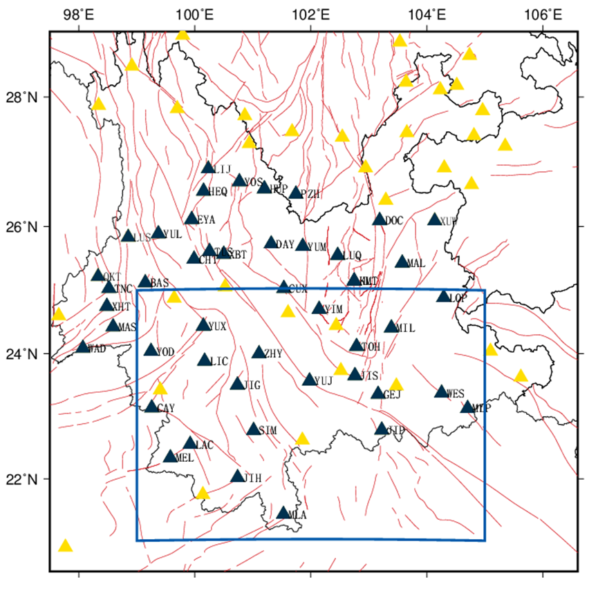

**Figure S1.** **Seismography stations distribution map used in study. The blue rectangle is the study region, the black triangles are the seismography stations used in relocation, and yellow triangles are stations these are not used in relocation.**

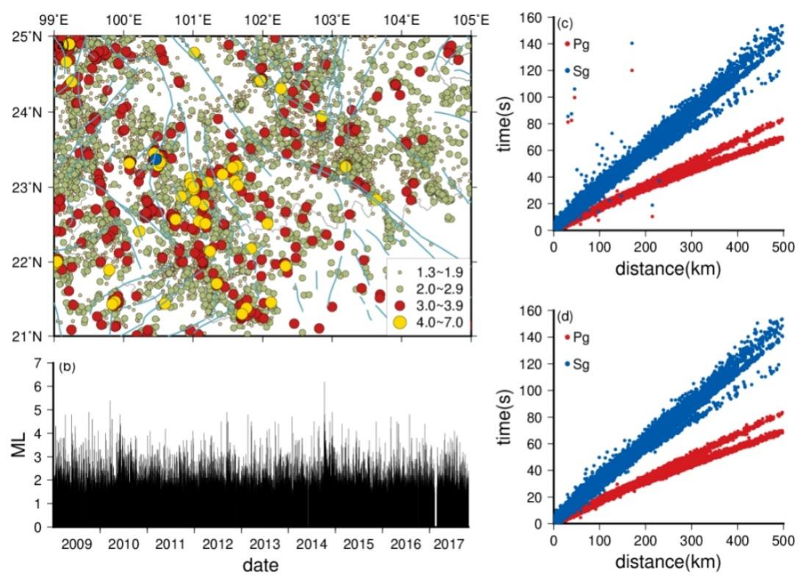

**Figure S2.** **Earthquake distribution map(a), magnitude-time chart(b), epicenter distance-travel time chart before filtering (c) and after filtering(d). The data used here is chosen from seismic phase catalogue in relocation analysis.**

### S2.Seismic relocation

Double difference hypocenter relocation algorithm(Waldhauser 2001, Waldhauser and Ellsworth 2000) applied in this study, has been widely accepted by seismologists worldwidely(Hauksson and Shearer 2005, Mottaghi et al. 2010, Sippl et al. 2018, Yang et al. 2003) due to its advantage of independence on the master event. The swarm center is used in double difference hypocenter relocation algorithm instead of master event in the arrival-time difference (ATD) location model(Spence 1980), the relocation accuracy of which mainly depends on the accuracy of the master event. Relative residual of travel time is also applied in this study to reduce the effect of crust velocity model. And waveform cross-correlation also help reduce the error of seismic phase report. These all constrained the relocation error to be about tens of meters. Michelini and Lomax (2004) and following case studies(Sheng et al. 2017) have testified that velocity structure of the hypocenter affected seismic ray and the hypocenter relocation results. Three crust velocity models were used in this study to relocate and the accurate aftershocks relocation distribution was used to depict the geometric characteristic of faults.

Due to the big study region, two global velocity model, PREM velocity model (Dziewonski and Anderson 1981) and AK135 velocity model(Kennett et al. 1995) and one modified regional velocity model from previous researcher on the familiar region(Short as HN model below) (Hu and Han 2013) were applied in our relocation analysis(Fig. S3) were used in hypocenter relocation.

Since such a lot seismic event data, the conjugate gradient method (LSQR) was applied to obtain equation solution. Considering the comparatively large relocation error of raw location data, two groups with 8 iteration method was applied in caculation. Because seismic location is the matching process of seismic event data in certain range in the whole target area, the different location results will come out with different location parameters. The null seismic event data was abandoned when too large distance with other seismic events in inversion iteration process(Waldhauser and Ellsworth, 2000).

All parameters used in relocation pretreatment and its meaning could be found in Table S1, while all parameters used in relocation and its meaning in Table S2.

**Table S1 All parameters used in relocation pretreatment and its meaning**

|  |  |  |
| --- | --- | --- |
| MINWGHT | 0 | Minimum weight chosen[0~1(Best)] |
| MAXDIST | 400 | The largest distance between event and stations (km) |
| MAXSEP | 15 | The maximum dispersion between event pairs (km) |
| MAXNGH | 15 | The maximum neighbor number of every event |
| MINLNK | 4 | The minimum connection number of every event with a neighbor |
| MINOBS | 4 | The saved minimum connection of evey event pair |
| MAXOBS | 50 | The saved maximum connection of evey event pair (ranking with the distance between every event pair) |

**Table S2 All parameters used in relocation and its meaning**

|  |  |  |
| --- | --- | --- |
| IDAT | 2 | Data type, 1=data with cross-correlation only，2=data with seismic phase only |
| IPHA | 3 | Seismic phase type，1=P wave，2=S wave ，3=P&S wave |
| DIST | 400 | The largest distance between seismic swarm center and stations (km) |
| OBSCT | 4 | The minmum number of cross-correlation or seismic phases that could connect single event into seismic swarm |
| ISOLV | 2 | Algorithm type，1=SVD，2=LSQR |
| NSET | 2 | Group number of iteration |
| NITER | 5,3 | Iteration times of evey group |
| NLAY | x | Layer number of velocity model (12 is upper limit, modified from velocity model) |
| RATIO | x | Poisson’s ratio( modified from velocity model) |

### S3.Spatial distribution of b value

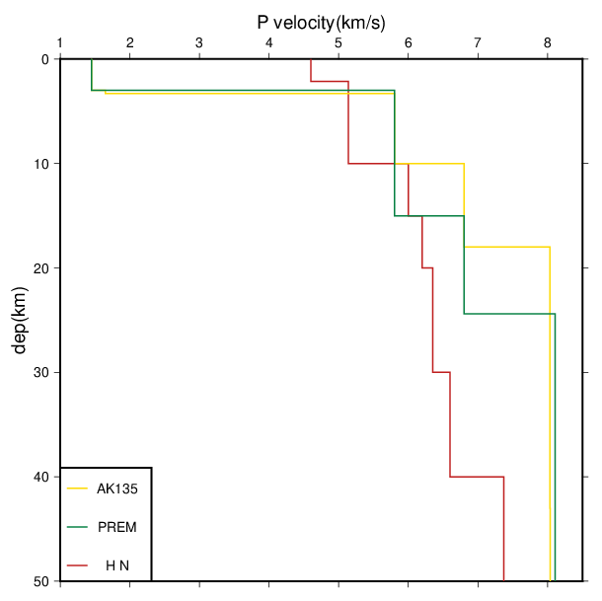

**Figure S3. Crust velocity models used in double difference hypocenter relocation. Abbrevations: AK135=AK135 velocity model(Kennett, Engdahl and Buland 1995), PREM = PREM velocity model (Dziewonski and Anderson 1981) and , HN= modified regional velocity model (Hu and Han 2013)**

Gutenberg-Richter law (Gutenberg and Richter 1944) is a main basic, also very important formula in seismological research. The b value, originating from Gutenberg-Richter law, is related with the characteristic of the medium(Mogi 1967, Scholz 1968). The spatial distribution of b-value is considered to be relative with the stress state, or smaller b-value means higher stress level(Wiemer and Wyss 1997, Wyss 1973).It is possible that different magnitude-frequency relation exists in different seismic zone and the main factor affecting b-value is the inhomogeneity degree of the medium(MOGI 1962).

The maximum likelihood method(Cao and Gao 2002, Utsu 1965) is used when obtaining b-value. When obtaining spatial distribution of b-value in study region, the whole study region was divided into 0.05°*0.05°mesh points. In order to make the b-value reliable in statistic calculation, a minimum number of earthquake samples(N) was set at 50 in calculating b-value at every mesh point(Wiemer 2001), meaning the null b-value was obtained when earthquake sample number is smaller than 50. The main error in b-value calculation originates from the inaccurate Mc(Stein and Hanks 1998).

### S4.Seismic energy, density distribution analysis

The following classic magnitude-energy equation(Gutenberg and Richter 1941) was used to transfer magnitude into energy with unit erg :

 (1)

The whole study region was divided into k*l mesh grids at 0.15°*0.15°(longitude*latitude), 0.2°*0.2° and 0.3°*0.3°. Then the statistic matrix E result comes out as following.

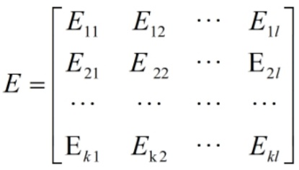 (2)

, energy density map, is the total seismic energy released in the mesh point at i row, j column. And the matrix E is called energy matrix of the study region.

Based on the equations above, the number of seismic events in every mash gird(Left charts in Figs 7, 8 and 9) and corresponding seismic energy density distribution map could be obtained(Right charts in Figs 7, 8 and 9). An abnormal belt of seismic energy and density along the XXFS could be identified from the distribution map.

### S5.Focal mechanism solution analysis

Three velocity models (PREM, AK135 and HN) were used in relocation. Though some difference between the results from three models exists, the error of results is acceptable. In order to obtain focal mechanism solutions as many as possible, the relocation result from HN model, which have the most events, were applied here.

The generalized Cut and Paste method(gCAP) (Zhu and Ben-Zion 2013), was applied to obtain focal mechanism solution in the study region. The traditional focal mechanism solution method that use first motion of P-wave, demands well distribution of seismography stations and is not able to inverse the epicenter depth and magnitude. The gCAP method not only has overcome all these shortcomings, but also have low requirement on crust velocity model accuracy(Xie et al. 2017, Zheng et al. 2009). This gCAP method assigns different weighting to Pnl wave and S wave to calculate the fitting error function between [theoretical](javascript:;) and actual seismic phase. Then the optimal solution can be obtained through grid searching. Because no much surface waves are generated by small events, gCAP method is not very easy to fit the optimal depth, which is very possible to result large error when inversion on small event. The events used in this study region are main small events (ML≥1.3) and all parameters need to be adjusted in advance in order to obtain optimal solution. In the process of parameters adjustment, previous research results of event cases in our study region were used as references. The parameters of inversion frequency, filtering range and weight of Pnl-wave were adjusted continuously to obtain the close inversion results to previous results (Fig. S4 and Table S3).

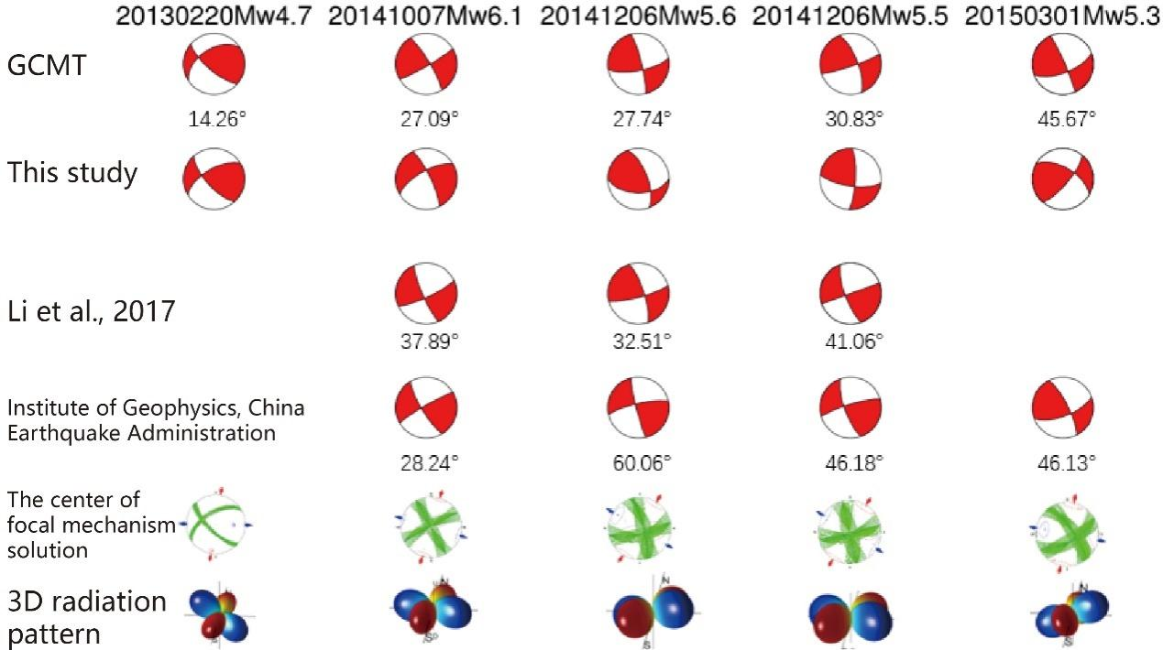

**Figure S4. The inversion results list of mid-strong earthquakes selected from the event catalogue. The angle below each focal mechanism solution is the rotational angle**

**Table S3. Focal mechanism solution parameters of middle-strong earthquakes**

|  |  |  |  |  |  |  |  |  |  |  |  |  |  |  |  |
| --- | --- | --- | --- | --- | --- | --- | --- | --- | --- | --- | --- | --- | --- | --- | --- |
| Source | 20130220Mw4.7 | | | 20141007Mw6.1 | | | 20141206Mw5.6 | | | 20141206Mw5.5 | | | 20150301Mw5.3 | | |
| Strike | Dip angle | Rake angle | Strike | Dip angle | Rake angle | Strike | Dip angle | Rake angle | Strike | Dip angle | Rake angle | Strike | Dip angle | Rake angle |
| GCMT | 237 | 49 | 24 | 329 | 81 | 174 | 79 | 72 | 9 | 339 | 71 | 173 | 69 | 66 | 6 |
| This study | 239 | 63 | 23 | 240 | 69 | -12 | 90 | 52 | 31 | 98 | 71 | 14 | 40 | 75 | 32 |
| Li et al | - | - | - | 65 | 80 | -10 | 75 | 80 | 15 | 70 | 90 | -15 | - | - | - |
| IGP | - | - | - | 240 | 84 | 12 | 257 | 79 | 6 | 253 | 81 | 16 | 69 | 67 | 15 |

**Note: IGP means Institute of Geophysics, China Earthquake Administration**

**Since three velocity models were applied in relocation process**

### S6.Regional stress field inversion

Based on the method of Hardebeck and Michael (2006), a matlab package, MSATSI (Martínez‐Garzón et al. 2014), was used to calculate the stress field in study region. According to the inversion method of Michael (1987), the method applied here divided the study region into mesh grids and assumed the stress in each mesh point is even, and damping parameter was added into inversion process to constrain the stress field distribution.

G:\99、文档\1、论文\1、毕业论文\25、图\17.tif

**Figure S5. The relationship map between fitting error and model length. The selected damping parameter is shown as a blue cross. The result is calculated from 0.15°*0.15° mesh grids of the study region.**

Through MSATSI program, the optimal damping coefficient obtained from regional stress field inversion is 0.9, selected in inversion process (Fig. S5). When the damping coefficient(e) is lower than 0.9, the inversion error doesn’t improve conspicuously, meaning the local characteristic of stress field is obvious, while higher than 0.9, the inversion error increased sharply, meaning integral characteristic of stress field is obvious(Cui et al. 2019, Guo et al. 2014).

At the same time, the coefficient of stress deformation(R)(Gephart and Forsyth 1984) was used in this study. R here was defined as:

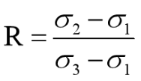 （4-1）

In which, ,  and  are maximum, middle and minimum principal stress axes respectively. When the coefficient of stress deformation(R value) is close to 1 or 0, that means both axes( and )are in tensional status or both axes（ and ） in compressive status; When R is close to 0.5, that means three axes are in stable status(Guiraud et al. 1989, Wan et al. 2016, Huang et al. 2016).

Cao A, Gao SS. 2002. Temporal variation of seismic b‐values beneath northeastern Japan island arc. Geophysical research letters.29:48-41-48-43.

Dziewonski AM, Anderson DL. 1981. Preliminary reference Earth model. Physics of the earth and planetary interiors.25:297-356.

Gephart JW, Forsyth DW. 1984. An improved method for determining the regional stress tensor using earthquake focal mechanism data: application to the San Fernando earthquake sequence. Journal of Geophysical Research: Solid Earth.89:9305-9320.

Guiraud M, Laborde O, Philip H. 1989. Characterization of various types of deformation and their corresponding deviatoric stress tensors using microfault analysis. Tectonophysics.170:289-316.

Gutenberg B, Richter C. 1941. Seismicity of the Earth: Geological Society of America.

Gutenberg B, Richter CF. 1944. Frequency of earthquakes in California. Bulletin of the Seismological Society of America.34:185-188.

Hardebeck JL, Michael AJ. 2006. Damped regional‐scale stress inversions: Methodology and examples for southern California and the Coalinga aftershock sequence. Journal of Geophysical Research: Solid Earth.111.

Hauksson E, Shearer P. 2005. Southern California hypocenter relocation with waveform cross-correlation, part 1: Results using the double-difference method. Bulletin of the Seismological Society of America.95:896-903.

Kennett BL, Engdahl E, Buland R. 1995. Constraints on seismic velocities in the Earth from traveltimes. Geophysical Journal International.122:108-124.

Martínez‐Garzón P, Kwiatek G, Ickrath M, Bohnhoff M. 2014. MSATSI: A MATLAB package for stress inversion combining solid classic methodology, a new simplified user‐handling, and a visualization tool. Seismological Research Letters.85:896-904.

Michael AJ. 1987. Use of focal mechanisms to determine stress: a control study. Journal of Geophysical Research: Solid Earth.92:357-368.

Michelini A, Lomax A. 2004. The effect of velocity structure errors on double‐difference earthquake location. Geophysical Research Letters.31.

MOGI K. 1962. Study of elastic shocks caused by the fracture of heterogeneous materials and its relations to earthquake phenomena. Bulletin of the Earthquake Research Institute, University of Tokyo: Tokyo, Japan.125-173.

Mogi K. 1967. Regional Variations in Magnitude-Frequency Relation of Earthquakes. Bulletin of the Earthquake Research Institute University of Tokyo.45:313-325.

Mottaghi A, Rezapour M, Yaminifard F. 2010. Double-difference relocation of earthquake hypocenters along the southern flank of the Central Alborz, Iran. Bulletin of the Seismological Society of America.100:2014-2023.

Rydelek PA, Sacks IS. 1989. Testing the completeness of earthquake catalogues and the hypothesis of self-similarity. Nature.337:251-253.

Scholz C. 1968. Microfracturing and the inelastic deformation of rock in compression. Journal of Geophysical Research.73:1417-1432.

Sippl C, Schurr B, Asch G, Kummerow J. 2018. Seismicity structure of the northern Chile forearc from> 100,000 double‐difference relocated hypocenters. Journal of Geophysical Research: Solid Earth.123:4063-4087.

Spence W. 1980. Relative epicenter determination using P-wave arrival-time differences. Bulletin of the Seismological Society of America.70:171-183.

Stein RS, Hanks TC. 1998. M≧ 6 earthquakes in southern California during the twentieth century: No evidence for a seismicity or moment deficit. Bulletin of the Seismological Society of America.88:635-652.

Utsu T. 1965. A method for determining the value of b in a formula log n=a-bM showing the magnitude frequency relation for earthquakes. Geophysics Bulletin of Hokkaido University.13.

Waldhauser F. 2001. hypoDD--A program to compute double-difference hypocenter locations.

Waldhauser F, Ellsworth WL. 2000. A double-difference earthquake location algorithm: Method and application to the northern Hayward fault, California. Bulletin of the seismological society of America.90:1353-1368.

Wan Y, Sheng S, Huang J, Li X, Chen X. 2016. The grid search algorithm of tectonic stress tensor based on focal mechanism data and its application in the boundary zone of China, Vietnam and Laos. Journal of Earth Science.27:777-785.

Wiemer S. 2001. A software package to analyze seismicity: ZMAP. Seismological Research Letters.72:373-382.

Wiemer S, Wyss M. 1997. Mapping the frequency‐magnitude distribution in asperities: An improved technique to calculate recurrence times? Journal of Geophysical Research: Solid Earth.102:15115-15128.

Wyss M. 1973. Towards a physical understanding of the earthquake frequency distribution. Geophys JR Astron Soc.31:341-359.

Xie Z, Zheng Y, Liu C, Shan B, Riaz MS, Xiong X. 2017. An integrated analysis of source parameters, seismogenic structure, and seismic hazards related to the 2014 MS 6.3 Kangding earthquake, China. Tectonophysics.712:1-9.

Yang Z, Chen Y, Zheng Y, Yü X. 2003. Accurate relocation of earthquakes in central-western China using the double-difference earthquake location algorithm. Science in China Series D: Earth Sciences.46:181-188.

Zhu L, Ben-Zion Y. 2013. Parametrization of general seismic potency and moment tensors for source inversion of seismic waveform data. Geophysical Journal International.194:839-843.

Cui, H., Wan, Y., Huang, J., Sheng, S., &Jin, Z. (2019). Inversion for the tectonic stress field and the characteristic of the stress shape factor of the detachment slab in the Pamir-Hindu Kush area (in Chinese with English abstract). *Chinese Journal of Geophysics*, 62(5), 1633-1649.

Guo, X., Chen, X., Wang, S., & Wang, H., (2014). Focal Mechanism of Small and Moderate Earthquakes and Tectonic Stress Field in Sichuan-Yunnan Areas (in Chinese with English abstract). *China Earthquake Engineering Journal*, 36(3), 599-607.

Hu, N., Han, Z., (2013). Seismological study on behaviors of present-day movement of arcuate tectonic belt in southeast Yunnan (in Chinese with English abstract). *Seismology and Geology*, 35(1), 1-21.

Huang, J., Wan, Y., Sheng, S., Li, X., &Gao, X., (2016). Heterogeneity of present-day stress field in the Tonga-Kermadec subduction zone and its geodynamic significance (in Chinese with English abstract). *Chinese Journal of Geophysics*, 59(2), 578-592.

Sheng, S., Wan, Y., Wang, X., Huang, J., Xu, Z., & Li, J. (2017). Relocation of the 2013 Songyuan earthquake swarm in Jilin Province and its seismogenic structure (in Chinese with English abstract). *Earth Science Frontiers*, 24(2), 212-219.

Zheng, Y., Ma, H., Lu, J., Ni, S., Li, Y., & Wei, S. (2009). Source mechanism of strong aftershocks (Ms5.6) of the 2008/05/12 Wenchuan earthquake and the implication for seismotectonics (in Chinese). *Science in China Series D*: Earth Sciences, 52(6), 739-753.